Note To remember: about defining fields and unique constraints
class CartItem(models.Model):
cart = models.ForeignKey(to=Cart, on_delete=models.CASCADE, related_name='items', default=None)
product = models.ForeignKey(to=Product, on_delete=models.CASCADE)

quantity = quantity = models.PositiveSmallIntegerField(
validators=[MinValueValidator(1)]
)

class Meta:
unique_together = [['cart', 'product']]
*********************************************************
To define the list of http methods that are accepted to any ViewSet:
class CartItemViewSet(ModelViewSet):

# This list must be in lower case

http_method_names = ['get', 'post', 'patch', 'delete'];

def get_serializer_class(self):
if self.request.method == 'POST':
return AddCartItemSerialzier

elif self.request.method == 'PATCH':
return UpdateCartItemSerializer

return CartItemSerializer

def get_queryset(self):
return CartItem.objects.filter(cart_id = self.kwargs['cart_pk']).select_related('product')

def get_serializer_context(self):
return { 'cart_id': self.kwargs['cart_pk'] }

*********************************************************

Note (to remember): we must always check the number of query that are executed before finish from API, we can use Django Toolbar for that.
*********************************************************
Note (To remember): the runtime fields must define inside the serializer if we want to send them with body.
class AddCartItemSerialzier(serializers.ModelSerializer):
id = serializers.UUIDField(read_only=True)

product_id = serializers.IntegerField() # Here we set product_id
# because it is populated only in runtime

def validate_product_id(self, value):
if not Product.objects.filter(pk = value).exists():
raise serializers.ValidationError(f'No product found with value: {value}')
return value

class Meta:
model = CartItem
fields = ['id', 'product_id', 'quantity']
*********************************************************
Note 1: is_staff in auth_user for telling if the user can access the admin area.
Note 2: If one of middleware return response then the next one will not be executed (normal behavior).
*********************************************************

To extend the user model, we have 2-options:
- Extend User: inherit from User class For storing attributes related to authentication
- Create Profile: use composition and one to one relationship for storing non-auth related attributes.
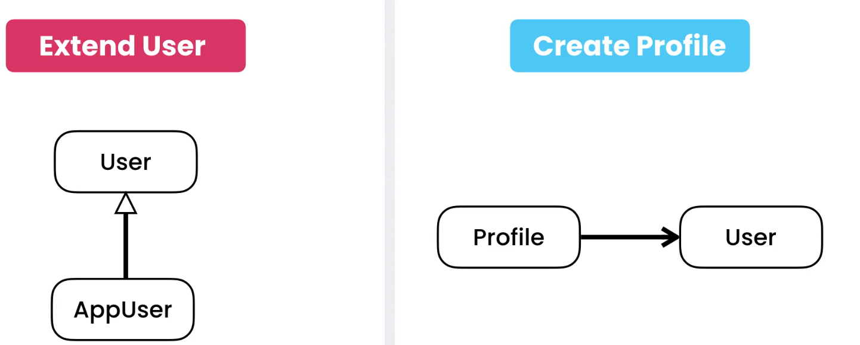
*********************************************************
To override the custom user model:
from django.contrib.auth.models import AbstractUser

from django.db import models

# Create your models here.
class User(AbstractUser):
email = models.EmailField(unique=True, max_length=150)
*********************************************************
Then we define inside the settings:
AUTH_USER_MODEL='core.User'
*********************************************************

Then if we have dependency between User-model and Any other independent app, we use:
from django.conf import settings

class LikedItem(models.Model):
user = models.ForeignKey(to=settings.AUTH_USER_MODEL, on_delete=models.CASCADE)

content_type = models.ForeignKey(to=ContentType, on_delete=models.CASCADE)

object_id = models.PositiveIntegerField()

content_object = GenericForeignKey()
*********************************************************
In UserAdmin For Admin site to make the email-field appear, then we do:
from django.contrib.auth.admin import UserAdmin as BaseUserAdmin

class UserAdmin(BaseUserAdmin):
add_fieldsets = (
(
None,
{
"classes": ("wide",),
"fields": ("username", "usable_password", "password1", "password2", "email"),
},
),
)
*********************************************************
Note: If we create the core User model class late in project may we end with:
- Delete full database and re-create it
- Delete the venv folder and recreate it.
- Run the migrations again
*********************************************************

Note (to remember): the list_display in admin.py can’t accept relation with attributes.
To solve the problem we define the properties as methods inside the models.py for the same registered model:
Ex: in admin.py
@admin.register(models.Customer)
class CustomerAdmin(admin.ModelAdmin):
list_display = [ 'first_name', 'last_name', 'membership', 'orders' ]

And for models.py:
from django.contrib import admin
class Customer(models.Model):

# first_name = models.CharField(max_length=255)
# last_name = models.CharField(max_length=255)
# email = models.EmailField(unique=True)
user = models.OneToOneField(to=settings.AUTH_USER_MODEL, on_delete=models.CASCADE)

class Meta:
ordering = ['user__first_name', 'user__last_name']

@admin.display(ordering='user__first_name')
def first_name(self):
return self.user.first_name # type: ignore

@admin.display(ordering='user__last_name')
def last_name(self):
return self.user.last_name; # type: ignore
*********************************************************
Note (From me): Foreach model we create, django will create permissions for add, update, get, delete permissions and store them in auth_permission
*********************************************************

To create custom permissions that can be used with model-class, we define:
- Define the meta-class inside the target model
- Define permissions list that contains tuples with two fields

class Order(models.Model):
PAYMENT_STATUS_PENDING = 'P'
PAYMENT_STATUS_COMPLETE = 'C'
PAYMENT_STATUS_FAILED = 'F'

PAYMENT_STATUS_CHOICES = [
(PAYMENT_STATUS_PENDING, 'Pending'),
(PAYMENT_STATUS_COMPLETE, 'Complete'),
(PAYMENT_STATUS_FAILED, 'Failed'),
]

placed_at = models.DateTimeField(auto_now_add=True)

payment_status = models.CharField(max_length=1, choices=PAYMENT_STATUS_CHOICES, default=PAYMENT_STATUS_PENDING)

customer = models.ForeignKey(to=Customer, on_delete=models.PROTECT)

class Meta:
permissions= [
('cancel_order', 'can cancel order') # this custom permission
]
*********************************************************

To adding djsoer:
- Run command: pip install -U djoser
- In installed apps:
INSTALLED_APPS = (
'django.contrib.auth',
(...),
'rest_framework',
'djoser',
(...),
)
- Updating the urls.py of main project:
urlpatterns = [
(...),
re_path(r'^auth/', include('djoser.urls')), # re_path is from django.urls
]
*********************************************************

To config the auth engine to use JWT:
- In settings.py:
REST_FRAMEWORK = {
'DEFAULT_AUTHENTICATION_CLASSES': (
'rest_framework_simplejwt.authentication.JWTAuthentication', # we must add this comma
),
}

- In settings.py config the headers:
SIMPLE_JWT = {
'AUTH_HEADER_TYPES': ('JWT',),
}

- In settings.py add to disable token auth: (TOKEN_MODEL is the default authentication technique for rest_framework but it stores the data in db)
DJOSER = {
'TOKEN_MODEL': None,
# other settings
}

- Update the urls.py of the main project:

urlpatterns = [
(...),
re_path(r'^auth/', include('djoser.urls')),
re_path(r'^auth/', include('djoser.urls.jwt')),
]
*********************************************************

To override the user create serializer to include our fields that contains the data about our customer:
- In settings.py:
DJOSER = {
'TOKEN_MODEL': None,
'SERIALIZERS': {
'user_create': 'core.serializers.UserCreateSerializer',
},
# other settings
}
--------------------------------------------------------------------------------
- Then we create serializers.py in core-app, with the content:
  - Note: here we inherit every thing from Base.Meta for serializer meta class
from djoser.serializers import UserCreateSerializer as Base

class UserCreateSerializer(Base):

class Meta(Base.Meta):
fields = ['id', 'username', 'email', 'password', 'first_name', 'last_name']
*********************************************************

To create our profile api, we go to store-app:
- Inside the serializers.py:
class CustomerSerializer(serializers.ModelSerializer):
user_id = serializers.IntegerField()
class Meta:
model = Customer
fields = ['id', 'user_id', 'phone', 'birth_date', 'membership']

- Inside the views.py of store-app:
class CustomerViewSet(CreateModelMixin, UpdateModelMixin, RetrieveModelMixin, GenericViewSet):
queryset = Customer.objects.all()
serializer_class = CustomerSerializer

- Inside the urls.py of store-app:
router.register('customers', views.CustomerViewSet)
*********************************************************
https://django-rest-framework-simplejwt.readthedocs.io/en/latest/settings.html
*********************************************************
To override the JWT lifetime:
SIMPLE_JWT = {
'AUTH_HEADER_TYPES': ('JWT',),
"ACCESS_TOKEN_LIFETIME": timedelta(days=30),
}

*********************************************************
http://localhost:8000/auth/jwt/create
*********************************************************

