package main

import (
"fmt"
"runtime"
"time"
)

func doWork(id int) {
fmt.Printf("the id started is: %d at %s\n", id, time.Now().Format("15:04:05"))
time.Sleep(1 * time.Second)
fmt.Printf("the id ended is: %d at %s\n", id, time.Now().Format("15:04:05"))
}

func main() {
for i := 0; i < 5; i++ {
go doWork(i)
}

time.Sleep(2 * time.Second)

fmt.Println("Number of CPUs: ", runtime.NumCPU())
// if we set this to 0, then nothing will be altered
fmt.Println("For go: ", runtime.GOMAXPROCS(0))
}
************************************************************

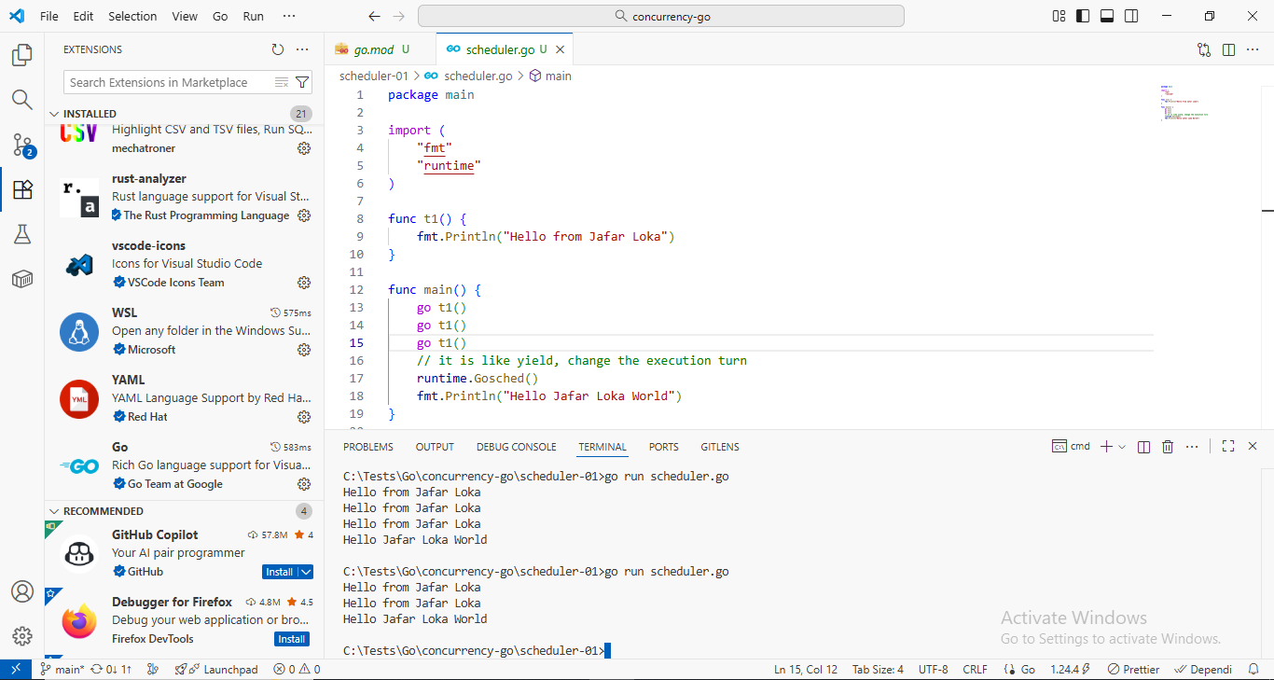
************************************************************
package main

import (
"fmt"
"runtime"
)

func t1() {
fmt.Println("Hello from Jafar Loka")
}

func main() {
go t1()
go t1()
go t1()
// it is like yield, change the execution turn
runtime.Gosched()
fmt.Println("Hello Jafar Loka World")
}
************************************************************

To build simple http get with go routine:
package main

import (
"fmt"
"io"
"net/http"
"strings"
"time"
)
const characters = "abcdefghijklmnopqrstuvwxyz"
func CheckLetters(url string, freq []int) {
resp, err := http.Get(url)
if err != nil {
panic("Error in Get")
}
defer resp.Body.Close()
if resp.StatusCode != 200 {
panic("Error with status: " + resp.Status)
}
body, _ := io.ReadAll(resp.Body)
for _, c := range body {
t1 := strings.ToLower(string(c))
t1Index := strings.Index(characters, t1)
if t1Index >= 0 {
freq[t1Index] += 1
}
}
fmt.Println(url, " completed")
}

func main() {
freq := make([]int, 26)
url := "https://example.com"
for i := 0; i < 10; i++ {
// this will may cause race conditions
go CheckLetters(url, freq)
}
time.Sleep(5 * time.Second)
for t1, t2 := range characters {
fmt.Printf("%c is: %d\n", t2, freq[t1])
}
}
************************************************************
Simple share variable with multiple routine (race condition):
package main

import (
"fmt"
"time"
)
func spend(t1 *int) {
for i := 0; i < 1000000; i++ {
*t1 -= 10
}

fmt.Println("Spend completed")
}
func save(t1 *int) {
for i := 0; i < 1000000; i++ {
*t1 += 10
}
fmt.Println("Save completed")
}
func main() {
t1 := 500
go save(&t1)
go spend(&t1)
time.Sleep(2 * time.Second)
fmt.Println("Total is: ", t1)
}

************************************************************
To solve multiple share between multiple routines:
package main

import (
"fmt"
"sync"
"time"
)

func spend(t1 *int, mutex *sync.Mutex) {
for i := 0; i < 1000000; i++ {
mutex.Lock()
*t1 -= 10
mutex.Unlock()
// From Doc: Gosched yields the processor, allowing other goroutines to run.
// It does not suspend the
// current goroutine, so execution resumes automatically.
// runtime.Gosched()
}

fmt.Println("Spend completed")
}
func save(t1 *int, mutex *sync.Mutex) {
for i := 0; i < 1000000; i++ {
mutex.Lock()
*t1 += 10
mutex.Unlock()
// here the goroutine runs on multiple processors, so the result also has race conditions
// runtime.Gosched()
}
fmt.Println("Save completed")
}
func main() {
t1 := 500
// When we create a new mutex, its initial state is always unlocked.
mutex := sync.Mutex{}
go save(&t1, &mutex)
go spend(&t1, &mutex)
time.Sleep(1 * time.Second)
mutex.Lock()
fmt.Println("Total is: ", t1)
mutex.Unlock()
}
---------------------------------------------------------------------------------------

To solve the problem of multiple share for variable:
package main

import (
"fmt"
"io"
"net/http"
"strconv"
"strings"
"sync"
"time"
)

const characters = "abcdefghijklmnopqrstuvwxyz"

func CheckLetters(url string, freq []int, mutex *sync.Mutex) {
resp, err := http.Get(url)
if err != nil {
panic("Error in Get")
}
defer resp.Body.Close()
if resp.StatusCode != 200 {
panic("Error with status: " + resp.Status)
}
body, _ := io.ReadAll(resp.Body)
mutex.Lock()
for _, c := range body {
t1 := strings.ToLower(string(c))
t1Index := strings.Index(characters, t1)
if t1Index >= 0 {
freq[t1Index] += 1
}
}
mutex.Unlock()
fmt.Println(url, " completed")
}

func main() {
freq := make([]int, 26)
url := "https://jsonplaceholder.typicode.com/users/"
mutex := sync.Mutex{}
for i := 1; i < 11; i++ {
// this will may cause race conditions
go CheckLetters(url+strconv.Itoa(i), freq, &mutex)
}
time.Sleep(5 * time.Second)
mutex.Lock()
for t1, t2 := range characters {
fmt.Printf("%c is: %d\n", t2, freq[t1])
}
mutex.Unlock()
}
---------------------------------------------------------------------------------------
package main

import (
"fmt"
"runtime"
"strconv"
"sync"
"time"
)

func writer(data *[]string, mutex *sync.RWMutex) {
for i := 0; ; i++ {
mutex.Lock() // this will lock for wrting only
*data = append(*data, "Data with index: "+strconv.Itoa(i))
mutex.Unlock()
time.Sleep(100 * time.Millisecond)
fmt.Println("Data has been added")
}
}

func getAllData(data *[]string) []string {
copyData := make([]string, 0, len(*data))
copyData = append(copyData, *data...)
return copyData
}

func reader(data *[]string, mutex *sync.RWMutex, start time.Time) {
for i := 0; i < 1000; i++ {
mutex.RLock()
allData := getAllData(data)
mutex.RUnlock()
runtime.Gosched()
fmt.Println("Data with length: ", len(allData), ", take: ", time.Since(start))
}
}

func main() {
data := make([]string, 0, 10000)
mutex := sync.RWMutex{}
go writer(&data, &mutex)
start := time.Now()
for i := 0; i < 2000; i++ {
go reader(&data, &mutex, start)
}
time.Sleep(50 * time.Second)
}
---------------------------------------------------------------------------------------

