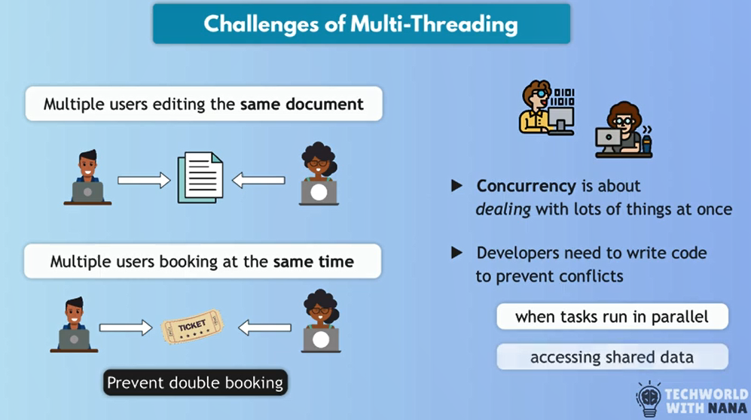
************************************************************
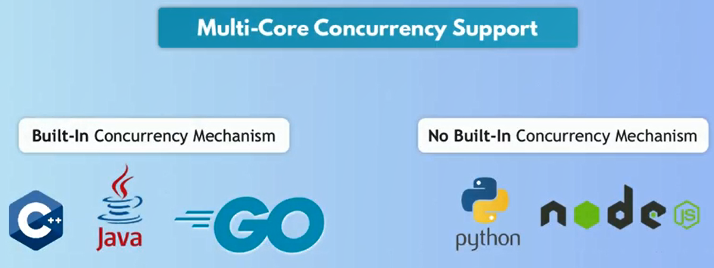
************************************************************
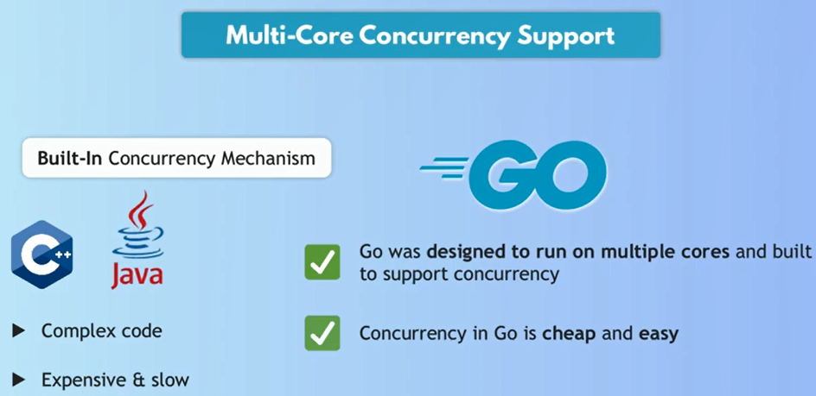
************************************************************
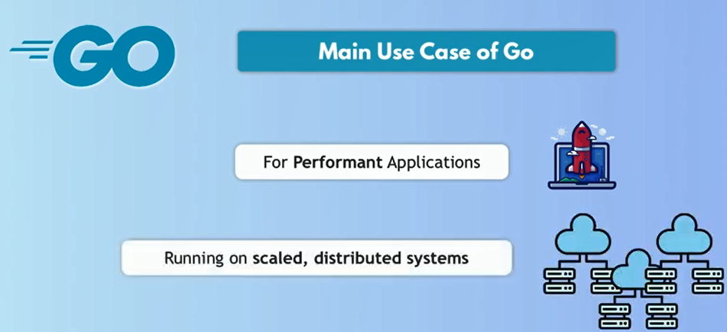
************************************************************
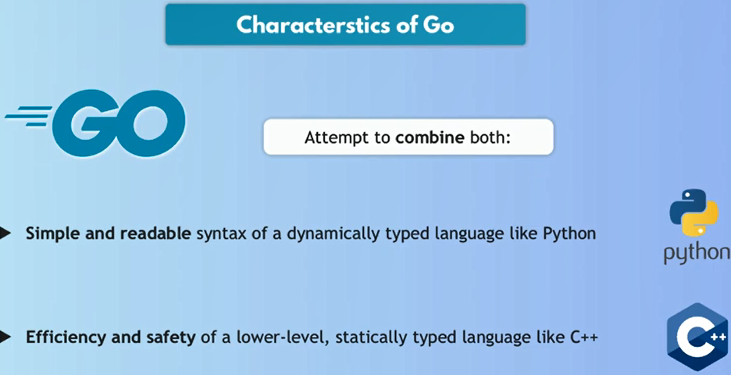
************************************************************
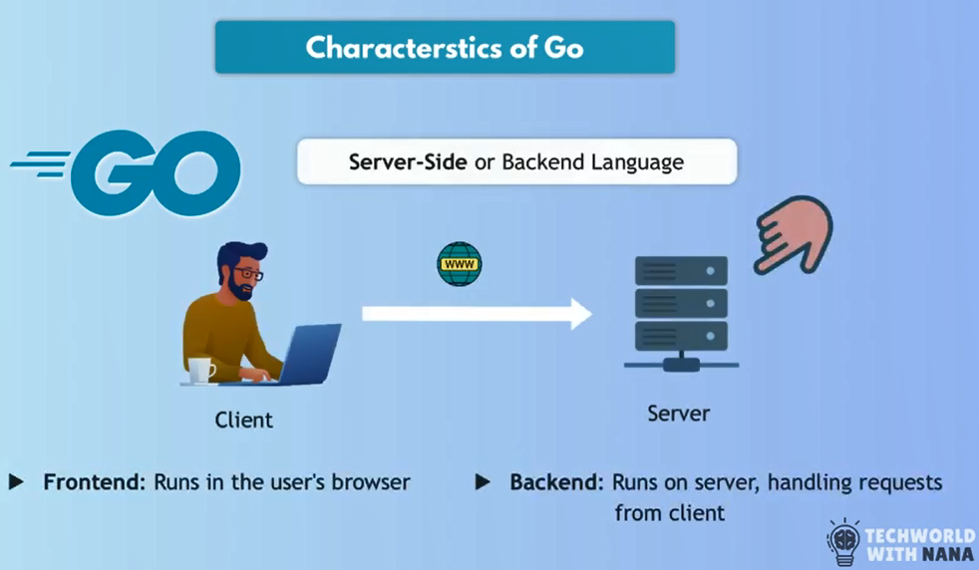
************************************************************
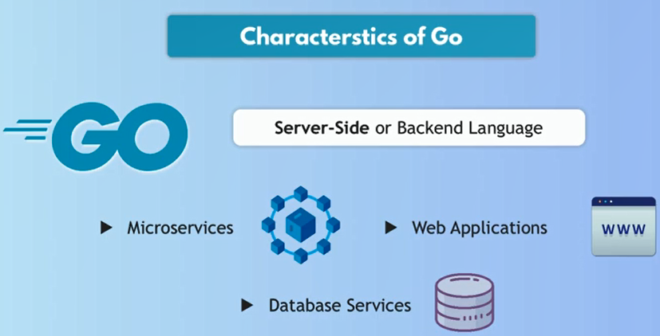
************************************************************
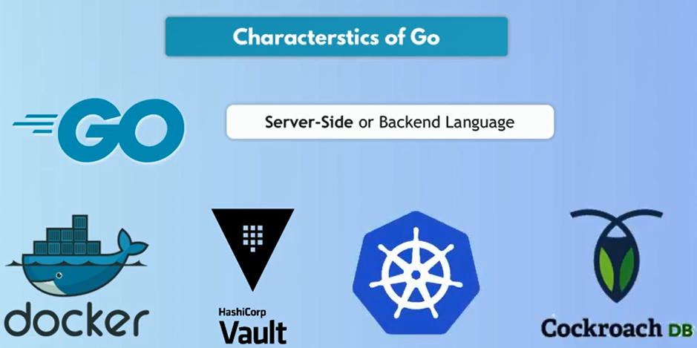
************************************************************
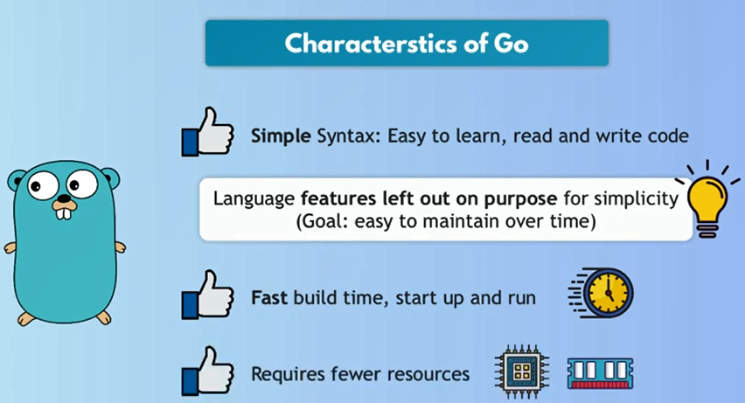
************************************************************
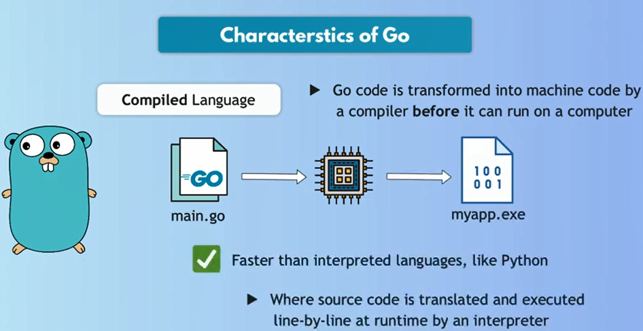
************************************************************
Run The Same Binary For Different OS:
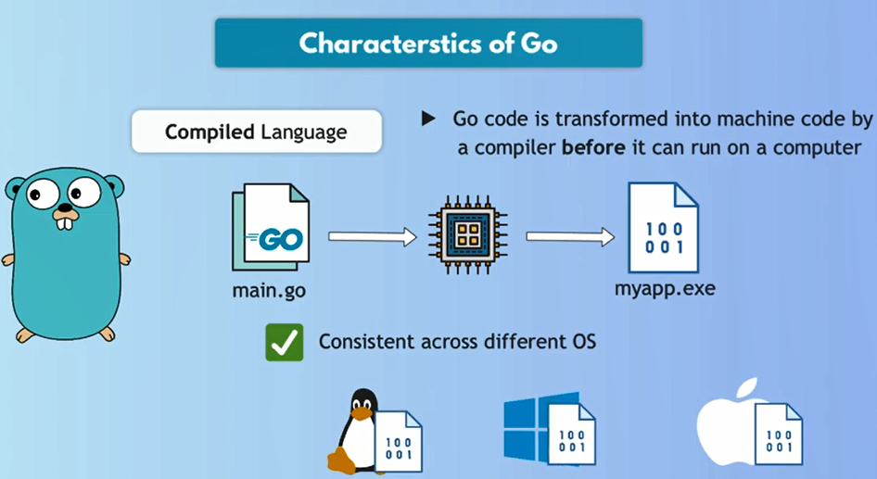
************************************************************
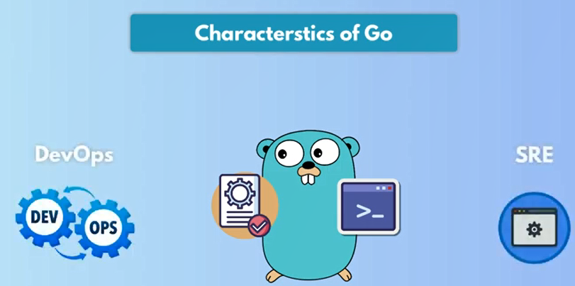
************************************************************
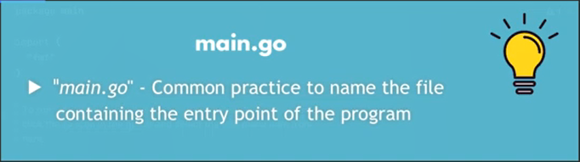
************************************************************
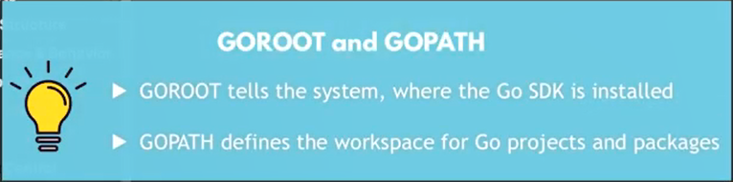
************************************************************
Every Thing In Go Organize in packages
************************************************************
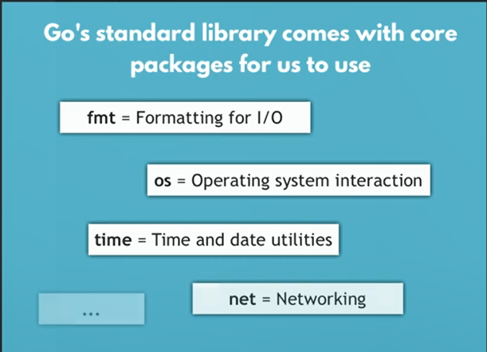
************************************************************
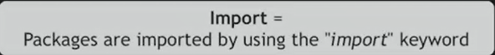
************************************************************
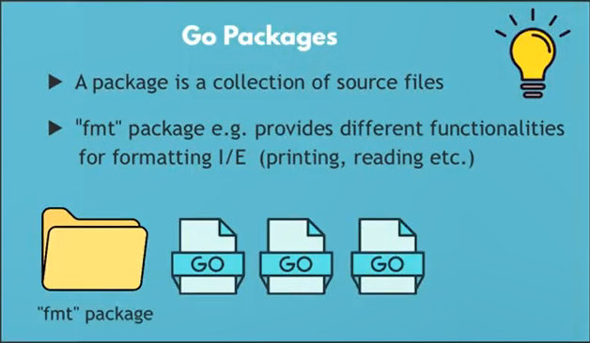
************************************************************
For Creating New Mod File For Go-Project, We Run Command:
- Command: go mod init companyName/ModuleName
  - Example: go mod init jafarLoka/mymodule
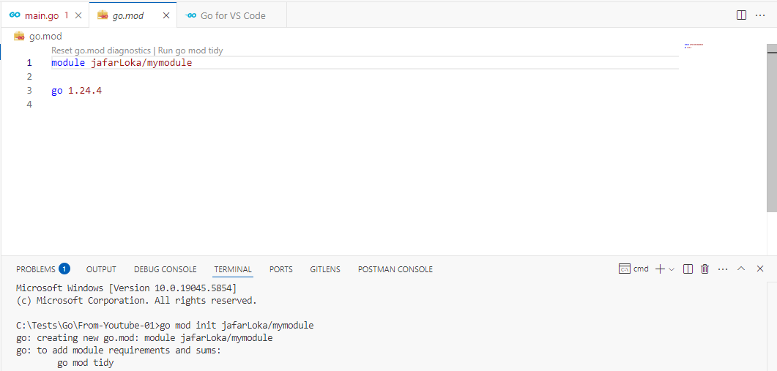
************************************************************
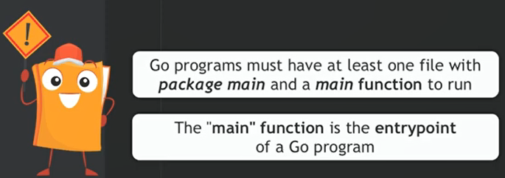
************************************************************
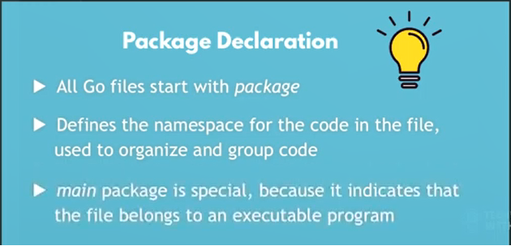
************************************************************
To Run The Program: go run main.go
To Compile The Program: go build main.go
************************************************************
Functions In Go, Starts With: func
************************************************************
The basic I/O library in Go is: fmt
************************************************************
The Basic Structure For Simple Go Program Is:
package main

import "fmt"
func main() {
fmt.Println("Welcome to our Todolist App!")
}

************************************************************
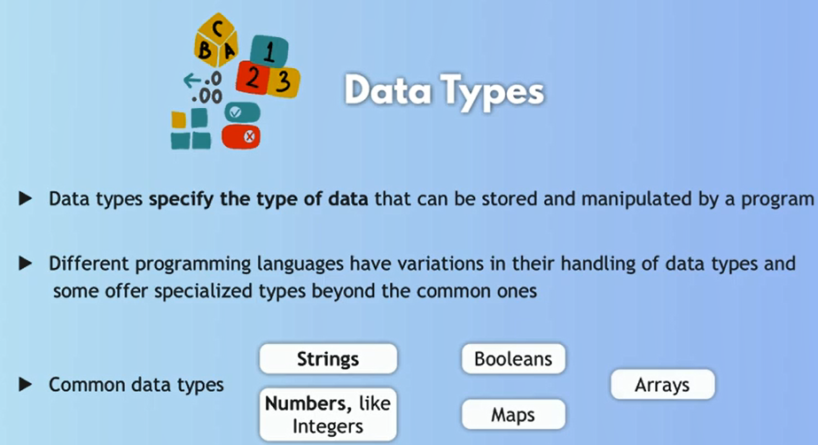
************************************************************
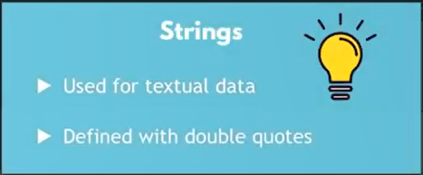
************************************************************
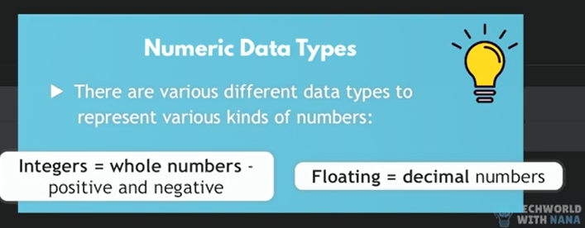
************************************************************

To use Variables In go, We Declare Them Using var-keyword.
var task01 = "1. Watch the crash course of Go"

var task02 = "2. Build network automation tools with Go"

var task03 = "3. Build Microservices Applications With gRPC"

var task04 = "4. Build my Applications using Go"
************************************************************
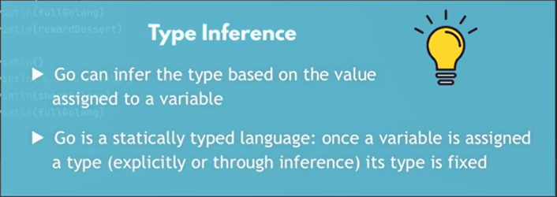
************************************************************
The new way to declare the go-variables is by using: :=
task05 := "5. Test new type of declaring variables"

fmt.Println("*** New Variable Declaration ***")
fmt.Println(task05)
************************************************************



