The way to declare lists in go: (This declaration called slice)
var taskList = []string{
"1. Watch the crash course of Go",
"2. Build network automation tools with Go",
"3. Build Microservices Applications With gRPC",
"4. Build my Applications using Go",
}
*******************************************************

*******************************************************
If we declare variables without using them, then the result is:
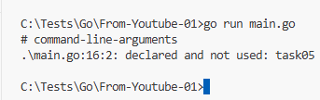
*******************************************************
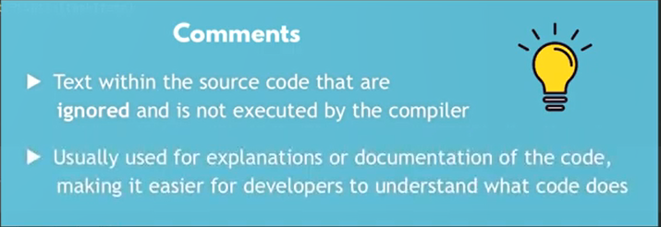
*******************************************************

If we define the size of slice, then it’s Array:
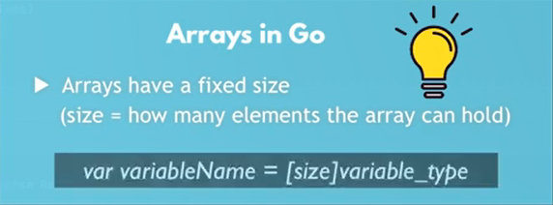
*******************************************************
We declare arrays: var list = [size]variable_type {} // it is constant size
- Ex: var tasks = [20]string {"…", "…"}
*******************************************************

*******************************************************
To print multiple variables, using fmt:
fmt.Println("*** Task Of Items ***")
fmt.Println("Tasks", taskSlice)
*******************************************************
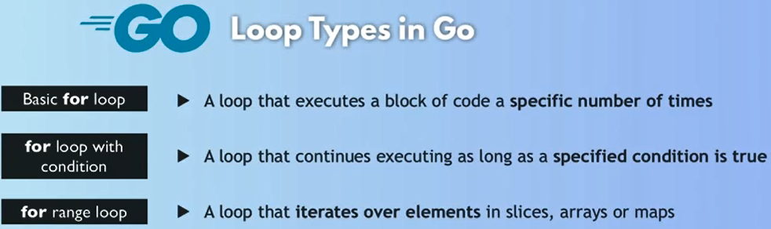
*******************************************************
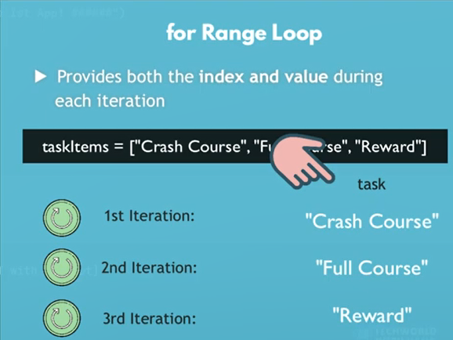
*******************************************************
Note: for and range is reserved words in Golang:
for index, task := range taskSlice {
fmt.Println("The index is:", index, ", and task is: ", task)
}
*******************************************************
Using _ to ignore variables, especially for index of for && range loops:
Here we use temp variables with for-loop (task-variable)
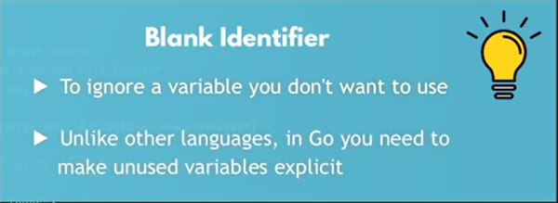
*******************************************************
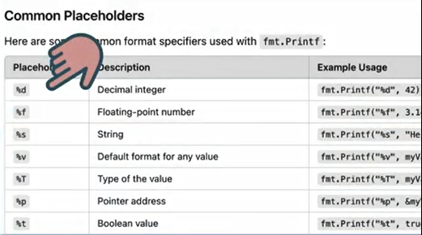
*******************************************************
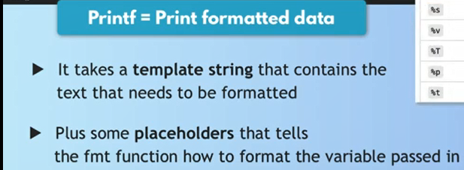
*******************************************************
We Can use format string using fmt:
for index, task := range taskSlice {
fmt.Printf("%d. %s\n", index+1, task)
}
*******************************************************
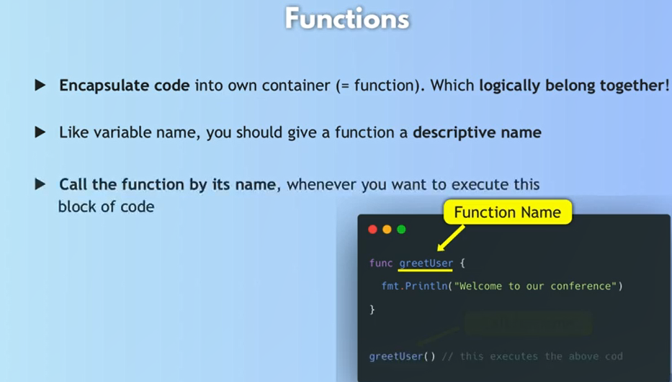
*******************************************************
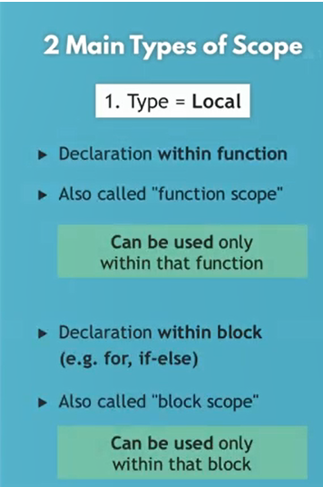
*******************************************************
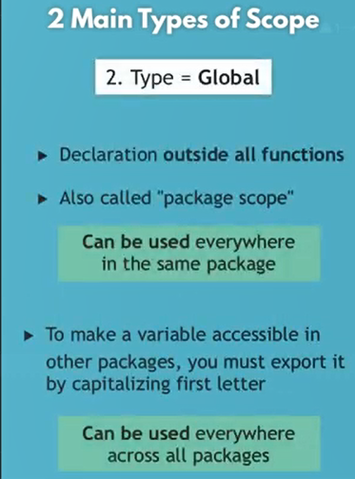
*******************************************************
To define function with params:
func printTasks(taskItems []string) {
fmt.Println("##### Welcome to our Todolist App! #####")

for index, task := range taskItems {
fmt.Printf("%d. %s\n", index+1, task)
}
}
*******************************************************
To make the function return a value, we must change the signature of the function:
Note: If the function return many values not one, we must use (), ex: ([]string, …etc)
func addTask(taskItems []string, newTask string) []string {
var updatedTaskItems = append(taskItems, newTask)

return updatedTaskItems
}
*******************************************************

To Create Http Server:
package main

import "fmt"
import "net/http"

func main() {
// in this way we create handle for / without register it in ListenAndServe
http.HandleFunc("/", helloLoka)
http.ListenAndServe("localhost:8080", nil);
}

func helloLoka(responseWriter http.ResponseWriter, request *http.Request) {
var greeting = "Hi, My Name is Jafar Loka. Welcome to Todo project";
fmt.Fprintln(responseWriter, greeting);
}
*******************************************************
func printTasks(responseWriter http.ResponseWriter, taskItems []string) {

fmt.Println("List of my Todos")

for index, task := range taskItems {
// fmt.Println(index+1, ".", task)
fmt.Fprintf(responseWriter, "%d. %s\n", index+1, task)
}
}
*******************************************************

