We Can Use Macros In Rust For Print Values, Every Thing In Rust That Ends With ! Is Macro:
fn main() {
let y = 10;

// y = 20; // This Will Raise Compile Error

let mut x = 20;

println!("The Value Of X, Before Changing Is: {}", x);

x = 25; // If We Don't Use The Previous Value, Warning Will Appear

println!("Hello, world!, y is: {}, x is: {}, x+y is: {}", y, x, y+x);
}
***************************************************************
Rust Is Static Typing Language, That Means It Must Know The Type Of Variables In Compile Time
***************************************************************
Data Types In Rust Can Be Combine In Two Groups: Scaler And Compound Data Types
***************************************************************
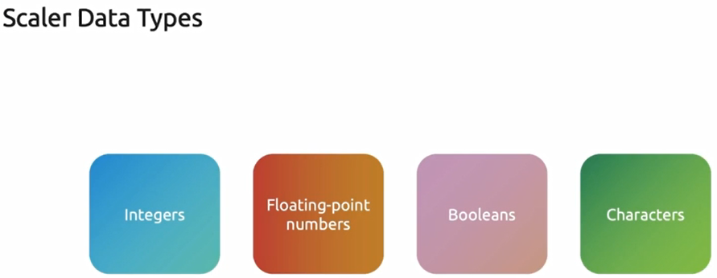
***************************************************************
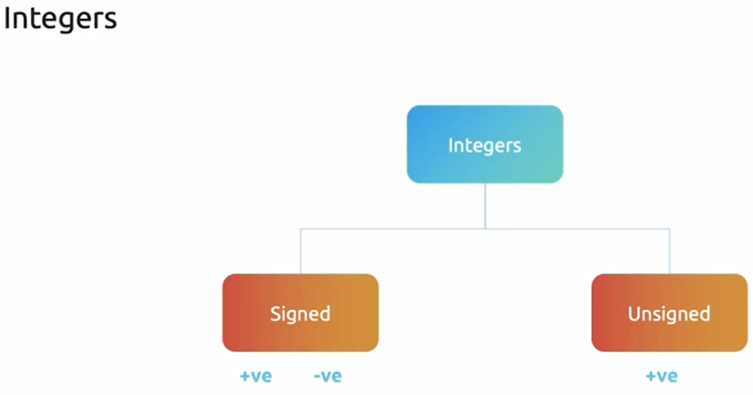
***************************************************************
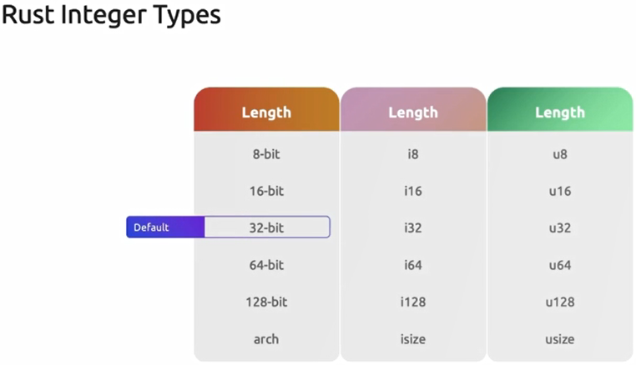
***************************************************************
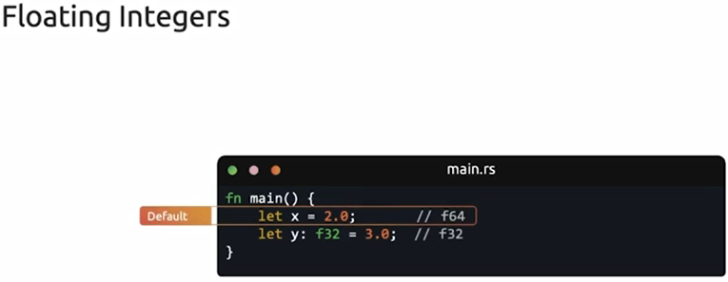
***************************************************************
/*
* Testing The Integer Types
*/
let a1 = 98_999;
let a2 = 0xfff;
let a3 = 0o337;
let a4 = 0b1111_0000;
let a5 = b'a';

println!("a1 is: {}, a2 is: {}, a3 is: {}, a4 is: {}, a5 is: {}", a1, a2, a3, a4, a5);
***************************************************************
/*
* Testing Floating Types
*/
let a6 = 2.5;
let a7: f32 = 4.9;
println!("a6 is: {}, a7 is: {}", a6, a7);
***************************************************************
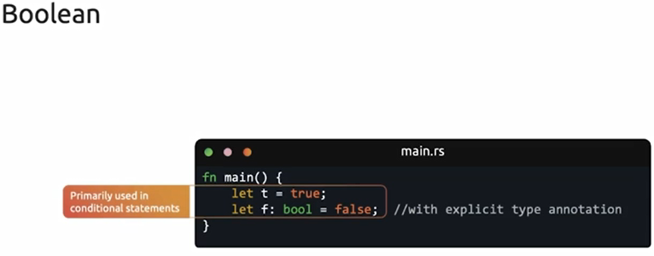
***************************************************************
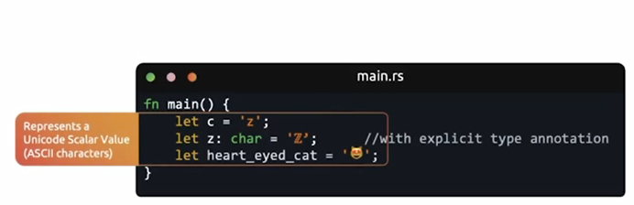
***************************************************************
Can compound data at once.
It has primary types: Tuples and Arrays.
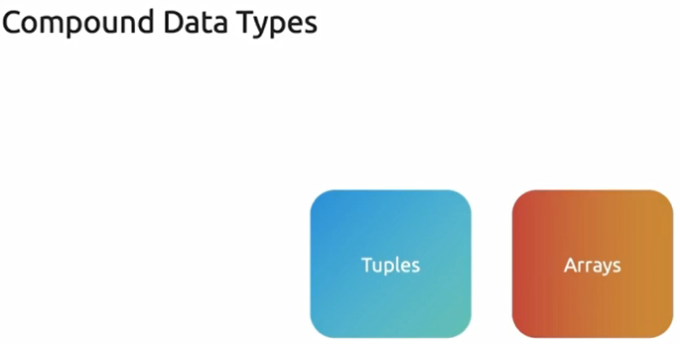
***************************************************************

let tup: (i32, f64, u8) = (500, 6.5, 1);

// We can destructing tuple:
// Here we can assign types for each variable
let (x, y, z) = tup;

println!("The value of x is: {}, the value of y is: {}, the value of z is: {}", x, y, z)

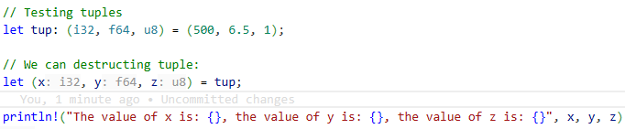
***************************************************************
// Access the tuple element directly, using . then index
// also we can set the type of each variable
// index start from 0
let x1 = tup.0;
let y1: f64 = tup.1;
let z1 = tup.2;

println!("The value of x1 is: {}, the value of y1 is: {}, the value of z1 is: {}", x1, y1, z1);
***************************************************************
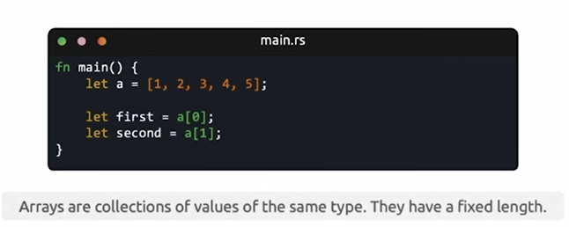
***************************************************************

// Testing Arrays
let arr = [1, 2, 3, 4, 5];

// println!("The Array is: {}", arr); // This will give compiler error
let temp = arr[3];

println!("The 1st value is: {}, the 2nd value is: {}, the 3rd value is: {}, the 4th value: {temp}", [0], arr[1], arr[2])
***************************************************************
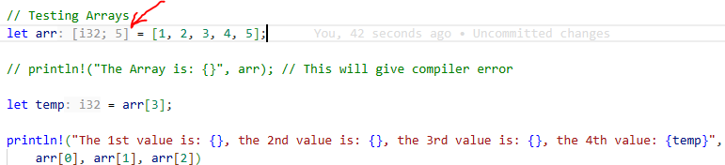
***************************************************************
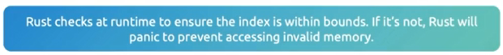
***************************************************************
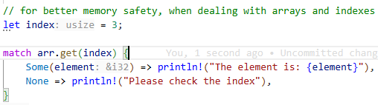
***************************************************************
***************************************************************
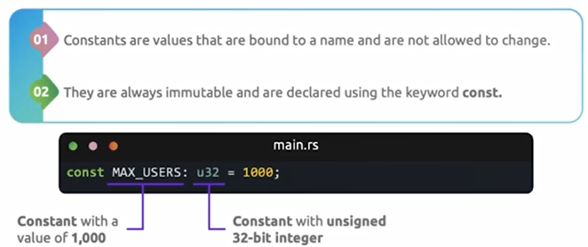
***************************************************************
Note 1: The constants in rust must be all uppercase with _ between words.
Note 2: We must declare the type of constant.
***************************************************************
// Testing Constants
const MAX_USERS: u32 = 1000;

println!("The max users is: {MAX_USERS}");
***************************************************************
The 1 means: the global scope.
The 03 means: we can set it to function the generate different values.

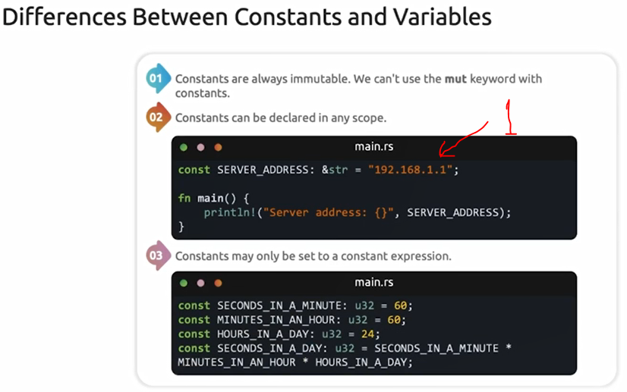
***************************************************************
Shadowing in rust means: The variable can be used multiple times.
***************************************************************
// Testing Shadowing
let a = 5;

let a = a + 1; // Shadowing the first 'a'

println!("The value of a is: {a}"
{
let a = a * 2; // Shadowing within new scope
println!("The value of a in inner scope: {a}");
}

println!("The value of a outside scope is: {a}");
***************************************************************
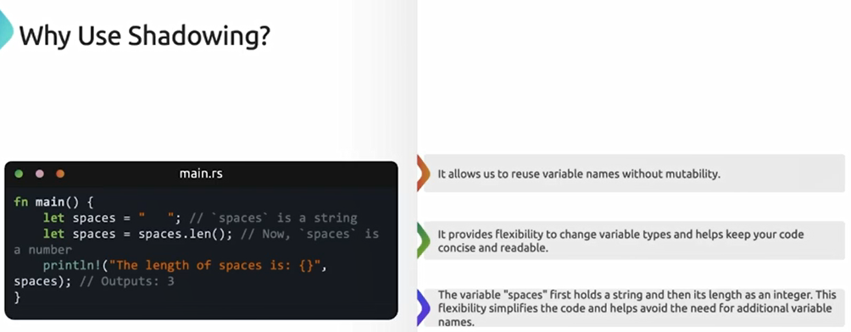
***************************************************************
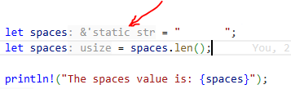
***************************************************************
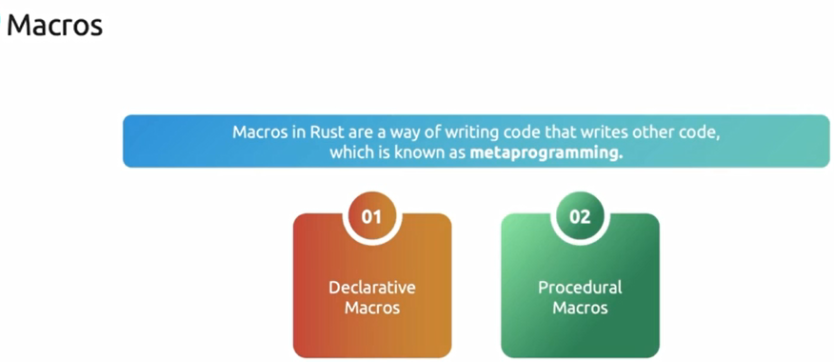
***************************************************************
use std::io;

fn main() {
println!("Please enter your age: ");

let mut input = String::new();

io::stdin().read_line(&mut input).expect("Failed to read line");

let input = input.trim();

let input: u32 = input.parse().expect("Please enter a number!");

println!("Your age is: {input}");
}
***************************************************************

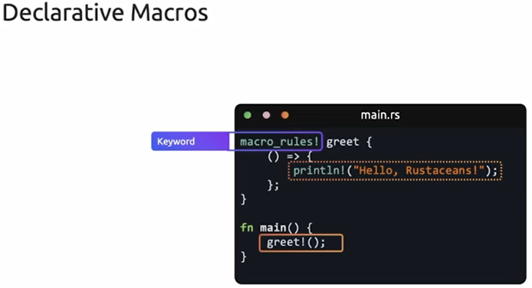
***************************************************************
To pass parameters to macro:
Note: here expr means that name can be any valid rust expr (variables )
macro_rules! greet {
($name:expr) => { // Here also we can pass no arguments
println!("Hello {}!", $name)
}
}

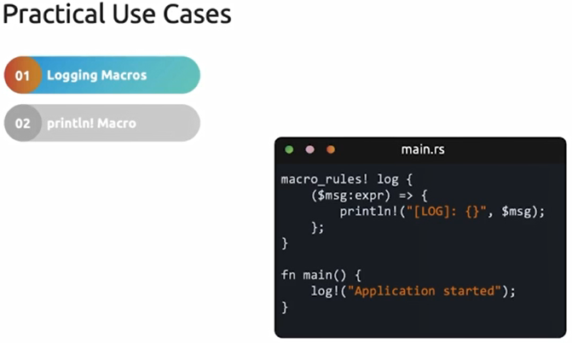
***************************************************************
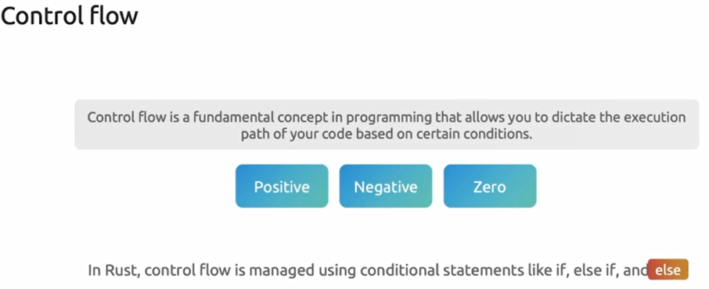
***************************************************************
fn main() {
let number: i32 = 7;
if number > 10 {
println!("ERROR!!!");
} else if number > 5 {
println!("TRUE!!!");
} else {
println!("ERROR!!!");
}
}
***************************************************************

