if number > 1 && number < 8 {
println!("Number Between 1 and 8");
}
****************************************************************************
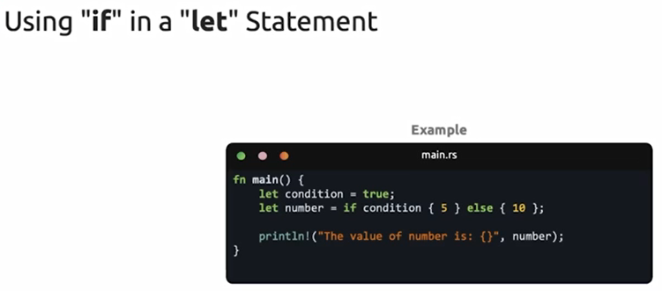
****************************************************************************
let mut count: i32 = 0;

loop {
count += 1;
println!("The count is: {}", count);
if count == 6 {
break;
}
}
****************************************************************************
We can return value from loop:
let result = loop {
count += 1;
println!("The count is: {count}");

if count > 6 {
break count * 2;
}
};

println!("The final result is: {result}");
****************************************************************************
The result is mut-variable:
'outer: loop {

loop {
if result > 15 {
break 'outer;
}
if result > 13 {
break;
}
}
result += 1;
println!("The result is: {result}");
}
****************************************************************************

****************************************************************************
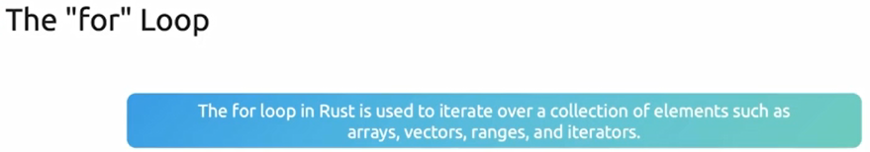
****************************************************************************
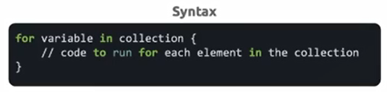
****************************************************************************
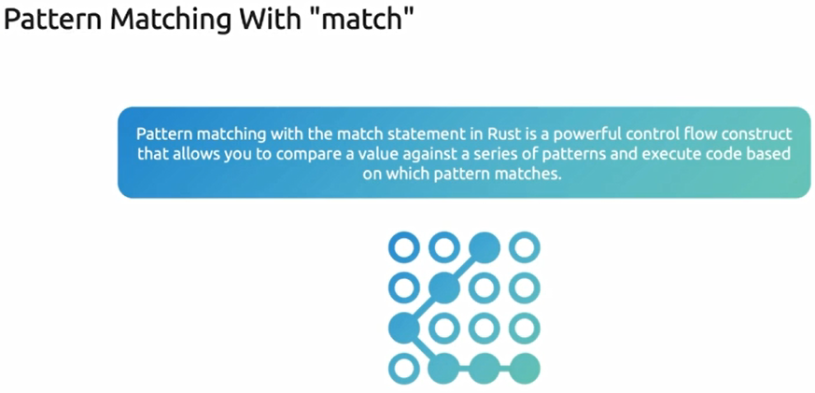
****************************************************************************
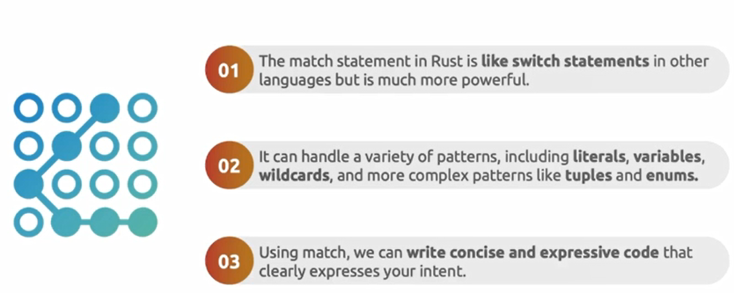
****************************************************************************
let mut number = 3;

while number != 0 {
println!("number is: {number}");
number -= 1;
}

println!("Hello, world!");
****************************************************************************

let arr: [i32; 5] = [1, 2, 3, 4, 5];

for num in arr {
println!("The num is: {num}");
}

for i in 1..6 {
println!("i is: {i}");
}
****************************************************************************
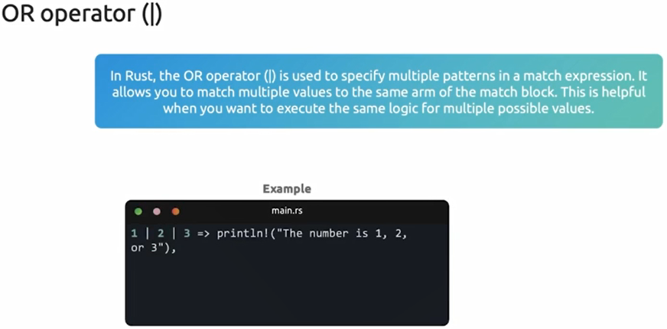
****************************************************************************

let number: i32 = 3;
match number {
1 => println!("The number is 1"),
2 => println!("The number is 2"),
3 => println!("The number is 3"),
_ => println!("Something else"),
}

let number: i32 = 7;
match number {
1..=5 => println!("Number between 1 and 5"),
6..=10 => println!("Number between 6 and 10"),
_ => println!("Something else"), // if we don't set it, it will give error
}

println!("Hello, world!");

****************************************************************************
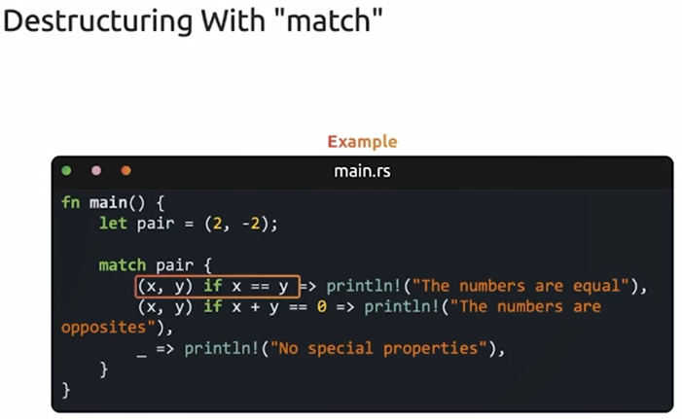
****************************************************************************

This example about using wildcard _
