To get list of invoice items that belongs to invoice, then we use, Include-method:

[HttpGet]
public async Task<ActionResult<IEnumerable<Invoice>>> GetInvoices(
int page = 1, int pageSize = 10, InvoiceStatus? status = null
)
{
return await _context
.Invoices
.AsQueryable()
.Include(x => x.InvoiceItems)
.Where(t1 => t1.Status == status)
.OrderByDescending(x => x.InvoiceDate)
.Skip((page -1) * pageSize)
.Take(pageSize)
.ToListAsync();
}
**************************************************************
Note: The Include() method is a convenient way to include dependent entities. However, it may cause performance issues when the collection of dependent entities is large. For example, a post may have hundreds or thousands of comments. It is not a good idea to include all comments in the query result for a list page. In this case, it is not necessary to include dependent entities in the query.
**************************************************************
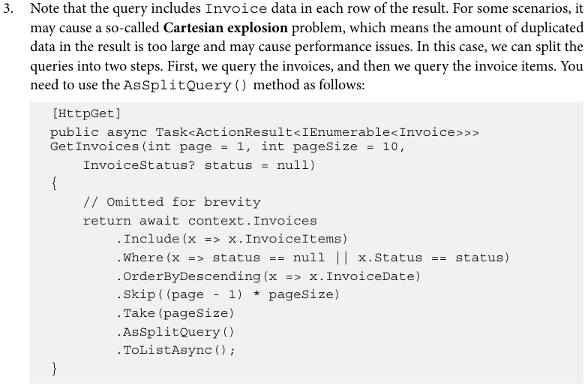
**************************************************************
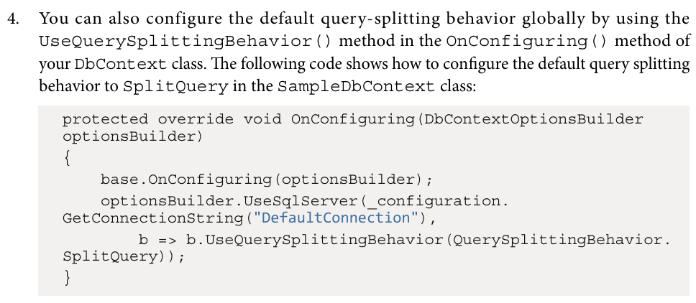
**************************************************************

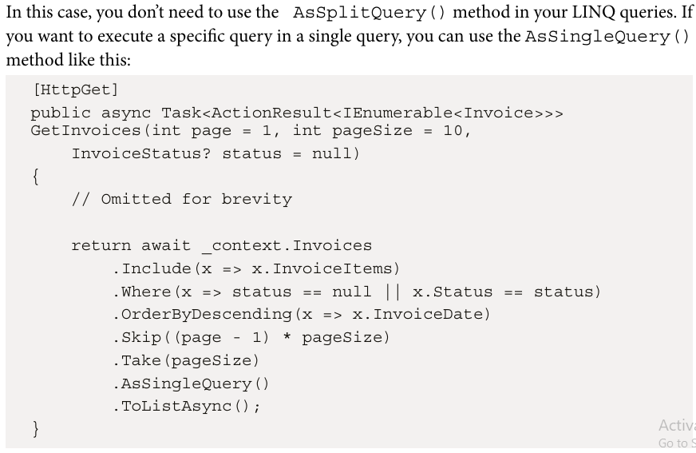
**************************************************************
However, split queries may cause other issues. For example, multiple queries increase the number of round trips to the database. In addition, if another thread modifies the data between the two queries, the result may be inconsistent. Therefore, you should consider the pros and cons of split queries to fit our scenarios.
**************************************************************
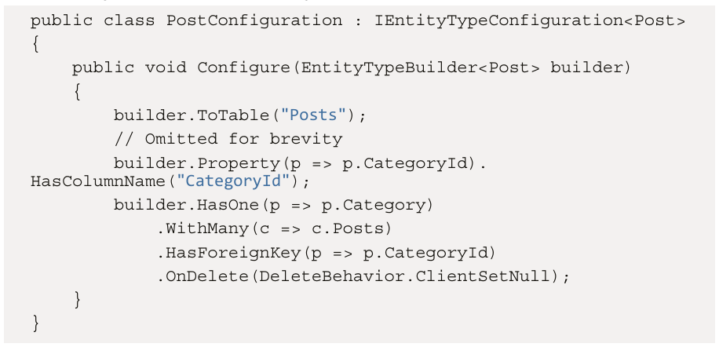
**************************************************************
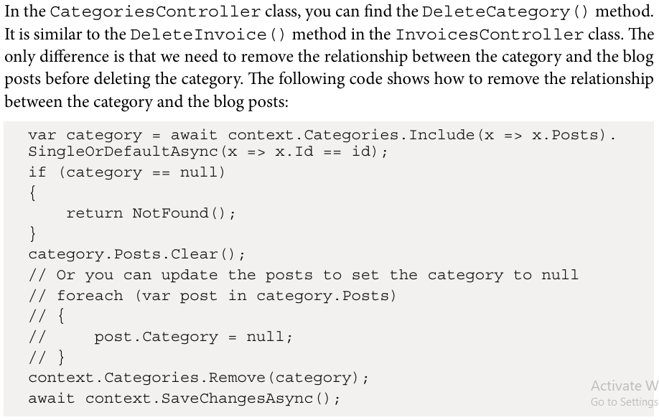
-----------------------------------------------------------------------------------------

You can clear the Posts property of the category entity, or you can update the Category property of the blog posts to set it to null. In this way, the CategoryId property of the blog posts will be set to null when the category is deleted. Also, it is required to load related entities using the Include method, because EF Core needs to track the changes of related entities as well.
**************************************************************
To create many to many relationship between two models:
namespace JLokaTestEFCore.Models
{
public class Movie
{
public Guid Id { get; set; }
public string Title { get; set; } = string.Empty;
public string? Description { get; set; }
public int ReleaseYear { get; set; }
public List<Actor> Actors { get; set; } = new List<Actor>();
}
}
-----------------------------------------------------------------------------------------
namespace JLokaTestEFCore.Models
{
public class Actor
{
public Guid Id { get; set; }
public string Name { get; set; } = string.Empty;
public List<Movie> Movies { get; set; } = new List<Movie>();
}
}
**************************************************************

To create specific configurations for many to many relationship:
using JLokaTestEFCore.enums;
using JLokaTestEFCore.Models;
using Microsoft.EntityFrameworkCore;

namespace JLokaTestEFCore.Data
{
public static class MovieModelCreatingExtensions
{
public static void ConfigureMovie(this ModelBuilder builder)
{
builder.Entity<Movie>(b =>
{
b.ToTable("Movies");
b.HasKey(i => i.Id);
b.Property(p => p.Id).HasColumnName("Id");
b.Property(p => p.Title).HasColumnName(nameof(Movie.Title)).HasMaxLength(255).IsRequired();
b.Property(p => p.Description).HasColumnName(nameof(Movie.Description));
b.Property(p => p.ReleaseYear).HasColumnName(nameof(Movie.ReleaseYear)).IsRequired();
b.HasMany(m => m.Actors).WithMany(a => a.Movies).UsingEntity<MovieActor>(

j => j.HasOne(ma => ma.Actor).WithMany(a => a.MovieActors).HasForeignKey(ma => ma.ActorId),

j => j.HasOne(ma => ma.Movie).WithMany(m => m.MovieActors).HasForeignKey(ma => ma.MovieId),

j =>
{
j.Property(ma => ma.UpdateTime).HasColumnName(nameof(MovieActor.UpdateTime))
.HasDefaultValueSql("CURRENT_TIMESTAMP");
j.HasKey(ma => new { ma.MovieId, ma.ActorId});
}
);
});

}
}
}
**************************************************************

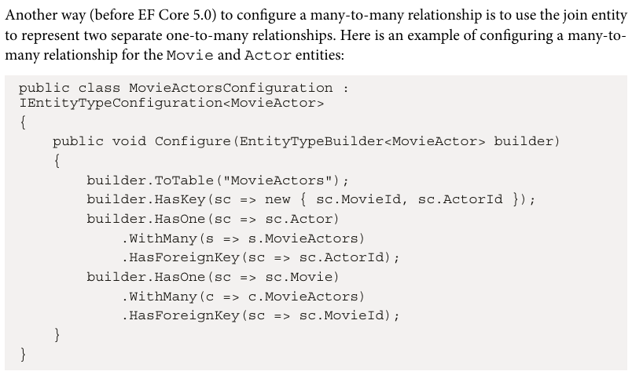
**************************************************************
In a many-to-many relationship, such as Movie and Actor, we may need to get the actors of a movie or get the movies of an actor. So, we need to expose both entities through the REST API. You can create two controllers using the following commands:
Ex: dotnet aspnet-codegenerator controller -name MoviesController -api -outDir Controllers --model Movie --dataContext InvoiceDbContext -async -actions
Ex: dotnet aspnet-codegenerator controller -name ActorsController -api -outDir Controllers --model Actor --dataContext InvoiceDbContext -async -actions
**************************************************************

To create unique index:
using JLokaTestEFCore.enums;
using JLokaTestEFCore.Models;
using Microsoft.EntityFrameworkCore;

namespace JLokaTestEFCore.Data
{
public static class MovieModelCreatingExtensions
{
public static void ConfigureMovie(this ModelBuilder builder)
{
builder.Entity<Movie>(b =>
{
b.ToTable("Movies");
b.HasKey(i => i.Id);
b.Property(p => p.Id).HasColumnName("Id");
b.Property(p => p.Title).HasColumnName(nameof(Movie.Title)).HasMaxLength(255).IsRequired();
b.Property(p => p.Description).HasColumnName(nameof(Movie.Description));
b.Property(p => p.ReleaseYear).HasColumnName(nameof(Movie.ReleaseYear)).IsRequired();
b.HasMany(m => m.Actors).WithMany(a => a.Movies).UsingEntity<MovieActor>(
j => j.HasOne(ma => ma.Actor).WithMany(a => a.MovieActors).HasForeignKey(ma => ma.ActorId),
j => j.HasOne(ma => ma.Movie).WithMany(m => m.MovieActors).HasForeignKey(ma => ma.MovieId),
j =>
{
j.Property(ma => ma.UpdateTime).HasColumnName(nameof(MovieActor.UpdateTime))
.HasDefaultValueSql("CURRENT_TIMESTAMP");
j.HasKey(ma => new { ma.MovieId, ma.ActorId});
}
);
b.HasIndex(p => p.Title).IsUnique();
});

}
}
}
**************************************************************

[HttpPost("{id}/movies/{movieId}")]
public async Task<IActionResult> AddMovie(Guid id, Guid movieId)
{
if(_context.Actors == null)
{
return NotFound("Actors is null");
}

var actor = await _context.Actors.Include(x => x.Movies).SingleOrDefaultAsync(x => x.Id == id);

if(actor == null)
{
return NotFound($"Actor with id: {id} not found");
}

var movie = await _context.Movies.FindAsync(movieId);
if(movie == null)
{
return NotFound($"Movie with id: {id} not found");
}

if(actor.Movies.Any(x => x.Id == movieId))
{
return Problem($"Movie with id: {movieId} already exists for actor with id: {id}");
}

// here we should check for existing of movies for actor before adding
actor.Movies.Add(movie);
await _context.SaveChangesAsync();
return CreatedAtAction("GetActor", new { Id = actor.Id }, actor);
}

[HttpGet("{id}/movies")]
public async Task<IActionResult> GetMovies(Guid id)
{
if(_context.Actors == null)
{
return NotFound("Actors is null");
}

var actor = await _context.Actors.Include(x => x.Movies).SingleOrDefaultAsync(x => x.Id == id);

if(actor == null)
{
return NotFound($"No actor with id: {id}");
}
// here we must make the response with dto
return Ok(actor.Movies);
}

[HttpDelete("{id}/movies/{movieId}")]
public async Task<IActionResult> DeleteMovie(Guid id, Guid movieId)
{
if(_context.Actors == null)
{
return NotFound("Actors is null");
}

var actor = await _context.Actors.Include(x => x.Movies).SingleOrDefaultAsync(x => x.Id == id);

if(actor == null)
{
return NotFound($"No Actor with Id: {id}");
}

var movie = await _context.Movies.FindAsync(movieId);
if(movie == null)
{
return NotFound($"No movie with id: {movieId}");
}
// Note that it does not delete the movie from the database; it just deletes
// the relationship between the movie and the actor.
actor.Movies.Remove(movie);
await _context.SaveChangesAsync();

return NoContent();
}
**************************************************************

