After we select the chart:
- We can change the bold option.
- We can change the font size option
- And many more
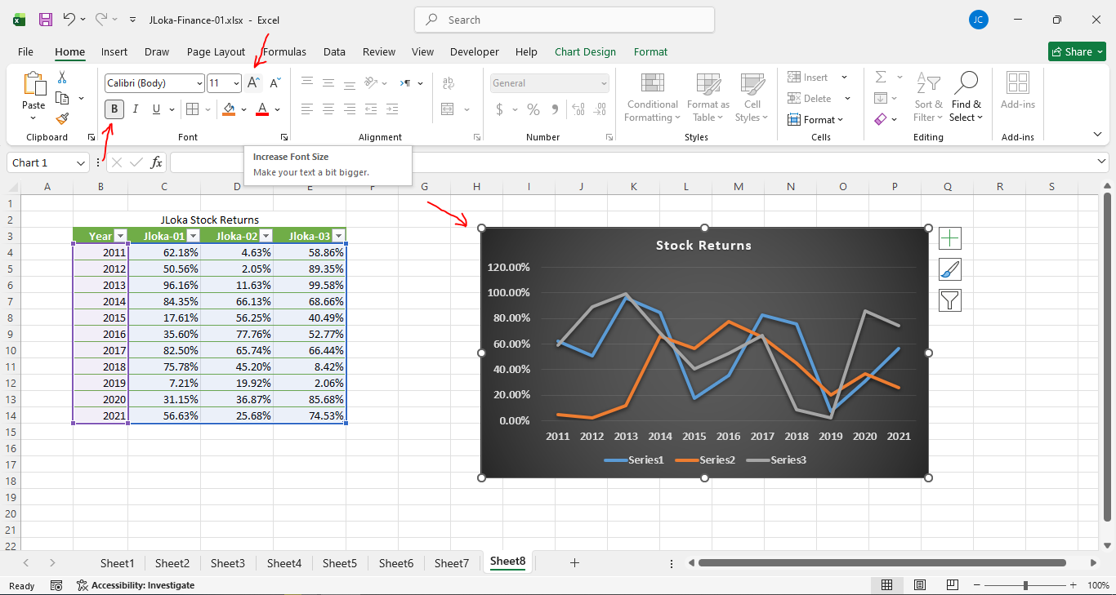
===================================================

We can change the data:
- Select the chart.
- Right-click, and choose “Select Data…”
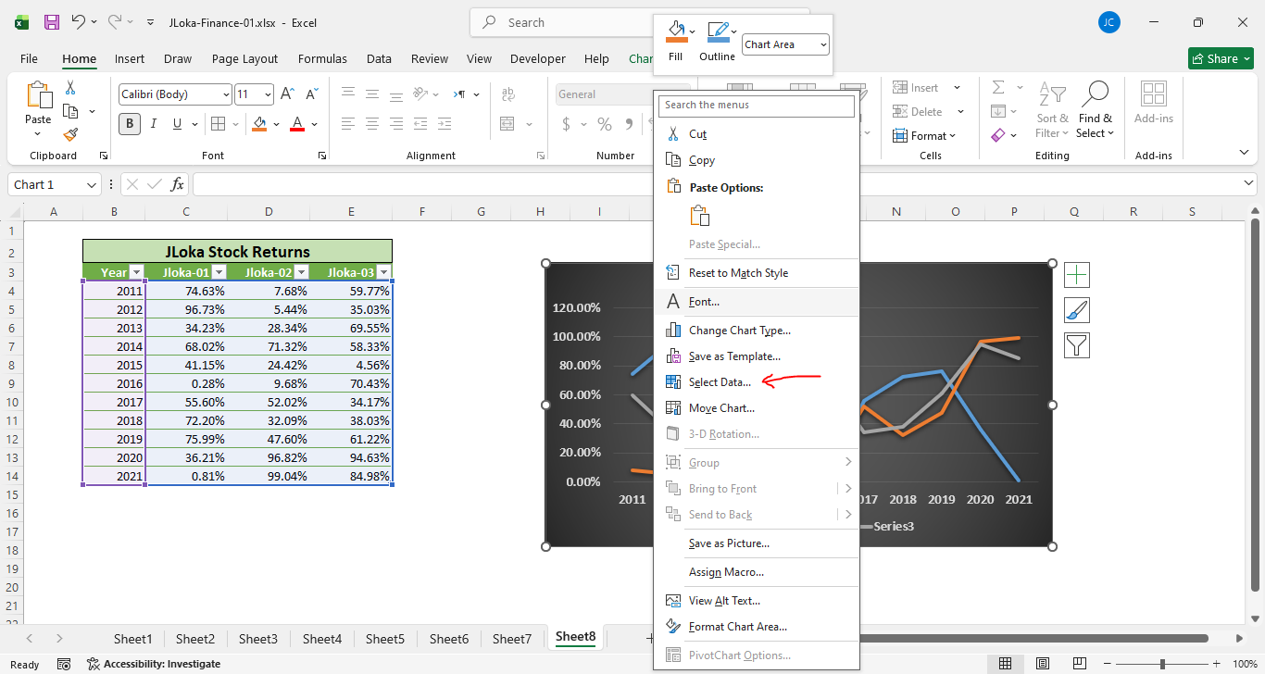
===================================================
After we select all the table data, the entries or series should be populated in the data source dialogue:
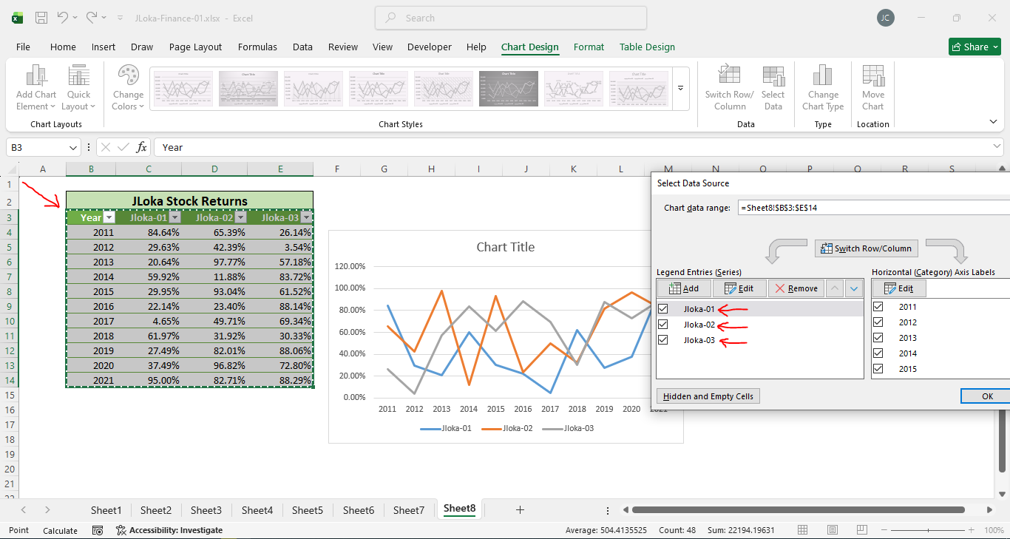
===================================================

From the chart design, we can add data labels through the chart elements:
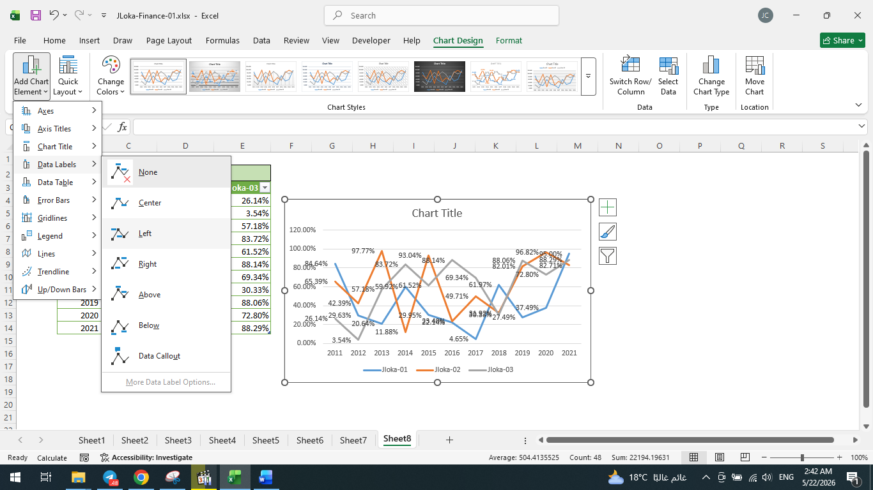
===================================================
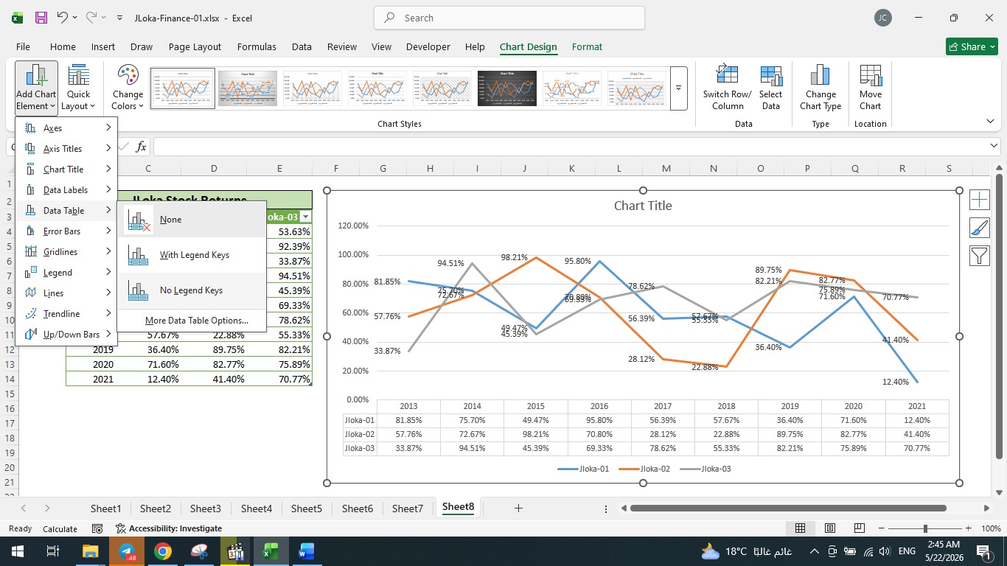
===================================================

The Pie Chart and options from the + icon:
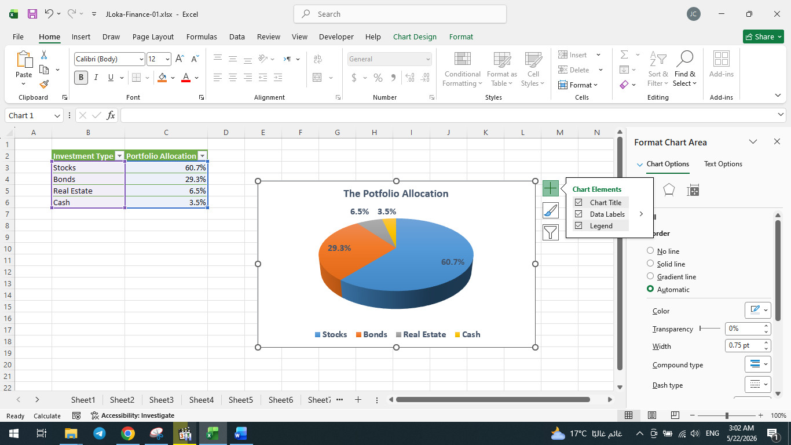
===================================================
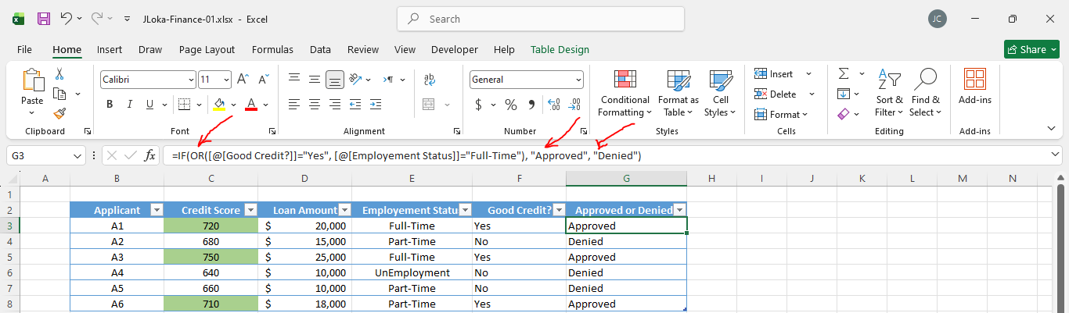
===================================================

After selecting the data for the pie chart, we can add a background to it:
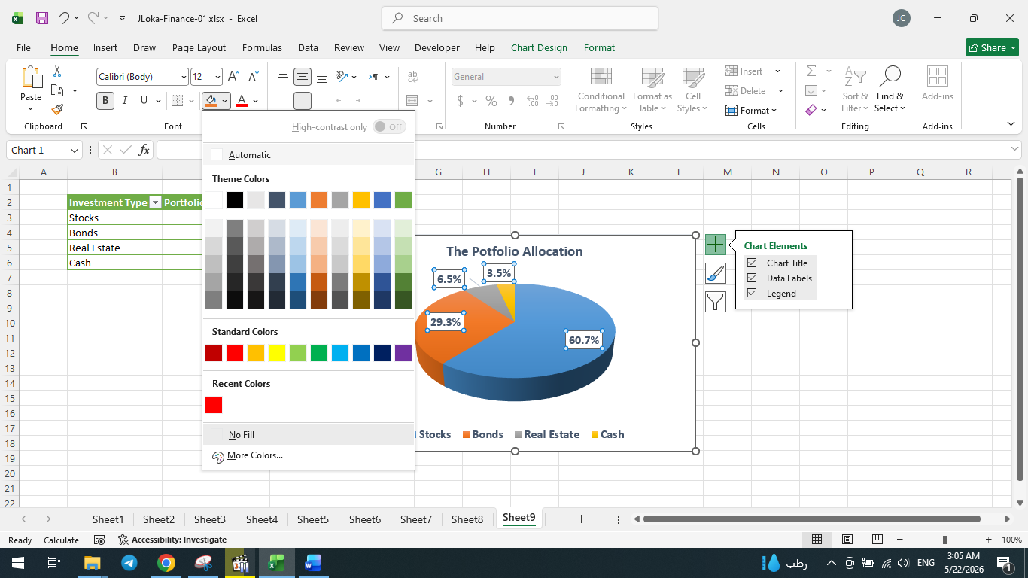
===================================================
VLOOKUP: retrieve data based on a vertical column.
===================================================
The nested If-Formula using and-operator & or-operator:
=IF(OR([@[Good Credit?]]="Yes", [@[Employment Status]]="Full-Time"), "Approved", IF(AND(C3>650, [@[Loan Amount]]<12000), "Approved", "Denied"))
===================================================

The formula of VLOOKUP is:
=VLOOKUP($G3, Table1, 3, FALSE)
- The search value
- Where to search for the value
- The column index that we want to display
- Exact Matching (False || 0)
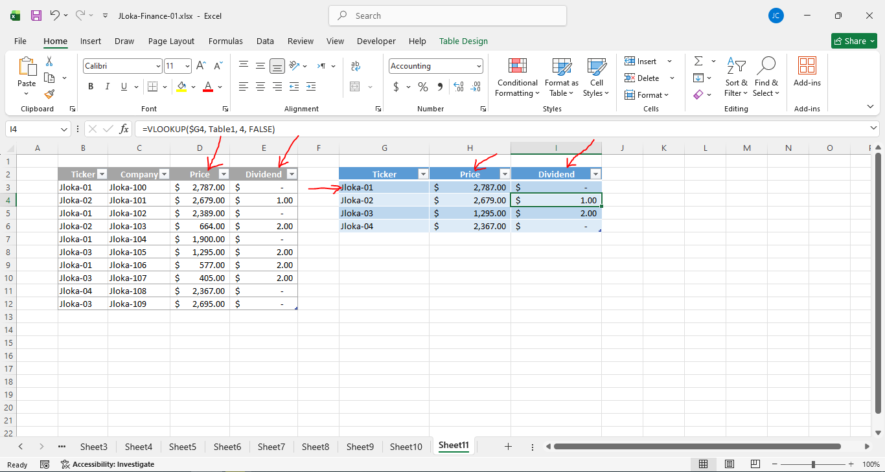
===================================================

The problem with the previous approach if we move the column.
And to solve it, we use XLOOKUP:
=XLOOKUP([@Ticker], Table18[Ticker], Table18[Dividend], "Missing")
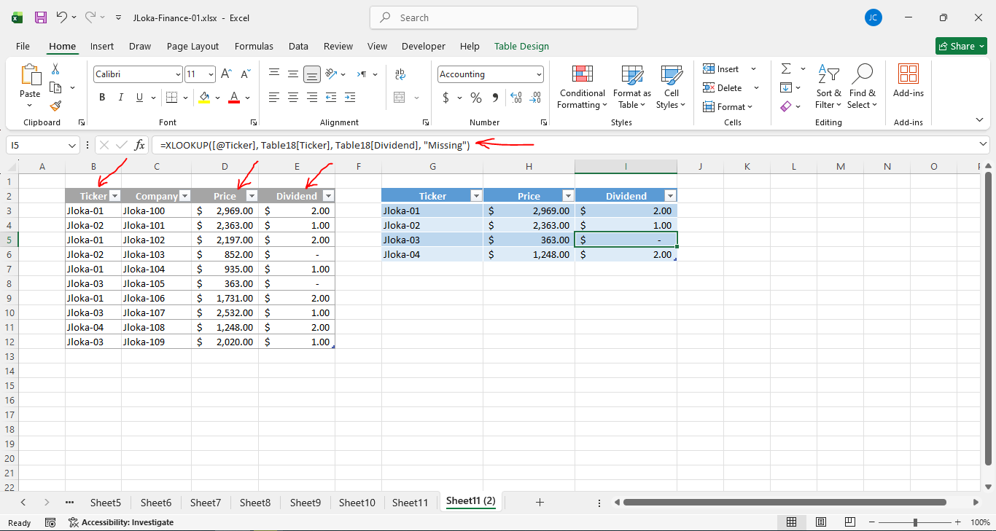
===================================================

The formula of Match-function is: =MATCH(I3, $B$3:$B$8,0)
- I3 is: the searching value
- The second is the array where we want to search.
- The matching value.
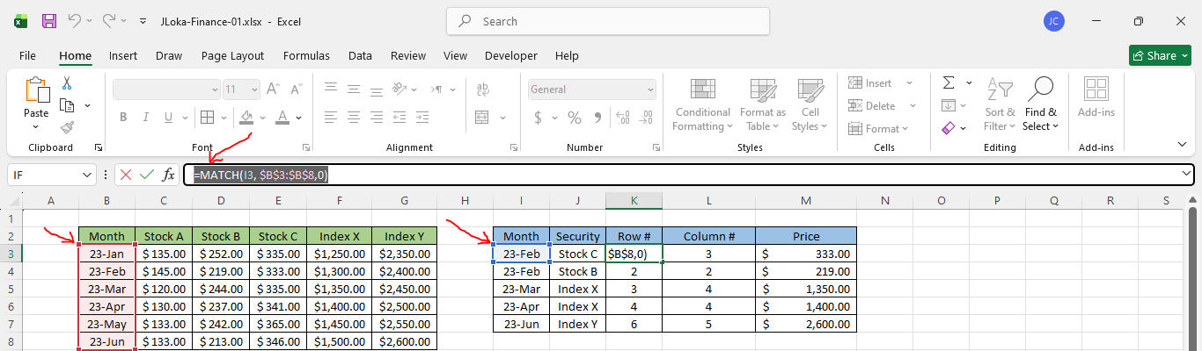
===================================================
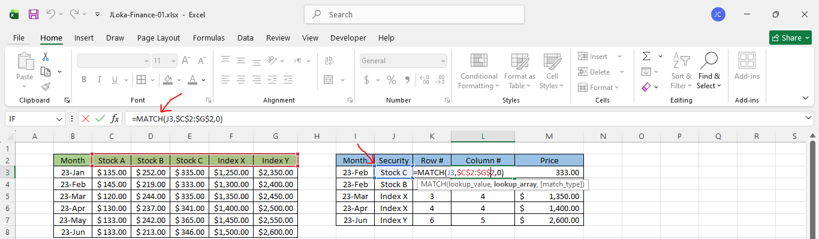
===================================================

The index formula is: =INDEX($C$3:$G$8, K3,L3)
- The first is the array where to search.
- The second is the row number.
- The third is the column number.



