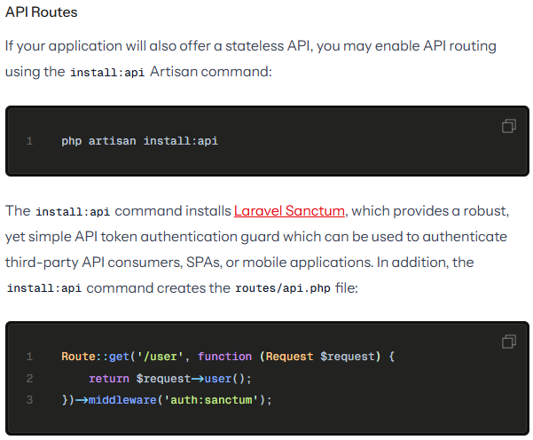
********************************************************
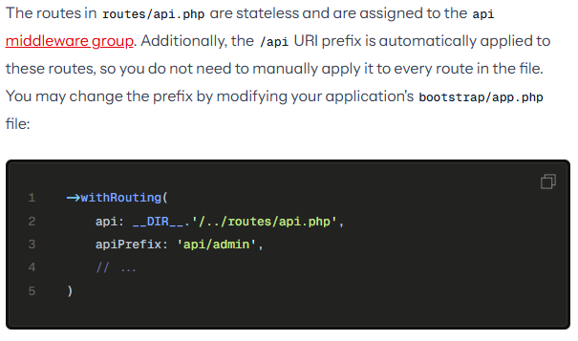
********************************************************
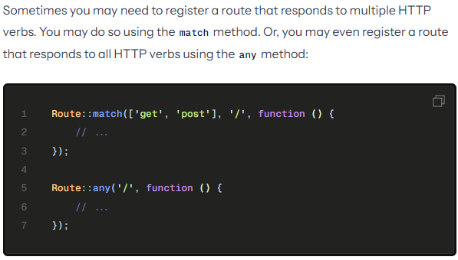
********************************************************
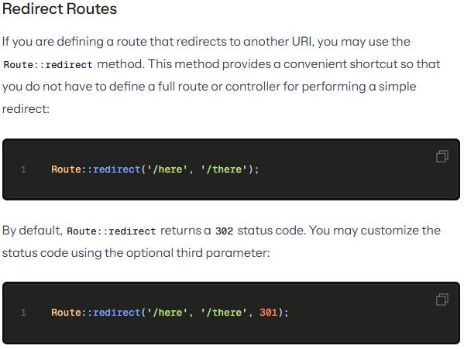
********************************************************
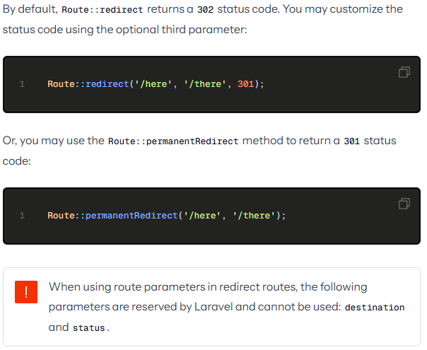
********************************************************
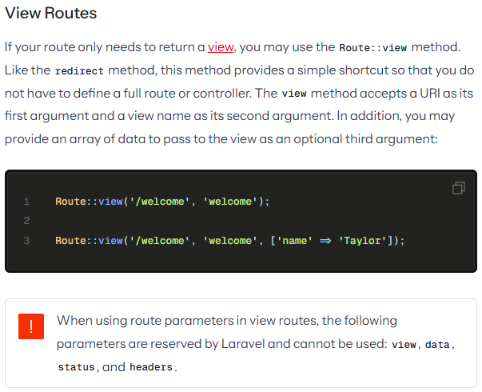
********************************************************
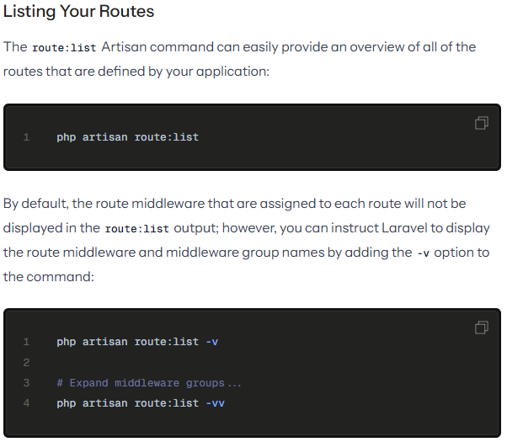
********************************************************
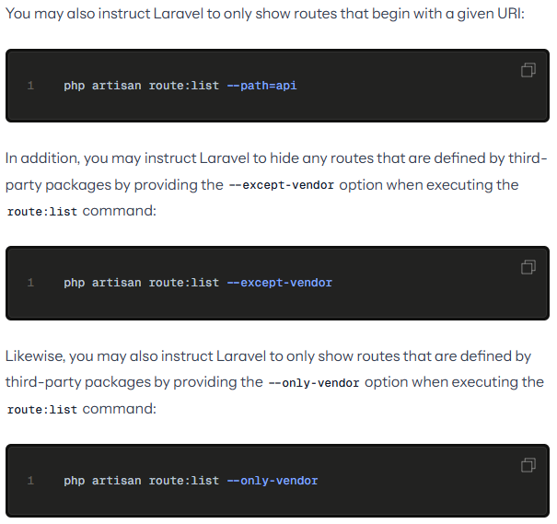
********************************************************
<?php

use Illuminate\Foundation\Application;
use Illuminate\Foundation\Configuration\Exceptions;
use Illuminate\Foundation\Configuration\Middleware;
use Illuminate\Support\Facades\Route;

return Application::configure(basePath: dirname(__DIR__))
->withRouting(
web: __DIR__.'/../routes/web.php',
api: __DIR__.'/../routes/api.php',
commands: __DIR__.'/../routes/console.php',
health: '/up',
then: function() {
Route::middleware('api')
->prefix('webhooks')
->name('webhooks.')
->group(base_path('routes/webhooks.php'));
}
)
->withMiddleware(function (Middleware $middleware): void {
//
})
->withExceptions(function (Exceptions $exceptions): void {
//
})->create();
********************************************************



