To use JWT with SQL Server and ef core, we need these packages:
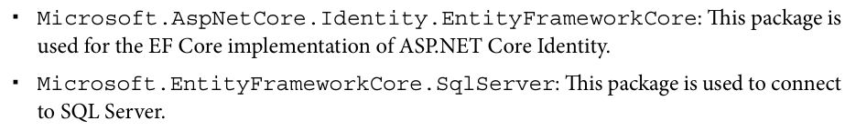
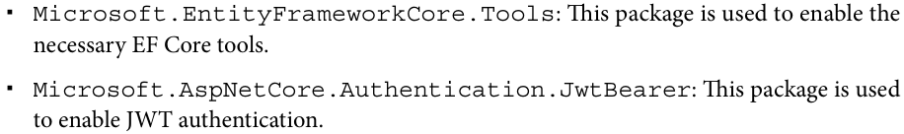
************************************************************************
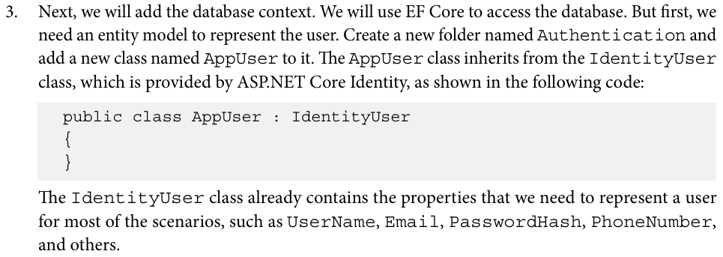
************************************************************************
using Microsoft.AspNetCore.Identity;

namespace JLokaAuthentication.Authentication
{
public class AppUser: IdentityUser
{
}
}
************************************************************************

For using identity with db context:

using Microsoft.AspNetCore.Identity.EntityFrameworkCore;
using Microsoft.EntityFrameworkCore;

namespace JLokaAuthentication.Authentication
{
public class AppDbContext(DbContextOptions<AppDbContext> options, IConfiguration configuration) : IdentityDbContext<AppUser> (options)
{
protected override void OnConfiguring(DbContextOptionsBuilder optionsBuilder)
{
base.OnConfiguring(optionsBuilder);
optionsBuilder.UseSqlServer(configuration.GetConnectionString("DefaultConnection"));
}
}
}
************************************************************************
{
"Logging": {
"LogLevel": {
"Default": "Information",
"Microsoft.AspNetCore": "Warning"
}
},
"AllowedHosts": "*",
"ConnectionStrings": {
//"DefaultConnection": "Server=DESKTOP-K9V44R0\\SQLExpress;Database=JLokaDB;Trusted_Connection=true;TrustServerCertificate=true;MultipleActiveResultSets=true;"
"DefaultConnection": "Server=localhost;Database=Itcp;User ID=sa;Password=P@ssw0rd1;TrustServerCertificate=true;MultipleActiveResultSets=true;"
}
}
************************************************************************
As we can see, this AppDbContext is purely for ASP.NET Core Identity. If you have other entities in your application, you can create a separate DbContext for them if you want to. You can use the same connection string for both DbContexts.
************************************************************************
var builder = WebApplication.CreateBuilder(args);

// Add services to the container.

builder.Services.AddControllers();

// Add the db context
builder.Services.AddDbContext<AppDbContext>();
// Add the identity model and attach to db context
builder.Services.AddIdentityCore<AppUser>()
.AddEntityFrameworkStores<AppDbContext>()
.AddDefaultTokenProviders();
//Add authentication with options
builder.Services.AddAuthentication(options =>
{
options.DefaultAuthenticateScheme = JwtBearerDefaults.AuthenticationScheme;
options.DefaultChallengeScheme = JwtBearerDefaults.AuthenticationScheme;
options.DefaultScheme = JwtBearerDefaults.AuthenticationScheme;
}).AddJwtBearer(options =>
{
var secret = builder.Configuration["JwtConfig:secret"];
var issuer = builder.Configuration["JwtConfig:ValidIssuer"];
var audience = builder.Configuration["JwtConfig:ValidAudiences"];

if (secret is null || issuer is null || audience is null)
{
throw new ApplicationException("Jwt is not set in the configuration");
}

options.SaveToken = true;
options.RequireHttpsMetadata = false;
options.TokenValidationParameters = new TokenValidationParameters()
{
ValidateIssuer = true,
ValidateAudience = true,
ValidAudience = audience,
ValidIssuer = issuer,
IssuerSigningKey = new SymmetricSecurityKey(Encoding.UTF8.GetBytes(secret)),
};
});

builder.Services.AddEndpointsApiExplorer();
builder.Services.AddSwaggerGen();

var app = builder.Build();

// Configure the HTTP request pipeline.
if (app.Environment.IsDevelopment())
{
app.UseSwagger();
app.UseSwaggerUI();
}

app.UseHttpsRedirection();

app.UseAuthentication();
app.UseAuthorization();

app.MapControllers();

app.Run();
************************************************************************
And to make the controller or methods use Authorization:
[Authorize]
[ApiController]
[Route("[controller]")]
public class WeatherForecastController : ControllerBase
{
private static readonly string[] Summaries = new[]
{
"Freezing", "Bracing", "Chilly", "Cool", "Mild", "Warm", "Balmy", "Hot", "Sweltering", "Scorching"
};

private readonly ILogger<WeatherForecastController> _logger;

public WeatherForecastController(ILogger<WeatherForecastController> logger)
{
_logger = logger;
}

[HttpGet(Name = "GetWeatherForecast")]
public IEnumerable<WeatherForecast> Get()
{
return Enumerable.Range(1, 5).Select(index => new WeatherForecast
{
Date = DateOnly.FromDateTime(DateTime.Now.AddDays(index)),
TemperatureC = Random.Shared.Next(-20, 55),
Summary = Summaries[Random.Shared.Next(Summaries.Length)]
})
.ToArray();
}
}
************************************************************************
To generate a JWT token, we need to provide the following information:
The issuer of the token: This is the server that issues the token.
The audience of the token: This is the server that consumes the token. It can be the same as the issuer or include multiple servers.
The secret key to sign the token: This is used to validate the token.
************************************************************************
To use the controller for Account, we must inherit from ControllerBase:
using JLokaAuthentication.Authentication;
using Microsoft.AspNetCore.Identity;
using Microsoft.AspNetCore.Mvc;

namespace JLokaAuthentication.Controllers
{
[ApiController]
[Route("[controller]")]
public class AccountController(UserManager<AppUser> userManager, IConfiguration configuration) : ControllerBase
{
}
}
************************************************************************

