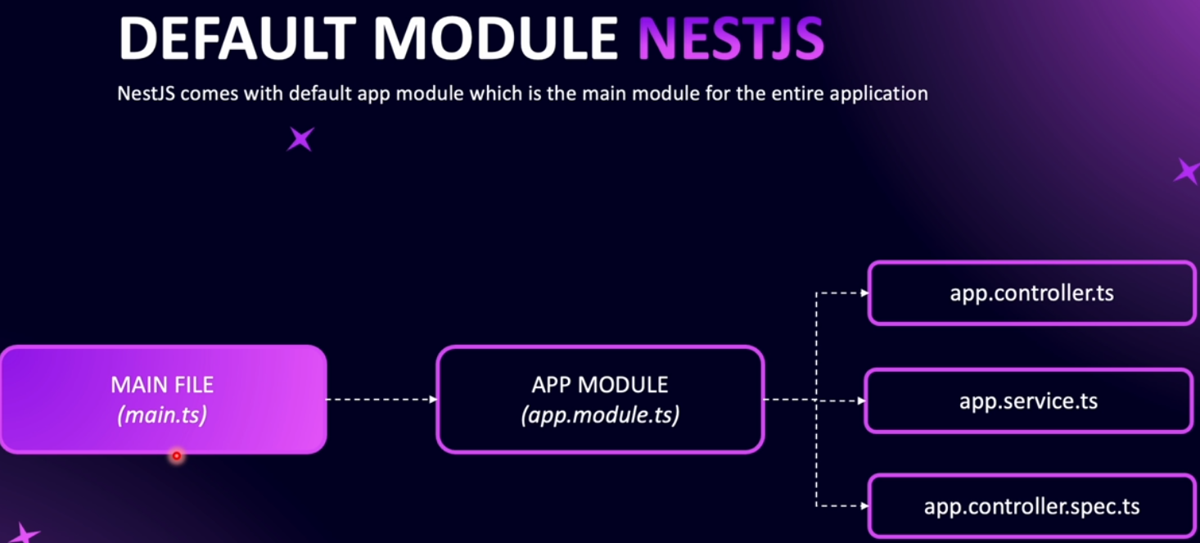
******************************************************************
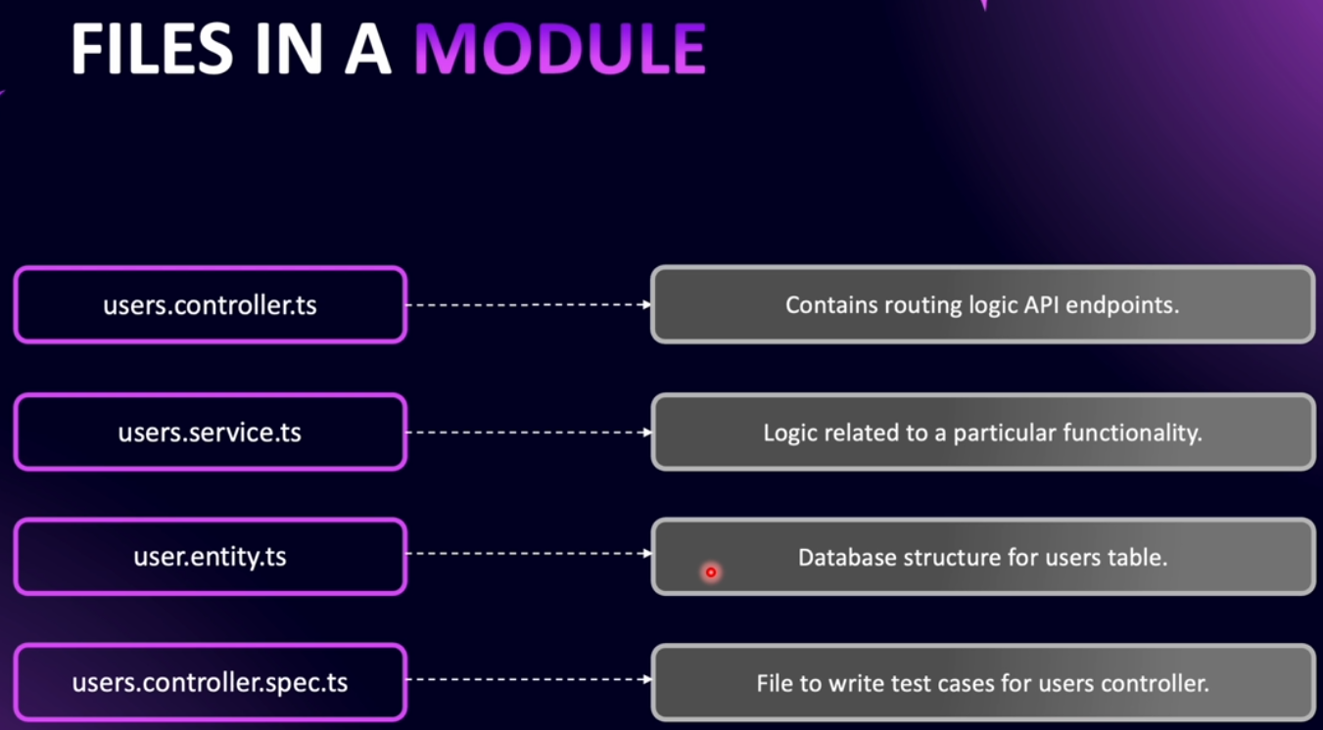
******************************************************************
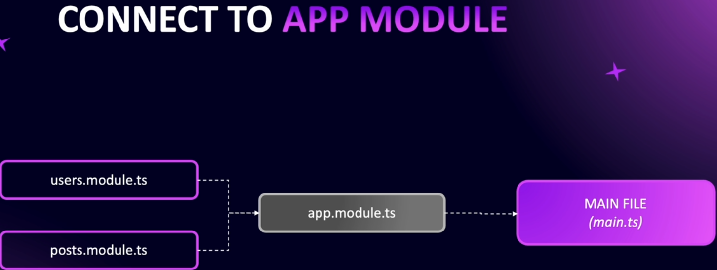
******************************************************************
To generate new module: nest generate module ModuleName
******************************************************************
To generate new controller: nest generate controller ControllerName
******************************************************************

import { Controller, Get, Param } from '@nestjs/common';

@Controller('users')
export class UsersController {
@Get('/')
public getUsers() {
return [
{ name: 'JLoka-01', job: 'Web Developer' },
{ name: 'JLoka-02', job: 'Mobile App Developer' },
];
}

// Note: If we don't set 'id' with param then id will become an object
@Get('/:id')
public getUserById(@Param('id') id: number) {
// console.log(`The id is: ${id}`);
return { id: id, name: 'JLoka-01', job: 'ITE Developer' };
}
@Post('/')
public createNewUser(@Body() data, @Headers() headers) {
console.log(`The data is: ${JSON.stringify(data)}`);
console.log('headers are: ', headers);
return { msg: 'User Created Successfully' };
}

}
******************************************************************

To add pipe to request:
Note: When we use pip for params they must be required
import {
Body, Controller, Get, Headers, Param,
Post, Query, ParseIntPipe,
} from '@nestjs/common';

// Note: If we don't set 'id' with param then id will become an object
@Get('/:id')
public getUserById(
@Param('id', ParseIntPipe) id: number,
@Query('sort') sort: string,
) {
// console.log(`The id is: ${id}`);
return {
type_: typeof id,
id: id,
name: 'JLoka-01',
job: 'ITE Developer',
sort,
};
}
******************************************************************
By using global pipes for validation we can’t avoid the problem of extra values in the request, so the attacker can pass malicious content to our request
******************************************************************
To use validation with pipe: npm i class-transformer
import { ValidationPipe } from '@nestjs/common';
async function bootstrap() {
const app = await NestFactory.create(AppModule);
app.useGlobalPipes(
new ValidationPipe({
whitelist: true,
forbidNonWhitelisted: true,
}),
);

await app.listen(process.env.PORT ?? 3000);
}
******************************************************************
app.useGlobalPipes(
new ValidationPipe({
whitelist: true,
forbidNonWhitelisted: true,
transform: true,
}),
);
------------------------------------------------------------
@Post('/')
public createNewUser(@Body() userDto: CreateUserDto) {
console.log(`The data is: ${JSON.stringify(userDto)}`);
console.log(typeof userDto); // Object
console.log(userDto instanceof CreateUserDto);
// true, but without transformer: true in global pipe, it will be: false
return { msg: 'User Created Successfully' };
}
******************************************************************
To validate any number type (else we get bad request):
import { Type } from 'class-transformer';
import { IsInt } from 'class-validator';

export class GetUsersParamDto {
@IsInt()
@Type(() => Number)
id?: number;
}
-------------------------------------------------
@Get('/:id')
public getUserById(@Param() t1: GetUsersParamDto) {
return {
type_: typeof t1,
id: t1,
name: 'JLoka-01',
job: 'ITE Developer',
};
}
-------------------------------------------------

// To avoid the parsing errors of ts
@Get('/')
public getUsers() {
return {
name: 'JLoka-01',
job: 'ITE Developer',
};
}
******************************************************************
To install mapped types to avoid code duplication: npm i @nestjs/mapped-types
And to use it, we can use extends:
import { PartialType } from '@nestjs/mapped-types';
import { CreateUserDto } from './create-user.dto';

// Make all properties of CreateUserDto are optional
export class UpdateUserPartDTO extends PartialType(CreateUserDto) {}
******************************************************************
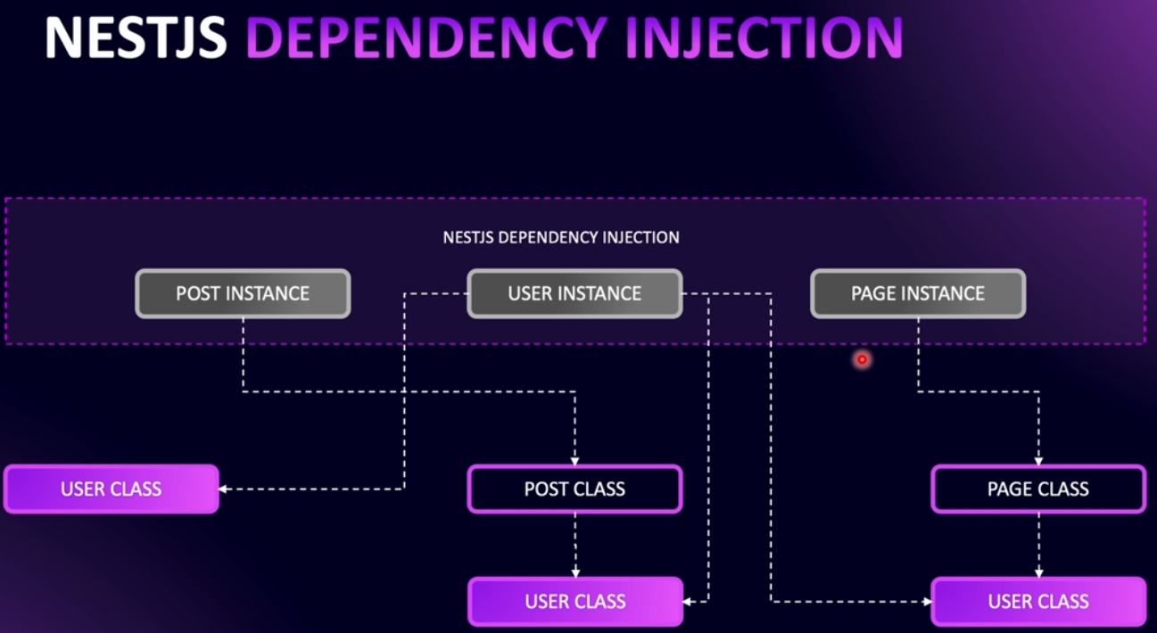
******************************************************************
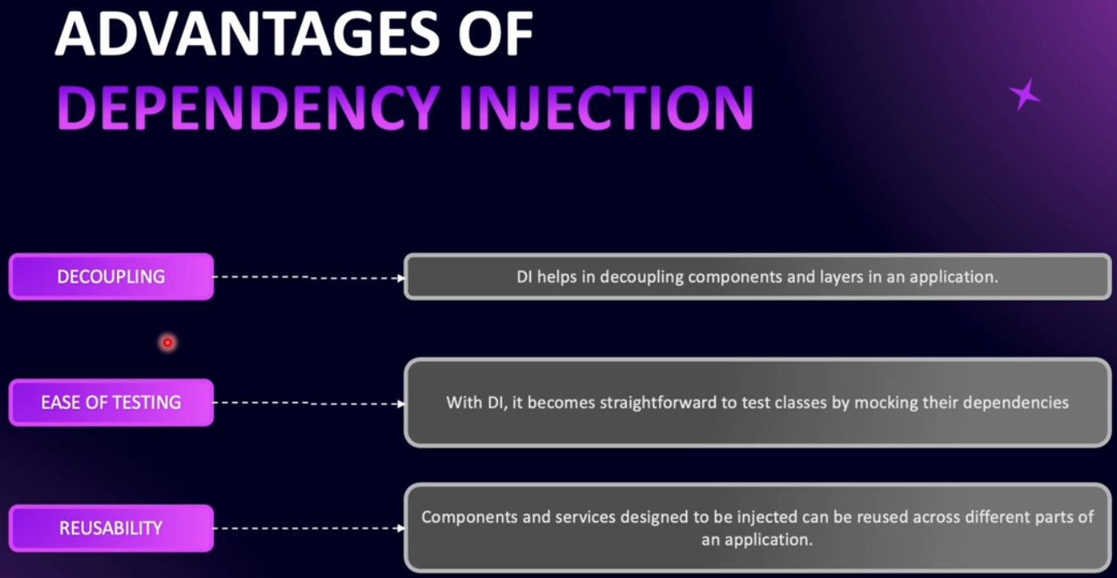
******************************************************************
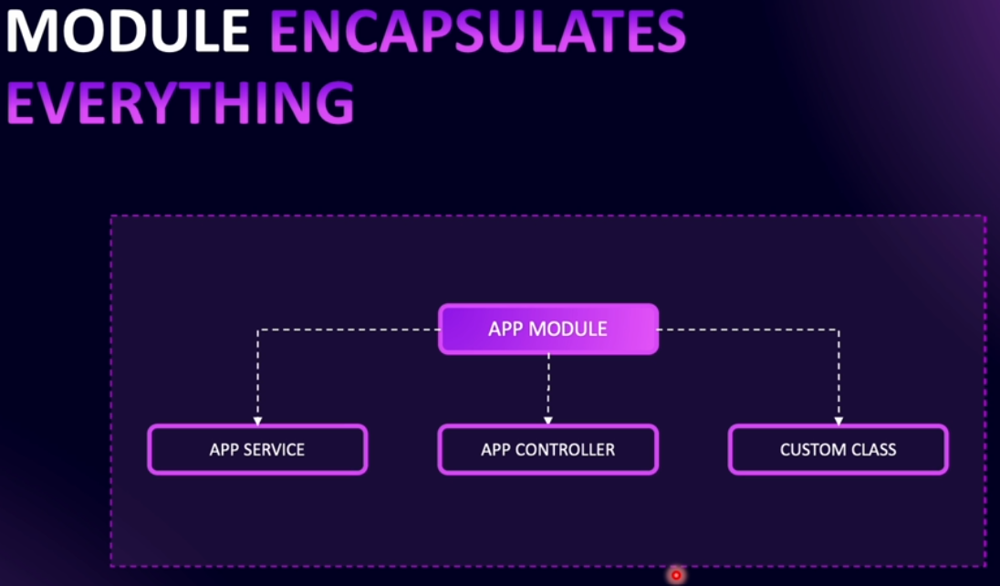
******************************************************************
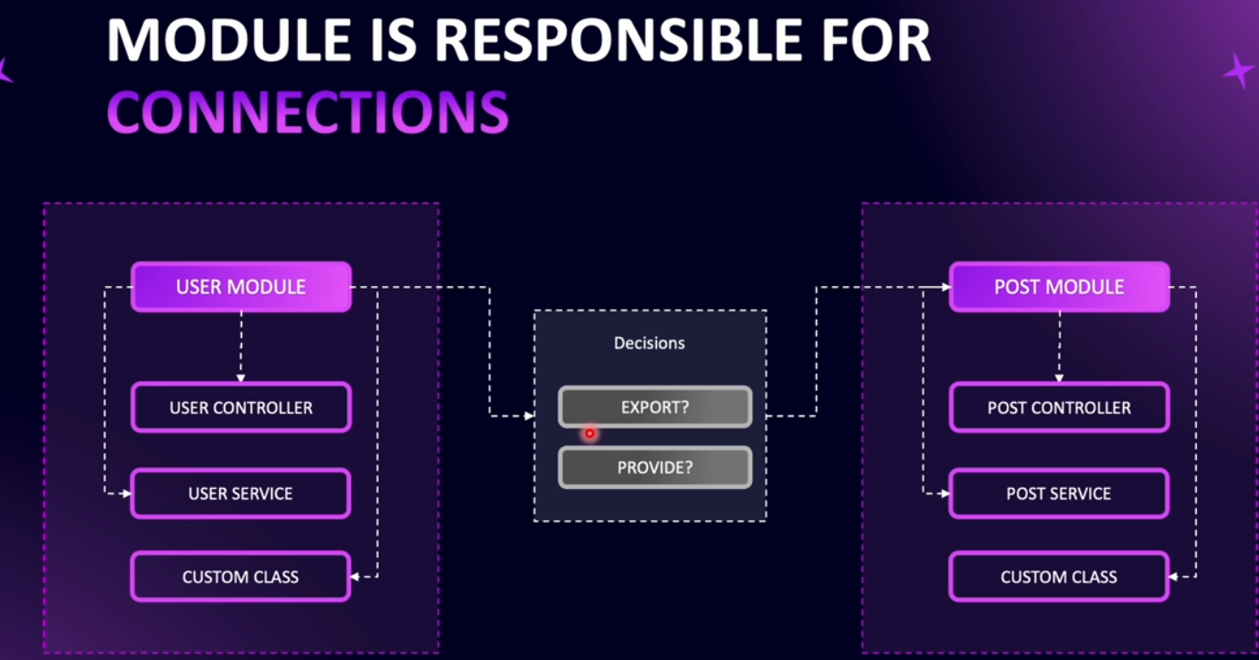
******************************************************************
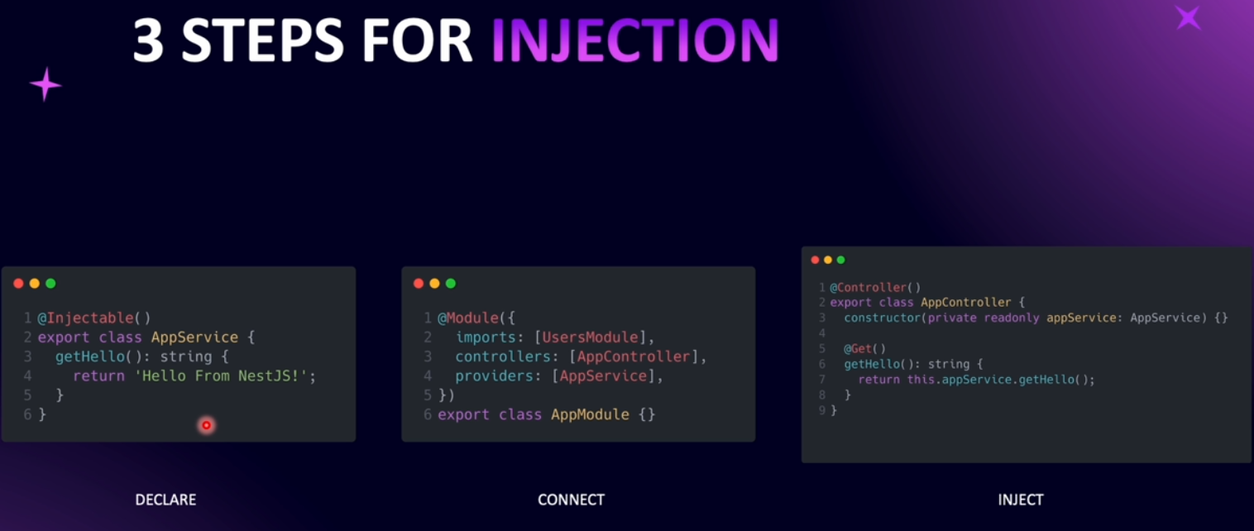
******************************************************************
To use services inside other services:
import { Module } from '@nestjs/common';
import { UsersController } from './users.controller';
import { UsersService } from './users.service';

@Module({
// eslint-disable-next-line prettier/prettier
controllers: [UsersController],
providers: [UsersService],
exports: [UsersService], // this service become available to use by other modules
})
export class UsersModule {}

--------------------------------------------------------------------------------------------------------
import { Module } from '@nestjs/common';
import { PostsController } from './posts.controller';
import { PostsService } from './posts.service';
import { UsersModule } from 'src/users/users.module';

@Module({
controllers: [PostsController],
providers: [PostsService],
imports: [UsersModule], // this will import only the services that are exported in UsersModule
})
export class PostsModule {}

--------------------------------------------------------------------------------------------------------
import { Injectable } from '@nestjs/common';
import { UsersService } from 'src/users/users.service';

@Injectable()
export class PostsService {

constructor(private readonly usersService: UsersService) {

}

}

--------------------------------------------------------------------------------------------------------
To solve the circular dependency:
import { forwardRef, Module } from '@nestjs/common';
import { AuthController } from './auth.controller';
import { AuthService } from './auth.service';
import { UsersModule } from 'src/users/users.module';

@Module({
controllers: [AuthController],
providers: [AuthService],
imports: [forwardRef(() => UsersModule)],
exports: [AuthService],
})
export class AuthModule {}

--------------------------------------------------------------------------------------------------------

Then inside the other module (UsersModule):
import { Module, forwardRef } from '@nestjs/common';
import { UsersController } from './users.controller';
import { UsersService } from './users.service';
import { AuthModule } from 'src/auth/auth.module';

@Module({
// eslint-disable-next-line prettier/prettier
controllers: [UsersController],
providers: [UsersService],
exports: [UsersService], // this service become available to use by other modules
imports: [forwardRef(() => AuthModule)],
})
export class UsersModule {}
--------------------------------------------------------------------------------------------------------
Then inside the services of each module (users, auth services):
import { forwardRef, Inject, Injectable } from '@nestjs/common';
import { UsersService } from 'src/users/users.service';

@Injectable()
export class AuthService {

constructor(
@Inject(forwardRef(() => UsersService))
private readonly usersService: UsersService
) {}
}

--------------------------------------------------------------------------------------------------------
import { forwardRef, Inject, Injectable } from '@nestjs/common';
import { AuthService } from 'src/auth/auth.service';

@Injectable()
export class UsersService {
constructor(
@Inject(forwardRef(() => AuthService))
private readonly authService: AuthService
) {}
}
******************************************************************

