Next.js automatically optimizes fonts in the application when you use the next/font module. It downloads font files at build time and hosts them with your other static assets. This means when a user visits your application, there are no additional network requests for fonts, which would impact performance.
==========================================================
To add a new font, first create font.ts:
import { Inter } from 'next/font/google'

export const inter = Inter({ subsets: ['latin'] })

Then import it at the root layout:
import '@/app/ui/global.css';
import { inter } from '@/app/ui/fonts';

export default function RootLayout({
children,
}: {
children: React.ReactNode;
}) {
return (
<html lang="en">
<body className={`${inter.className} antialiased`}>{children}</body>
</html>
);
}
==========================================================
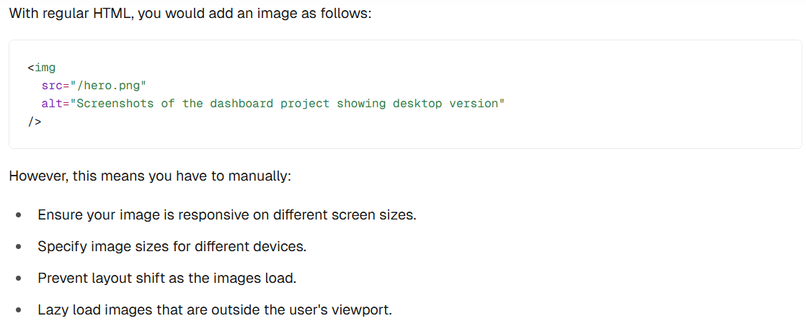
==========================================================
Image Optimization is a large topic in web development that could be considered a specialization in itself. Instead of manually implementing these optimizations, you can use the next/image component to automatically optimize your images.
==========================================================
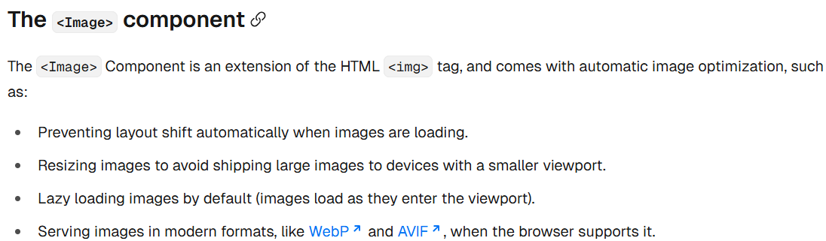
==========================================================
Images without dimensions and web fonts are common causes of layout shift due to the browser having to download additional resources.
==========================================================

import Image from 'next/image';

<div className="flex items-center justify-center p-6 md:w-3/5 md:px-28 md:py-12">
{/* Add Hero Images Here */}
<Image
src={"/hero-desktop.png"}
width={1000}
height={760}
className='hidden md:block'
alt="Screenshots of the dashboard project showing desktop version"
/>
<Image
src="/hero-mobile.png"
width={560}
height={620}
className='block md:hidden'
alt="Screenshots of the dashboard project showing mobile version"
/>
</div>
==========================================================

