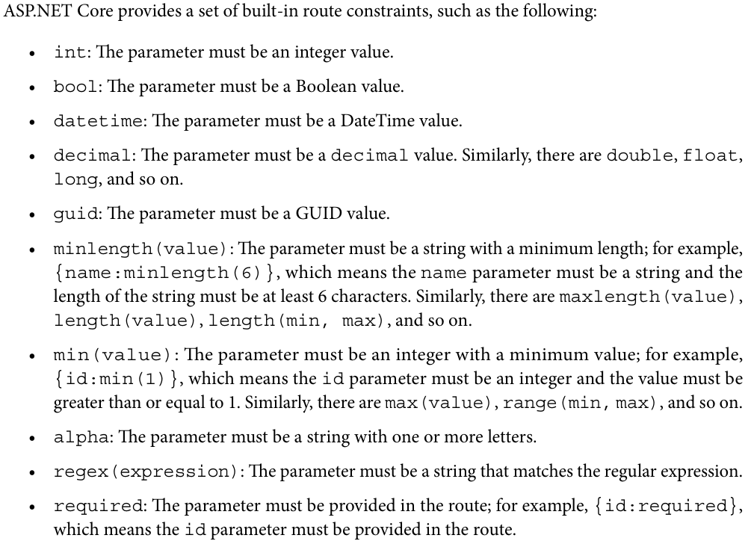
*********************************************************
If the value of the route parameter does not match the route constraint, the action method will not accept the request, and a 404 Not Found response will be returned.
*********************************************************
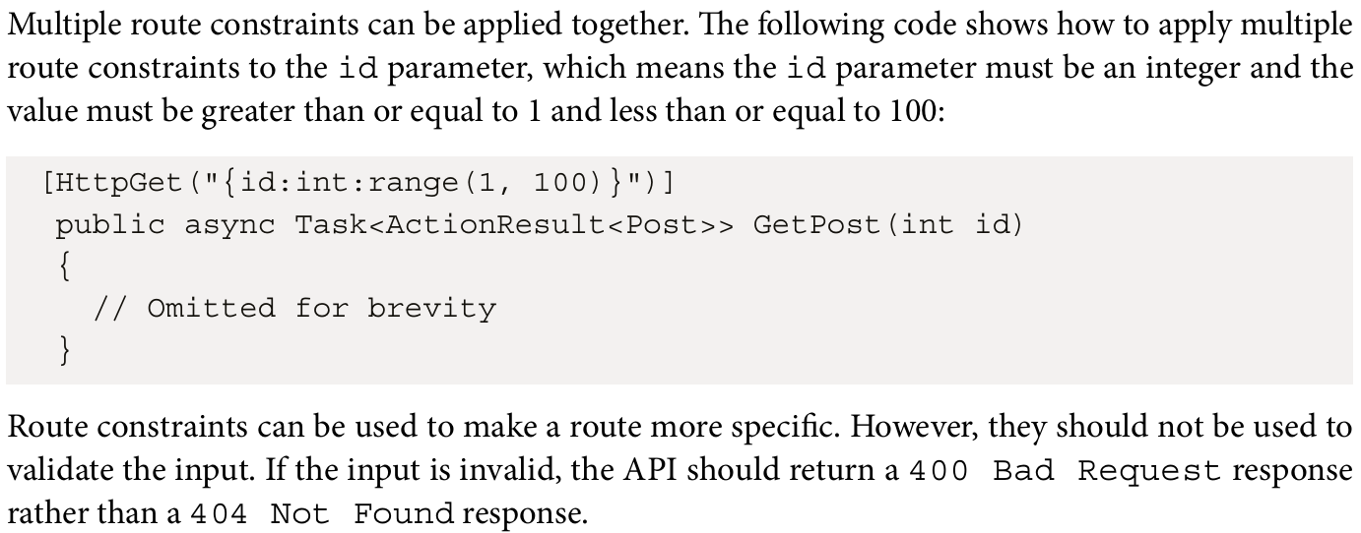
*********************************************************
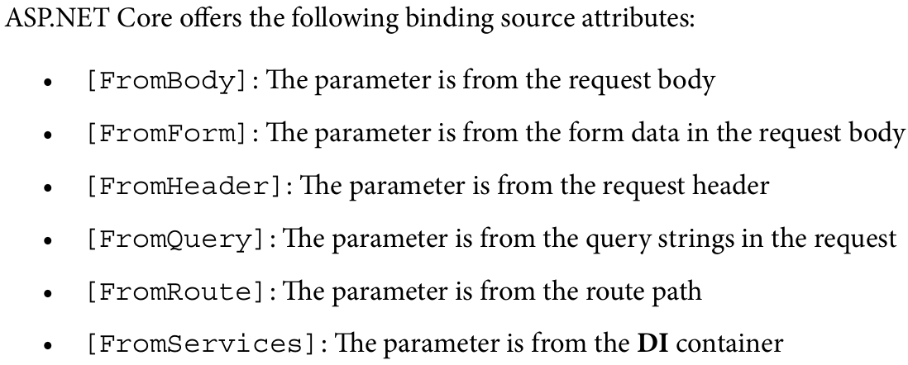
*********************************************************
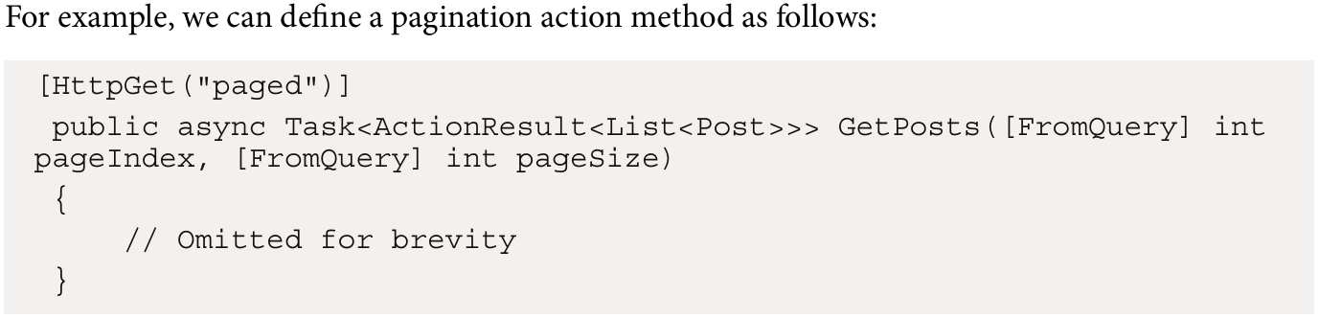
*********************************************************
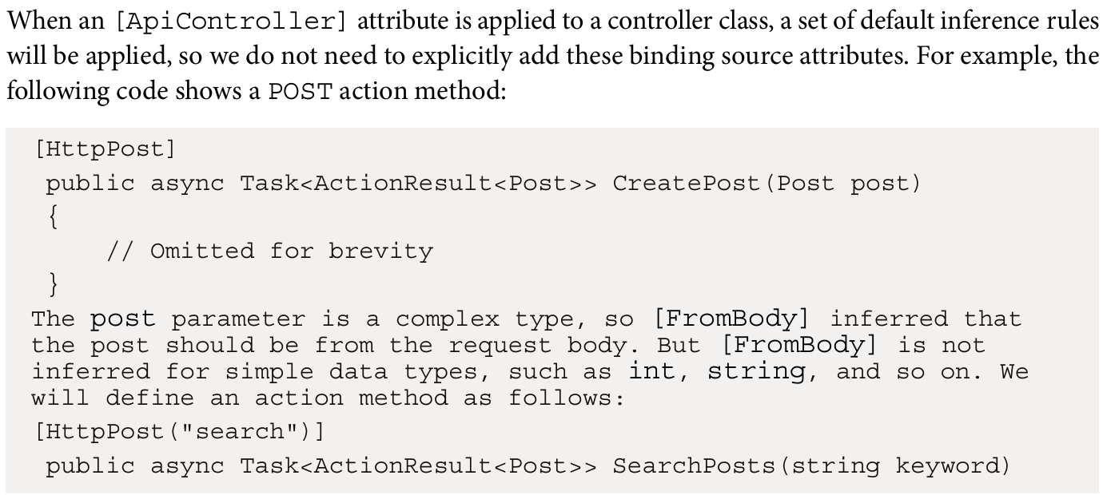
*********************************************************
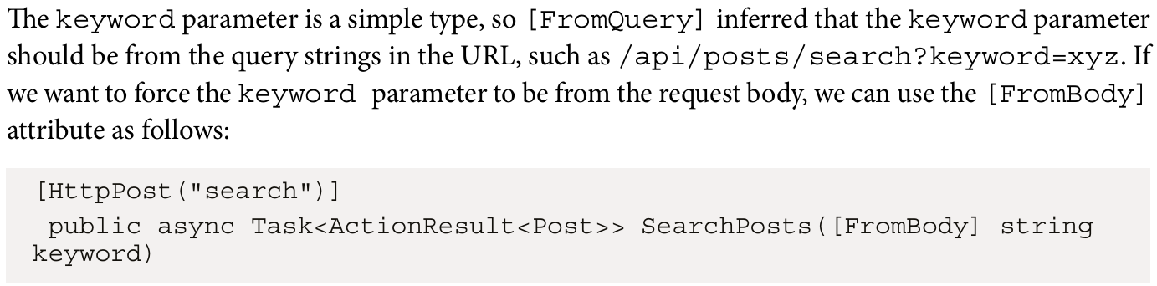
*********************************************************
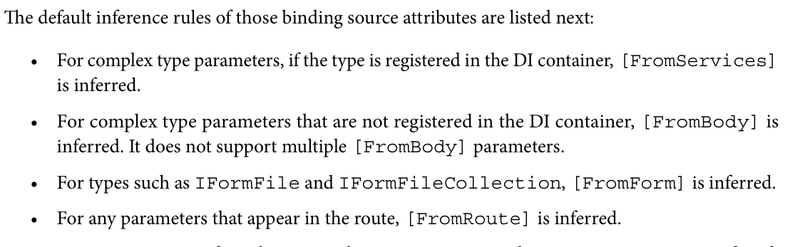
*********************************************************

ASP.NET Core provides a comprehensive configuration framework that makes it easy to work with configuration settings. A configuration is considered a key-value pair. These configuration settings are stored in a variety of sources, such as JSON files, environment variables, and command-line arguments, or in the cloud, such as Azure Key Vault. In ASP.NET Core, these sources are referred to as configuration providers. Each configuration provider is responsible for loading configuration settings from a specific source.
*********************************************************
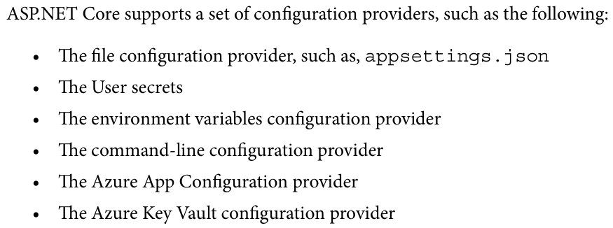
*********************************************************
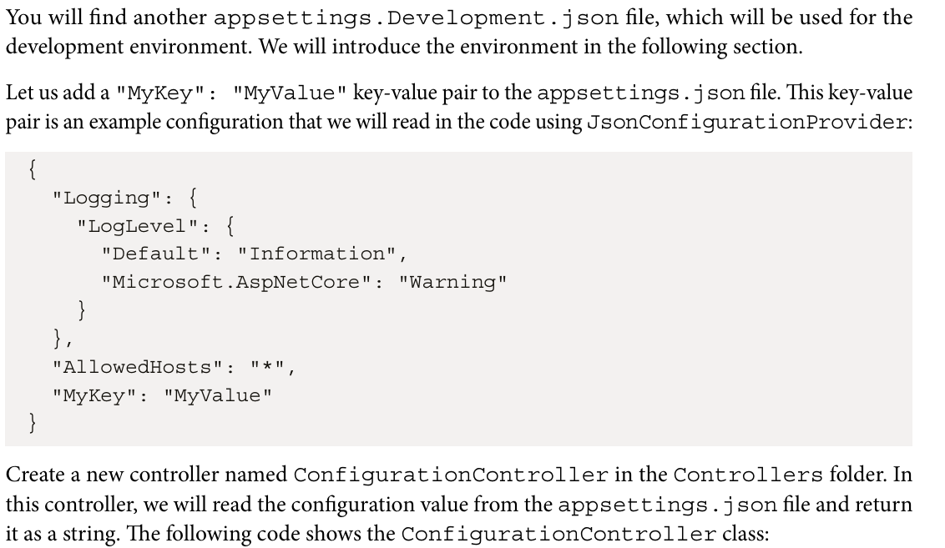
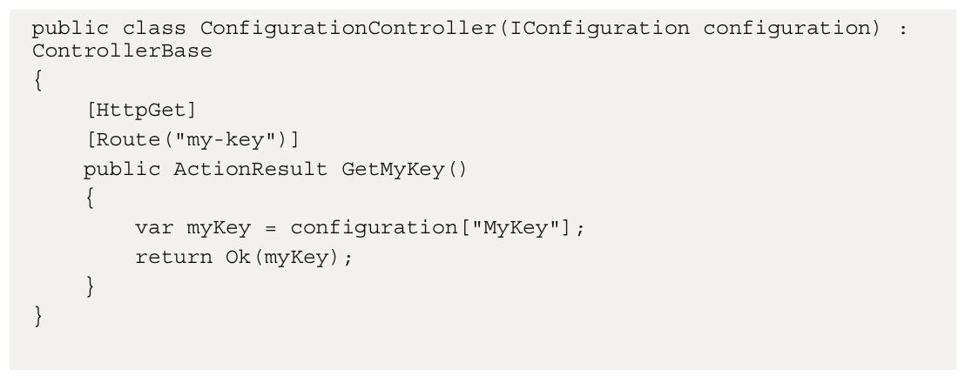
*********************************************************
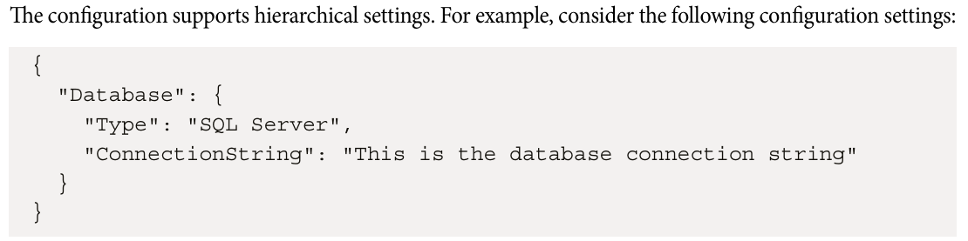
*********************************************************
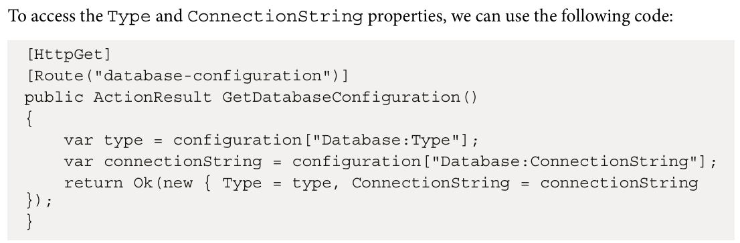
*********************************************************

Using the IConfiguration interface, we can access the configuration settings with the configuration[key] format. However, hardcoding the keys is not a good practice. To avoid hardcoding, ASP.NET Core supports the options pattern, which can provide a strongly typed way to access hierarchical settings.
*********************************************************



