The Publish option enables you to save your Excel workbooks to a folder on your OneDrive for Business account and then publish them to Microsoft’s Power BI (Business Intelligence) stand-alone application that enables you to create visual dashboards that highlight and help explain the story behind the worksheet data.
==========================================================
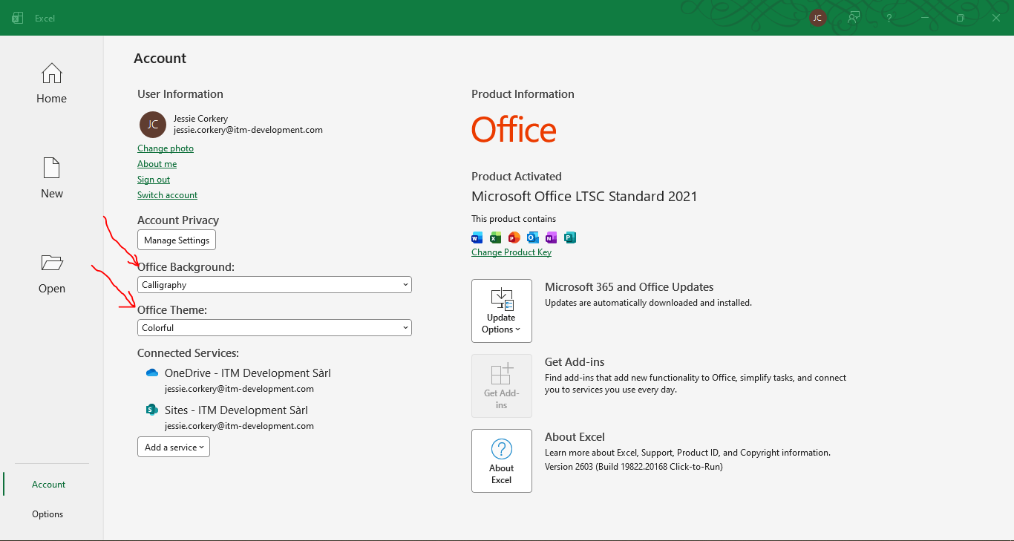
==========================================================
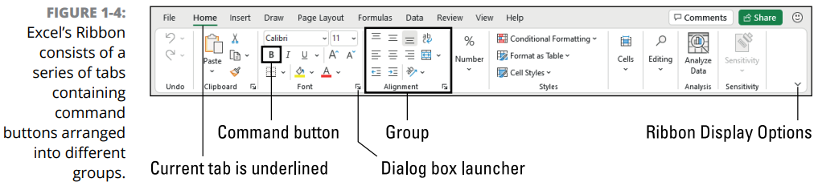
==========================================================
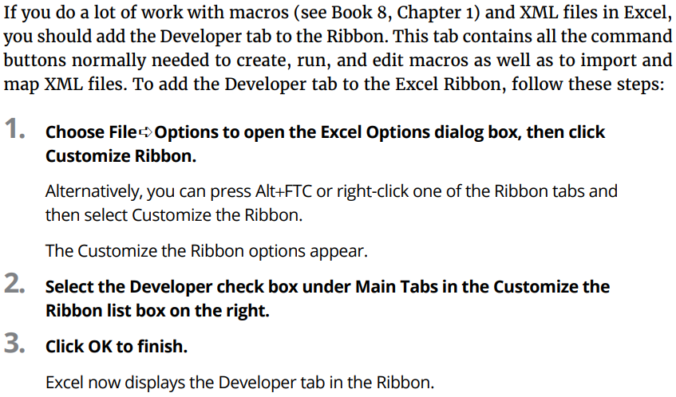
==========================================================
The Cell contents section of the Formula bar is important because it always shows you the contents of the cell, even when the worksheet does not. (When you’re dealing with a formula, Excel displays only the formula result in the cell and not the formula itself.) You can edit the contents of the cell in this area at any time. By the same token, when the Cell contents area is blank, you know that the cell is empty as well.
==========================================================
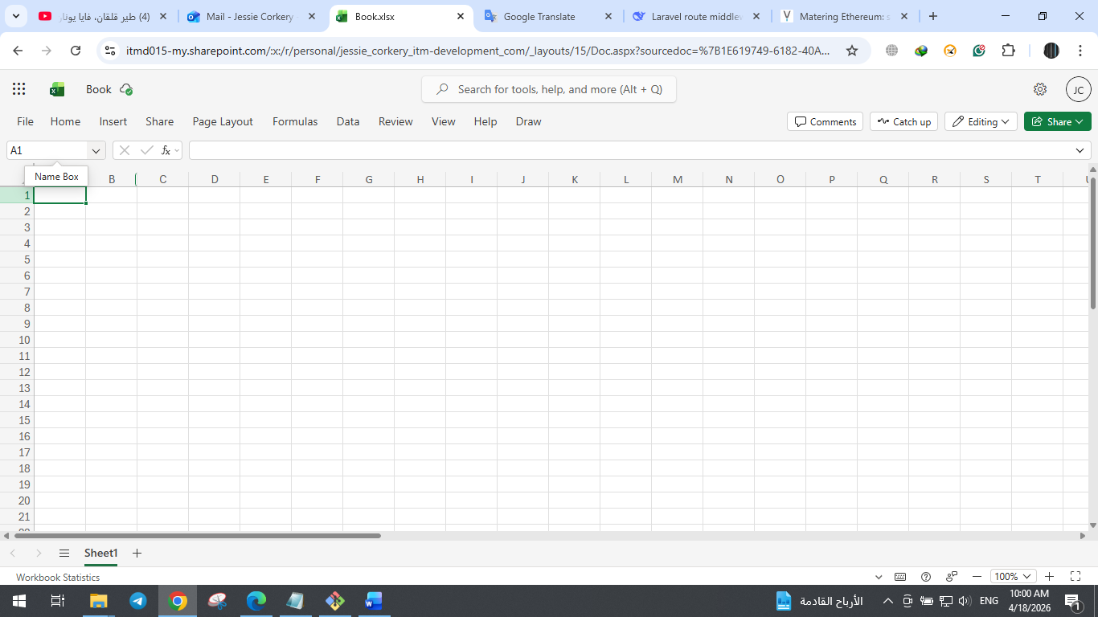
==========================================================
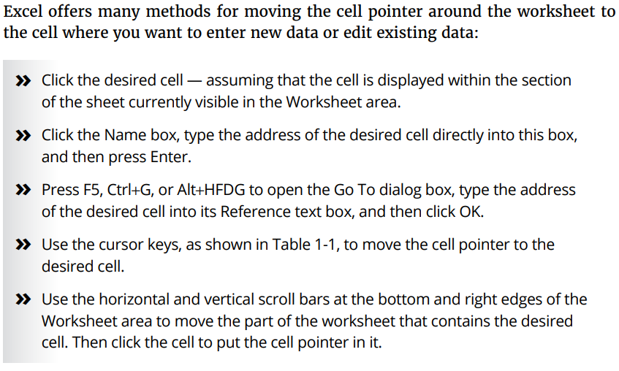
==========================================================
Excel offers extensive online help in the Help taskbar that you can make use of anytime while using the program. To display the Excel Help taskbar, click the Help button on the Help tab of the Ribbon (Alt+Y2H) or press F1.



