To create playwright using npm & node.js: npm init playwright@latest
*****************************************************
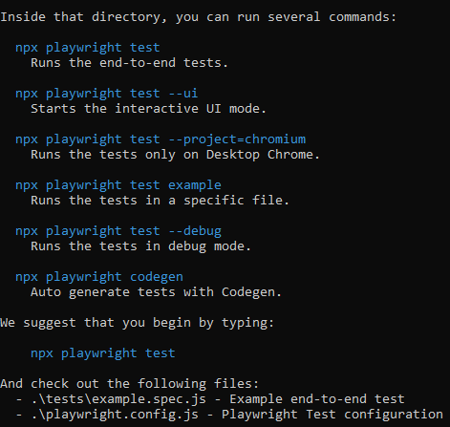
*****************************************************

In playwright.config.js we can mention the name of the browsers on which we want to execute the test case.
projects: [
{
name: 'chromium',
use: { ...devices['Desktop Chrome'] },
},
{
name: 'firefox',
use: { ...devices['Desktop Firefox'] },
},
{
name: 'webkit',
use: { ...devices['Desktop Safari'] },
},
],
*****************************************************
import { test, expect } from '@playwright/test'

test('check cart icon', async ({ page }) => {
await page.goto('https://ecommerce-playground.lambdatest.io/')
await page.locator('span.title', {hasText: ' Mega Menu'}).hover()
await page.locator('a[title="Desktop"]').click();
let t1 = page.locator('div.carousel-item.active > img[title="Palm Treo Pro"]')

await t1.scrollIntoViewIfNeeded()
await t1.hover()
await page.waitForTimeout(1000)

let t2 = page.locator('button[title="Add to Cart"]').nth(1)
await expect(t2).toBeVisible()
})
*****************************************************
To show the report of playwright: npx playwright show-report
*****************************************************

