To install typeorm for nestjs: npm install --save @nestjs/typeorm typeorm mysql2
****************************************************************
Then to use it with app module:
import { Module } from '@nestjs/common';
import { AppController } from './app.controller';
import { AppService } from './app.service';
import { TypeOrmModule } from '@nestjs/typeorm'

@Module({
imports: [
TypeOrmModule.forRoot({
type: 'mariadb',
host: 'localhost',
port: 3306,
username: 'root',
password: '123',
database: 'test',
entities: [],
synchronize: true
})
],
controllers: [AppController],
providers: [AppService],
})
export class AppModule {}
****************************************************************
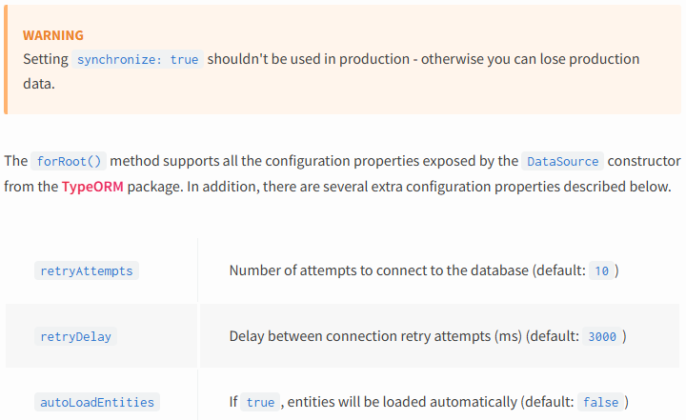
****************************************************************
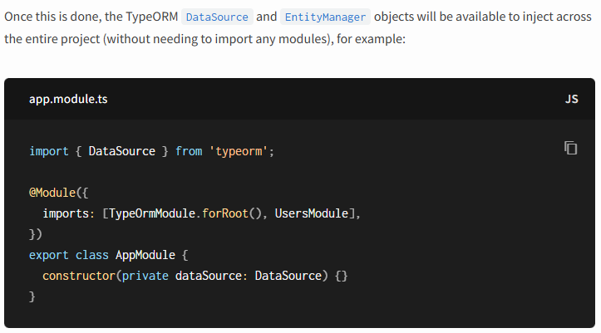
****************************************************************

To define the User entity:
import { Column, Entity, PrimaryGeneratedColumn } from "typeorm";

@Entity()
export class User {
@PrimaryGeneratedColumn()
id: number;
@Column()
firstName: string;
@Column()
lastName: string;
@Column({ default: true })
isActive: boolean;
}
---------------------------------------------------------------------------------
Then we import it in entities:
import { Module } from '@nestjs/common';
import { AppController } from './app.controller';
import { AppService } from './app.service';
import { TypeOrmModule } from '@nestjs/typeorm'
import { User } from './users/user.entity';

@Module({
imports: [
TypeOrmModule.forRoot({
type: 'mariadb',
host: 'localhost',
port: 3306,
username: 'root',
password: '123',
database: 'test',
entities: [User],
synchronize: true
})
],
controllers: [AppController],
providers: [AppService],
})
export class AppModule {}
****************************************************************
The to define the Users module:
import { Module } from '@nestjs/common';
import { UsersController } from './users.controller';
import { UsersService } from './users.service';
import { TypeOrmModule } from '@nestjs/typeorm';
import { User } from './user.entity';

@Module({
imports: [TypeOrmModule.forFeature([User])],
controllers: [UsersController],
providers: [UsersService]
})
export class UsersModule {}
****************************************************************

This module uses the forFeature() method to define which repositories are registered in the current scope. With that in place, we can inject the UsersRepository into the UsersService using the @InjectRepository() decorator:

import { Injectable } from '@nestjs/common';
import { InjectRepository } from '@nestjs/typeorm';
import { User } from './user.entity';
import { DeleteResult, Repository } from 'typeorm';
@Injectable()
export class UsersService {

constructor(
@InjectRepository(User) private userRepository: Repository<User>
) {}

async findAll():Promise<User[]> {
return this.userRepository.find()
}

async findOne(id: number) :Promise<User | null> {
return this.userRepository.findOneBy({ id })
}

async remove(id: number): Promise<DeleteResult> {
return this.userRepository.delete(id)
}
}
****************************************************************

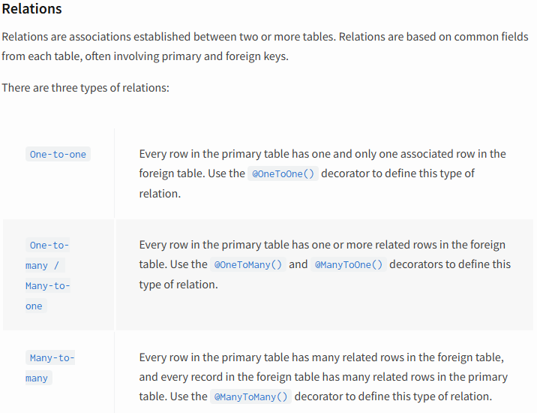
****************************************************************

To autoload entities:
@Module({
imports: [
TypeOrmModule.forRoot({
type: 'mariadb',
host: 'localhost',
port: 3306,
username: 'root',
password: '123',
database: 'test',
autoLoadEntities: true,
entities: [Photo],
synchronize: true
}),
UsersModule
],
controllers: [AppController],
providers: [AppService],
})
export class AppModule {}
****************************************************************
And to define one to many && many to one relation:
import { User } from "src/users/user.entity";
import { Column, ManyToOne, OneToOne, PrimaryGeneratedColumn } from "typeorm";

export class Photo {
@PrimaryGeneratedColumn()
id: number;

@Column()
path: string;

@ManyToOne(() => User, (user) => user.photos)
user: User;
}
---------------------------------------------------------------------------------

import { Photo } from "src/photo/photo.entity";
import { Column, Entity, OneToMany, PrimaryGeneratedColumn } from "typeorm";

@Entity()
export class User {
@PrimaryGeneratedColumn()
id: number;

@Column()
firstName: string;

@Column()
lastName: string;

@Column({ default: true })
isActive: boolean;

@OneToMany(() => Photo, photo => photo.user)
photos: Photo[]
}
****************************************************************
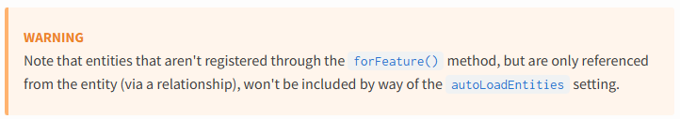
****************************************************************
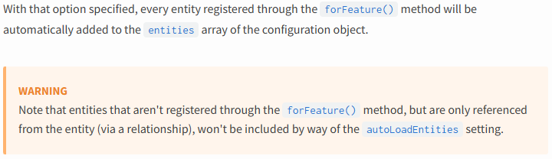
****************************************************************

To separate the entity definitions instead of use annotations with entities classes:
For user.schema.ts:
import { EntitySchema } from 'typeorm';
import { User } from './user.entity';

export const UserSchema = new EntitySchema<User>({
name: 'User',
target: User,
columns: {
id: {
type: Number,
primary: true,
generated: true,
},
firstName: {
type: String,
nullable: false,
},
lastName: {
type: String,
nullable: false,
},
isActive: {
type: Boolean,
default: true,
},
},
relations: {
photos: {
type: 'one-to-many',
target: 'Photo'
}
}
})
****************************************************************

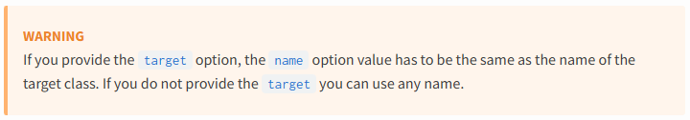
****************************************************************
@Module({
imports: [TypeOrmModule.forFeature([UserSchema])],
controllers: [UsersController],
providers: [UsersService]
})
export class UsersModule {}
****************************************************************

