# How to use Backpack Alley Query Runner

1. Open your Java IDE and import the QR_Group5 project file
2. Once the project has loaded you have the option to run the GUI interface or use the console by toggling between GUI or Console in the configurations drop down in the upper right  
   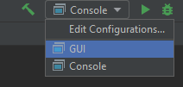

## GUI Option

1. Run the program by clicking on the green triangle.
2. A window will pop up with login data filled in. Click on Connect.
3. Select the query you would like to use from the drop-down.  
   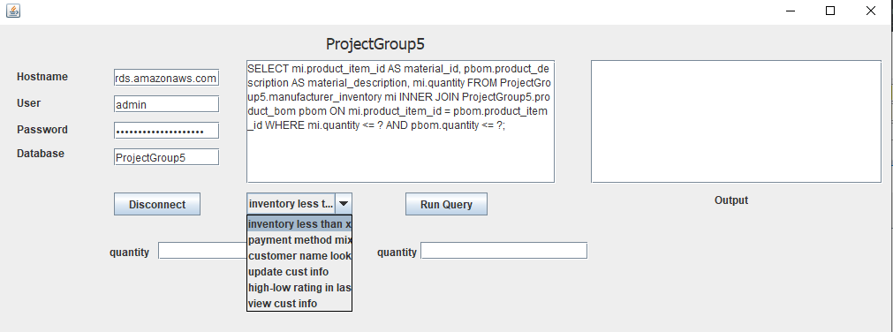
4. Depending on the query selected, parameters may be required. Fill in the parameters as indicated.
5. Click on Run Query.
6. The results will appear for your viewing.
7. When you want to quit, click Disconnect to end the program.

## Console Option

1. Run the program by clicking on the green triangle.
2. The console will ask you for your login information. For expansion, there are defaults
   1. Host – leave empty to use the default, or you can enter:  
      **projectdbs.cn3usp1d3gjf.us-east-1.rds.amazonaws**
   2. User – leave empty to use the default, or you can enter:   
      **admin**
   3. Password - This is required to be entered: **lKMNGgnpCzu4Wj7e0lPq**
   4. Database - leave empty to use the default, or you can enter:  
      **ProjectGroup5**
3. The console will give you a list of queries you can run and ask for your selection. Enter the option you’d like.
4. The query will print for your reference. If parameters are required, you’ll be asked to enter them and then the query will run and print the results.
5. The results in formatted to be easily copied and pasted in csv
6. To quit the program, enter 0 for exit.