ExamVault
Product Walkthrough
Screen-by-screen guide across every user role
Prepared for client review

Contents
1. Student — the exam-taking experience
2. Admin — running an organization on ExamVault
3. Super Admin — managing the platform

1. Student
The core experience — taking exams, tracking results, and earning certificates.
Every student who logs into ExamVault gets a focused, personal workspace: the exams assigned to them, their results as soon as they’re published, certificates for the exams they’ve passed, and a notification inbox that keeps them up to date. The screens below walk through that experience end to end.

Dashboard
The student’s home page — a snapshot of upcoming exams, completed exams, average score, and total score, with quick links into exams, results, notifications, and profile.
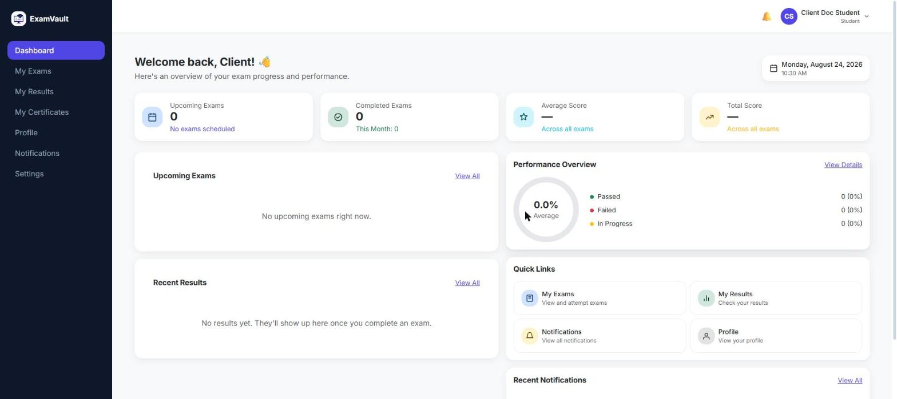

My Exams
Every exam assigned to the student, with quick filters for Upcoming, In Progress, Completed, and Expired, plus search and creation-method filters.
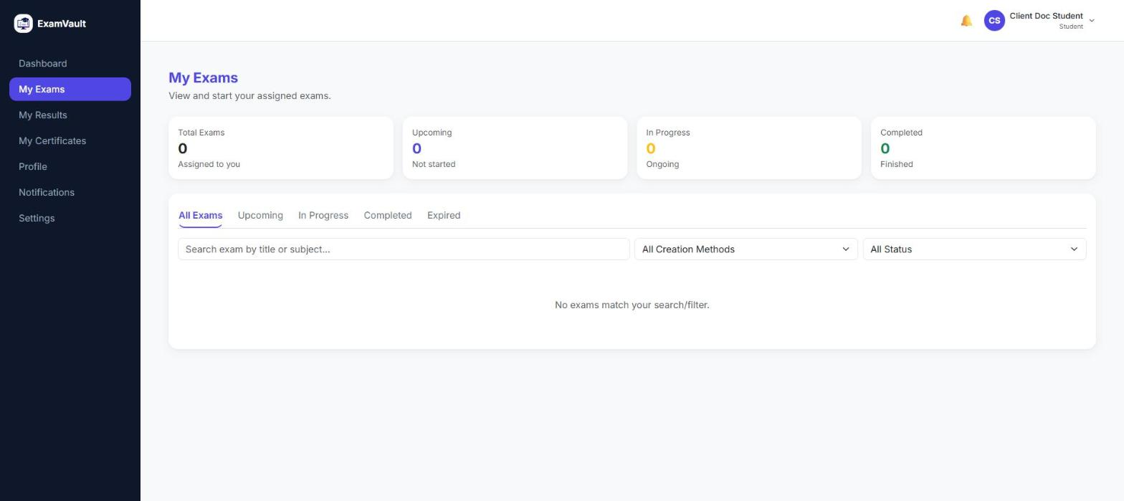

My Results
A complete history of the student’s exam attempts and scores, with a pass/fail/in-progress breakdown and a visual performance overview.
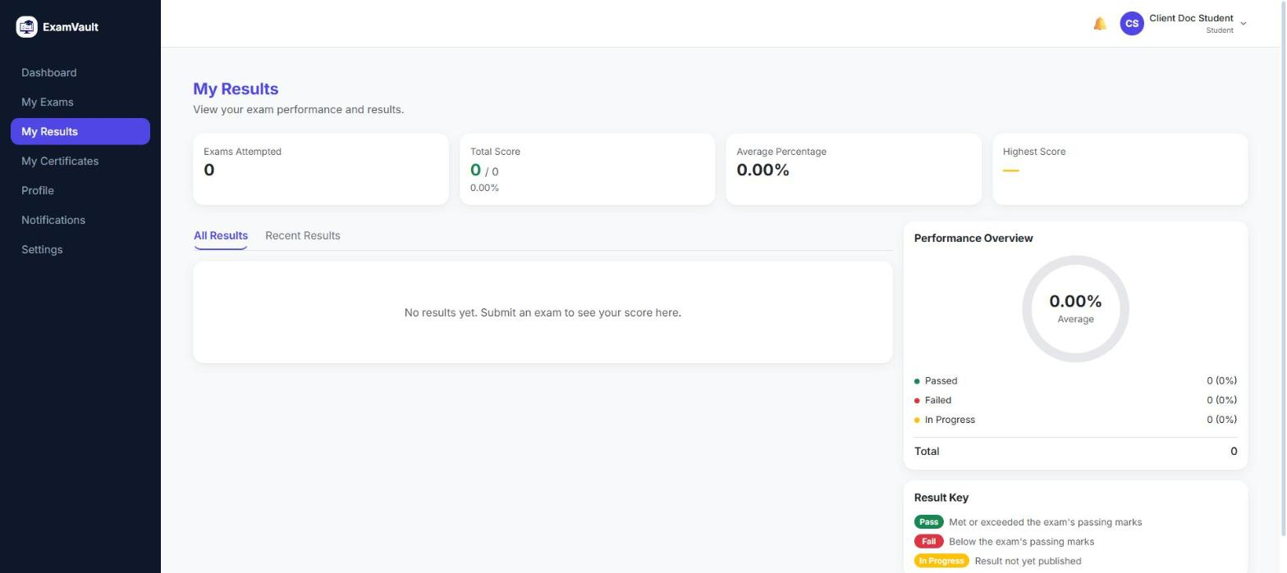

My Certificates
Certificates earned for exams where the student scored 80% or above, searchable by exam name.
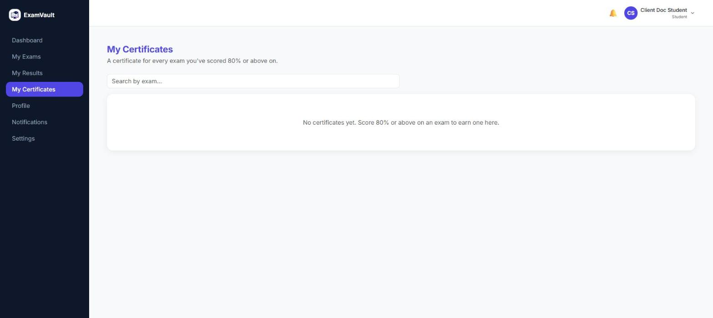

Notifications
The student’s notification inbox for exam updates, results, and system announcements, with per-category notification preferences they can turn on or off.
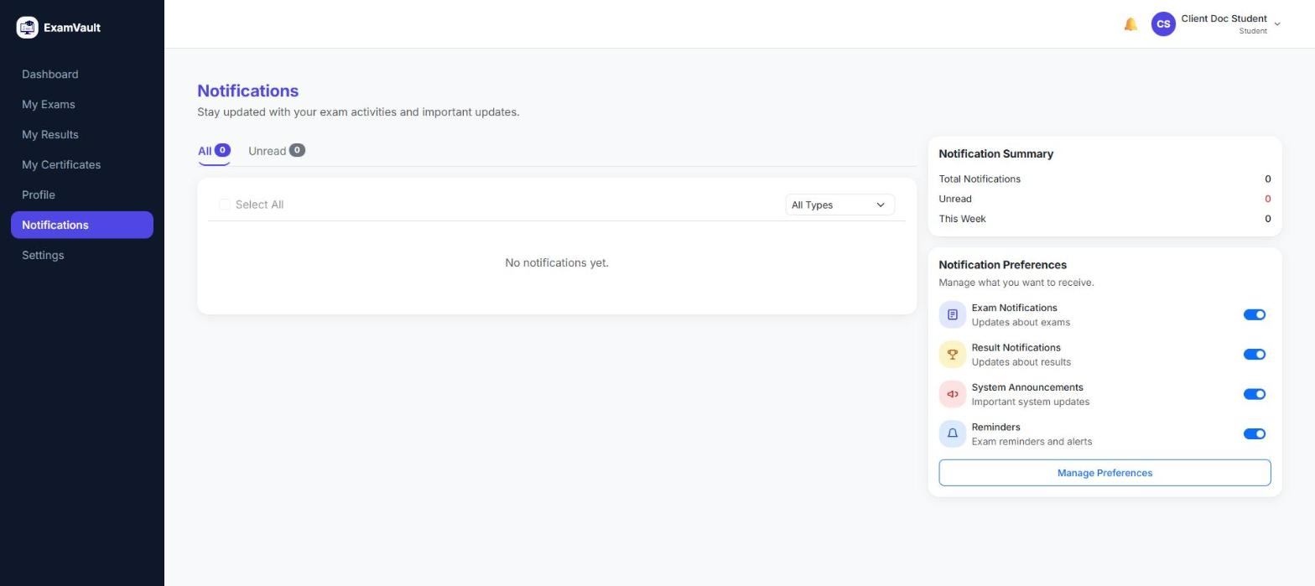

Profile
The student’s personal profile — contact details and account information — with tabs for security, preferences, active sessions, and account activity history.
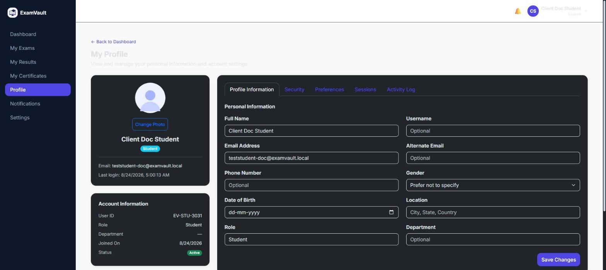

Settings
Account-level settings covering personal information, notification preferences, and security options like changing a password or managing active sessions.
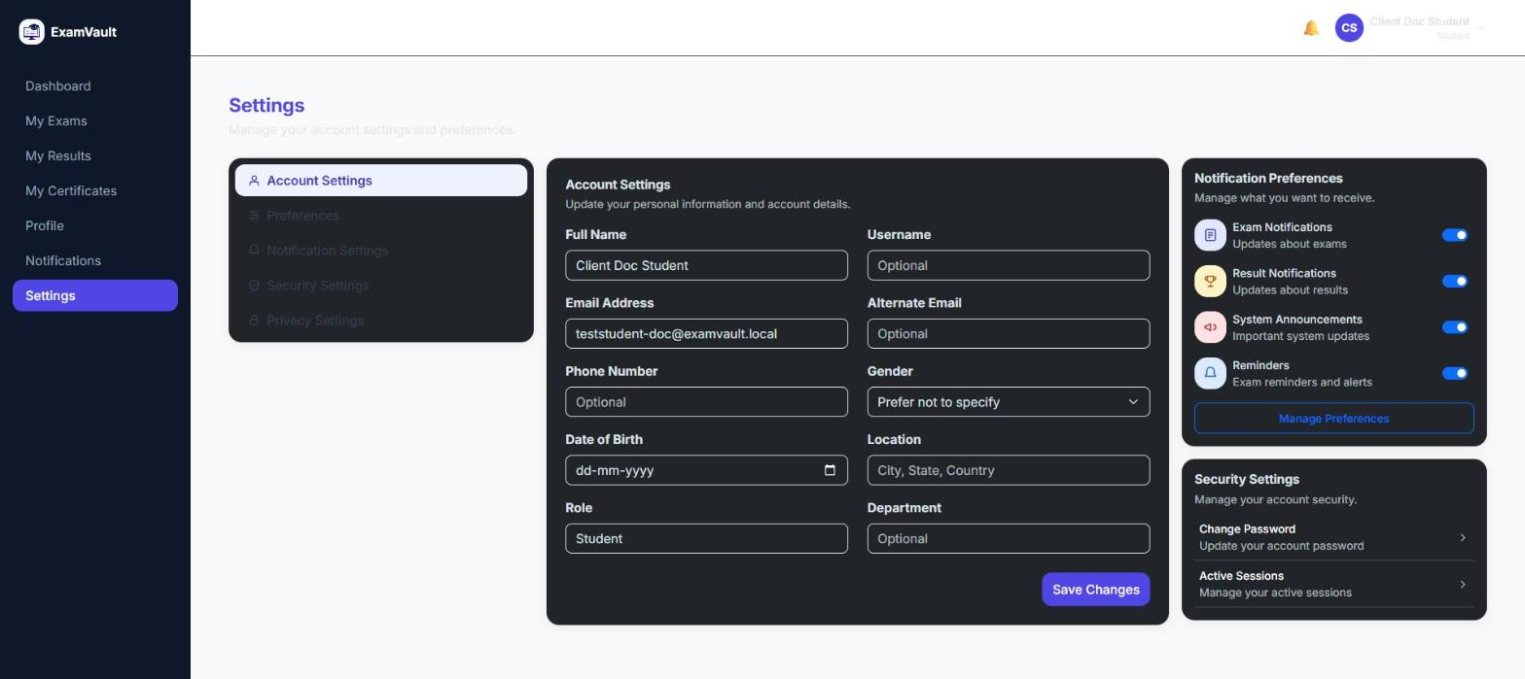

2. Admin
Everything an organization needs to run its own exams, students, and staff.
An Organization Admin manages their institution’s entire presence on ExamVault: creating and scheduling exams, managing students and staff, watching exams live as they happen, grading what can’t be auto-scored, and reporting on how everything performed. This is the full, working core product.

Dashboard
The organization’s home page — total users, total exams, total attempts, average score, active and published exam counts, a 7-day exam activity trend, and quick actions to create an exam or manage users.
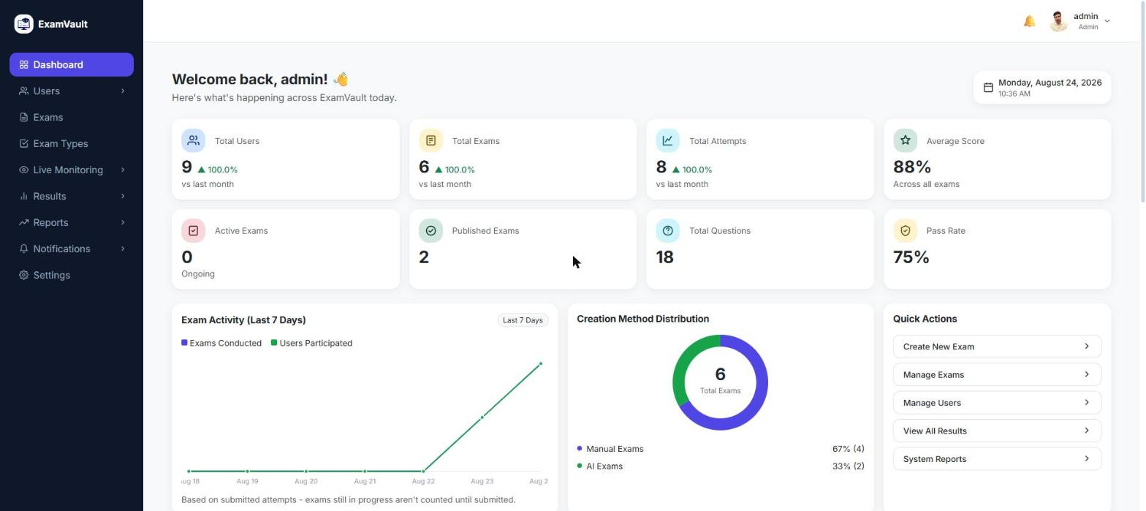

All Users
Manage every user in the organization — students and admins — with role and status filters, bulk import, export, and quick actions to view, edit, or remove a user.
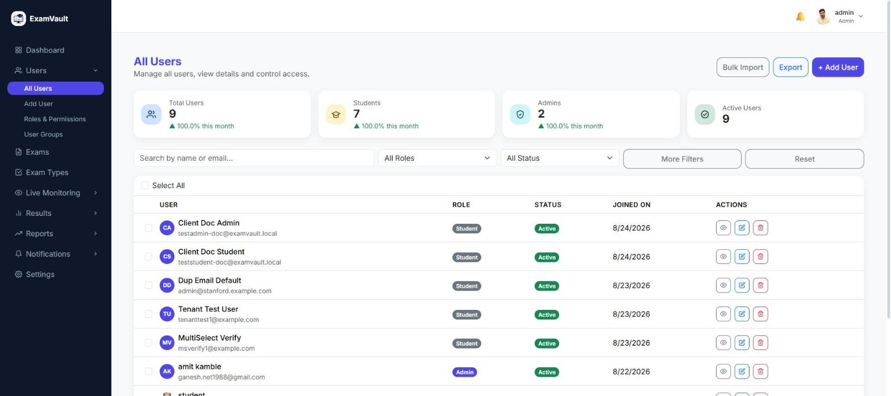

User Groups
Organize students into groups or batches, making it faster to assign exams to a whole cohort at once.
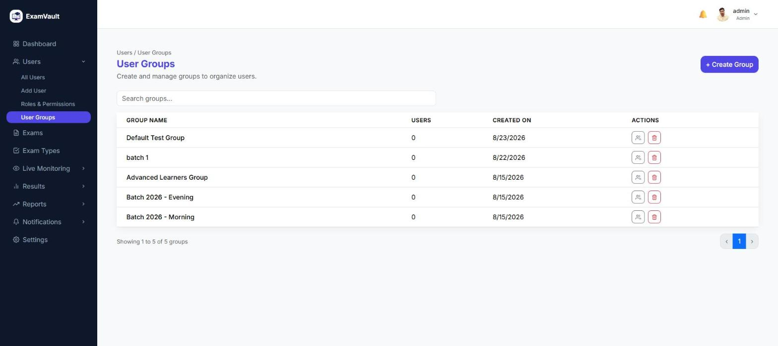

Manage Exams
The full list of exams created in the organization, with status (Draft / Published / Archived), category, duration, and total marks, plus quick actions to view, edit, or delete each one.
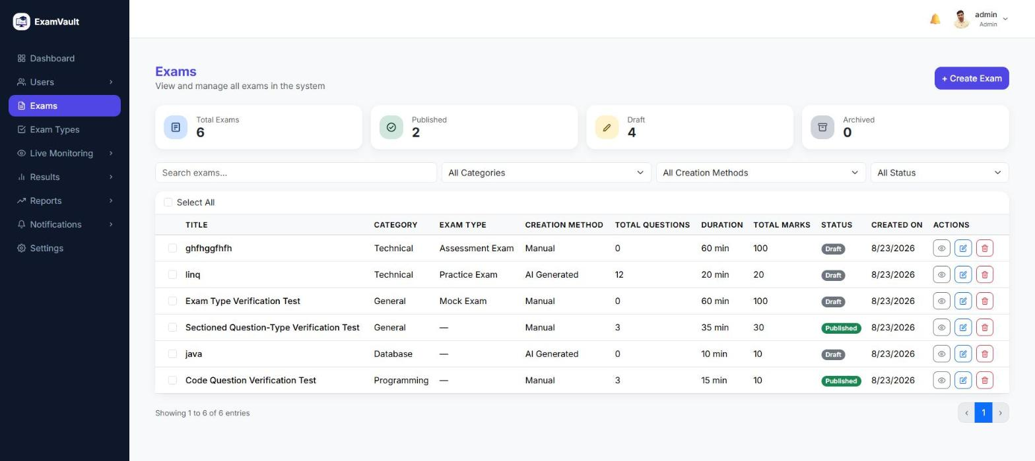

Exam Types
The purpose-based exam classifications available when creating an exam — Practice, Mock, Certification, Entrance, Recruitment, and more — fully customizable by the organization.
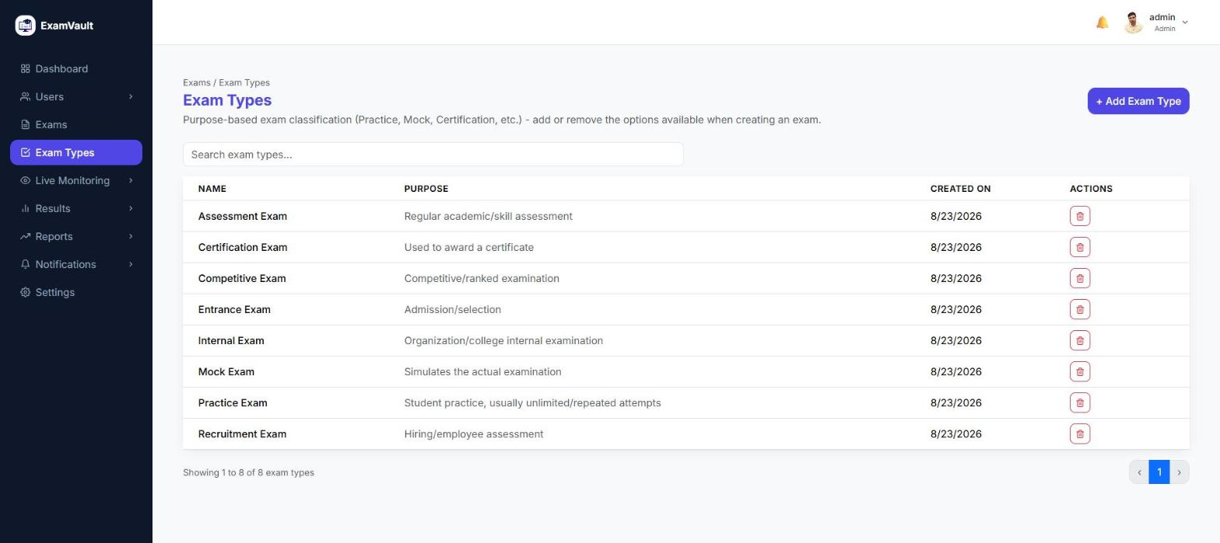

Live Monitoring — Active Exams
A real-time view of every exam currently in progress across the organization, with live counts of active exams, students testing, and any alerts raised.
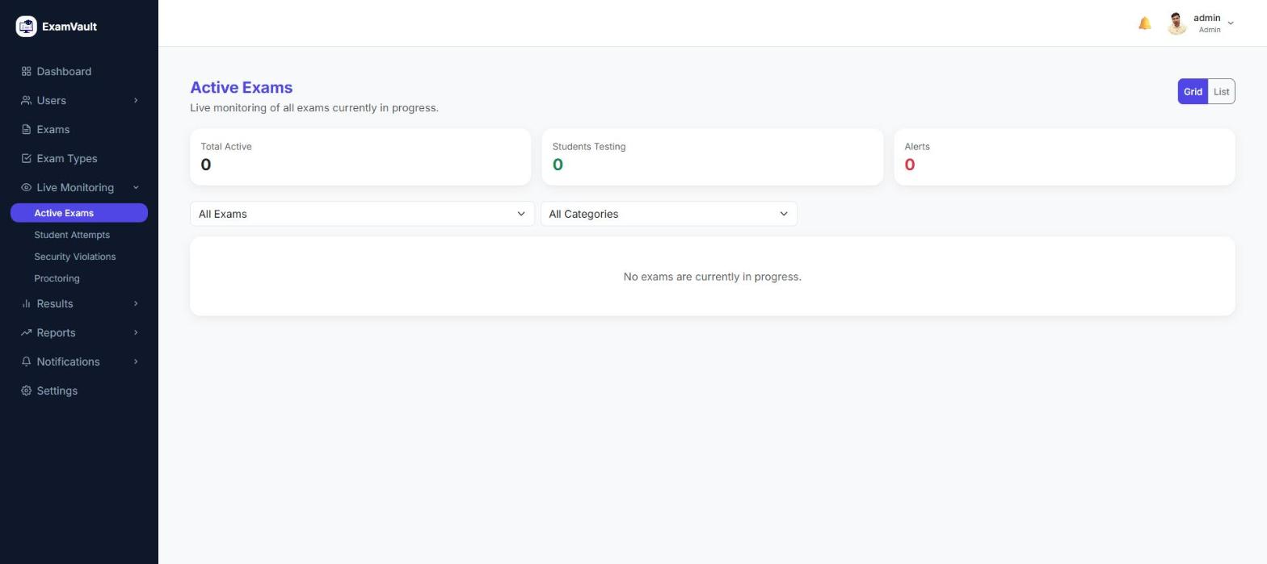

Live Monitoring — Proctoring
A live proctoring dashboard showing which students are currently being monitored during an exam. Detection runs privately in the student’s own browser; live video is opt-in per session and off by default.
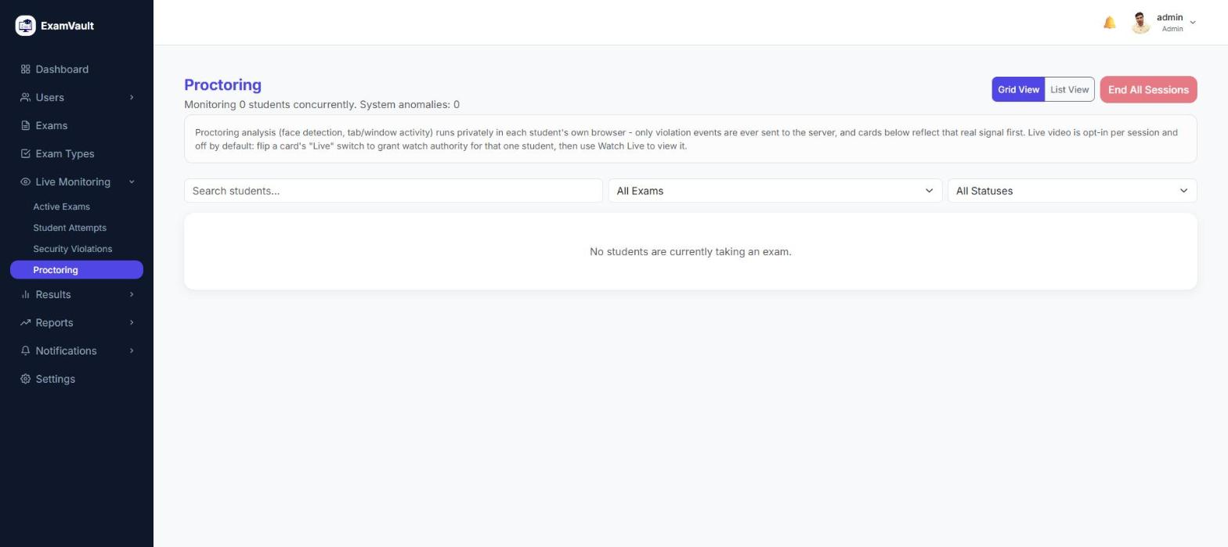

Result Analytics
Deep analytics on exam performance — average score, pass percentage, score distribution, a pass/fail trend over time, and the top-performing exams and categories.
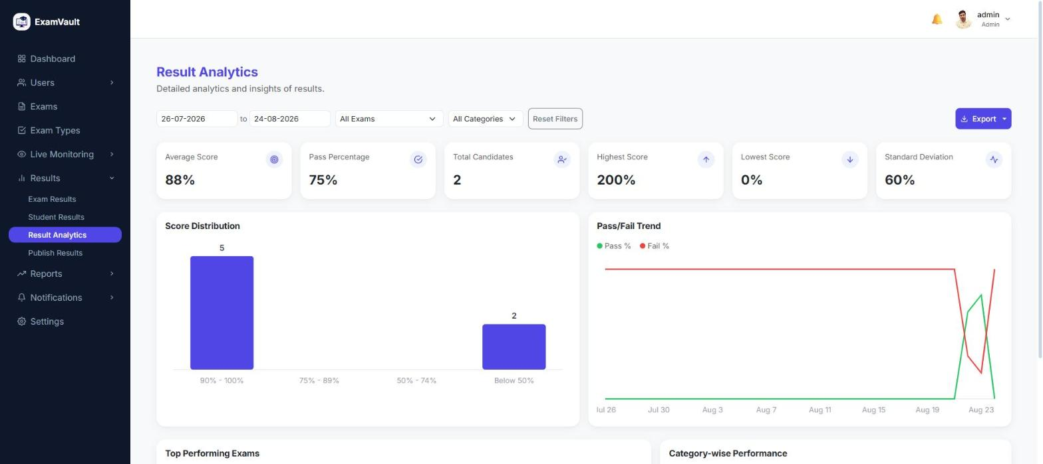

Publish Results
A review step between grading and students seeing their scores — admins choose exactly when a result set goes live.
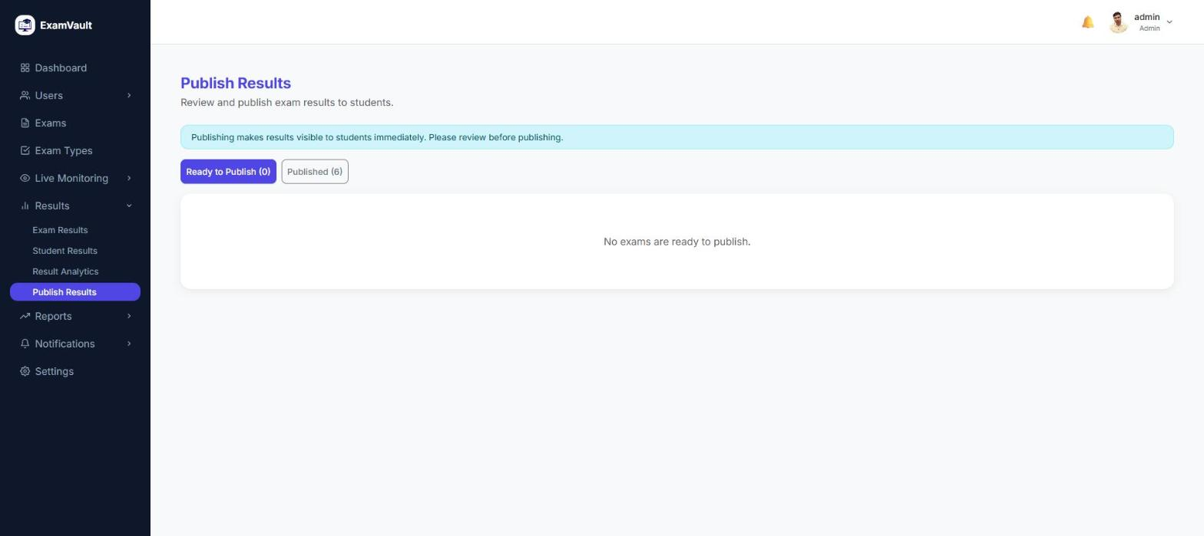

Exam Reports
Reporting on exam activity — total exams, attempts, average score, pass rate, and completion rate — with a breakdown of the top exams by attempts.
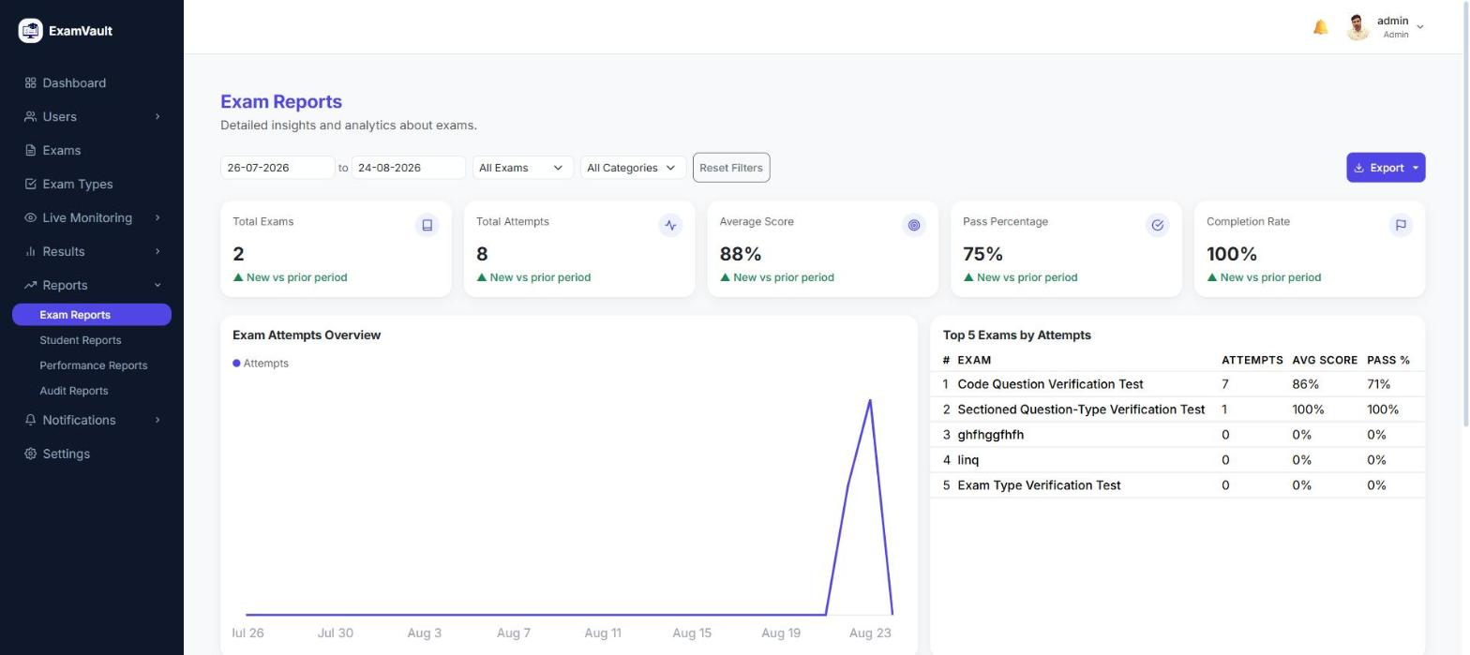

Audit Reports
A full audit trail of activity in the organization — logins, data changes, and exam actions — broken down by type and charted over time.
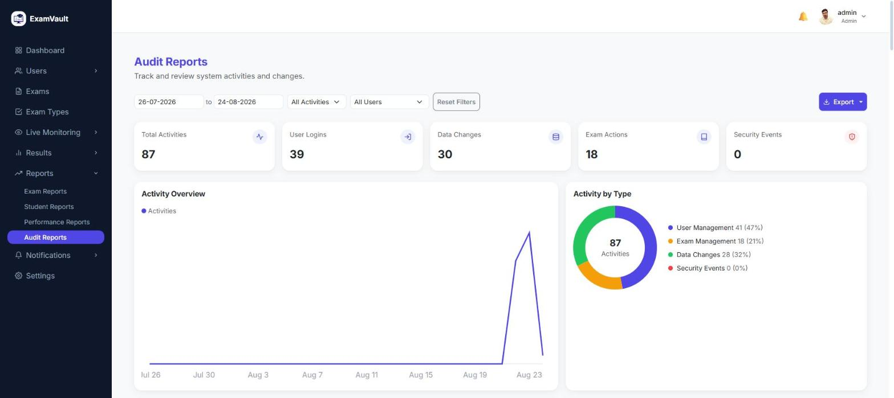

Notification Templates
Reusable, professional templates for common notifications — exam assigned, exam reminder, result published, and more — so communication stays consistent across the organization.
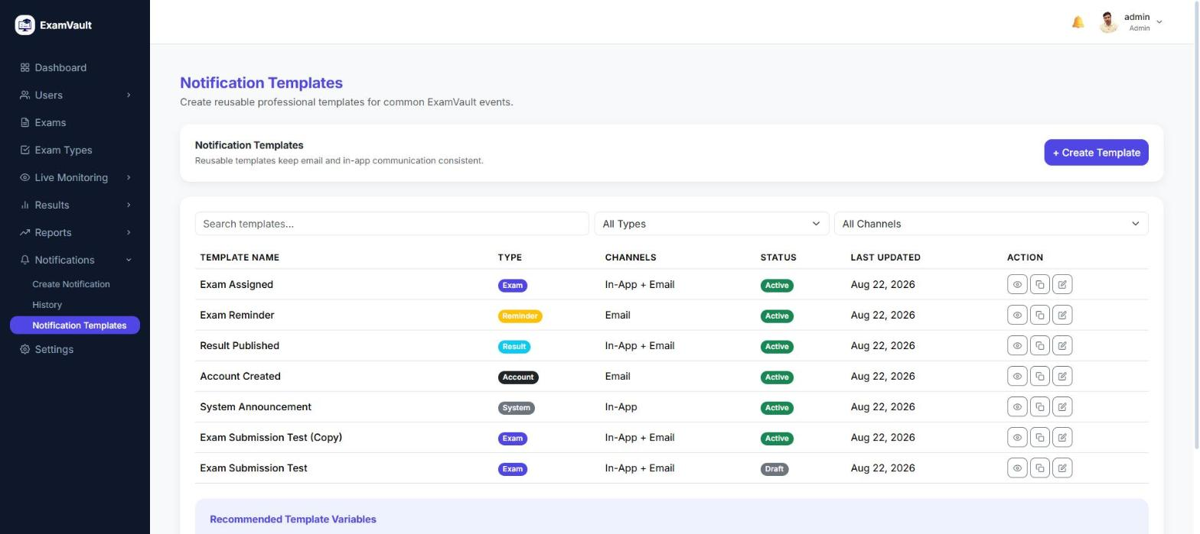

Assign Exam
A guided four-step flow to assign an exam to students or a batch: select the exam, choose the students, set the schedule and settings, then review before confirming.
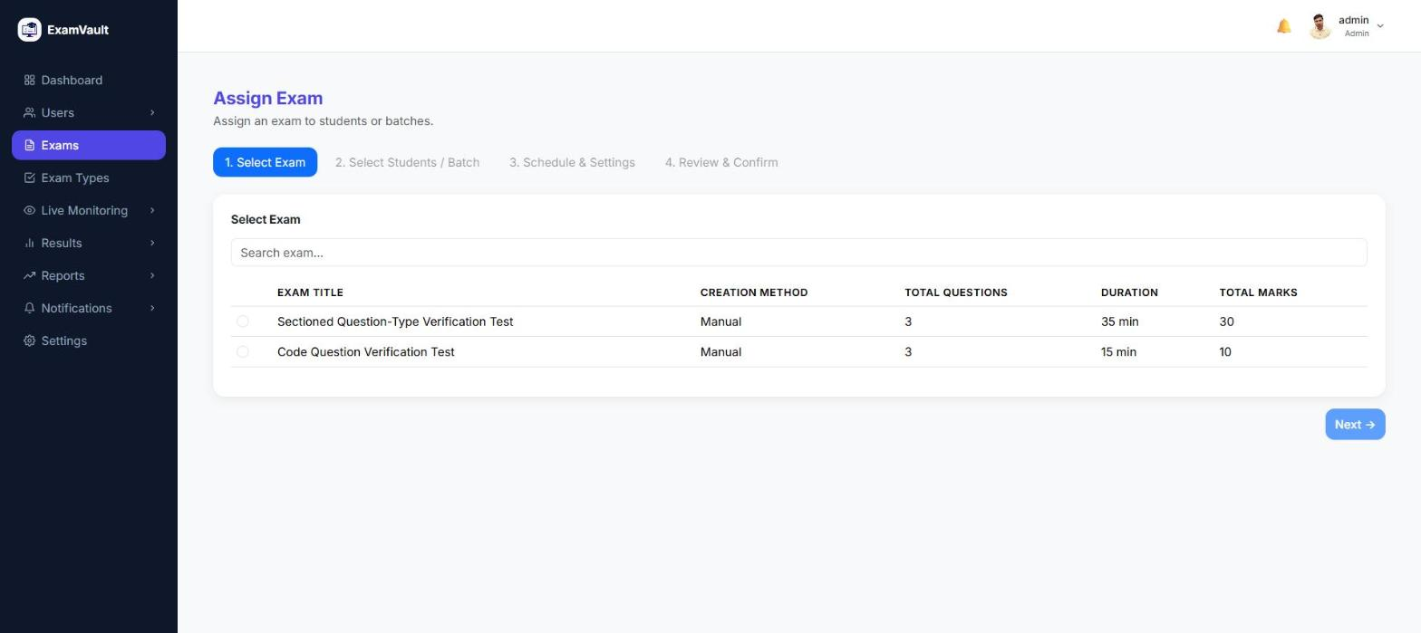

Exam Review & Publish
A single exam’s full detail page — its settings, assigned students, and quick actions to assign more students, manage questions, grade code answers, publish, or archive.
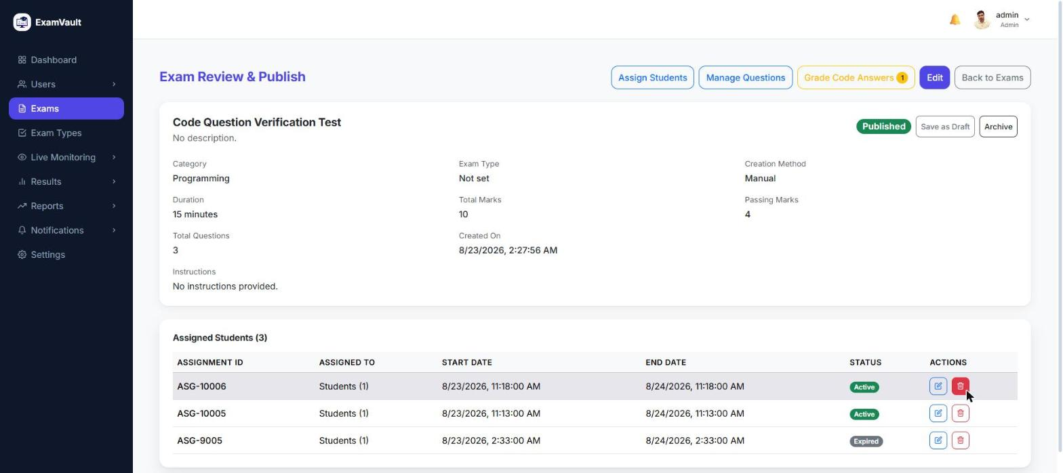

Grade Answers
A focused grading workspace for subjective and code-based answers that can’t be auto-scored, showing each student’s submission alongside a marks field.
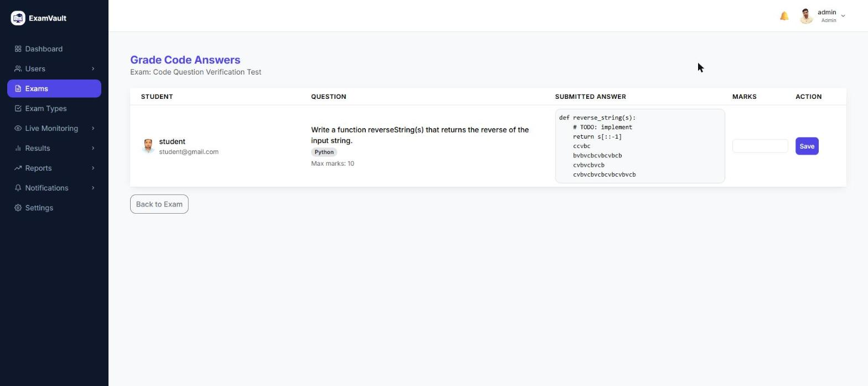

3. Super Admin
A platform-wide console for managing every organization on ExamVault.
The Super Admin sits above every individual organization, with visibility across the whole platform: every organization, every user, and the live health of the system itself. The screens below are the parts of that console that are fully live today.

Dashboard
The Super Admin’s platform-wide home page, showing total organizations and a list of recently created ones.
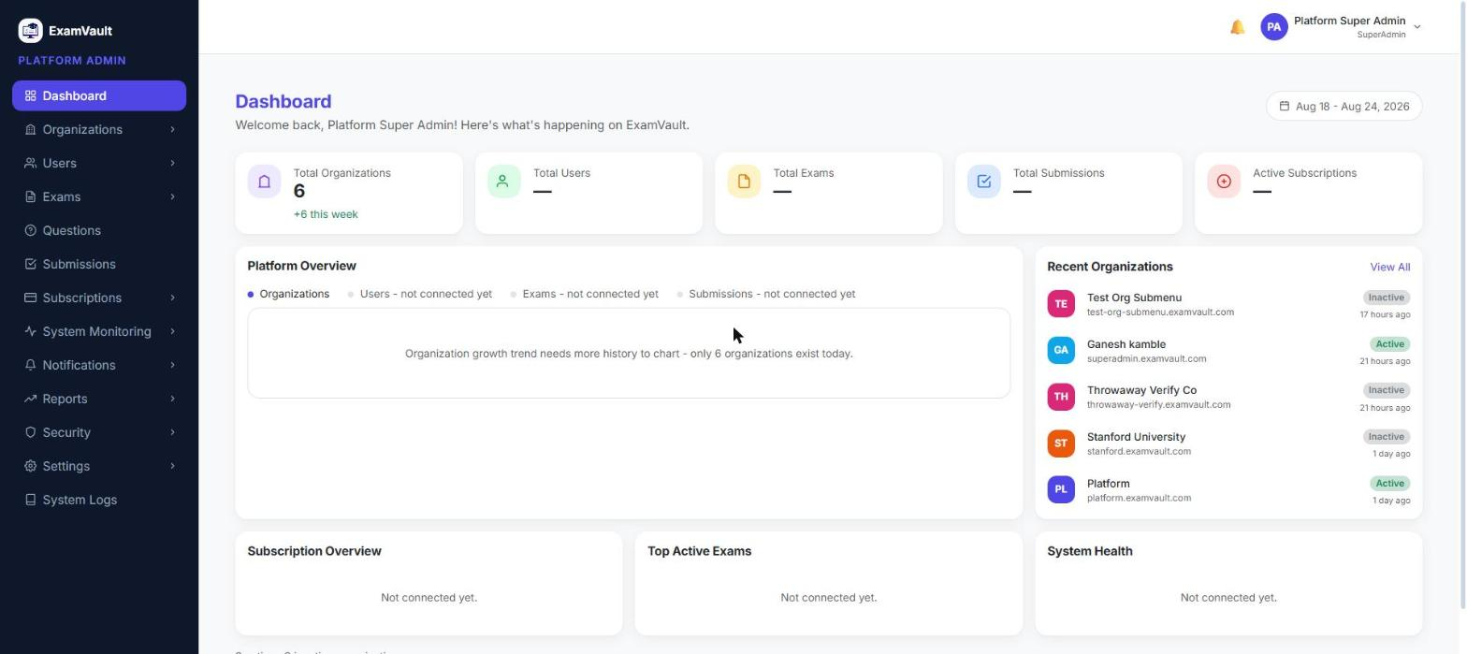

All Organizations
Every organization on the platform, with All / Active / Suspended tabs, search, and quick actions to view details, add an admin, or deactivate an organization.
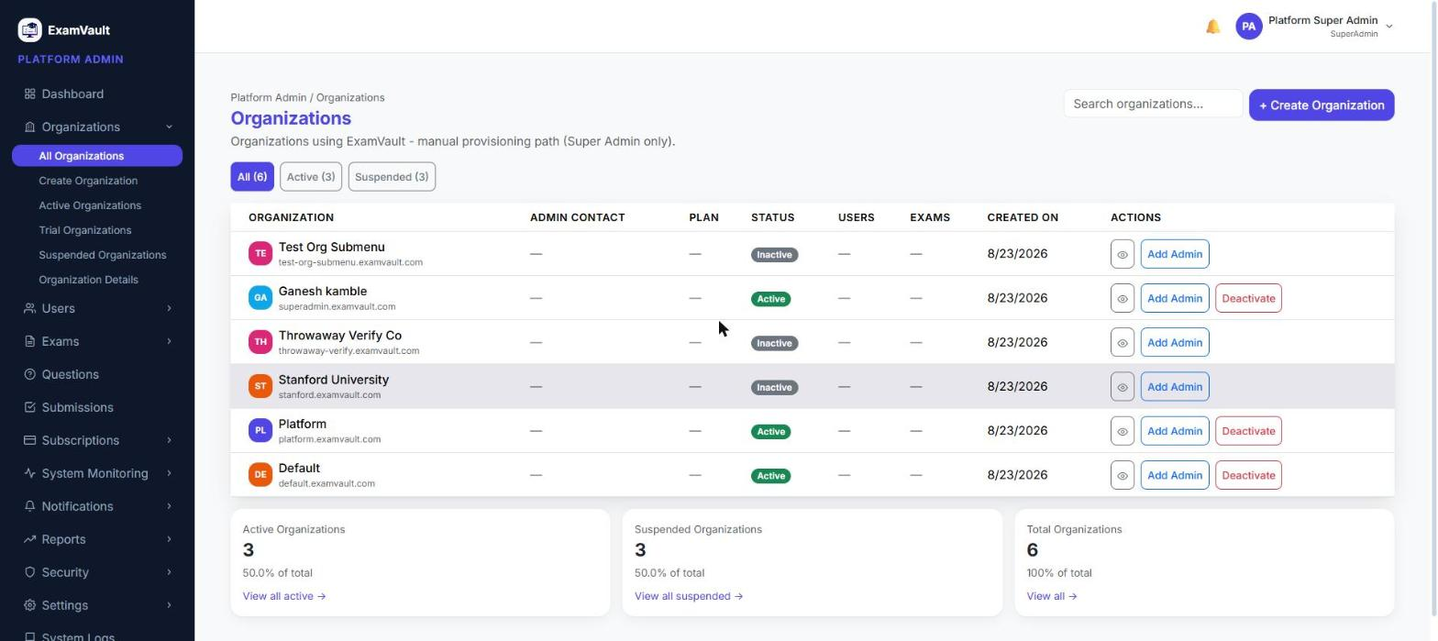

Organization Details
A single organization’s detail page, with its core information up top and tabs for usage, admins, users, exams, subscriptions, activity log, and settings.
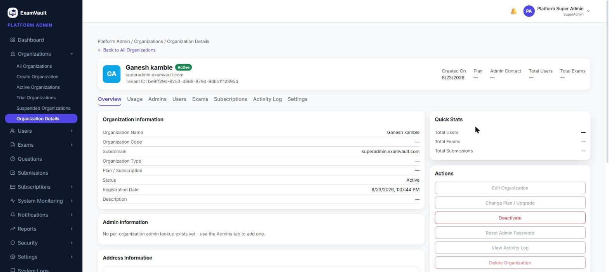

All Users
Every user across every organization on the platform, with role and status filters and a live breakdown by role — students, organization admins, and platform admins.
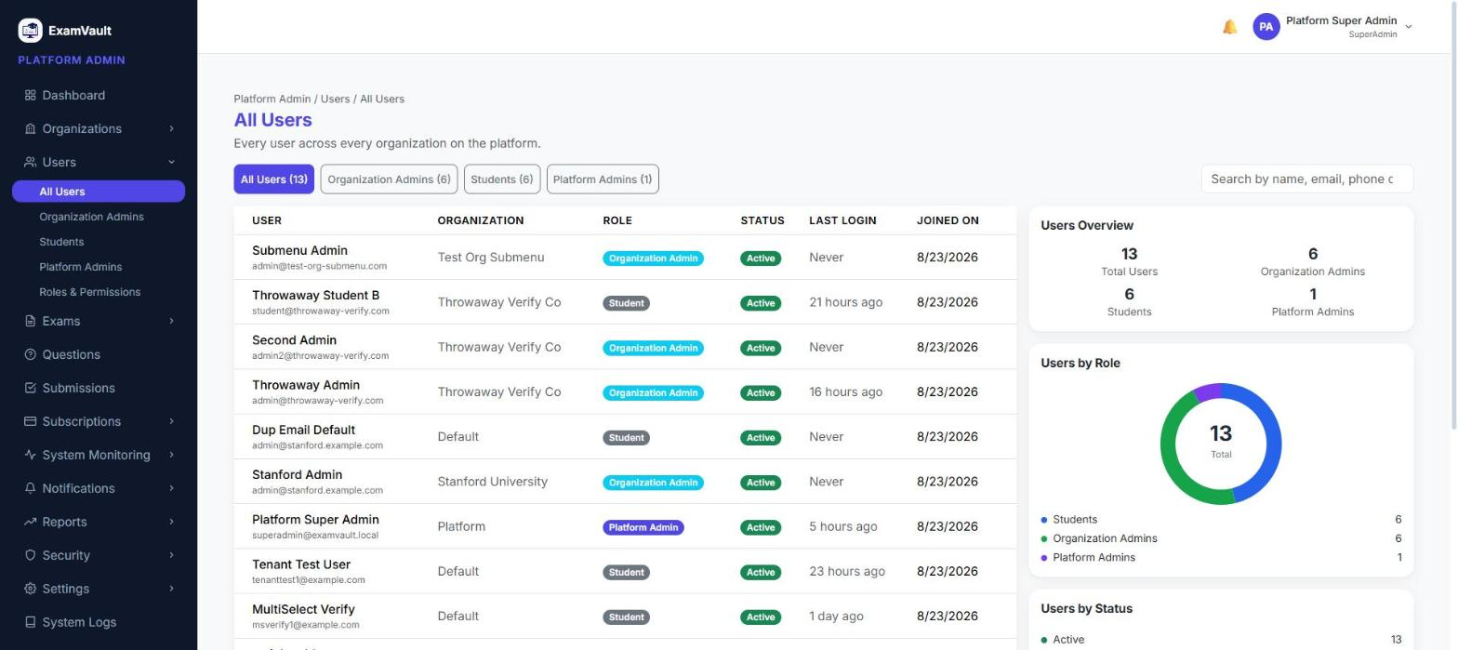

System Monitoring
A real-time, at-a-glance view of platform health — active organizations, active exams, and the ratio of backend services currently online — with live widgets for each area.
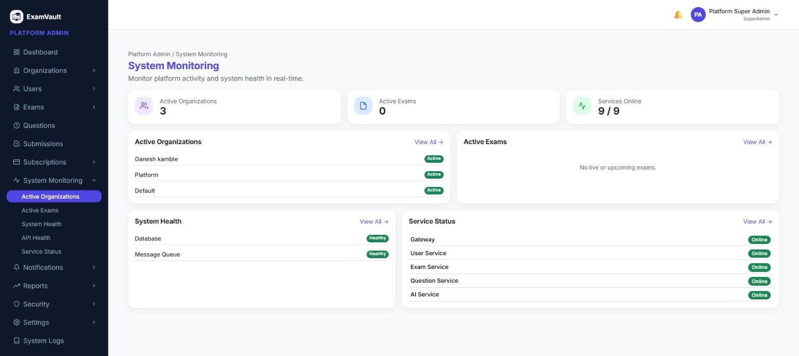

Service Status
Live health and response time for the API Gateway and every backend service, refreshing automatically every 15 seconds.
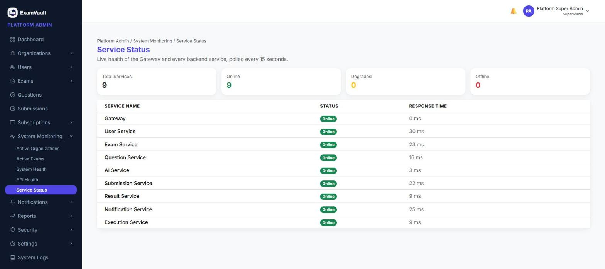

System Health
Real-time status of shared platform infrastructure — the database and message queue — polled continuously so issues surface immediately.
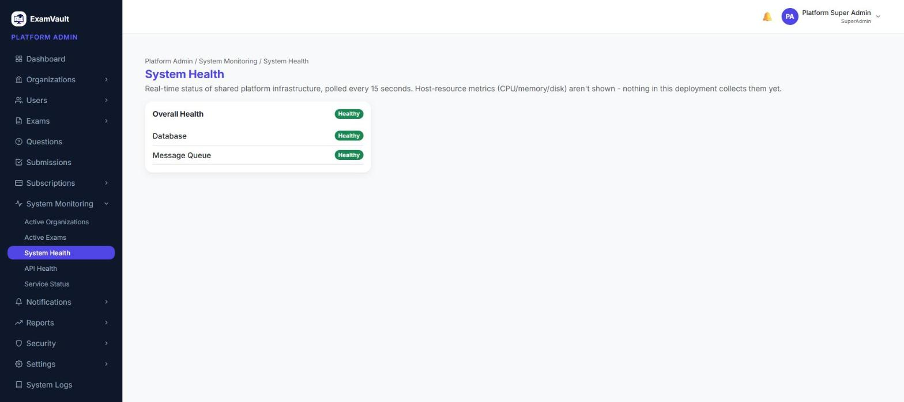

Organization Report
Platform-wide reporting on organizations — total, active, and inactive counts, a status breakdown, and the top organizations by user count.
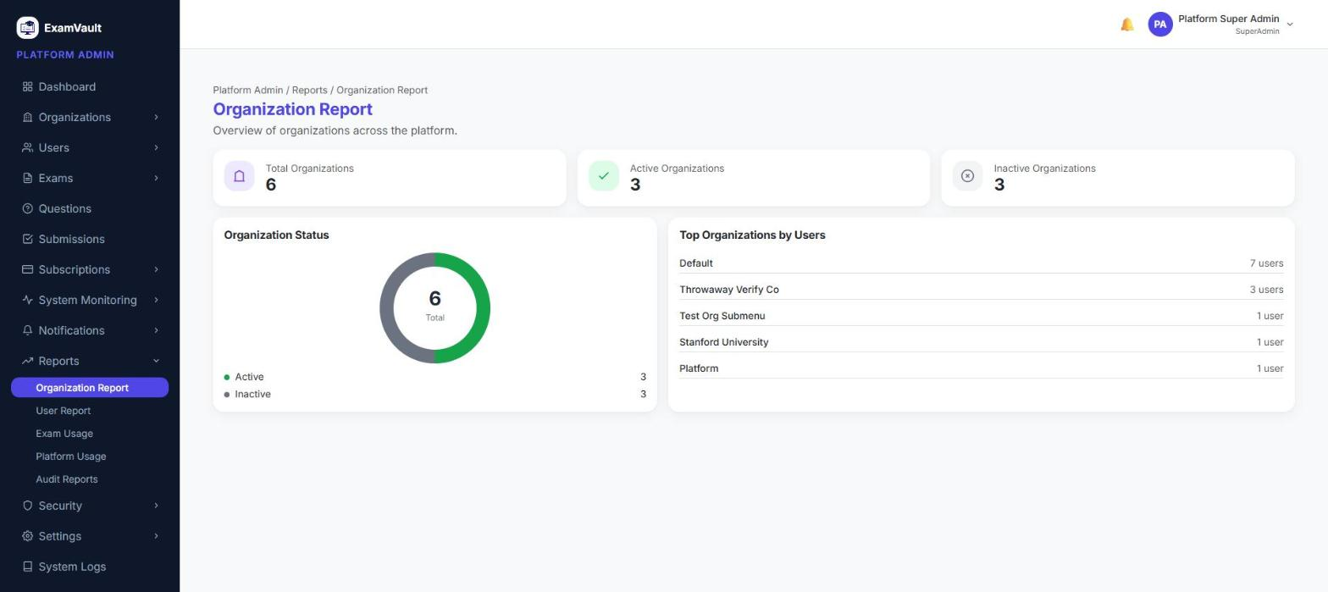

Notification History
A record of every notification sent across every organization on the platform, with delivery status and filtering by type, channel, and status.
