Activity Log

Ng Wei Shyang
15033996
BSc (Hons) in Computer Science
Sunway University

Initial Project Plans
The topic of this project is steganography. Steganography is a technique of concealing a message, can be file, image, video, etc in another file, message, image or video, etc.
The purpose of this project is to research of the current existing steganography method, and improve the algorithm. Improved steganography will result in higher difculty in retrieving the data for non-designated person. There are various existing steganography algorithm, while some are simpler, meanwhile some are more sophiscated. For more sophiscated steganography algorithm, some are harder to detect, meanwhile some are almost impossible to retrieve the data for one who are not designated to the secret message.
Initially, the projects had yet decide on what steganography particularly this project will focuses on. The decision on steganography focus will comes later after more literature review and deeper understanding.
Initialy timeline are included in the last page of this document.
These discussions goes within the first 2 meeting with supervisor, and is mutually agreed upon both parties.

Related work/ annotated bibliography
The main source of literature for literature review are from IEEE database. These are getting from the search result of Google Scholar. Another source of literature review is Springer database. The search term used here is “steganography”, “h.264”, and combination with other more specific keyword.
Analysis of selected work and literature are in planning document literature review. The finding and implication of literature review to the projects is H.264 codec process and element, and various steganography method.
Literature review are discussed with supervisor at third meeting, and his opinion on the literature review is the format used, and request to change from 2 column to 1 column format.

Project revision
Detail of proposed steganography algorithm pair are discussed in plannin document. The steganography algorithm are reviewed by supervisor. No test and validation are carried out to ensure the steganography algorithm is correct because it required implementation and testing on the algorithm, which are bound with time constraint. The review of proposed steganography algorithm pair are in the last meeting with supervisor.
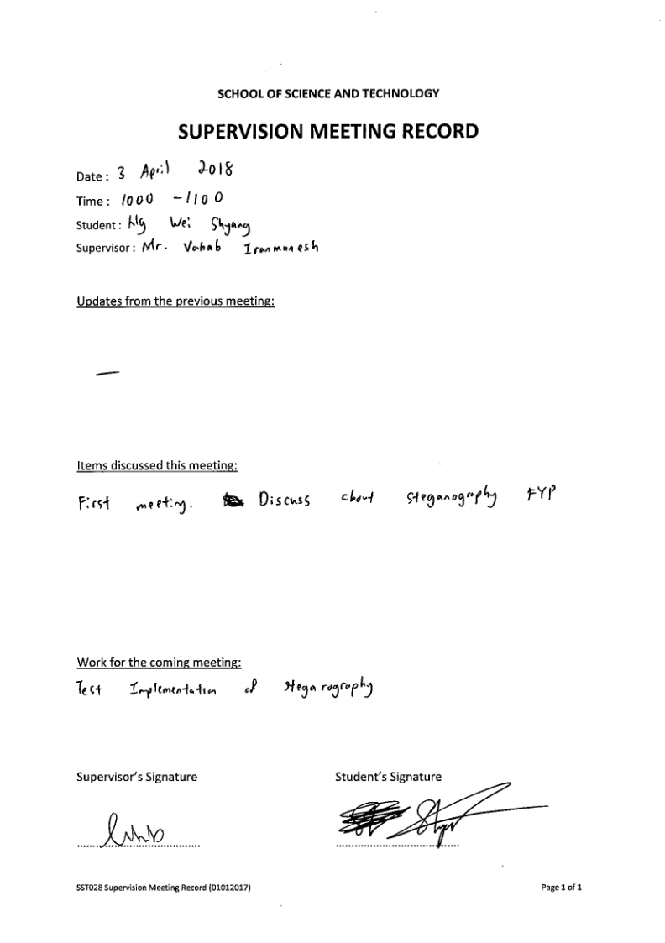
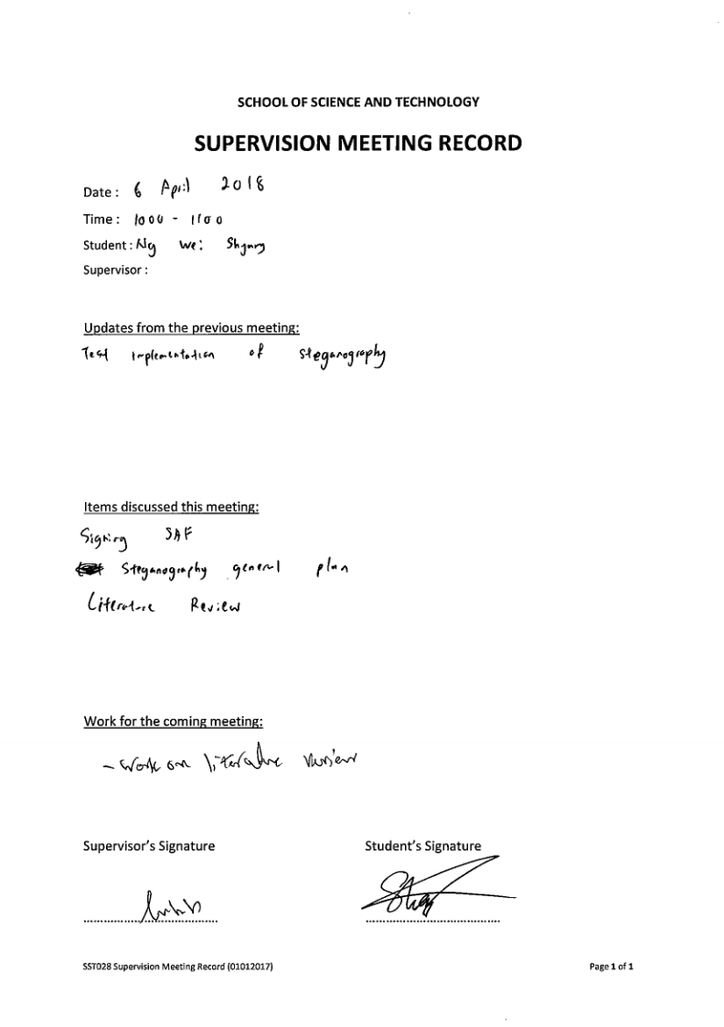
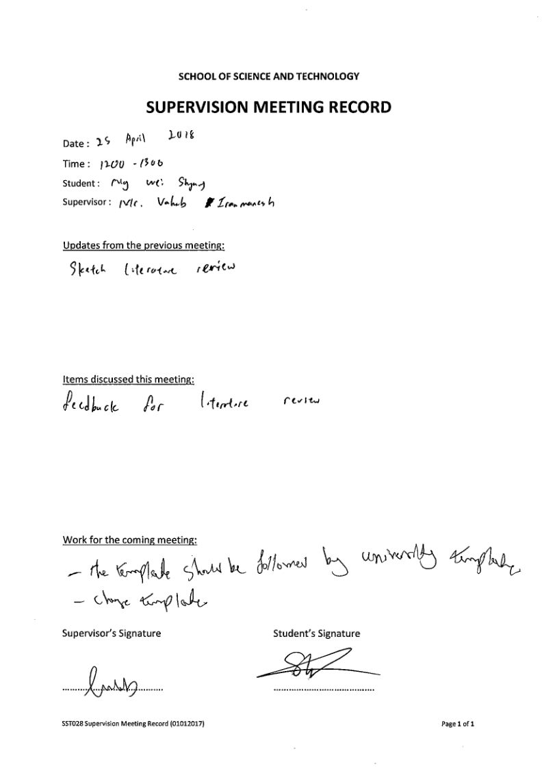
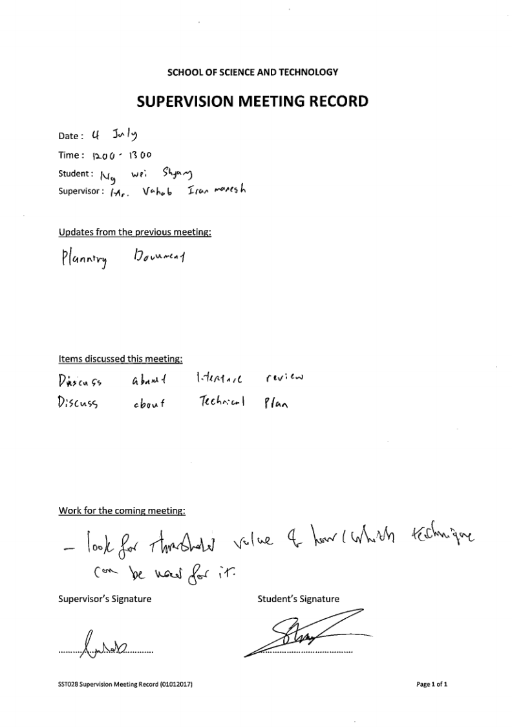

Initial Timeline
Activities / Tasks
Week
Capstone Project 1 (Diploma Final Year Project: 14 weeks)
Capstone Project 2
1
2
3
4
5
6
7
8
9
10
11
12
13
14
15
16
17
18
19
20
21
22
23
24
25
26
27
28

Plan template and SAF

Literature Review

Draft of methadology

Finalize of metadology

Draft of planning documents

Finalize planning documents

Implementation

Thesis Writing

Viva presentation

