Credit Risk and Peer to Peer Lending

Abstract— Our study reviewed three papers on Peer-to-Peer (P2P) lending and credit risk. It showed the effectiveness of Logistic Regression and Deep Neural Networks in predicting loan acceptance and default. It also covered several other machine learning models and proved the significance of financial factors in predicting borrower default.
Now, we aim to enhance risk assessment in P2P lending by combining the insights from these papers and training multiple machine learning models. We plan to integrate more financial variables into our model and explore the potential of ensemble learning techniques. We will also use multiple measurements to compare the final results.

Keywords: Peer-to-Peer lending, credit risk, machine learning, Logistic Regression, Deep Neural Networks, financial factors, risk assessment
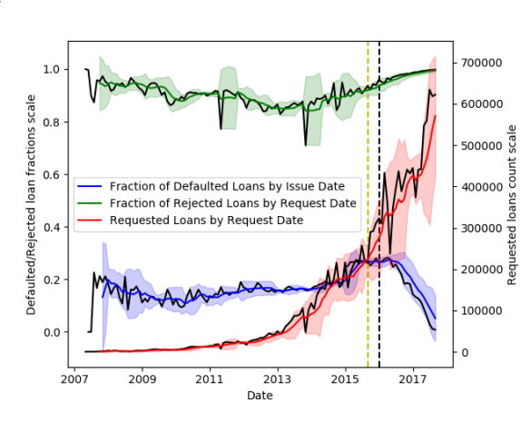
Figure 1: Time series plots of the dataset for 1st paper

- INTRODUCTION
Due to the setbacks of traditional lending methods such as hard to meet lending criteria, long approval processes and limited accessibility the market has been looking for an alternative for a
Model | Metric | Training Score | Recall Rejected
LR | AUC | 89% | 60.20%
LR | Recall macro | 77.90% | 59.90%
SVM | Recall macro | 52.60% | 68.40%
SVM | AUC | 97.30% | 43.30%
long time. Therefore, Peer-to-Peer (P2P) lending has emerged as a viable financial mechanism in the current money market. This paper focuses on exploring P2P lending and aims to enhance default prediction and risk assessment in this domain through the application of Artificial Intelligence (AI) and Machine Learning (ML) techniques. Our main objective is to delve deeper into the world of P2P lending, examining its potential to revolutionize the financial landscape and improve credit risk management. Using AI and ML techniques, we aim to develop robust models that can accurately predict loan default and assess risk in P2P lending platforms.
These advanced technologies offer the opportunity to leverage
Table 1: loan acceptance results and parameters for SVM and LR grid
vast amounts of data, enabling more precise risk evaluation and
informed decision-making.

- Literature Review
First paper we studied was “"P2P Loan Acceptance and Default Prediction with Artificial Intelligence". It mainly focused on assessing the effectiveness of machine learning algorithms in predicting loan acceptance and default risk in the context of peer-to-peer (P2P) lending. The objective of the paper was to understand the basics of P2P lending, the importance of accurate loan acceptance, and default prediction.
The study compared different machine learning algorithms for prediction tasks. It revealed that Logistic Regression performs best in predicting loan rejection, while Deep Neural Networks show the highest performance in predicting defaults. These findings suggest that different algorithms may be more suitable for specific prediction tasks within the P2P lending domain. This paper provided time series plots of the dataset, illustrating the number of defaulted loans, rejected loans and total requested loans over time. The plot (Figure 1) shows trends and fluctuations with standard deviations represented by shaded areas. There is also a table related to two major ML methods, Logistic Regression and Support Vector Machines, which compares these two methods in different sectors such as their training score and Recall rate. We will use paper 1 as the main body of our final project and use the other two papers as supporting papers for our main paper.

The second paper focused on predicting the failure of peer-to-peer (P2P) lending platforms specially in China using machine learning algorithms. That paper identified key variables that could predict platform failures and assess the robustness and importance of these variables in predicting survival.
It used six machine learning models: Logistic Regression, Support Vector Machine, Random Forest, Artificial Neural Network, Extreme Gradient Boosting and a Stacking-Based Ensemble Learning model. They were used to construct prediction models for platform failure.
It used useful preprocessing techniques including the filter method based on Spearman rank correlation and the wrapper method with forward selection and backward elimination. By analyzing the feature subsets identified across different models and selection methods, the study established the reliability and relevance of the selected variables in predicting platform failures.
The study evaluated the predictive performance of the models by gradually adding variables to the models and assessing their performance. The average performance of the six models was evaluated and variable importance was considered based on their correlations with the target variable. 2nd paper also explored a compact feature subset by selecting exactly five variables using the wrapper method.
The findings of this paper suggested that reducing the number of variables in the feature subset does not significantly affect the performance metrics, with an AUC value of approximately 0.96 and an F1 score of around 0.88. The selected variables consistently appear in the feature subsets across different models and selection methods indicating their reliability in predicting platform failures.
In the last paper we reviewed, the focus was on analyzing the factors that contribute to borrower default in peer-to-peer (P2P) lending and developing effective prediction models. The paper primarily used logistic regression (LR) due to its suitability for modeling binary outcomes, such as default and non-default outcomes and its ability to estimate probabilities.
This paper showed the significance of financial characteristics in predicting borrower default in P2P lending. Some of the financial factors considered include loan amount, loan term, interest rate, annual income, income source verification, FICO score and debt-to-income ratio. These variables are important indicators of a borrower's financial stability and credit worthiness as was proved in the paper statistically.
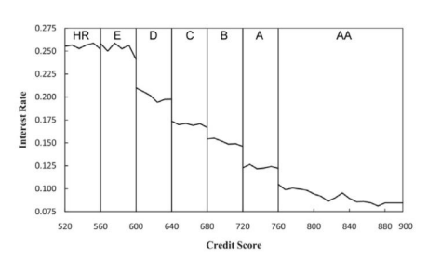
Figure 2: Interest rates between and within credit-rating categories

As you can see from Figure 2, the effect of the borrower's credit rating on their funding success has been analyzed. The creditworthiness of borrowers from other characteristics than credit rating is asked as well. We can see that 28 % of the interest spread between the highest credit rating category (A.A.) and the least trustworthy borrower (HR), is determined by other characteristics than the credit rating. Other attributes in this paper are debt-to-income ratio, the number of current delinquencies or the number of credit inquiries.
The study used a two-phase model for predicting default risk. The first phase focused on predicting loan rejection, while the second phase predicted default risk for approved loans. LR is found to be the best performer for the first phase, achieving a high test set recall macro score. For the second phase, linear and nonlinear deep neural networks (DNNs) were applied and found to have the best performance, with a high test set recall score for defaults. This was a proof for the potential of artificial intelligence in improving credit risk models and reducing default risk in issued loans.
The paper also explored the application of the model to loans taken specifically for small businesses. It is observed that the first phase of the model performs significantly better when trained on the whole dataset, while the second phase performs significantly better when trained on the small business subset. This suggests a potential discrepancy between how these loans are screened and how they should be analyzed in terms of default prediction.

- Methodology

In this section, we will talk about the general methodology which has been used in our project to analyze and predict default risk using our dataset obtained from Lending-Club.
Before starting the first phase of our ML algorithm implementations which is data preprocessing, it is a good idea to have a brief look at our dataset to see what we are working with. Figure3, is a histogram that shows the distribution of loan amounts for rejected and accepted loans:

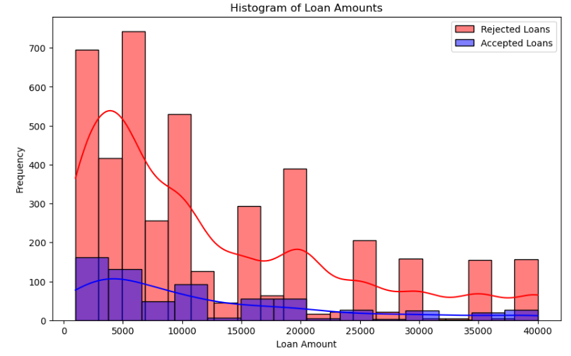
Figure 3: Frequency of loan amounts

Figure 3 shows that on any selected loan amount interval, number of rejected loans is way more than accepted ones in our dataset. Also we can see that most of the issued loans are less than $20000 and the ratio of rejected verses accepted loans initially decreases and after a short rise, decreases one more time and stays almost constant for the rest of the chart.
It will also be beneficial if we show the distribution of debt/income ratio, dti , for rejected and accepted loans in a boxplot to compare their distributions and check out the outliers for these two groups:

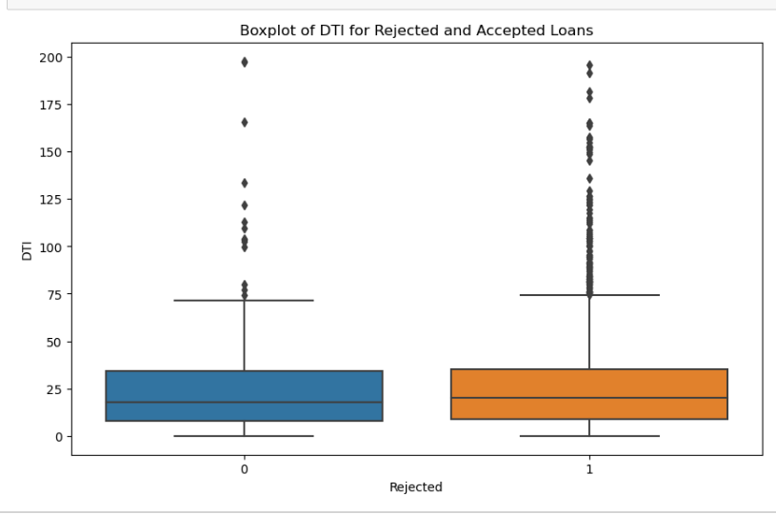
Figure 4: Boxplot of DTI

Figure 4 indicates that minimum, median and maximum as well as IQR range for two groups are almost the same but the number of outliers in the rejected group is way more than the outliers in its counterpart, the accepted group.
Now that we have an initial idea about our dataset and some of its basic features, we will start data preprocessing to get a clean data. This involves handling missing data and outliers. We will use techniques such as filtering out records with missing information and applying appropriate imputation methods.
For the preprocessing stage, we are performing the following steps to get a clear dataset to work with:

- Date Encoding: The “issue_d” column which is one of the independent variables of our dataset is converted to date-time format so we can use it properly later in our model if we needed it.
- Null Value Removal: We remove all null values and entries form our dataset.
- Eliminating Small Count Categories: We delete categories in the purpose column that have a count less than a certain threshold (For instance, less than 8). This will help us reduce the dimensionality of data and prevent overfitting on categories with very few samples.
- Label Replacement: We replace the existing labels in the purpose column with labels that can be easily called from pandas and TensorFlow. We did this to prevent errors due to typos or inconsistent capitalization.
- One-Hot Encoding: We created dummy variables for each category in the purpose column since ML algorithms can’t work with categorical data directly and by creating dummy variables, we converted the categorical variable into a format that can be provided to the machine learning algorithms to improve prediction results.
- Removing NaN values in Training and Testing Sets: We eliminated rows in training and testing sets that had NaN values.

The next step will be Feature Selection and Engineering.
To enhance the predictive capabilities of our models, we will choose relevant features from the dataset. In addition to the attributes explored in previous studies, we will try to use additional variables that we assume can possibly impact default risk. To select the features which will be variables in our model, we have to know the relationship between all of our variables. A correlation matrix map will help us to achieve this goal.

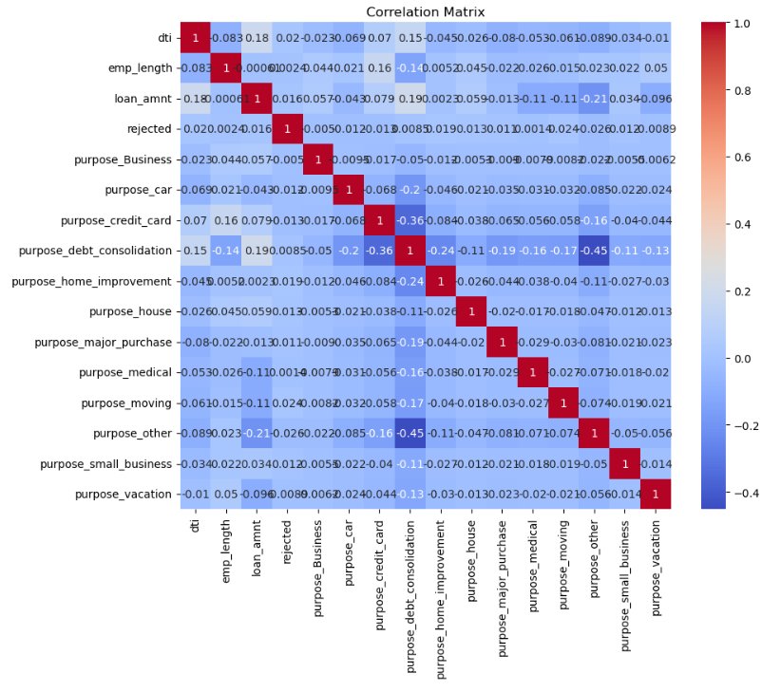
Figure 5: Correlation Matrix of variables

From the correlation matrix provided in Figure 9 we can see that there is a rather moderately strong negative correlation between “debt consolidation” and “other” factors. We can’t ignore the correlation between “credit card” and “debt consolidation” too. These correlations might cause multi collinearity and cause the predictor variable to provide redundant or overlapping information. Also these correlated variables can add noise and duplicate information into the model which will result in overfitting, where the model performs very well on the training data but fails to generalize well to new data. It will also disrupt our feature selection phase since it alters the feature importance. Thus, to reduce the effects of highly correlated variables in our dataset, we will be more careful in feature selection section and also apply dimensionality reduction to mitigate the effects of correlated variables in our dataset. Important features of our dataset by random forest model criteria are:

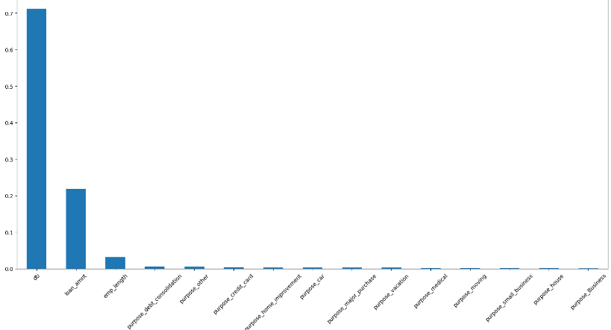
Figure 6: Feature Importance

Figure 6 shows us the important features of our dataset in an ascending order and we can see that the debt to income ratio, dti, is by far the most important feature of our data followed by loan amount and then employment length. These results also instinctively make sense and we would have suspected these variables to be the most effective variables on loan issues even without this mathematical proof.
.
Next step for us is data Transformation and normalization where we will identify possible non-linear relationships between variables within the dataset by applying appropriate transformations, such as logarithmic and square root transformations.
Finally, we will apply many models to our dataset and features and then select our model and will try to evaluate it.
We will explore various algorithms and techniques such as Logistic Regression, Linear Regression, XGBoost, Random Forest, Gradient Boosting, …
We will even build a stacking classifier by adding some of the best performing classifiers mentioned above to see if merging and stacking them will help us get a better, more comprehensive model or not.

We will evaluate performance using appropriate evaluation metrics, such as accuracy, precision, recall and F1-score and to see how well the model fits and can predict the data, we will use R squared criteria as our main tool of measuring how well a model describes the data.
We will compare these criteria for each single one of the mentioned machine e=learning models and select the one or ones that fit and predict our data the best. Also, in order to optimize the performance of our selected model, we will conduct a hyper parameter tuning process using grid search.

- Results

First model we will train is Stochastic Gradient Descent Classifier (SGD Classifier). We will use a pipeline in combination with a grid search for this classifier. Note that applying pipeline will help us with imputing the missing and NaN entries, scaling the data and implementing the stochastic gradient model while grid search will aid us in hyper parameter tuning. More specifically, we are tuning alpha, the learning rate, and penalty hyper parameters of SGD Classifier in our grid search. The results with best parameters α = 0.001 and penalty =12 are:

Stochastic Gradient Descent
ROC AUC score | Recall(Rejected) | Recall(Accepted)
0.51912 | 0.70265 | 0.31532
Note that the ROC AUC score is a measure of how well the model can distinguish between classes rejected and accepted while the recall tells you what proportion of the positive/negative classes were correctly identified. We can see that SGD model performs well on identifying rejected loans but lacks accuracy when it comes to identify the accepted ones. This is due to the fact that the number of rejected loans is way more than the accepted loans in our training dataset as we showed in the histogram of Figure 3 which makes bias for the classification between them for our SGD model. We will compare the other models with the numbers we got here for the SGD model since it is the original model of the parent paper.

Next, we will try to train a simple liner model. The values of measurement for this SLR are:
Simple Linear Regression
R² value | Recall(Rejected) | Recall(Accepted)
-0.01847 | 1 | 0
R² value of this model shows that it can definitely not describe the pattern in the data and predict the new entries.
The problem we had with recall rates in the previous SGD model worsens in linear model and this model classifies all of the data as rejected ones.

As our next model, we will investigate a 2nd degree polynomial model. Note that for this model, we need to transform our data points and features to have a square form and then we will train a linear regression on the transformed data points. The values of measurement for our polynomial model are:
2nd degree Polynomial
R² value | Recall(Rejected) | Recall(Accepted)
-0.024994 | 1 | 0
R² value has improved in compared to the simple linear model but still that it can’t describe the pattern in the data and predict the new entries.
Also even polynomial model classifies all of the data as rejected ones just like the simple linear regression model.

We expected these two models to perform bad since Linear regression and Polynomial models are often used for modelling continuous data but our response variable in this dataset is a binary type outcome (Rejected or Accepted).

A better model for predicting such binary outcome is Logistic Regression. Thus, we will try and see if we can confirm our initial assumption of Logistic Regression performing better than our initial two ML models.

Logistic Regression
R² value | Recall(Rejected) | Recall(Accepted)
-0.22718 | 1 | 0

R² value has been improved significantly in compared to SLR and 2nd degree Polynomial model but still is less than an acceptable value and our recall rate for accepted loans is still zero.

As our next model, we will implement the Extreme Gradient Boosting or XGBoost model. XGBoost is a scalable, distributed gradient-boosted decision tree (GBDT) machine learning library which provides parallel tree boosting and is the leading machine learning library for regression, classification and ranking problems.

XG Boost
ROC AUC | Recall(Rejected) | Recall(Accepted) | R²
0.50808 | 0.97876 | 0.03738 | -0.29599

XG Boost performed much better than the previous models and its ROC AUC value is very close to the SGD Classifier which was the original model of the parent paper.
In addition to that, its R² value is even higher than Logistic Regression and for the first time we have a model that the recall rate of the accepted loans is not zero in it which shows in XG Boost model there is actually a chance that a new entry gets assigned to accepted class.

Now, we will model a Random Forest ML algorithm on our data to see how it performs. Random Forest is a widely used Machine Learning algorithm which combines the output of multiple decision trees to reach a single result. Its ease of use and flexibility have fueled its adoption, as it handles both classification and regression problems and thus can be suitable for us in this particular case where we are dealing with a binary logistic like dependent response variable.

Random Forest
ROC AUC | Recall(Rejected) | Recall(Accepted) | R²
0.49343 | 0.92144 | 0.06542 | -0.571244

ROC AUC score of Random Forest is a little bit smaller than CG Boost model but instead, the R² value is significantly higher than XGBoost in Random Forest model and R squared has improved around 93% which shows the superiority of this model over XGBoost. Remember that XGBoost was our best model before Random Forest and superiority of RF model over XGBoost shows how far ahead Random Forest model is in compared to other ML models we trained before it.
Needless to say that Recall rates for accepted loans has been improved as well (more than 75% improvement in compared to XGBoost).
Therefore, Random Forest is the best model for undercovering the pattern in our dataset and describing and predicting issued loans.
Finally, since we reached to good results in Random Forest, XG Boost and Gradient Boosting, we want to test the idea of building a model by all of these three models and stacking them together as a single Logistic Regression model to see if it produces even better results. We call this last model a Stacking Classifier. Stacking is an ensemble learning technique that combines multiple classification and regression models via a meta-classifier. The base level models are trained based on a complete training set, then the meta-model is fitted based on the outputs.

Some pros of this stacking method are:

- It can increase predictive performance over any single model because it leverages the strengths of each base model.
- It can capture non-linear patterns by combining non-linear base models.
- It provides a way to use multiple models in a single prediction.

Base models for this Stacking Classifier will be:

- Random Forest Classifier (RFC)
- Gradient Boosting model (GB)
- Extreme Gradient Boosting model (XG Boost)

The final model, or meta-model, will be a Logistic Regression model. This model takes the outputs of the base models and makes a final prediction.

Random Forest
ROC AUC | Recall(Rejected) | Recall(Accepted) | R²
0.5 | 1 | 0 | -0.2272

We can see that the Stacking Classifier totally under performed in compared to its base models. This can happen due to several reasons. Some possible reasons behind this can be:

Overfitting: Stacking combines multiple models which can lead to increased complexity. If the meta-model (in this case, logistic regression) is too complex, it might overfit to the training data, leading to poor performance on unseen data.

Poor Meta-model Performance: The performance of a stacking model heavily depends on the choice of the meta-model. If the meta-model is not suitable for the task or the specific dataset, the stacking model might underperform.

Correlated Base Models: Stacking works best when the base models are diverse, meaning they make different types of errors. If the base models are very similar or correlated, they will likely make the same mistakes and stacking them won’t improve the performance.

Hyperparameter Tuning: The hyperparameters of the base models and the meta-model might need further tuning

- Conclusion

This report shows our methodology for modelling the issued loans prediction using AI and Machine Learning algorithms. Our objective is to enhance risk management practices on P2P lending platforms.
Through a review of existing literature, we have gained valuable insights into the prediction of default risk. Studies have shown the significance of borrower characteristics, credit history, loan attributes and the effectiveness of ensemble methods in improving predictive accuracy.
In the next step, we collected and preprocessed the dataset from LendingClub, ensuring data quality and suitability for analysis. By incorporating additional variables beyond those explored in previous studies, such as higher degrees of debt to income ratio, employment stability, loan purpose,... we expanded the scope of our analysis.
Feature selection and engineering techniques were employed to identify the most relevant variables and create new features based on domain knowledge. This step helped us capture underlying patterns and relationships within the data, and improving the performance of our models.
Evaluation of our models involved utilizing metrics such as Precision-Recall score, AUC PR score and ROC_AUC to assess their predictive capabilities. By comparing different models based on various criteria, we saw that the models that are often used for modelling continuous data such as Simple Linear Regression (SLR) or Polynomial Regression (2nd degree), can’t predict and classify our binary like output well while the models like Logistic Regression which are better suited for this kind of dataset out performed both of the mentioned ML models as expected with a much higher R squared value.
Although the Logistic Regression performed better than SLR and 2nd degree Polynomial it was still not acceptable for our purpose and thus we explored other possible suited ML models for modelling our data. Extreme Gradient Boosting (XGBoost) was able to model our data much better than Logistic Regression while our other model Random Forest showed the best results and was able to undercover the pattern underlying our data better than any other model, predicting and classifying new entries the best. Hence, we identified the best performing model that aligned with our specific objective of predicting rejected loans given specific information on its effecting variables.

REFERENCES
- Deloitte Reports. Beyond fintech: Disruptive innovation in lending. 2017.
- Kate Beioley. Fca sets out crackdown on peer-to-peer lending. Financial Times, 2018.
- Financial Conduct Authority. Cp18/20: Loan-based (’peer-to-peer’) and investment-based crowdfunding platforms: Feedback on our post-implementation review and proposed changes to the regulatory framework. 2018.
- Nilas Möllenkamp. Determinants of loan performance in p2p lending. B.S. thesis, University of Twente, 2017.
- R. E. Sorace, V. S. Reinhardt, and S. A. Vaughn, “High-speed digital- to-RF converter,” U.S. Patent 5 668 842, Sept. 16, 1997.
- M. Tumminello, T. Aste, T. Di Matteo, and R. N. Mantegna. A tool for filtering information in complex systems. Proceedings of the National Academy of Sciences of the United States of America, 102(30):10421–10426, 2005.

