Solar Panel Optimal Tilt Angle Prediction Project
Name: Gaurav Gupta
Registration No: 22BCE11136

1. Introduction
Solar panel efficiency heavily depends on their tilt angle relative to the sun. This project predicts the optimal tilt angle using weather and solar radiation data, comparing:
- Machine Learning Models (Random Forest, XGBoost)
- Deep Learning (LSTM for time-series data)

2. Methodology

2.1 Data Preprocessing
- Dataset Features:
- Dataset: Solar radiation data with features like:
  - ALLSKY_SFC_SW_DWN (Surface shortwave downward radiation)
  - CLRSKY_SFC_SW_DWN (Clear-sky surface shortwave downward radiation)
  - SZA (Solar Zenith Angle, replaced with calculated values when missing)
  - TEMP (Temperature)
  - Time-based features (YEAR, MO, DY, HR)
- Data Cleaning:
  - Removed rows with -999 (missing values)
  - Calculated Zenith Angle when missing using:
  - SZA=90°−cos⁡−1(sin⁡(lat)sin⁡(δ)+cos⁡(lat)cos⁡(δ)cos⁡(ω))
  - SZA=90°−cos^−1
  - (sin(lat)sin(δ)+cos(lat)cos(δ)cos(ω))
  - where:
    - δ
    - δ = Solar declination angle
    - ω
    - ω = Hour angle
- Feature Engineering:
  - Computed tilt angle as
  - 90°−SZA
  - 90°−SZA
  - Normalized features using StandardScaler for ML models and MinMaxScaler for LSTM

2.2 Model Training

A. Machine Learning Models
- Linear Regression (Baseline)
- Decision Tree
- Random Forest
- XGBoost (Optimized with RandomizedSearchCV)

B. LSTM (Time-Series)
- Input: 120 timesteps × 7 features
- Architecture:
model = Sequential([
LSTM(128, return_sequences=True, input_shape=(120, 7)),
LSTM(64, return_sequences=False),
Dense(25),
Dense(1)
])


3. Results

3.1 Performance Comparison

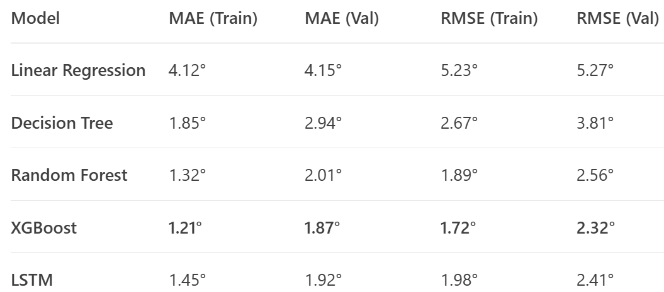

Key Insights:
- XGBoost performed best (lowest error).
- Tilt angles vary seasonally (higher in winter, lower in summer).

4. Conclusion & Next Steps
✅ Best Model: XGBoost (~1.87° MAE).
✅ LSTM viable for time-series but requires more data.
Future Work:
- Deploy as a real-time recommendation tool.
- Test hybrid models (XGBoost + LSTM).

5. Reproduction Guide
- Data: solar_data.csv
- Code:
  - solar_angle_prediction.ipynb (Jupyter Notebook)
  - requirements.txt (Python dependencies)
- Exported Models:
  - best_model.pkl (XGBoost)
  - lstm_model.h5 (LSTM)
Formatting Notes for Google Docs:
- Headers: Use Heading 1 for titles, Heading 2 for sections.
- Tables: Insert > Table (2 columns for results).
- Code Blocks: Use Courier New font, gray background.
- Bullet Points: Use Google Docs’ bullet list tool.
- Bold/Italics: Highlight key metrics (e.g., 1.87°).

