Documents Management System of ISAT U HR

A Capstone Project
Presented to the Faculty of
Iloilo Science and Technology University
Miagao, Iloilo, Philippines

In Partial Fulfillment
of the Requirements for the Degree
Bachelor of Science in Information Technology

by

John Carlo P. Gabadal
Michael A. Atilano Jr.
Gian Alexis E. Ecle

2026

Chapter 1
INTRODUCTION
Background of the Study
In today's digital age, technology plays an important role in improving how organizations manage and process information. Many institutions are adopting web-based systems to make their operations more efficient, organized, and accessible (Sakib et al., 2025). These systems help simplify daily tasks and make information easier to store and retrieve. One area that benefits from digitalization is Human Resource (HR) management, which involves handling various employee records, documents, and administrative requirements (Groenewald, 2004). Through the use of technology, HR departments can manage documents more efficiently and maintain organized records.
Despite the growing use of technology, some organizations continue to experience difficulties in managing human resource documents due to manual processes and records stored in different locations. These practices make it difficult to locate specific documents, maintain organized records, and monitor the status of submitted requirements, resulting in delays in HR tasks. According to Ochave et al. (2026), manual, paper-based HR processes can be time-consuming and prone to data inaccuracies. Groenewald (2004) also discussed the challenges involved in implementing and managing electronic document systems in a human resource setting. These issues highlight the need for a more organized system for managing HR documents, allowing authorized personnel to access records more easily and monitor document processing efficiently.

Lorejo (2026) developed a web-based electronic document management system for a human resource department in the Division of Tagbilaran City. The system was designed to address difficulties in managing HR documents by allowing users to upload, download, and access documents online instead of relying entirely on physical records or manual document handling. This makes it easier for authorized personnel to find and manage files without spending too much time searching through paper documents. The system also provides a more organized way of storing records and allows users to access documents from different locations, as long as they have an internet connection and the necessary permissions. According to the study, the system was considered convenient, useful, and easy to use, while its efficiency and accessibility were also evaluated positively. These findings show that web-based document management can help simplify document handling, improve access to important records, and support a more organized HR process. This approach is relevant to institutions that handle many employee documents and need a more reliable way to store, retrieve, and manage them (Lorejo, 2026).
Although Lorejo (2026) found that the web-based document management system was convenient, accessible, and useful for handling HR documents, the study mainly focused on the system's acceptability and performance. Further investigation is needed to determine how similar systems can support more detailed document processing, such as tracking approval stages, automatically forwarding documents between responsible personnel, generating reports, and keeping a history of document submissions and status changes. The system was also developed for a specific division, so its suitability for institutions with different HR requirements and approval procedures may need further evaluation. In addition, the study emphasized the importance of implementing clear usage policies, which points to the need for proper guidelines on system use and document security. These areas provide opportunities for further research into document management systems that support a wider range of HR processes and institutional needs (Lorejo, 2026).
The proposed Documents Management System of ISAT U (Iloilo Science and Technology University ) HR (Human Resource) is designed to support the specific document management needs of ISAT U Miagao. The system provides a centralized repository where faculty members can upload their required HR documents, while HR personnel and administrators can access and manage submissions according to their assigned roles. It includes document status tracking, allowing faculty to check whether their documents have been approved, rejected, or returned by HR, as well as the final decision made by the administrator. The system also records review remarks, maintains activity logs, and stores document information to help authorized users monitor previous actions and retrieve records when needed. In addition, the system provides separate dashboards for faculty, HR personnel, and administrators, making it easier for each user to perform their assigned tasks. These features aim to make document submission, review, and recordkeeping more organized and transparent (Lorejo, 2026).

Objectives of the Study
The general objective of this study is to develop a centralized and automated Documents Management System for the ISAT U HR (Human Resource) Management Office that improves the management, security, and accessibility of HR documents and employee records.
Specifically, the study aims to:
- enabling digital submission, filing, and approval tracking of HR documents;
- create a centralized digital repository for storing and organizing HR documents.
- provide employees with access to their personal records and HR requests;
- reduce paper-based processing by enabling digital processing;
e. evaluate the system using ISO 25010:2023;
Conceptual Framework
The conceptual framework of the study is illustrated in Figure 1 showing the input, process, and output.
Figure 1
The Conceptual Framework of the Study
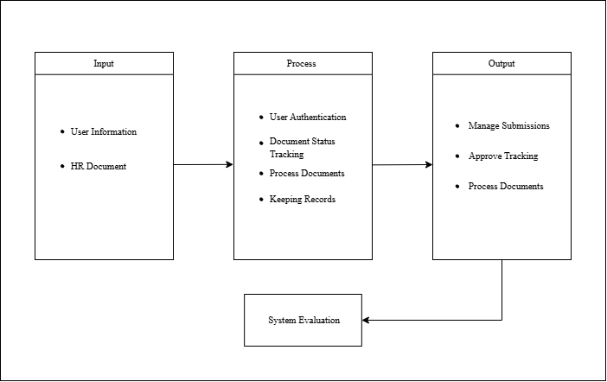
The Input section contains the information the system needs to start managing documents, namely user information and HR documents. User information is used to identify faculty members and other authorized users, while the HR documents are the files they submit to the system. Together, these serve as the starting point for all later stages. With complete and accurate input, the system can organize submissions properly and prepare them for processing, review, and storage.
The Process section describes how the system handles the submitted documents. It begins with user authentication, which ensures that only authorized individuals can access the system. Once logged in, users can submit their HR documents, and the system tracks the status of each one as it moves through review. The system then processes the documents, allowing HR personnel to check them against the necessary requirements and update their status. Finally, the system keeps records of all documents and their history in one central location so they remain organized and easy to retrieve.
The Output section presents the results after the system has processed the submitted documents. It allows users and HR personnel to manage submissions, making it easier to view, organize, and monitor the files that have been uploaded. Through approval tracking, the progress and outcome of each document can be followed, so users know whether their submissions have been approved or still need action. The output also includes the processed documents themselves, which have been reviewed by HR personnel and are ready for use or storage. Because all records are kept in one central location, faculty members and HR personnel can find and access documents quickly, which reduces delays and helps keep records orderly.
Definition of Terms
Activity Logs. In the study Design and Development of Electronic Document Archiving System, described an audit trail feature that monitors user logs within an electronic document archiving system. The system also allows users to upload files and control who can access them. In this study, it refers to the records of actions performed by users, such as uploading documents, reviewing submissions, and changing document statuses. These records help the administrator monitor document-related activities and check previous actions when needed. (Daluyon ,2024).
Approval Workflow. The system allows HR-related processes to be handled digitally instead of relying entirely on paper-based procedures. In this study, it refers to the process in which faculty members submit documents for review by HR personnel, followed by the administrator's final review. Each stage updates the document's status, allowing faculty members to monitor the progress of their submissions and helping ensure that documents are reviewed by the appropriate personnel (Mentri and Zainal 2025).
Centralized Storage. Allows authorized personnel to upload, download, and access documents through a shared online platform. Similarly, Sáez et al. (2025) proposed a platform that brings employee document management together in one system, covering different stages of employment. In this study, it refers to keeping faculty HR documents in one organized digital location. This allows authorized faculty members, HR personnel, and administrators to access and manage the documents according to their roles, making records easier to find and reducing dependence on scattered files and paper-based storage (Lorejo, 2026)
Document Management System. Developed a web-based document management system for a human resource department that allows authorized personnel to upload, download, and access documents online. The system provides a more organized way to store and retrieve HR documents, making them easier to manage and access when needed. In this study, it refers to a web-based platform where faculty members can submit their required HR documents, while HR personnel and administrators can review submissions, update document statuses, and manage records according to their assigned roles (Lorejo, 2026).
Document Submission. Developed a web-based document management system for an HR department that allows personnel to upload and download documents online. Similarly, Falo and Encarnacion (2024) proposed an online document management system to make document submission, approval, and storage easier for faculty and staff.In this study, it refers to the process in which faculty members upload their required HR documents through the system for review by HR personnel and the administrator. This process provides a more convenient way to send documents, monitor their status, and keep submitted records organized without relying entirely on physical copies. (Lorejo, 2026)
Document Tracking. Developed a system that allows users to track documents from submission until approval. It also provides features for viewing received documents, checking pending releases, and managing declined and archived documents. Similarly, Rodriguez (2024) developed eDALAYON, a document management and monitoring system that includes a document-tracking module to help personnel monitor document processing.In this study, it refers to the process of monitoring the status and progress of faculty-submitted HR documents as they pass through HR review and administrative approval. This allows faculty members and authorized personnel to check the current status of documents and identify submissions that still require action (Castro et al ,2022)
Historical Records. Developed a system for managing employee information, including leave credits, service records, and training programs. The system also supports the management and monitoring of archived employee documents. In addition, Groenewald (2004) discussed electronic document management features such as version control, which keeps track of changes made to documents over time.In this study, it refers to the previously submitted documents and recorded information about their processing, allowing authorized personnel to review earlier submissions and check previous document statuses when needed (Argana et al. ,2020).
HR Documents. Developed a system for managing employee records, including leave credits, service records, and training development information. Similarly, Lorejo (2026) studied a web-based document management system for an HR department that allows authorized personnel to upload, download, and access documents online.In this study, it refers to the files and records submitted by faculty members to meet the university's human resource requirements, such as SALN, leave-related documents, DTR, PDS, and other personnel records. These documents are stored and managed through the system so that authorized faculty members, HR personnel, and administrators can access and process them according to their assigned roles (Argana et al,2020).
Role-Based Access Control. Explored how access to documents can be managed according to users' roles and positions within an organization. The system assigns different permissions to users, allowing them to perform document-related tasks based on their responsibilities. In this study, it refers to assigning specific permissions to faculty members, HR personnel, and administrators. Faculty members can submit and monitor their own documents, HR personnel can review submissions and update document statuses, while administrators can manage user accounts and make final document decisions. This helps protect confidential HR records and ensures that each user can access only the functions permitted by their assigned role (Destini and Tony, 2024).

Status Updating. Developed a system that allows users to track documents from submission until approval. It includes features for viewing received documents, checking documents pending release, displaying declined documents, and archiving records. These features help users identify the current stage of document processing. In this study, it refers to changing a document's status as it moves through the review process. HR personnel can mark submissions as approved, rejected, or returned, while administrators can provide the final decision. The updated status allows faculty members to monitor their submissions and understand whether further action is needed (Castro et al, 2022).
User Authentication. Developed a web-based HR system with authentication to help protect employee information from unauthorized access. The system requires users to be authenticated before accessing its features and records. In this study, it refers to verifying a user's identity through valid login credentials before allowing access to the system. This helps protect confidential HR documents and ensures that only registered users can access the system according to their assigned roles (Khuhro et al., 2018).
Significance of the Study
The implementation of the Documents Management System of ISAT U HR is significant because it provides a centralized and organized approach to managing human resource documents. By allowing faculty members to submit documents online, HR staff to review submissions and update their status, and administrators to oversee document processing, the system aims to improve the accessibility and efficiency of HR document management (Sundayn et al. 2026).

Faculty Members. The system assists faculty members by making the submission and monitoring of HR-related documents easier and more convenient. Through online document uploading and status tracking, faculty members can submit required documents and check whether their submissions have been approved, rejected, or returned for correction, it also helps them keep documents such as SALN, Daily Time Record (DTR), Personal Data Sheet (PDS), leave-related documents, and other personnel records organized, allowing them to spend less time handling paperwork and more time focusing on their teaching and other responsibilities.
HR Staff. The system assists HR staff in managing faculty documents more efficiently by allowing them to view submitted files, check document details, update submission statuses, and provide remarks when corrections are needed. Through a centralized system, HR staff can keep document submissions organized and monitor which documents have been approved, rejected, or returned for correction. This helps reduce the time spent manually sorting and searching for documents, allowing HR staff to focus more on reviewing submissions and handling other personnel-related tasks
System Administrator. The system assists the system administrator in monitoring faculty document submissions, overseeing document statuses, and managing user accounts. Through the system, the administrator can view submitted documents, check their status, manage user access, and review activity logs to monitor recorded actions. These features help the administrator maintain an organized system and oversee document processing more conveniently.

Future Researchers. The study may serve as a reference for future researchers who plan to develop or improve web-based document management and human resource information systems. It provides ideas on how digital document submission, document tracking, and personnel record management can be applied to improve HR processes. Future researchers may use the study as a basis for identifying system limitations, exploring additional features, and developing solutions that better address the document management needs of educational institutions
Scope and Limitations of the Study
The study focuses on the development of the Documents Management System of ISAT U HR, a web-based system designed to improve the submission, review, tracking, and management of human resource documents at Iloilo Science and Technology (ISAT U) – Miagao Campus. The system allows faculty members, including teaching and non-teaching personnel, to submit HR-related documents online and monitor the status of their submissions. These documents may include the Statement of Assets, Liabilities, and Net Worth (SALN), Personal Data Sheet (PDS), Individual Performance Commitment and Review (IPCR), leave-related documents, clearances, and other personnel records required by the Human Resource Office. HR staff can access submitted documents, review their contents, update their status to approved, rejected, or returned for correction, and provide remarks when necessary. The system administrator can oversee document submissions, monitor document statuses, manage user accounts, and review activity logs. The system also uses user authentication and email-based One-Time Password (OTP) verification to provide an additional layer of security during login. Through these features, the system aims to provide a centralized repository for HR documents and make document processing more organized and accessible.
The study is limited to the management of HR-related document submissions and their review within ISAT U – Miagao Campus. It does not automatically determine whether a submitted document meets all institutional requirements, as the review and approval decisions remain under the responsibility of authorized HR personnel and the system administrator. The system’s effectiveness depends on the accuracy and completeness of the information and files submitted by faculty members, as well as the proper use of the system by its users. It does not replace the official policies, procedures, and judgment of the Human Resource Office, nor does it guarantee that submitted documents are correct or free from errors. Furthermore, the system is limited to the document types, user roles, and workflow included in its development and does not necessarily cover every HR process, such as payroll processing, device integration, or automated computation of employee benefits. Its email OTP verification also depends on the availability of the email service and the user's access to the registered email account. Lastly, the system is specifically designed for the HR document management needs of ISAT U – Miagao Campus; additional adjustments to its features, document requirements, and approval procedures may be necessary before it can be implemented in other campuses or institutions.
Chapter 2
REVIEW OF RELATED LITERATURE AND RELATED STUDIES
This chapter provides a comprehensive review of existing literature and studies that form the foundational context for the development of a Document Management System (DMS) for the Human Resource department. It presents a detailed examination of relevant thematic concepts, including the evolution of digital human resource practices, the technical frameworks of information systems, and the critical success factors for organizational transformation. Furthermore, this chapter identifies prior research and established systems to underscore the technological gaps that the proposed Document Management System of ISAT-U (Iloilo Science and Technology University ) HR (Human Resource) aims to address.

Review of Related Studies
Approval Tracking. This refers to the process of monitoring the status of submitted documents as they go through the review and approval process. It allows users to determine whether a document is awaiting review, has been approved, has been. In the study “Web-Based Human Resource Management System Using Laravel Framework,”explored the development of a web-based application for managing maintenance employees using the Laravel framework. Their study provides related context on how web-based applications can support employee management, although the available description does not explicitly confirm approval-status tracking (Bambang et al. , 2025).
Similarly, Sundayn et al. (2026), in their study “Computerization of University Personnel Administration: Design and Implementation of a Web-Based Management System,” developed a web-based system for managing university personnel activities, including leave applications, recruitment, appointment-letter processing, and staff records. Their study demonstrates how web-based technology can help organize personnel-related processes.
Automated Reporting. This refers to the process of generating reports from information stored in a system without manually compiling all the data. It helps organize records and present relevant information in a structured format for easier monitoring and decision-making. In the study “Development and Implementation of a Web-Based Human Resource Management System of the Great Plebeian College,” examined the development of a web-based system for managing human resource activities. This study is related to the use of web-based technology in organizing HR information and supporting administrative tasks (Ochave et al. ,2026)
Automated Workflow. This refers to the use of a system to move documents through predefined steps, such as submission, review, and approval, reducing the need for manual handling and follow-ups. In the study “Development and Pilot Evaluation of DICT-EAAS: A Web-Based Employee Attendance and Accomplishment System for Document Workflow Automation,” developed a web-based system that organizes employee document processing, including DTR uploads, document preparation, reviewer routing, approval or return for revision, notifications, and administrator monitoring. The study demonstrates how workflow automation can organize document processing and help employees and reviewers manage submissions more efficiently. (Raquepo et al. ,2026).

Centralized Repository. This refers to a single location where documents are stored, organized, and accessed by authorized users. It helps reduce scattered records and makes it easier to find and manage documents when needed. In the study “DocTrack: A Dynamic Document Tracking System for the University of Northern Philippines,” developed a web-based system that serves as a central repository for documents from creation until approval. It supports document uploading, tracking, retrieval, and archiving, while also providing security measures to protect stored documents from unauthorized access (Castro et al. ,2022)
Document Capture / Upload. This refers to the process of submitting digital documents to a system for storage and processing. It allows users to upload files electronically instead of relying entirely on printed documents and manual submission.In “A Web-Based Electronic Document Management System for Human Resource Department,” the developed system was evaluated in terms of document uploading and downloading, convenience, and usefulness. The findings indicated that users found these functions acceptable, supporting the use of digital document submission in HR departments (Lorejo's , 2026).
Historical Records. This refers to previously stored documents that are preserved for future reference. These records allow authorized users to retrieve past information when needed and help prevent documents from being misplaced or difficult to find. In the study “Electronic Document Archiving System,” developed an electronic document archiving system for the EIA office at Central Philippine University. The system was designed to store documents electronically, support document retrieval through a web browser, and provide backup and restoration to help preserve stored records (Balbontin et al. , 2026)
HR Specific Functionality. This refers to the features of a system designed to support human resource tasks, such as managing employee information, organizing personnel records, and handling HR-related documents and processes. In the study “A Web-Based Electronic Document Management System for Human Resource Department,” developed a web-based system for managing HR documents. The study focused on making document uploading, downloading, and access more convenient for users, demonstrating how an electronic document management system can support document-related activities in a human resource department (Lorejo, 2026).
Similarly, Sundayn et al. (2026), in their study “Computerization of University Personnel Administration: Design and Implementation of a Web-Based Management System,” developed a web-based system for university personnel administration. The system covers personnel-related activities such as staff records, leave applications, recruitment, and appointment-letter processing, demonstrating how web-based technology can support different administrative HR functions.
Multi-Factor Authentication. This refers to a security method that requires users to verify their identity using more than one authentication factor before accessing a system. For example, users may enter their password and then provide a one-time password (OTP) sent to their registered email address. In the study “Secured Forensics Reporting Web Based on Two Factor Authentication,” developed a web-based reporting application that uses an OTP sent through email and reCAPTCHA during login to provide an additional layer of security. The study demonstrates how two-factor authentication can help protect user accounts and strengthen the security of web-based applications (Sivakumaran and Abdullah , 2022).

Synthesis
The proposed Documents Management System of ISAT U HR aims to improve the way the Human Resource Office manages, processes, and monitors faculty documents at ISAT U – Miagao Campus. The system provides a centralized platform where faculty members can submit their HR-related documents online and monitor the progress of their submissions. It also allows HR staff to review documents, provide remarks, update submission statuses, and manage records more efficiently. Additionally, the system provides separate access for faculty members, HR staff, and administrators to ensure that each user can perform tasks according to their assigned responsibilities. Features such as document status tracking, activity logs, and email-based One-Time Password (OTP) verification are also included to improve document monitoring, recordkeeping, and system security.
The development of the proposed system is supported by (Lorejo, 2026)in the study entitled A Web-Based Electronic Document Management System for Human Resource Department. The study demonstrated how a web-based platform can make HR document uploading, downloading, and accessing more convenient and organized. This supports the proposed system's approach to managing HR documents digitally rather than relying mainly on manual processes. However, the proposed Documents Management System of ISAT U HR further focuses on the document review and approval process by providing document status monitoring, review remarks, role-based access, activity logs, and email OTP verification. These features allow faculty members to monitor their submissions while helping HR staff and administrators manage document-related activities in a more systematic way.
Through these functions, the proposed Documents Management System of ISAT U HR aims to provide a more organized, accessible, and secure approach to handling HR documents. It builds on the concept of Lorejo's study while addressing the specific document submission, review, tracking, and recordkeeping needs of ISAT U – Miagao Campus.

Chapter 3
METHODOLOGY
This chapter presents the methodology and design of the proposed Documents Management System of ISAT U (Iloilo Science and Technology Univsity )HR (Human Resource). It describes the project, the Scrum Agile development approach, the system requirements, the users and their functions, and the diagrams that illustrate the document workflow and system structure.
Project Description
Documents Management System of ISAT U HR is a web-based system designed to manage the submission, storage, and processing of human resource documents at ISAT U Miagao. It aims to address difficulties in organizing HR documents, monitoring submission status, and maintaining accessible records for authorized personnel.
The system allows faculty members to upload their required HR documents and monitor their submission status. HR Staff can review submitted documents, update their status, and forward them for administrative review. Meanwhile, the System Administrator can manage user accounts, monitor system activities, and perform administrative functions related to document processing.
Through its document submission, centralized storage, status tracking, and approval workflow features, the system is expected to improve the organization and monitoring of HR documents. It also aims to provide a more systematic process for handling faculty records while allowing authorized users to access and manage documents according to their assigned roles.

Project Development
The Documents Management System of ISAT U HR will be developed using the Scrum Agile methodology. This approach allows the development team to build the system incrementally, test its functionality, and improve its features based on feedback and identified requirements. The development process will focus on providing an organized and accessible platform for managing the submission, review, tracking, and storage of human resource documents.
The development process will begin with requirements analysis, in which the needs of Faculty, HR Staff, and the System Administrator will be identified. The team will then design the system's user interfaces, database structure, and workflow based on the identified requirements.
During implementation, the team will develop the system's main features, including user authentication, document submission, centralized storage, status tracking, document review, administrative approval, and activity logging. These features will be developed incrementally and reviewed throughout the development process.
System testing will be conducted to verify that the features function correctly and that each user can access only the functions permitted by their assigned role. Errors and inconsistencies identified during testing will be corrected, and the system will be improved based on evaluation results and user feedback.
Finally, the system will be prepared for deployment in its intended environment. Maintenance activities will include correcting errors, improving existing functions, and ensuring that the system continues to support the document management needs of ISAT U Miagao HR.
The proposed development process follows common Scrum activities: defining and prioritizing the product backlog, selecting work for a sprint, designing and developing the selected features, testing the increment, reviewing the result, and using feedback to plan the next sprint. The team can develop the project in increments, beginning with authentication and role-based access, followed by document submission, HR review and status tracking, and administrative account and activity-log functions.
Figure 2. Scrum Agile Methodology

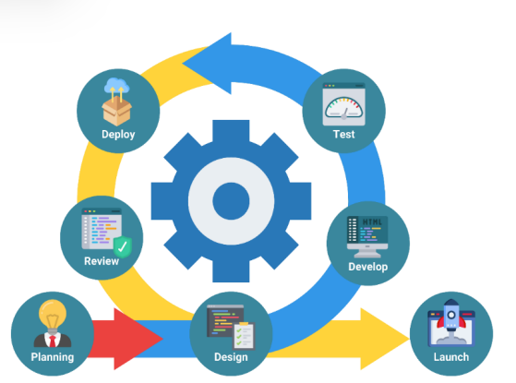
Note; Adapted from the study of (Rodriges III, 2024)
The study employed Scrum Agile as its software development methodology because of its flexibility and its emphasis on continuous feedback and improvement. Unlike a strictly linear model, Agile allows the researchers to revisit and refine earlier decisions as new insights emerge from testing and stakeholder review, reducing the risk of building features that do not match the actual needs of the ISAT U HR.

Activity Diagram
The activity diagram illustrates the document lifecycle from login and submission through HR review and status notification. If the document is incomplete or needs correction, HR Staff returns it with remarks, and the faculty member can revise and resubmit it. Otherwise, HR Staff records the decision, and the system updates the status so the faculty member can view the result.
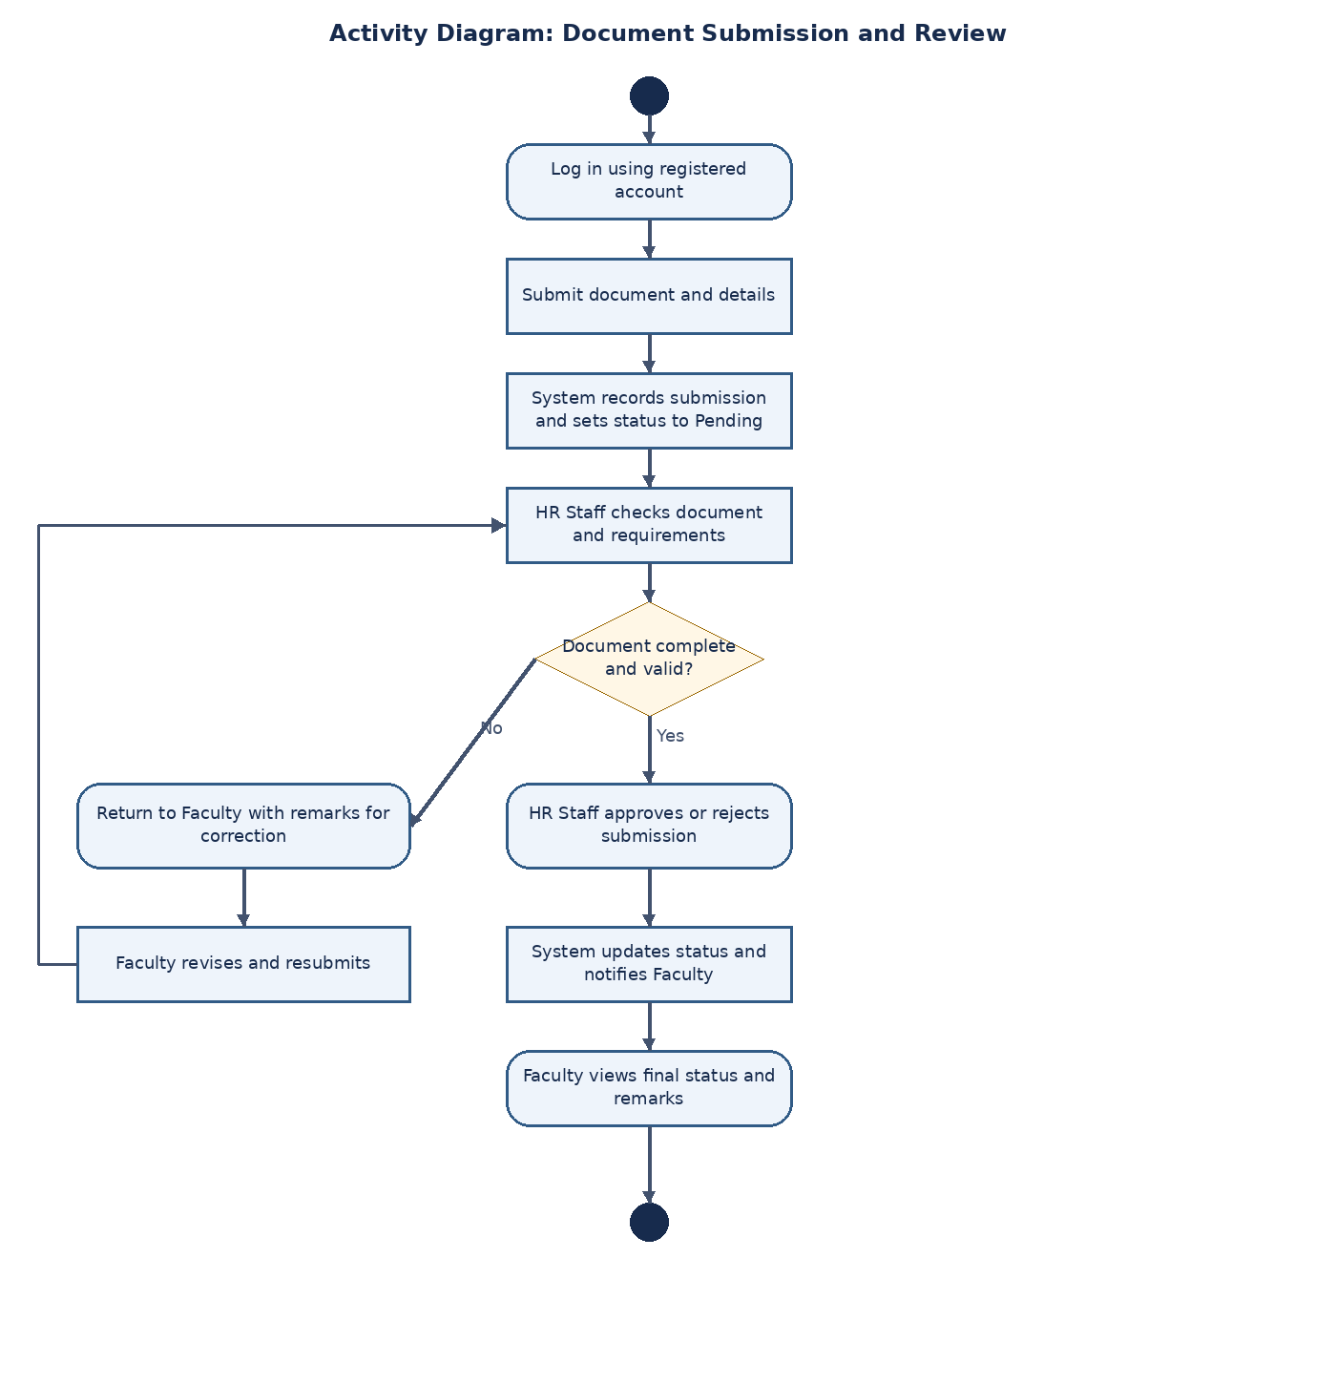
Figure 6. Activity Diagram of the Document Management System of ISAT U HR
The activity diagram models the lifecycle of a document request using standard UML notation. The workflow begins at the initial node, where the Employee logs in and uploads a document request. A fork then splits the process into two concurrent actions: the HR Personnel verifies the submitted document while the Database Server independently stores the request information. Along the verification path, a decision determines whether the request is approved or rejected; both outcomes converge at a merge node before the decision is stored in the database. A join node then synchronizes both concurrent paths, after which the Employee views the updated request status and the process ends at the final node. Separately, the System Administrator carries out an independent, scheduled process consisting of retrieving documents or records, generating institutional reports, and performing a database backup to preserve HR data over the long term.
Use Case Diagram
A use case diagram is a type of Unified Modeling Language (UML) diagram used during the process design phase to illustrate the interactions between actors (users) and the system. It visually represents the main functionalities available within the system and the specific roles of its users. In this study, the diagram is used to define the authority and actions of the system's three primary actors: the Employee, the HR Personnel, and the System Administrator.
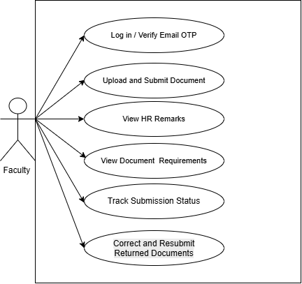
Figure 3. Use Case Diagram for Faculty
Faculty use the system to log in, check document requirements, upload submissions, monitor statuses, read HR remarks, and correct and resubmit documents when a submission is returned.
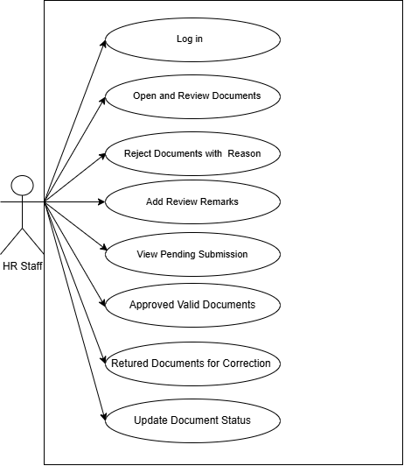
Figure 4. Use Case Diagram for HR Staff

HR Staff are responsible for reviewing submitted documents. They can inspect files, add remarks, and record an outcome as approved, rejected, or returned for correction. The diagram keeps these document decisions under HR Staff rather than assigning them to the System Administrator.
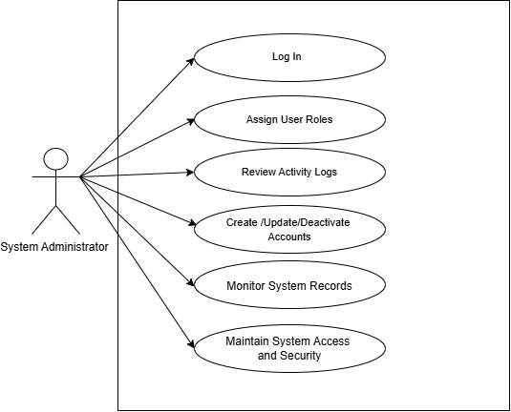
Figure 5. Use Case Diagram for System Administrator
The System Administrator manages user accounts and roles and reviews activity logs to help maintain system security and oversight. This role does not make the HR review decision unless the project requirements are formally changed.

Requirements Analysis

The requirements analysis identifies the functions and features needed for the development of the Documents Management System of ISAT U HR. It determines how the system will support faculty members, HR staff, and the system administrator in submitting, reviewing, tracking, and managing human resource documents. The requirements are based on the objectives of the study, the document-processing workflow of the Human Resource Office, and the related literature and studies discussed in Chapter 2.

Lorejo (2026), in the study A Web-Based Electronic Document Management System for Human Resource Department, presented a web-based system that supports online document uploading, access, and retrieval. This provides a basis for developing a centralized platform where authorized users can manage HR documents more conveniently. Similarly, Sakib et al. (2025) discussed the development of digital human resource management, supporting the use of information systems to organize HR-related activities. These studies provide context for the proposed system's centralized document storage and online submission features.

The requirements also consider document workflow and tracking. Raquepo et al. (2026), in Development and Pilot Evaluation of DICT-EAAS: A Web-Based Employee Attendance and Accomplishment System for Document Workflow Automation, discussed a web-based system that supports document processing, reviewer routing, approval or return for revision, and notifications. These functions are relevant to the proposed system's workflow, in which faculty members submit documents, HR staff review submissions and provide remarks, and the system administrator conducts the final administrative review of documents forwarded by HR. The proposed system also allows faculty members to monitor document statuses, helping them determine whether their submissions have been approved, rejected, or returned for correction.

Security and access control are also considered in identifying the system requirements. Sivakumaran and Abdullah (2022) described a web-based application that uses email-based One-Time Password (OTP) verification as an additional security measure. This supports the consideration of email OTP verification during login to help verify users' identities. In addition, access permissions are organized according to user roles to ensure that faculty members, HR staff, and the system administrator can access the functions appropriate to their responsibilities.

Based on the objectives of the study, workflow, and related literature, the system requires functional and non-functional requirements. The functional requirements specify the operations that the system must perform, while the non-functional requirements describe the expected qualities and constraints of the system.

Functional Requirements. The system must allow authorized users to log in and access functions according to their assigned roles. Faculty members must be able to submit HR documents electronically, view their submitted documents, and track their processing statuses. HR staff must be able to access submitted documents, review their contents, provide remarks, update the review status, and forward appropriate submissions for administrative review. The system administrator must be able to manage user accounts, monitor document records and system activities, and perform the final administrative review of documents forwarded by HR. The system must also provide centralized document storage and maintain activity logs to support document management and monitoring.

Non-Functional Requirements. The system must provide appropriate access control to protect HR documents from unauthorized access. Its interface must be understandable and usable by faculty members, HR staff, and the system administrator. The system must maintain accurate document records and status information, provide reliable access to stored submissions, and process user requests within a reasonable time under normal operating conditions. The system should also support maintainability so that authorized developers can update or improve its functions when necessary.

These requirements serve as the basis for the design and development of the Documents Management System of ISAT U HR. They ensure that the proposed system addresses the document submission, review, tracking, security, and administrative needs identified in the study.
System Evaluation

The Documents Management System of ISAT U HR will be evaluated using the ISO/IEC 25010:2023 software quality model to determine whether the system meets its intended objectives and requirements. The evaluation will focus on the system's ability to support the submission, storage, review, tracking, and management of human resource documents at ISAT U – Miagao Campus. A total of twenty (20) respondents will participate in the evaluation, consisting of ten (10) end users and ten (10) Information Technology (IT) experts.

The end users will evaluate the system based on their experience using its features, including document submission, status tracking, document review, and access to system information. The IT experts will assess the system's software quality, functionality, security, reliability, and other technical characteristics. Their assessments will help determine the system's strengths and identify areas that may require improvement.

The evaluation will cover the following software quality characteristics based on the researchers' evaluation questionnaires:

Functional Suitability. This characteristic will assess whether the system provides the functions needed to accomplish the intended tasks of its users. It will consider the completeness, correctness, and appropriateness of functions such as document submission, document review, status updating, user account management, and activity log monitoring.

Performance Efficiency. This characteristic will assess the system's response time and resource utilization when performing its functions. It will consider whether users can log in, upload documents, retrieve records, and check submission statuses within a reasonable amount of time under normal operating conditions.

Compatibility. This characteristic will assess the system's ability to operate within its intended environment and coexist with other software or systems where applicable. It will also consider interoperability when information exchange with other systems is relevant to the system's intended use.

Interaction Capability. This characteristic will assess whether the system is understandable and easy to learn and operate. It will consider the clarity of the interface, navigation, dashboards, document submission forms, status information, error prevention, and user assistance.

Reliability. This characteristic will assess whether the system performs its intended functions consistently under normal operating conditions. It will consider the system's availability, fault handling, and ability to recover affected data and operations following interruptions where applicable.

Security. This characteristic will assess whether the system protects HR documents and user information from unauthorized access or modification. It will consider user authentication, email-based One-Time Password (OTP) verification, role-based access control, data integrity, and activity logs.
Maintainability. This characteristic will assess the extent to which the system can be examined, tested, corrected, and modified when necessary. It will focus on the system's organization and the ease with which authorized developers can identify errors and maintain existing functions.
Flexibility. This characteristic will assess whether the system can be adapted to reasonable changes in user needs, software environments, and operational requirements within the project's scope.
Safety. This characteristic will assess applicable safeguards that help prevent unsafe system operation or unacceptable operational risks. Since the system primarily manages digital HR documents, this assessment will focus on relevant software and operational safeguards applicable to its intended use.
The evaluation will use structured questionnaires for end users and IT experts. Both questionnaires will use a five-point rating scale, with 5 representing Excellent, 4 representing Very Good, 3 representing Good, 2 representing Fair, and 1 representing Poor. Respondents will rate the statements according to their experience with or assessment of the system.

After collecting the completed questionnaires, the responses will be tabulated and analyzed using the weighted mean to determine the assessment for each criterion. The weighted mean will be computed using the following formula:
[ \bar{x}=\frac{\sum fx}{N} ]
Where: (\bar{x}) = weighted mean
(f) = frequency of responses for each rating
(x) = numerical value assigned to each rating
(N) = total number of valid responses for the item being analyzed
The computed weighted means will be interpreted using the following rating ranges:
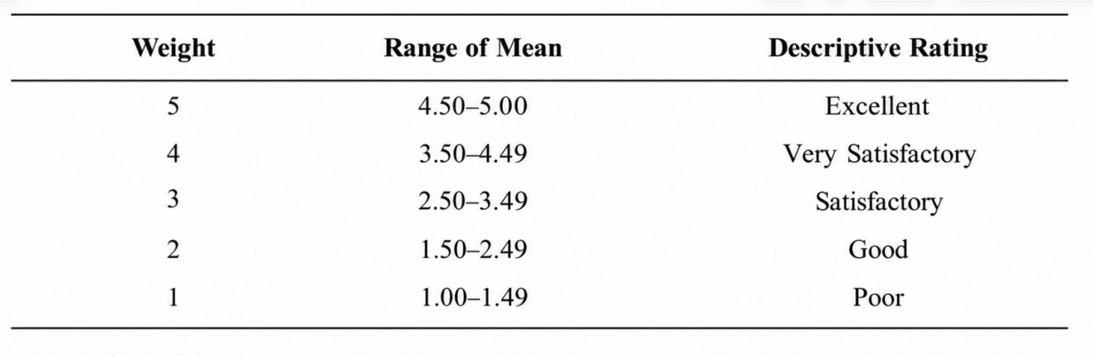
The results from the ten (10) end users and ten (10) IT experts will be summarized to determine their assessments of the system. The findings will be used to identify the system's strengths and areas for improvement. Feedback from both groups will guide the researchers in refining the system's functionality, usability, security, reliability, and overall quality. Through this evaluation, the researchers will determine how well the Documents Management System of ISAT U HR meets the needs of its intended users and the project's requirements.
References
Aliazas, J. V., Cruz, R. D., & Ilagan, N. (2024). Enhancing university operations: A study of the Electronic Document Management Systems (EDMS) of one higher education institution. Twist, 19(3), 229–237. https://twistjournal.net/twist/article/view/337
Balbontin, P. A., Cahilig, S. A., Elecanal, E. T., Navarro, C. R., & Villafania, S. D. (2026). Electronic document archiving system. BAHÁNDÌAN, Institutional Repository of Central Philippine University. https://repository.cpu.edu.ph/handle/20.500.12852/2227
Bambang Irawan, & Aldi Hardiansyah, M. (2025). Design and development of a web-based maintenance employee management application using laravel framework. Technovasia: Journal of Technology & Computer Research in Innovation, Science, and Applications, 1(1), 27–47. https://journal-iam.com/index.php/technovasia/article/view/26
Castro, F., Quilon, E. R., & Arruejo, A. (2022). DocTrack: A dynamic document tracking system for the University of Northern Philippines. Journal of Innovative Technology Convergence, 4(2), 23–34. https://doi.org/10.69478/jitc2022v4n2a03
Daluyon, M. A. (2024). Design and development of electronic document archiving system. Journal of Innovative Technology Convergence, 6(4), 35–44. https://doi.org/10.69478/jitc2024v6n4a03
Destini, J. S., & Tony, T. (2024). Implementing hierarchical role-based access control for document administration in student organizations. Internet of Things and Artificial Intelligence Journal, 4(4), 785–802. https://doi.org/10.31763/iota.v4i4.832
Elwin Argana, Francisco, V. C., & Romy Jun Sunico. (2020). Human resource information system with Digital Archiving. International Journal of Computer (IJC), 39(1), 14–25. https://www.researchgate.net/publication/343808489_Human_Resource_Information_System_with_Digital_Archiving
Groenewald, T. (2004). Electronic document management: A human resource management case study. SA Journal of Human Resource Management, 2(1). https://doi.org/10.4102/sajhrm.v2i1.29
Lorejo, Ruben C. . (2026, April 25). A web-based electronic document management system for human resource department. Pantao (The International Journal of the Humanities and Social Sciences). https://pantaointernationaljournal.com/2026/04/26/publication-1055-a-web-based-electronic-document-management-system-for-human-resource-department/
Mentri, A. H., & Zainal, N. (2025). Cahaya bebas HR document management system. Applied Information Technology And Computer Science, 6(1), 1105–1124. https://periodical.uthm.edu.my/index.php/aitcs/article/view/18838
Nair Sivakumaran, S., & Abdullah, Z. (2022). Secured forensics reporting web based on two factor authentication. Applied Information Technology And Computer Science, 3(2), 101–117. https://periodical.uthm.edu.my/index.php/aitcs/article/view/7505
Ochave, S. M., Tresenio, M. M. N., Rabina, P. M. M., Corpuz, M. C. S., & Cruz, C. P. O. (2026). Development and implementation of a web-based human resource management system of the great plebeian college. International Journal of Latest Technology in Engineering Management & Applied Science, 15(4), 423–436. https://doi.org/10.51583/ijltemas.2026.150400037
Ralutin, J. G. (2024). Development of Human Resource Management System for Kalinga State University. AIDE Interdisciplinary Research Journal, 8, 141–148. https://doi.org/10.56648/aide-irj.v8i1.116
Raquepo, V., Blanco, J. A., Lumanog, C. J., Soriano, M. J., D. Antonio, K. C., & Reymond C. Dalupang, R. (2026). Development and pilot evaluation of DICT-EAAS: A web-based employee attendance and accomplishment system for document workflow automation. International Journal of Latest Technology in Engineering Management & Applied Science, 15(4), 1256–1269. https://doi.org/10.51583/ijltemas.2026.150400109
Redoblo, J. L. G. (2021). Online multi-function heis tracking system. Research Journal of Education, Science and Technology, 1(1), 24–35. https://doi.org/10.63179/rjest.v1i1.52
Rodriguez III, B., Verallo, C. J. A., Aquiatan, V. T., Agpad, S. B., De Loyola, R. C., & Bibangco, E. J. P. (2024). eDALAYON: A document management and monitoring system for the department of the Interior and local government, Philippines. Philippine Journal of Science, Engineering, and Technology, 1(1), 34–41. https://doi.org/10.63179/pjset.v1i1.57
Sakib, Md. N., Ullah, M. S., & Rahman, Md. M. (2025). Mapping the evolution of Digital Human Resource Management: A systematic review and bibliometric analysis. Future Business Journal, 11(1). https://doi.org/10.1186/s43093-025-00577-9
Sijjad Ali, Muhammad Aamir, P., Attaullah, B., Adeel, A., Suhail Ahmed, K., Shoukat, H., University of Science and Technology of China, Anhui, China, Beijing University of Posts and Telecommunications, China, Khwaja Fareed University of Engineering and IT, Rahim Yar Khan, Pakistan, University of Science and Technology of China, Anhui, China, Quaid-i-Azam University, Islamabad, Pakistan, & Quaid-i-Azam University, Islamabad, Pakistan. (2018). FGEHF: Authenticated web based application for human resource management system. Indian Journal of Science and Technology, 11(43), 1–12. https://doi.org/10.17485/ijst/2018/v11i43/131751
sundayn, P. U., IGWE, J. S., CHUKWU, J., OJIMADU, C. J., & NWALI, M. E. (2026). Computerization of University Personnel Administration: Design and implementation of a web-based management system. Journal of Advanced Multidisciplinary Studies (JAMS). https://doi.org/10.68050/jams.2026.545

