**TRUE BUS**

### Installing

1. True Bus Installation steps- This is probably the simplest way for most users.
   1. Upload the source folder via ftp or file manager
   2. Create a database, your database name.
   3. Using the link <http://yoursitename.com/Installer/installer.php> run the installer
   4. Fill out your database details in the installer and save your changes.
   5. A form for filling out your site details, smtp details will appear, enter your details and save your changes.
   6. You have your site ready

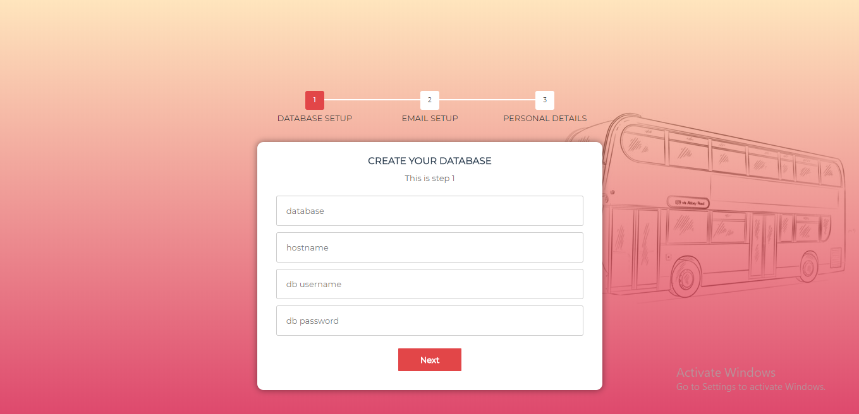

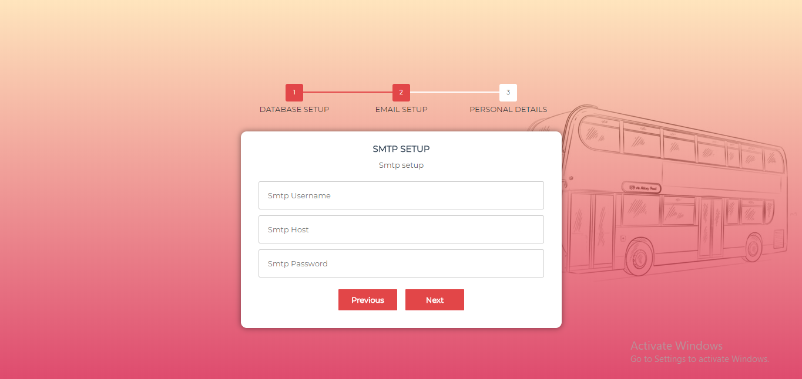

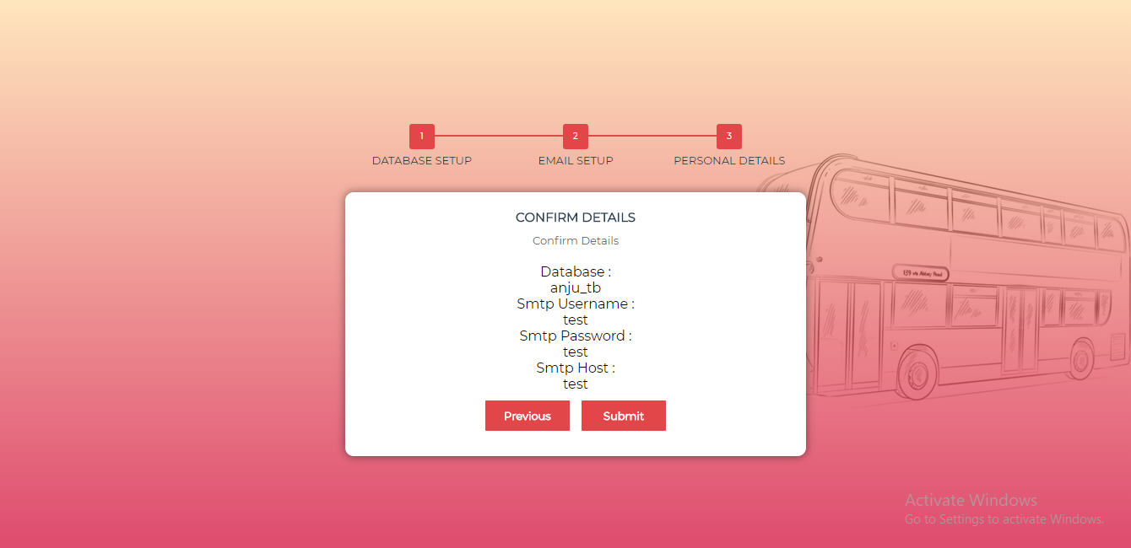

### Admin Login Details

1. Login using the following url with username and password admin, admin into the TrueBus admin panel.
2. Username:admin
3. Password:admin
4. URL: <http://yoursitename.com/admin/>

### User Login Details

1. Login using the following url with username and password.
2. Username:test@gmail.com
3. Password:123456
4. URL: <http://yoursitename.com>

### Agent Login Details

1.Login using the following url with username and password.

2.Username:agent

3.Password:agent

4.URL: http://yoursitename.com/admin