Attach the electrods to the patients according to the picture

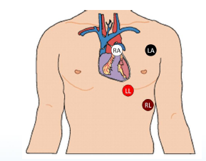

Connect the with dock station to the laptop using the USB cable.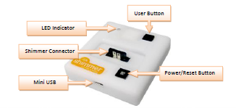

Place the Shimmer in the dock. Be careful to place the front part of the Shimmer facing the writing "Shimmer" on the dock station.

Switch on the Shimmer using the Power button in the dock station. The green led should switch on and the Shimmer should be visible as external hard drive in the laptop.

Remove the shimmer from the dock station.

The green led on the shimmer should start blinking, then the green led will be on for a couple of seconds and then it should blink again.

Place the Shimmer on the table.

Repeate this with all the shimmer following the order:

1. Wrist L
2. Wrist R
3. Ankle R
4. ECG1
5. ECG2

Note: for ECG1 and ECG2 no leds will blink.

Place the Shimmers in the straps

FIGURE

Attach the Shimmer to the body taking care of the orientation as in the pictures.