Consideration about clusters
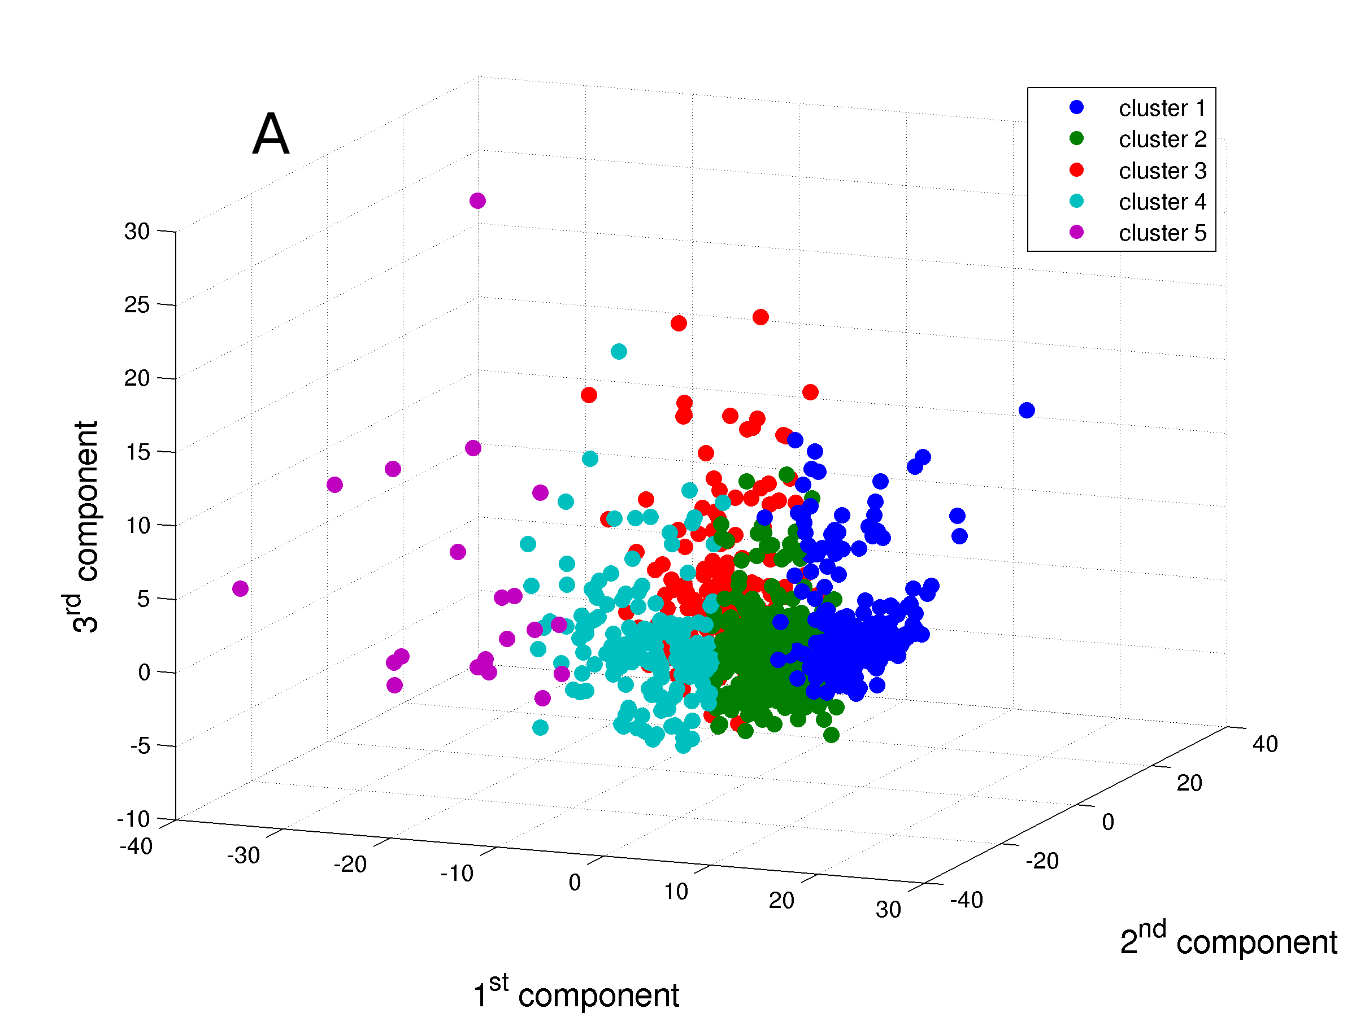
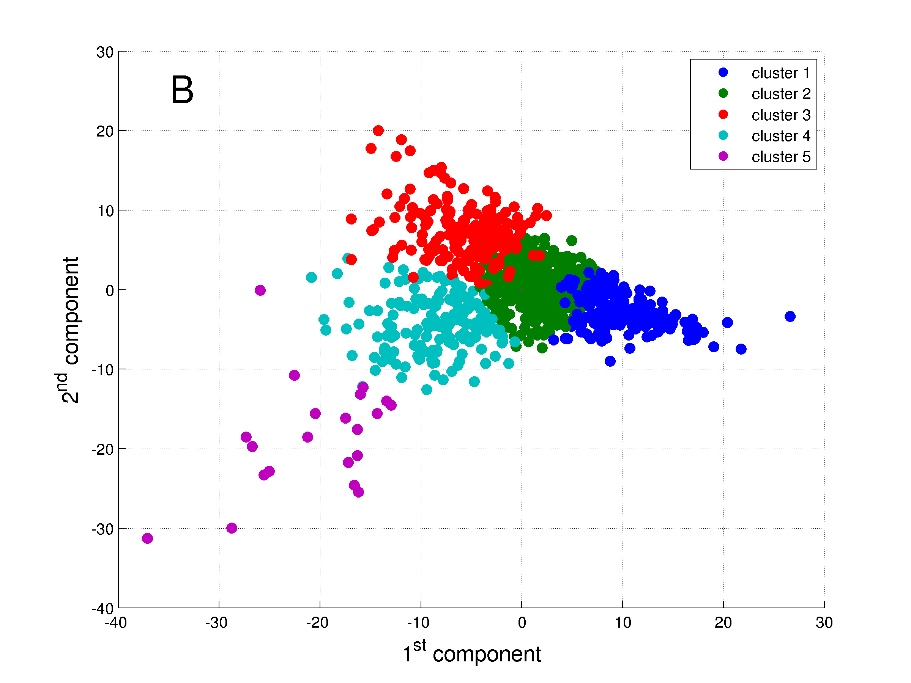

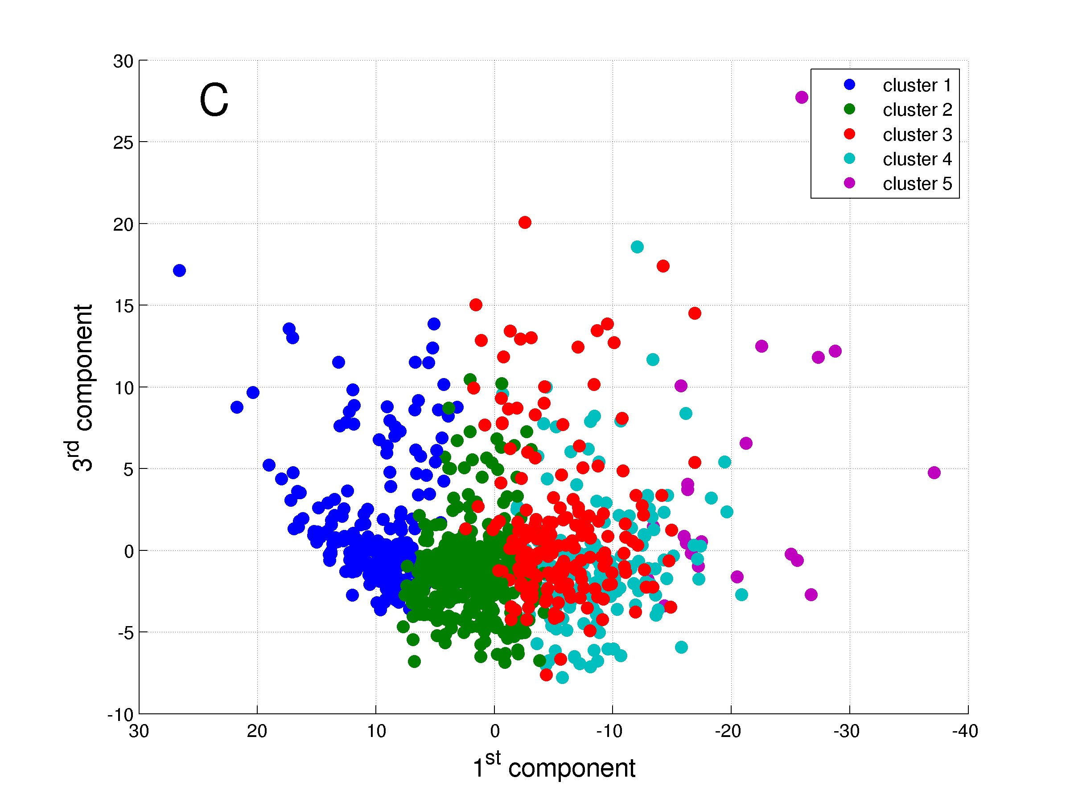
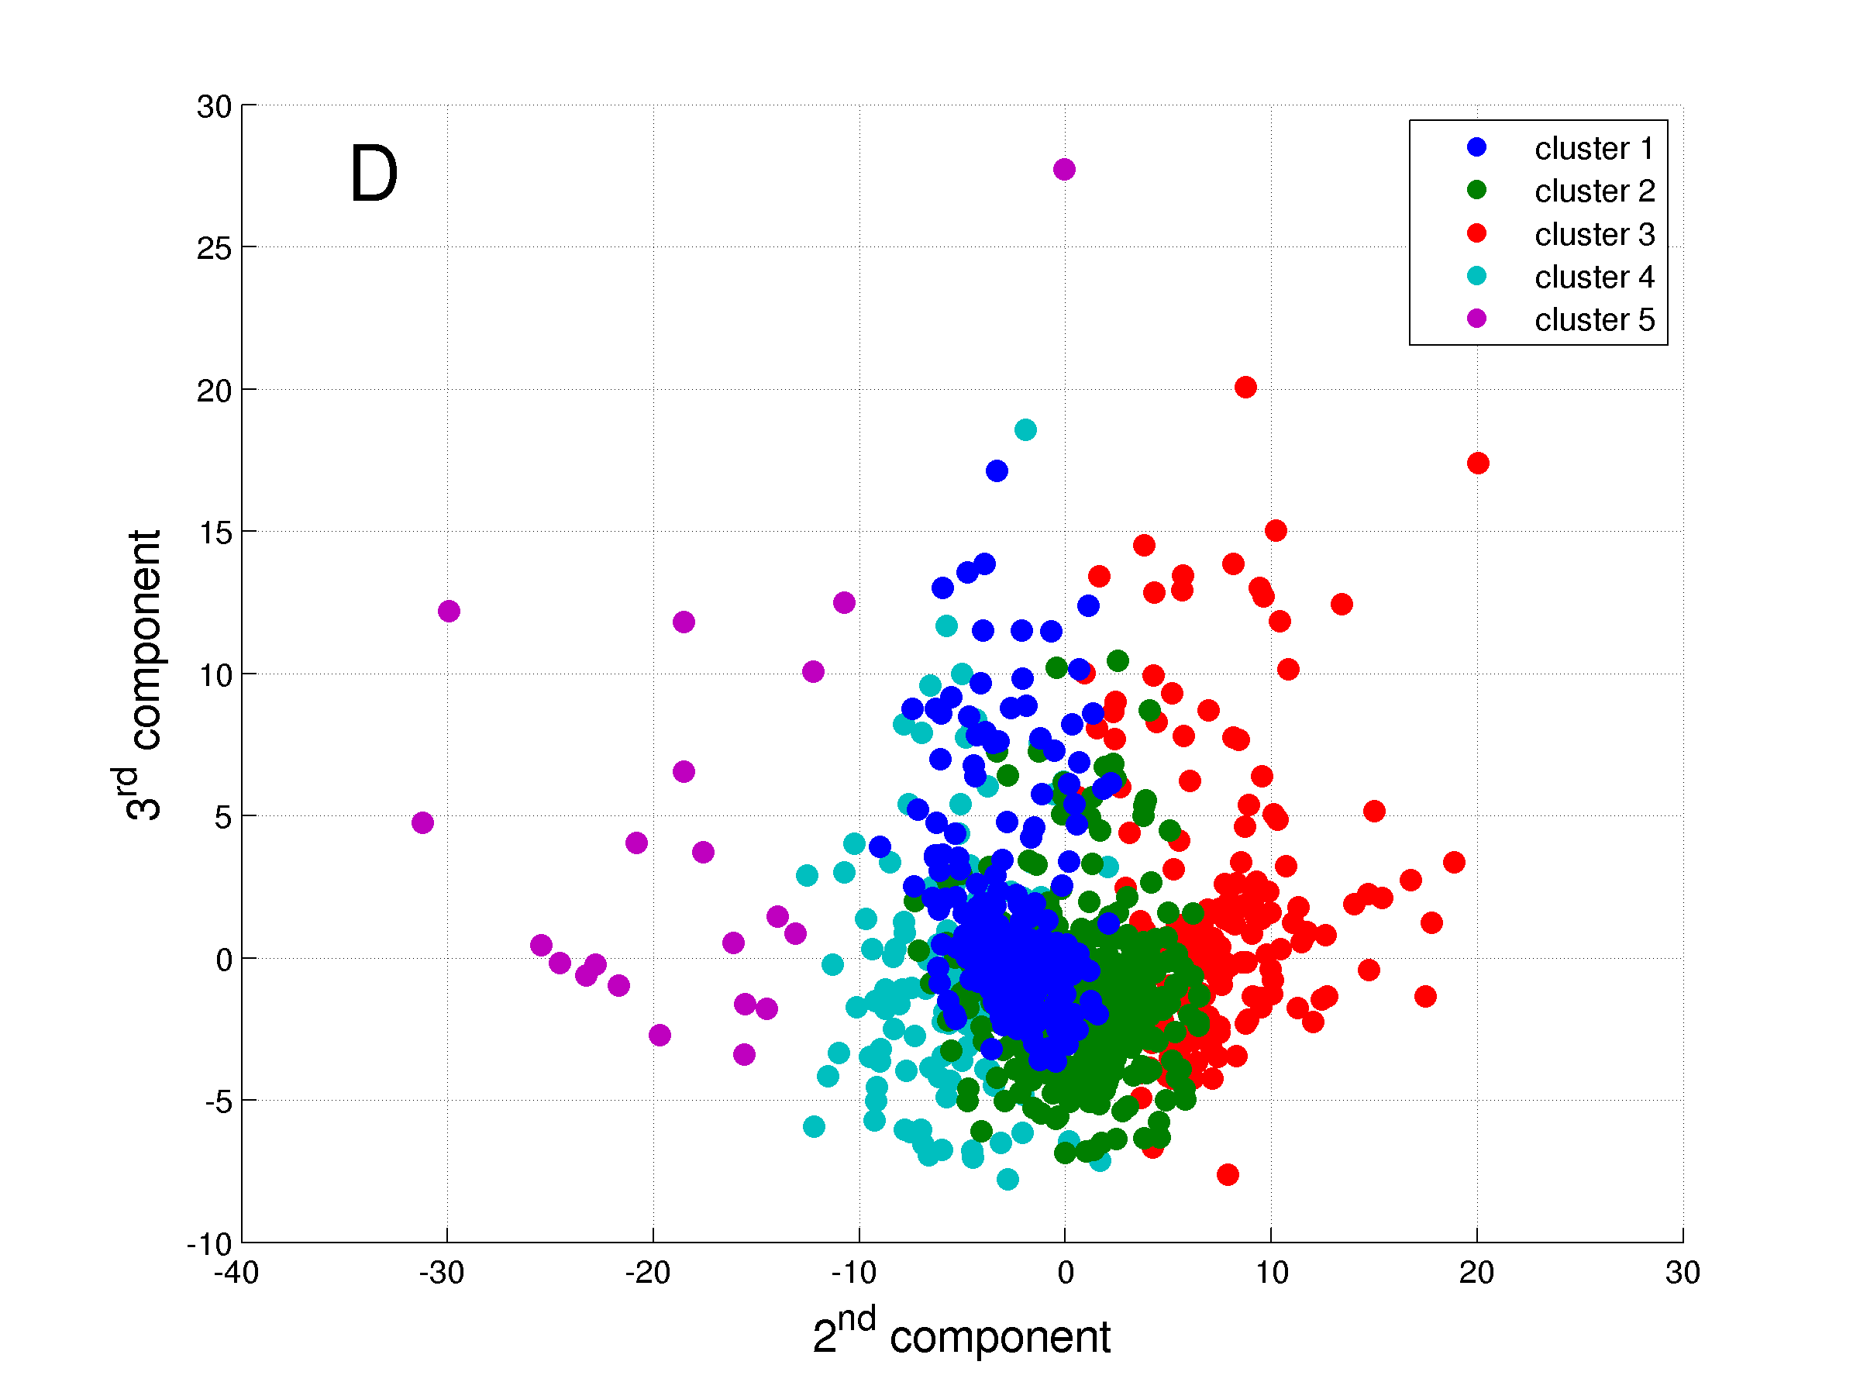

Figure 5

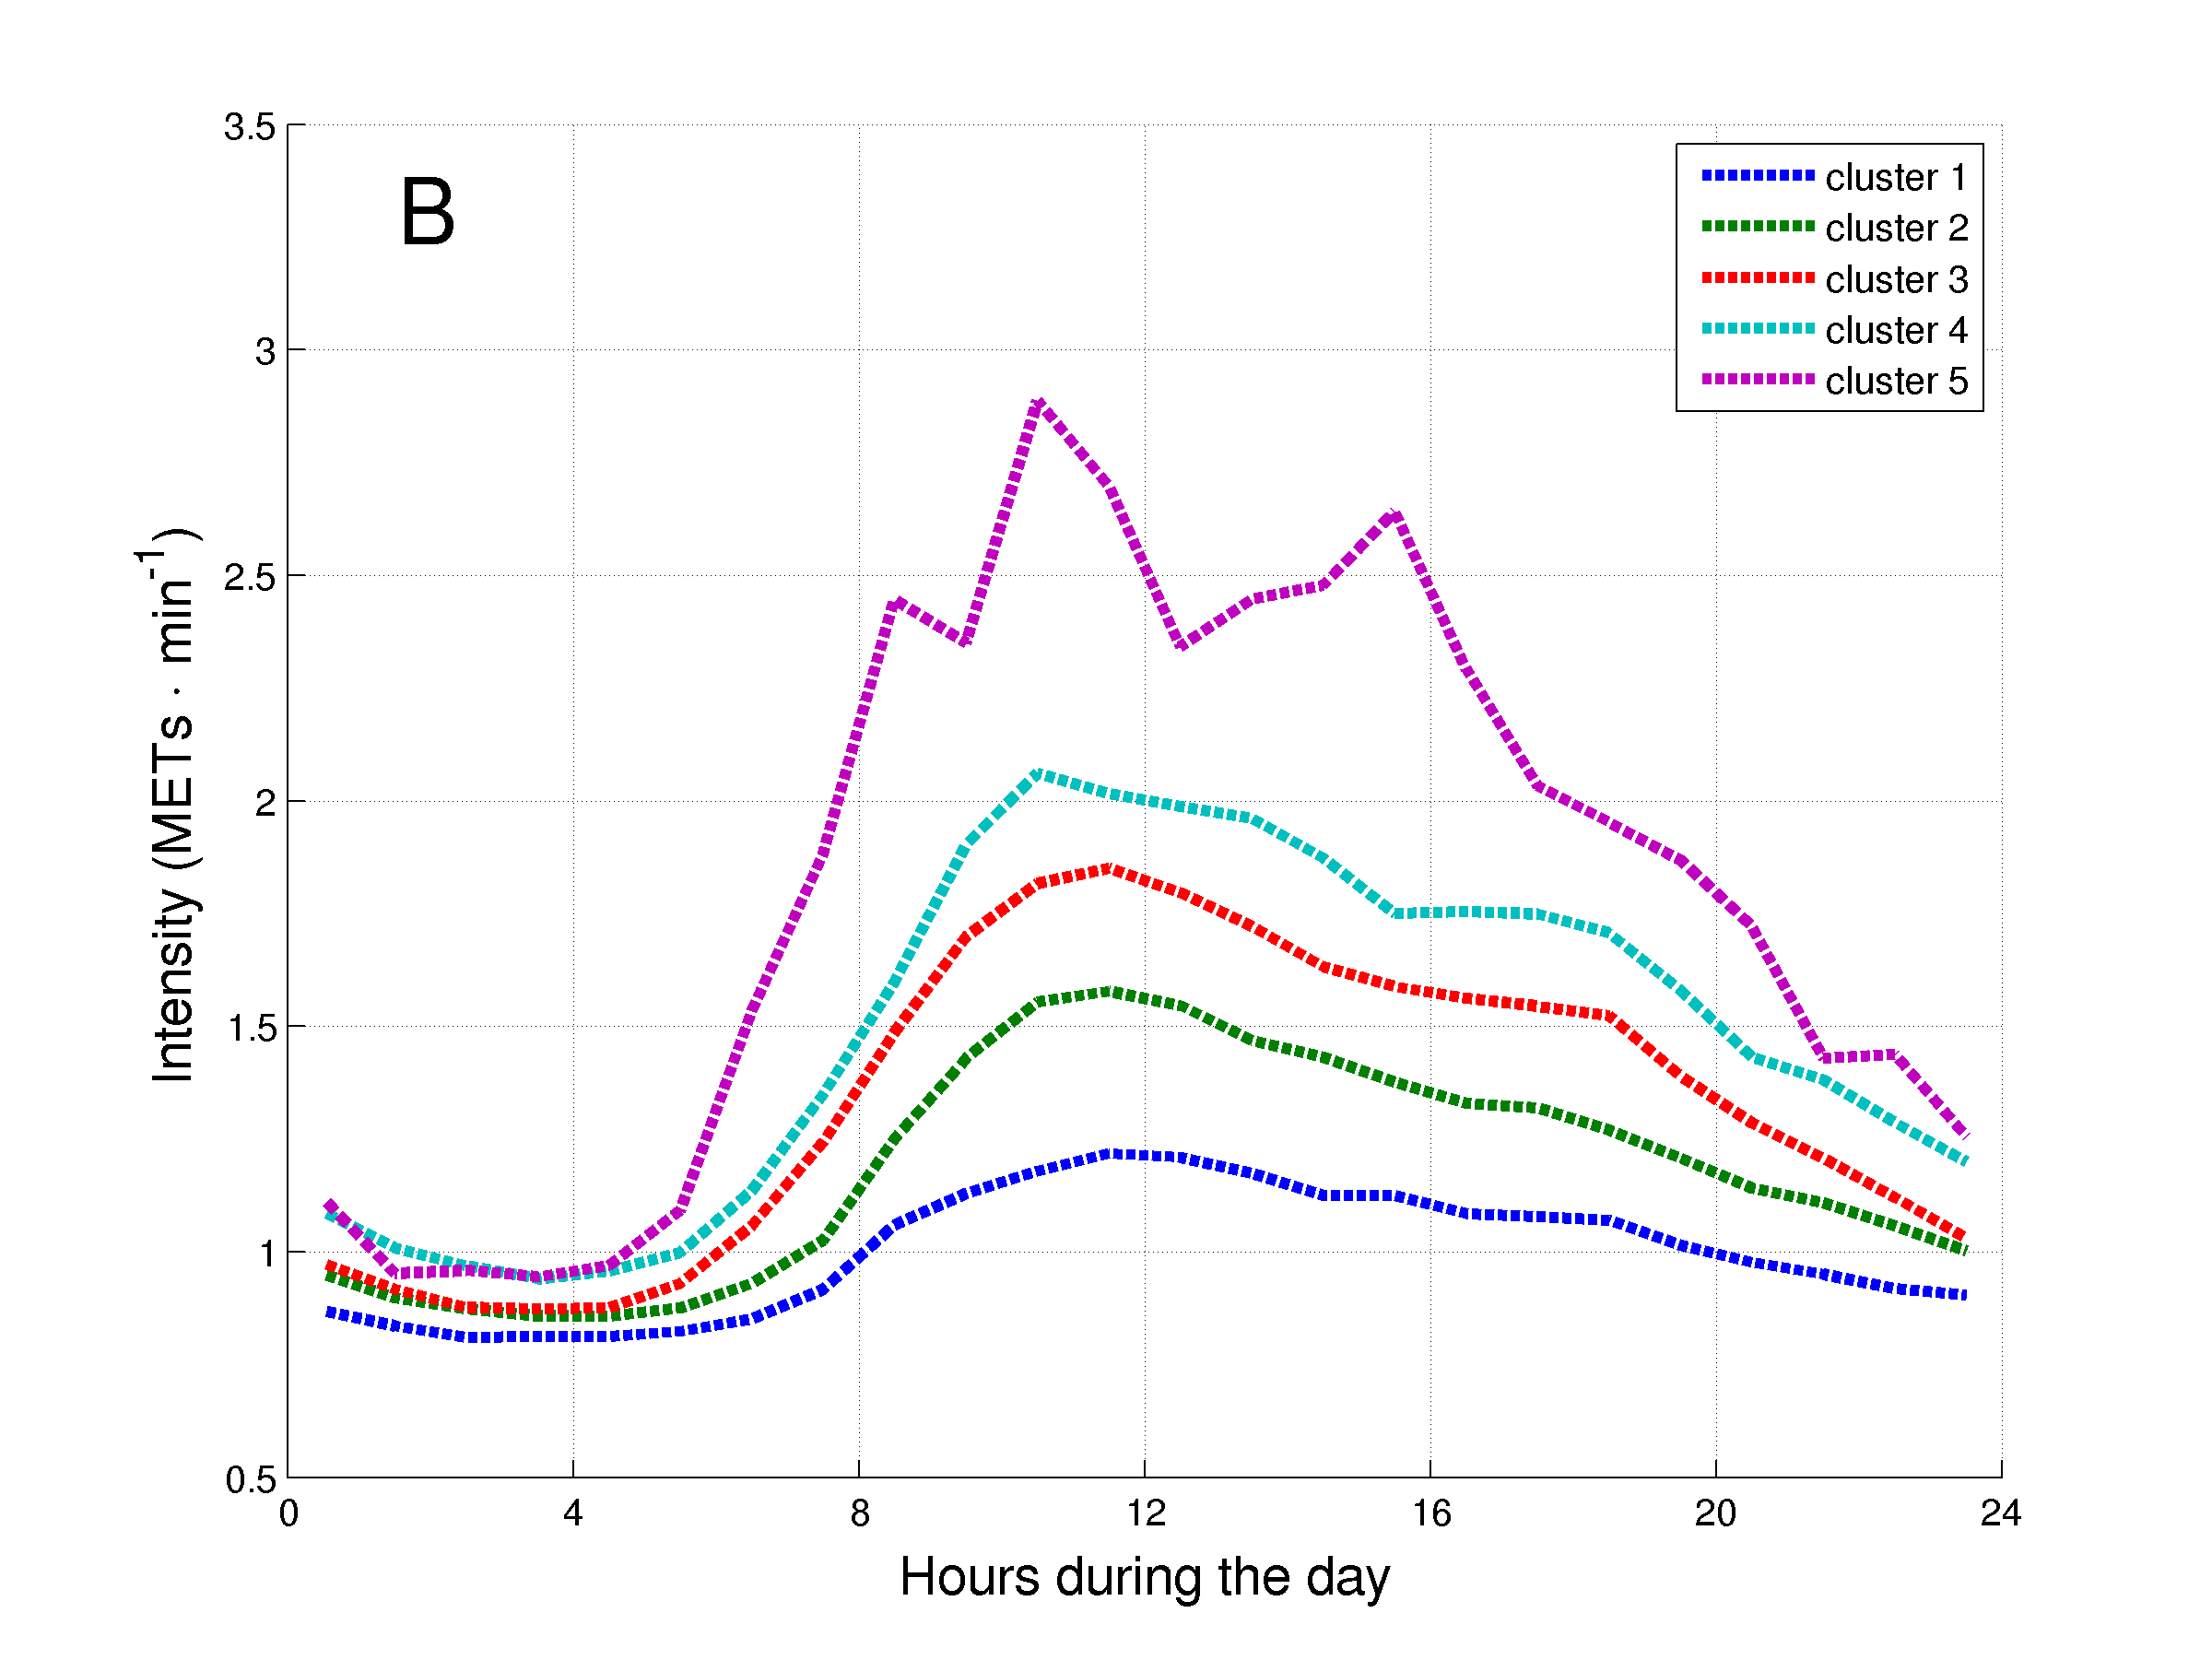
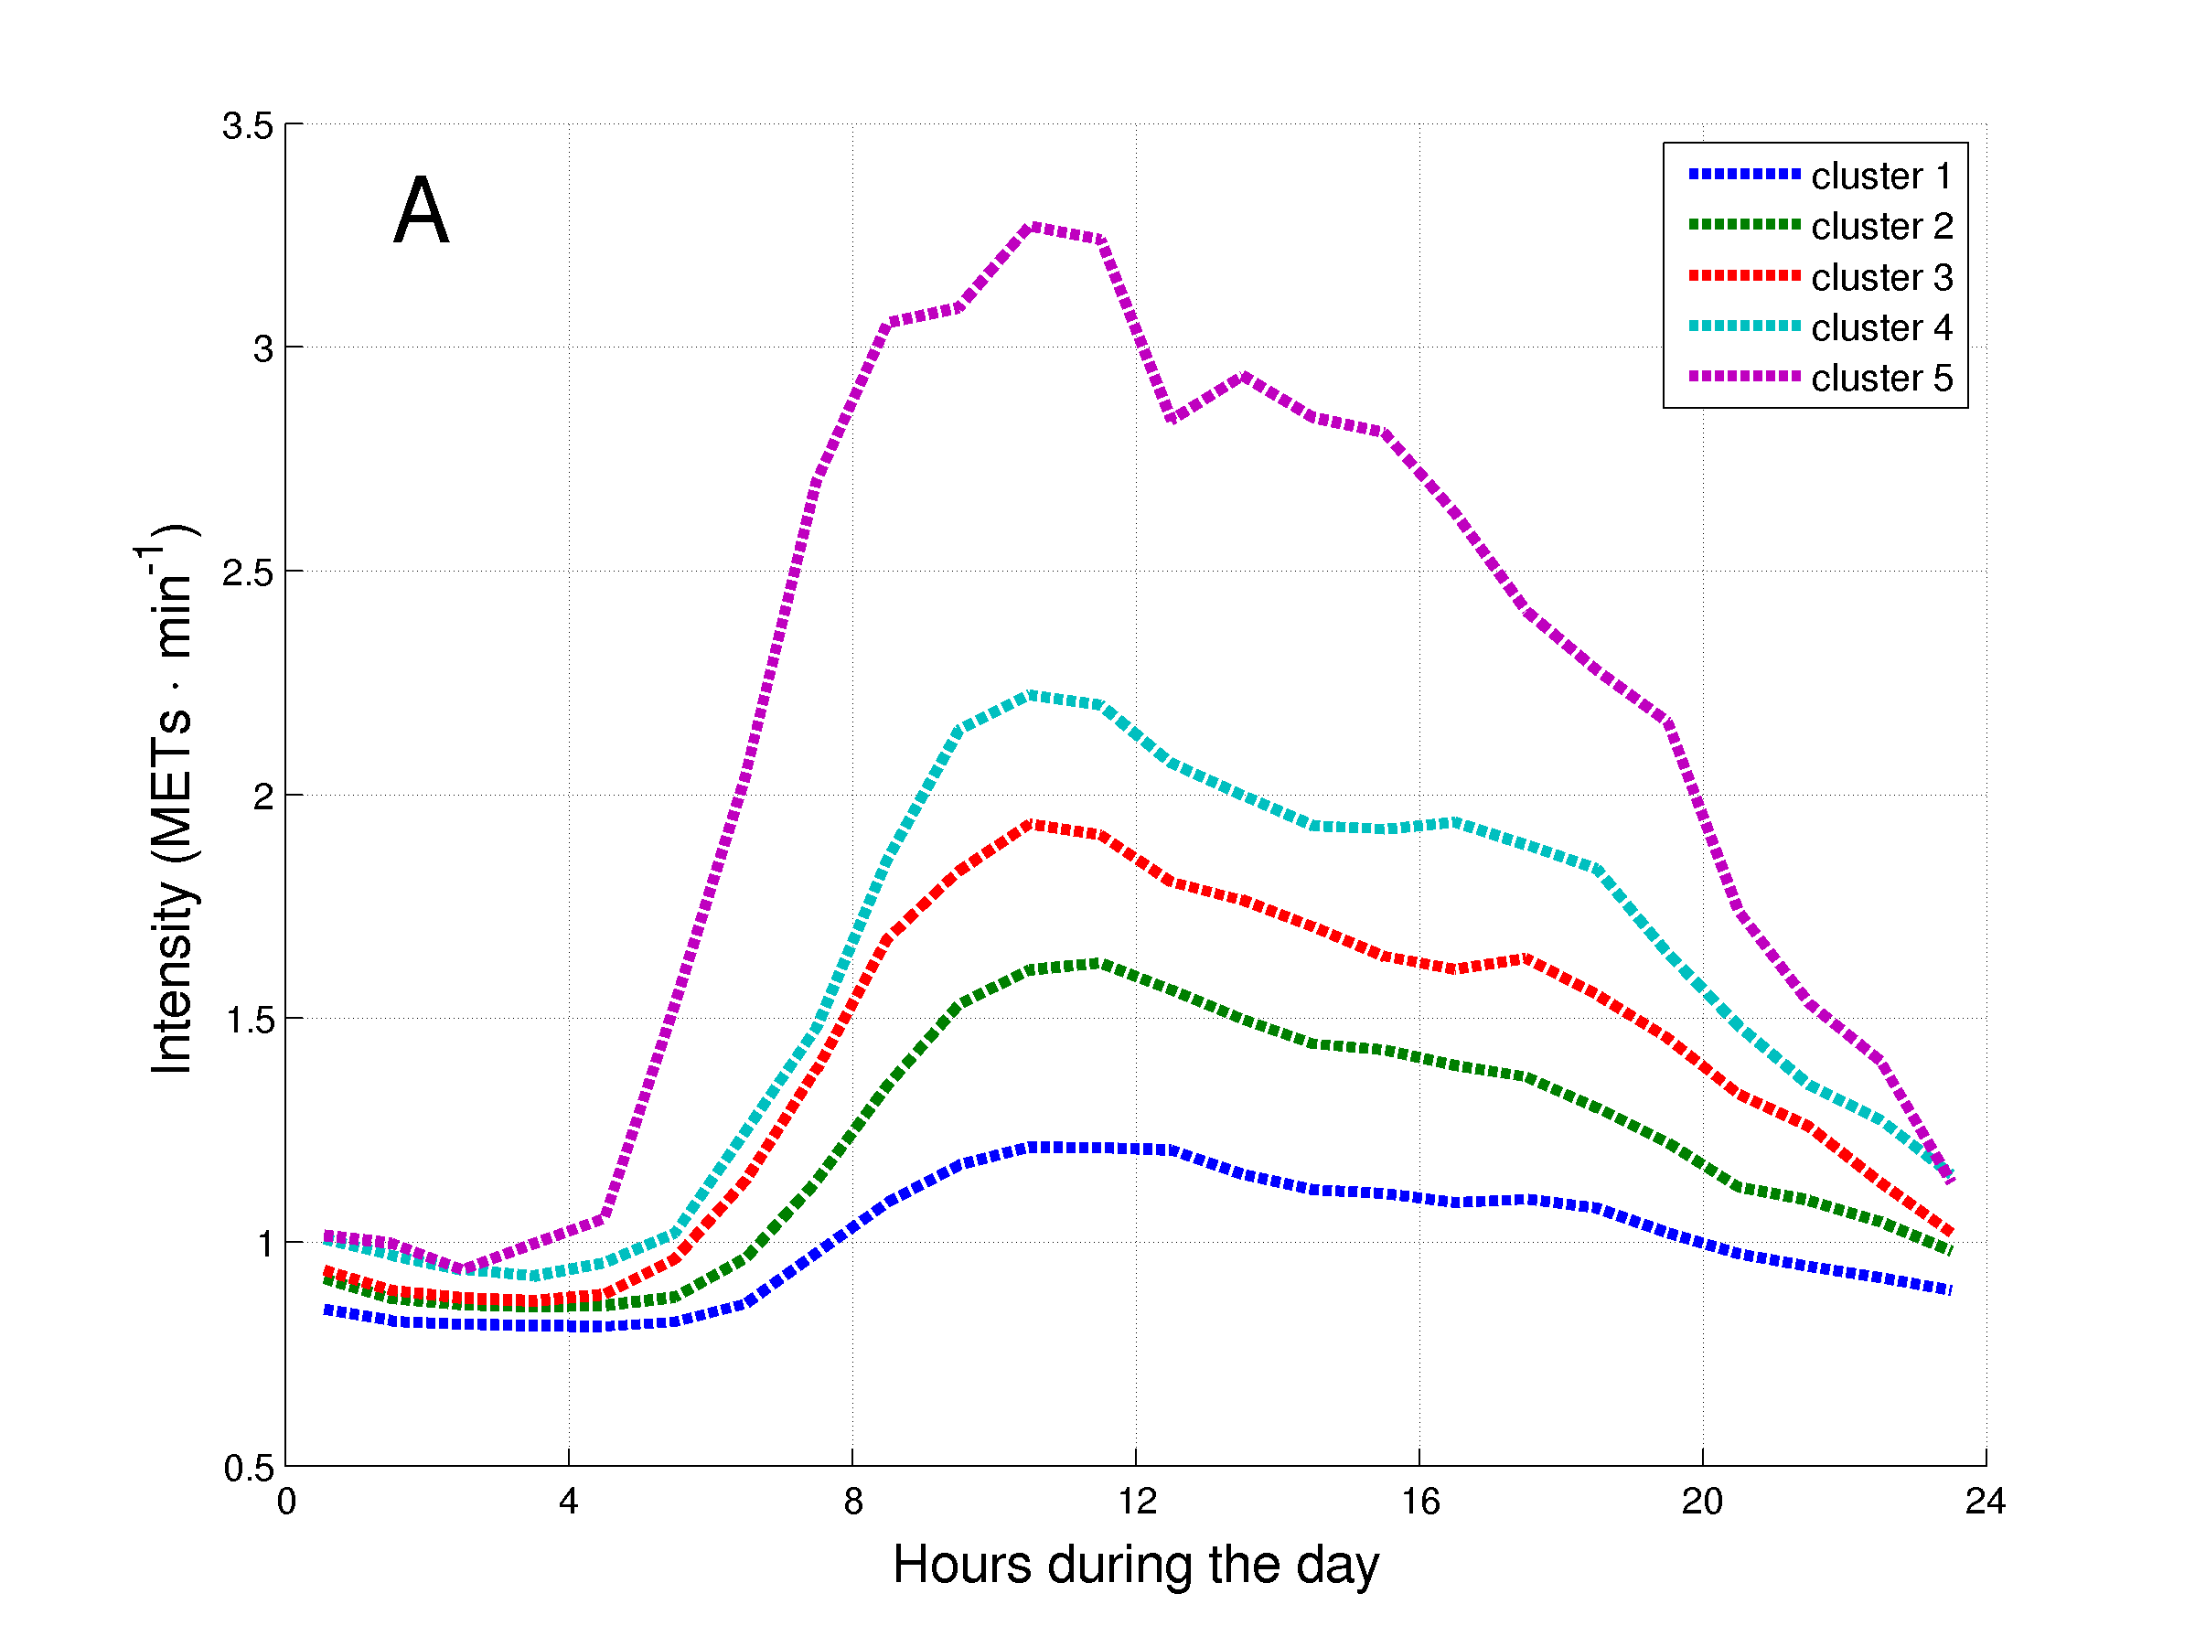

Figure 6
From a closer view to the clusters:
The first component is able to separate the first two clusters (less active) from the three more active ones. We can indeed trace two lines in Fig.5B and Fig.5C (perpendicular to the axis representing the 1st component) and separate the blue cluster, the green and the rest. The blue and the green correspond to the two “less active clusters”.
The second component is not really useful to divide inactive patients (difficult to find a line that separates the red, light blue and magenta clusters in Fig.5B and Fig.5D), but it is able to separate the most active clusters (magenta) from the rest.
For the red and light blue clusters (medium active patients) it's important to consider all the three principal components (a combination of them). Indeed considering only the first component those clusters would be added to the active cluster (Fig.5B and Fig 5C). On the other hand, considering the second component those clusters would be added to the inactive ones (Fig.5B).

Having a look at the components composition we may notice that the first component is related to the time/duration of the bouts (the most relevant features of the 1st component involved ≥2-min and ≥10-min bouts of VLI) and the second components is related to the EE during activities (the most relevant of the 2nd component involved the total daily EE in MVI and the daily EE in ≥2-min and ≥10-min bouts of MVI).

We may suggest that duration of MVI bouts could be an useful marker to separate patients that are not very active.
In order to separate patients that are more active it's better to look at the EE during the performance of MVI.

