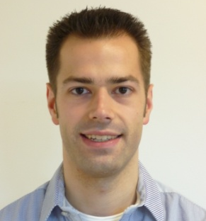
Curriculum Vitae
Ralph Wijshoff

Personal Information

Full name: Ralph Wilhelm Christianus Gemma Rosa Wijshoff

Address: Heijdenpad 1, 6151 BL Munstergeleen, the Netherlands
Cellphone: +31 6 107 586 70
E-mail: ralph.wijshoff@outlook.com

Date of birth: 24 June 1984
Place of birth: Sittard, the Netherlands
Nationality: Dutch

Research Positions

2014-present Research Scientist – Philips Research Eindhoven
Application oriented research in the Patient Care & Measurements group.

2009-2014 PhD Student - Eindhoven University of Technology and Philips Research Eindhoven
Research on the reduction of motion artifacts in photoplethysmography to expand its applicability in ambulatory monitoring and during cardiopulmonary resuscitation.

Education

2009 MSc Electrical Engineering (cum laude)
Eindhoven University of Technology, the Netherlands
Specialization: (medical) signal processing
Average grade: 8.9/10

2006 BSc Electrical Engineering (cum laude)
Eindhoven University of Technology, the Netherlands
Average grade: 8.9/10

2003 Propaedeutic Electrical Engineering (cum laude)
Eindhoven University of Technology, the Netherlands
Average grade: 8.9/10

2002 Grammar School (cum laude)
Trevianum Scholengroep, Sittard, the Netherlands
Average grade: 8.9/10

Experience

2007–2009 Secretary of the Executive Committee of the IEEE Benelux Section

2006–2007 Treasurer and Vice-Chairman of the IEEE Student Branch Eindhoven

2004–2006 Staff member of the Student Office of the department of Electrical Engineering

Certificates

2011 Certificate of participation in the Masterclass Photonic Devices Entrepreneurship

2006 Certificate of participation in the language course English for Academic Purposes

Computer Skills

Programming: Matlab, LabVIEW, C, C++
Software: LaTeX, Orcad Capture CIS, PSpice, Borland C++ Builder

Spoken Languages

Dutch mother tongue, a fair command of the English language

Awards

October 2013 Runner-up in the “Best of the Best” competition of Resuscitation 2013, the Annual Symposium of the European Resuscitation Council

October 2007 IEEE Award for outstanding leadership and service to the IEEE Student Branch of the Eindhoven University of Technology

