Training and monitoring methodologies for chronic obstructive pulmonary disease patients in daily life

PROEFSCHRIFT

ter verkrijging van de graad van doctor aan de Technische Universiteit Eindhoven, op gezag van de rector magnificus prof.dr.ir. C.J. van Duijn, voor een commissie aangewezen door het College voor Promoties, in het openbaar te verdedigen op donderdag 2 juni 2016 om 16:00 uur

door

Gabriele Spina

geboren te Palermo, Italië

Dit proefschrift is goedgekeurd door de promotoren en de samenstelling van de promotiecommissie is als volgt:

voorzitter: prof.dr.ir. A.B. Smolders
1e promotor: prof.dr.ir. R.M. Aarts
2e promotor: prof.dr. E.F.M. Wouters (CIRO+)
1e copromotor: dr.ir. A.C. den Brinker (Philips)
2e copromotor: dr. M.A. Spruit (CIRO+)
leden: prof.dr.ir. P.F.F. Wijn
dr.ir. T.J. Tjalkens
adviseur: dr.ir. P. Casale (Holst Centre)

This work was supported by the Foundation for Technical Science (STW) under project 10536.

Cover designed by Luis Quelhas Marques and Daniele Raiteri.

Daniele Raiteri
Technology aware circuit designs for smart sensors on plastic foils
Eindhoven University of Technology
ISBN: 978-90-386-3645-0

©D. Raiteri 2014
All rights are reserved.
Reproduction in whole or in part is prohibited
without the written consent of the copyright owner.

Table of Contents
List of figures vi
List of tables vii
List of abbreviations viii
List of symbols x
1 Introduction 1
1.1 Background 1
1.2 Problem statement 1
1.3 Aim of the thesis 1
1.4 Scope of the thesis 1
1.5 Outline of the thesis 2
1.6 Own contributions 2
2 CRNTC+: A smartphone-based sensor processing framework for prototyping personal healthcare applications 3
2.1 Introduction 4
2.2 Related works 4
2.3 Processing framework approach 5
2.4 Implementation 6
2.5 Framework characterization 7
2.6 Experimental evaluation 8
2.6.1 Epilepsy evaluation study 8
2.6.2 Epilepsy study results 8
2.7 Conclusion and future work 9
3 COPDTrainer: A Smartphone-based Motion Rehabilitation Training System with Real-Time Acoustic Feedback 11
3.1 Introduction 12
3.2 Related works 13
3.3 Smartphone-based training approach 14
3.3.1 Teach-mode operation 15
3.3.2 Train-mode operation 16
3.3.3 Motion exercise modeling 16
3.4 Algorithm implementation 17
3.4.1 Teach-mode implementation 17
3.4.2 Train-mode implementation 19
3.4.3 Exercise performance class estimation 19
3.5 Evaluation study 20
3.5.1 Training exercises 20
3.5.2 Data collection and exercise features 21
3.5.3 Validation with healthy participants 22
3.5.4 Evaluation with COPD patients 22
3.6 Results 23
3.6.1 Validation with healthy participants 23
3.6.2 Evaluation with COPD patient in intervention study 24
3.7 Discussion 29
3.8 Conclusion and future work 30
4 Conclusions 32
Appendix 33
References 34
Acknowledgments 35
List of Publications 36
Summary 37
Curriculum Vitae 38

List of figures

List of tables

List of abbreviations

AC Alternating Current 20
AD Analog to Digital 4
ADC Analog to Digital Converter 11
ALU Arithmetic Logic Unit 46
AMOLED Active-Matrix Organic Light-Emitting Diode 11
CAD Computer Aided Design 4
CB Conduction Band 24
CMOS Complementary Metal Oxide Semiconductor 12
CPU Central Processing Unit 1
CS Current Steering 90
DA Digital to Analog 4
DC Direct Current 19
DFF Data Flip Flop 99
DNL Differential Non-Linearity 93
DOS Density of States 25
DPCA Differential parametric capacitor amplifier 73
DR Dynamic Range 42
DRC Design Rule Checker 20
EDA Electronic Design Automation 19
ENOB Effective Number Of Bits 21
FW Finger Width 70
GBW Gain BandWidth 45
GIZO Gallium-Indium-Zinc-Oxide 89
HD High Definition 2
IC Integrated Circuit 1
INL Integral Non-Linearity 44
IPMC Ionic Polymer Metal Composite 11
LED Light-Emitting Diode 12
LS Level Shifter 106
LSB Least Significant Bit 44
LTPS Low Temperature PolySilicon 90
LVS Layout Vs Schematic 20
MEC Maximum Equal Criterion 46
MOSFET Metal-Oxide-Semiconductor Field Effect Transistor 10
MSB Most Significant Bit 94
MTR Multiple Trapping and Release 24
NM Noise Margin 47
OC Output Characteristic 29
OSC Organic SemiConductor 70
OTA Operational Transconductance Amplifier 21
PBG Planar Bottom-Gate 16
PC Parametric Capacitor 67
PCell Parameterized Cell 20
PLS Positive-feedback Level Shifter 106
PTG Planar Top-Gate 16
RF Radio Frequency 5
RFID Radio Frequency IDentification 2
SAM Self-Assembled Monolayer 24
SAR Successive Approximation Register 21
SBG Staggered Bottom-Gate 16
SFDR Spurious Free Dynamic Range 95
SNDR Signal to Noise and Distortion Ratio 44
SNR Signal to Noise Ratio 42
STG Staggered Top-Gate 16
TC Transfer Characteristic 29
TCTG Top-gate Transfer Characteristic 29
TFT Thin-Film Transistor 2
VCO Voltage Controlled Oscillator 46
VRH Variable Range Hopping 25

List of symbols

C_{dec} Decoupling capacitor [F] 80
C_{i} Insulator capacitance per unit area [F/μm²] 27
C_{L} Load capacitance [F] 52
C_{p} Parasitic capacitance [F] 81
C_{SG} Source to gate capacitor [F] 70
C_{TGG} Top-gate to gate capacitor [F] 70
C_{TGS} Top-gate to source capacitor [F] 70
E_{i} Energy level of the i^{th} localized state [J] 26
E_{p} Pinch-off electric field [V/cm] 28
f_{t} Cut-off frequency [Hz] 37
FW Finger Width [μm] 38
G_{diff} Differential gain [V/V] 87
G_{m} Transconductance of the operational amplifier [A/V] 52
g_{m} Transconductance of the transistor [A/V] 37
K_{B} Boltzmann constant [J/K] 25
L Channel length [μm] 28
L_{G} Length of the gate metal in the PC [μm] 70
N_{t} Number of localized/trap states - 25
Q_{D} Channel charge at the drain side [C] 27
Q_{S} Channel charge at the source side [C] 27
R’_{sub} Substrate resistance [Ω] 29
R_{L} Load resistance [Ω] 52
SC Sub-Channels - 38
T Working temperature of the transistor [K] 27
T₀ Semiconductor disorder characteristic temperature [K] 25
T_{CLK} Clock period [s] 45
V_{D} Drain voltage [V] 27
V_{DD} Supply voltage [V] 49
V_{DS} Drain-source voltage [V] 28
V_{FB} Flat-band voltage [V] 27
V_{G} Gate voltage [V] 27
V_{OD} Overdrive voltage [V] 28
V_{p} Equivalent Early voltage [V] 28
V_{S} Source voltage [V] 27
V_{SS} Sub-threshold slope [V] 28
V_{TG} Top-gate Voltage [V] 31
W_{G} Width of the gate metal in the PC [μm] 70
W_{OSC} Width of the OSC in the PC [μm] 70
γ Traps coefficient [K/K] 32
ε₀ Electric constant [F/m] 68
ε_{r} Dielectric constant - 68
η Top-gate coupling parameter [μm/ μm] 34
θ Heaviside unit step function - 25

Your soul is what you make it, that is everywhere you go

Mari Kvien Brunvoll

Introduction

Background
The prevalence of chronic diseases in general is on the rise due to an aging population and to environmental and lifestyle changes [ref icare_2]. This is particularly true for respiratory diseases such as chronic obstructive pulmonary disease (COPD), which is a progressive and irreversible disease that results in airflow limitation and significant extra pulmonary effects (e.g. muscle weakness, osteoporosis, etc.). It is estimated that 210 million people have COPD worldwide and 10.4% of the population above 40 years have moderate to severe COPD [ref icare_3]. Furthermore, by 2030, COPD is predicted to become the 3rd leading cause of mortality. While deaths from other major diseases are on the decline, COPD related deaths are increasing, Figure 2. The escalation in occurrence of COPD coupled with growth in healthcare staffing shortages, are causing a rapidly increasing economic and healthcare burden. COPD is a heterogeneous disease; therefore, personalized care is essential for improved economic, clinical and patient outcomes.
The embedded platform developed will support all chronic diseases; however, for this project the carrier application selected for the platform development is chronic obstructive pulmonary disease (COPD). COPD is a progressive and irreversible disease that affects the lung function but also has significant extra-pulmonary effects.
.

Problem statement
Processing.

Aim of the thesis
The thesis aims at a breakthrough innovation in the development and validation of a remote monitoring and decision making platform for patients suffering from chronic diseases. The focus is on patients who have recently been hospitalized or discharged from a rehabilitation centre. By continuously monitoring the patient, early intervention can be provided, Figure 1. As a result, re-hospitalizations can be prevented, which will not only reduce the economic burden of chronic diseases, but will also improve the quality of life of patients.

Scope of the thesis

Outline of the thesis

Own contributions

CRNTC+: A smartphone-based sensor processing framework for prototyping personal healthcare applications

While smartphone apps for health monitoring and patient support are of great interest to care providers and patients alike, suitable development and evaluation frameworks are currently lacking. We present and evaluate an Android open-source smartphone framework CRNTC+ for sensors data acquisition, signal processing, pattern analysis, interaction and feedback, based on the Context Recognition Network Toolbox (CRNT). CRNTC+ extends the original CRNT by providing components to read smartphone and external sensor data, supporting annotations, and various output components. Here, we formally evaluate CRNTC+ regarding extensibility, scalability, and energy consumption. We present study results where CRNTC+ was deployed in an application to detect epileptic seizures. Results showed that CRNTC+ is well-suited for prototyping health applications in real-life, where online sensor data recording and recognition is needed.

Introduction
When utilising the various internal sensors and interconnection to external devices, modern smartphones can become on-body hubs for sensor data acquisition, processing, and feedback in personal health applications. The potential of smartphones has been widely recognised for medical training, monitoring, and assistance [1]. Evaluating smartphone-based solutions with patients often requires to develop applications and re-implement functionality. Smartphone-based software frameworks could reduce this implementation burden and enable developers to quickly prototype solutions. However, many existing smartphone frameworks lack essential features, including algorithms for sensor pattern recognition, signal processing, or software interfaces with different external sensors (see related work in the next section). Thus patients cannot choose and interoperate sensors. Since frameworks such as the Context Recognition Network Toolbox (CRNT) have been widely used with PC-based computer architectures [2], an integrating approach could leverage from existing algorithm implementations on smartphones. In this paper, we present an open-source Android-based sensing and processing framework that integrates multiple sensing modalities especially suitable for patient monitoring. Our extended CRNTC+ framework integrates the complete CRNT functionality and provides additional input/output components to utilise smartphone-internal sensors and services as well as external devices attachable via wireless protocols, e.g. Bluetooth, ANT. The smartphone-specific framework and the CRNT were partitioned through dedicated interfaces and thus can be extended independently. Nevertheless, our partitioned design does not affect framework users during configuration and use. In particular, the paper makes the following contributions: 1) We introduce our CRNTC+ framework design and present its application-independent implementation. 2) We formally evaluate our framework and consider extensibility, scalability, and energy consumption. 3) In an exemplary prototype design, we evaluate CRNTC+ for detecting epileptic seizure events. We chose epilepsy to evaluate CRNTC+, since patients suffering from epileptic seizures face various difficulties in daily life. In particular, major seizures may render patients unconscious and thus in potentially threatening situations. Thus, seizure detection could support patients and caregivers by alarming when a patient needs external help. Most sensorbased seizure monitoring approaches used single modalities focusing on limb acceleration or heart activity during seizures [3, 4]. Our results show that CRNTC+ can be used as a flexible solution for recording and detecting epileptic seizures during daytime using smartphones.

Related works
Several frameworks have been proposed to facilitate smartphone application prototyping. A number of smartphone data processing frameworks addressed specific applications, e.g. Pocket-Sphinx [5]. Pocket-Sphinx is a continuous speech recognition tool ported to Android. Other approaches include the Dandelion framework that uses RPC for message passing [6]. More recently, some general purpose sensor processing frameworks have been proposed. While a full review is beyond the scope of this paper, some examples are highlighted. The FUNF framework [7] and the SENSE Observation System platform are able to acquire data over third-party sensors, supporting Bluetooth and ANT protocol transmissions. However, data analysis is primarily done through cloud processing and native processing algorithms have to be implemented with a proprietary API. The Open Service Architecture for Sensors (OSAS) framework is an event-based programming system for sensor networks. It facilitates sensor nodes programming in a sensor network. To implement solutions, functionality needs to be implemented using regular coding. Another software framework designed for rapid prototyping of activity recognition applications is CRNT [2]. CRNT uses a component-oriented architecture, where complete data processing chains can be configured by instantiating, parameterising, and interlinking components. Users of CRNT can thus develop an application without in-depth knowledge in programming. CRNT has been ported to many different PCbased platforms. The potential for utilising this framework in a smartphone environment has not been investigated so far.

Processing framework approach
Our CRNTC+ architecture design follows a componentoriented approach, including Readers, Writers, Filters, Classifiers, and others. The parameterisable components are incorporated through a run-time engine that can flexibly handle communication links between components in order to customise functionality. The architecture is partitioned into smartphone-specific and generic data processing layers to separate platform APIdependent components and those for general data handling. Besides smartphone-specific components, including many Readers and Writers, CRNTC+ incorporates all generic data processing components of CRNT [2] for signal handling and pattern processing. Moreover, several CRNT Writers, such as for file logging and WLAN communication, are directly usable. Figure 1 illustrates the layered design in a functional example. The basic architectural principles of component instantiation and data handling established for CRNT have been retained in the CRNTC+ framework. Component communication links can be routed within a layer and between layers. The architecture can be expanded by adding further components to both smartphone-specific and generic data processing layers. All components and communication links between them are configured and parameterised jointly through a JSON-based description. Hence, to design an application, components just need to be selected, parameterised, and interlinked only.

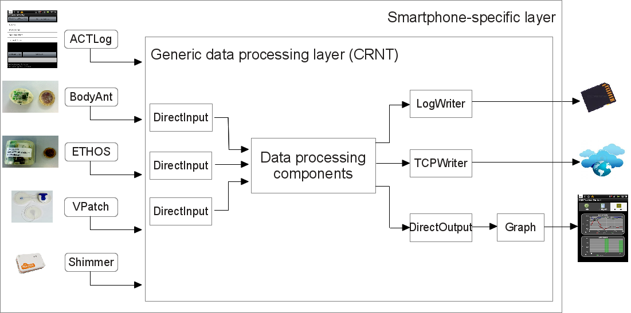
Figure 1 Functional overview of the CRNTC+ framework. Reader components are used to capture sensor data and user input , while Writer components serve to output information, e.g. through a Graph component or via a WLAN link. Our approach considers smartphone-specific (platformdependent) and generic data processing layers.

Implementation
In our framework design and implementation we targeted extensibility, and scalability through convenient interfaces to add and customise components. Moreover, design efficiency is key to minimise energy consumption. Here, we detail the implementation of key component classes: Readers and Writers. Moreover, general implementation considerations for CRNTC+ on the Android platform are described. Readers: To interface with sensors and devices via different communication standards Readers are used. Through Readers, various smartphone-integrated sensors can be recorded. Examples for external device interfaces include BluetoothReader and ANTReader components. Readers connect to devices specified in the component configuration. Depending on the sensor device protocol, data streaming is subsequently started and readings are decoded for further processing in the framework. E.g., ANTReader uses the ANT+ protocol to connect to sports or custom devices, such as BodyANT, ETHOS, and Vpatch. The BluetoothReader can be used, e.g., to interface to a heart rate belt or to Bluetooth accelerometers. Due to the phone APIs, Readers reside in the smartphone-specific layer of CRNTC+. Writers: Writers encode data streams from CRNTC+ for further analysis and feedback. E.g., the Graph component provides a timeseries view on the phone’s screen for reviewing sensor or feature data. Writers reside in smartphone-specific and generic data processing layers. E.g., data file logging to an SD card can be performed through the LogWriter component using generic POSIX calls, whereas the Graph component requires platform-dependent features. Component instantiation: In CRNTC+ a JSON-based configuration is used to describe component instances, their parameters, and communication links. A JSON configuration is instantiated at runtime by matching a class definition of the component. The GSON library was used to convert JSON representation into Java Objects using string mapping. When a JSON configuration file is loaded, the type field representing the module is checked and, if it matches to a map key, this module is instantiated by using the class definition that is coupled to the key. Reader for user annotations: To enable smartphone users annotating sensor data, CRNTC+ integrates an ACTLog component, which works as a reader for user input. ACTLog provides a configurable UI within CRNTC+ to capture annotations in pre-configured categories. To annotate data, the phone user needs to tap and hold a category label and then select a sub-category label instance from a configured list displayed. Annotations can be directly processed in CRNTC+ or stored to a labels file for subsequent analysis. ACTLog resides in the smartphone-specific layer. Between-layer communication: Besides direct withinlayer communication, DirectInput and DirectOutput components are used as internal gateways to transfer data between framework layers. This design is needed to bridge between the different implementations of both layers: while the smartphone-specific layer uses native code of the Android platform, the generic processing is integrated as a library in the CRNTC+ application. A direct data communication between the layers is essential to minimise overhead and processing load compared to other communication forms between layers, such as RPC or TCP/UDP.

Framework characterization
To evaluate the CRNTC+ framework performance, we assessed extensibility, scalability, and energy consumption. Extensibility: We evaluated the ease of adding a new component and measured the steps necessary to create new Readers and Writers. Table 1 summarizes the extensibility evaluation results. Four steps were needed to add a new sensor Reader component and Writer, with 18 code lines and 22 code lines, respectively. Adding a new UI element requires five steps and 34 code lines. While the actual complexity of adding components depends on the required functionality, the evaluation indicates the basic framework-specific requirements for an extension. It can be observed that UI elements require the largest effort, since an icon is needed and the Android framework requires to handle life cycles of “Activities”. Overall, the result indicates that the framework does not imply complex steps for functionality extension. Scalability: We evaluated scalability by incrementally adding, recording, and visualizing calibrated accelerometer data from Shimmer sensors. To assess performance we measured CPU usage and measurement jitter. Up to three sensors could be simultaneously recorded without loosing samples at a sampling rate of 200 Hz. When using four sensors, responsiveness of the UI reduced and CPU time for updating the UI decreased. This result suggests that three sensors could be safely recorded without loosing samples. Energy consumption: For the Epilepsy case study described in Sec. VI, two applications have been created for gathering sensors data and for seizure event detection. During the execution of both applications, energy consumption of the smartphone was monitored. With the full sensor configuration, battery level discharged by 80% during _6 hours of sensor recording. This result can be explained by the continuous data writing onto the SD card, decoding of data sent via Bluetooth, and continuous screen use for annotating data. It can be expected that reducing sensors will reduce energy needs. Similarly, online processing without storing to the SD card could increase battery life.

Table 1 Extensibility assessing CRNT+ for adding components. Estimations indicate the smallest effort. For functional components, actual effort can be larger.
Add Readers components
Step | Minimum lines of code | Other complexities
- Extend Module class | 3 | Further subclassing
- Extend ReaderClass class | 13 | Depending on sensor
- Add Module class definition | 1 | None
- Add ReaderClass class definition | 1 | None
Add Writers components
Step | Minimum lines of code | Other complexities
- Extend OutputModule class | 7 | None
- Extend OutputClass class | 13 | None
- Add Module class definition | 1 | None
- Add OutputClass class definition | 1 | None
Add user interface (UI) components
Step
- Extend GUIModule class | 12 | None
- Extend MyTabActivity class | 13 | Retrieve GUIModule
- Create icons | 0 | None
- Create layout xml file | 3 | Depends on GUI structure
- Create drawable xml file | 6 | None

Experimental evaluation

Epilepsy evaluation study
We evaluated the CRNTC+ framework in a case study to investigate data acquisition from multi-modal on-body sensors and recognising seizures. Since epileptic seizures often occur only sporadically in patients during daytime, two expert actors were asked to simulate five different seizures types (myoclonic, tonic, tonic-clonic, clonic, myoclonic tonic-clonic) during ten everyday activities, including lying in bed, getting dressed, scratching, drinking from a glass, brushing teeth, sit-ups, shaking hands, using mouse, typing on a keyboard, folding towels. Heart rate data were acquired using a Shimmer ECG module, placed at the left upper arm. The module featured a 3D accelerometer too. Disposable electrodes were connected to the ECG module and attached to the participant’s chest. Respiratory data were acquired using a Braebon, strap, placed around participants’ thorax and connected to a second Shimmer ECG module. Another 3D accelerometer was placed at the right upper arm. Two full inertial motion units (one ETHOS and one Shimmer 9DOF) were placed at participants’ left and right wrists. Data was acquired at two different sampling rates: for the Shimmer units 100 Hz, and for the ETHOS sensor 128 Hz. All the sensing modules were hold in place using adjustable velcro straps. Data from all sensors was recorded via Bluetooth (Shimmer) and ANT (ETHOS) using a Sony Ericsson Xperia active smartphone. A study observer was carrying the phone and used ACTLog to annotate the activities during recordings. Since expert actors were recorded instead of epilepsy patients, heart rate and breathing pattern reacted with a delay and caused by the physical activity related to simulated seizures, rather than an actual seizure. Thus, ECG and respiratory data was considered to assess the CRNTC+ framework scalability, but excluded from further analysis.

Epilepsy study results
Approximately 40 min of continuous recording were acquired per participant. Data was segmented using a window size of 100 sa. Variance of the 3D accelerometers unit placed on both the upper arms and on the dominant wrist was analysed and used in a two-class classification (seizure against non-seizure). All analyses were performed using the CRNTC+ and a frame-based evaluation. First, to train an offline kNN classifier (k=3), 500 samples per class were randomly selected from data from both actors. Remaining samples were used for testing. Subsequently, to test the feasibility of real-time seizure detection, the configuration was tested online. For practical application we considered that the system should alarm within one second from the start of a seizure. To satisfy the real-time constraint of the online evaluation, the training set needed reduction to 100 samples and only one sensor was used. The performance limiting factors for the real-time analysis were the Shimmer sensor data transmission and the classifier processing. The offline detection test using 3 accelerometers, showed a class specific accuracy of 74% for seizure event and 64% for non-seizure. For the one-sensor configurations, 72% and 59% was obtained for the upper left arm, 76% and 63% for the upper right arm, and 81% and 62% at the wrist, for seizure events and non-seizure times respectively. Subsequently, the right wrist sensor was chosen to test online recognition performances. Figure 2 summarizes the performance results. For the online recognition, the reduced training set resulted in a deteriorated performance, with 78% for seizure events and 55% for non-seizure times. After revising the training set to the core seizure phase with high motion intensity only, performance improved to 86% for seizure events and 78% for non-seizure times.
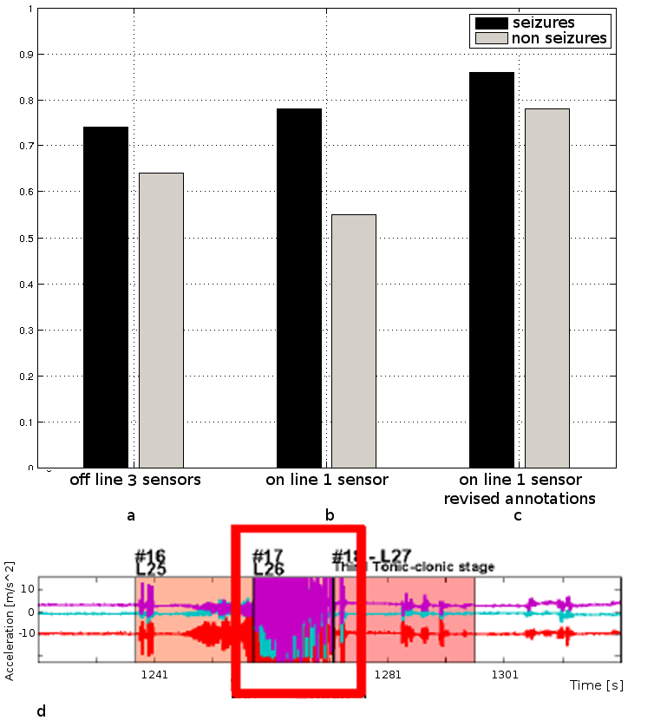
Figure 2 Epilepsy seizure detection performance using the CRNTC+ framework. (a): offline, using three 3D acc. units placed on the upper arms and dominant wrist. (b): online, using one 3D acc. unit at wrist. (c): online, using one 3D acc. unit at wrist with revised training data (see main text for details). (d): Annotation example for a Tonic-clonic seizure. The red square marking indicates the seizure part used as training data for the results in panel (c).

Conclusion and future work
We proposed and evaluated a new framework for smartphone-based sensor data recording and processing, which emphasises extensibility and leverages the widely used CRN toolbox for generic data processing algorithms. The new CRNTC+ was implemented in a layered framework design. Our formal evaluation and study results showed that CRNTC+ is versatile to handle various multi-modal sensors and recognition solutions, which are essential to prototype patient care solutions with phones. While the present investigation focused on assessing feasibility of CRNTC+ for epilepsy detection in daily life, further work is needed to optimize the detection by evaluating additional algorithms and evaluation in larger studies.

COPDTrainer: A Smartphone-based Motion Rehabilitation Training System with Real-Time Acoustic Feedback
Patient motion training requires adaptive, personalized exercise models and systems that are easy to handle. In this paper, we evaluate a training system based on a smartphone that integrates in clinical routines and serves as a tool for therapist and patient. Only the smartphone’s build-in inertial sensors were used to monitor exercise execution and providing acoustic feedback on exercise performance and exercise errors. We used a sinusoidal motion model to exploit the typical repetitive structure of motion exercises. A Teach-mode was used to personalize the system by training under the guidance of a therapist and deriving exercise model parameters. Subsequently, in a Train-mode, the system provides exercise feedback. We validate our approach in a validation with healthy volunteers and in an intervention study with COPD patients. System performance, trainee performance, and feedback efficacy were analysed. We further compare the therapist and training system performances and demonstrate that our approach is viable.

Introduction
Cardiopulmonary fitness is a well-known condition for our long-term health and wellness [11]. In particular, patients suffering from the widespread cardiovascular diseases (CVD) and chronic pulmonary obstructive disease (COPD) can benefit from physical training. Nevertheless, CVD and COPD patients have special requirements regarding fitness training, related to their physical ability, determining type and intensity of exercises, and practical systems to support them. For example, generally healthy people could regularly jog and run, and even over-train without immediate health consequences. In chronic patients, both over-training and undertraining could lead to quick and detrimental worsening of the health condition, resulting in exacerbations and hospitalisation, or death [2]. In addition, chronic patients often fear to exercise wrongly [16], if not under therapist supervision. While therapists can recommend exercises for the patient’s independent training, both therapist and patient have no means to assess the exercise performance during independent training. Ubiquitous and on-body systems could enable patients to perform additional physical training on their own, in addition to the supervised training with a therapist. Fitness and sports studies revealed a series of challenges for monitoring and coaching, when using ubiquitous and onbody sensing systems. In a recent survey, Kranz et al. [10] identified usability improvement, instruction quality, and long-term motivation as core design aspects of fitness training systems. Usability improvement refers to reduced labour in maintaining log-books or other manual records during training. Instruction quality refers to the guidance a trainee is provided with, to adequately execute an exercise. We believe that system feedback could prevent injuries, or worsening conditions in patients. During rehabilitation exercise training, for example, different errors can co-occur and should be identified accordingly. Moreover, it is essential that an error estimation algorithm can handle different exercises with minimal adjustments to support training variety. Adequate feedback depends on individual skills and fitness level, which is particularly varying in chronic patients corresponding to their rehabilitation progress. Thus, error estimation algorithms should be adjustable to a patient’s individual capability level. Until now, many error monitoring approaches focused on individual exercises or specific multisensor training devices that helped to stratify error conditions. However, attaching multiple devices is often too difficult for patients to train individually. While on-body sensors could be comfortable during exercise training, their cost and handling is challenging for patients. The widespread adoption of smartphones provides a platform for healthcare applications that is directly available to patients. In this work, we introduce a smartphone-based motion rehabilitation training system, intended for individual exercising of chronic patients. The system processes motion sensor data online on the phone and provides real-time acoustic feedback regarding the exercise performance and quality. We investigate whether exercise model parameters describing typical rehabilitation exercises can be derived from a smartphone’s internal sensors to reliably support patient training and provide real-time feedback. In particular, this paper provides the following contributions: 1. We introduce a training approach, where the trainee has to attach a holster carrying the smartphone only. After an initial rehabilitation exercising session with the therapist (Teach-mode), individual training (Train-mode) can be performed. 2. We validated our system with healthy individuals performing six limb movement exercises as they are commonly prescribed for COPD patients. We model errors using motion parameters and classify nine performance classes (including “correct” and eight error conditions). Subsequently, we evaluate our system in an intervention study with seven COPD patients. We assess system recognition performance regarding exercise and performance classes. 3. In further analyses of the COPD patient study data, we determine patients’ training performance, error trends, and feedback efficacy. Furthermore, we compare the therapist training error assessment against the sensor-based measurements. We confirm that the smartphone-based training system can achieve similar performance than when assessed by a therapist. Our approach integrates into this clinical rehabilitation routine by incorporating a Teach-mode, where training is performed under therapist supervision. During Teach-mode, our system derives motion parameters that are subsequently used during the Train-mode to estimate training performance and quality. Hence, the system could serve as a novel tool for therapists and their chronic patients to improve training options, both in the rehab center and at home. The smartphone serves as single training device, thus reducing starting barriers for rehabilitation training, including cost, availability, and handling of devices.

Related works
A few works assess the quality of exercise activities being performed, especially for clinical applications. Analysing exercises performance is usually done by means of cameras [9], depth cameras [4] or optical motion capture systems in combination with passive markers (Vicon, OptiTrack). In general vision-based systems allow users to easily extract a human skeleton automatically, but require constrained environments to install and calibrate cameras. Various ambient and on-body device developments identified opportunities for continuous training and coaching in fitness and sports outside the lab, such as the Ubifit Garden [5], MOPET system [1], and Triple- Beat [6]. Smartphones are being widely deployed and provide several integrated sensors to analyze data in real-time and provide training performance feedback. Thus, smartphones could be used as stand-alone systems to minimize costs hurdles in applications. For example smartphones were used as a mobile exercise skill assessment tool (GymSkill) to support personal health and fitness [12]. GymSkill monitors exercise quality performed on a balance board and provides feedback according to various parameters including regularity of movements. Muehlbauer et al. [14] exploited arm worn smartphones to recognize and count upper body resistance training exercises from a acceleration sensors. In [15] the authors introduced an algorithm based on dynamic time warping, which uses acceleration data to evaluate the number and duration of correctly recognized repetitions. The application provided real-time feedback on the duration of repetitions and was studied in healthy individuals. Further parameters, including the range of motion and efficacy of the feedback were not considered. Wearable distributed sensors and other dedicated devices were used in several exercise and sports studies. Strohrmann et al. [17] assessed performance level, training assistance and fatigue monitoring of runners. Tseng et al. [18] used accelerometers and compass sensors in a rehabilitation game to increase motivation. The system provided scores on movement quality. A fixed rule-set was used to recognise activities. Chang et al. in [3] proposed a system to recognize motion patterns and count repetitions of a limited set of freeweight exercises using acceleration data from a glove and a chest belt. The system did not provide feedback on execution quality since start and end of a repetition were not detected. Although their counting algorithm showed good results, it needed re-training to obtain accurate results for different exercise speeds. Moreover, training data was required to obtain pattern models off-line. Velloso et al. [19] used five Xsens sensors and a Kinect camera to derive pattern models during an exercise demonstration performed by an expert. The system then detected mistakes and guided users on improving their performance. Three weight training exercises were studied, however system recognition performance to detect training errors were not analysed. The deployment of the Kinect camera constrained the field of view to a 2m distance from the system. Limbs should not be pointed directly at the camera or be occluded by the body, which limits the exercises that could be monitored. The related works discussed above focused mainly on gym monitoring applications for healthy subjects. Often these approaches relied on multi-sensor information and pattern recognition methods, requiring individual learning of motion pattern models. Our work aims at describing different training exercises with the same exercise quality parameters and a sinusoidal model. In our approach, a smartphone serves as single measurement, estimation, and feedback device for assessing patient exercise performances. We evaluate our method’s recognition performance for classifying execution errors, which is necessary to deploy the system in practice and especially in a clinical application. To the best of our knowledge, no existing commercial or academic work exploits smartphones to assess training quality in chronic patients. Likewise, recognition performance for classifying execution errors was not evaluated in similar systems for a clinical application.

Smartphone-based training approach
The ability to perform particular motion exercises differs between trainees, due to individual motion constraints. Chronic patients often suffer from limiting pathologies and muscle weakness, thus may not be able to perform exercises at the same speed or range of motion of another trainee. To use the smartphone as an exercise monitoring and feedback device in this user group, it was attached in a holster to a body part or limb involved in the exercise. The phone’s integrated inertial sensors could thus capture the motion performance. After performing one exercise, the holster could be moved to a position designated for the next exercise. Illustrations on the phone’s screen guided the trainee during attachments. Here, we describe our training approach that includes Teach-mode and Train-mode operation as illustrated in Figure 3 and our motion exercise modeling approach.

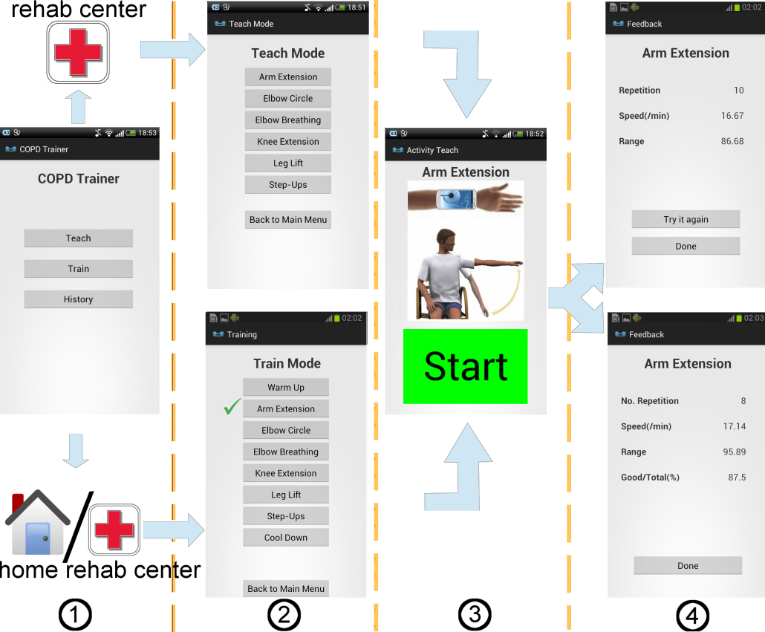
Figure 3 COPDTrainer training approach. Our smartphone app is meant to enable individual training options of a patient, besides the training with therapists. (1): Patient/therapist selects Teach-mode or Train-mode. (2): Select an exercise, here Arm extension. (3): Begin exercising after pressing start. (4): After exercising different summary screens are shown, depending on the operation mode.

Teach-mode operation
The Teach-mode allows therapists to personalise the system for a trainee under direct supervision, e.g. during the regular physiotherapy practicing times. Any selectable exercise can be performed and the trainee learns from the therapist how to attach the phone and perform a particular exercise. Illustrations are shown on the screen after selecting an exercise to remind the patient about the exercise execution independently of the operation mode. In Teach-mode, the therapist initially guides the patient during the first trials to perform the exercise accurately. Subsequently, the Teach-mode recording is started by pressing a large button on the phone’s screen. A preset number of exercise repetitions (ten in the current implementation) will then be acquired from the phone’s inertial sensors. From the recorded data, all necessary exercise model parameters, i.e. mean and variance of the duration and of the range of motion of the limb during the ten repetitions) are estimated and stored for further use in the Train-mode. The derived parameters are shown on the smartphone, such that the therapist and trainee can review them. If the therapist judges that the trainee did not perform the exercise with sufficient quality, the session could be repeated. Moreover, the system checks consistency of the exercise repetitions and can thus reject a Teach-mode session that shows extensive execution variability. These choices consider the clinical routines, where therapists have only 30 to 45 min per patient for assessment, therapy, and exercise training. Thus, complex interactions with the device were avoided.

Train-mode operation
During Train-mode, the derived exercise models are arranged in a todo-list for the trainee to complete. This mode is intended to be used by the trainee to exercise without therapist supervision, i.e. at the rehab center or at home. After selecting an exercise to be performed and starting the Train-mode, inertial motion data is recorded from the phone’s sensors and processed in real-time to count the exercise repetitions and detect errors. While training, the smartphone system will provide acoustic feedback on the counted repetitions and notify when errors occur. E.g., if the trainee had practised an exercise with the therapist before, but starts to perform repetitions faster than during the Teach-mode, the system will provide the feedback “move slower”. This feedback could prevent injuries from repetitive erroneous movements. Finally, after that the configured number of repetitions were detected, the system will ask the trainee to stop and displays a summary of the execution performance.

Motion exercise modeling
Based on the observation that many fitness exercises have a repetitive structure, from training with free weights to cardio fitness motion, we consider a sinusoidal motion model. For each exercise, a representative motion feature could be chosen that represents a sinusoidal pattern. The feature can be based on a single raw sensor axis or fused from several sensors, such as orientation estimates. For example, in a lateral arm abduction exercise, where the phone is attached to the wrist, the anterior-posterior orientation angle could be used as motion feature. Figure 4 shows an example waveform for several repetitions of an exercise. Advised by three therapists and after consulting COPD guidelines, we derived speed of motion (corresponding to the period frequency) and range of motion (corresponding to the feature amplitude) from the sinusoidal pattern of each exercise repetition. In Kinesiology speed and range of motion, together with their relative tolerances and the number of repetitions, are considered standard measures for exercise monitoring [7]. Estimating movement speed during exercises is useful to educate patients in breathing techniques (i.e. by exercising the patient can learn how to breath with a correct timing). Based on these exercise quality parameters, we derived performance classes, such that the classes are applicable to various exercises that are performed by repetitive movements. During the Teach-mode, exercise repetitions are used to represent repetition range and duration parameters using two normal distributions. In the Train-mode, these model parameters are used to identify nine performance classes. The classification approach is further described in the following section.

Algorithm implementation
Here, we describe the algorithm implementation for segmenting and evaluating exercise performances in a stand-alone Android smartphone application.

Teach-mode implementation
For any exercise to be monitored, the smartphone body attachment and the motion feature representing the sinusoidal pattern need to be chosen. Subsequently, during the Teachmode, the application records inertial sensor data from accelerometers, magnetometers, and the orientation API, and stores the data for the later analysis. Since the Teach-mode is performed under therapist supervision, no real-time feedback will be provided. Once the trainee completes an exercise session with a preset number of repetitions, the application loads the stored data and extracts the exercise model parameters. The following processing steps were applied to derive the model parameters.
Filtering. The selected motion feature was filtered using a moving average to remove tremor-induced noise and sensor noise. The window size was set proportional to the amount of data acquired (i.e. WindowSize = DataSize Scaling/Factor , with ScalingFactor determined empirically and set to 80). We observed that this approach provided consistent results across the different exercises. Since the number of repetitions is preconfigured, we assume that the total data amount recorded is proportional to the movement speed during the exercise execution: the faster a trainee performs the exercise, the lower muscular tremor would be, and thus, data averaging can be reduced. Bounds were applied to the averaging window size, to prevent ineffective averaging for very fast/slow repetitions (15≤WindowSize≤31 sa.)
Period estimation. By estimating the position of positive and negative peaks in the filtered motion feature, exercise repetitions were counted. For the Arm abduction exercise, Oy will be maximal when the arm is raised to shoulder height. It reaches its minimum value when the arm returns to the neutral position (arm aligned to the trunk). We used an adaptive hillclimbing algorithm to detect positive and negative peaks (denoted in Figure 4 by pp_{i} and np_{i}, respectively), given a peak threshold θ. The hill-climbing algorithm is a popular first choice among optimisation algorithms. While there are many alternatives, such as simulated annealing or tabu search, hill-climbing can achieve sufficient or better results if runtime is constrained, such as in the real-time system targeted here. Figure 4 illustrates an example motion waveform with the exercise parameters. In particular a maximum (minimum) was selected, if both sides (uphill h_{u} and downhill h_{d}) are greater than the peak threshold θ. In this work, we estimate θ during the Teach-mode. Starting from an initial setting θ = θ_{in}, θ was adjusted in steps of 1.2 until the preset repetition number was obtained. We set the number of exercise repetitions to ten. The fitted θ=θ_{opt} was subsequently applied during Trainmode operation.

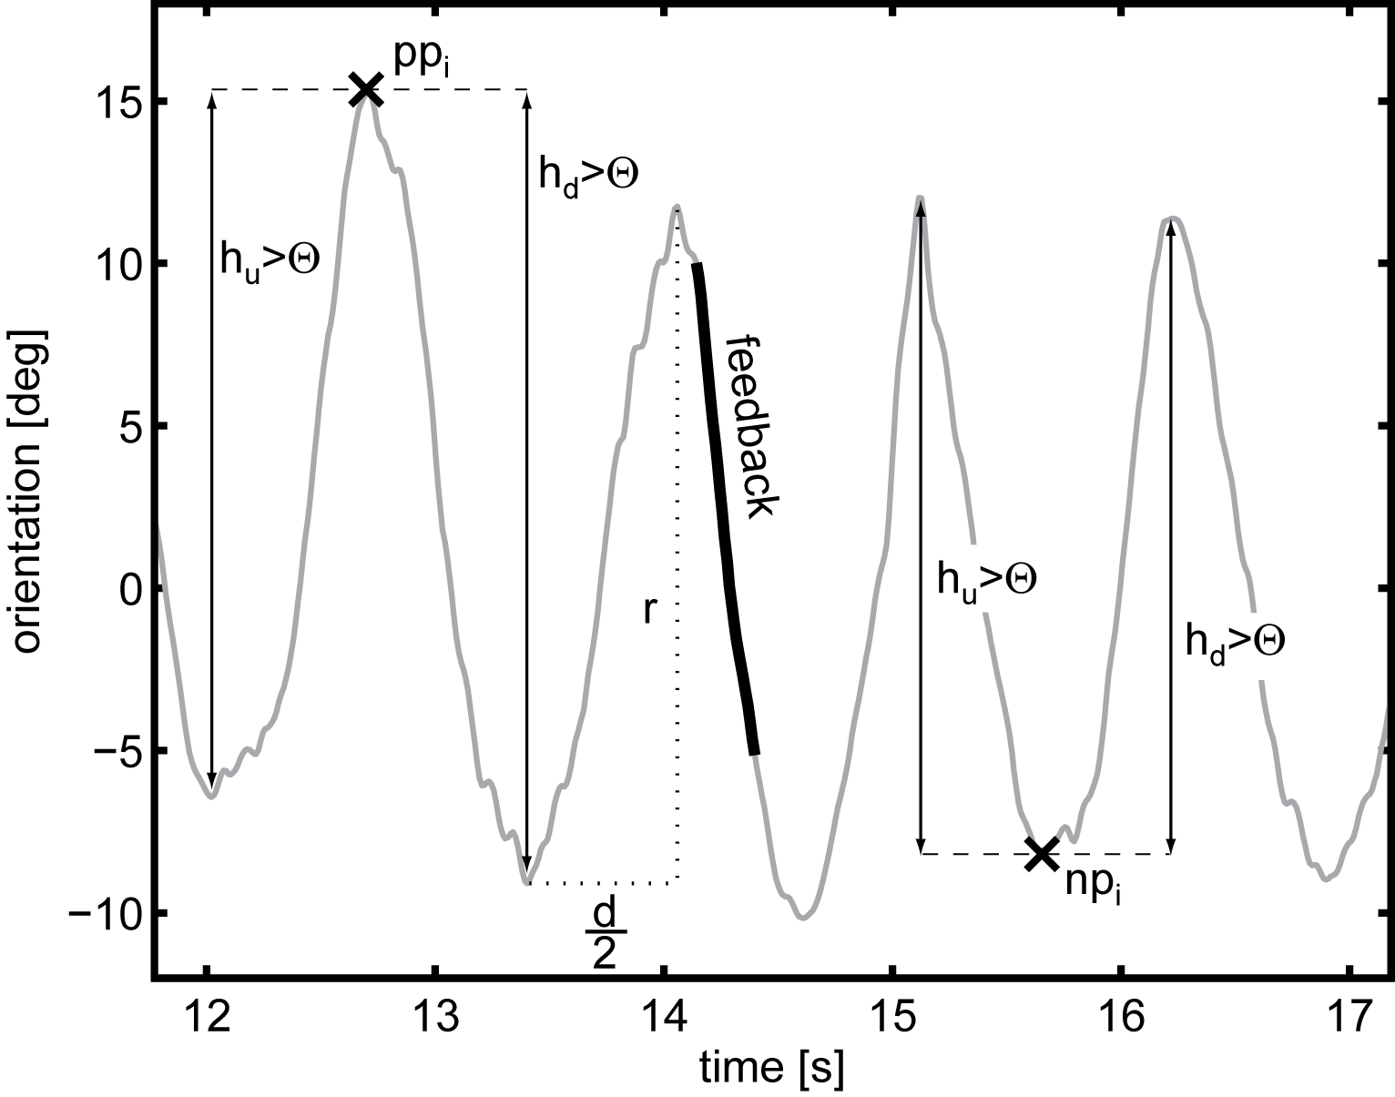
Figure 4 Example waveform of the Pitch motion feature (O_{y}) selected for the Arm abduction exercise. The hill-climbing parameter θ is fitted during system runtime (Teach-mode) for each exercise. The horizontal dashed line indicates the estimated duration d/2, the vertical line indicates the estimated range of motion r. Online feedback is provided in the indicated region.

Peak correction. While the hill-climbing algorithm has low runtime complexity, the detection of local maxima and minima remains susceptible to detecting additional peaks (insertion), e.g. during vibrations, or to missing peaks (deletion) if the signal amplitude decreases. In situations where there is one insertion or deletion error in sequence, the alternating order of positive and negative peaks is interrupted. If two consecutive positive or negative peaks were derived a peak correction algorithm was applied. This peak correction works by first removing redundant peaks and then inserting missing peaks that were missed during the first iteration of the hill-climbing algorithm. If two consecutive positive (negative) peaks were detected, the algorithm compare them and removes the one having a smaller (greater) amplitude, thus restoring the alternating of maxima and minima. Subsequently, time intervals Δt between two consecutive peaks were used to determine if there could be peaks missing. If an interval was larger than m_{Δt+}σ_{Δt}, where m_{Δt} and σ_{Δt} are mean and standard deviation of the intervals, it was assumed that peaks might be missing. Missing peaks were searched by applying hill-climbing within the section delimited by the consecutive peaks. A smaller threshold θ (reduced by 20% of its initial value) was then used. The hill-climbing was iterated while adjusting θ until a peak was found, or a lower limit of θ < θ_{opt}/2 was reached.
Exercise model parameter estimation. The following five parameters were derived: number of repetitions (n), mean and standard deviation of repetition duration d (m_{d}, σ_{d}), and mean and standard deviation of the range of motion r (m_{r}, σ_{r}). The repetition duration was derived from the time interval Δt between two adjacent minima. The range of motion was derived from the magnitude difference between adjacent negative and positive peaks. The number of repetitions could be obtained by counting the number of maxima. Since capabilities between trainees vary a small initial peak threshold θ_{in} was fixed per exercise to detect small motion, while avoiding capturing vibration and noise. Table 2 provides an overview on the exercises and parameters.

Table 2 Overview on the rehabilitation exercises and parameter ranges estimated in this work. All parameters were dynamically fitted during system runtime to personalize the training.
Exercise | Motion feature | θ_{in}  [degree] | [θ_{min} - θ_{max}]  [degree] | [d_{min} - d_{max}]  [samples] | [r_{min} - r_{max}]  [degree]
Ex1: Arm abductions | Pitch O_{y} | 25 | [22.5-22.5] | [3.1-4.6] | [70.4-82.8]
Ex2: Elbow circle | Pitch O_{y} | 15 | [13.5-18.9] | [1.5-2.6] | [24.0-42.6]
Ex3: Elbow breathing | Azimuth O_{x} | 15 | [13.5-13.5] | [2.5-3.2] | [40.1-68.1]
Ex4: Knee extensions | Pitch O_{y} | 15 | [13.5-13.5] | [2.6-3.5] | [58.3-87.0]
Ex5: Leg lifts | Pitch O_{y} | 10 | [3.1-9.0] | [2.5-3.3] | [7.6-21.9]
Ex6: Steps up | Pitch O_{y} | 6 | [3.1-9.0] | [3.5-4.9] | [13.0-36.4]

Train-mode implementation
Data segmentation. In contrast to the Teach-mode, Trainmode operation requires online period estimation and subsequent performance analysis. A sliding window was used to segment the incoming data stream. The sliding window size was set to cover two average repetitions based on the parameters estimated in the Teach-mode (2m_{d}) with an overlap of 75% between consecutive windows. The overlap ensures timely feedback during a newly detected repetition.
Period estimation. The hill-climbing algorithm was applied in the sliding windows, configured according to the Teachmode. Due to the overlap in sliding windows, duplicate peak detections had to be corrected by matching the peak locations across the sliding windows.

Exercise performance class estimation
Based on the peak detection, repetitions could be counted. To provide timely feedback, i.e. before the trainee starts a subsequent repetition, the first half of a repetition was evaluated to estimate duration and range of motion estimates. In preliminary tests, we observed that the error incurred by considering only half of a repetition was negligible. The derived duration d_{i} and range of motion r_{i} estimates were used to compare with the parameters estimated in the Teach-mode, i.e. m_{d}, σ_{d}, m_{r} and σ_{r}. For duration and range of motion, each repetition performance is estimated based on a Gaussian distribution N(m_{d}; σ_{d}) and N(m_{r}; σ_{r}). The performance of each exercise is classified into 3 class types: inbetween, under and above the ranges: [m_{d} - 2σ_{d}, m_{d} + 2σ_{d}] and [m_{r} - 2σ_{r}, m_{r} +2σ_{r}]. In total, there are then nine different classes to which each performed exercise repetition could be associated. While we aimed here at a generic system that can deal with various exercises, some of them may not benefit from all performance classes. For the exercise Steps up, only three performance classes (Correct, Too fast, Too slow) were expected, since step height was fixed by the stairs used, thus range of motion was not relevant for this exercise. After the performance class corresponding to the ongoing repetition was evaluated, an audio feedback was provided to the trainee, to notify if a repetition was erroneously performed. The nine performance classes and feedback are listed in Table 3.

Table 3 Performance classes, feedback and condition used to identify exercise quality.
# | Performance class  (feedback) | Condition
1 | Correct  (-) | d_{i} ϵ [m_{d} - 2σ_{d};m_{d} + 2σ_{d}],  r_{i} ϵ [m_{r} - 2σ_{r};m_{r} + 2σ_{r}]
2 | Too fast  (move slower) | d_{i} < m_{d} - 2σ_{d},  r_{i} ϵ [m_{r} - 2σ_{r};m_{r} + 2σ_{r}]
3 | Too slow  (move faster) | d_{i} > m_{d} + 2σ_{d},  r_{i} ϵ [m_{r} - 2σ_{r};m_{r} + 2σ_{r}]
4 | Too large  (move lower) | d_{i} ϵ [m_{d} - 2σ_{d};m_{d} + 2σ_{d}],  r_{i} > m_{r} + 2σ_{r}
5 | Too small  (move higher) | d_{i} ϵ [m_{d} - 2σ_{d};m_{d} + 2σ_{d}],  r_{i} < m_{r} - 2σ_{r}
6 | Too fast and too large  (move slower and lower) | d_{i} < m_{d} - 2σ_{d},  r_{i} < m_{r} + 2σ_{r}
7 | Too fast and too small  (move slower and higher) | d_{i} < m_{d} - 2σ_{d},  r_{i} < m_{r} - 2σ_{r}
8 | Too slow and too large  (move faster and lower) | d_{i} > m_{d} + 2σ_{d},  r_{i} > mr + 2σ_{r}
9 | Too slow and too small  (move faster and higher) | d_{i} > m_{d} + 2σ_{d},  r_{i} < m_{r} - 2σ_{r}

Evaluation study
To test and evaluate our training system, two sets of experiments were conducted. Initially, the system was validated with healthy participants using a scripted protocol where all performance classes have been equally represented. Subsequently, the training system was evaluated in an intervention study with COPD patients. The study was performed during normal therapy training sessions to evaluate the overall system performances and the feedback efficacy. Here we summarise the considered exercises and present the study protocols used with healthy participants and COPD patients.

Training exercises
Six exercises were chosen according to the COPD guidelines and in consultation with therapists. The exercises selected (as illustrated in Figure 5) do not require additional equipment to be performed, thus can be used also outside of the rehab center. Due to their utility in exercising the breathing, the therapists considered these exercises suitable for daily training at home. The exercise set consist of three upper body exercises and three lower body exercises. The upper body exercises, arm abductions (AA), elbow circles (EC) and elbow breathing (EB), increase strength in arm and shoulder muscles, while the lower body exercises, knee extensions (KE), leg lifts (LL) and step-ups (SU), train lower body muscles.

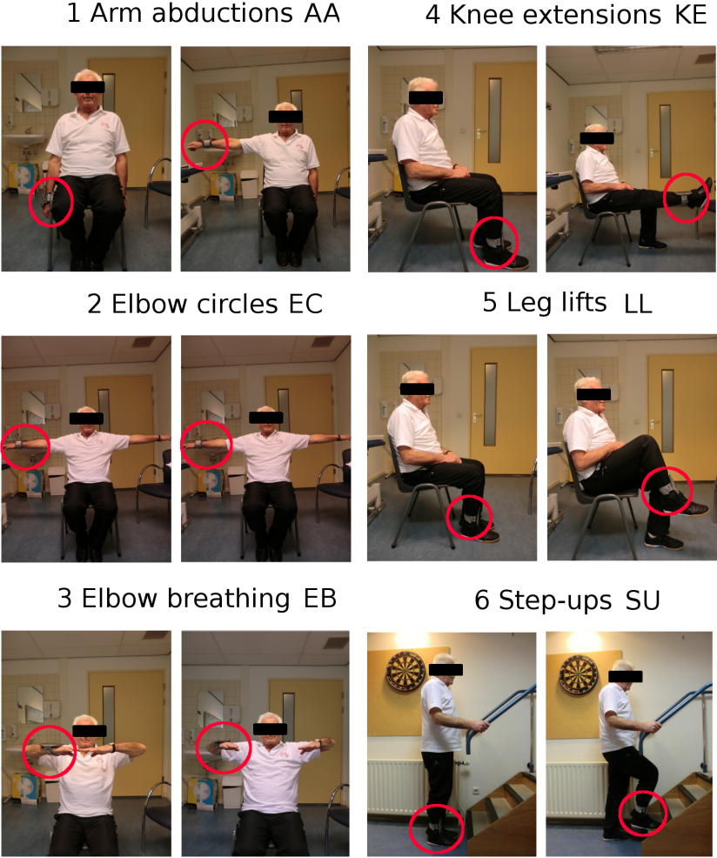
Figure 5 Illustration of the exercises selected for the training system evaluation with COPD patients. The patient is wearing the smartphone (red circle) on limbs that are involved in the different exercises. During the active part of the movements the patients were recommended to breathe in (inhale) and during the return phase to breathe out (exhale).

Data collection and exercise features
Both healthy participants and COPD patients were asked to wear the smartphone in a holster during the exercises. The holster was attached to the right wrist during the upper body exercises and to the right ankle during the leg exercises using Velcro straps. Three acceleration signals (A_{x}, A_{y}, A_{z}) and three Euler orientation angles (Azimuth O_{x}, Pitch O_{y} and Roll O_{z}) were recorded from the 3D accelerometer and magnetometer sensors embedded in a Samsung Galaxy SIII phone. Data was acquired at the sampling frequency of ~50Hz using the Android Software Development Kit (SDK). From the available motion signals, we chose orientation estimates as features to describe the sinusoidal exercise pattern. According to the phone orientation at the body, Azimuth orientation angle (O_{x}) was used for elbow breathing and Pitch (O_{y}) for all other exercises. Orientation estimates can be efficiently derived on smartphones, thus the approach can be used even on entry-level phones.

Validation with healthy participants
In this validation, we quantified the accuracy of the system in detecting the nine performance classes listed in Table 3. Four healthy participants (all male, 26±2.5 years old) were individually asked to perform nine exercise sessions of at least ten repetitions in the university sport center. An expert personal trainer instructed the participants to perform the exercises as required according to the protocol and supervised the whole data collection. After a first set of repetitions to familiarize with the exercise, ten continuous repetitions were recorded for the evaluation. The data gathering started with the acquisition of one correct session of ten repetitions during the Teach-mode. Afterwards participants were asked to perform the repetitions using the Train-mode.

Evaluation with COPD patients
Subsequently to the validation, we tested the training system in a pilot intervention study with COPD patients. For this evaluation, seven COPD patients (age 60 ± 10 years) were recruited while they were following a rehabilitation program in a specialized center for pulmonary diseases. The patients ranked a COPD GOLD score between II and III, FEV₁ was between 37% and 69% and FEV₁/FVC was between 27% and 69%. After being instructed on the exercise execution, one Teach-mode session for each exercise was performed with one therapist guiding the patient in order to perform correct movements and rejecting sessions that were not performed correctly. After completing the Teach-mode for all the exercises the therapist did not interact anymore with the patients to simulate individual training exercise executions. The patients started the Train-mode session by touching the start button on the smartphone’s screen and then began with the the training. During the exercise execution, the application gave audio feedback if an erroneous repetition was detected and asked the patients to terminate the session when ten repetitions were counted. While the patients were performing the exercises, one therapist judged each repetition, according to the movement errors defined before and annotated the performance for each repetition in a table. After the recordings, the annotations were digitized. Furthermore, a ground truth was derived after the recordings by reviewing the raw sensor data timeseries and labeling error classes for each exercise repetition based on the data. The ground truth labels were aligned according to the peaks and valleys in the sinusoidal exercise pattern. Speed and range of motion of each repetition were then calculated according to Table 3. In total each patient was asked to perform three sessions of ten repetitions per each of the six exercises. Patients could take a break in between if they wished to do so. Data was acquired in two sessions at separate days. During the first session four patients (P1, P2, P3, P4, 1 male and 3 female) were examined and during the second session the remaining 3 patients (P5, P6, P7, 2 male and 1 female). In the first session, patients (P1-P4) were specifically asked to alternate their training such that at least one other exercise was done in between Teach-mode and Train-mode performance of an exercise. With this protocol, we intended to avoid excessive effects of exercise memorisation. In the second session, patients (P5-P7) were not asked for alternating exercises. In our subsequent analysis we did not observe performance differences between the two sessions.

Results
This section describes the results of our system validation with healthy participants and the evaluation with COPD patients. Performance of the system to detect execution errors is detailed for both investigations. For the patient study, we furthermore analysed feedback efficacy. Finally, we compared the therapist’s performance in detecting erroneous exercise repetitions with the ones of our system.

Validation with healthy participants
We formally evaluated our system with a dataset acquired from healthy participants, using a scripted exercise and performance protocol. According to the protocol, participants were asked to perform all exercise movement errors, besides the correct execution of each exercise. Thus, the script and supervising trainer provided reference information for the ground truth used. Here we detail the recognition accuracy for all nine performance classes and six exercise classes.
Recognition confusion among performance classes. The average performance classification accuracy of the system was 96:2%, confirming that applicable feedback would have been provided for almost every exercise repetition. The confusion matrix for providing matching feedback (i.e. classify too slow when the recorded motion was slower than in the Teach-mode) for all performance classes is shown in Figure 6. The matrix illustrates very good accuracies for all performance classes, above 90%. Lowest accuracy (92%) was observed for performance class 9 (Too slow & too small), where thirteen repetitions where misclassified. A further analysis attributed these classification errors to challenges in performing Leg lifts (Ex. 5).
Recognition accuracy for exercise classes. To further analyse correctness of the feedback, Figure 7 shows the accuracy distribution across exercises and performance classes. It can be observed that most of the erroneous feedback in performance class 9 was given during exercise Leg lifts (Ex. 5), where the system showed lowest accuracy (77:5%).
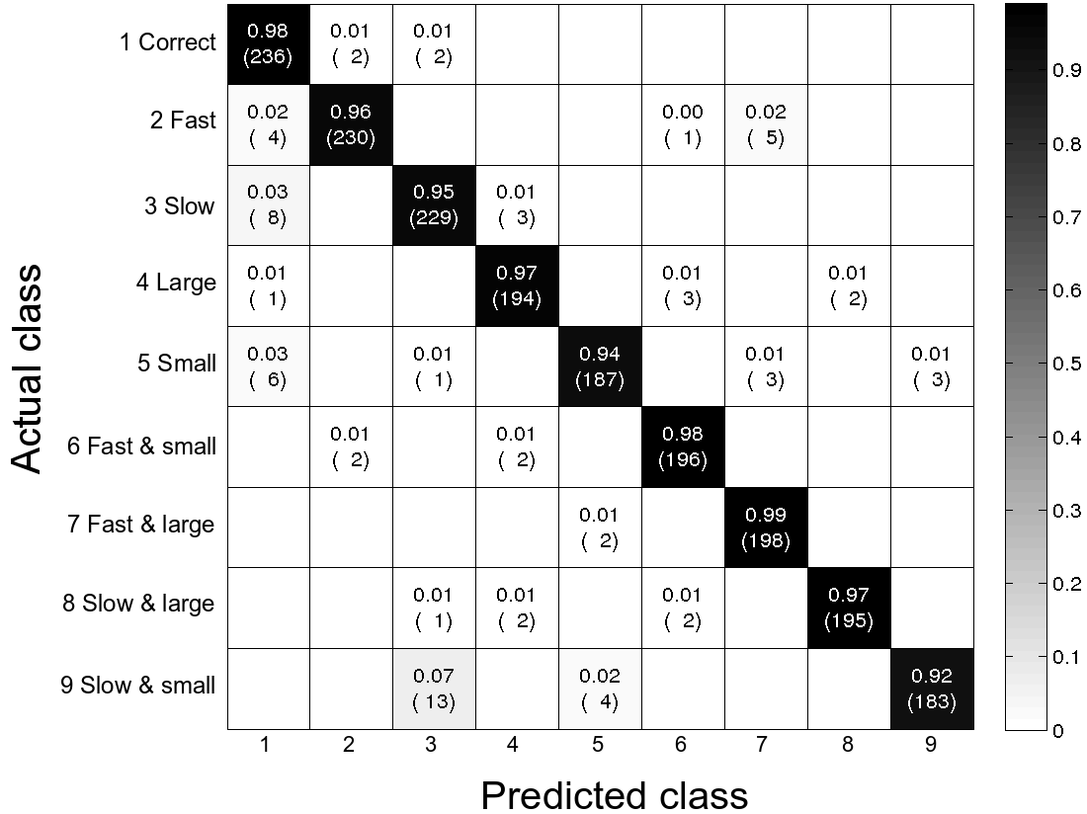
Figure 6 Recognition confusion for providing matching feedback across all exercises and validation study participants (healthy adults). Numbers in cells show class-relative accuracy (first line) and number of instances (second line).

Evaluation with COPD patient in intervention study
We evaluated system performance for counting exercise repetitions and recognizing the trainee errors performed in a group of seven COPD patients. During the intervention study recordings, we observed that the therapist could not accurately assess all exercise repetitions, because it was difficult to observe the patient’s movements and annotate the exercise performances simultaneously. A ground truth labeling was derived in a post-recording step according to the raw sensor measurements, as explained in Section Evaluation with COPD patients. We needed to exclude two sessions of Stepups performed by Patient 1, three sessions of Leg lifts, by Patient 3, and one session of Knee extensions by Patient 7, due to data recording issues. Patient 6 could only complete the first session of Elbow circles due to shoulder pain. In total, 1176 exercise repetitions were acquired and analyzed.
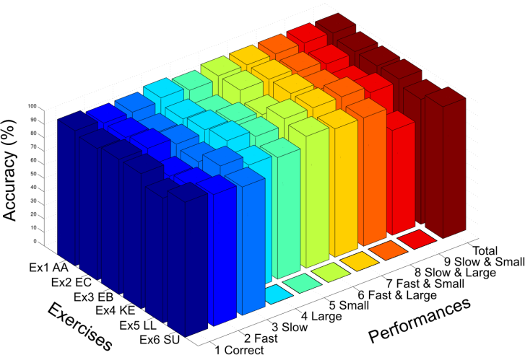
Figure 7 Recognition accuracies for exercises and performance classes in all validation study participants (healthy individuals). For exercise Step up (Ex. 6), no instances for performance classes 4-9 were recorded.

Accuracy in counting repetitions. Redundant feedback (insertions due to noise or vibration) and missing feedback (deletions due to missing peaks) were further considered in this analysis. Figure 8 shows examples of the two error types. Both insertion and deletion errors were considered for determining repetition counting performances. We denoted n_{p} as the number of repetitions performed and n_{c} the number of repetitions counted by the application. The repetition counting error incurred by our system for each exercise session is represented by ec = |n_{c} – n_{p}|. The error ratio for each exercise and patient are shown in Figure 9. Even thought the average counting error across all exercises for Patient 1 was acceptable (e_{c} = 9%), repetitions of P1 were challenging to identify, in particular during Elbow circle (e_{c} = 20%) and Leg lift (e_{c} = 31%) exercises. By grouping the patients, the two exercises challenging for repetition counting were instead Leg lift (e_{c} = 9.6%) and Step-up (e_{c} = 6.3%). For all other exercises, the error incurred by our training system was below 3%. The overall counting accuracy (acc_{c}) across all patients and exercises was set to acc_{c} = 100% - error_{tot}%, with acc_{c} = 96.7%.
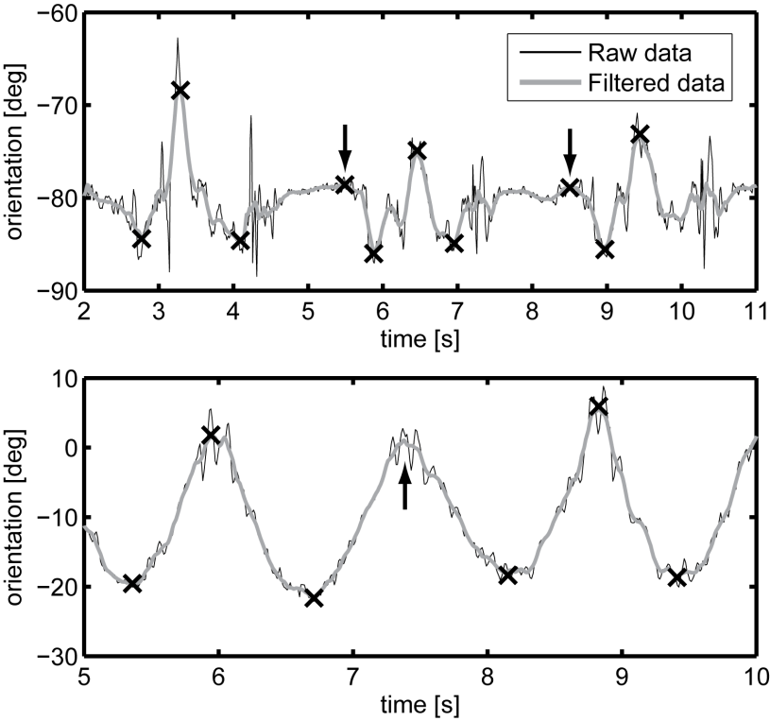
Figure 8 Timeseries plots from Leg lift (top) and Elbow circle (bottom) exercises illustrating insertion and deletion errors. Crosses indicate the local maxima and minima identified. Arrows indicate insertion (top) and deletion errors (bottom).

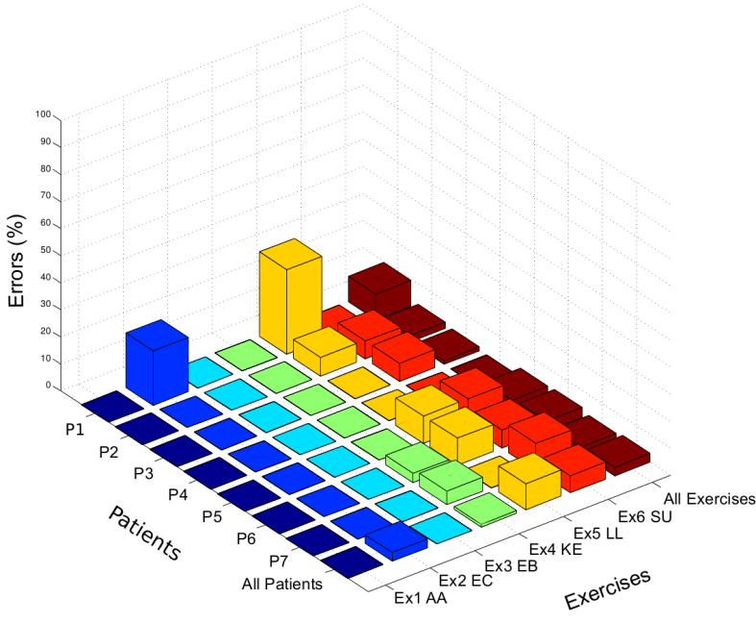
Figure 9 Exercise repetition counting error distribution in the patient intervention study.

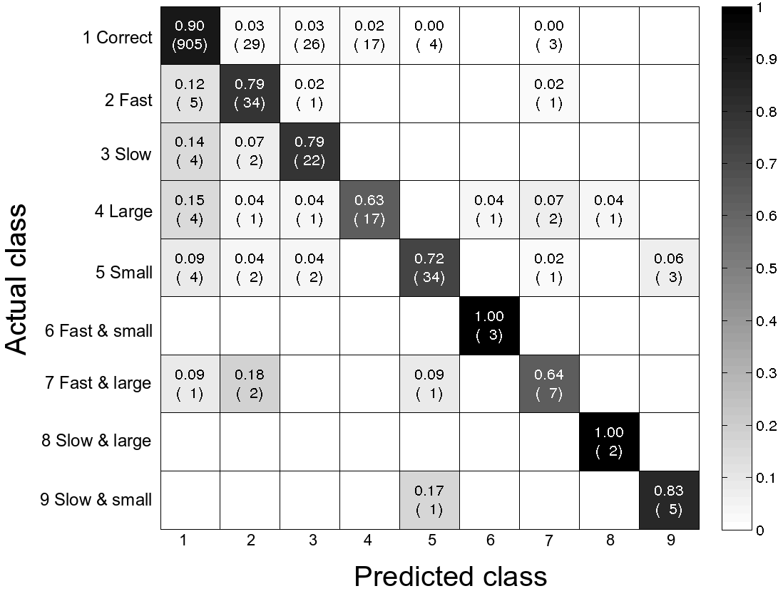
Figure 10 Recognition confusion for providing matching feedback across all exercises and intervention study patients. Numbers in cells show class-relative accuracy (first line) and number of instances (second line).

Accuracy of system feedback. Feedback caused by insertion errors represented repetitions that were actually not performed by the user (no ground truth reference available). Insertions were not further considered for the feedback analysis. Deletion errors were handled and taken into account when computing feedback accuracy, however deletions are not visible in the confusion matrix. The confusion matrix illustrating the system accuracy for providing matching feedback is depicted in Figure 10. Overall, an accuracy of 87.5% was achieved. Correctly performed repetitions (performance class 1) were recognized at 90%. For Too large (class 4) and Too fast and too small (class 9) a lower accuracy (63% and 64%, respectively) with regard to the healthy participants validation, was obtained. Furthermore, the distribution of the error across exercise repetitions was investigated and is shown in Figure 11. It can be observed that errors occurred mostly during first and last repetition of each exercise session (17% and 21% of the total errors, respectively). We assume that these repetitions may have been influenced by interactions of trainee and smartphone to start and stop recordings. Figure 12 further analyses the system’s feedback with regard to individual exercises and patient. As the result shows, for Patient 3, lowest accuracy (84%) was obtained. Leg lifts (Ex. 5) were the most challenging to recognise, resulting in an accuracy of 85%.
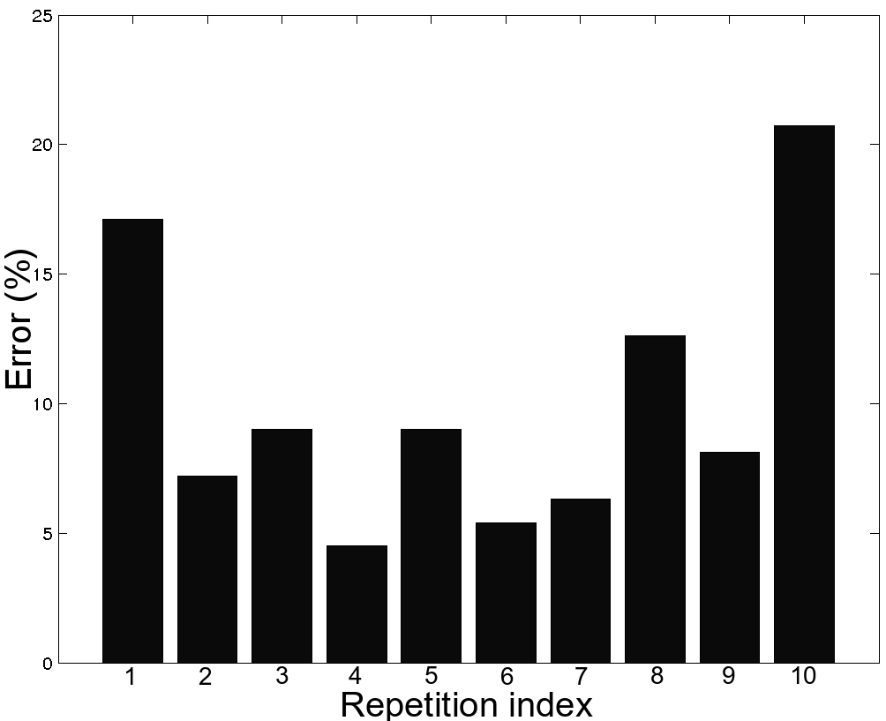
Figure 11 Patient performance error distribution for all exercise repetitions. Most errors occurred during first and last repetitions.

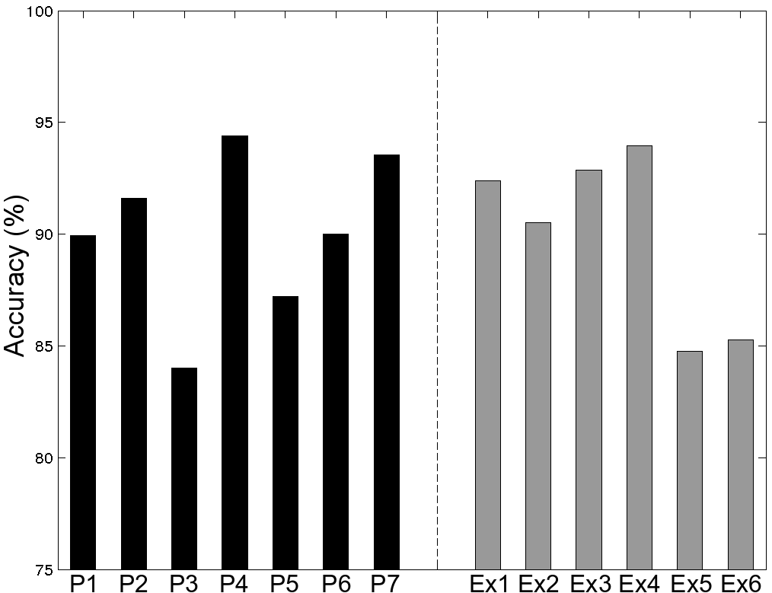
Figure 12 System feedback accuracy per patients (P1-P7) and exercise (Ex1-Ex6) in the intervention study.

Efficacy of the smartphone-based intervention. We evaluated the efficacy of feedback provided during the exercise sessions. Figure 13 shows how patients reacted to feedback during the training. After an audio feedback, a total of 297 repetitions were performed correctly. Feedback for 57 repetitions was ignored, with subsequent repetitions performed erroneously too. By analyzing changes in exercise performances, we observed that in 119 cases feedback caused a change in the following movement (both, correct and other erroneous performance). In 71 cases the feedback was ignored, not causing any change in behavior. In only 8 cases might the feedback have led to performing errors in the following repetition.
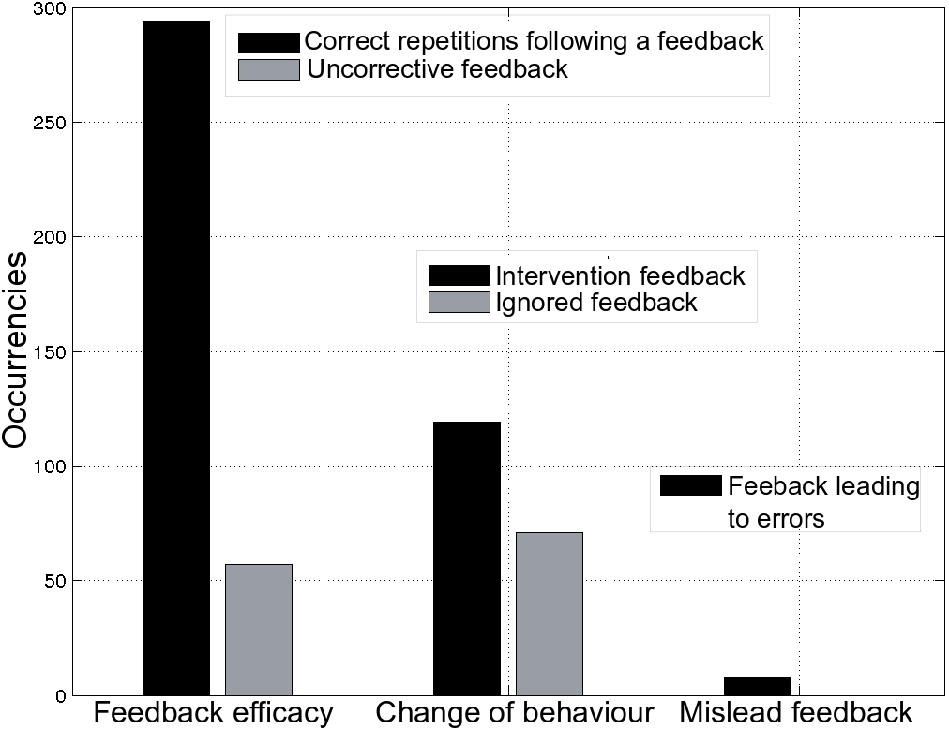
Figure 13 Feedback efficacy of the training system during the patient intervention study.

Comparison of therapist and training system. From literature it is known that therapists may disagree amongst them or could make errors when assessing training performance [8]. We analysed the therapist’s assessment in comparison to our ground truth. With this analysis, we could estimate an adequate performance level for our training system. Our analysis showed that the therapist performs better than our training system for the performance class Correct (96% vs. 90%). For all error performance classes, the training system shows better performance. Overall, performances match each other closely suggesting that the training system is suitable for providing exercise feedback.

Discussion
Our training error classification technique is based on a sinusoidal motion model, which showed good results in detecting movement errors for both, healthy adults and chronic patients. We chose this method over others for two reasons: (1) using machine learning techniques requires a training set to obtain the classifier model. In particular, a sufficient number of exercise error instances would be required. For our application, it was not feasible to let patients perform exercise errors due to the risk of injuries. (2) With machine learning techniques, it is difficult to differentiate variations in performance of the same exercise from execution errors. Hence, we formalized error classes by considering deviations from the correct execution using our sinusoidal model. We consider that other exercises can be integrated in our training system by selecting a suitable motion feature that reflects the sinusoidal pattern and estimating the initial hill-climbing parameter threshold. Subsequently, speed and range of motion can be considered to determine the performance classes. The relevance of a Teach-mode was confirmed by the parameter ranges obtained after estimating exercise model parameters for every patient. Hence, we expect that our exercise analysis approach is scalable to other patient groups requiring exercise training feedback systems.Figure 6 shows excellent system accuracies in the validation with healthy subjects for all performance classes. The remaining classification errors could be explained by the fact that participants could not always maintain speed and range of motion, while performing all repetitions of an exercise. Lowest accuracy for the error combination Too slow & too small (performance class 9) could be attributed to the challenge in performing individual exercises, e.g. Leg lift (Ex. 5). With regard to the clinical analysis, errors in counting Steps up occurred for all patients (Figure 9). This can be explained by the fact that patients often toed the step before completing it. For Patient 1, the lowest counting accuracy was obtained. Patient 1 was the oldest and most severely affected participant in the study and for this patient the exercises were more difficult to perform fluently. From literature it is known that tremor is larger for slow and small movements [13], which may have resulted in peak detection errors and lower counting accuracies for Elbow circles and Leg lift exercises. When analyzing exercises within a small range of motion, the algorithm was more sensitive to noise and resulted in wrong peak detection. The lowered recognition accuracies (Figure 10) of our intervention study compared to healthy participant validation could indicate the effect of vibrations due to muscle tremor. Teaching and training were performed very close in time. The variation of how patients would perform the exercises at home may be higher and exercise memorisation may have diminished. Nevertheless, we think that patients could benefit from the COPDTrainer app when training at home: it is probable that patients will perform more errors at home and thus the system’s guidance feedback on movement errors will be more effective compared to the clinical setting. For this study, the therapist’s presence during all study sessions was required to ensure patient safety. During the train-mode, the therapist did not aim at influencing the exercise performance of patients in any way. Moreover, the therapist was a well-known person to the patients. Still, patients may have been affected in their behaviour in subtle form since they were watched by another person. This would differ from the setting at home. We also considered video recording the exercise repetitions, but apart from the unmet safety requirements, cameras may imply even stronger physiological stress to patients. They were used to train in presence of a therapist while not in presence of a camera. Subsequent clinical studies should aim at a step-wise reduction of supervision through therapists or other means, in order to accustom patients with the new technology. This paper focuses on evaluating performance and feedback efficacy of a patient training system using a smartphone only. Our primary goal was to derive an easily reusable modelling approach. We did not investigate in long-term usability, motivational aspects, and user acceptance. Nevertheless, we have taken these aspects into account by choosing the smartphone as sensing and feedback platform. While in our study, patients did not express issues in handling the phone, it is clear that further app design refinement could support patients. We believe that smartphone apps can be optimised for wide user acceptance. A wearable device would incur less weight to carry and be more comfortable during training. In contrast, patients are already familiar with smartphones. Patients could immediately use them remotely, even in developing countries where distances may not allow them to attend a rehab center regularly. Our training and modelling approach can be used as well with wearable sensor bracelets or smartwatches that integrate audio or vibration feedback.

Conclusion and future work
In this work, we investigated a novel smartphone-based exercise training and feedback system for chronic patients using smartphone-integrated sensors only. Our approach integrates into therapy routines, where an initial training session with a therapist is used to derive exercise quality parameters. In subsequent patient training sessions, the system can provide instant acoustic feedback on the detected exercise performance. Our validation with healthy participants showed an overall accuracy of 96.2%. We implemented an intervention study with seven COPD patients in their regular rehabilitation environment to assess the viability of our approach. Repetitions were counted at 96.7% accuracy and trainee performance classification rate was 87.5%. Based on our result, we concluded that a smartphone-based training system can be used to asses the performance and execution quality of a rehabilitation exercises in COPD patients. Based on the system performance and feedback efficacy, we believe that our approach and developed methods will be a vital basis for future investigations on training systems for different patient groups. Additional steps are needed to confirm the clinical relevance and integration into clinical practice. In this regard, we consider our work as a pilot study, providing the basis for validating COPDTrainer in a clinicallysupervised intervention at the patient’s home.

Identifying physical activity profiles in COPD patients using topic models
With the growing amount of physical activity (PA) measures, the need for methods and algorithms that automatically analyze and interpret unannotated data increases. In this paper, PA is seen as a combination of multimodal constructs that can cooccur in different ways and proportions during the day. The design of a methodology able to integrate and analyze them is discussed, and its operation is illustrated by applying it to a dataset comprising data from COPD patients and healthy subjects acquired in daily life. The method encompasses different stages. The first stage is a completely automated method of labeling low-level multimodal PA measures. The information contained in the PA labels are further structured using topic modeling techniques, a machine learning method from the text processing community. The topic modeling discovers the main themes that pervade a large set of data. In our case, topic models discover PA routines that are active in the assessed days of the subjects under study. Applying the designed algorithm to our data provides new learnings and insights. As expected, the algorithm discovers that PA routines for COPD patients and healthy subjects are substantially different regarding their composition and moments in time in which transitions occur. Furthermore, it shows consistent trends relating to disease severity as measured by standard clinical practice.

Introduction
The prevalence of chronic diseases, in general, is rising due to an ageing population, as well as due to environmental and lifestyle changes. This is particularly true for respiratory diseases, such as chronic obstructive pulmonary disease (COPD), which is a progressive and irreversible disease that results in airflow limitation and significant extra pulmonary effects, which limit physical activities [1]. Physical activity (PA), defined as any bodily movement produced by skeletal muscles that requires energy expenditure (EE) [2], is known to be a relevant indicator of COPD patients’ health status. Current COPD treatment guidelines strongly recommend pulmonary rehabilitation programs with the intent of increasing PA and maintaining the changes over time, including when patients are discharged to home [3]. Although learning to exercise and maintaining exercising is really difficult, this is possibly less of an issue for other effective behavioral changes like reducing the sedentary time. New methodologies assessing PA and a better insight into daily PAs of patients with COPD are needed to accurately characterize the disease and assist clinicians in designing targeted therapeutic strategies and personalized coaching programs that do not rely on a priori fixed objectives [4]. Since patients are not able to accurately self-report their physical activities [5], models describing PA should be learned in an unsupervised fashion without the need of user annotations. Moreover, they should be suitable to harmoniously integrate multiple low-level PA measures (such as intensity levels of the activities performed or step counts), and the associated physiological responses into meaningful descriptors [6]. With recent improvements in wearable sensor technologies, it becomes easier in daily life to acquire massive amounts of different sensors data. At the same time, however, it is difficult to combine and extrapolate meaningful information in absence of any supervision or annotation. In this paper, measures of PA and physiological responses are presented as the letters composing the words that describe PAs. The cooccurrence of these words in different ways and proportions during the day creates groups of PA constructs describing the main topics that pervade the day of a patient, i.e., PA routines. Routines could also occur at different times and in different proportions across the day for different patients or subgroups of patients, thus characterizing their activity behavior. In this work, we show that the low-level fusion of sensors data into “words” combined with topic modeling holds the promise of discovering new and clinically relevant insights. In particular, this paper provides the following contributions. (1) We propose a methodology to create a vocabulary of meaningful words describing PA from a set of multimodal PA measures without the need of any supervision or parameter tuning. Using the generated vocabulary, we discover PA routines that pervade daily life of healthy control subjects and a subgroup of COPD patients pairwise matched for age, gender, and body mass index (BMI). (2) We infer the underlying PAroutine structure of the dataset available (comprising more COPD patients) on day segments of 30 min and on the first 6 h at once describing, respectively, the temporal regularities of the multimodal PAmeasures, and the estimated time spent by the subjects under study in each of the routines. (3) Finally, we investigate for the first time whether discovered PA routines are related to disease severity, whether they can be deployed to cluster subjects of the matched dataset and, furthermore, to recognize from which group each assessed day comes from.

Related works

COPD Ambulatory Monitoring
The automatic monitoring and analysis of chronic diseases has always been central in research on wearable sensors. Physical activities in patients with moderate to very severe COPD has been objectively documented using motion sensors, which provide more accurate, individualized, and detailed information on body movement than questionnaires [7]. Liao et al. [8] provided a reviewfocused on describing current wearable technologies for measuring the PA level of COPD patients. In particular, validated devices should be used, since activity monitors can be less accurate in patients whose walking speeds is as low as 0.5 miles/h. The use of data from ten wearable sensors as indicator of PA levels and physiological responses to recognize a set of 11 scripted activities is illustrated in [9]. In particular, a comparative study of supervised machine learning techniques is presented with emphasis placed on achieving high recognition accuracy. The number of sensors and the complexity of the algorithms are second to that objective. Research on PA levels of COPD patients usually deploys one single activity monitor to minimize obstructiveness.

COPD Physical Activities
It has been consistently shown that COPD patients have lower PA levels than their healthy peers [10], and that reduced levels of PA are related to an increased risk of hospital admission and mortality [11]. Outcome variables related to this type of analysis are focused mainly on amount and volume parameters, such as number of steps,walking time, volume of PAas expressed by total number of counts, and total EE. Although these are important health markers of patients suffering from COPD, interventions thus far have failed to demonstrate important increases in these outcome variables. Moreover, the relation with severity of the disease, assessed by the forced expiratory volume in the first second (FEV1 ), is not strong or not significant [12]. Bouts of PA described by their frequency, duration, and intensity were introduced by Gonzalez et al. [4] in order to explore whether these patients meet the general guidelines for PA for older adults. Information about physiological responses were not considered in the analysis.

Symbolic Representation of Data
Alternatively to the selection of statistical attributes (such as mean duration of activity bouts within a day or the time spent in activity bouts of different intensities) which are mainly driven by intuition and experience, other approaches can be used to represent and analyze patient’s data. Symbolic representation of continuous data offers several advantages, such as the possibility to be used in combination of a wide set of algorithms from the text processing community. Symbolic approaches like SAX [13] have been proposed to reduce efficiently a time series to a set of symbols of a vocabulary. In addition to the a priori fixed size of the vocabulary, this method assumes a particular distribution, which may not be always valid and may limit the performance of series mining tasks [14], [15]. In order to construct features for discriminative tasks, Saria et al. [16] proposed a method that discovers in a time-series recurring subsequences having similar shape, but that, at the same time, can exhibit significant variability (deformable motifs). Number and length of the motifs need to be specified beforehand and, if applied to multidimensional time series, the method assumes that motifs along all the dimensions are happening synchronously.

Probabilistic Unsupervised Modeling
A probabilistic approach for unsupervised mining of electronic health data has been introduced by Schulam et al. [17]. Time series of clinical markers were clustered taking into account confounding factors that might affect data. In line with the generative modeling of multidimensional time series outlined by the authors and increasing the abstraction level of the activity bouts, we might think of these constructs as primitive descriptors of PA that are latently coupled to each other. Organizing bouts in higher level and coherent structures that cooccur during a day, more informative PA constructs could be described (i.e., PA routines). Topic models suit this goal since they represent a class of algorithms able to discover hidden structures in collections of documents. Due to their pattern discovery capability, they have been explored in the wearable sensor and activity recognition community. Huynh et al. [18] showed that daily routines of activities can be recognized as a probabilistic combination of activity labels, such as walking, discussing at whiteboard, etc. They also addressed the point of avoiding supervised learning approaches by clustering raw sensor data in order to build the vocabulary of activity primitives. Their approach was tested only on data from one single subject, and the vocabulary of primitives had a fixed size chosen a priori. Seiter et al. [19] compared three topic model approaches and analyzed three public datasetswith different properties affecting the discovery, such as primitive rate, activity composite specificity, primitive sequence similarity, and composite-instance ratio. These authors compared the activity composite discovery performance against the performance of a k-means clustering algorithm providing guidelines for optimal parameter selection. Their results indicated that latent Dirichlet allocation (LDA) shows higher robustness against noise compared to k-means and other topic modeling approaches. The application of a nonparametric framework to create the vocabulary and discover human routines from sensor data was investigated using a Dirichlet process Gaussian mixture model (DPGMM) in [20]. Although this approach does not need to specify the number of unique artificial words, it assumes that data should come from the same distributions used to create the mixture model. In the case of populations with different activity behavior as healthy subjects and COPD patients at different stages, this might not be true and the mapping of the raw sensor data to vocabulary words might not be correct.

Background
Topic models are algorithms for discovering the main themes that pervade a large and unstructured collection of documents. Data are treated as observations arising from a generative probabilistic process, in which hidden variables reflect the thematic structure of a collection of documents. The intuition behind using the LDA [21] to discover PA routines is that each day is a mixture of thematically coherent PA measures just as a text document is a mixture of thematically coherent words. The graphical model for LDA is provided in Figure 14. All the assessed days (also called documents d_{1:D} ) share the same set of daily routines (also called topics β_{1:K} ) that are defined as Dirichlet distributions over the observed set of PA descriptors (also called words W or terms of a fixed vocabulary). Observing activities in patients is a difficult task since it is time intensive and intrusive. At the same time, patients are not able to accurately self-report their physical activities [5], and the training of a classifier requires annotations that in a daily life scenario are difficult to obtain. In order to make themethodology fully unsupervised, we assume that the observed words (input of the model) are composed by multimodal measures coming from a body area sensor network. Each assessed day exhibits PA daily routines in different proportion indicated as θ_{1:D} , i.e., each day has a different distribution over the routines that also follows a Dirichlet distribution. In such a model, the N words (W_{d},n_{1 :N} ) that compose the D documents are the only random variables observed and depend on the per word topic assignment (Z_{d},n ) and all the β_{k} . The daily routines then are composed indirectly by low-level PA measures that belong, with a certain probability distribution, to different thematic areas. Different routines will have different PA measures with different probabilities. Topic modeling algorithms calculate the hidden structure that likely generated the observed collection of documents. In particular, for this analysis, we use variational inference to approximate the intractable posterior distribution over hidden variables defined by LDA. In a nutshell, variational inference posits a parametrized family of distributions over the hidden structure, and then, finds the member of that family that is closest to the posterior according to the Kullback–Leibler divergence. The reader is invited to refer to [21] for an exhaustive explanation.

Figure 14 Graphical model for LDA. Each node is a random variable, edges denote possible dependences. The only observed variables (shaded) are the words (W). The distribution of the words in a routine (β) and the distribution of the routine in a document (θ) depend only on the topic hyperparameters η and α that control the mean shape and sparsity of the distributions. Z represents the word topic assignment.

Methods
In the application of LDA, a word, defined to be an instance of a vocabulary, is considered as the basic unit of discrete data. In this paper, multimodal monitoring signals, composed of PA measures and physiological responses, are symbolized first as letters. Our approach in selecting the letters and then the words composing the vocabulary benefits from a methodology that preserves the interpretability of the vocabulary and that allows the generation of words that could also not appear in the current documents. The multidimensional data space is first divided in subspaces, and for each subspace, we use cluster analysis to divide PA measures and physiological responses into discrete clusters levels (letters) that are then combined to formwords.We use soft assignments to link an intensity bout (IB) with thewords in the vocabulary such that any bout has a probability to belong to each of the terms created. We extract the vocabulary in a subset of COPD and healthy patients and show that the vocabulary chosen can fit the model on a larger cohort of patients. The dataset and the methodology developed are described in detail in the following sections.

Dataset
Data from 1001 patients suffering from mild to very severe COPD were collected across ten countries (United Kingdom, Ireland, The Netherlands, Germany, Switzerland, Italy, Spain, The United States of America, Brazil, and Australia) as part of previous studies (references are omitted for the sake of brevity) without overlaps with the current post hoc analysis. Subjects were included if they met the following inclusion criteria: COPD with a postbronchodilator forced expiratory volume in the first 1 s (FEV1 ) / forced vital capacity (FVC) ratio < 0.70 and stable condition (i.e., no symptoms of increased shortness of breath and sputum production compared to usual). The dataset comprises only baseline data, which means that the COPD patients were not undergoing any specific intervention by the time of the assessment. Centers from The Netherlands and UK also provided data on 66 healthy control subjects that were matched for age, gender, and BMI with a subgroup of 66 COPD patients. On the basis of a 1:1 multivariate matching, the closest possible case:control matches were determined. Subjects matched exactly for age and gender, the median error between BMI values of matching subjects was 0.58 [0.29–1.2] Kg/m2. Subject group characteristics are presented in Table 4. PAs of COPD and healthy subjectswere assessed during daily life by mean of the SenseWear Armband and SenseWear Mini Armband activity monitors [22]. These devices combine an accelerometer with different physiological sensors: a heat flux sensor, a galvanic skin response (GSR) sensor, a skin temperature (ST) sensor, and a near-body ambient temperature sensor. Data are sampled in 1-min intervals and together with demographic characteristics (such as gender, age, height, and weight) were used to estimate EE and metabolic equivalent of task (MET) using proprietary algorithms developed by the manufacturer. The use of multisensory data in combination with pattern recognition algorithms ensures that the MET estimation is insensitive to noise and random motion artifacts [23]. For each minute, the associated steps count (SC) and information about the sleeping status of a subject (0 = awake, 1 = sleeping) are also provided by the sensor. The SenseWear Armband has been shown to be valid both in field [24] and in laboratory studies [25]. COPD patients and healthy subjects wore the sensor both during daytime and nighttime so that continuous nonscripted activities were recorded in a natural environment. A minimum of four days (two weekdays + Saturday + Sunday) was considered acceptable to include a subject in the analysis [26], with the device being used for at least 22 h/day. From the minutes coded by the activity monitor as “sleeping,” the longest period of night sleep was extracted, and the awakening point defined as the time instant after such period. Brief awake periods (<10 min) of very light intensity (MET < 2.0) within time intervals coded as “sleeping” longer than 2 h were considered part of the sleeping time. Recorded days were synchronized according to this point in order to minimize the intrinsic variability of the data. Data prior to the awakening point were discarded from the analysis. Subjects with at least 12 h of data after the awakening point were included for a total of 977 COPD patients and 66 healthy controls. The median number of days analyzed per patient was 6 (four weekdays, two weekend days), resulting in a total of 5846 valid PA days assessed, of which 3916 (67%) were weekdays and 1930 (33%) weekend days. In median, 982 min were analyzed per patient each day (992 weekdays, 961 weekend days). Ethics Board approval was obtained from the local ethics committees, and written informed consent was provided by participants.

Table 4 Subject group characteristics. Data are summarized as absolute frequency (n), relative frequency (%), or median and quartiles [Q1–Q3].
 | All COPD  n = 977 | Matching healthy  n = 66 | Matching COPD  n = 66
Male/Female (n) | 636/341 | 30/36 | 30/36
Age (years) | 66 [61–72] | 65 [61–70] | 65 [61–70]
BMI (Kg/m2) | 25.8 [22.5–29.4] | 25.2 [23–27.3] | 25 [22.5–27.8]
FEV1 (% predicted) | 49 [34–64] | 107 [97–117] | 42 [29–63]
GOLD 1–2–3–4 (n) | 89–385–330–173 | - | 8–16–23–19
Assessed days (n) | 5846 | 404 | 395
Weekend days (%) | 33 | 32.6 | 33.6
Weekdays (%) | 67 | 67.4 | 66.4
Days per subject | 6 [6–6] | 6 [6–6] | 6 [6–6]
Minutes per subject | 982 [913–1060] | 965 [918–1014] | 972 [919–1035]

Vocabulary
One of the most important choices one has to make when applying LDA to activity data is the nature and number of terms forming the vocabulary. In order to limit the heuristics, we used a data-driven methodology to automatically create the vocabulary without specifying its size beforehand. Sensor data from the 66 healthy subjects and the matched COPD patients subsample were used to automatically create the vocabulary of words without specifying its size beforehand. Each 1-min data point consists of a 7-D measurement vector comprising: MET, ST, GSR, Longitudinal Acceleration (Acc_{L}), Transversal Acceleration (Acc_{T}), SC, and Sleeping Status (SL). Acc_{L} and Acc_{T} were combined to compute vector magnitude (VM).METs data were first divided into activity intensity categories (IC) using the thresholds proposed by the American College of Sports Medicine [27]: very light intensity (IC_{VL}), < 2.0 METs; light intensity (IC_{L} ), 2.0 to 2.9 METs; and moderate-to-vigorous intensity (IC_{MV}), ≥ 3.0 METs. Minutes marked by the sensor as sleeping and with METs < 2.0 formed a separated category named sleeping (IC_{S}). For simplicity, we will refer to the IC only with subscripts S, VL, L, MV. Figure 15 shows an example of a one day METs data stream with the respective IC superimposed. Consecutive minutes exhibiting the same IC_{s} are then grouped together in IB of variable duration (d). In each IB, we calculated the mean (μ) of ST, GSR, VM, and SC. The original sensor data stream is then represented by a series of IBs, where each bout is fully characterized by a six-elements feature vector Ṽ

$$Ṽ = \left[IC, d, μST, μGSR, μVM, μSC\right].$$

Subsequently, for each intensity category (S, VL, L, and VL), the most relevant subset of features was selected such that the multicluster structure of the data can be best preserved. Features were selected using the Multi-Cluster Feature Selection (MCFS) method that deploys spectral regression with l₁-norm regularization in order to select features jointly instead of evaluating each feature independently [28]. The feature vector Ṽ can then be simplified according to

$$V = \left[IC, f1, f2, f3 \right].$$

Figure 15 Continuous data stream representing METs value (gray line) is first quantized in IC (blue is sleeping, ciano is very light, green is light, and red is moderate to vigorous intensity). IC of the same intensity form bouts. Features are computed within the bouts, and the most relevant for each intensity, according to the feature selection procedure, will be combined to create PA descriptors.

The features not selected by the feature selection algorithm can be interpreted as wildcard characters representing multiple terms in the vector space ([IC, f₁, f₂, f₃, f₄] and [IC, f₁, f₂, f₃, f₄, f₅] are two such terms of [IC, f₁, f₂, f₃]). As intuitively explained later in this section, wildcarding and the removal of frequent words help in generating sparse topics [21]. The selected features f_{jϵ{1,2,3}} obviously might be different for each intensity. To generate the vocabulary of words, each of the selected features was first standardized, and then, mapped into a set of discrete levels (which could be interpreted as the letters of our words) using a k-means clustering algorithm. The algorithm automatically selects for each feature the number of levels Kfj in away that the resulting clustering levels L_{pϵ{1:K}} are the most stable under small perturbations of the input dataset [29]. Levels are sorted according to their mean value L_{p} in ascending order such that the first level (L₁) represents clusters with the smallest feature values, and the last level (L_{K}) represents clusters with the highest feature values. Features selected and levels are shown in Table 5. Mean value and variance of the levels were stored and used to create the documents as described in Section IV-D. The vocabulary of terms was built by allowing all the possible combinations between levels sharing the same IC. For the sleeping category, for example, the feature f₁ = d, f₂ = μ_{GSR}, and f₃ = μ_{VM} were selected and divided in K^{f1} = K^{f2} = 2 and K^{f3} = 3 levels, respectively. The N^{S} (N^{S} = K^{f1} ∙ K^{f2} ∙ K^{f3}) terms of the vocabulary describing the sleeping intensity category ($t_{1ϵ\{1:N^{s}\}}^{S}$) can be represented by a simplified feature vector according to

$$t_{1}^{S}:\left[S, L_{1}^{d}, L_{1}^{GSR}, L_{1}^{VM}\right] \\ t_{1}^{S}:\left[S, L_{1}^{d}, L_{1}^{GSR}, L_{2}^{VM}\right] \\ ⋮ \\ t_{12}^{S}:\left[S, L_{2}^{d}, L_{2}^{GSR}, L_{3}^{VM}\right]$$

Table 5 Features selected for each intensity and associated levels.
Sleeping |  |  |  | Very light
d | $$μ_{GRS}$$ | $$μ_{VM}$$ |  | d | $$μ_{ST}$$ | $$μ_{VM}$$
$$L_{1} L_{2}$$ | $$L_{1} L_{2}$$ | $$L_{1} L_{2} L_{3}$$ |  | $$L_{1} L_{2}$$ | $$L_{1} L_{2}$$ | $$L_{1} L_{2} L_{3}$$
Light |  |  |  | Moderate to vigorous
d | $$μ_{ST}$$ | $$μ_{GRS}$$ |  | d | $$μ_{ST}$$ | $$μ_{VM}$$
$$L_{1} L_{2}$$ | $$L_{1} L_{2} L_{3} L_{4}$$ | $$L_{1} L_{2}$$ |  | $$L_{1} L_{2}$$ | $$L_{1} L_{2} L_{3}$$ | $$L_{1} L_{2}$$

The sum of terms across different activity levels is the total number of words. In particular, a total of 48 terms were created (12 for S, 8 for VL, 16 for L, and 12 for MV intensity). Note that we did not need to specify the number of unique artificial words (vocabulary size) beforehand. As a last step, we weighted the informativeness of the words in the vocabulary based on their inverse document frequency (IDF) score. Those terms that have a high IDF are considered more informative, because they rarely occur in the collection. In particular, we removed thewords occurring in at least 90% of the documents since, occurring so frequently, they are more likely to obscure than facilitate a meaningful decomposition of the collection of documents. The term frequency (TF), usually used in combination with IDF to form the TF-IDF score [30], was not considered because it penalizeswords that appear rarely within a document such as words of moderate to vigorous intensity, these words are important in the identification of routines correlated with the disease. The removed terms are [VL, $L_{1}^{d},$ $L_{1}^{ST},$ $L_{2}^{MV}$], [VL, $L_{1}^{d},$ $L_{2}^{ST},$ $L_{1}^{MV}$], and [VL, $L_{1}^{d},$ $L_{2}^{ST},$ $L_{2}^{MV}$]. The IDF score of the words, and, subsequently, the set of removed words, are related to the wildcarding procedure previously described. If more letters are used, the words created will be more specific with the consequence of a higher IDF score average for the words in the vocabulary. On the other hand, a higher threshold on the IDF score (i.e., IDF equal to the one of the words present in 70% of documents) could cause the removal of all the terms useful to identify specific patients’ subtypes. Although a rigorous methodology would be necessary to select the optimal combination of feature selected and words removed in order to generate sparse topics, we empirically found out that setting a strict threshold on the IDF (90% of documents) and performing feature selection at the level of the letters works well for our purpose.

Routine discovery
For topic discovery,we used the LDAimplementation of [21], and we considered each day of assessment as a separate document. Each IB was mapped with an instance of the vocabulary by associating the selected features in V with their closest levels and then concatenating the three closest levels found. The distances for each bout between the feature point f_{j} and all the levels L_{p} are
$$d_{p}\left(f_{j}\right)=\frac{\left|f_{i}-\right.\left.L_{p}^{f_{j}}\right|}{σ_{p}} ∀p=\left\{1,…,K^{f_{j}}\right\}.$$

Once that a term of the vocabulary was assigned to each IB, documents were created by constructing for each day a histogram of terms. We chose the number of routines (R) equal to 15, and set the hyperparameter α equal to 0.01 as in [18]. Empirically we found that a number of routines greater than 15 led to duplicated routines. Hyperparameters are optimized with a variational expectation maximization algorithm initialized by randomly choosing a small number of “seed” documents [30].We selected 18 seeds (nine from healthy subjects and nine from COPD patients). Routines did not change in their overall composition with different seed sets.

Routine inference
Once the routines were calculated, first, we inferred day segments (i.e., in this case, a day segment is considered as the equivalent of a text document) in order to know which routines are active during different parts of the day. For this, we used sliding windows of T = 30 min of duration as suggested in [19]. From the observations (the bouts) in a sliding window, a histogram of terms has to be created as input for the topic inference. This means that the bouts in the window have to be mapped to terms from the dictionary. We did this by soft assignment as follows. For each bout described by feature vector V, the distances d_{p} (f_{j}) of each particular feature f_{j} to the cluster levels $L_{p}^{f_{j}}$ were determined. These distances were converted to feature weights according to
$$w\left(f_{j},{ L}_{p}\right)=\frac{e^{{-d}_{p}}}{\sum_{p=1}^{K^{f_{j}}}{e^{{-d}_{p}}}}.$$

Thus, smaller distances imply higher feature weights, and the sum of the feature weights over the different clusters equals 1. We then create the term weights by summing all the feature weights. The final normalized term weightWt is the termweight divided by the sum of all term weights. The normalized term weights are, thus, values between 0 and 1. Normalized term weights of terms associated with other intensity categories were set to 0. Finally, we use the normalized term weights to create the histogram. For each term in the dictionary, we sum all the weights stemming from the all the bouts in the window. Second, we applied routine inference on the first 6 h of the assessed days in order to estimate the minutes spent in each routine during the most active part of the day. The same mapping procedure described for sliding windows of 30 min was applied in the case of a unique fixed window of 6 h.

Results
Since PA measures during the weekdays and the weekend days are known to be different [26] results were computed separately. Kruskal–Wallis ANOVA test and Dunn’s multiple comparisons test were used to determine significance of the results. A value of P < 0.05 was considered significant. Pearson’s coefficientwas used to investigate correlations in the entire dataset of 977 COPD patients. The findings are organized as follows. First, an interpretation of the discovered routines using the dataset of matched COPD and healthy subjects is given to highlight differences in intensity composition of routines and associated physiological responses. Second, results from the inference on window segments of 30 min are presented to qualitatively show two examples of daily routines patterns from a healthy subject and a COPD patient. Discovered routines are successively inferred on the first 6 h of all the assessed days of 66 healthy subjects and 977 COPD patients to quantitatively assess differences between selected groups of subjects and trends across different stages of COPD. Finally, the dataset of matched pairs is used to evaluate the routines in discriminative tasks, such as dividing healthy from patients and recognizing to which population each of the assessed days belongs.

Routine interpretation
Figure 16 illustrates the distribution of the discovered routines β1,..,15 over the terms of the vocabulary. Three routines related to low intensity levels (R2, R8, R9), nine routines related to moderate-high intensity levels (R1, R3, R4, R5, R6, R10, R12, R14, R15) and one routine composed by a combination of VL, L, and MV descriptors (R7) were discovered in data from 66 COPD patients and 66 healthy subjects. Two separate routines characterizing, respectively, the sleeping behavior (R11) and high intensity levels (R13) were also found. Each of these routines is characterized by the probability over the terms, where each term is defined by a certain combination of feature levels. For each routine, the three most important terms (i.e., terms of highest probabilities in this routine) can be found in Table 6. The words composing a particular routine are listed together with their occurrence probability (e.g., the first word of R1: [MV 1 2 2] refers to a simplified feature vector V given by [MV, Ld1 , LST 2 , LV M 2 ] and has occurrence probability equal to 40%). Routines, that might be considered similar by only looking at their intensity composition, are different at the level of the descriptors. As an example, Figure 16 shows that R3 and R5 are formed for the 20% by MV descriptors and for the 50% by L descriptors. Analyzing the letters that compose the descriptors shows that both the MV descriptor and the L descriptors of R5 have higher values in the feature level corresponding to the ST (second letter, see Table 6). This illustrates that some routines differ depending on physiological responses. In absence of appropriate labels for these topics, such insights into routines are relevant for interpreting the inferences of topics per subject.
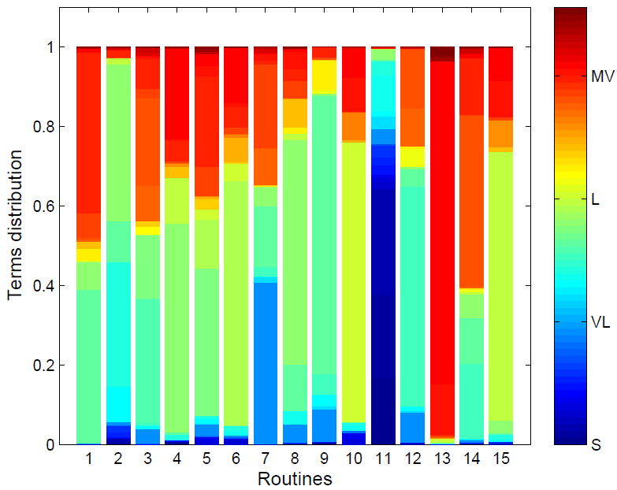
Figure 16 Distribution of the routines over the terms of the vocabulary.

Daily pattern of routines
Figure 17 illustrates the activation probabilities of the extracted routines when day segments of 30 min are sequentially inferred. The inference on sequential day segments provides a qualitative representation of the temporal behavior of the routines. The top and the bottom plots show the routine patterns for a COPD and a healthy subject, respectively. It can be seen that three PA routines (R2, R11, and R9) pervade the day of a COPD patient (see top plot of Figure 17). In particular, this patient spent most of his time performing activities that involve a L intensity descriptor of short duration, with high μ_{ST}, and low μ_{GSR} and a VL intensity descriptor of long duration, with high μ_{ST} and high μ_{VM}. Three hours after the patient awoke, R9 becomes dominant for about 3 h. This routine includes a L descriptor of short duration, high μ_{ST}, and low μ_{GSR}. The graph also shows that the patient slept in the afternoon for about 1 h (probably he rested after having lunch), and after that he continued with the same behavior of the morning. After 14 h from the awakening of the subject, R2 starts decreasing and R11, that characterizes the sleeping behavior, starts to become the most active routine. On the other hand, the day of the healthy subject shows a larger variety of active routine patterns. The bottom plot of Figure 17 shows that the routines R15, R12, R14, R1, R15, R13, and R8 are sequentially active. Around 9 h after his awakening, just before the evening, this subject assumes a behavior similar to his COPD match, i.e., routine R2 becomes the dominant routine until the sleeping time. From the examples, it can be deduced that this particular day of theCOPDpatient is more static compared to the one of the healthy subject if the number of transitions between the most active routines is considered. Although we did not use the trajectories of the routines as in Figure 17 in our further analysis they can be used for classification tasks by modeling the trends of routines activation with multitask Gaussian processes [31] or using sequential patterns [32]. In order to extract cumulative (over several days of assessment) characteristics of a subject we, instead, inferred the routines on the first 6 h of the days of each subject as if it was one day segment. On the right side of Figure 17 the star plots describe the averages of the routines’ activation probabilities across the assessed days of the same two subjects when the inference is performed on the first 6 h after their awakenings. In this case, routines’ activation probabilities can also be considered as an estimate of the time spent in each routine during the most active part of the day. The subjects are represented as a star whose each spoke length is proportional to the average time spent in the associated routine over the assessed weekdays. For clarity, only the most active routines over the assessed days are shown. We see that the shapes of the stars are remarkably different. Routines R11 and R2 were the most active for the COPD patient while, in contrast, the healthy subject spent most of his time performing more active routines such as R1, R12, and R14. Differences in the shapes of the star plot (i.e., time spent in different routines) are consistent across healthy and COPD patients and will be discussed in the next section.

Table 6 Routine matrix. The three dominant words for each of the 15 discovered routines.
R1 | % | R2 | % | R3 | % | R4 | % | R5 | %
MV 1 1 2 | 0.40 | L 1 3 1 | 0.39 | L 1 1 2 | 0.31 | L 1 3 1 | 0.53 | L 1 2 2 | 0.37
L 1 2 1 | 0.39 | VL 2 2 2 | 0.31 | MV 1 1 2 | 0.22 | MV 1 3 2 | 0.23 | MV 1 2 2 | 0.23
L 1 3 1 | 0.07 | L 1 2 1 | 0.10 | L 1 2 2 | 0.16 | L 1 4 1 | 0.11 | L 1 3 2 | 0.12
R6 | % | R7 | % | R8 | % | R9 | % | R10 | %
L 1 3 2 | 0.62 | VL 1 1 1 | 0.41 | L 1 3 1 | 0.57 | L 1 2 1 | 0.70 | L 1 4 2 | 0.70
MV 1 3 2 | 0.14 | MV 1 2 1 | 0.21 | L 1 2 1 | 0.12 | VL 1 1 1 | 0.08 | MV 1 3 1 | 0.09
L 2 3 2 | 0.06 | L 1 2 1 | 0.15 | L 2 3 1 | 0.07 | L 2 2 1 | 0.08 | MV 1 3 2 | 0.07
R11 | % | R12 | % | R13 | % | R14 | % | R15 | %
S 1 1 3 | 0.27 | L 1 1 1 | 0.55 | MV 1 3 2 | 0.81 | MV 1 1 2 | 0.43 | L 1 4 1 | 068
S 1 1 2 | 0.21 | MV 1 1 2 | 0.15 | MV 1 3 1 | 0.13 | L 1 1 1 | 0.19 | MV 1 3 1 | 0.09
S 1 1 1 | 0.17 | MV 1 1 1 | 0.09 | MV 2 3 2 | 0.02 | MV 1 2 2 | 0.14 | MV 1 3 2 | 0.08

Figure 17 Left: Routine activation probabilities determined from a particular day of a COPD patient (top) and a healthy subject (bottom). Only topics with a maximum activation larger than 0.1 are shown. Right: Star plots illustrating the average time spent on the three most active routines of the same COPD patient and healthy subject during the first 6 h of their assessed days. R2, R11, R12 and R1, R12, R14 are, respectively, the three most active routines for the COPD patient (top) and the healthy subject (bottom).

Trends in routines activation
Figure 18 shows the average values of the estimated time spent in each routine for all the 977 COPD patients, the matched 66 COPD patients, the matched 66 healthy subjects, and for the 977 COPD patients stratified according to their disease severity, where GOLD1 and GOLD4 indicate, respectively, the least and most severe stage of COPD. Each point in the figure identifies the mean over all the subjects of each group, where each subject is represented by the mean of the time spent in the different routines over the assessed weekdays (left) and weekend days (right). Comparison between the time spent in each of the 15 routines in the 977 COPD patients and the subgroup used to extract the routines (see inside the green dashed rectangles in Figure 18) shows that there are no statistical differences (p > 0.2) in the time spent in each routine between the two groups in both assessed weekdays and weekend days. This indicates that the model is able to generalize across many COPD patients. When matched COPD and healthy subjects are compared (see inside the red rectangles in Figure 18), we found statistical differences between the two groups (p < 0.05) during weekdays in R2, R3, R5, R10, R11, R12, R14, R15. During weekend days, statistical differences were found in R3, R4, R7, R14, R15. A reduced number of statistical differences in the weekend days indicates that the two groups assume a more similar behavior during these days. This might be due to the fact that healthy subjects could still be active workers or that they perform weekly activities such as grocery shopping. On the contrary, they might use the weekend days to sleep more and rest. These assumption could be confirmed by an increased value of the time spent in R2 and R11 during the weekend days of healthy subjects. High values of these two routines characterize only the COPD patients group during the weekdays. Comparing healthy subjects and the four different COPD groups (see inside the dashed blue rectangles in Figure 18), we observe five main trends over the different stages of the disease both in weekdays and weekend days. R2 and R11 are increasing with the increase of COPD severity. R2 represents a medium-inactive PA routine composed for the 39% by [L, Ld1 , LST 3 , LGSR 1 ] and by the 31% by [V L, Ld2 , LST 2 , LGSR 2 ]. The first PA descriptor represents light intensity movements characterized by short duration that cause a high increase of the temperature. The second term represents very light intensity movements of long duration that cause a moderate increase of physiological responses (high body temperature and high GSR). The positive trend is interrupted in the most severe group of patients that compensate a smaller value for R2 with a higher value of R11 and R15. A high value of the time spent in R11 could be associated with the most severe patients since their conditions might force them to spend more time in bed. R15 is characterized mainly by light intensity PA terms characterized by higher physiological responses if compared with R2. This might indicate a bigger effort in performing activities. The increased value of R2 for healthy subjects during weekend days has been discussed previously. Another rising trend is shown by R11 representing the time spent, while performing very inactive behavior (mainly sleeping). On the other hand, we note that R3, R12, and R14 decrease with an increase in COPD severity. These three routines indicate movements performed with medium-high activity intensities characterized by small physiological responses. Of particular, interest are R3, R12 since they are weakly, but significantly correlated with FEV1 ,%predicted (ρ = 0.3, p = 2× 10−23, ρ = 0.2, p = 5.8× 10−11 , respectively), and R14 weakly correlated with FEV1 (ρ = 0.2, p = 3×10−5 ). No correlationwas found with age and BMI indicating that these discovered routines are decoupled from these variables. Statistical differences (p < 0.0001) have been found in the percentage of activation of R3 and R14 between healthy subject and all the COPD severity classes (both weekdays and weekend days). For R3 statistical differences (p < 0.0001) were also found between the first two stage of the disease (GOLD1, GOLD2) and the last two stages (GOLD3 and GOLD4) during the weekdays. For weekend, only between GOLD1 and the last two stage of disease (GOLD3 GOLD4) and between GOLD2 and GOLD4. For R12, statistical differences (p < 0.0001) have been found between healthy subject and GOLD2, GOLD3, GOLD4 (both weekdays and weekend days). Between the GOLD1 and GOLD3–4 (also during the weekend days), between GOLD2 and GOLD4 (also weekend).

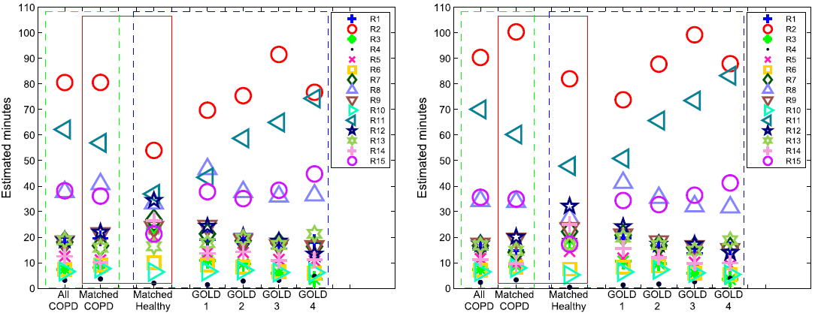
Figure 18 Activation topic averages during weekdays (left) and weekend days (right). The green dashed rectangles indicate the comparison between all the COPD patients (n = 977), and the COPD subset used to generate the routines (n = 66). The red rectangles indicate the comparison between the matched COPD patients (n = 66) and the matched healthy subjects (n = 66). The dashed blue rectangles indicate the comparison between the healthy subjects (n = 66), GOLD1 (n = 89), GOLD2 (n = 385), GOLD3 (n = 330), and GOLD4 (n = 173). Inference was performed in the first 6 h after the awakenings from the night sleep.

Discriminatory power of routines
In order to further validate the findings shown in Figure 18 and assess the discriminatory power of PA routines, we first clustered the 66 patient:control matches and, subsequently, their assessed weekdays. For the first clustering experiment, each of the 66 healthy subjects and 66 matching COPD patients was represented by the average time spent in each routine over the assessed weekdays as symbolically shown in the star plots of Figure 17. Distance-based features were extracted using only R3, R12, and R14 because of their correlation with the FEV1, %predicted and FEV1 : variables used to assess airway obstruction in the current clinical setting. In particular, we calculated the pairwise Kullback–Leibler pairwise distances between all the subjects represented by the averaged time spent in R3, R12, and R14. Using Kruskal’s normalized stress1 criterion, we created a set of locations in three dimensions whose interpoint distances approximate the routine dissimilarities between subjects. We finally clustered the subjects such represented using a k-mean clustering algorithm with k = 2 achieving 86% accuracy in dividing the two groups. For the second experiment, we clustered the 536 assessed weekdays (273 for healthy subjects, 263 for COPD patients), which were represented by the associated daily time spent by the subjects in R3, R12, R14. After extracting the same typology of features, we clustered the days in k = 2 groups achieving 82% of accuracy in discriminating between days that belong to healthy subjects and days belonging to COPD patients. This shows that activity biomarkers derived from routines can potentially be used in diagnostic decision support systems, but also in monitoring systems providing feedback on a daily basis.

Conclusion
Unsupervised discovery of latent structures in data from activity monitors is becoming more relevant due to the increasing amount of available multimodal data. Using relatively simple assumptions and settings, we have shown that interpretable and consistent results can be obtained from a large set of unannotated real-life data concerning a large population of COPD and healthy subjects. We have shown that PA routines can be used effectively to integrate and represent the underlying structure of PA measures and physiological responses that characterize the activities of the subjects under study. In particular, it is shown that PA routines in COPD patients and healthy subjects are considerably different regarding their composition and that they show certain consistent trends depending on COPD clinical characteristics. The discovered PA routines were found suitable to label, in an unsupervised way, subjects and assessed days. Moreover, inferring the routine structure on day segments of relatively short duration, it was possible to model PA routine patterns across the day and to identify moments in time in which transitions of the most active routines occur. Some methodological considerations need to be taken into account. First, demographics information (such as working activities) and comorbidities were not available which could influence PA. Second, the routines identified would benefit from a sensitivity study using a new sample of COPD-healthy pairs matching with the same characteristics. Although a more detailed clinical interpretation of the discovered routines is extremely interesting and planned as follow-up of this study, the discovered PA routines apparently reflect the stage of the disease as measured by common clinical practice and could be valid constructs to quantify PA behavior change in patient with limited exercise capacity such as with COPD. As such, it is an encouraging step into the direction of practical applications of these techniques in daily life to design, for instance, interventions and coaching systems with realistic goals for this population.

Conclusions

Appendix

References
[1] O. I. Franko and T. F. Tirrell, “Smartphone app use among medical providers in acgme training programs,” Journal of medical systems, vol. 36, no. 5, pp. 3135–3139, 2012.
[2] D. Bannach, P. Lukowicz, and O. Amft, “Rapid prototyping of activity recognition applications,” Pervasive Computing, IEEE, vol. 7, no. 2, pp. 22–31, 2008.
[3] J. Lockman, R. S. Fisher, and D. M. Olson, “Detection of seizure-like movements using a wrist accelerometer,” Epilepsy & Behavior, vol. 20, no. 4, pp. 638–641, 2011.
[4] S. Nasehi and H. Pourghassem, “Real-time seizure detection based on eeg and ecg fused features using gabor functions,” in Intelligent Computation and Bio-Medical Instrumentation (ICBMI), 2011 International Conference on. IEEE, 2011, pp. 204–207.
[5] D. Huggins-Daines, M. Kumar, A. Chan, A. W. Black, M. Ravishankar, A. Rudnicky et al., “Pocketsphinx: A free, real-time continuous speech recognition system for hand-held devices,” in Acoustics, Speech and Signal Processing, 2006. ICASSP 2006 Proceedings. 2006 IEEE International Conference on, vol. 1. IEEE, 2006, pp. I–I.
[6] F. X. Lin, A. Rahmati, and L. Zhong, “Dandelion: a framework for transparently programming phone-centered wireless body sensor applications for health,” in Wireless Health 2010. ACM, 2010, pp. 74–83.
[7] N. Aharony, W. Pan, C. Ip, I. Khayal, and A. Pentland, “Social fmri: Investigating and shaping social mechanisms in the real world,” Pervasive and Mobile Computing, vol. 7, no. 6, pp. 643–659, 2011.

Acknowledgments

List of Publications

Journal articles:
1.

Proceedings and conference contributions:
5.

Patent applications:
10.

Other contributions:
12.

Summary

Curriculum Vitae
Gabriele Spina was born on October 22nd, 1986 in Palermo, Italy.
After completing high school at the “Liceo Scientifico Galielo Galilei” in 2005 in Palermo, he studied biomedical engineering at Campus Bio-medico University of Rome, Rome, Italy. In 2012, he received his Master’s degree cum laude and moved to the Netherlands to pursue a Doctoral degree at Eindhoven University of Technology.

Since his Master’s, his main interest focused on xxx. During his Master’s project, he worked on xxx.

During his PhD, he focused on xxx. The results of his effort on this topic are described in this dissertation.

The SENSE Observation System, http://www.sense-os.nl/home
OSAS, http://www.win.tue.nl/san/wsp/index.html
Shimmer, http://www.shimmer-research.com
The Braebon Respiratory Effort Sensor, http://www.braebon.com
Android OS, Google. http://www.android.com

