HANDSHAKE

Cooperative Vehicle Negotiation Protocol

MASTER ENGINEERING BLUEPRINT
The Complete Technical Specification for Design, Build & Certification

Architecture · Protocol · AI Models · Safety (ISO 26262 / SOTIF) · Cybersecurity (ISO/SAE 21434)
VRU Protection · Platooning · Cooperative Perception · Federated Learning · Liability & EDR

Version 4.0 — DEFINITIVE ENGINEERING BLUEPRINT
CONFIDENTIAL — For Engineering & Investment Due Diligence

1. Executive Summary

Handshake is a production-grade, safety-certified cooperative negotiation protocol for vehicle-to-vehicle (V2V) and vehicle-to-everything (V2X) communication. It enables every type of vehicle — from a manually driven car to a fully autonomous freight truck — to exchange intent, negotiate right-of-way, protect vulnerable road users, and coordinate movement in real time, with or without any infrastructure support.
This document is the complete engineering blueprint. It supersedes all prior documents and incorporates every technical gap previously identified. It is structured so that a competent engineering team can build Handshake directly from this specification, and an ASIL-D certification auditor can use it as the primary safety evidence document.

1.1 What Makes Handshake Different
Dimension | Today's V2X (BSM broadcast only) | Handshake
Coordination | Each car decides alone | Stateful negotiation — vehicles actively resolve conflicts
Right-of-way | No mechanism — silent assumption | Explicit ROW token exchange with deterministic tiebreaker
VRU Protection | Not in V2X scope | First-class subsystem with ASIL-D hard safety gate
AI Integration | None | 5-model AI stack with ASIL-D firewall and OOD detection
Cooperative Perception | Not in standard | CPM sharing extends sensor range through occlusions
Safety Certification | Not required | Full ISO 26262 ASIL-D + SOTIF (ISO 21448) design
Cybersecurity | IEEE 1609.2 only | ISO/SAE 21434 full TARA + CSMS + HSM + SCMS
Platooning | Not in standard | CACC extension with gap control and dissolve protocol
Works offline | Yes (broadcast) | Yes — full negotiation without RSU or cellular
Continuous learning | Not possible | Privacy-preserving federated learning pipeline

1.2 Core Design Principles
- Safety First: No AI model, no network message, and no software bug in the QM partition can cause unsafe vehicle behaviour. The ASIL-D partition is the only authority for actuator commands and is isolated by hardware.
- Assume Breach: The V2X radio will receive malicious messages. The ML models will encounter out-of-distribution inputs. The OS will be exploited. The safety architecture must remain correct regardless.
- Standards-First: Every component reuses existing automotive standards (J2735, IEEE 1609.2, 3GPP PC5, ETSI ITS, ISO 26262, ASAM OpenDRIVE). Nothing is invented that already exists.
- Graceful Degradation: At every level, loss of any component results in a more conservative — never more dangerous — behaviour. Infrastructure, cloud, AI, and V2X are all optional enhancements.
- Privacy by Design: No raw driving data leaves the vehicle. Pseudonym rotation prevents long-term tracking. Federated learning updates are differentially private.

2. Complete System Architecture

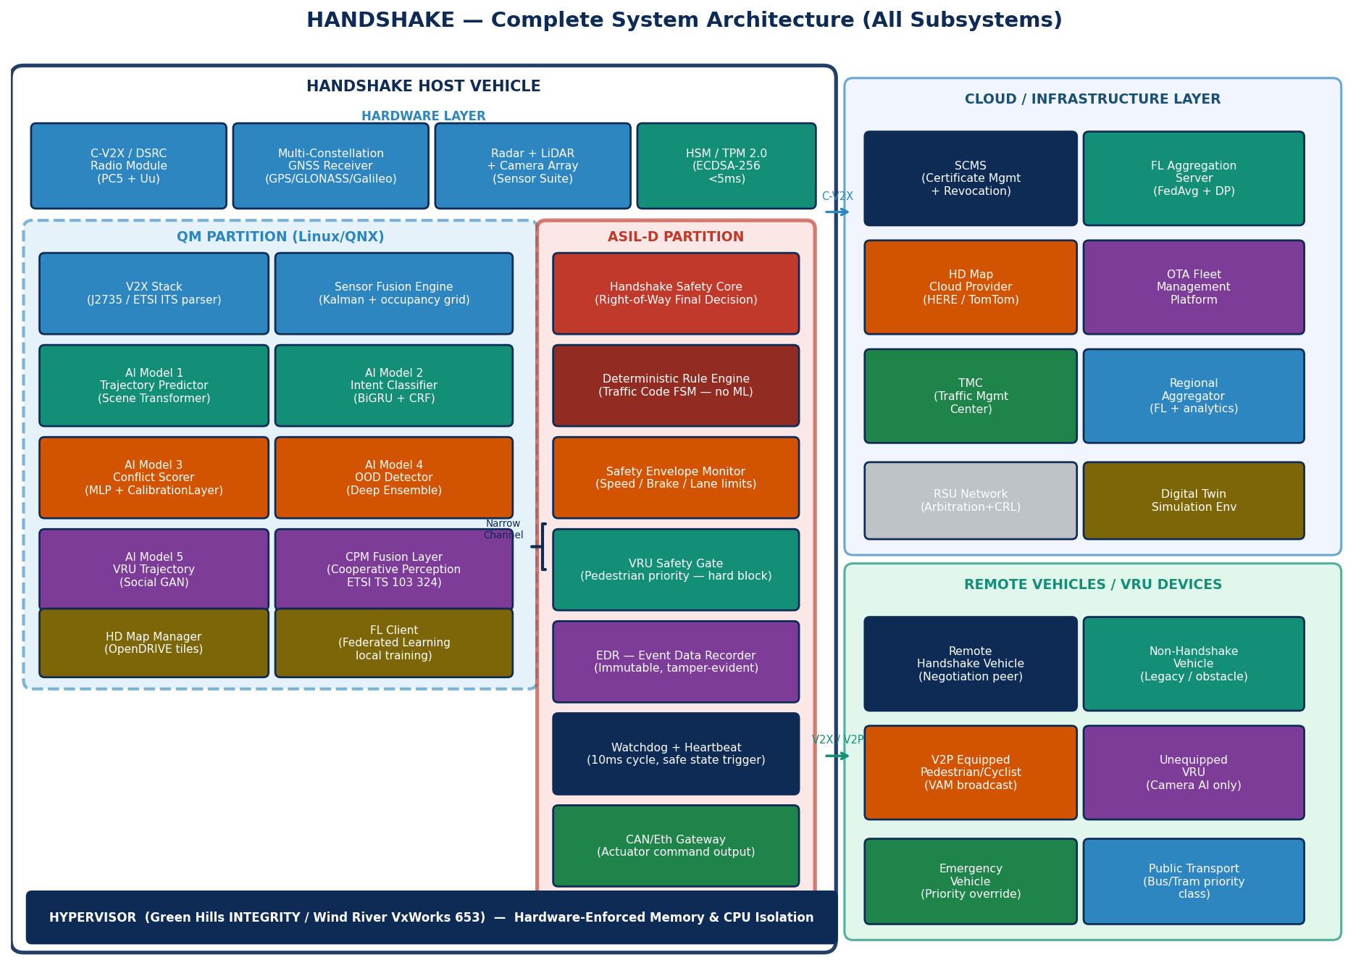
Figure 1 — Handshake Complete System Architecture. All subsystems shown: hardware layer, QM partition (5 AI models, CPM, HD map, FL client), ASIL-D partition (safety core, rule engine, VRU gate, EDR, watchdog), cloud/infrastructure layer, and remote vehicle/VRU types.

2.1 Architecture Layers

Hardware Layer
The hardware layer comprises five physical components. The C-V2X radio module (Qualcomm 9150 or AutoChips AC8315) handles all wireless communication in both PC5 direct mode and Uu cellular mode. The multi-constellation GNSS receiver provides position, velocity, and timing with sub-metre accuracy under normal conditions. The sensor suite — millimetre-wave radar, solid-state LiDAR, and RGB/IR cameras — provides local environment perception. The HSM (Hardware Security Module, either an Infineon SLB 9670 or NXP SE050) provides tamper-resistant cryptographic operations. The automotive SoC (NVIDIA DRIVE Orin, Qualcomm Snapdragon Ride, or NXP S32G) hosts all software layers.

Hypervisor
A Type-1 automotive hypervisor (Green Hills INTEGRITY, Wind River VxWorks 653, or PikeOS) enforces hardware-level isolation between the QM and ASIL-D partitions. Memory pages, CPU time slices, and I/O access are exclusively allocated per partition with no shared resources except the formally specified narrow channel. The hypervisor itself is certified to ASIL-D.

QM Partition
The Quality Managed partition runs a POSIX-compatible OS and hosts all software that benefits from rich development ecosystems: the V2X message parsing stack (J2735 / ETSI ITS decoder), the sensor fusion engine (Kalman filter + occupancy grid), five AI/ML models (trajectory predictor, intent classifier, conflict scorer, OOD detector, VRU trajectory predictor), the Collective Perception Message fusion layer, the HD map tile manager, and the federated learning client. QM software has controlled network access and supports OTA updates. A compromise of any QM component cannot affect ASIL-D outputs.

ASIL-D Partition
The ASIL-D partition runs a certified RTOS and contains only the components that directly affect vehicle safety: the Handshake Safety Core (right-of-way final decision logic), the Deterministic Rule Engine (traffic code FSM), the Safety Envelope Monitor (physical limit enforcement), the VRU Safety Gate (pedestrian/cyclist hard block), the Event Data Recorder writer (immutable log), and the Watchdog/Heartbeat process. Total target code size: under 15,000 lines of MISRA-C:2012. No dynamic memory allocation, no floating-point, no recursion, no network access.

Cloud / Infrastructure Layer
The cloud layer provides enhancement services that improve performance but are never required for safety: the SCMS certificate management system (certificate issuance and revocation), the federated learning aggregation server, the HD map cloud provider (HERE, TomTom, or Waymo), the OTA fleet management platform, TMC connectivity, and the digital twin simulation environment. All communication with the cloud layer is encrypted (TLS 1.3) and authenticated (mutual TLS with SCMS certificates). Loss of all cloud connectivity triggers no safety events — the vehicle continues operating in full offline mode.

2.2 Narrow Channel Interface
The only data path from QM to ASIL-D is a 32-byte fixed-size shared memory structure, written by QM at 50Hz and polled by ASIL-D at 100Hz. The structure is validated by a hardware CRC32 check before ASIL-D reads it. If CRC fails, ASIL-D uses the last valid value and increments a stale-data counter. Three consecutive CRC failures trigger a safe state transition.
/* Narrow Channel Structure — QM writes, ASIL-D reads (32 bytes) */ typedef struct __attribute__((packed)) { uint32_t session_id; /* Active negotiation session ID */ uint8_t peer_count; /* Peers in session (max 32) */ int16_t own_speed_cms; /* Own speed in cm/s */ int16_t own_accel_cms2; /* Own acceleration in cm/s² */ uint8_t peer_priorities[8]; /* Top-8 peer priority scores */ uint8_t collision_prob_pct; /* Conflict Scorer output × 100 */ uint8_t urgency_class; /* 0=LOW 1=MED 2=HIGH 3=CRIT */ uint8_t ai_health_score; /* Aggregated model health (0–100) */ uint8_t ood_flag; /* 0=in-dist, 1=OOD detected */ uint8_t vru_present; /* 0=none, 1=detected, 2=crossing_prob>0.6 */ uint8_t weather_class; /* 0=clear .. 5=ice */ uint8_t odd_phase; /* Current ODD phase (1–4) */ uint8_t map_age_days; /* Days since map tile last updated */ uint8_t reserved[2]; /* Reserved, must be 0x00 */ uint32_t crc32; /* CRC-32 over all preceding bytes */ } HandshakeNarrowChannel_t; /* Exactly 32 bytes */

3. Safety Architecture

3.1 Hypervisor Partitioning
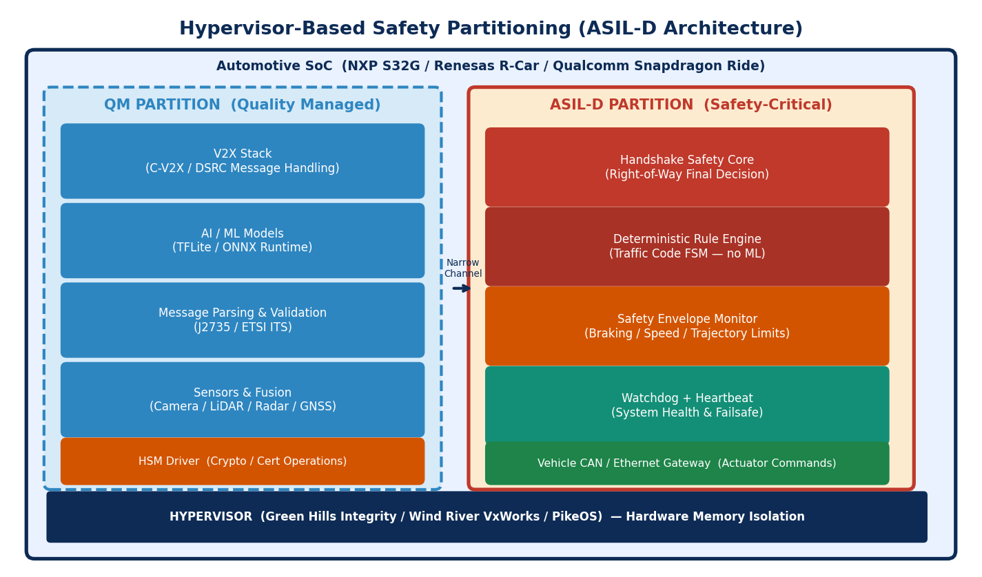
Figure 2 — Hypervisor-based ASIL-D safety partitioning. QM partition (left) hosts all rich-ecosystem software. ASIL-D partition (right) is the sole authority for actuator commands.

The safety architecture is built on the Assume Breach principle: it is mathematically impossible for a software defect or malicious exploit in the QM partition to cause an unsafe actuator command. This is enforced by the hypervisor's hardware memory protection unit (MPU), which prevents any write by QM software to ASIL-D memory pages. The ASIL-D partition cannot be compromised through the V2X radio, the AI model stack, the OS, the map tile system, or any network interface.

3.2 ISO 26262 HARA — Hazard Analysis & Risk Assessment
ID | Hazardous Event | S | E | C | ASIL | Safety Goal
H-01 | ROW granted to vehicle on direct collision course | S3 | E4 | C3 | D | SG-01: System shall not grant ROW that results in collision probability > 0.001 at t+3s
H-02 | Deceleration command causes rear-end collision | S3 | E4 | C2 | C | SG-02: Deceleration commands shall not exceed host vehicle's advertised following safety distance
H-03 | System operates outside declared ODD undetected | S2 | E3 | C2 | B | SG-03: ODD exit shall be detected within 3s; fallback activated before actuation is affected
H-04 | Malformed/spoofed V2X message accepted as valid | S3 | E3 | C3 | D | SG-04: All messages must pass HSM signature verify before use; failure discards message
H-05 | AI model output corrupts priority score to wrong value | S2 | E4 | C2 | C | SG-05: AI outputs are advisory only; ASIL-D rule engine applies independent physical bounds check
H-06 | VRU in conflict zone not detected — ROW granted | S3 | E4 | C3 | D | SG-06: VRU presence (P>0.6) shall block all ROW grants regardless of negotiation state
H-07 | ASIL-D watchdog failure leaves system in undefined state | S3 | E2 | C3 | C | SG-07: Watchdog miss triggers safe state within 20ms; safe state is controlled deceleration
H-08 | GPS spoofing causes incorrect traffic law profile | S2 | E2 | C2 | A | SG-08: Multi-constellation cross-check; peer position consistency validation
H-09 | Session deadlock — vehicles block intersection indefinitely | S1 | E3 | C1 | A | SG-09: Session timeout forces conservative yield after 150ms without resolution
H-10 | Platoon emergency dissolve fails — gap closure collision | S3 | E2 | C2 | C | SG-10: DISSOLVE command triggers independent emergency braking via ASIL-D envelope monitor

3.3 Safety Goals & Technical Safety Requirements

SG-01 — ROW Collision Prevention (ASIL-D)
- TSR-01.1: The Collision Probability output of the Conflict Scorer shall be compared to a threshold of 0.80. If exceeded, the ASIL-D Safety Core shall issue a HARD_YIELD command regardless of the Rule Engine's traffic-law-based decision.
- TSR-01.2: The Trajectory Predictor shall compute a minimum time-to-collision (TTC) for all active session peers. If TTC < 1.5 seconds, the Safety Envelope Monitor shall apply emergency deceleration at up to 0.6g independent of any Handshake session state.
- TSR-01.3: The Rule Engine FSM shall be formally verified using the SPIN model checker to have zero reachable unsafe states under all possible message combinations for the defined traffic code profiles.

SG-06 — VRU Hard Block (ASIL-D)
- TSR-06.1: The VRU Safety Gate shall evaluate the vru_present field of the Narrow Channel at every 10ms ASIL-D cycle. If vru_present ≥ 2 (crossing probability > 0.6), the gate shall immediately set a CROSSING_ZONE_HOLD flag that blocks all GRANT_ROW outputs for a minimum of 5 seconds or until vru_present returns to 0.
- TSR-06.2: The VRU Safety Gate shall operate independently of the Handshake Safety Core — it cannot be disabled, bypassed, or overridden by any session state, traffic law rule, or operator command.

3.4 Safe State Definition & Transition
Safe State Level | Trigger Condition | Behaviour | Recovery
Level 0 — Normal | All systems nominal | Full Handshake protocol active | N/A
Level 1 — Advisory Silence | AI health < 70% OR ODD exit (non-critical) | Stop sending negotiation messages; continue BSM broadcast; alert driver | Automatic: condition clears for >30s
Level 2 — Degraded Mode | Weather class ≥ 4 OR map tile > 90 days | Operate with reduced speed limits and increased yield margins; driver alert | Automatic: condition improves
Level 3 — Controlled Deceleration | ASIL-D watchdog miss OR ODD exit (critical) OR ASIL-D fault | Decelerate at ≤0.3g to complete stop in lane; hazard lights on; emergency contact if equipped | Manual: requires driver takeover + system restart with technician approval
Level 4 — Emergency Stop | TTC < 0.8s OR collision_prob > 0.95 OR brake system failure signal | Maximum braking at up to 0.8g; all other Handshake output suspended | Manual: incident report required

3.5 SOTIF — Safety of the Intended Functionality (ISO 21448)
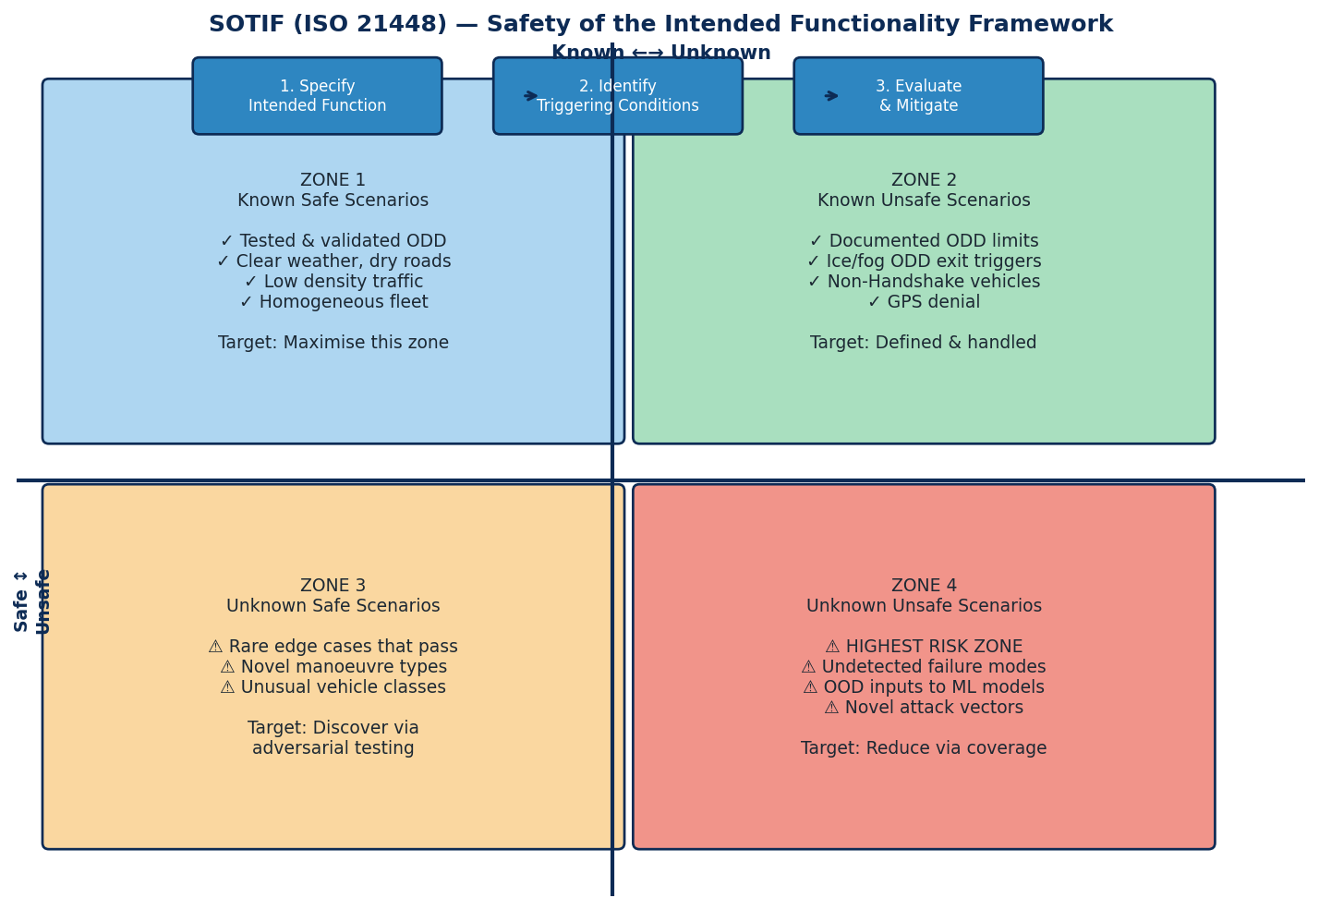
Figure 3 — SOTIF Four-Zone Model for Handshake. Zone 4 (unknown unsafe) must be minimised through adversarial testing, OOD detection, and field monitoring.

ISO 21448 addresses scenarios where the system behaves as designed but the design is insufficient. For Handshake, SOTIF is primarily relevant to the AI model stack and sensor inputs. A component can function perfectly and still produce an unsafe outcome if its operational boundaries are not well understood.
SOTIF Triggering Condition | Affected Component | Zone | Mitigation in Blueprint
Pedestrian obscured by heavy rain — crossing intent missed | VRU Classifier (Model 5) | Zone 4 | OOD Detector (Model 4) flags low-confidence inputs; Rule Engine applies 3× yield margin when vru_present flag is in uncertain state
Novel intersection type not in training data | Trajectory Predictor (Model 1) | Zone 3/4 | OOD Detector triggers conservative mode; map tile provides lane context as fallback; Rule Engine defaults to yield-to-all at unknown junctions
Impaired driver behaving erratically — intent classifier confused | Intent Classifier (Model 2) | Zone 3 | Anomaly detection in fusion layer; high entropy output → Rule Engine treats peer as maximum uncertainty obstacle
Construction zone with non-standard markings | Rule Engine FSM | Zone 3 | Construction zone flag in TMC feed activates special FSM profile; manual traffic code override via operator portal
Multi-vehicle platoon member suddenly braking — false merge signal | Conflict Scorer (Model 3) | Zone 3 | Platoon PLATOON_STATE message provides ground truth; conflict scorer fused with platoon gap data; independent safety envelope check
GPS constellation partially jammed — position error > 2m | Negotiation Rule Engine | Zone 4 | Multi-constellation GNSS; position uncertainty fed into ODD exit trigger; peer position consistency check detects outlier positions

4. Cybersecurity Architecture (ISO/SAE 21434)

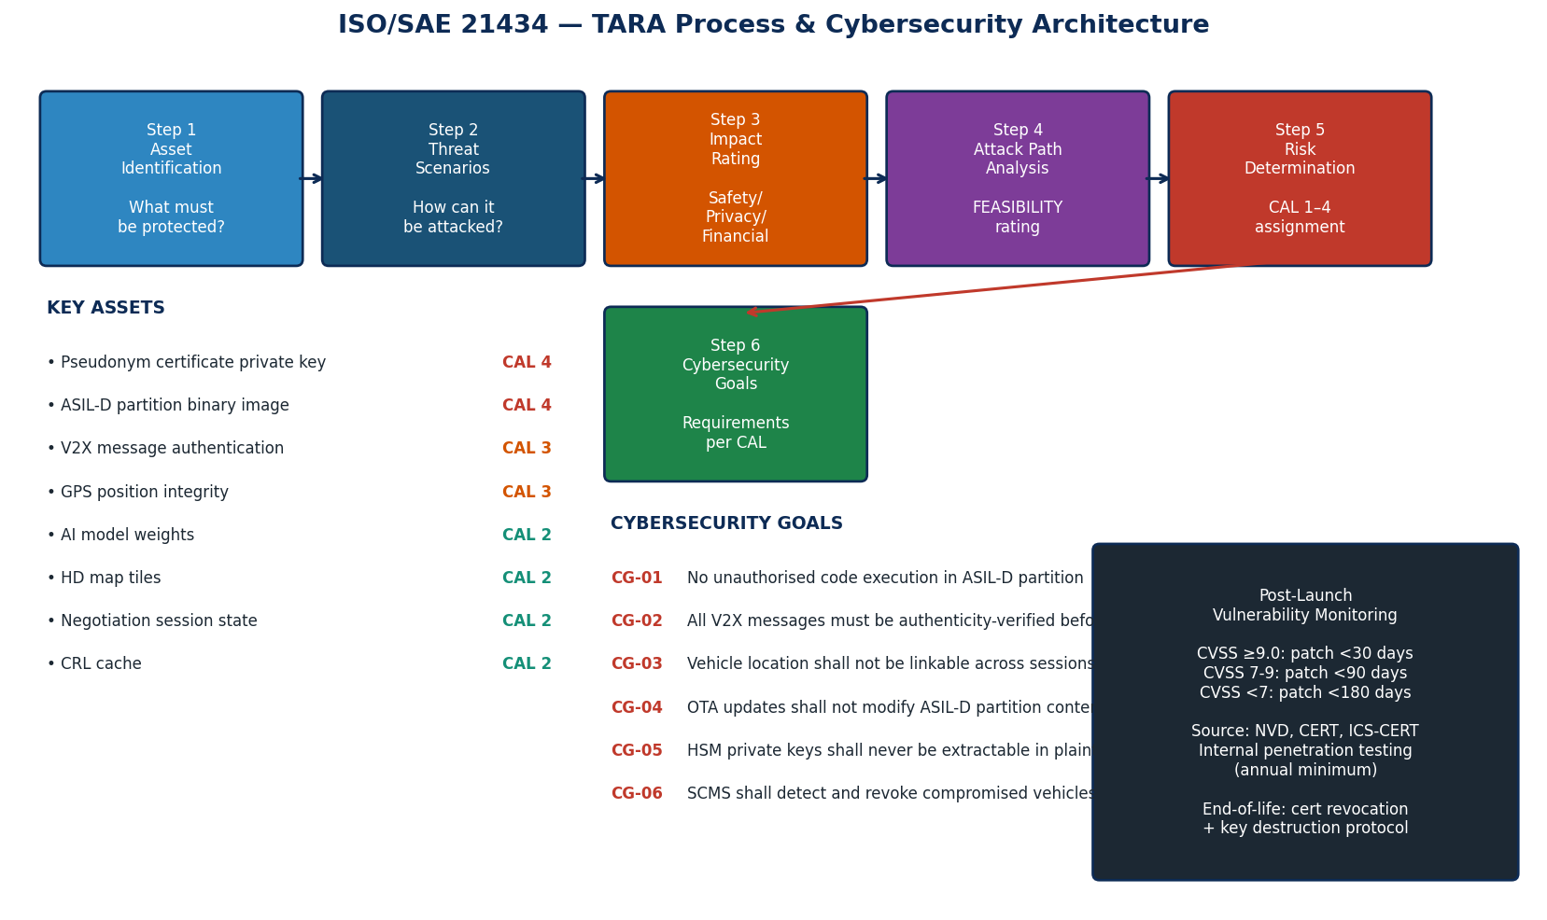
Figure 4 — ISO/SAE 21434 TARA process, asset register, cybersecurity goals, and post-launch vulnerability monitoring obligations.

4.1 Cybersecurity Management System (CSMS)
ISO/SAE 21434 requires the organisation operating Handshake to maintain a Cybersecurity Management System — an organisational framework for managing cybersecurity risk throughout the product lifecycle. The CSMS encompasses: cybersecurity policy and objectives; cybersecurity risk management process; competence and awareness requirements; information security controls; supplier management (applying cybersecurity requirements to all V2X chipset, HSM, and SCMS vendors); evidence of monitoring and continuous improvement.

4.2 TARA — Threat Analysis & Risk Assessment

4.2.1 Asset Register
Asset | Cybersecurity Property | CAL | Rationale
Pseudonym certificate private key | Confidentiality, Integrity | CAL 4 | Compromise enables impersonation of any vehicle; SCMS linkage would expose fleet
ASIL-D partition firmware | Integrity | CAL 4 | Modification enables arbitrary unsafe actuator commands
V2X message authentication chain | Integrity | CAL 3 | Spoofed messages can manipulate ROW decisions leading to collision
GNSS position data | Integrity | CAL 3 | Position spoofing causes wrong traffic law applied; potential collision
AI model weights (all 5 models) | Integrity | CAL 2 | Weight poisoning degrades predictions; OOD detector and rule engine are mitigating controls
HD map tiles | Integrity | CAL 2 | Map tampering causes wrong lane context; Rule Engine defaults to yield-to-all without map
Negotiation session state | Integrity, Availability | CAL 2 | Session hijack or DoS; fallback to BSM-only is safety-acceptable
Driver/fleet telemetry | Confidentiality | CAL 2 | Privacy breach; no safety impact if integrity maintained
OTA firmware update channel | Integrity, Authenticity | CAL 3 | Must be signed; ASIL-D partition excluded from OTA entirely

4.2.2 Threat Catalogue & Attack Paths
Threat ID | Threat | Attack Path | Impact | CAL | Controls
T-01 | Sybil identity spoofing | Single adversary uses multiple HSMs or clones device IDs to broadcast from fake identities | Traffic disruption; priority gaming | CAL 3 | SCMS hardware identity binding; behaviour consistency scorer; spatial clustering detection
T-02 | V2X message replay | Capture authentic ROW message; re-broadcast after session expires to confuse new session | Wrong ROW assignment | CAL 3 | 200ms timestamp window; per-session nonce; HSM-verified monotonic counter
T-03 | GPS signal spoofing | Broadcast false GPS at higher power than authentic signal | Wrong position → wrong traffic law → collision | CAL 3 | Multi-constellation GNSS; peer position cross-check; velocity continuity check
T-04 | ML model poisoning | Inject carefully crafted V2X messages to shift trajectory predictions adversarially | Incorrect yield causing collision | CAL 2 | Input sanity bounds (hard); OOD detector (Model 4); ASIL-D rule engine override
T-05 | V2X channel DoS/jamming | Flood 5.9GHz channel to block all Handshake messages | Negotiation fails; vehicles must act independently | CAL 2 | DCC priority for safety messages; fallback to BSM-only; conservative yield-to-all default
T-06 | Malicious OTA firmware | Compromise OTA pipeline to inject modified QM partition code | AI model corruption; privacy breach | CAL 3 | Dual-signature OTA (vendor + OEM); ASIL-D excluded entirely; hardware attestation
T-07 | Certificate revocation DoS | Prevent CRL updates to keep revoked vehicles in circulation | Revoked attacker maintains trust | CAL 2 | Local CRL cache with 30-day validity; cross-RSU CRL gossip protocol
T-08 | ASIL-D partition side-channel | Use timing or power analysis to extract ASIL-D signing key | Total system compromise | CAL 4 | All crypto in HSM; ASIL-D partition uses HSM exclusively; no soft-crypto

4.3 Security Architecture — SCMS + HSM
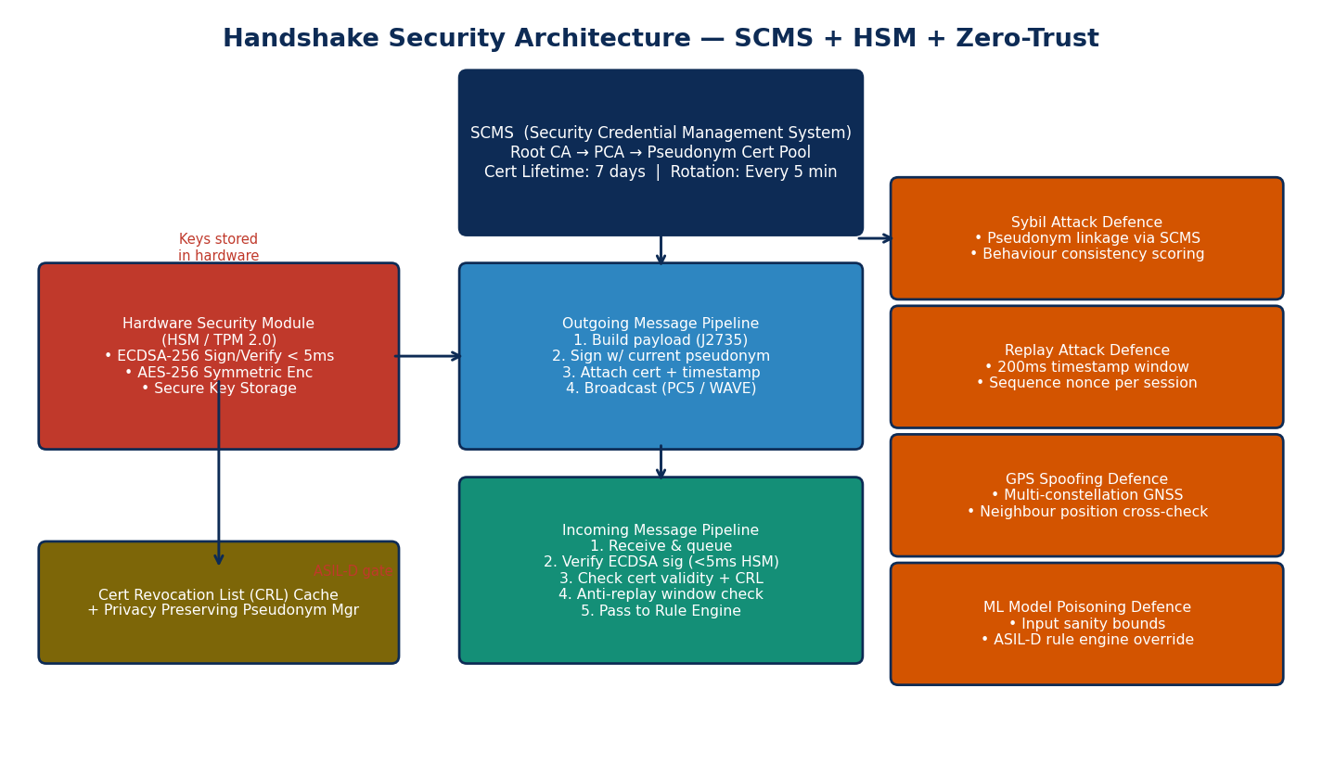
Figure 5 — Security architecture: SCMS certificate hierarchy, on-vehicle HSM pipeline, message signing/verification, and four threat mitigations.

4.3.1 SCMS Certificate Hierarchy
Root CA → Intermediate CA → Pseudonym Certificate Authority (PCA) → Vehicle Pseudonym Certificate Pool. Each vehicle holds 20 pre-fetched pseudonym certificates (7-day validity each). The active certificate rotates every 5 minutes. Two independent Linkage Authorities (LA1, LA2) must both cooperate to de-anonymise any vehicle from its pseudonym — no single party can perform de-anonymisation.

4.3.2 Message Signing Pipeline
Outgoing V2X Message Pipeline: 1. Build J2735 payload (BSM / eBSM / ROW message) 2. Generate nonce = PRNG(session_id XOR timestamp_ms) 3. payload_with_nonce = payload || nonce || timestamp_ms 4. signature = HSM.ECDSA_sign(SHA-256(payload_with_nonce), active_pseudonym_key) 5. message = payload_with_nonce || signature || active_cert 6. Broadcast via C-V2X PC5 sidelink Incoming V2X Message Pipeline: 1. Receive message from radio buffer 2. Check cert not in local CRL cache → reject if present 3. Verify cert chain to trusted PCA root → reject if invalid 4. HSM.ECDSA_verify(SHA-256(payload_with_nonce), signature, cert.pubkey) → <5ms 5. Check timestamp_ms within [now-200ms, now+50ms] → reject if outside window 6. Check nonce not seen in session replay cache → reject if duplicate 7. Validate payload schema (J2735 bounds check) → reject if malformed 8. Pass to QM V2X stack → AI pipeline → Narrow Channel

4.4 Post-Launch Vulnerability Management
CVSS Score | Severity | Patch SLA | Notification | Source Monitoring
≥ 9.0 | Critical | 30 days | Immediate fleet alert | NVD, CERT/CC, ICS-CERT, vendor advisories
7.0 – 8.9 | High | 90 days | Fleet notification + workaround | NVD, CERT/CC, bug bounty programme
4.0 – 6.9 | Medium | 180 days | Standard release cycle | Routine monitoring
< 4.0 | Low | Next scheduled release | Changelog only | Routine monitoring

5. Communication Layer

5.1 Radio Technology
Parameter | C-V2X PC5 (Primary) | DSRC / WAVE (Fallback)
Standard | 3GPP Release 14+ (PC5 sidelink) | IEEE 802.11p / WAVE
Frequency | 5.9 GHz (ITS band) | 5.9 GHz (ITS band)
Range (direct V2V) | Up to 500m | Up to 300m
Latency (one-way) | 3–8ms | 5–15ms
Channel access | Mode 4 SB-SPS (semi-persistent scheduling) | CSMA/CA
Infrastructure mode | Uu (LTE/5G NR) for TMC/SCMS | 802.11p infrastructure mode
OEM adoption trend | Strong growth (Qualcomm, AutoChips, NXP) | Legacy; declining new deployment
Regulatory trend (US) | FCC Report & Order 2020 allocates 30MHz | Legacy only; 45MHz reallocated
Regulatory trend (EU) | Both mandated by EU delegated regulation | ITS-G5 deployed; dual-mode required

5.2 Message Schema — Complete Specification

5.2.1 Enhanced Basic Safety Message (eBSM)
The eBSM is a J2735 BasicSafetyMessage with Handshake-specific Type-Length-Value (TLV) extensions in the Regional Extension field. All extensions are backwards compatible — a standard V2X receiver will decode the base BSM and ignore the TLV fields.
eBSM Structure (J2735 + Handshake TLV Extensions): [J2735 BSM Core — 40 bytes mandatory] MsgCount : UINT8 /* 0–127, wraps */ ID : OCTET(4) /* Temporary pseudonym ID */ DSecond : UINT16 /* Millisecond within minute */ Lat/Long/Elev : INT32×3 /* Position (1/10 micro-deg) */ Accuracy : OCTET(4) /* Position confidence ellipse */ Transmission : ENUM /* FORWARD/REVERSE/NEUTRAL/... */ Speed : UINT16 /* 0.02 m/s units */ Heading : UINT16 /* 0.0125 deg units */ Angle : INT8 /* Steering wheel angle */ Accel4way : SEQUENCE /* Long+Lat accel, yaw rate, vert accel */ BrakeStatus : BIT_STRING /* Brake applied, ABS, traction ctrl... */ VehicleSize : SEQUENCE /* Width + length in cm */ [Handshake TLV Extension — Regional Extension, 38 bytes] TLV_TYPE : UINT8 = 0xA1 /* Handshake Intent Extension */ TLV_LENGTH : UINT8 = 36 intentManoeuvre: UINT8 /* 0=STRAIGHT 1=TL 2=TR 3=UT */ /* 4=ML 5=MR 6=STOP 7=EMERGENCY */ intentConfidence:UINT8 /* 0–100 (percent) */ intentSourceFlags:UINT8 /* BIT0=V2X,BIT1=indicator,BIT2=AI */ trajectoryBrief: OCTET(24) /* 3×waypoint, each 8 bytes: */ /* dLat(INT16), dLon(INT16), */ /* dHead(INT8), dSpeed(INT8), */ /* timeOffset(UINT8), conf(UINT8) */ handshakeVersion:UINT8 /* Protocol version (current: 0x04) */ oddPhaseFlags : UINT8 /* Current ODD phase (1–4) */ sessionCount : UINT8 /* Active negotiation sessions */ trustScore : UINT8 /* Self-reported consistency score */ reserved : OCTET(3) /* Must be 0x00 */ crc16 : UINT16 /* CRC-16 over TLV payload */

5.2.2 Negotiation Message Catalogue
Message | Type | Size (bytes) | Key Fields | Timeout
REQUEST_ROW | V2V Unicast | 48 | session_id, requester_psid, target_psid, priority_score (UINT16), confidence_pct, trajectory_hash (SHA-256 truncated 4B), timestamp_ms, sequence_nonce | 50ms
CONTEST_ROW | V2V Unicast | 48 | session_id, contester_psid, target_psid, own_priority_score, own_confidence, counter_trajectory_hash, timestamp_ms, sequence_nonce | 50ms
GRANT_ROW | V2V Unicast | 32 | session_id, grantor_psid, grantee_psid, expiry_timestamp, traffic_rule_applied (UINT8 code) | N/A
DEFER_ROW | V2V Unicast | 32 | session_id, deferring_psid, defer_duration_ms, yield_speed_target_cms | N/A
ARBITRATION_REQ | V2V→RSU | 64 | session_id, all_participant_psids[8], all_priority_scores[8], conflict_zone_lat, conflict_zone_lon, conflict_zone_radius_m | 100ms
ARBITRATION_GRANT | RSU→V2V | 40 | session_id, winner_psid, traffic_rule_code, rule_text_ref (UINT16) | N/A
RELEASE | V2V Broadcast | 24 | session_id, releasing_psid, zone_cleared (bool), conflict_duration_ms | N/A
EMERGENCY | V2V Broadcast | 32 | emergency_type (ENUM), position, velocity_vector, severity (1–4), source_psid | Immediate; no ack
VRU_ALERT | V2X Broadcast | 32 | alert_type, vru_position, vru_velocity, crossing_prob_pct, alert_radius_m, source_psid | Immediate; repeat 5Hz
PLATOON_STATE | V2V Broadcast | 40 | platoon_id, position_in_platoon, leader_psid, gap_to_ahead_cm, speed_cms, accel_cms2, intended_manoeuvre | 20Hz continuous
CPM_OBJECT | V2V Broadcast | ~200/object | object_id, class_enum, position, velocity, confidence, sensor_type, detection_timestamp, dimensions | 10Hz

5.3 Channel Access & Congestion Control
Handshake uses a four-priority channel access model over the 5.9 GHz ITS band. Priority 0 (highest) is used for EMERGENCY, VRU_ALERT, and ARBITRATION_GRANT messages. Priority 1 is used for REQUEST_ROW, CONTEST_ROW, GRANT_ROW, and DEFER_ROW. Priority 2 is used for eBSM at 10Hz and PLATOON_STATE at 20Hz. Priority 3 is used for CPM_OBJECT and informational messages.
The Decentralised Congestion Control (DCC) algorithm from ETSI TS 102 687 governs transmission rates for all messages. At channel load > 70%, Priority 2 and 3 messages are throttled. At channel load > 85%, Priority 3 messages are dropped entirely. Priority 0 and 1 messages are never throttled. In RSU-enhanced zones, the RSU acts as a channel coordinator and can pre-empt low-priority transmissions to guarantee negotiation bandwidth.

6. Negotiation Protocol — Complete Specification

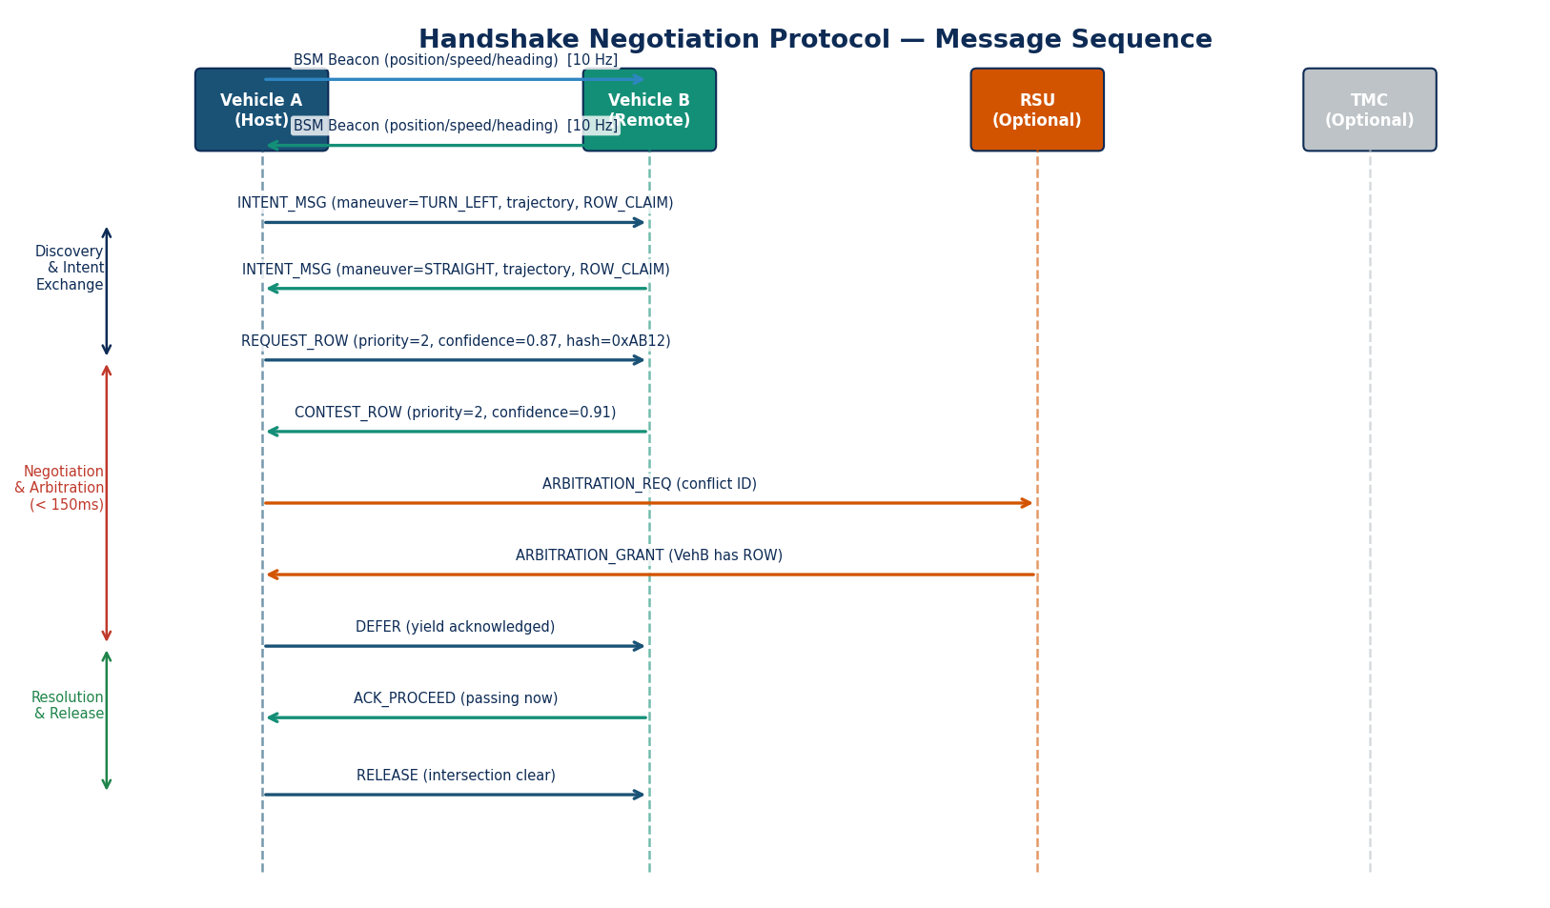
Figure 6 — Handshake negotiation message sequence. Three phases: Discovery & Intent Exchange, Negotiation & Arbitration (< 150ms total), Resolution & Release.

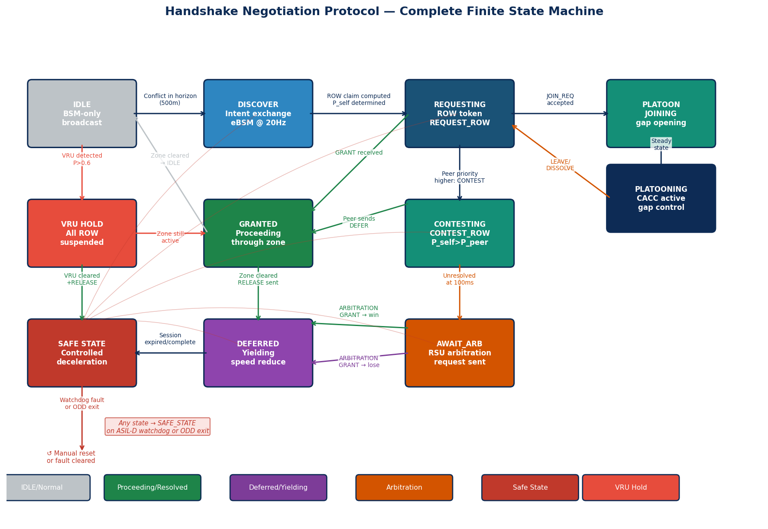
Figure 7 — Complete Protocol Finite State Machine. All 11 states including IDLE, DISCOVERING, REQUESTING, CONTESTING, AWAIT_ARB, GRANTED, DEFERRED, SAFE_STATE, VRU_HOLD, PLATOON, PLT_JOIN. Any state can transition to SAFE_STATE on ASIL-D watchdog fault or ODD exit.

6.1 Priority Scoring Algorithm
Every vehicle entering a negotiation session computes a deterministic priority score. The score is computed entirely within the ASIL-D partition using only integer arithmetic.
/* Priority Score Computation (ASIL-D, integer arithmetic) */ /* All values are UINT16 unless otherwise noted */ traffic_law_rank = fsm_lookup(traffic_code_profile, junction_type, own_approach_direction, peer_approach_direction); /* Returns 0–100. Right-hand rule: vehicle from right = 100, others = 0. Stop sign: arrived first = 80. Equal = 50. */ approach_advantage = clamp((peer_ETA_ms - own_ETA_ms) / 100, 0, 20); /* 0–20. Arrived first at conflict zone = higher score. */ vehicle_class_weight = lookup_class_weight(vehicle_type); /* EMERGENCY=30, POLICE=25, BUS=15, TRUCK=5, CAR=0 */ conflict_contribution= compute_contribution(own_trajectory, peer_trajectory); /* 0–100 (percent). Higher = more responsible for conflict */ /* Penalty = (conflict_contribution × 20) / 100 */ conflict_penalty = (conflict_contribution * 20) / 100; /* 0–20 */ priority_score = traffic_law_rank + approach_advantage + vehicle_class_weight - conflict_penalty; /* Range: 0–130, clamped to UINT8 (0–255) with headroom */ /* TIEBREAKER (if |score_A - score_B| < 3): */ if (abs(own_priority - peer_priority) < 3) { /* Stage 1: ETA to conflict centre, lower wins */ if (own_ETA_ms != peer_ETA_ms) { winner = (own_ETA_ms < peer_ETA_ms) ? SELF : PEER; } else { /* Stage 2: PSID hash XOR session_id, higher wins */ own_hash = SHA256_truncate32(own_psid XOR session_id); peer_hash = SHA256_truncate32(peer_psid XOR session_id); winner = (own_hash > peer_hash) ? SELF : PEER; } }

6.2 Complete State Machine Specification
State | Entry Condition | Actions on Entry | Exit Conditions | Outputs
IDLE | Boot / session release / VRU cleared | Stop negotiation broadcasts; set BSM @ 10Hz | Conflict detected within 500m planning horizon | eBSM @ 10Hz
DISCOVERING | Conflict horizon entered | Increase eBSM to 20Hz; collect peer intent messages; start 50ms discovery timer | Intent received from all detected peers OR timer expires | eBSM with intent @ 20Hz
REQUESTING | Discovery complete; own priority computed | Unicast REQUEST_ROW to highest-priority conflicting peer; start 50ms response timer | GRANT received → GRANTED; CONTEST received → CONTESTING; timeout → retry once, then AWAIT_ARB | REQUEST_ROW unicast
CONTESTING | Received REQUEST_ROW with lower priority than own score | Compute own full priority score; unicast CONTEST_ROW; start 50ms timer | Peer sends DEFER → GRANTED; peer sends GRANT → DEFERRED; timeout → AWAIT_ARB | CONTEST_ROW unicast
AWAIT_ARB | V2V unresolved at 100ms OR symmetric tie unbreakable | Send ARBITRATION_REQ to nearest RSU; start 50ms RSU response timer | RSU sends GRANT (won) → GRANTED; RSU sends GRANT (lost) → DEFERRED; no RSU/timeout → DEFERRED (fail-safe) | ARBITRATION_REQ to RSU
GRANTED | Own ROW confirmed by GRANT or ARB_GRANT | Issue PROCEED command via Narrow Channel; log to EDR; maintain monitoring | Conflict zone clear (trajectory departed zone) → Release & IDLE | PROCEED cmd; EDR write; zone monitoring
DEFERRED | Peer ROW confirmed; own DEFER issued | Issue YIELD speed command; maintain minimum safe distance; monitor for zone clear | Peer sends RELEASE AND own trajectory clear → IDLE; peer fails to proceed in 10s → REQUESTING (re-initiate) | YIELD cmd; speed reduction; EDR write
VRU_HOLD | vru_present ≥ 2 in Narrow Channel | Set CROSSING_ZONE_HOLD; suspend all ROW grants; broadcast VRU_ALERT; reduce speed | vru_present = 0 for 3s AND negotiation zone clear | VRU_ALERT broadcast; no ROW grants; speed reduce
SAFE_STATE | Watchdog fault OR ASIL-D fault OR critical ODD exit | Controlled decel at ≤0.3g; hazards on; all Handshake output suspended; EDR write fault code | Manual: driver takeover + technician reset | Deceleration cmd; hazard lights; EDR fault log
PLATOONING | PLATOON_JOIN_ACK received; steady state | Activate CACC gap controller; subscribe to leader's PLATOON_STATE @ 20Hz | PLATOON_LEAVE sent OR DISSOLVE received OR leader lost >200ms → IDLE | CACC gap cmd; PLATOON_STATE @ 20Hz
PLT_JOINING | PLATOON_JOIN_REQ sent | Identify target gap; shadow leader speed; open gap via speed reduction | PLATOON_JOIN_ACK → PLATOONING; timeout or REJECT → IDLE | Speed shadow cmd; JOIN_REQ

7. AI/ML Model Stack — Complete Specifications

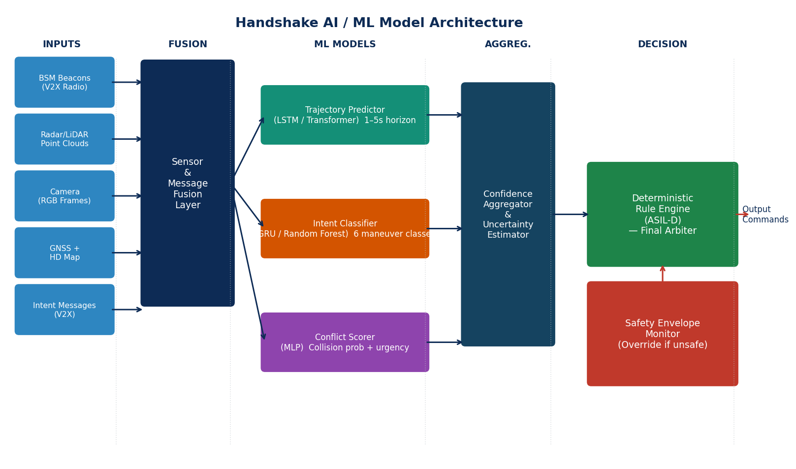
Figure 8 — Handshake AI model pipeline. Five parallel models feed the Confidence Aggregator, which passes bounded advisory scores to the ASIL-D Rule Engine. The Rule Engine is the final and only authority for actuator commands.

Critical design constraint: AI model outputs are advisory inputs to the ASIL-D Rule Engine only. No model can directly command any actuator. The Rule Engine can override any model output. An ASIL-D binding rule exists for each model that limits how its outputs can influence vehicle behaviour.

7.1 Model 1 — Scene Transformer Trajectory Predictor
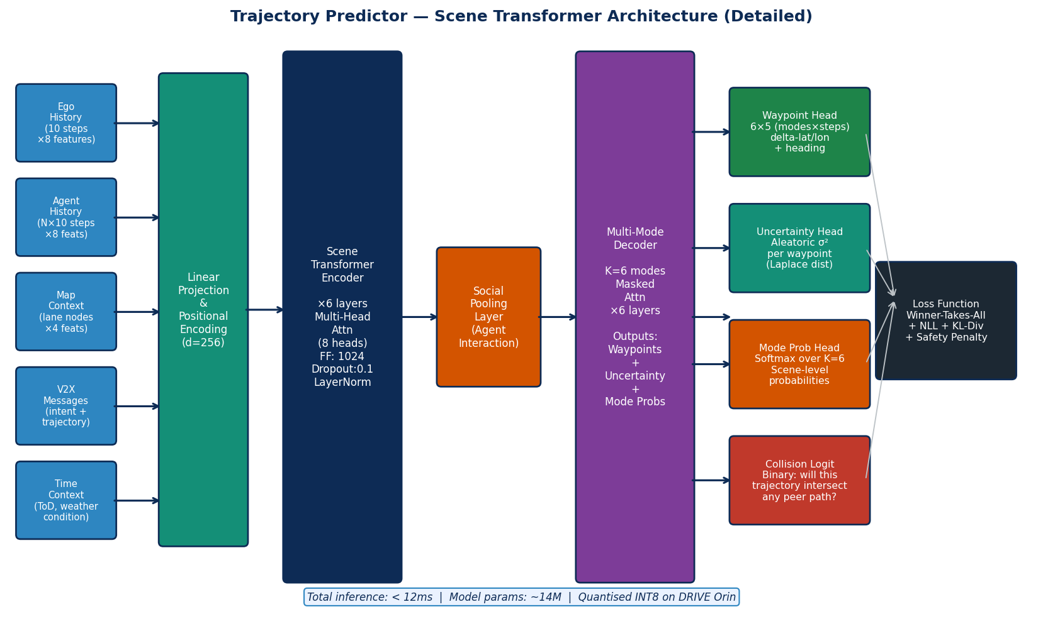
Figure 9 — Scene Transformer architecture: 6-layer encoder with social pooling, 6-layer multi-mode decoder producing K=6 trajectory hypotheses with per-waypoint uncertainty and collision logits.

7.1.1 Architecture
Component | Specification | Notes
Input embedding | Linear projection d=256; sinusoidal positional encoding (temporal); learned PE (agent index) | Unified across all agent types (vehicles, VRUs)
Map encoding | PointNet variant on OpenDRIVE lane node graph → 64-dim lane context vector per proximate lane | Pre-processed offline; loaded from map tile cache
Encoder | 6 × Transformer encoder layers; 8-head multi-head attention; FF dim=1024; pre-LN normalisation; GELU; dropout=0.1 | d_model=256 throughout encoder
Social pooling | 32×32 occupancy grid (0.5m/cell); max-pool agent features per cell; concat to encoder output | Captures close-range interaction missed by dot-product attention
Decoder | 6 × Transformer decoder layers; K=6 parallel mode streams; masked self-attention per mode; FF dim=1024 | Each mode is an independent hypothesis
Waypoint head | Linear 256→10 (5 steps × 2 coordinates); delta encoding from current position; residual from encoder | Outputs predicted Δlat/Δlon per timestep
Uncertainty head | Linear 256→10; Softplus → aleatoric variance σ²; Laplace distribution | Per-waypoint uncertainty used by Conflict Scorer
Mode probability head | Linear 256→K=6; Softmax → scene-level mode probability | Winner-Takes-All training selects best mode
Collision logit | Linear 256→1 per mode; Sigmoid; checks intersection with all peer trajectory sets | Binary: does this mode collide with any peer?
Parameters | ~14M (FP32) → ~3.5M effective (INT8 quantised) | Fits on DRIVE Orin INT8 TensorRT engine

7.1.2 Training & Deployment Configuration
MODEL 1 — Training Configuration Dataset: nuScenes + Waymo Open Dataset + KITTI + pilot fleet data Target: 100M+ vehicle-seconds labelled trajectories Split: 70/10/20 (train/val/test — scene-level split, no data leakage) Augment: Rotation [0,2π], speed scale [0.8–1.2], position noise σ=0.1m, agent dropout 20%, V2X message dropout 10% Optimiser: AdamW | lr=1e-4 | weight_decay=1e-4 Scheduler: Cosine annealing T_max=100, η_min=1e-6 Batch: 128 scenes (8× A100 80GB) | Epochs: 100 Loss (Winner-Takes-All): L = 1.0×L_ADE + 0.5×L_NLL_Laplace + 0.2×L_collision_BCE + 0.1×L_diversity Targets: ADE@1s<0.3m | ADE@3s<0.6m | FDE@3s<1.0m | MR<0.12@3s Deployment (DRIVE Orin INT8 TensorRT): Quantisation: PTQ symmetric INT8; calibration on 2000 scenes Accuracy drop: <0.5% ADE vs FP32 Latency: <12ms (95th percentile, 32 agents) Memory: ~180MB; GPU allocation: ~8% of Orin Fallback (thermal throttle / CPU overload): → Reduce to K=3 modes, 3-agent limit, 3-step horizon → Flag degraded_mode bit in Narrow Channel → Rule Engine applies 1.5× yield margin automatically

7.2 Model 2 — Bidirectional GRU Intent Classifier
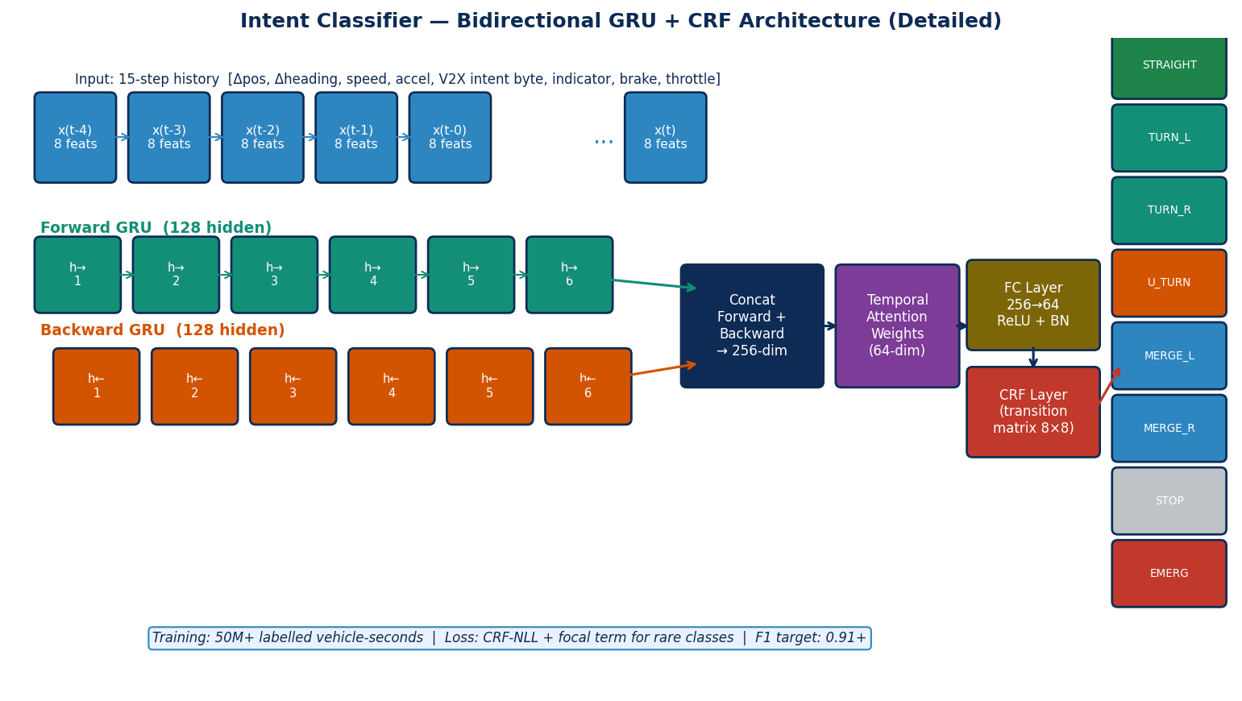
Figure 10 — Intent Classifier: BiGRU + temporal attention + CRF output layer enforcing physically plausible class transition sequences.

7.2.1 Architecture & Training
Component | Specification
Input | 15 timesteps × 8 features: [Δlat, Δlon, Δheading, speed_ms, accel_ms2, v2x_intent_byte, indicator_state, brake_pressure_norm]. Z-score normalised per feature.
BiGRU Layer 1 | 128 hidden units per direction (256 total); tanh; recurrent dropout=0.15
BiGRU Layer 2 | 128 hidden units per direction (256 total); tanh; recurrent dropout=0.10
Temporal attention | Learned 64-dim query; dot-product attention over 15 steps; softmax; context = weighted sum
FC layer | 256→64; ReLU; Batch Normalisation; Dropout=0.2
CRF layer | Linear-chain CRF; 8×8 transition matrix learned end-to-end
Classes (8) | STRAIGHT, TURN_LEFT, TURN_RIGHT, U_TURN, MERGE_LEFT, MERGE_RIGHT, STOP, EMERGENCY
Output | Viterbi decode → best class; forward algorithm → probability distribution; Entropy → confidence
Training | 50M labelled timesteps; class-balanced; CRF-NLL + Focal loss (γ=2.0); Adam lr=3e-4
Targets | Macro F1 > 0.91; EMERGENCY F1 > 0.95; U_TURN F1 > 0.88; latency < 6ms INT8
ASIL-D binding | If intent_entropy > 1.5 bits: treat peer as UNKNOWN → maximum-uncertainty obstacle in Rule Engine

7.3 Model 3 — Conflict Scorer MLP
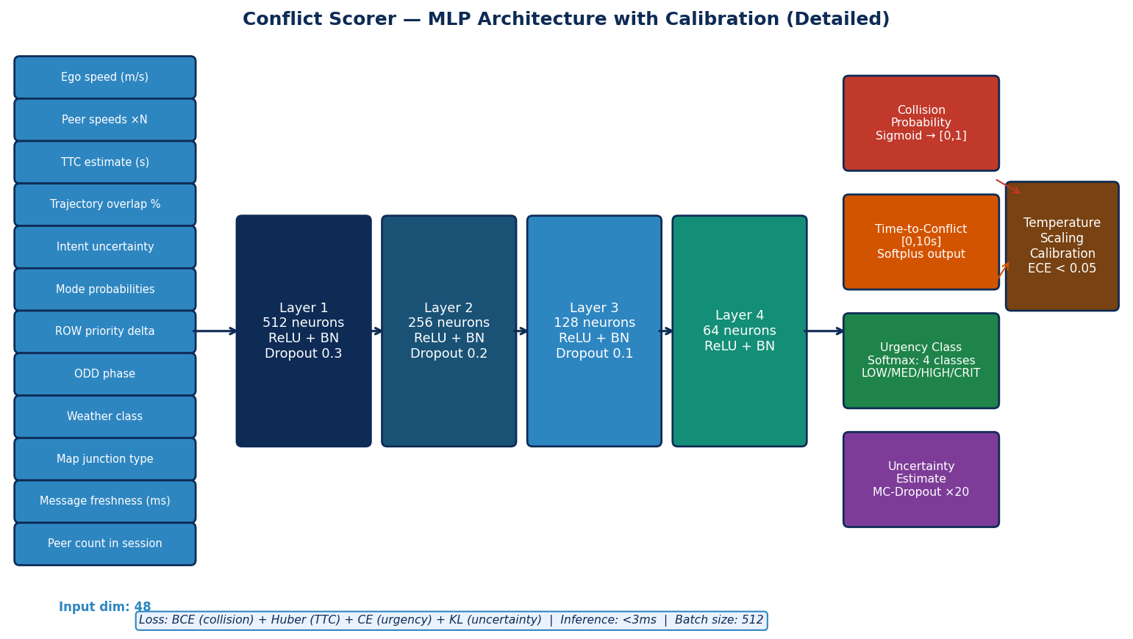
Figure 11 — Conflict Scorer MLP with MC-Dropout uncertainty and temperature scaling calibration. Three output heads: collision probability, time-to-conflict, urgency class.

7.3.1 Architecture & Training
Component | Specification
Input (48 dims) | Ego kinematics (6) + peer kinematics capped at N=4 (32) + model outputs (4) + session context (4) + ODD context (2)
Architecture | 4 layers: 512→256→128→64 neurons; ReLU + BatchNorm + Dropout (0.3/0.2/0.1/0)
Uncertainty | Monte Carlo Dropout (p=0.1, T=20 passes); epistemic uncertainty estimate
Output 1 — Collision prob | Sigmoid → [0,1]; temperature scaled for ECE < 0.05
Output 2 — Time-to-conflict | Softplus → [0,10s]; Huber regression loss
Output 3 — Urgency class | 4-class Softmax: LOW / MEDIUM / HIGH / CRITICAL
Training | BCE (collision×2) + Huber (TTC) + CE (urgency) + KL (uncertainty); batch=512; 80 epochs; A100
ASIL-D binding | collision_prob > 0.80 → HARD_YIELD (cannot be overridden); epistemic_std > 0.20 → treat as collision_prob=1.0

7.4 Model 4 — Out-of-Distribution Detector (NEW — required for SOTIF)
This model was missing from prior specifications. It is required by ISO 21448 (SOTIF) to detect when the AI stack is operating outside its validated performance envelope. Without OOD detection, models produce confident but wrong outputs in novel scenarios — the most dangerous ML failure mode.
Component | Specification
Method | Deep Ensemble (5 independently trained copies of Models 1+2+3) + Energy-based OOD score
Energy score | E(x) = −log Σ_k exp(logit_k(x)); lower energy = higher OOD likelihood
Ensemble disagreement | Variance of predictions across 5 members; high variance = OOD signal
OOD threshold | τ_E and τ_V set at 99th percentile of in-distribution validation set (tuned per model)
OOD types detected | (1) Input anomaly: sensor data outside trained distribution; (2) Distribution shift: gradual drift; (3) Adversarial: intentional perturbation
Output | in_distribution (bool) + ood_score [0,1] + ood_type enum
Latency | < 5ms additional (ensemble runs on separate CPU threads in parallel)
Action on OOD | Rule Engine: switch to max-conservative mode; speed limit 30km/h; yield to all; driver alert; EDR log; model retraining flag
Training | Same datasets as base models; trained independently with different random seeds

7.5 Model 5 — VRU Trajectory Predictor (NEW — required for V2P)
Component | Specification
Architecture | Social GAN (Generator: LSTM encoder-decoder; Discriminator: LSTM scene discriminator)
Generator input | 8-step history (0.8s) of: position, velocity, gait speed, group membership, device broadcast (if V2P equipped), crossing intent signal
Generator output | 20 stochastic trajectory samples; 12 steps (2.4s horizon @ 5Hz); position + velocity
Social pooling | Relative position pooling between all VRUs in scene; up to 20 pedestrians/cyclists
Special subclass models | Cyclist: bike lane adherence; Child: higher-variance distribution; Wheelchair: kerb-bound; Elderly: slower speed distribution
V2P fusion | If pedestrian carries V2P device: VAM broadcast position + velocity used as primary; camera prediction as secondary confirmation
Crossing intent sub-model | 3-class MLP (NO_CROSS / WILL_CROSS / CROSSING); features: approach angle, gaze direction estimate (from facial keypoints if visible), foot position vs kerb, group intent
Accuracy targets | ADE@2s < 0.35m; FDE@2s < 0.7m; collision miss rate < 0.5%; crossing intent F1 > 0.88
Training data | ETH/UCY pedestrian datasets + PIE intent dataset + JAAD crossing dataset + proprietary

8. Vulnerable Road User (VRU) Protection Subsystem

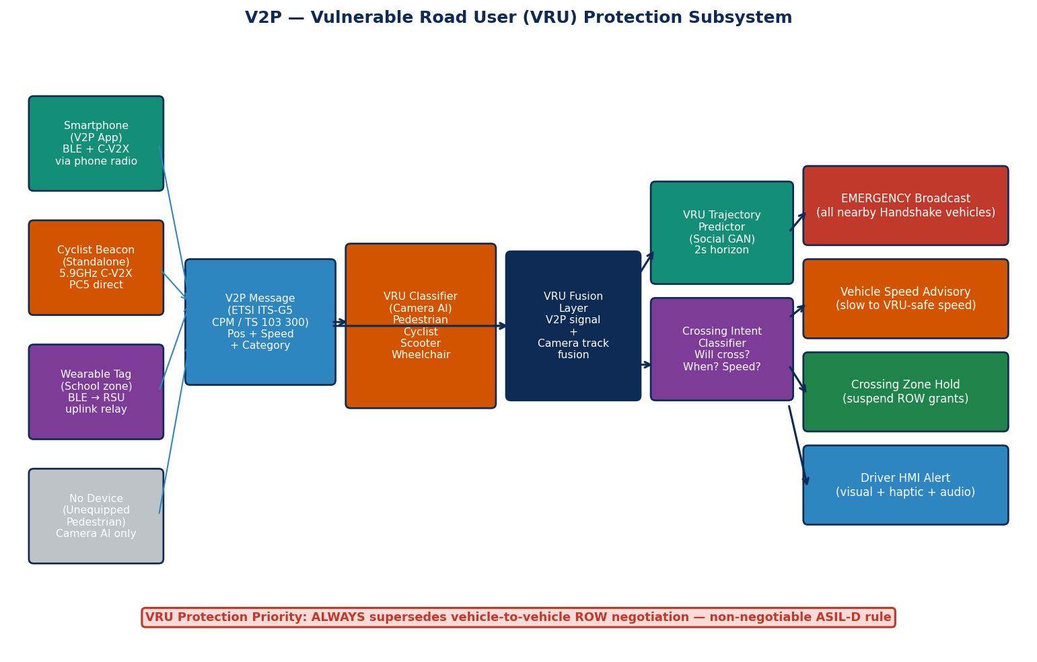
Figure 12 — V2P subsystem: four input types (smartphone, cyclist beacon, wearable relay, unequipped/camera-only). Pipeline produces crossing intent probability → triggers VRU_HOLD state and ASIL-D hard safety gate.

VRU protection is a FIRST-CLASS, NON-NEGOTIABLE subsystem. In urban deployments, failure to protect pedestrians and cyclists constitutes a critical safety violation and blocks regulatory approval. The VRU Safety Gate in the ASIL-D partition operates independently of and with higher priority than any V2V negotiation.

8.1 V2P Communication Standard
Handshake adopts ETSI TS 103 300-3 for VRU Awareness Messages (VAM). VAMs are broadcast by equipped VRU devices at 10Hz on the same 5.9 GHz ITS channel, at priority class 1 (same as ROW messages). The standard defines:
- vruProfileType: PEDESTRIAN, CYCLIST, MOTORCYCLIST, ANIMAL
- vruSubProfileType: ORDINARY, CHILD, ELDERLY, PHYSICALLY_IMPAIRED, VISUALLY_IMPAIRED
- clusterGroupLabel: enables family or crowd group detection
- situationContainer: heading confidence, motion prediction, hazard assessment
- pathHistory: last 3 waypoints for trajectory context

8.2 Unequipped Pedestrian Detection
The majority of pedestrians in Phase 1 will not carry V2P devices. The VRU Classifier (running in QM at 20Hz on camera feed) detects and classifies all VRUs using a YOLO-based detector fine-tuned on pedestrian/cyclist datasets, outputting bounding box + class + confidence + estimated speed vector. Output is fused with any available VAM messages from equipped VRUs in the VRU Fusion Layer, which resolves identity matches and produces a unified VRU object list.

8.3 Crossing Intent Algorithm & ASIL-D Binding Rule
/* VRU Crossing Intent Computation (QM partition, Model 5 sub-model) */ crossing_features = [ approach_angle_to_road, /* Angle between VRU heading and road */ distance_to_kerb_m, /* Metres to kerb edge */ gaze_towards_road, /* From facial keypoint model [0,1] */ group_crossing_signal, /* Others in group already crossing? */ v2p_intent_field, /* From VAM if equipped [0=no,1=yes] */ historical_crossing_rate /* Base rate for this location */ ]; P_will_cross = sigmoid(MLP(crossing_features)); /* [0,1] */ /* VRU Safety Gate (ASIL-D partition — non-overridable) */ /* Polled every 10ms from Narrow Channel vru_present field */ IF vru_present == 2 THEN /* P_cross > 0.6 threshold */ CROSSING_ZONE_HOLD := TRUE; /* Blocks all ROW GRANTs */ MAX_SPEED_CMD := 15 km/h; /* Hard speed limit in zone */ BROADCAST VRU_ALERT; /* All nearby vehicles notified */ HOLD_DURATION := MAX(5000ms, zone_clear_signal); END_IF /* This rule CANNOT be bypassed by: */ /* - Any V2V negotiation session result */ /* - Any ROW priority score */ /* - Any driver command */ /* - Any TMC instruction */ /* - Any software update (ASIL-D partition is OTA-excluded) */

9. Cooperative Perception — CPM Integration

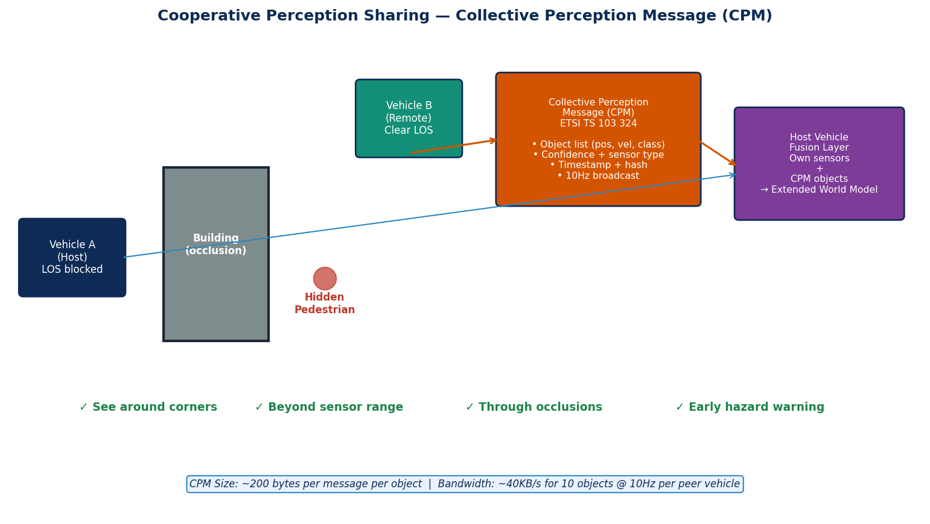
Figure 13 — Cooperative Perception: Vehicle B's sensor detections (including a hidden pedestrian behind a building) are shared via CPM. Vehicle A fuses received objects into its Extended World Model.

Cooperative Perception (also called Collective Perception) allows Handshake-equipped vehicles to share their sensor detections with nearby vehicles, effectively extending each vehicle's perception range beyond its own sensor limitations and around occlusions.

9.1 CPM Standard & Integration
Parameter | Specification
Standard | ETSI TS 103 324 — Collective Perception Service (CPS)
Broadcast rate | 10Hz (channel priority class 2, lower than ROW messages)
Object types | UNKNOWN, PEDESTRIAN, CYCLIST, MOPED, MOTORCYCLE, PASSENGER_CAR, BUS, LIGHT_TRUCK, HEAVY_TRUCK, TRAILER, ANIMAL, ROAD_OBSTACLE
Per-object payload | Position (lat/lon/alt ± confidence ellipse), velocity (2D ± confidence), heading, object class + confidence, sensor type (camera/radar/lidar), dimensions estimate, detection timestamp, time-to-expiry
Message size | ~200 bytes/object; 10 objects per CPM ≈ 2KB; ~40KB/s per peer at 10Hz
Channel budget | CPM throttled to 20% of available channel capacity via DCC; priority 2 dropped under congestion
Transmission eligibility | Only objects with confidence > 0.5 AND not already visible to receiver (visibility check via shared position + geometry)

9.2 CPM Fusion Algorithm
CPM Object Fusion (QM partition, runs after own-sensor fusion): For each received CPM_OBJECT: 1. Verify sender signature (HSM, already done in V2X pipeline) 2. Check sender trust_score ≥ 50 (from eBSM consistency scorer) 3. Transform CPM object position to own coordinate frame 4. Assign initial confidence: C_cpm = reported_confidence × 0.7 (30% discount for second-hand data vs own sensor data) 5. Cross-check: does own sensor fusion show anything nearby? - If own radar/camera confirms at distance≤1m: C_fused = MAX(C_own, C_cpm) - If partially confirmed (1–5m): C_fused = (C_own + C_cpm) / 2 - If not confirmed (new occlusion object): C_fused = C_cpm 6. Insert into Extended World Model with: object_id, class, position, velocity, C_fused, source=CPM, age=0ms 7. Age objects: increment age each fusion cycle (50ms) Expire objects: remove if age > expiry_time OR age > 500ms whichever first 8. Pass Extended World Model to all AI models as additional input

9.3 CPM Safety Constraints
CPM objects are used only for awareness and prediction — they never trigger autonomous braking or actuation directly. All CPM-derived objects feed into the AI models as additional context. If a CPM-derived object would trigger a safety response, the ASIL-D partition independently confirms via the sensor fusion data in the Narrow Channel before acting. This ensures CPM data cannot be weaponised to cause spurious emergency stops.

10. Cooperative Platooning Protocol

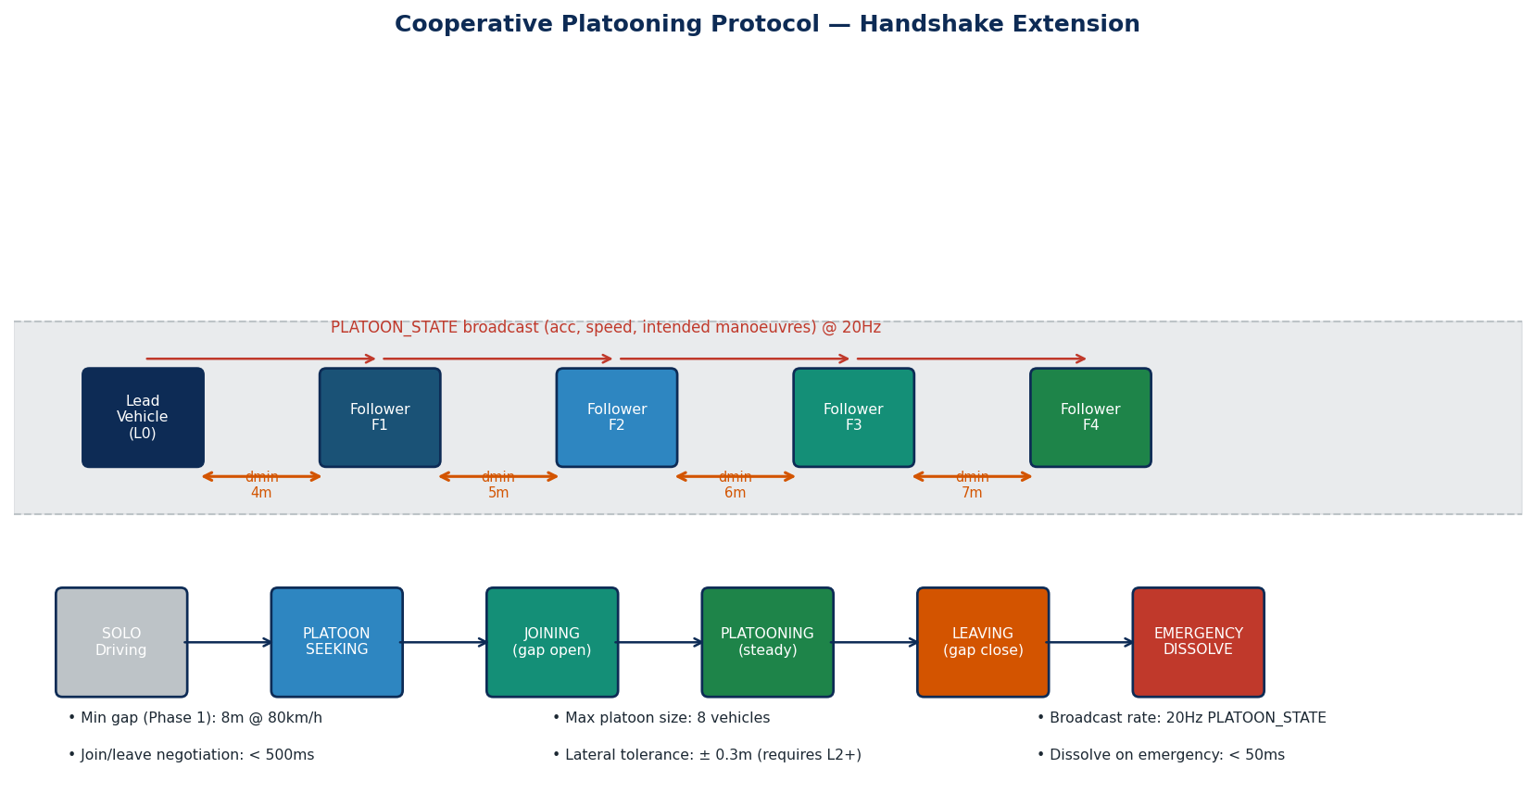
Figure 14 — Cooperative Platooning. Up to 8 vehicles; minimum gap 8m at 80km/h; PLATOON_STATE broadcast at 20Hz; full state machine governs join/platoon/leave/dissolve transitions.

10.1 Protocol Overview
The platooning protocol is a Handshake extension that coordinates a convoy of vehicles travelling together at highway speeds. It uses Cooperative Adaptive Cruise Control (CACC) to maintain time-gap-based following distances with sub-second response via V2X rather than waiting for radar measurement. The platooning state machine operates alongside the core negotiation FSM — a platooning vehicle may simultaneously participate in intersection negotiations when the platoon encounters an intersection.

10.2 Gap Control Algorithm
/* CACC Gap Controller (QM partition; command gated by ASIL-D envelope) */ d_setpoint = t_gap × v_self + d_min; /* t_gap=0.5s, d_min=4m */ e_gap = d_actual - d_setpoint; /* Positive: too far. Negative: too close */ /* PID with leader feed-forward */ a_ff = a_leader; /* Immediate feed-forward from PLATOON_STATE */ a_fb = Kp×e_gap + Kd×(v_leader - v_self) + Ki×∫e_gap dt; a_cmd = a_ff + a_fb; /* Kp=0.45, Kd=0.35, Ki=0.01 (tuned on CAN bus latency profile) */ /* ASIL-D Safety Envelope (always applied after PID) */ a_cmd = clamp(a_cmd, -3.5, +2.0); /* m/s², comfort limits */ IF d_actual < d_emergency THEN /* d_emergency = 4m */ a_cmd = -8.0; /* Emergency brake override */ END_IF /* Leader state estimation (if PLATOON_STATE not received >100ms) */ IF last_platoon_state_age > 100ms THEN v_leader_est = trajectory_predictor.predict(leader_last_state); a_cmd += 0.5 × max_gap_penalty; /* Precautionary expansion */ END_IF

10.3 Join, Leave & Emergency Dissolve
Event | Trigger | Protocol | ASIL-D Action
PLATOON JOIN | Follower detects compatible platoon within 100m | Send PLATOON_JOIN_REQ (capabilities, desired position); receive ACK → open gap; transition to PLATOONING | None; normal envelope monitoring
PLANNED LEAVE | Fleet instruction or navigation divergence | Send PLATOON_LEAVE; increase own d_setpoint to 15m; decelerate to create gap; exit when gap confirmed | None; normal deceleration limit
EMERGENCY DISSOLVE | Leader sends DISSOLVE OR leader PLATOON_STATE lost > 200ms OR own emergency event | Broadcast DISSOLVE to all members; each vehicle transitions to independent IDLE with 2s spacing | Safety Envelope: prevents gap below d_emergency during dissolve
CUT-IN Detection | Non-platoon vehicle detected in platoon gap via own radar + CPM | Leader sends gap reassignment; affected follower opens gap + triggers local ROW negotiation | VRU Gate monitors for pedestrian in gap throughout

11. Weather-Adaptive Degradation System

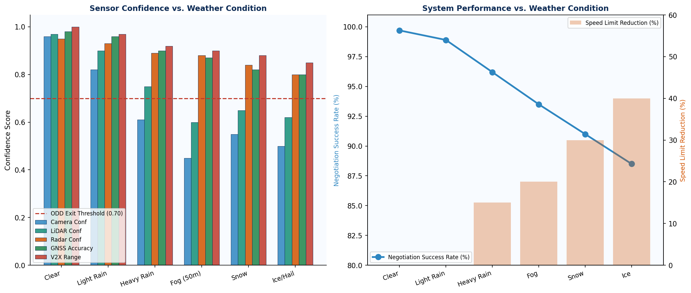
Figure 15 — Sensor confidence and negotiation performance vs. weather condition. Red line = ODD exit threshold. Right: negotiation success rate and automatic speed limit reduction.

11.1 Weather Classification
Weather class is determined by fusing four data sources: (1) windscreen wiper activation rate and speed (a reliable proxy for precipitation intensity, available via CAN bus on virtually all modern vehicles); (2) ABS/traction control slip data (detects reduced road friction); (3) ambient light and camera contrast metrics (detects fog and reduced visibility); (4) TMC-distributed weather data when available via Uu channel. The highest-severity source governs the weather class assigned.

11.2 Degradation Response Matrix
Weather Class | Fusion Confidence Multiplier | Max Speed Override | Sensor Weighting Adjustment | AI Model Adjustment | ODD Action
0 — Clear | 1.00× | None | Equal weight | Normal | Normal operation
1 — Light Rain | 0.88× | None | Radar +10%, Camera −10% | Expand trajectory uncertainty ×1.15 | Normal operation; monitor
2 — Heavy Rain | 0.72× | −15 km/h | Radar +30%, Camera −30% | Expand uncertainty ×1.35; reduce trajectory horizon to 4s | Warning; Phase 3/4 only
3 — Fog (vis≥50m) | 0.65× | −20 km/h | Radar 3× weight; Camera −50%; LiDAR −20% | Reduce K=3 modes; deweight CPM camera objects | Phase 1/2: ODD exit; Phase 3+: degraded
4 — Light Snow | 0.62× | −25 km/h; max 80km/h | Radar primary; disable lane marking model; use HD map lanes | Reduce trajectory horizon to 3s; expand lat uncertainty ×2 | Phase 1: ODD exit; Phase 2+: degraded
5 — Heavy Snow/Ice | 0.50× | −40 km/h; max 60km/h | Radar only for obstacles; GNSS for position; V2X 3× weight | Reduce horizon to 2s; urgency threshold halved | Phase 1/2/3: ODD exit; Phase 4: degraded + heavy monitor

11.3 ODD Exit Formal Trigger Conditions
The following conditions are formalized as verifiable software requirements (per ISO 26262 Part 6) and trigger an ODD exit → Level 1 or Level 3 Safe State:
/* ODD Exit Monitor (ASIL-D partition, 10ms polling cycle) */ /* Trigger 1: GNSS uncertainty */ IF gnss_position_uncertainty_m > 2.0 FOR 3 consecutive seconds THEN trigger_odd_exit(REASON_GNSS_UNCERTAINTY); END_IF /* Trigger 2: Sensor fusion confidence */ IF sensor_fusion_confidence < 0.65 FOR 3 consecutive seconds THEN trigger_odd_exit(REASON_SENSOR_CONFIDENCE); END_IF /* Trigger 3: V2X reception rate */ IF (known_nearby_peer_count > 0) AND (v2x_message_rate_hz < 6.0 FOR 5 consecutive seconds) THEN trigger_odd_exit(REASON_V2X_DEGRADED); END_IF /* Trigger 4: Speed limit violation */ IF vehicle_speed > (odd_phase_max_speed + 10 km/h) THEN trigger_odd_exit(REASON_SPEED_VIOLATION); END_IF /* Trigger 5: Map mismatch */ IF map_road_geometry_match < 0.5 FOR 10 consecutive seconds THEN trigger_odd_exit(REASON_MAP_MISMATCH); END_IF /* Trigger 6: Weather degradation */ IF weather_class >= weather_class_odd_limit[odd_phase] THEN trigger_odd_exit(REASON_WEATHER); END_IF /* weather_class_odd_limit = [3, 4, 5, 5] for phases 1–4 */

12. Federated Learning Pipeline

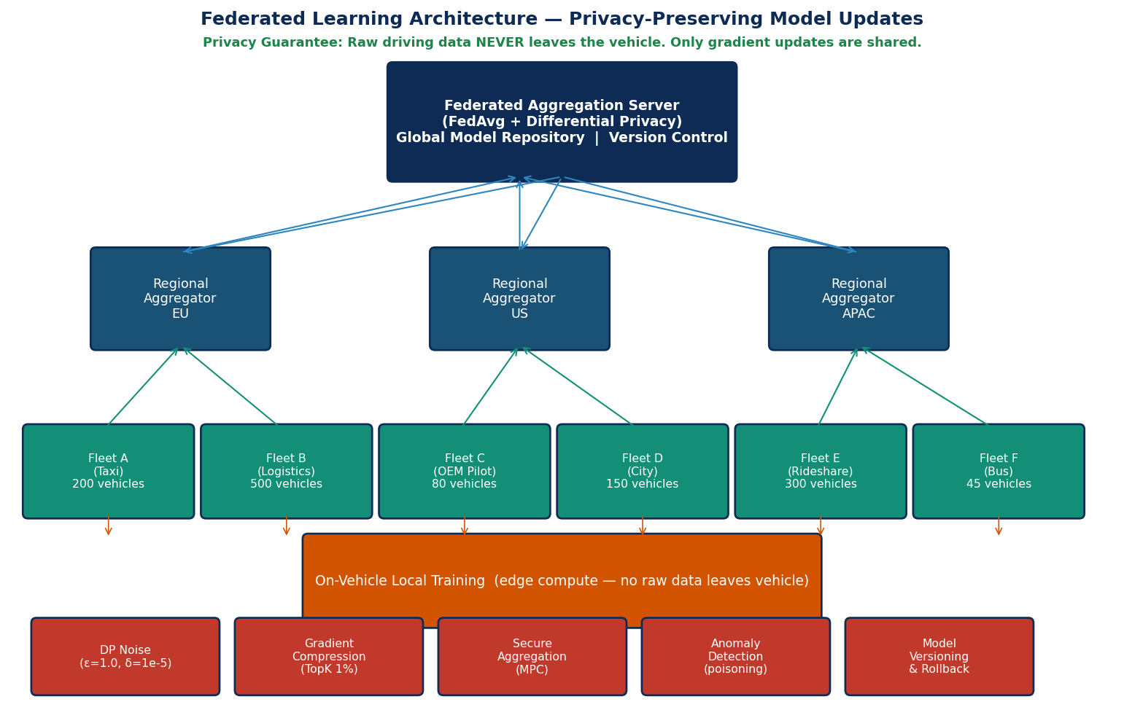
Figure 16 — Privacy-preserving Federated Learning. Raw data never leaves the vehicle. Gradient updates are protected by differential privacy noise, gradient compression, and secure multi-party aggregation.

12.1 Design Rationale
AI models trained on a fixed initial dataset will degrade over time as driving patterns evolve, new vehicle types enter the fleet, new road layouts appear, and seasonal changes affect behaviour distributions. Without continuous learning, Handshake's AI performance would decay, increasing OOD detections and falling back to conservative mode more frequently. Federated Learning enables improvement without raw data ever leaving the vehicle — satisfying GDPR Article 25 (privacy by design), CCPA, and similar requirements globally.

12.2 FL Protocol Specification
Component | Specification
Algorithm | Federated Averaging (FedAvg) with per-layer adaptive learning rate (FedAdam variant)
Round cadence | Model 1 (Trajectory): weekly; Model 2 (Intent): fortnightly; Model 3 (Conflict): monthly; Models 4/5: monthly
Minimum participants | 100 vehicles per regional round (prevents gradient inversion attacks on small cohorts)
Local training | 5 epochs on last 7 days of local data; mini-batch SGD lr=1e-4; dataset: inference inputs + ground-truth outcomes
Differential privacy | Gaussian mechanism: noise multiplier σ=1.1, gradient clip norm C=1.0; target (ε=1.0, δ=1e-5) per round per vehicle
Gradient compression | Top-K sparsification K=1% of gradient dimensions + error feedback; reduces bandwidth ~56MB→~560KB per update
Secure aggregation | Pairwise masking protocol (Bonawitz et al. SecAgg); aggregation server sees only the sum, not individual gradients
Poisoning detection | Per-client gradient cosine similarity to round mean; clients with similarity < 0.3 excluded; Byzantine-robust aggregation (Krum or Trimmed Mean)
Model versioning | Semantic versioning MAJOR.MINOR.PATCH; automatic rollback if new model increases ODD trigger rate by > 5% on validation set
On-vehicle storage | Last 7 days of inference inputs labelled by outcome (resolved scenario); ~500MB local storage; encrypted at rest via HSM-derived key
OTA deployment | New global weights pushed via secure OTA to QM partition only; ASIL-D partition never updated remotely; dual-signature (vendor + OEM)

13. Operational Design Domain (ODD)

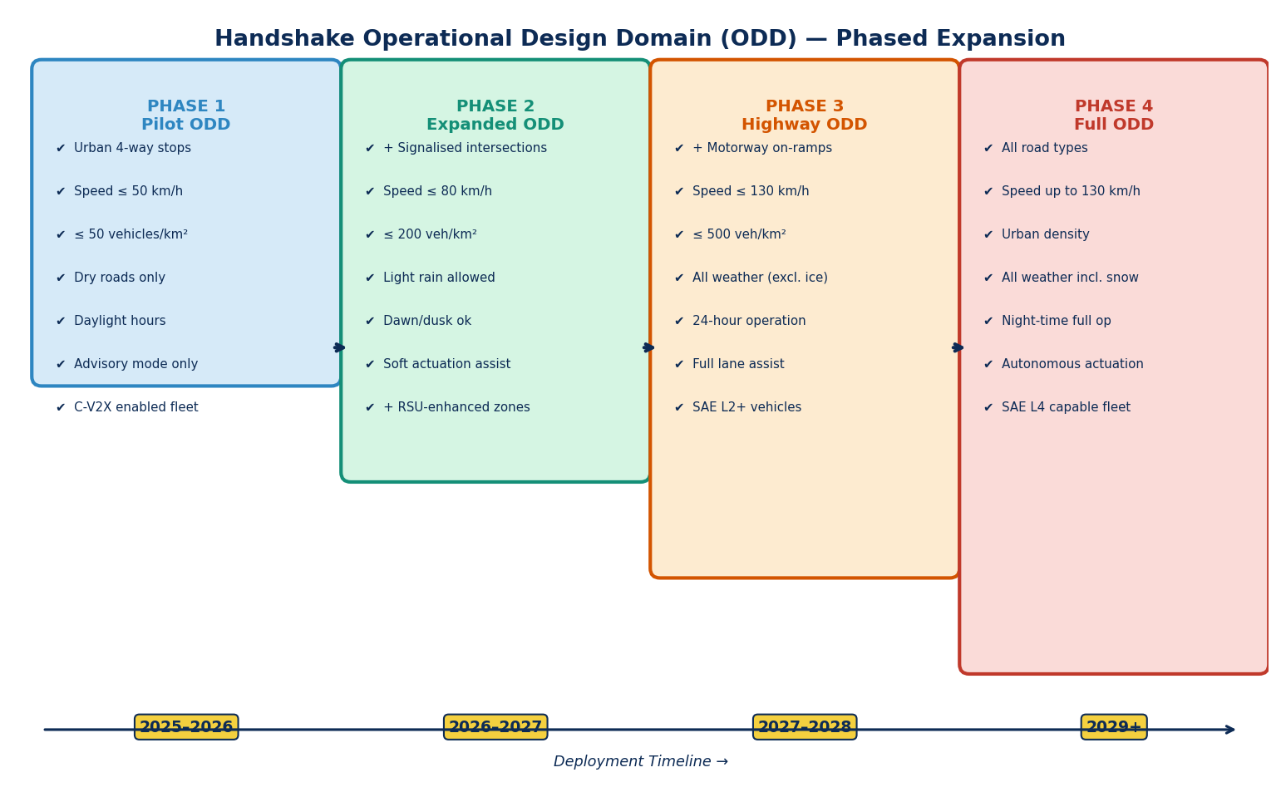
Figure 17 — ODD Phased Expansion. Four phases from urban intersection pilot (Phase 1) to full highway deployment (Phase 4).

13.1 Phase 1 ODD — Intersection Pilot
Parameter | Phase 1 Specification | Verification Method
Scenario type | 4-way stop intersections and T-junctions in pre-mapped urban grid | HD map coverage verified at deployment
Road type | Urban arterial; marked lanes; kerbs present; no roundabouts | Map attribute check at startup
Approach speed | ≤ 50 km/h | Real-time speed monitoring; ODD exit if exceeded
Vehicle type | C-V2X-enabled fleet vehicles only (no DSRC-only at Phase 1) | Radio capability handshake at session initiation
Traffic density | ≤ 50 vehicles/km² | Negotiation table capped at 32 concurrent peers
Weather | Dry road; visibility ≥ 100m; no fog, snow, or ice | Weather class = 0 or 1 only
Time of day | Daylight hours only (1h after sunrise to 1h before sunset) | GPS-derived civil twilight calculation
Mode | Advisory only — driver alert; no autonomous actuation | Mode flag in ASIL-D partition; actuator gateway disabled
Map requirement | HD map tile ≤ 90 days old; lane accuracy ≤ 0.3m | Map age check at startup and every 30 minutes
VRU devices | Camera-based VRU detection required; V2P devices optional | VRU classifier active and passing health check

13.2 Phase 2 — Urban Expansion
Parameter | Phase 2 Addition/Change | Notes
Intersections | + Signalised intersections (SPAT/MAP); + roundabouts; + school zones; + bus corridors | Requires RSU SPAT broadcast or TMC SPAT feed
Speed | ≤ 80 km/h | Negotiation latency budget tightened to 120ms
Weather | + Light rain (vis ≥ 50m) | Weather class ≤ 1; heavier rain → ODD exit
Vehicles | + SAE L2+ vehicles (soft actuation assist) | ASIL-D partition enables speed suggestion output to ADAS stack
Density | ≤ 200 vehicles/km² | RSU arbitration required in dense zones
Time | + Dawn and dusk (30 min window each side) | Camera confidence degraded; radar-primary mode

13.3 Phase 3 — Highway Merge
Parameter | Phase 3 Addition/Change | Notes
Scenario | + Motorway on-ramps and lane merges; + overtaking coordination | Merge scenario requires negotiation budget ≤ 80ms at 130km/h
Speed | ≤ 130 km/h | Emergency stop distance at 130km/h ≈ 150m; sensor range must exceed this
Weather | + Heavy rain (vis ≥ 20m); + light fog | Weather class ≤ 3; degraded mode active with radar-primary
Vehicles | SAE L3 vehicles may accept actuation commands | Full actuator authority within safety envelope
Fleet penetration | Minimum 15% Handshake-equipped vehicles for measurable benefit | V2X range 500m = relevant zone at 130km/h
Time | 24-hour operation | Night mode: camera confidence reduced; radar+LiDAR primary

13.4 Phase 4 — Full Deployment
Parameter | Phase 4 Specification | Notes
Road types | All road types: urban, rural, residential, motorway, car parks | Map coverage required for urban/suburban; sensor-only for uncharted roads
Speed | ≤ 130 km/h (speed limit capped) | Full negotiation budget met at all speeds
Weather | All weather including heavy snow (degraded mode) and ice (minimum-function mode) | ASIL-D envelope significantly tightens speed limits
Vehicles | Full SAE L4 actuator authority within ODD | ASIL-D partition always retains override capability
Night | Full 24-hour operation including night | IR camera + LiDAR primary at night; radar fallback
Multi-modal | Bus, tram, emergency vehicle priority classes active | Priority class extensions active

14. Event Data Recorder (EDR) & Liability Framework

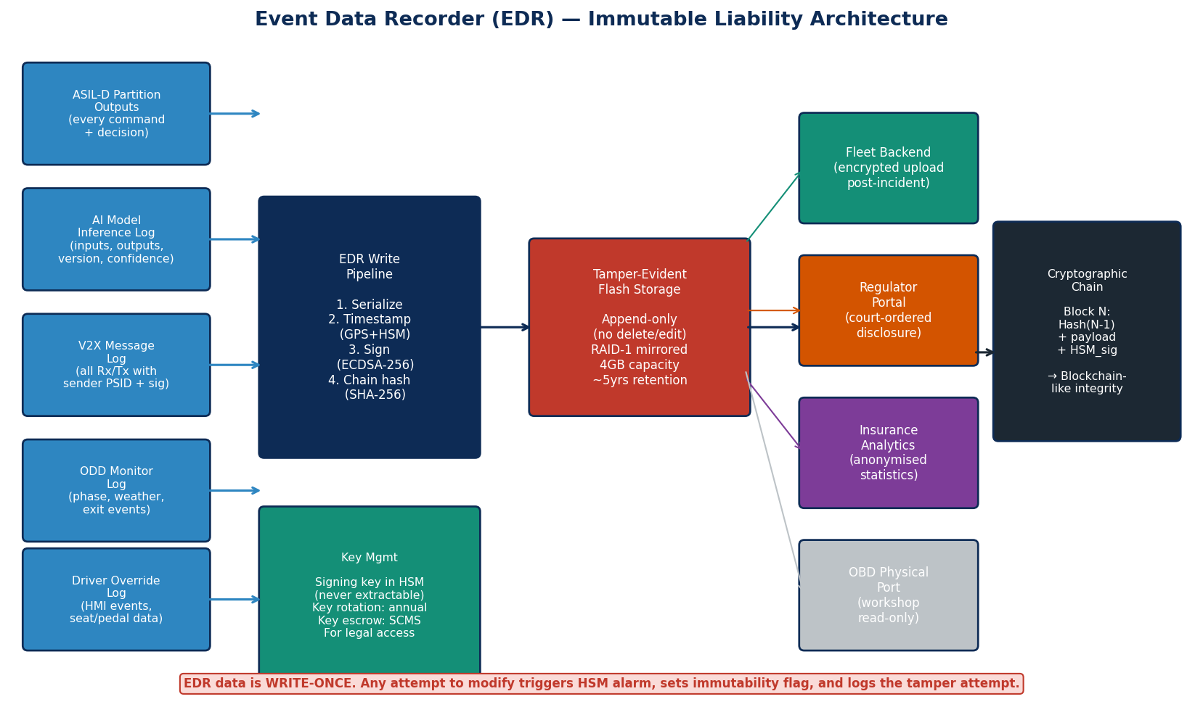
Figure 18 — EDR architecture: five data sources, HSM-signed cryptographic chain, append-only tamper-evident storage, and access pathways for fleet backend, regulator, insurance, and workshop port.

14.1 EDR Design Principles
Every ROW grant, every yield command, every ODD transition, every AI model output, every V2X message received, and every safety override MUST be logged to the EDR with microsecond timestamps, HSM-signed, and stored in tamper-evident hardware. This is not optional — it is the foundation of the liability framework and a prerequisite for any insurance product or regulatory approval.

14.2 EDR Data Schema
EDR Record Type | Fields Logged | Retention | Trigger
ROW_DECISION | session_id, timestamp_us, decision_type (GRANT/DEFER/HOLD), own_priority, peer_priority, traffic_rule_applied, collision_prob, urgency_class, ai_health, weather_class | 5 years or vehicle lifetime | Every negotiation outcome
AI_INFERENCE | session_id, timestamp_us, model_1_ADE, model_1_mode_probs[6], model_2_class, model_2_entropy, model_3_collision_prob, model_3_TTC, model_4_ood_flag, model_4_ood_score, model_versions[5] | 5 years | Every inference cycle during active session
V2X_RX | timestamp_us, sender_psid, message_type, sig_valid (bool), cert_valid (bool), replay_check (bool), message_hash | 90 days | Every received V2X message
V2X_TX | timestamp_us, own_psid, message_type, recipient_psid, message_hash | 90 days | Every transmitted V2X message
ODD_EVENT | timestamp_us, event_type, odd_phase_before, odd_phase_after, trigger_reason, sensor_confidence, weather_class, gnss_uncertainty | 5 years | Every ODD phase transition
VRU_EVENT | timestamp_us, vru_id, vru_class, crossing_prob, zone_hold_active, distance_m, v2p_equipped (bool) | 5 years | Every VRU detection above threshold
SAFE_STATE | timestamp_us, trigger_type, safe_state_level, decel_applied_g, prior_speed_ms, fault_code, watchdog_counter | Lifetime | Every safe state entry
DRIVER_OVERRIDE | timestamp_us, override_type, prior_recommendation, driver_action | 5 years | Every driver action overriding Handshake recommendation

14.3 Cryptographic Chain
/* EDR Cryptographic Chain (ASIL-D partition) */ /* Each record is a block in a hash chain — tamper detection is O(1) */ struct EDR_Block { uint8_t prev_block_hash[32]; /* SHA-256 of previous block */ uint64_t timestamp_us; /* GPS-synchronized microseconds */ uint8_t record_type; /* Enum from EDR schema above */ uint8_t payload[MAX_PAYLOAD]; /* Record-specific fields */ uint8_t hsm_signature[64]; /* ECDSA-256 signature by EDR key */ }; /* EDR signing key is a dedicated key pair in HSM, separate from V2X key */ /* EDR key CANNOT be used for any other purpose */ /* Key is write-once at manufacturing; no rotation; escrow with regulator */ /* Tamper detection: any modification to any block invalidates all */ /* subsequent blocks' chain hashes — immediately detectable */ /* Storage: append-only NOR flash (write endurance >100k cycles per cell) */ /* Mirroring: RAID-1 across two independent flash chips */

14.4 Liability Attribution Matrix
Incident Scenario | Liable Party | Key EDR Evidence | Handshake Obligation
ROW granted based on malformed message from peer | Peer vehicle's software vendor / OEM | V2X_RX record: sig_valid=true but payload anomaly; sender PSID; SCMS linkage request | EDR preserves all received messages with validation status — SCMS provides identity linkage for legal proceedings
ROW granted correctly; vehicle failed to execute | Vehicle OEM (actuator) | ROW_DECISION: GRANT issued; V2X_TX: PROCEED sent; CAN gateway: command transmitted; actuator response not matching | ASIL-D partition logs command vs actuator confirmation; discrepancy is OEM responsibility
AI model error caused wrong priority score | Handshake software vendor | AI_INFERENCE: model versions, input features, output scores; ROW_DECISION: priority scores used | AI inference log with model version enables exact reproduction; vendor provides model behaviour evidence
Vehicle operated outside declared ODD | Fleet operator / driver | ODD_EVENT: exit triggered with reason code; DRIVER_OVERRIDE: driver dismissed ODD exit warning | EDR shows ODD exit was triggered and driver chose to continue; operator policy governs accountability
Non-Handshake vehicle caused collision | Third-party driver | V2X_RX: no messages from that vehicle; own sensors show obstacle; AI inference shows model responded correctly | Absence of V2X messages is evidential; own inference log shows correct response to unequipped obstacle
GPS spoofing caused wrong junction profile | Attacker / no liability for Handshake | EDR shows GNSS_UNCERTAINTY triggered; peer cross-check anomaly logged; ODD_EVENT: GPS_SPOOF_SUSPECTED | EDR logs anomaly detection; demonstrates system behaved correctly given the adversarial inputs

15. End-to-End Data Flow & Timing Budget

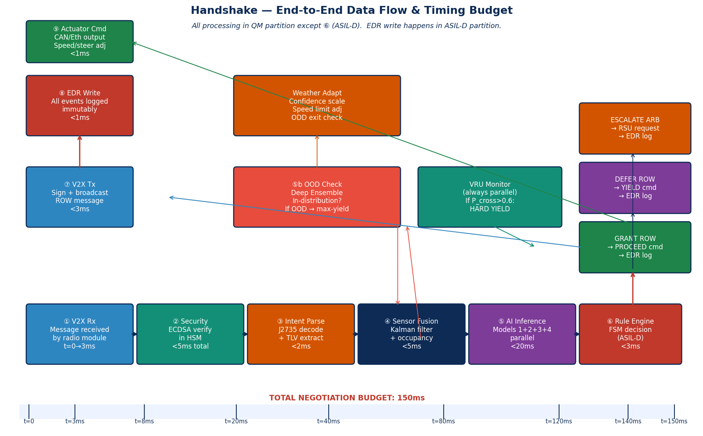
Figure 19 — End-to-end data flow from V2X message reception to actuator command. Nine processing stages with timing allocation. Total negotiation budget: 150ms. All parallel processes shown: OOD check, weather adaptation, VRU monitoring.

15.1 Timing Budget Breakdown
Stage | Processing | Budget | Allocation
① V2X Receive | Radio buffer → DMA → V2X stack queue | t=0 to 3ms | Radio hardware: 1ms; DMA: 0.5ms; queue overhead: 1.5ms
② Security Verify | HSM ECDSA-256 verify + cert chain check + CRL lookup + nonce check | 3ms to 8ms | HSM verify: 5ms guaranteed; cert chain: 0.5ms (cached); nonce: 0.1ms
③ Intent Parse | J2735 decode + TLV extraction + schema validation | 8ms to 10ms | J2735 decode: 1ms; TLV: 0.5ms; validation: 0.5ms
④ Sensor Fusion | Kalman update + occupancy grid + CPM fusion | 10ms to 20ms | Kalman: 5ms; grid: 3ms; CPM: 2ms
⑤ AI Inference (parallel) | Models 1+2+3+4+5 in parallel on GPU + CPU | 20ms to 45ms | Transformer: 12ms; BiGRU: 6ms; MLP: 3ms; OOD: 5ms (parallel); VRU: 8ms (GPU, parallel)
⑥ Rule Engine | FSM lookup + priority score + tiebreaker (ASIL-D) | 45ms to 48ms | FSM: 1ms; priority: 1ms; tiebreaker: 1ms; all integer arithmetic
⑦ V2X Transmit | Sign + broadcast ROW message | 48ms to 52ms | HSM sign: 5ms; broadcast: 1ms overhead
⑧ Remote processing | Remote vehicle receives and processes (mirror of ①–⑥) | 52ms to 100ms | Network RTT: 5–10ms; processing: ~45ms (same budget)
⑨ Resolution | GRANT/DEFER received; actuator command; EDR write | 100ms to 150ms | Response Rx+verify: 8ms; actuator cmd: 2ms; EDR write: 1ms; margin: 39ms

16. Infrastructure Integration & COTS Modification Guide

16.1 Required Hardware Modifications
Component | COTS Base | Required Modifications | Notes
C-V2X Radio | Qualcomm 9150 C-V2X Module | Add Handshake TLV encoder/decoder to J2735 firmware; implement session table (32 concurrent peers); add DCC priority 0–3 enforcement; expose latency telemetry API | Qualcomm provides SDKs; TLV extension requires firmware modification agreement
HSM | Infineon SLB 9670 / NXP SE050 | Write Handshake signing API (sign_v2x_message, verify_v2x_message, rotate_pseudonym); implement EDR key management (separate key pair); verify <5ms sign latency under load | HSM vendor provides evaluation kits; key ceremony required at manufacturing
SoC — GPU | NVIDIA DRIVE Orin | Deploy 5 TFLite/TensorRT INT8 model graphs; implement parallel inference scheduler; allocate GPU partitions (Models 1,5 on GPU; Models 2,3,4 on CPU threads) | NVIDIA DriveWorks SDK provides inference pipeline; model deployment tool: trtexec
SoC — MCU | NXP S32G (ASIL-D MCU core) | Implement ASIL-D partition in MISRA-C; integrate hypervisor configuration; implement narrow channel polling; implement EDR writer; implement CAN/Eth gateway | NXP provides AUTOSAR BSW stack; ASIL-D core requires separate silicon from QM GPU
Hypervisor | Green Hills INTEGRITY-178 tuMP | Configure partition layout (QM: Linux; ASIL-D: custom RTOS); define shared memory region (32 bytes); configure CPU time partition (QM: 80%, ASIL-D: 20% guaranteed); certification data package | Green Hills provides certification evidence pack for ASIL-D; hardware MPU config is safety-critical
GNSS | u-blox F9P (multi-constellation) | Enable GNSS uncertainty output (horizontal accuracy estimate); implement multi-constellation cross-validation; connect to HSM for GPS-synchronised timestamps for EDR | u-blox provides binary protocol SDK; no major modifications needed
HD Map | HERE HD Live Map SDK | Implement OpenDRIVE tile parser for junction types; implement map age check; build lane context → FSM input translator; implement map-free fallback mode | HERE provides automotive SDK; OpenDRIVE parsing library available open-source

16.2 RSU Requirements
When RSUs are available, they must support: (1) C-V2X PC5 and/or DSRC broadcast for SPAT/MAP, CRL segments, and SCMS certificate bundles; (2) Handshake ARBITRATION_REQ message reception and ARBITRATION_GRANT message transmission with < 30ms processing latency; (3) TMC connectivity via IPSec VPN for traffic code profile updates and event telemetry. Compatible RSU platforms: Cohda MK5/MK6, Kapsch V2X RSU, Commsignia R500.

16.3 TMC Integration API
Handshake TMC Integration API (REST + MQTT) REST Endpoints (HTTPS, mutual TLS): GET /v1/traffic-code-profiles/{region_id} Returns: active FSM traffic code profile JSON for jurisdiction POST /v1/events/incident Body: {lat, lon, incident_type, severity, radius_m} Action: Pushes priority alert to all RSUs in radius GET /v1/crl/latest Returns: current certificate revocation list (CRL) delta POST /v1/odd/phase-update Body: {deployment_zone_id, new_odd_phase, effective_time} Action: Updates ODD phase for all vehicles in zone MQTT Topics (MQTT v5, TLS): handshake/spat/{intersection_id} — SPAT messages (5Hz) handshake/map/{region_id} — MAP geometry updates handshake/weather/{zone_id} — Weather class updates (1min cadence) handshake/crl/push — CRL push (immediate on revocation) handshake/events/out/{vehicle_psid} — Per-vehicle event stream (to fleet) Authentication: OAuth 2.0 client credentials; scopes per operation type

17. Testing & Validation Strategy

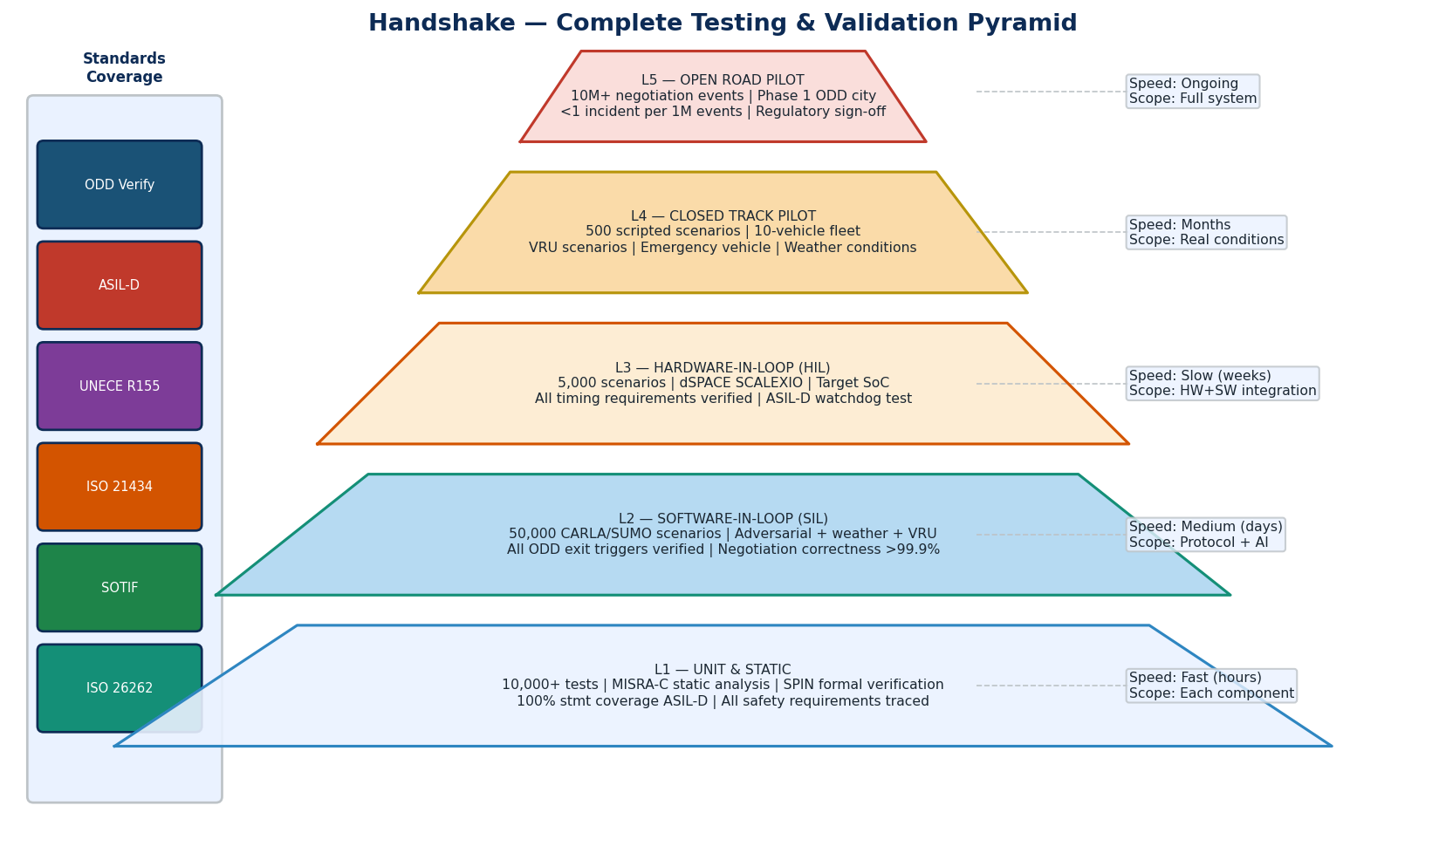
Figure 20 — Complete Testing Pyramid. Five levels from unit testing to open road pilot. Standards coverage mapped to each level.

17.1 Testing Level Specifications
Level | Environment | Tools | Scenario Count | Pass Criteria | Standard Coverage
L1 — Unit/Static | Software only | GTest, Pytest, SPIN (formal), PC-Lint (MISRA), Polyspace (formal proof) | 10,000+ unit tests; 100% SPIN state coverage | 100% statement coverage ASIL-D; 95% branch QM; zero MISRA violations; all FSM states formally verified | ISO 26262 Part 6 (unit testing)
L2 — SIL | CARLA 0.9 + SUMO 1.18 + custom V2X plugin | Handshake V2X simulator, adversarial scenario generator, weather injection module | 50,000 scenarios (ODD, edge cases, adversarial, weather) | Zero safety violations in defined ODD; all ODD exit triggers demonstrated; negotiation correctness > 99.9%; all AI fallback paths exercised | ISO 26262 Part 4; SOTIF Section 8
L3 — HIL | dSPACE SCALEXIO + NI VeriStand + Qualcomm 9150 eval board + SoC platform | Target hardware, real C-V2X radio, hardware GNSS simulator, CAN bus replay | 5,000 scenarios (timing, hardware latency, real radio behaviour) | All timing requirements met on target hardware; ASIL-D watchdog test passed; narrow channel CRC test passed; EDR write timing verified | ISO 26262 Part 4; ISO/SAE 21434 (hardware testing)
L4 — Closed Track | 10-vehicle instrumented fleet, controlled intersection, V2X RSU | Fleet telematics, video recording, independent safety observer | 500 scripted scenarios including VRU dummies, emergency vehicle, wet track | Zero Category 1 safety events; ROW accuracy > 99.5%; VRU hold always triggered; emergency override < 200ms; all ODD exit scenarios exercised | SOTIF Section 9; ISO 26262 confirmation measures
L5 — Open Road Pilot | Real urban environment, Phase 1 ODD city, public roads | Fleet telemetry, video, anonymised trip data, independent safety assessment | 10M+ negotiation events; 12-month minimum | < 1 Handshake-attributable incident per 1M events; ODD compliance > 99.9%; VRU false negative rate < 0.1% | Regulatory evidence for NHTSA/EU type approval

17.2 Critical Test Scenarios

Category A — Negotiation Correctness
- 4-way stop: all 24 permutations of arrival order; simultaneous arrival; equal priority tiebreaker
- Roundabout: 2–8 vehicles; priority to vehicles already in roundabout
- Highway merge: closing rate 10–30m/s; reject merge when TTC < 2s
- Emergency vehicle: corridor formation within 200ms; all statuses released after passage
- Negotiation under message loss: 10%, 20%, 50% packet drop; fallback always safe

Category B — Safety Boundary & ASIL-D
- AI model returns max confidence (1.0) for wrong class — rule engine overrides correctly
- GPS error injected 10m — ODD exit within 3 seconds; safe state cleanly achieved
- V2X radio jammed — fallback to BSM only; no unsafe actuator command emitted
- ASIL-D watchdog deliberate starvation — safe state within 20ms exactly
- Narrow channel CRC failure ×3 — ASIL-D uses last valid + triggers safe state

Category C — VRU & SOTIF
- Pedestrian dummy crosses at 1m in front — VRU_HOLD always triggered before intersection entry
- VRU occluded by parked vehicle — CPM from other equipped vehicle triggers correct hold
- Cyclist at night with reflective gear only — camera + radar fusion detects correctly
- OOD test: construction zone with non-standard markings — OOD detector flags; conservative mode activated

Category D — Adversarial (Cybersecurity)
- Sybil: 5 fake identities from one device — all blocked by SCMS behaviour scorer within 2 sessions
- Replay: captured REQUEST_ROW replayed at 500ms — rejected by timestamp window
- GPS spoof: fake signal ±50m — peer cross-check detects; ODD exit triggered
- ML poison: crafted messages to shift trajectory — collision_prob ASIL-D override triggers correctly

18. Regulatory Pathway & Standards Compliance

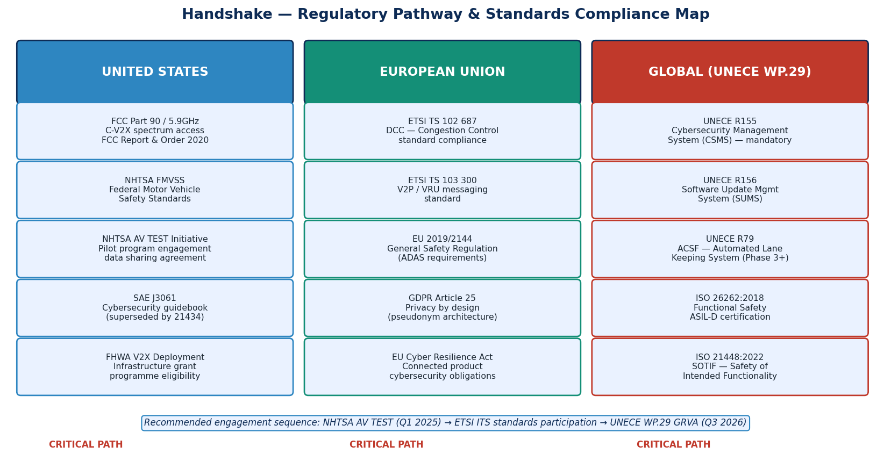
Figure 21 — Regulatory engagement map across US, EU, and global (UNECE WP.29) jurisdictions.

18.1 Standards Compliance Matrix
Standard | Status in This Blueprint | Evidence Deliverable
ISO 26262:2018 (Functional Safety) | Full ASIL-D design; HARA; FSC; MISRA-C; formal verification; safety case | ISO 26262 Safety Case document; ASIL-D audit readiness package
ISO 21448:2022 (SOTIF) | SOTIF analysis; triggering conditions; OOD detector; adversarial testing specification | SOTIF Analysis Report; triggering condition test results
ISO/SAE 21434:2021 (Cybersecurity) | Full TARA; CSMS design; 6 cybersecurity goals; penetration test plan; vulnerability monitoring | TARA Report; CSMS documentation; penetration test report
UNECE R155 (CSMS) | CSMS architecture specified; OTA security; supplier requirements | CSMS certification package (third-party audit required)
UNECE R156 (SUMS) | OTA platform design; ASIL-D excluded from OTA; dual-signature update | SUMS certification package
SAE J2735 | eBSM extension backwards compatible; negotiation messages in Regional Extension field | Protocol conformance test results
ETSI TS 103 300-3 (V2P/VRU) | Full VAM integration; VRU subsystem specified | ETSI ITS conformance test
ETSI TS 103 324 (CPM) | Full CPM integration; fusion algorithm specified | ETSI ITS conformance test
3GPP Release 14+ (C-V2X PC5) | Primary radio technology; DCC implemented; mode 4 SB-SPS | 3GPP conformance test (radio type approval)
IEEE 1609.2 / SCMS | Full SCMS integration; pseudonym management; CRL pipeline | SCMS deployment certification
ASAM OpenDRIVE | HD map consumption; tile parser specified | Map integration test
GDPR Article 25 | Privacy by design: pseudonym rotation; federated learning; no raw data upload | Privacy Impact Assessment (PIA)

18.2 Recommended Regulatory Engagement Sequence
- Q1 — Engage NHTSA AV TEST Initiative: submit voluntary safety self-assessment; join data sharing programme; target Phase 1 pilot designation
- Q2 — Join ETSI ITS standards working group (TC ITS) as observer; contribute Handshake extensions to V2P and CPM standards revisions
- Q3 — Initiate SCMS Certificate Policy agreement with US DOT SCMS Operator
- Q4 — Begin UNECE WP.29 GRVA informal engagement for Phase 3 type approval roadmap
- Year 2 — File FCC experimental licence for pilot spectrum access if needed
- Year 2 — Engage EU type approval authority for UNECE R155/R156 preliminary assessment
- Year 3 — Submit to third-party ASIL-D certification auditor (TÜV SÜD, SGS, or equivalent)

Appendix A — Complete Interface Specifications

A.1 Negotiation State Machine — All Transitions
State | Event | Next State | Condition | Action
IDLE | ConflictDetected | DISCOVERING | Peer trajectory intersects own in [1s,10s] horizon | Start discovery timer; increase eBSM to 20Hz
DISCOVERING | AllIntentsReceived | REQUESTING | All detected peers responded with intent OR timer(50ms) expired | Compute own priority score; select target peer
DISCOVERING | VRUDetected | VRU_HOLD | vru_present ≥ 2 raised | Transition immediately; suspend discovery
REQUESTING | GrantReceived | GRANTED | GRANT_ROW from peer with matching session_id | Issue PROCEED command via Narrow Channel; EDR log
REQUESTING | ContestReceived | CONTESTING | CONTEST_ROW with peer_priority ≥ own_priority | Recompute with contest data; decide winner
REQUESTING | Timeout×2 | AWAIT_ARB | No response in 100ms total | Send ARBITRATION_REQ to nearest RSU
CONTESTING | PeerDefers | GRANTED | DEFER_ROW received | Issue PROCEED command
CONTESTING | PeerGrants | DEFERRED | Own GRANT sent to peer | Issue YIELD command; reduce speed
CONTESTING | Timeout | AWAIT_ARB | No resolution in 100ms | Escalate to RSU
AWAIT_ARB | ArbGrantWin | GRANTED | ARBITRATION_GRANT with own_psid as winner | Proceed
AWAIT_ARB | ArbGrantLose | DEFERRED | ARBITRATION_GRANT with peer_psid as winner | Yield
AWAIT_ARB | NoRSU_Timeout | DEFERRED | No RSU response in 50ms | Fail-safe: yield to all
GRANTED | ZoneCleared | IDLE | Own trajectory has departed conflict zone | Send RELEASE; reset session
DEFERRED | PeerReleased | IDLE | RELEASE received AND own trajectory clear | Reset session
DEFERRED | PeerStalled | REQUESTING | Peer granted but not proceeding for 10s | Re-initiate session
VRU_HOLD | VRUCleared | IDLE | vru_present=0 for 3 consecutive seconds | Send zone clear broadcast
ANY | WatchdogFault | SAFE_STATE | ASIL-D watchdog miss or ASIL-D fault | Controlled deceleration; all output suspended
ANY | ODDExit(Critical) | SAFE_STATE | Critical ODD exit trigger (see Section 11.3) | Controlled deceleration
ANY | ODDExit(Advisory) | (Degraded Mode) | Advisory ODD exit trigger | Advisory silence; reduce BSM frequency

A.2 Traffic Code Profile — FSM Input Format
/* Traffic Code Profile JSON Schema */ { "profile_id": "UK_2024_v1", "jurisdiction": "GB", "effective_date": "2024-01-01", "junction_rules": [ { "junction_type": "FOUR_WAY_STOP", "arrival_scenario": "SIMULTANEOUS", "rule": "RIGHT_HAND_PRIORITY", "priority_table": { "FROM_RIGHT": 100, "FROM_LEFT": 0, "FROM_AHEAD": 50, "FROM_BEHIND": 0 } }, { "junction_type": "ROUNDABOUT", "rule": "YIELD_TO_CIRCULATING", "circulating_priority": 100, "entering_priority": 0 }, { "junction_type": "SIGNALISED", "rule": "SIGNAL_PHASE_PRIORITY", "green_phase_priority": 100, "amber_phase_priority": 20, "red_phase_priority": 0 } ], "vehicle_class_weights": { "EMERGENCY": 30, "POLICE": 25, "AMBULANCE": 30, "BUS": 15, "TRAM": 20, "HEAVY_GOODS": 5, "STANDARD": 0 }, "default_fallback": "YIELD_TO_ALL" }

Appendix B — Glossary

Term | Definition
ADE | Average Displacement Error — metric for trajectory prediction quality (metres)
ASIL | Automotive Safety Integrity Level A–D per ISO 26262; D is highest
BiGRU | Bidirectional Gated Recurrent Unit — recurrent neural network architecture
BSM | Basic Safety Message — SAE J2735 standard V2X broadcast message
CACC | Cooperative Adaptive Cruise Control — platooning gap control using V2X
CAL | Cybersecurity Assurance Level 1–4 per ISO/SAE 21434; 4 is highest
CPS | Collective Perception Service — ETSI standard for sensor data sharing
CPM | Collective Perception Message — ETSI TS 103 324 message type
CRF | Conditional Random Field — probabilistic sequence model for classification
CRL | Certificate Revocation List — list of revoked V2X pseudonym certificates
CSMS | Cybersecurity Management System per UNECE R155 and ISO/SAE 21434
DCC | Decentralised Congestion Control per ETSI TS 102 687
DP | Differential Privacy — mathematical privacy guarantee for federated learning
DSRC | Dedicated Short-Range Communication — IEEE 802.11p based V2X
eBSM | Enhanced BSM — Handshake extension of J2735 BSM with intent TLV fields
ECE | Expected Calibration Error — metric for probability calibration quality
EDR | Event Data Recorder — immutable tamper-evident log of all Handshake decisions
FMEA | Failure Mode and Effects Analysis — systematic safety analysis method
FDE | Final Displacement Error — endpoint error for trajectory prediction
FSM | Finite State Machine — deterministic computational model for Rule Engine
HARA | Hazard Analysis & Risk Assessment per ISO 26262 Part 3
HIL | Hardware-in-the-Loop testing — target hardware with simulated environment
HSM | Hardware Security Module — dedicated crypto processor
ISO 21448 | Safety of the Intended Functionality — SOTIF standard
ISO/SAE 21434 | Road vehicle cybersecurity engineering standard
MISRA-C | Motor Industry Software Reliability Association C coding guidelines (safety-critical)
ODD | Operational Design Domain — defined conditions for validated operation
OOD | Out-of-Distribution — inputs outside the AI model's training distribution
PCA | Pseudonym Certificate Authority — SCMS entity issuing vehicle pseudonym certificates
PC5 | 3GPP direct communication sidelink interface used by C-V2X
ROW | Right-of-Way — legal and logical priority to proceed through a conflict zone
RSU | Roadside Unit — infrastructure V2X node providing arbitration and CRL services
SAE L0–L4 | SAE driving automation levels: L0=no automation, L4=high automation within ODD
SCMS | Security Credential Management System — V2X PKI infrastructure
SIL | Software-in-the-Loop testing — simulation-based testing
SOTIF | Safety of the Intended Functionality — ISO 21448
SPAT | Signal Phase and Timing — V2X message from traffic lights to vehicles
TARA | Threat Analysis & Risk Assessment per ISO/SAE 21434
TTC | Time-to-Collision — predicted time before two trajectories intersect
V2P | Vehicle-to-Pedestrian — V2X communication with VRU devices
V2X | Vehicle-to-Everything — wireless communication between vehicles and environment
VAM | VRU Awareness Message — ETSI TS 103 300-3 message for equipped VRUs
VRU | Vulnerable Road User — pedestrians, cyclists, motorcyclists
WTA | Winner-Takes-All — training strategy for multi-mode trajectory models

