Homework 4: Cloud9 - Hangman

Gabrielle A. Jeuck

University of Maryland Global Campus

SDEV 400: Secure Programming in the Cloud

May 6, 2020

Homework 4: Cloud 9 - Hangman

# AWS Cloud 9 – Hangman.py

This version of the hangman has a few different key features to point out. Figures 1 to 7 show the code. Figures 8 to 10 show the current database scores. Figures 11-16 show gameplay under the user Gabby whose high score was already 100 in the database. The user continues to guess and gets bonus points if successfully guessing the full word. Otherwise, points are given on a standard basis. For example, if a user guesses only the characters in a word the standard points for easy mode are 5 and 15 for hard. If a user guesses the full word bonus points are given; easy mode 10 bonus points plus standard 5 points and hard mode gives 20 bonus points plus standard points of 15. Each time the user successfully guesses a word the score is updated to the database if it’s greater than the current score. Figures 17 to 22 show a user by the name of James playing to increase his score and to submit to the leaderboards. Figure 23 shows the current leaderboard which James is not in. Figure 24 shows James playing another game which increases his score and now puts him on the leaderboard. Figure 25 shows instructions on how to play the game and operate the menu. Figure 26 shows the credits. Figure 27 to 29 shows input validation for the user, menu, and gameplay. For the leaderboard section I created a global secondary index with a partition key of GameTitle and a sort key of Score. This allowed to sort the scores based off of the specific GameTitle. In the future, this could be improved for separate leaderboards of game modes. One could have GameTitle of Hangman-Hard or Hangman-Easy to separate the top scores based on modes. Figure 30 shows s3 bucket gjeuck-hangman with all files including mediumwords.txt which was not used.

# Test Cases

|  |  |  |  |  |
| --- | --- | --- | --- | --- |
| **Run** | **Input** | **Expected Output** | **Actual Output** | **Pass / Fail** |
| 1 | ThisNameIsTooLong  RawrGabby  Gabby | Prompt for inputting name must be between 1 and 14 characters  No scores and prompts menu  Pull top score from leaderboards and menu prompt | Please tell me your name: ThisNameIsTooLong  Your name must be between 1 and 14 characters long.  Please tell me your name: RawrGabby  No scores have been added for you, Rawrgabby  Try winning some to get on the leaderboards!  Please tell me your name: Gabby  Gabby has a top score of 135! | Pass |
| 2 | Menu:  A  !#$  8  1 | Invalid  Invalid  Invalid  Easy Play Menu | Enter your choice: A  Please select from the number choices 1-6!  Enter your choice: !#$  Please select from the number choices 1-6!  Enter your choice: 8  Please select from the number choices 1-6!  Enter your choice: 1  ---------------------  ------Easy Mode------  ---------------------  Let's play Hangman!  -------  | |  |  |  |  |  -------    _____  The word is 5 characters  Guess a letter or word: | Pass |
| 3 | Game play:  1  @  Null  A | Invalid character  Invalid character  Invalid  success | Guess a letter or word: 1  Invalid character. Please use letters only.  Guess a letter or word: @  Invalid character. Please use letters only.  Guess a letter or word:  Not a valid guess  Yay! You guessed the letter A.  A____  The word is 5 characters  Guessed Letters: ['A']  Guessed Words: [] | Pass |
| 4 | 3  4  5 | Display leaderboards  Display Instructions  Display Credits | ---- TOP 10 LEADERBOARDS ----  Rank Player Score  1 Gabby 135  2 Frank 100  3 James 55  4 SorryMissJacks 45  5 John 35  6 Janice 30  7 Peyton 30  8 Greg 30  9 Paxton 25  10 Maria 20  As seen in figure 25  Credits  Programming:  Gabrielle Jeuck  Testing:  Gabrielle Jeuck  Documentation:  Gabrielle Jeuck | Pass |
| 5 | Play again? “Y”  Play again? “N”  QUIT: 6 | Prompt menu  Exit program  Exit Program, thank user | Do you want to play again? Y/N: y  Welcome to Hangman Gabby!  1. Easy Play  2. Hard Play  3. Leaderboards  4. Instructions  5. Credits  6. Quit  Enter your choice:  Do you want to play again? Y/N: n  You didn't choose to play again.  Thank you for playing  Thank you for playing Gabby! | Pass |

Figures

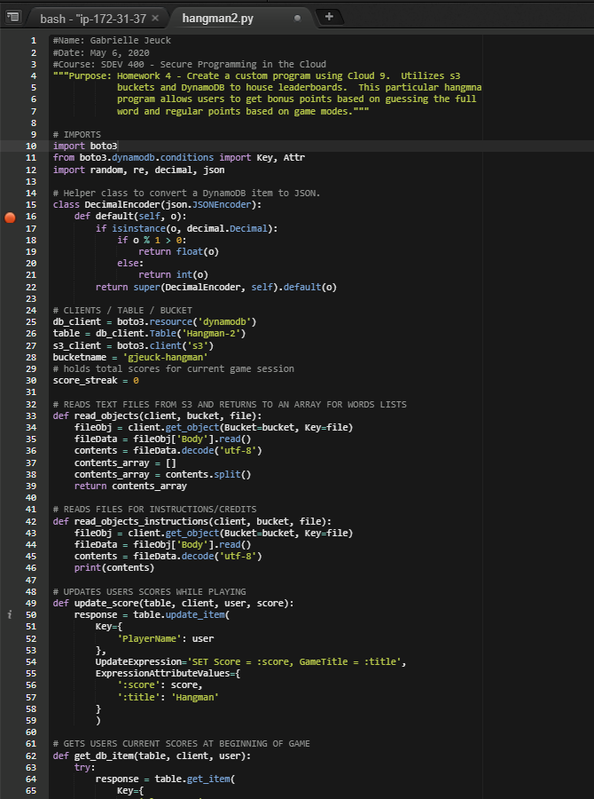

Figure 1. hangman2.py code 1 of 7

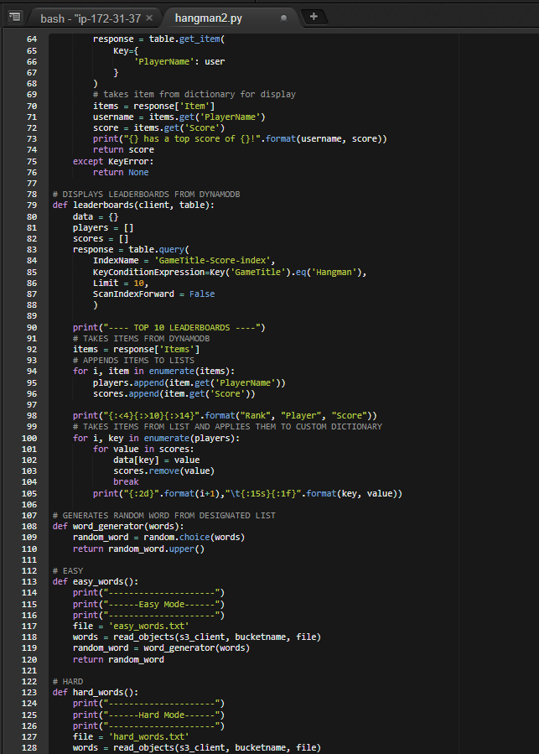

Figure 2. hangman2.py code 2 of 7

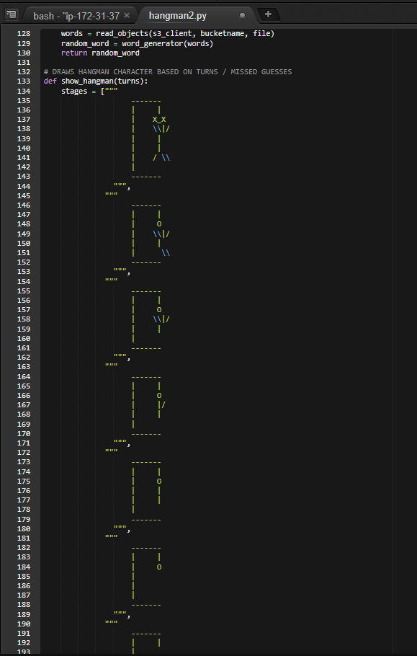

Figure 3. hangman2.py code 3 of 7

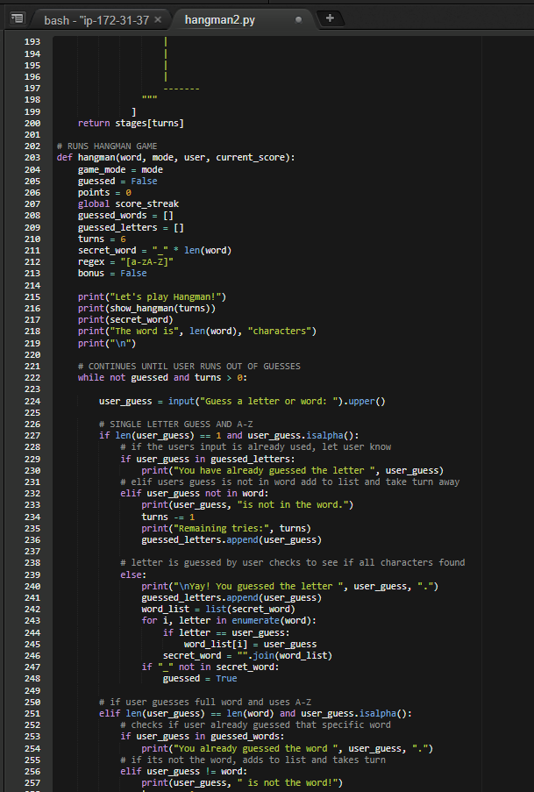

Figure 4. hangman2.py code 4 of 7

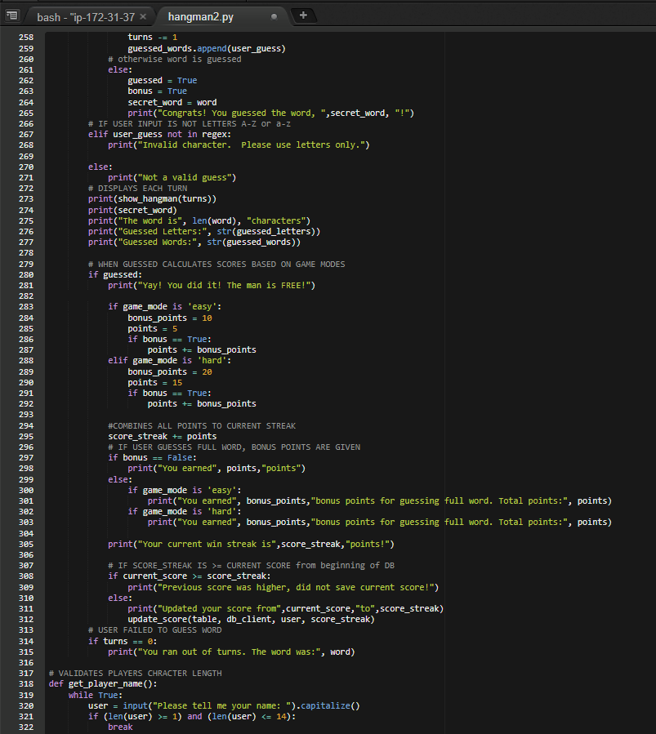

Figure 5. hangman2.py code 5 of 7

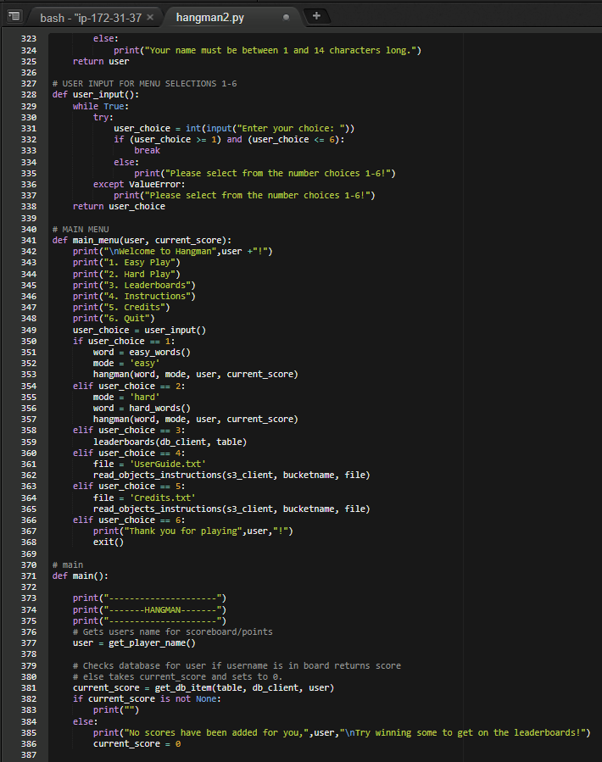

Figure 6. hangman2.py code 6 of 7

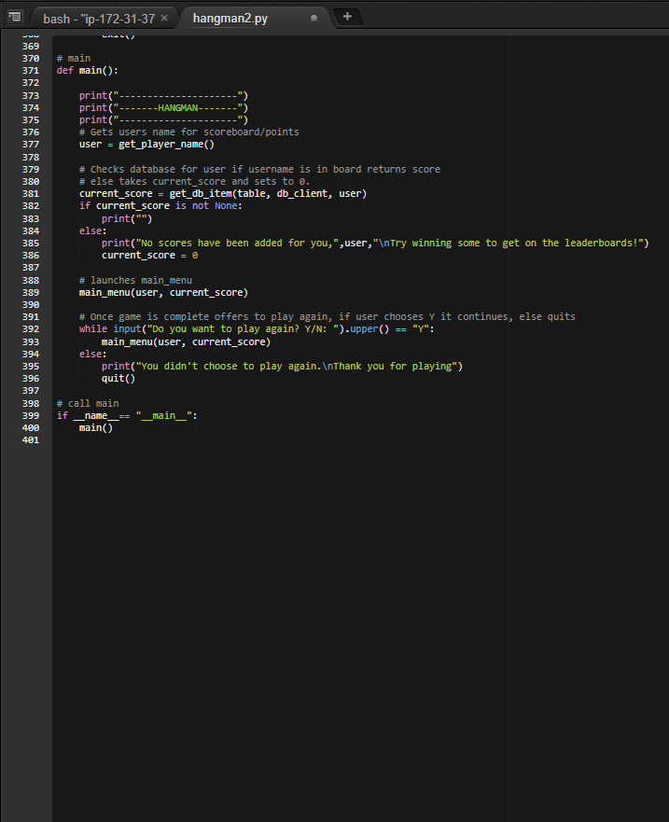

Figure 7. hangman2.py code 7 of 7

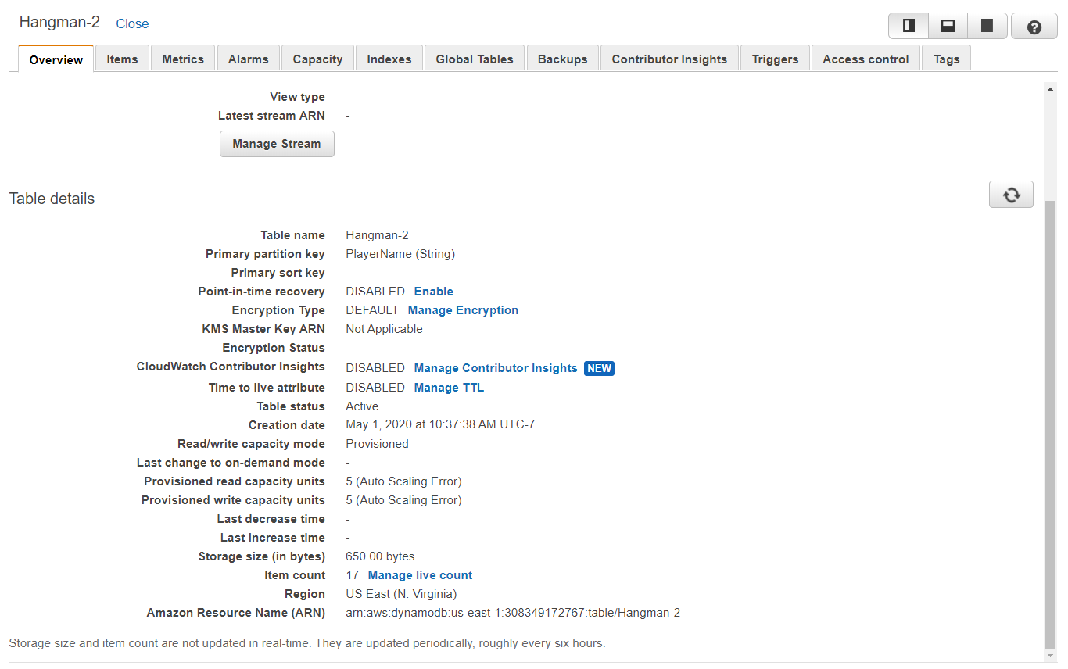

Figure 8. DynamoDB Overview

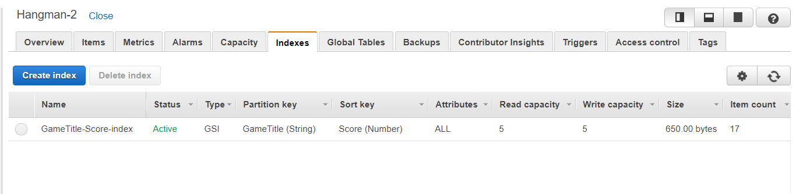

Figure 8. DynamoDB Global Secondary Indexes

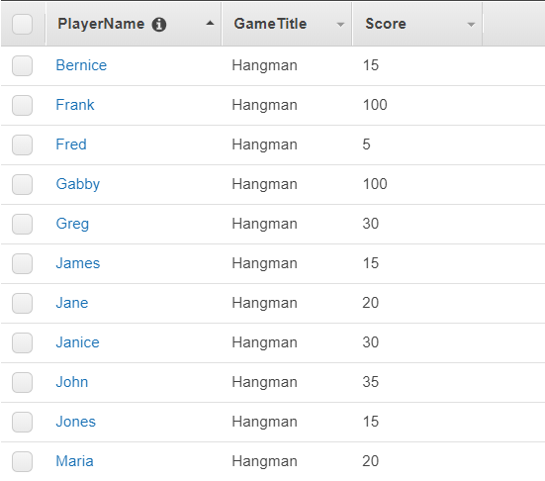

Figure 9. 1 of 2 Items in DynamoDB

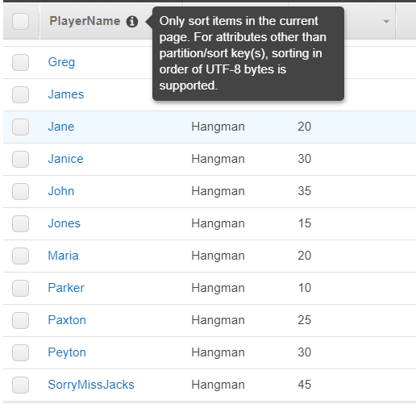

Figure 10. 2 of 2 Items in DynamoDB

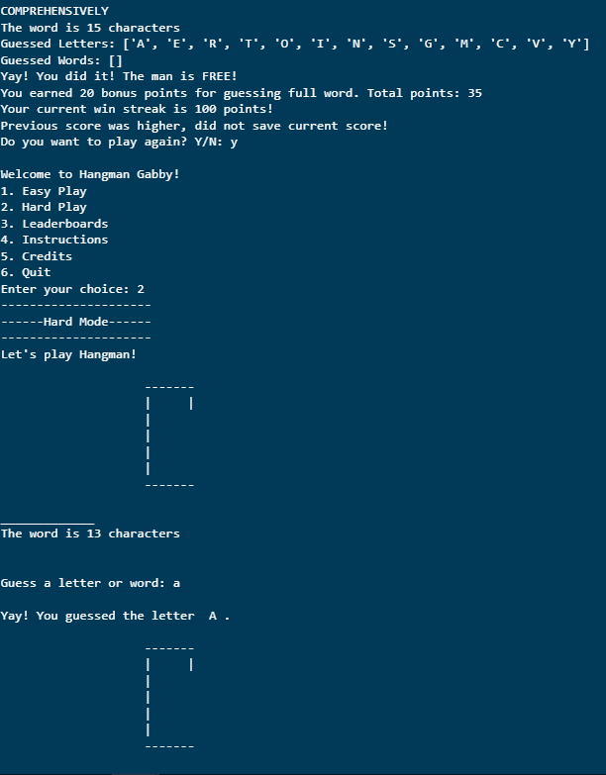

Figure 11. Gameplay Hard Mode 1 of 6 Player Gabby

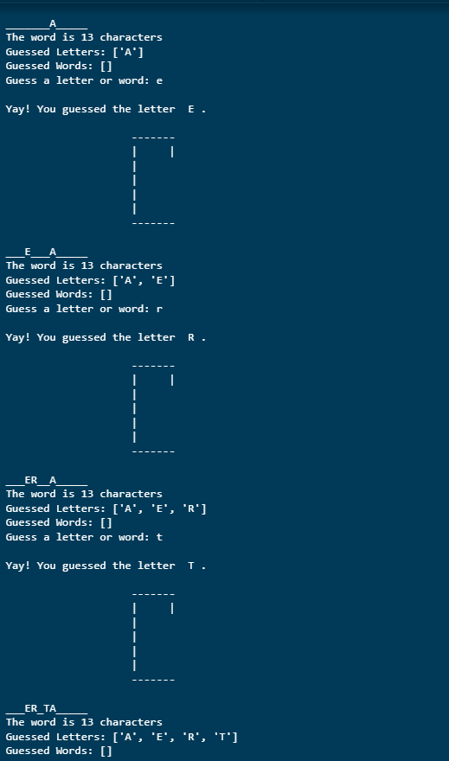

Figure 12. Gameplay Hard Mode 2 of 6 Player Gabby

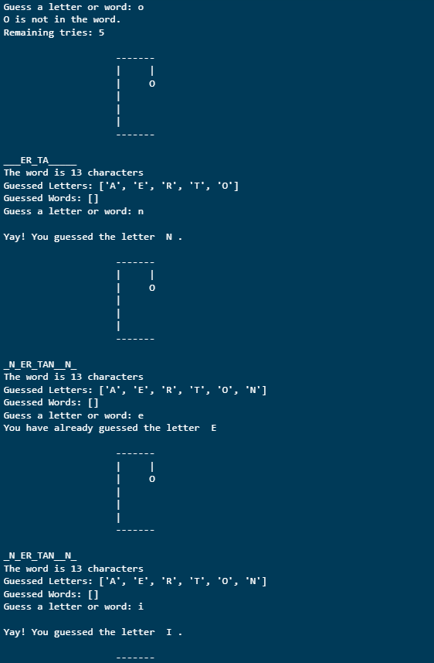

Figure 13. Gameplay Hard Mode 3 of 6 Player Gabby

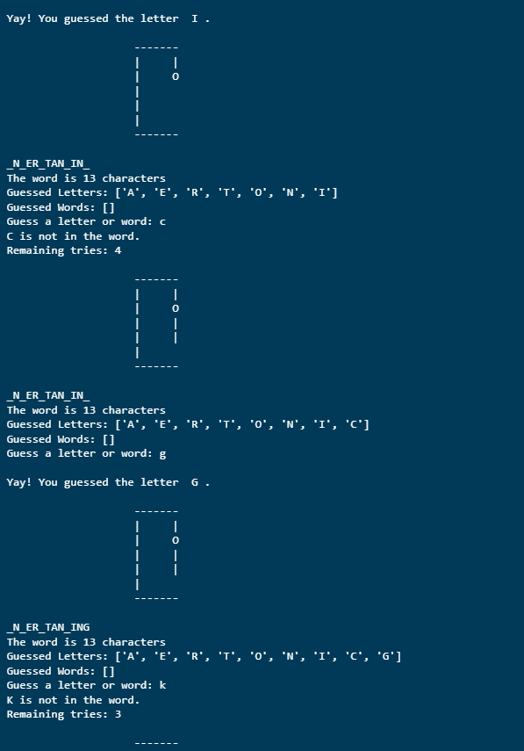

Figure 14. Gameplay Hard Mode 4 of 6 Player Gabby

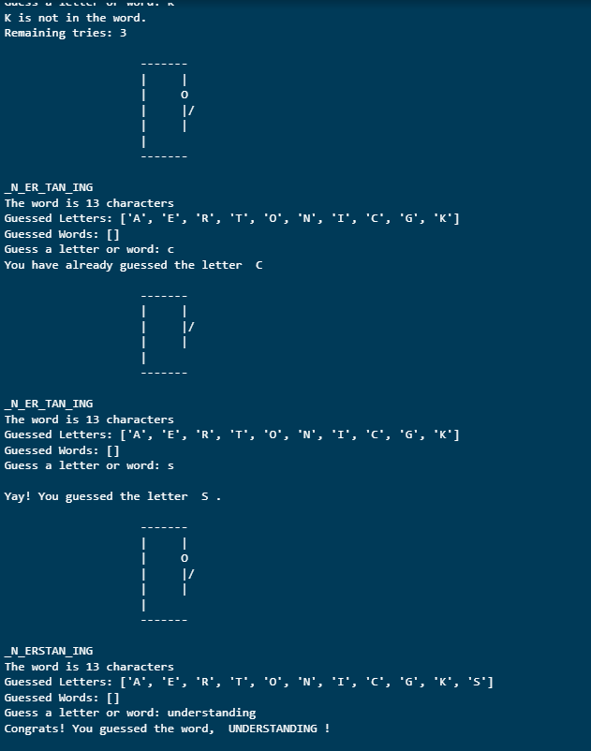

Figure 15. Gameplay Hard Mode 5 of 6 Player Gabby

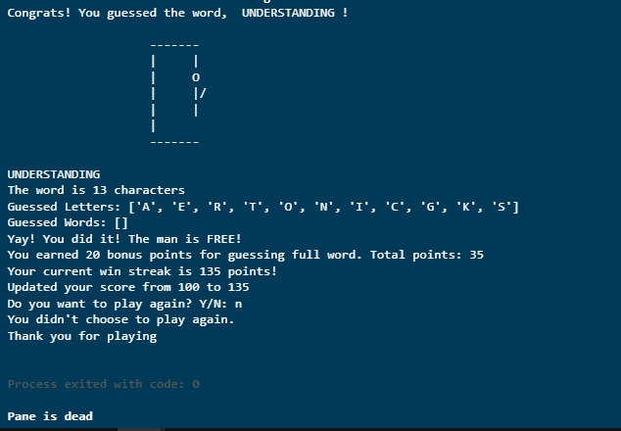

Figure 16. Gameplay Hard Mode 6 of 6 – Bonus is given for guessing full word and updated high score in leaderboards.

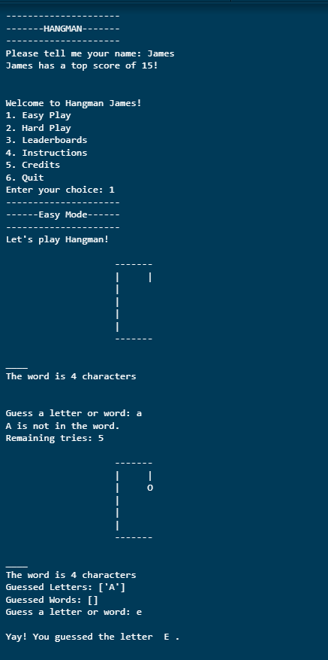

Figure 17. Gameplay Easy Mode – Player James 1 of 6

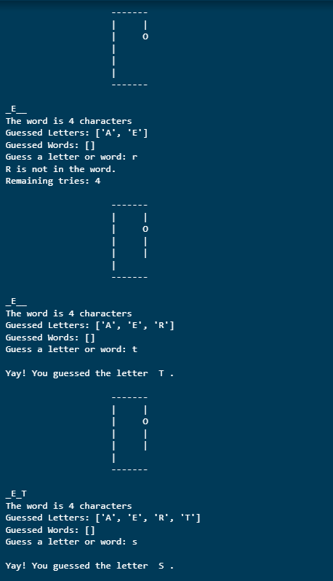

Figure 18. Gameplay Easy Mode – Player James 2 of 6

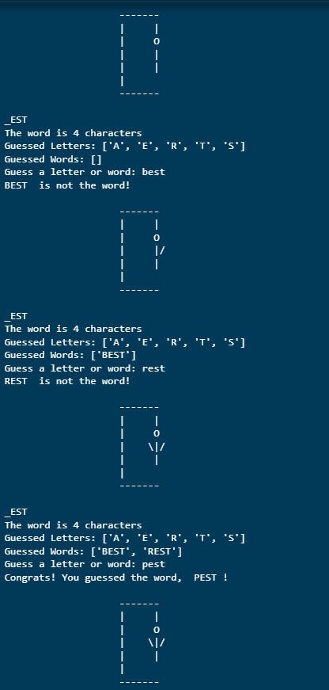

Figure 19. Gameplay Easy Mode – Player James 3 of 6

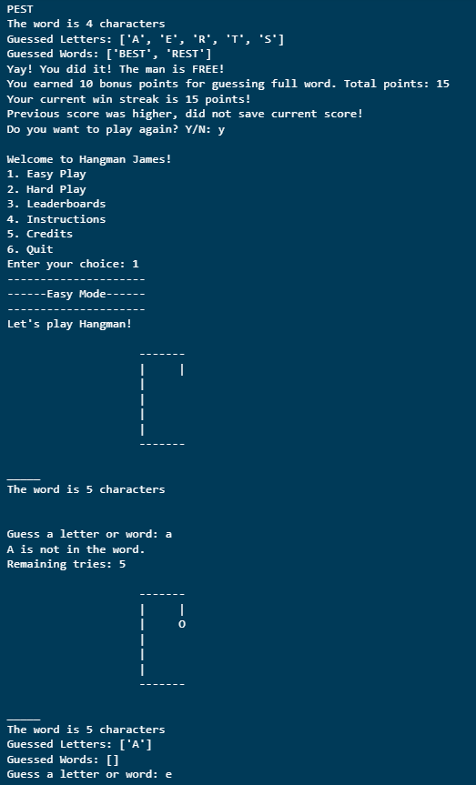

Figure 20. Gameplay Easy Mode – Player James 4 of 6 – Bonus points given for guessing the full word

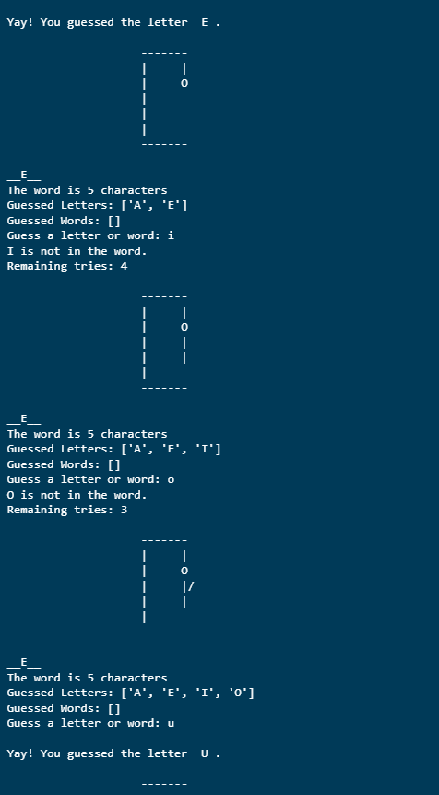

Figure 21. Gameplay Easy Mode – Player James 5 of 6

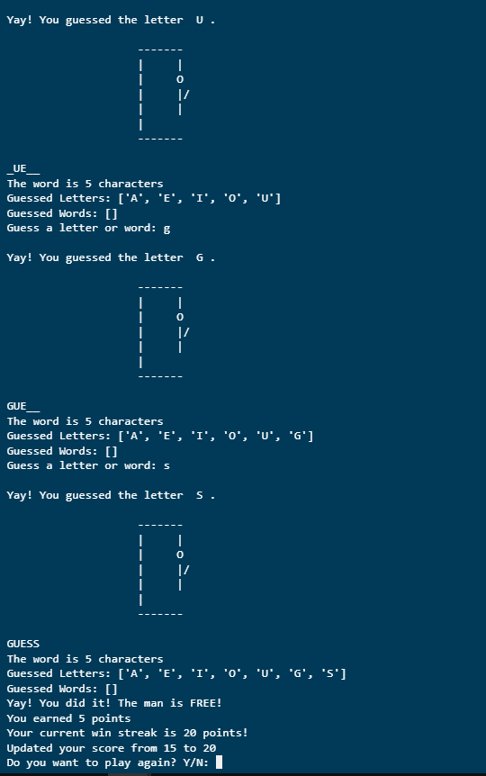

Figure 22. Gameplay Easy Mode – Player James 6 of 6 – Regular points given for guessing letters instead of full word and scores updated as points were greater than previous.

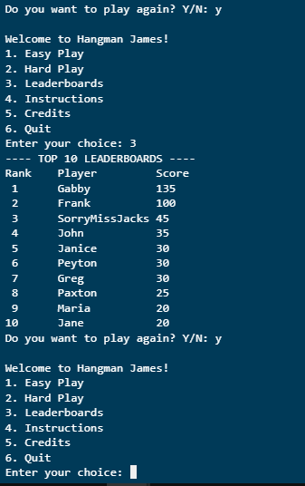

Figure 23. Leaderboards displayed to console – notice James is not on board

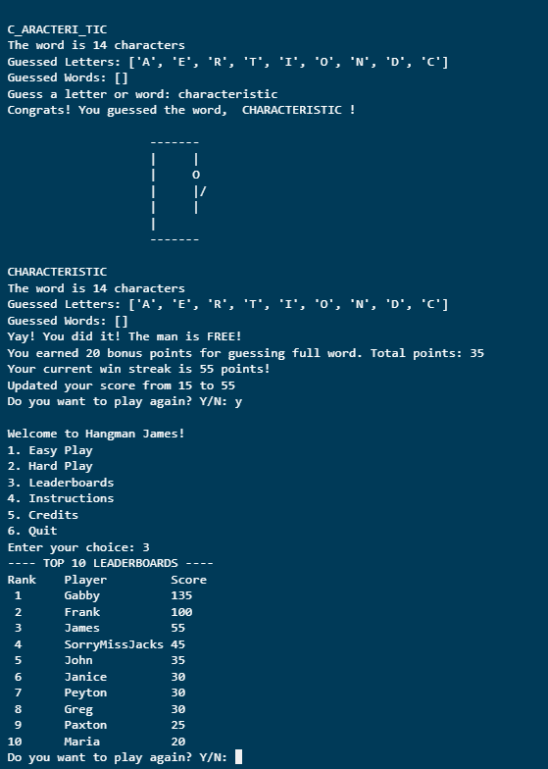

Figure 24. Played another game as James, updated score, and now shown on leaderboards!

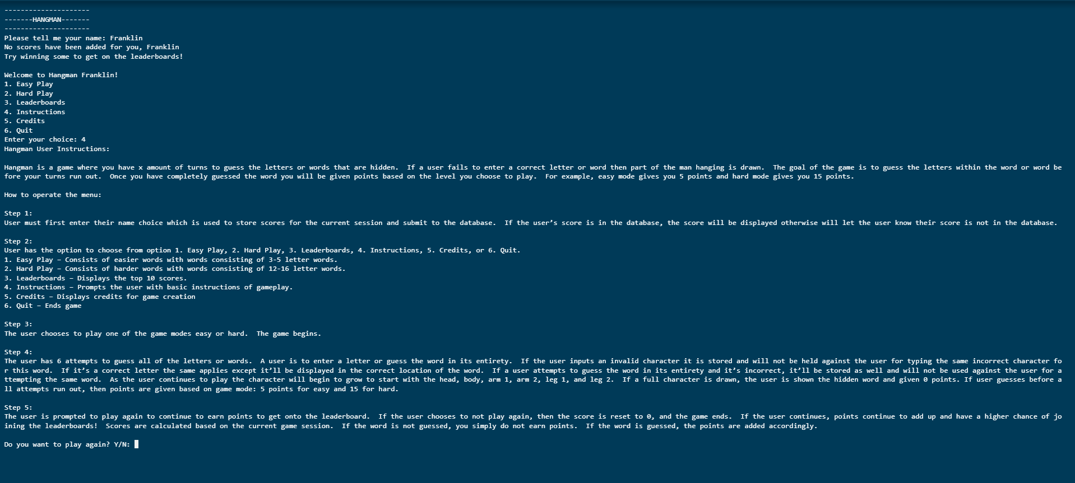

Figure 25. New player Franklin, no scores, and instructions.

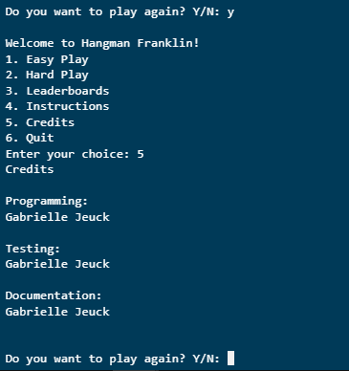

Figure 26. Credits

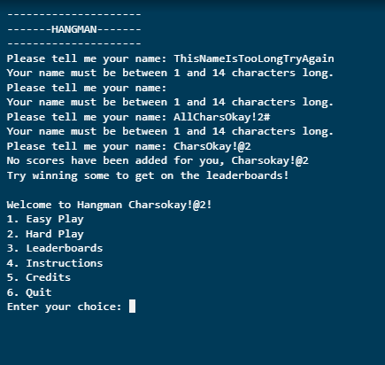

Figure 27. Input validation on names – limits character counts

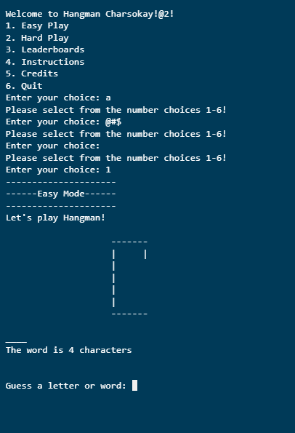

Figure 28. Input validation on menu

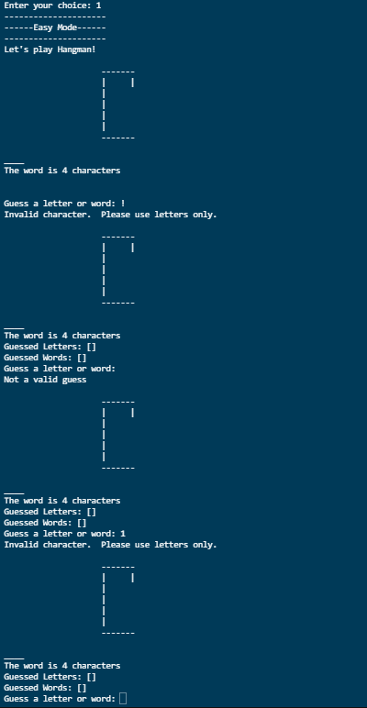

Figure 29. Input validation on gameplay – does not take turns away.

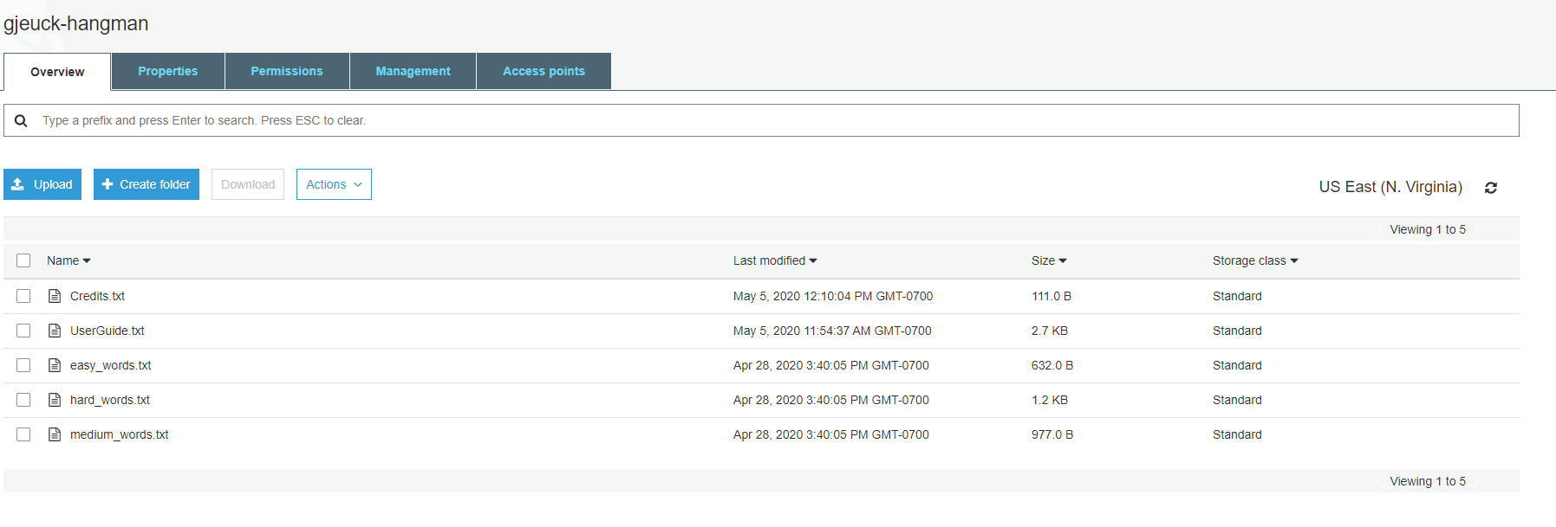

Figure 30. S3 Bucket gjeuck-hangman and files