S3: Homework 1

Gabrielle A. Jeuck

March 24, 2020

University of Maryland Global Campus

SDEV 400: Secure Programming in the Cloud

**AWS Management Console Creating Buckets/Folders**

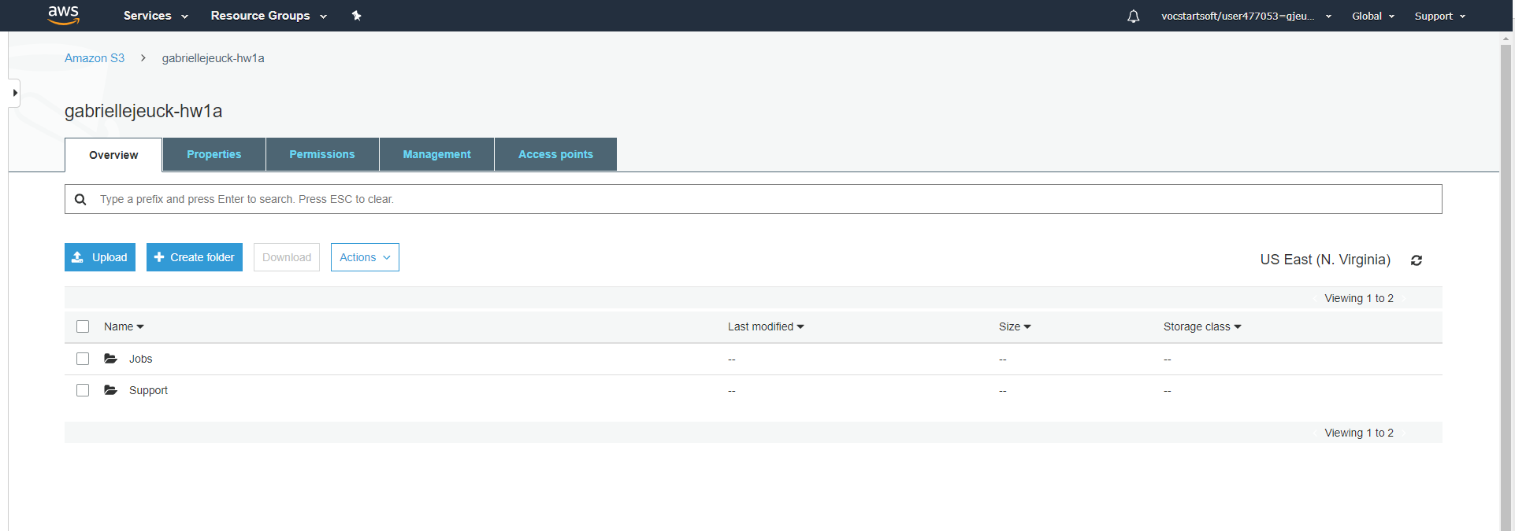

Figure 1. Creation of the first S3 with 2 folders gabriellejeuck-hw1a

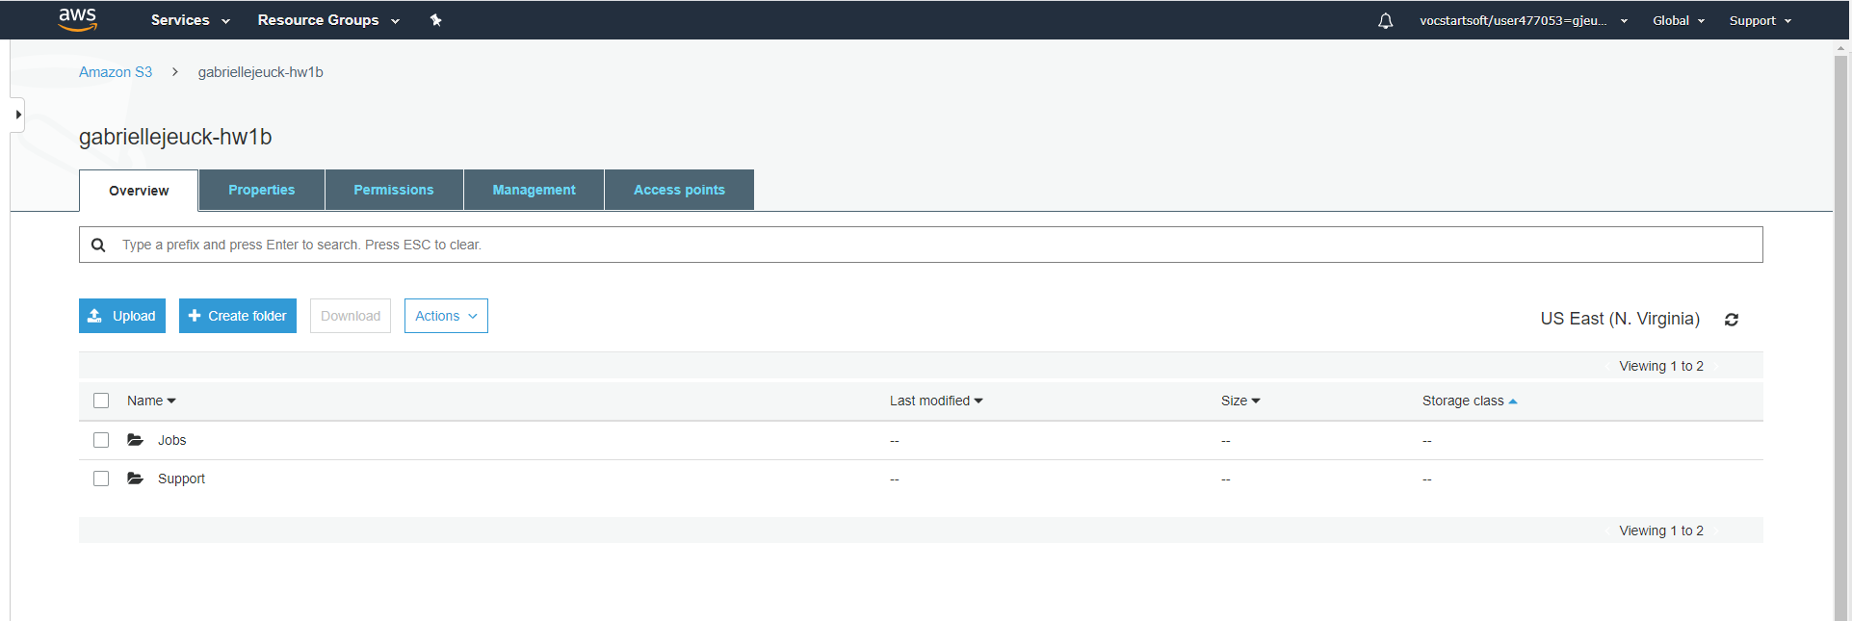

Figure 2. Creation of the second S3 with 2 folders gabriellejeuck-hw1b

**AWS Management Console Copying Files**

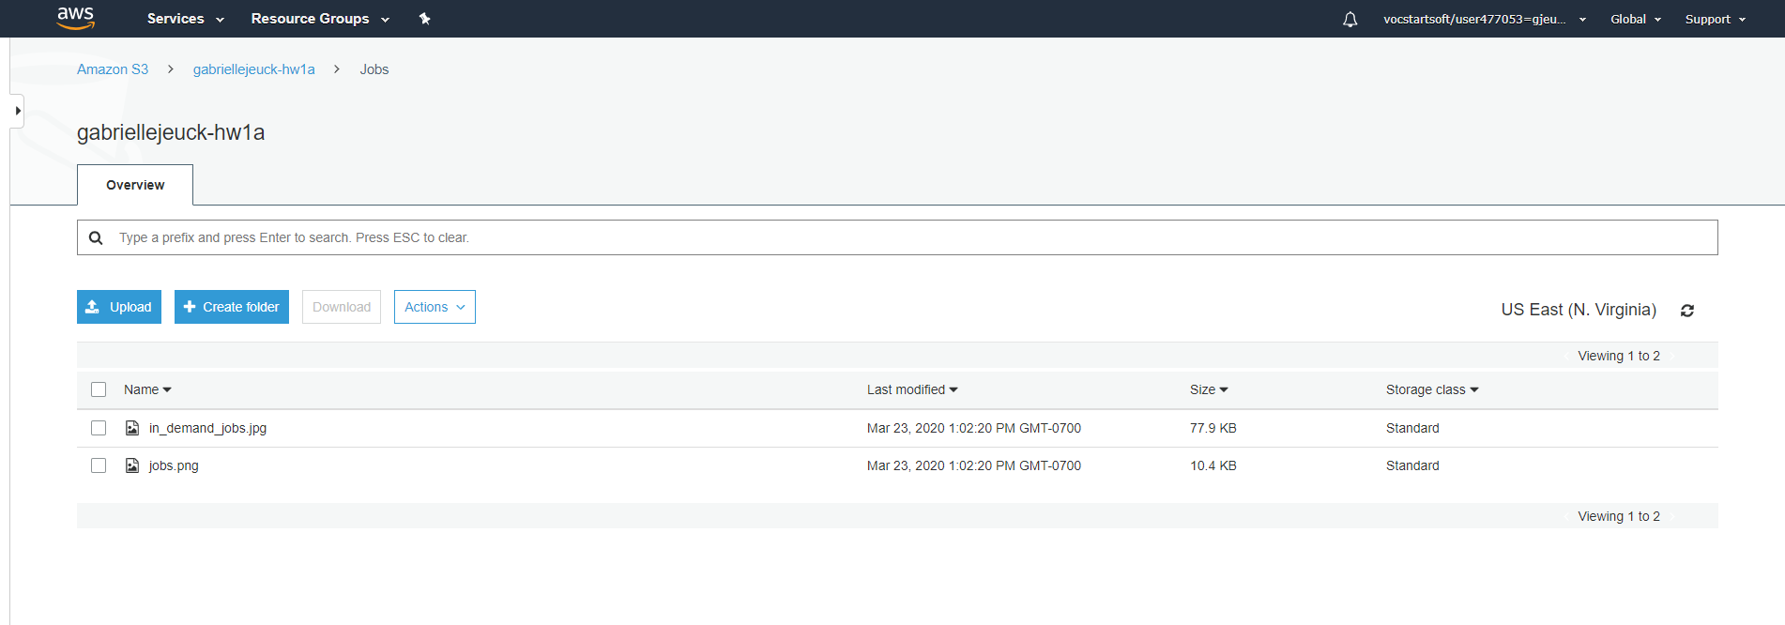

Figure 3. Two files placed into folder Jobs in bucket gabriellejeuck-hw1a

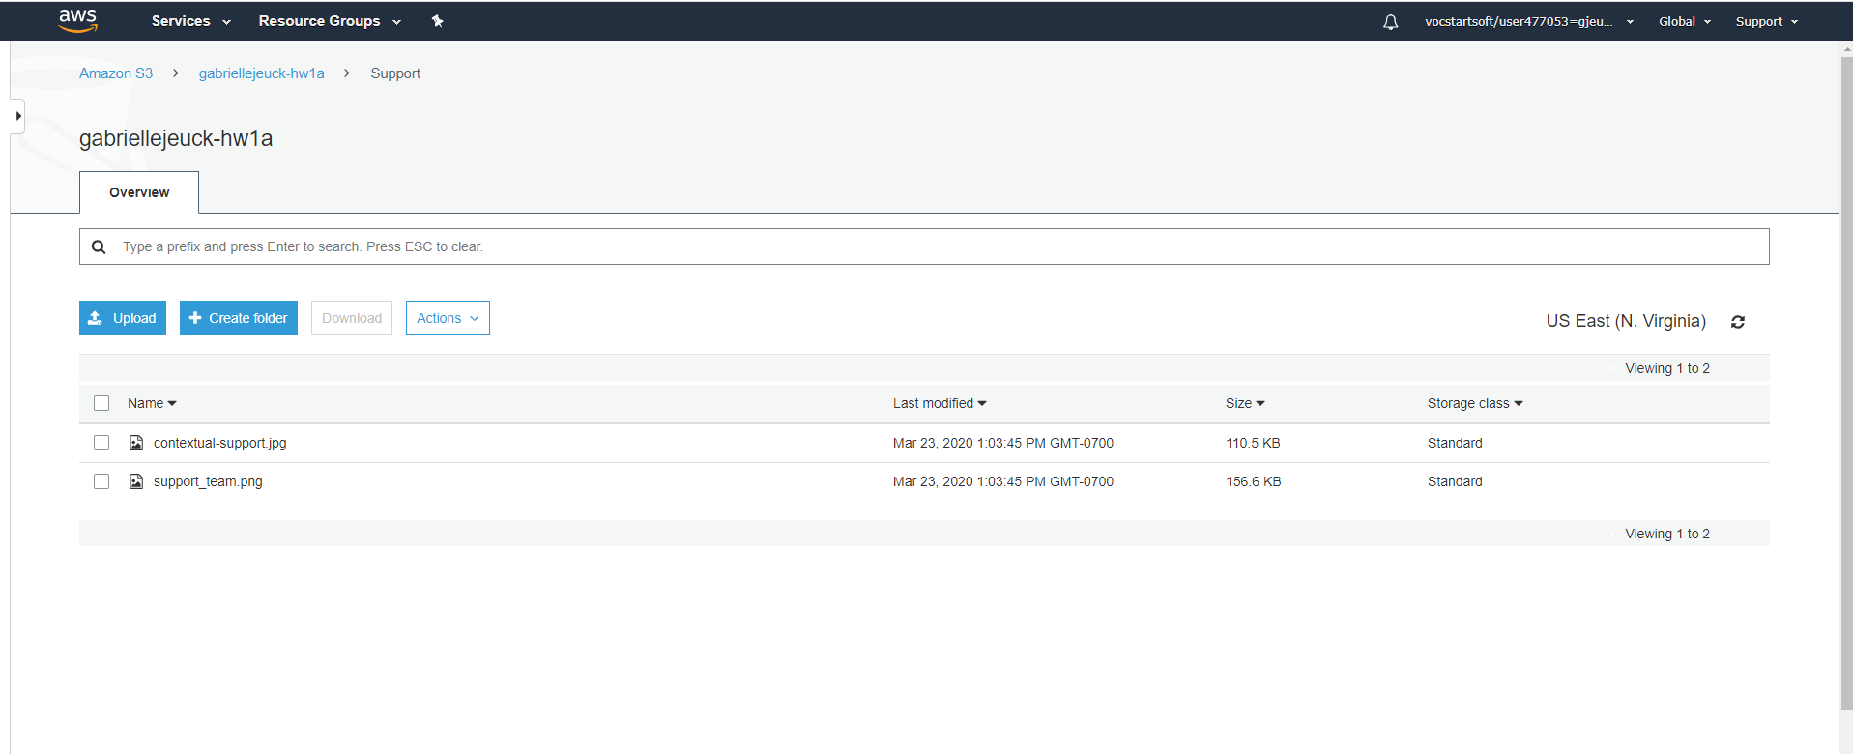

Figure 4. Two files placed into folder Support in bucket gabriellejeuck-hw1a

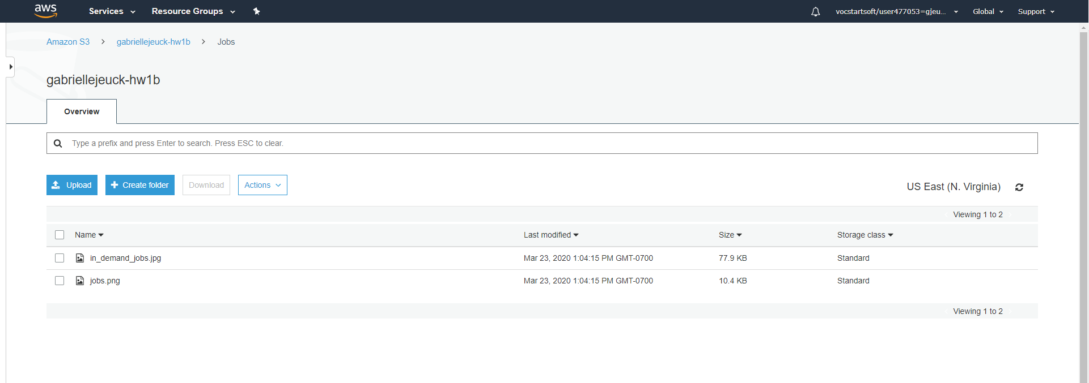

Figure 5. Two files successfully copied to bucket gabriellejeuck-hw1b/Jobs

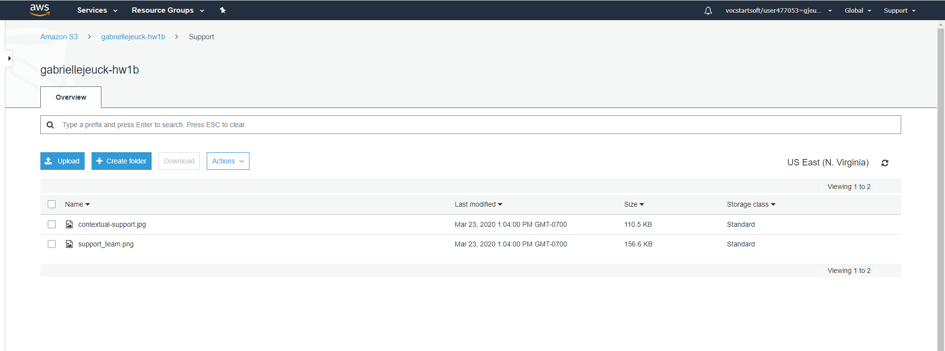

Figure 6. Two files successfully copied to bucket gabriellejeuck-hw1b/Support

**Python command-line menu-driven interface Buckets.py**

|  |  |  |  |  |
| --- | --- | --- | --- | --- |
| **Run** | **Input** | **Expected Output** | **Actual Output** | **Pass/Fail** |
| **1** | 1 – Create Bucket  First Name: GabriellE  Last Name: JeuCk  6 Digits: 444222  1 – Create Bucket  First Name: Jeff  Last Name: foX  6 digits: 123  6 digits: abc  6 digits: 123456 | New bucket created with name gabriellejeuck-444222  New list to print  And prompts to insert new 6 digits twice then creates new bucket jefffox-123456 | **See Figure 11** | **Pass**  **Pass** |
| **2** | 2 – Put an object in an already created bucket  Bucket: jefffox-123456  File: File.txt  2 – Put an object in an already created bucket  Bucket: jefffox-123456  File: Random.txt  2 – Put an object in an already created bucket  Bucket: jefffox-123456  File: Unknown.txt | File.txt was put into the jefffox-123456 bucket;  List items within bucket: File.txt  Random.txt was put into the jefffox-123456 bucket;  List items within bucket: File.txt and Random.txt  File not found error and proceed to being prompted again. | **See Figure 12**  **See Figure 13** | **Pass**  **Pass**  **Pass** |
| **3** | 3 – Delete an object in the bucket  Bucket: jefffox-123456  File: Random.txt  3 – Delete an object in the bucket  Bucket: my-stinky-bucket  File: File.txt  3 – Delete an object in the bucket my-stinky-bucket | Deletes file Random.txt from the bucket jefffox-123456  Deletes file File.txt from my-stinky-bucket  No file exists, should be prompted menu for new options | **See Figure 14**  **See Figure 15** | **Pass**  **Pass** |
| **4** | 4 – Delete bucket my-stinky-bucket  4 – Delete bucket that doesn’t exist | Bucket deleted  Error menu prompt | **See Figure 16**  **See Figure 17** | **Pass**  **Pass** |
| **5** | 5 – Copy object from bucket to another  From bucket: gabbyjeuck-334433  File: File.txt  To bucket: jefffox-123456  File: File.txt  5 – Copy object from bucket to another | Takes file File.txt from bucket gabbyjeuck-334433 and copies to jefffox-123456    Takes file Random.txt from bucket gabbyjeuck-334433 and copies to jefffox-123456 | **See Figure 18**  **See Figure 19** | **Pass**  **Pass** |
| **6** | 6 – Download Random.txt from gabbyjeuck-334433  6 – Download NotAFile.txt from gabbyjeuck-334433 | Downloads into AWS cloud  File does not exist | **See Figure 20 for before and figure 21 for after on downloads**  **See Figure 22** | **Pass**  **Pass** |
| **7** | 7 – Exit Program | Closes program and prints date and time in US Pacific | **See Figure 23** | **Pass** |

**SCREENSHOTS OF BUCKETS.PY CODES**

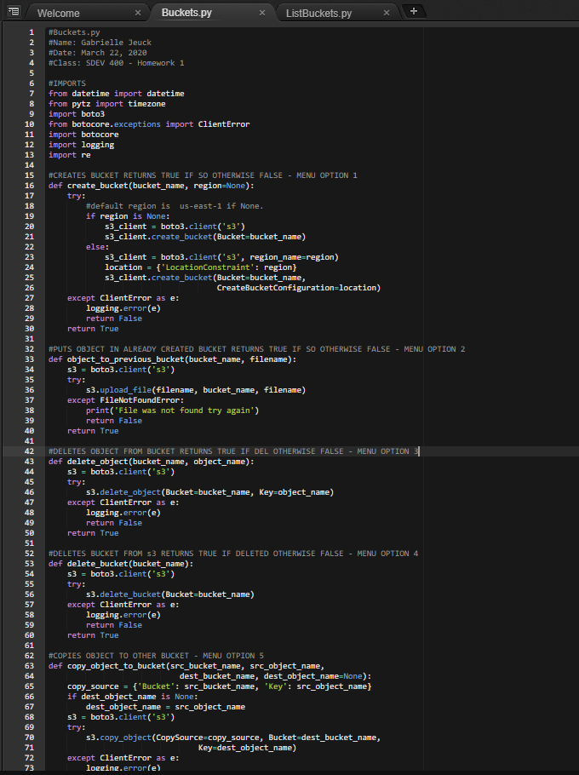

Figure 7. Buckets.py Code 1 of 4

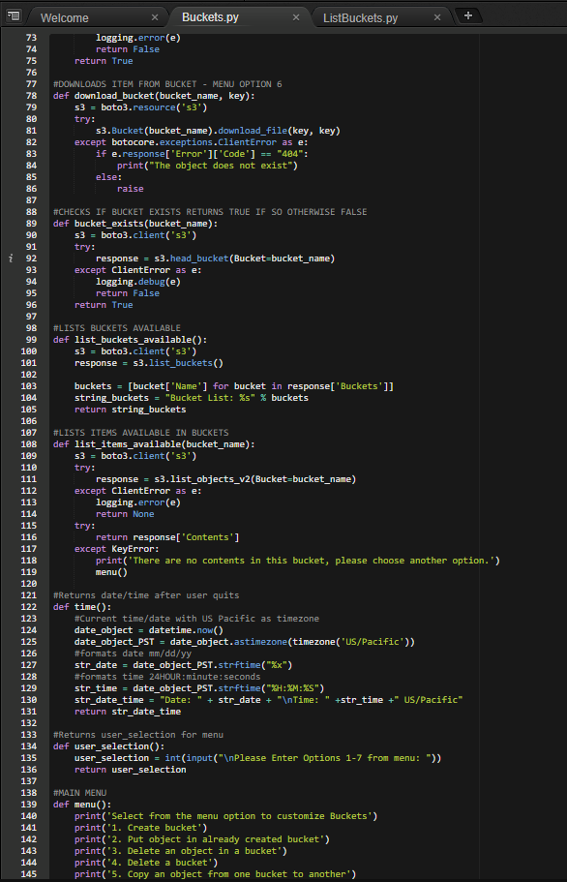

Figure 8. Buckets.py Code 2 of 4

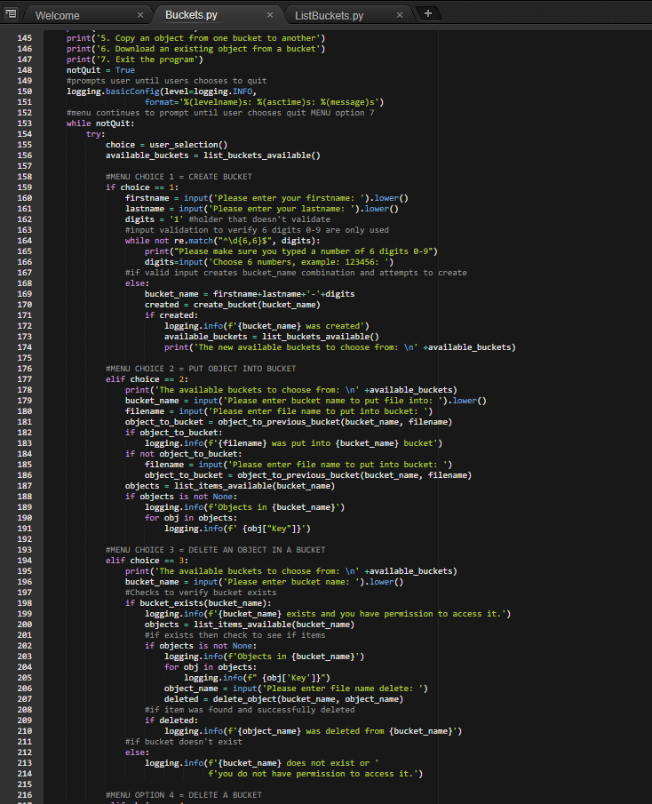

Figure 9. Buckets.py Code 3 of 4

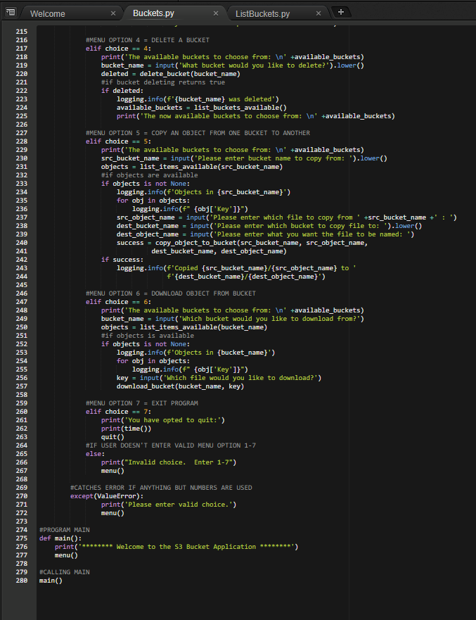

Figure 10. Buckets.py Code 4 of 4

**SCREENSHOTS OF BUCKETS.PY EXECUTION**

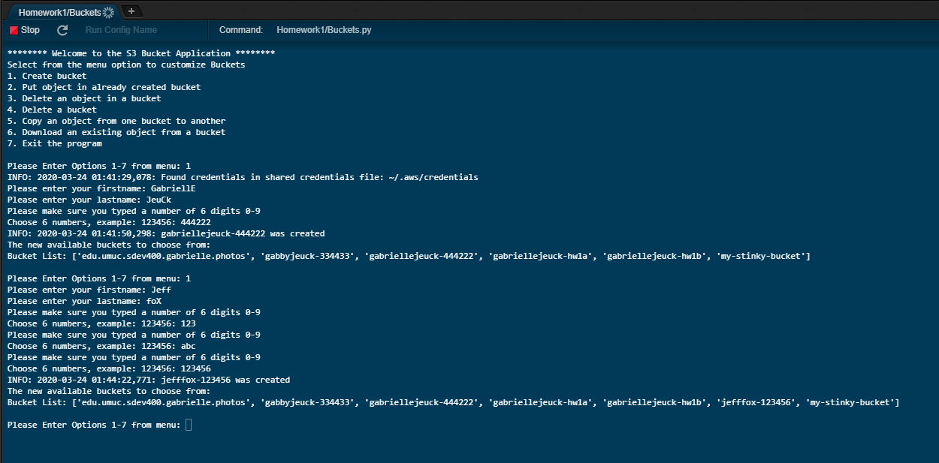

Figure 11. Test Run 1 – Creating new buckets

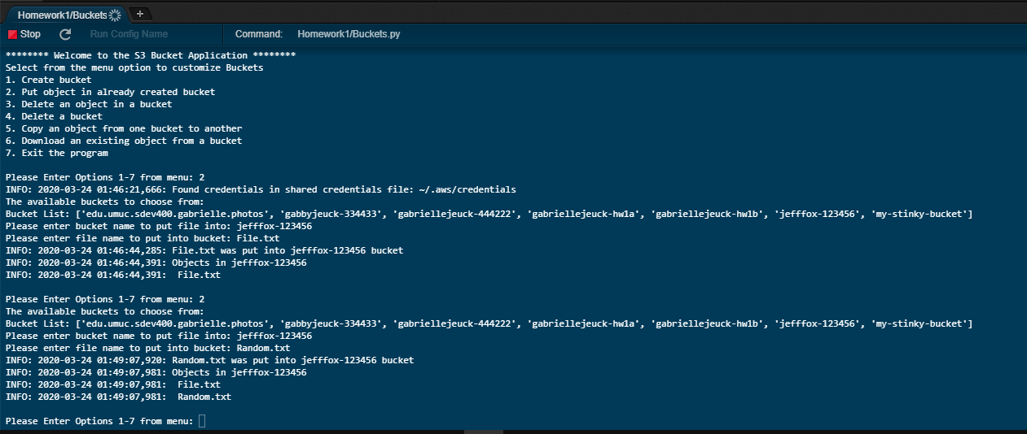

Figure 12. Test Run 2 – Putting files into buckets

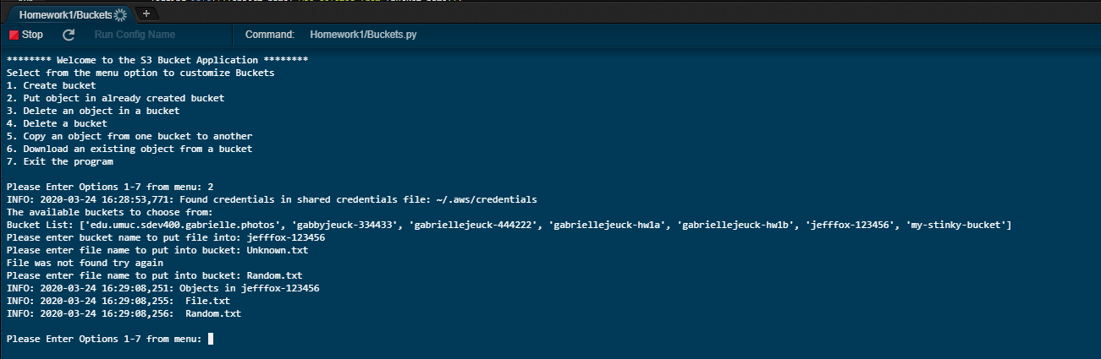

Figure 13. Test Run 2 – File not found exception

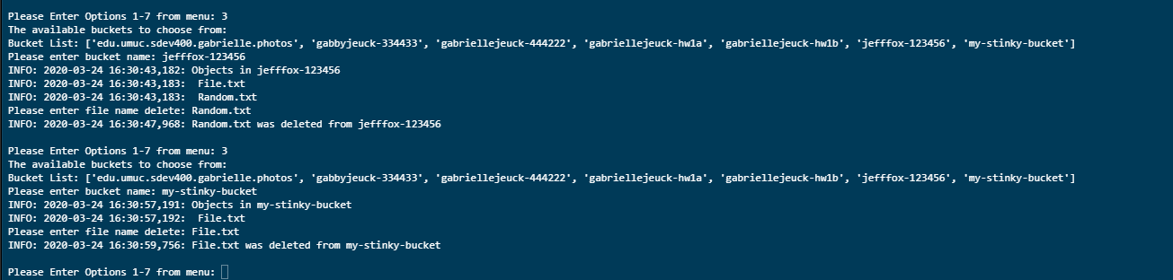

Figure 14. Test Run 3 – Delete files from buckets

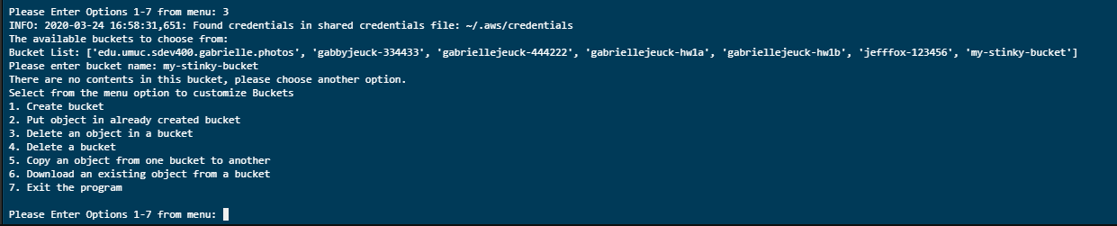

Figure 15. Test Run 3 – No file exists to delete in the bucket

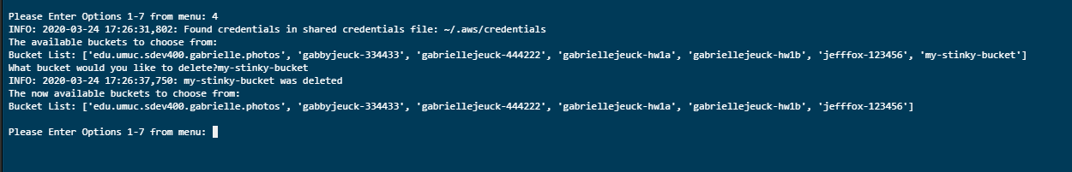

Figure 16. Test Run 4 – Delete bucket my-stinky-bucket



Figure 17. Test Run 4 – Delete non-existing bucket my-stinky-bugs

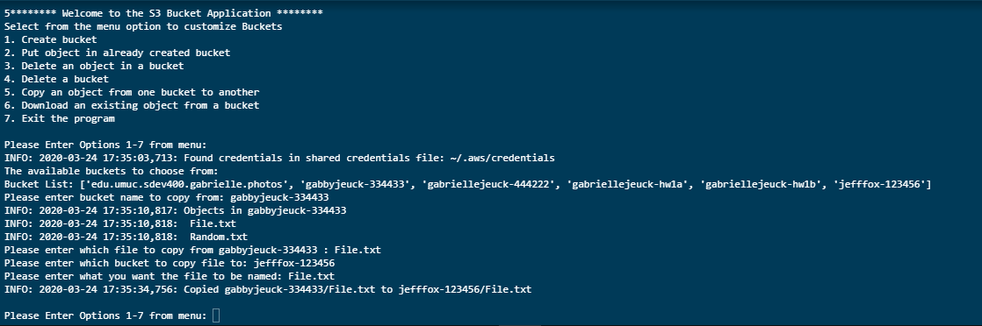

Figure 18. Test Run 5 – Copy File.txt from gabbyjeuck-334433 to jefffox-123456

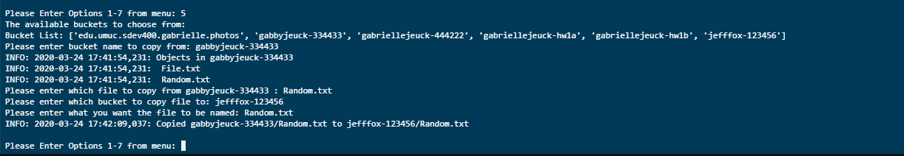

Figure 19. Test Run 5 – Copy Random.txt from gabbyjeuck-334433 to jefffox-123456

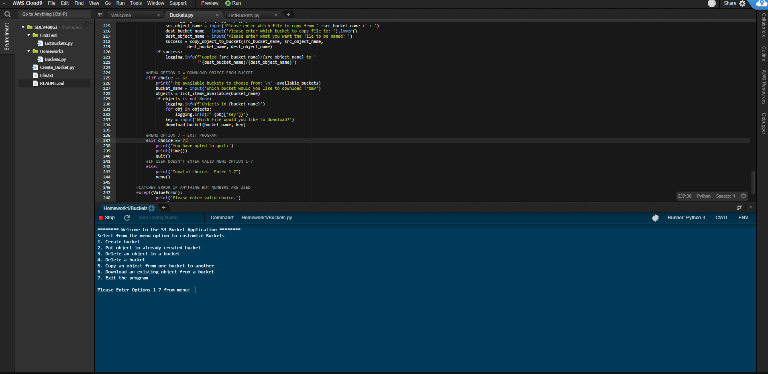

Figure 20. Test Run 6 – Download file from buckets – BEFORE

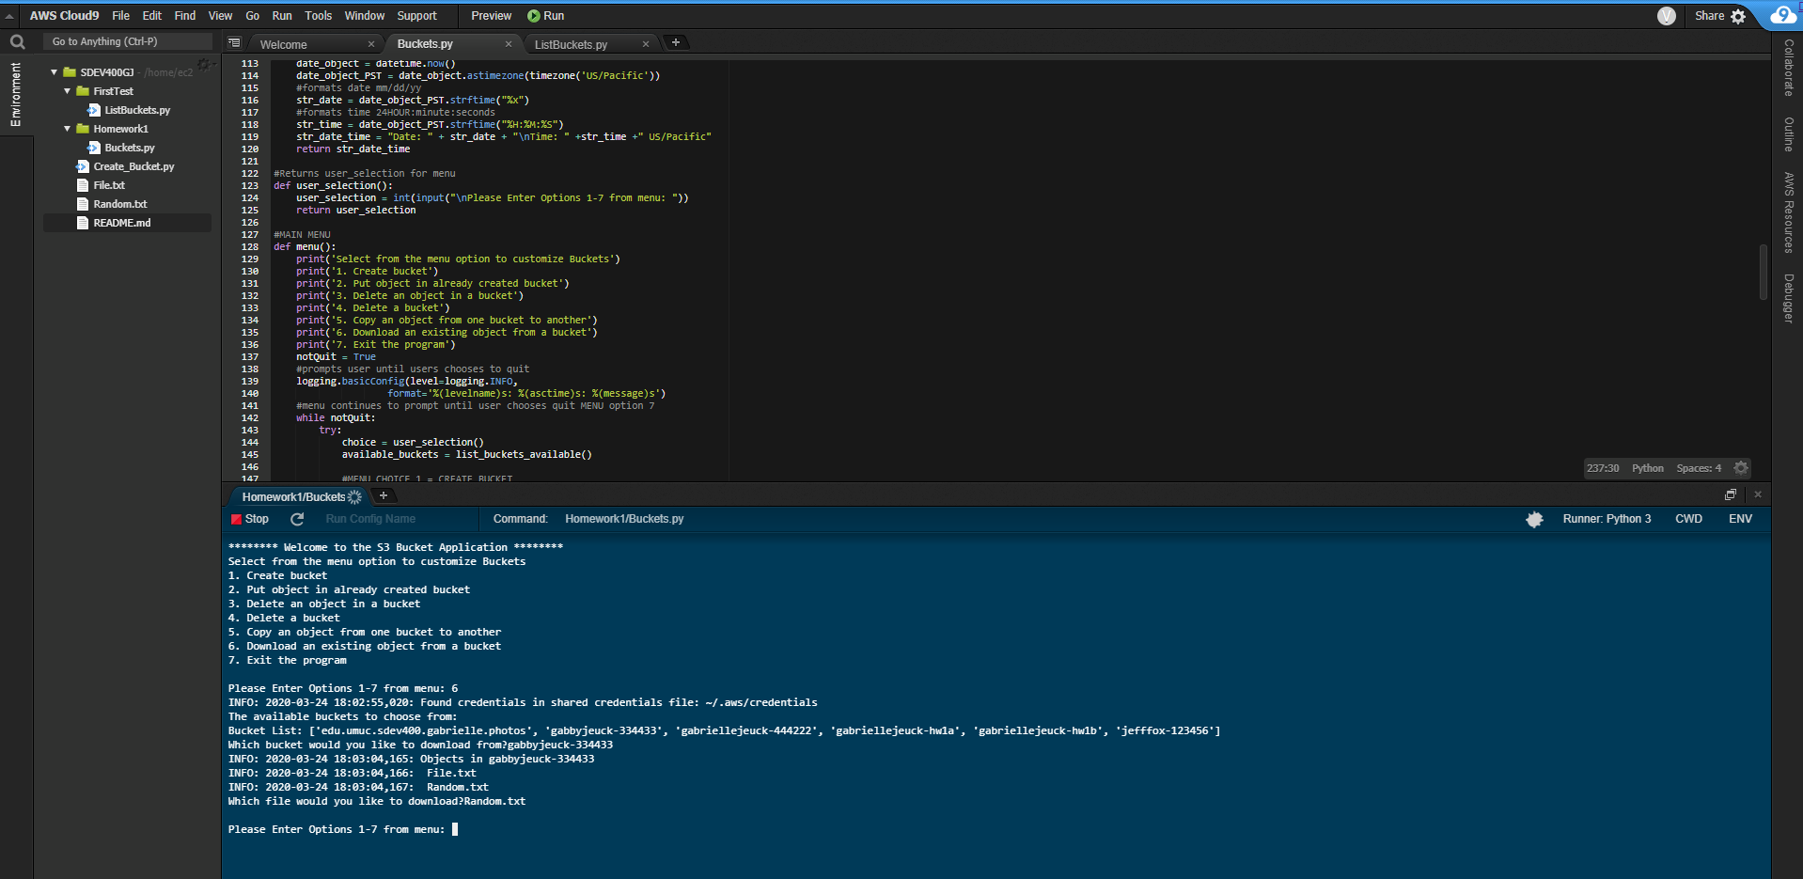

Figure 21. Test Run 6 – Download file from buckets – AFTER

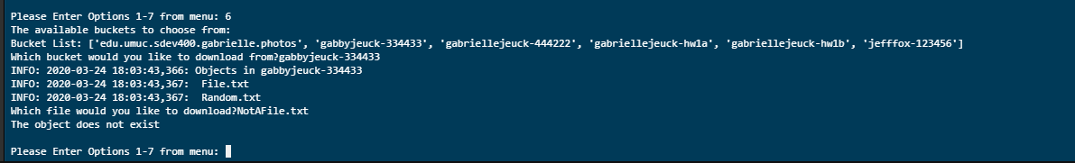

Figure 22. Test Run 6 – File doesn’t exist in the bucket

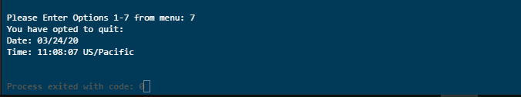

Figure 23. Test Run 7 – Exit Program

**SUMMARY:**

Each method works properly. I attempted to remedy any errors based on files/buckets not existing. Overall, I believe I managed to catch these exceptions or redirect for invalid inputs. Option 1, allows the user to create a bucket and automatically puts letters to lowercase as well as limits digits to 6 via regex. Option 2, allows items to be placed into specific buckets that are on the AWS Cloud 9. Option 3 allows deleting an object from a specific bucket. Option 4, allows deleting a bucket if it exists. Option 5, allows copying an object from one bucket to another if the file exists. Option 6, allows the user to download an item from a bucket that does not have a folder (this could be added for better functionality) and will store into Cloud 9. Option 7 exits the program with times and dates.