**Final Project**:

Function🡪 Stock Picker/Analysis

Stocks Listed🡪 Google (GOOGL), Apple (AAPL), JPMorgan (JPM), Goldman Sachs (GS), Microsoft (MSFT)

Functions🡪

* Display:
  + Name
  + Tickr
  + Price
  + Chart w/ performance indicators
* Modal Window:
  + Expert insights
* Search Feature
* Clickable buttons
* User profile
  + Name
  + Address
  + Email
  + Favorite stocks
* Stored data
* Navigation
  + Home
  + User account
  + LOGIN PAGE??? (Sign on form if possible)
    - “Do research on adding user authentication page/block and complete the functionality. Users will only see their own data after login.”
* PAGES
  + HOME
  + USER PROFILE
  + TICKER PROFILE
  + LOGIN (MAYBE)

Examples:

* <https://paulstamatiou.com/stocketa/#stocketa-adding-first-stock>
* [Yahoo finance](https://finance.yahoo.com/quote/%5EIXIC/chart?p=%5EIXIC#--)

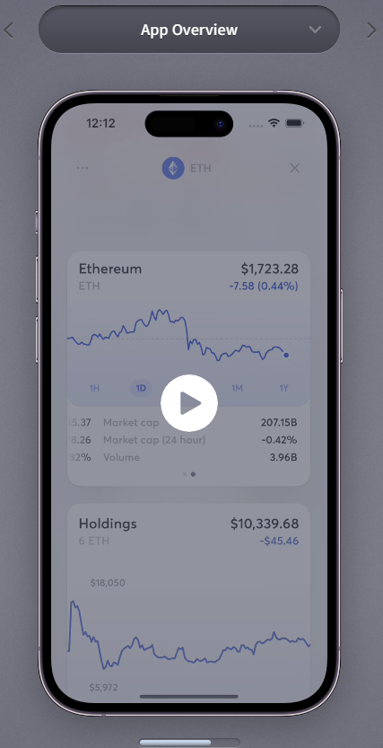 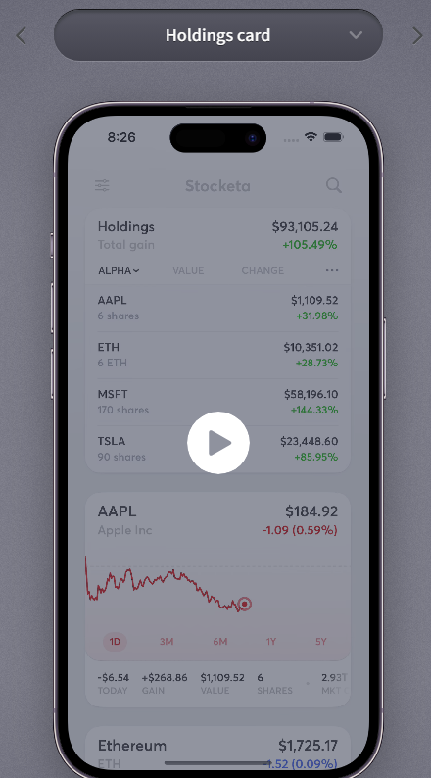

<https://dash.infinityfree.com/accounts/create/step3>

username if0_35627825

function UserComponent() {

  return (

<div>

    <h4> User Placeholder</h4>

</div>

  )

}

.tickerContainer {

    display: flex;

    border: 10px solid rgb(6, 46, 6);

    margin: 10px;

    padding: 10px;

  }

  .secondaryTickerContainer {

    display: flex;

    flex-direction: column;

    margin-right: 20px;

  }

  .thirdTickerContainer {

    display: flex;

    flex-direction: column;

  }

  .tickerContainer img {

    max-width: 500px;

    max-height: 500px;

    margin-bottom: 10px;

  }