MESIIN480323 : No SQL 19/01

Project Report

On

CASSANDRA

**reuters.json**

Gabriel Chaix & Malo Leroy & Charles Terrier

École Supérieure d’Ingénieurs Léonard de Vinci

Année 2023 / 2024

Index

Introduction and Problem Statement 2

I. Data Importation 3

II. Data cleaning 4

III. Querys 5

A. Simple querys (6) 5

1. List of reuters 5

2. List of texts titles 5

3. Titles, id and dateline of texts where id “120” 5

4. Count of reuters whose place is France. 5

5. Count of “texts” publications, 6

6. Count of texts WHERE title contains “News”, 6

B. Complex querys (2) 7

1. Count the number of articles having the topic ‘earn’. 7

2. Give the number articles written by each author ? 7

C. Hard query (1) 8

1. How much article there is by place 8

# Introduction and Problem Statement

Reuters is a news agency founded in 1851 in London. It is one of the global and generalist news agencies, an activity that represents a part of its revenue, mainly devoted to financial information. It is one of the largest news agencies in the world. We want to create a Cassandra database with reuters articles and query it.

# Data Importation

In a first manner, we must create our database using TablePlus. To do this, we run the following queries to build the database and then create the two tables that compose our database: “reuters” and “texts”.

Table creation - Figure 1.1

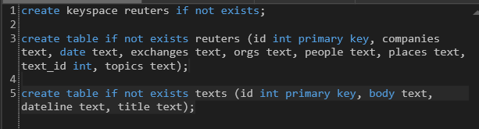

Once this is done, we must fill the tables with our dataset content. After downloading our [json file](https://learning.devinci.fr/pluginfile.php/217984/mod_folder/intro/reuters.json.zip) we added brackets [] at the start and the end and used replace all to add a comma at the end of each line, in order to make it a valid json.

Then here is the importation script we’ve wrote

←

After importing all the rows, we make sure that each rows is correctly imported.

# Data cleaning

The first step we’ve take into cleaning had been to update all the empty entry to NULL. To address this problem, we wrote a python script.

We also observe that ever text attribute had quotes, due to the importation script, since we did not success in modifying the importation script, we added a similar python function to take them off.



# Querys

## Simple querys (6)

### List of reuters

### List of texts titles

### Titles, id and dateline of texts where id “120”

### Count of reuters whose place is France.

### Count of “texts” publications,

### Count of texts WHERE title contains “News”,

In order to use the LIKE statement, we need to create a SASI index, let’s enable it in cassandra.yaml file.

Then we can create our custom index and use LIKE statement on the desire column.

## Complex querys (2)

### Count the number of articles having the topic ‘earn’.

In order to use the WHERE =’’ statement, we had to create a btree indexation on the topic column of reuters table.



### Give the number articles written by each author ?

To achieve this query, we need to make a join between reuiters and text tables. To do this in CQL, we unormalize the reuiters table by adding to it an attribute for author name. We create a new table and fill and clean it using our python script:

Now that author is part of the primary key, we can group by author.

## Hard query (1)

### How much article there is by place

