Low-Cost Cellular Accelerometer Node for Structural Health Monitoring
Gabe Kafka-Gibbons
NYU Tandon School of Engineering
Advisor: Masoud Ghandehari
Project context: Puerto Rico transmission tower structural health monitoring
Final report due: May 15, 2026
Working thesis
The prototype demonstrates continuous acceleration sensing, LTE-M cloud upload, reference-sensor agreement, and a successful three-week outdoor deployment; the next step is controlled PR tower testing, with firmware power optimization continuing in parallel.

Abstract
Transmission towers in Puerto Rico are exposed to wind, corrosion, fatigue, and notably hurricane loading, but post-event assessment is often limited to visual inspection rather than continuous measurement. This report presents a low-cost cellular accelerometer node for prototype structural health monitoring using the Nordic Thingy:91 X platform, its onboard ADXL367 accelerometer, LTE-M connectivity, and a Supabase/PostgREST cloud data path. The system samples triaxial acceleration as a continuous FIFO stream, packages readings into 100-sample batches, reports battery telemetry, and posts data over HTTPS to a cloud database and dashboard. A solar-assisted power architecture using a 2 W panel, BQ24074 charger/load-share, external 10 Ah LiPo buffer, and S7V8F5 regulated 5.0 V USB-C supply is specified to support unattended operation while keeping the Thingy:91 X hardware unmodified. Sensor viability was evaluated by benchmarking the Thingy accelerometer against a LORD S-200 reference sensor under the same excitation. Magnitude-based comparison reduced sensitivity to axis misalignment, while temporal alignment and calibration improved agreement between the prototype and reference signals. In the current validation dataset, raw magnitude correlation was approximately 0.939, calibrated magnitude correlation was approximately 0.955, magnitude RMSE was approximately 0.040 g, and FFT amplitude correlation was approximately 0.952 over 0 to 12.5 Hz. These results support the feasibility of using the integrated ADXL367 for prototype-level vibration monitoring and demonstrate an end-to-end sensor-to-cloud pipeline. The prototype has also completed a successful three-week outdoor deployment, so the remaining limitations are now more specific: the short reference-sensor validation window, tower-specific mounting and axis-alignment uncertainty, external-buffer state-of-charge telemetry, and additional validation on Puerto Rico tower sites.

Keywords
structural health monitoring; transmission towers; wireless sensing; cellular IoT; LTE-M; triaxial accelerometer; ADXL367; Nordic Thingy:91 X; solar-assisted power; Supabase; reference-sensor validation; FFT analysis

Table of Contents
Abstract 2
1. Broader Objective 4
1.1 Engineering Context 4
1.2 Research Objective 4
1.3 Scope of This Report 5
2. Specific Goals 5
2.1 Goal Summary 5
3. Devices 5
3.1 Hardware 6
3.2 Firmware and Software 7
3.3 Cloud Data Pipeline 8
4. Test Results and Success Criteria 9
4.1 Constant-Stream Power and Solar Feasibility 9
4.2 Accelerometer Viability Test 10
4.3 FFT Viability Test 11
4.4 Tilt Extraction Material 12
4.5 End-to-End Pipeline Evidence 13
5. Discussion 13
5.1 Limitations 13
5.2 Future Work 14
6. Conclusion 14
References 14
Appendix A. Hardware Specification 14
Appendix B. Firmware and Cloud Configuration 14
Appendix C. Data Processing and Additional Plots 15

1. Broader Objective

1.1 Engineering Context
Electric transmission towers are distributed assets that must remain functional under wind, rain, corrosion, fatigue, and extreme storm loading. In Puerto Rico, this problem is especially important because transmission infrastructure is exposed to hurricane-season hazards, salt-laden coastal air, difficult access conditions, and long recovery timelines after major weather events. Traditional inspection is often periodic or event-driven, so damage that changes the structural behavior of a tower may not be detected until a visual inspection is performed or a service problem appears.
Structural health monitoring addresses this gap by treating changes in measured dynamic response as evidence of possible changes in stiffness, looseness, connection condition, or boundary support. A tower does not need to be fully instrumented to make this useful at the prototype stage: even a small number of reliable vibration measurements can establish baseline behavior, support post-event comparison, and identify whether a site deserves closer inspection. For this reason, the critical engineering question is not only whether an accelerometer can record motion, but whether a low-cost field node can produce repeatable acceleration data, transmit it continuously, and retain enough power autonomy to be useful outside the laboratory.
The engineering constraints shape the system design. A practical node for remote tower monitoring should be low cost, physically simple, cellular rather than Wi-Fi dependent, and capable of operating from a solar-assisted power source. It should also avoid a custom circuit-board design unless the sensing, power, and data-pipeline assumptions are already proven. This project therefore uses the Nordic Thingy:91 X as an integrated sensor-node platform and evaluates whether its onboard ADXL367 accelerometer, LTE-M modem, and external solar/battery front end can support prototype-level structural monitoring with a constant stream of cloud-accessible data.

1.2 Research Objective
The research objective of this project is to evaluate whether a low-cost cellular accelerometer node can provide useful prototype-level vibration measurements for remote structural health monitoring. Specifically, the project tests whether the Nordic Thingy:91 X platform can collect triaxial acceleration data with its onboard ADXL367 accelerometer, transmit that data over LTE-M to a cloud database, and operate within a solar-assisted power architecture suitable for controlled PR tower testing after outdoor validation.
The objective is also comparative: the onboard accelerometer is evaluated against a LORD S-200 reference sensor to determine whether the low-cost integrated sensor preserves the dominant time-domain and frequency-domain behavior of the measured motion. Success is defined by an end-to-end feasibility result, not by full production readiness: the node must demonstrate working sensing, data transmission, power plausibility, reference-sensor agreement, and outdoor operability well enough to justify controlled testing on Puerto Rico transmission towers.

1.3 Scope of This Report
This report covers a proof-of-concept sensor node and validation study for structural health monitoring, not a complete deployed monitoring network. The report focuses on the design and evidence needed to judge whether the selected low-cost platform can support PR tower field testing: the hardware architecture, firmware and cloud data path, power model, outdoor deployment result, and comparison of the onboard accelerometer against a reference sensor.
The scope is intentionally limited to prototype feasibility. It does not claim production readiness, tower-level damage diagnosis, fleet-scale deployment, or environmental qualification. A successful three-week outdoor deployment has already demonstrated unattended operation under real weather, LTE, and solar exposure. Remaining deployment work is tower-specific: final mounting and enclosure integration, direct verification of the solar charging path at tower sites, external-buffer state-of-charge monitoring, and additional validation data under realistic Puerto Rico tower conditions.

2. Specific Goals

2.1 Goal Summary
The project goals translate the broader structural-health-monitoring objective into six measurable prototype outcomes:
- Build a working sensing node using the Nordic Thingy:91 X and its onboard ADXL367 accelerometer, with raw triaxial acceleration available for analysis.
- Demonstrate continuous acceleration capture by sampling the ADXL367 FIFO stream and packaging readings into 100-sample batches without relying on manual data collection.
- Prove the LTE-M cloud data path by posting acceleration batches and battery-related telemetry to Supabase/PostgREST and making the data visible in the dashboard/export workflow.
- Evaluate power feasibility by separating the current continuous-post firmware behavior from the intended solar-assisted duty-cycled field architecture, including internal-battery and external-buffer autonomy estimates.
- Validate accelerometer usefulness by comparing the prototype data against a LORD S-200 reference sensor in both time-domain magnitude behavior and frequency-domain amplitude content.
- Define the deployment envelope by identifying what the prototype already demonstrates through lab validation and three weeks of successful outdoor operation, and what remains for controlled PR tower testing, including tower mounting, enclosure integration, solar-path verification, and additional tower data.

3. Devices
This section documents the prototype as an integrated sensor-to-cloud system: the physical sensing node and external power chain, the firmware that reads and uploads acceleration data, and the cloud/dashboard path used for review and analysis. The emphasis is on what was assembled and tested, with remaining tower-rated enclosure and mounting work treated as future deployment work.

3.1 Hardware
Figure 3.1 summarizes the hardware architecture. The prototype uses an unmodified Nordic Thingy:91 X as the sensing, compute, local battery, and LTE-M communications node, with the field power hardware kept external. The external chain harvests solar energy, buffers it in a separate LiPo battery, and presents the Thingy with a regulated 5.0 V USB-C input.
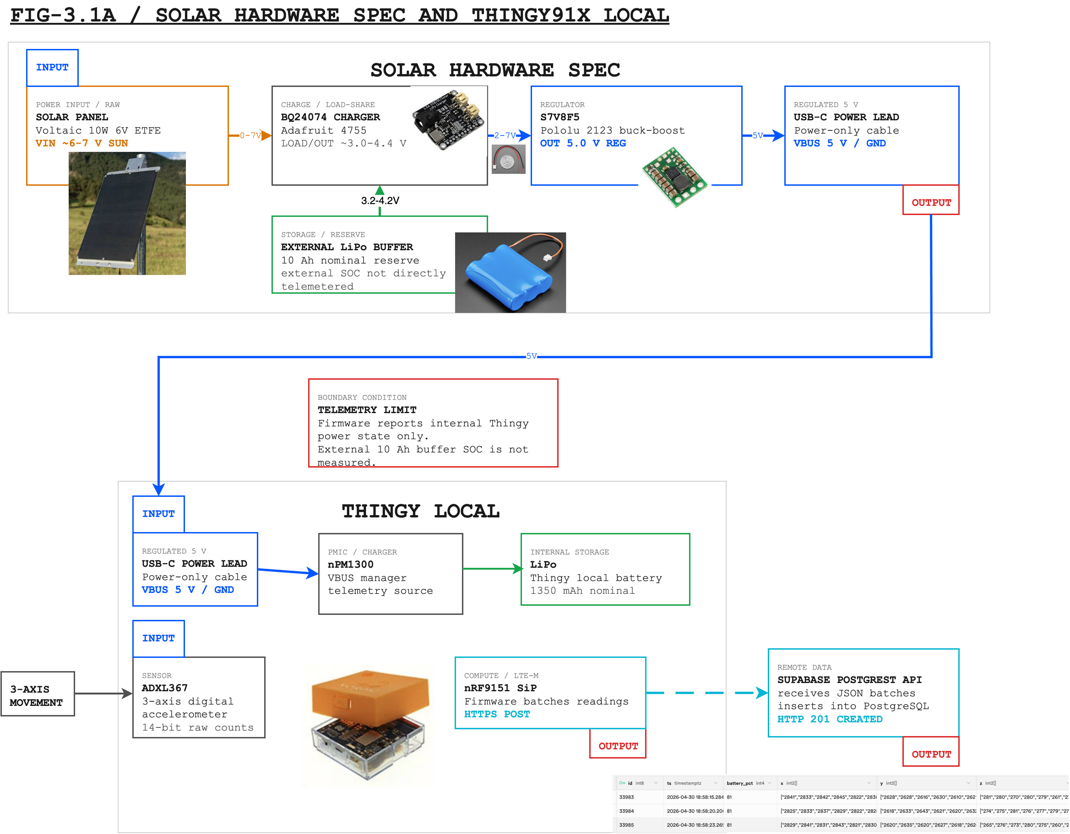
Figure 3.1. Solar hardware architecture for the PR-SHM sensor node. The BQ24074 manages solar charging and the external LiPo; the S7V8F5 provides the regulated 5.0 V USB-C input to the Thingy:91 X. Firmware telemetry describes the Thingy internal battery/PMIC domain, not the external 10 Ah buffer state of charge.
Editable source: public/diagrams/final-hardware-architecture.drawio. SVG export: public/diagrams/final-hardware-architecture.svg.
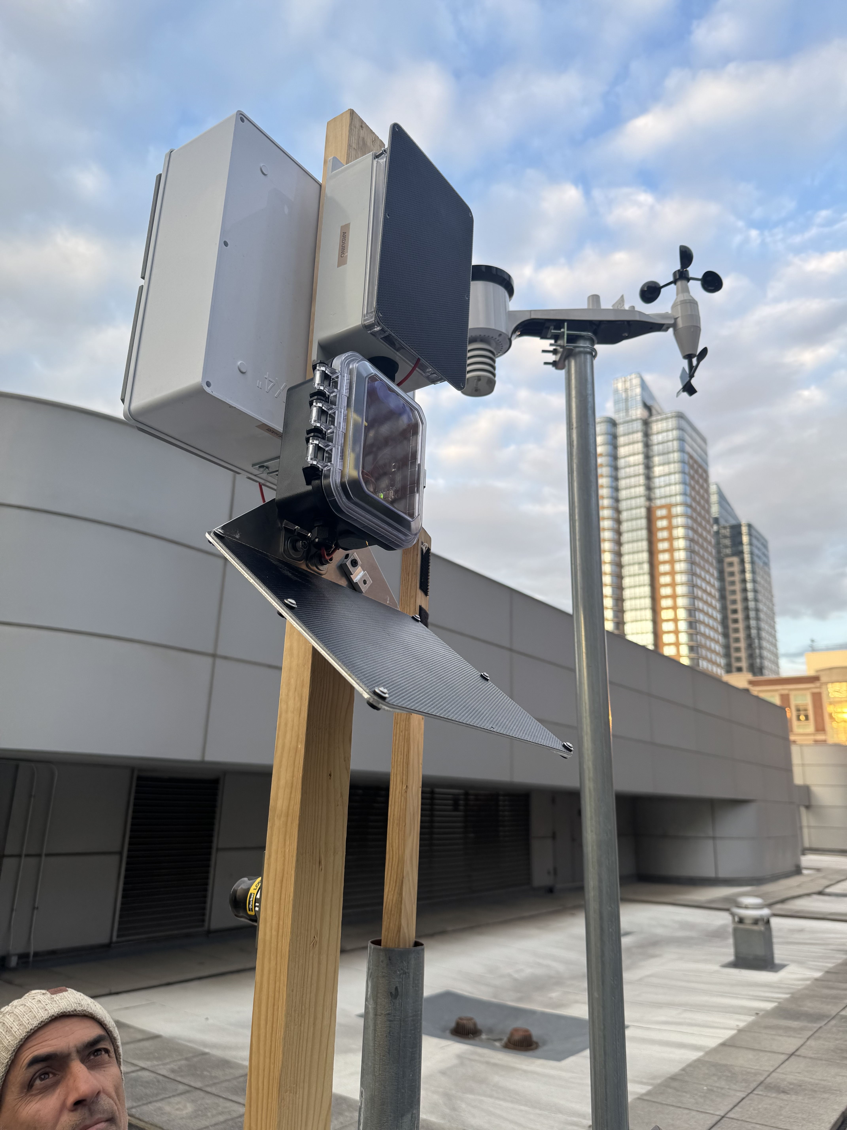
Figure 3.2. Assembled prototype hardware used for integration testing. The photo shows the physical sensor node, solar panel, and external power hardware in the outdoor test configuration used before final tower-rated enclosure and rigid PR tower mounting are completed.
Figure 3.2 shows the assembled hardware used for integration testing. The main design boundary is telemetry: firmware battery and charger readings come from the Thingy internal nPM1300/stock-LiPo domain and confirm the local battery and USB input state, but they do not directly measure the external 10 Ah buffer state of charge. The onboard ADXL367 provides the prototype acceleration measurement, while the LORD S-200 is reference equipment used only for validation.

3.2 Firmware and Software
The firmware is written in C on Zephyr through the nRF Connect SDK for the Thingy:91 X nRF9151 target. On boot, the application initializes the onboard ADXL367 accelerometer, the nPM1300 power interface, the cellular modem, and the TLS certificate used for HTTPS communication. The current firmware is a continuous-stream prototype: it prioritizes reliable sample capture and end-to-end upload rather than aggressive sleep scheduling.
Acceleration is captured from the ADXL367 FIFO at 25 Hz in the +/-2 g range. The firmware reads the sensor directly over I2C as signed 14-bit raw counts, drains the FIFO into a RAM message queue, and groups readings into 100-sample batches. Each batch therefore represents about four seconds of triaxial acceleration data. The batch payload stores the x, y, and z arrays plus internal Thingy battery percentage, preserving raw data for later conversion, calibration, and frequency analysis off-device.
The transport layer posts each batch to Supabase/PostgREST over LTE-M using the nRF modem TLS store and Zephyr REST client. A successful upload is indicated by an HTTP 201 or 200 response. If a batch POST fails, the firmware forces the modem offline, reconnects to LTE-M, and retries the batch once. Power firmware also exposes internal-battery voltage, current direction, VBUS presence, and charger-state reads for diagnostics; these readings describe the Thingy internal power domain, not the external solar buffer.

3.3 Cloud Data Pipeline
The cloud pipeline starts when the firmware sends an HTTPS POST to the Supabase PostgREST endpoint for the accel_batches table. Each database row represents one uploaded batch and contains the Supabase arrival timestamp, internal Thingy battery percentage, and three compact smallint arrays for x, y, and z acceleration counts. This compact row-per-batch format avoids the overhead of inserting one database row per accelerometer sample while preserving the raw triaxial data. Figure 3.3 summarizes this path.
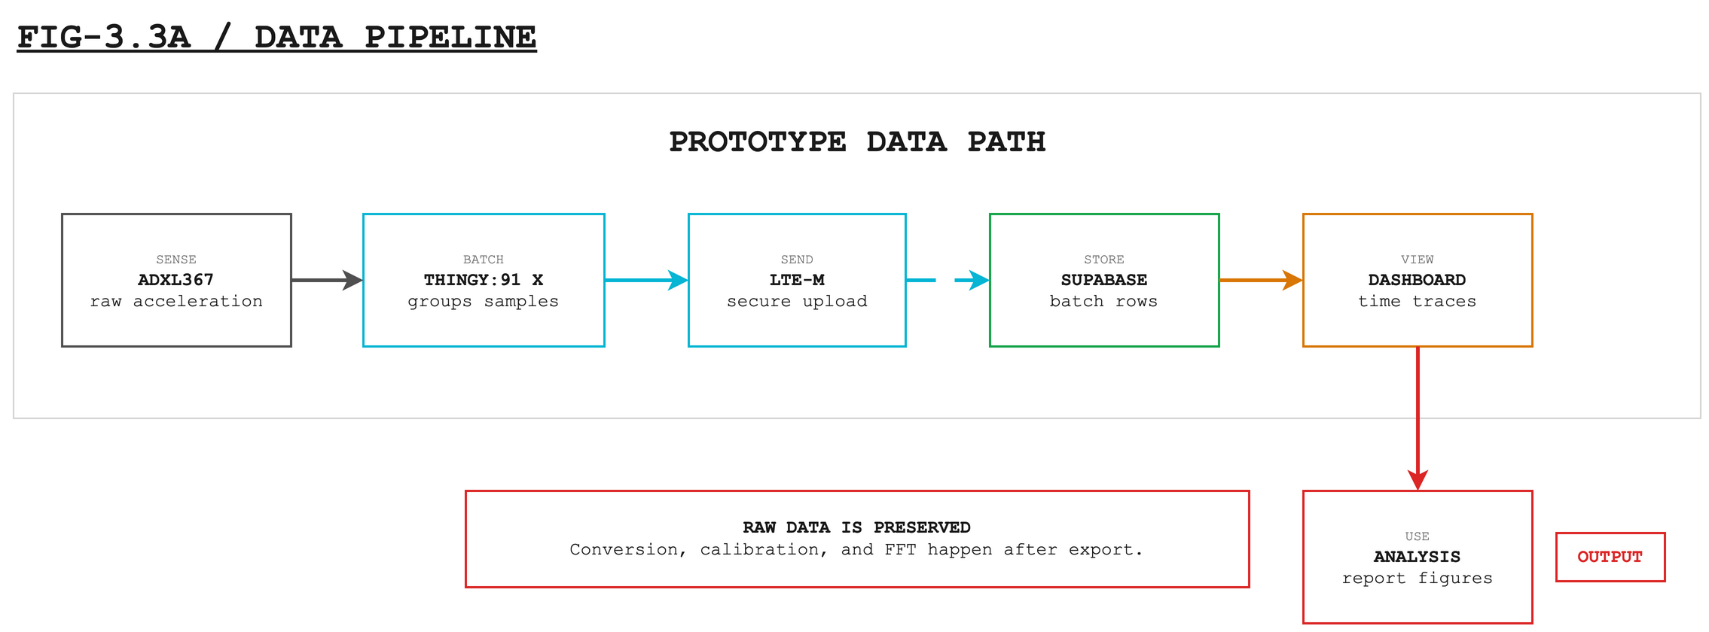
Figure 3.3. Minimal data pipeline for the PR-SHM prototype. Raw ADXL367 acceleration is batched on the Thingy:91 X, uploaded over LTE-M to Supabase, viewed in the dashboard, and exported for downstream calibration and FFT analysis.
Editable source: public/diagrams/data-pipeline-flowchart.drawio. SVG export: public/diagrams/data-pipeline-flowchart.svg. PNG export: public/diagrams/data-pipeline-flowchart.png.
For display and analysis, the database and frontend expand those batches back into a sample stream. The accel_samples_25hz SQL view unnests the x, y, and z arrays with ordinality and assigns 40 ms sample spacing for the 25 Hz stream; gaps longer than 15 seconds begin a new segment so outages remain visible. The React dashboard queries batch rows by time range, reconstructs per-sample traces for plotting, and uses a downsampled summary query for longer full-history views.
The pipeline intentionally keeps the stored acceleration values as raw counts. Unit conversion to g, magnitude calculation, calibration against the LORD reference sensor, and FFT analysis are performed downstream from exported database/CSV data. The main evidence for this section is the successful HTTP 201 upload path, rows present in accel_batches, dashboard visibility, and exported datasets used in the validation plots.

4. Test Results and Success Criteria
The results are organized around feasibility claims rather than build chronology. For each test, the report states the measurement method, the comparison metric, the observed result, and the remaining limitation. The strongest quantitative evidence is the axis-calibrated accelerometer validation, while the strongest field-readiness evidence is the successful three-week outdoor deployment under real environmental exposure.

4.1 Constant-Stream Power and Solar Feasibility
The assembled node completed a successful three-week outdoor deployment before tower installation. That result moves basic unattended outdoor operation from a future requirement to demonstrated prototype evidence under real weather, LTE, and solar exposure. It does not by itself close the power question for Puerto Rico tower deployment, because tower sites may have different sun exposure, enclosure temperature, LTE signal quality, and mounting constraints.
The long-term field argument comes from the duty-cycled power model. In the target operating schedule, the node sleeps for most of each hour, samples for a 10 minute window, processes briefly, and transmits once per hour. That model gives an average current of about 1.07 mA and daily consumption of about 95 mWh. With the 1350 mAh internal Thingy battery derated to 1080 mAh usable, the calculated internal-only autonomy is about 42 days. With the external 10 Ah buffer derated to 8 Ah usable, the calculated autonomy is about 311 days ideal, or about 249 days after an 80 percent conversion margin.
The current continuous-post firmware is intentionally more demanding than the final field target. It keeps the raw stream and LTE upload path active with frequent 100-sample batch posts, which is useful for validation but not optimized for battery life. The continuous model is closer to 20 mA at 5 V, or about 2.4 Wh/day. Under that behavior, the external 10 Ah buffer would last roughly 12 days ideal, about 10 days with conversion margin, and the internal battery alone would last only about 2.3 days. This difference is why duty-cycled sampling and upload remain firmware requirements before tower deployment.
The solar balance is favorable once the firmware is duty-cycled. A 2 W panel with a conservative 70 percent charge and regulation efficiency provides an estimated net harvest of about 7.7 Wh/day under the planning solar model, while the duty-cycled node consumes about 0.095 Wh/day. That is an approximate 81x daily energy surplus before site-specific shading and weather losses. The remaining hardware limitation is telemetry: the firmware reports the Thingy internal battery and VBUS domain, so an external-buffer voltage or state-of-charge measurement should be added before interpreting remote battery trends as true external reserve.

4.2 Accelerometer Viability Test
The accelerometer viability test compared the Thingy:91 X prototype against the LORD reference accelerometer over a 3,900-sample aligned window. The signals were first aligned by raw magnitude peaks, then the raw Thingy x, y, and z axes were mapped into the LORD g-frame using a three-axis affine calibration. Magnitude was computed after axis calibration, so the comparison evaluates a physically comparable acceleration magnitude rather than raw counts or unmatched device axes.
The calibrated magnitude trace closely followed the LORD reference during the impulsive event and subsequent ring-down. Across the validation window, the magnitude correlation was r = 0.955, RMSE was 0.040 g, and mean bias was -0.0089 g. This supports the prototype as a viable low-cost source for event and vibration-magnitude tracking under the tested mounting and sampling conditions; it does not yet establish absolute accuracy across all tower installations or mounting configurations.
Table 4.1. Summary metrics for the axis-calibrated accelerometer validation.
Metric | Result | Interpretation
Validation window and processing | 3,900 samples; 30.46 s; peak aligned; 3-axis affine calibration | Magnitude was computed after mapping raw Thingy axes into the LORD g-frame.
Time-domain magnitude agreement | Pearson r = 0.955; RMSE = 0.040 g; bias = -0.0089 g | Calibrated Thingy magnitude closely follows the LORD reference trace.
Normalized magnitude error | 3.8% of LORD RMS | Error is small relative to the observed reference response.
Frequency-domain agreement | Pearson r = 0.952; RMSE = 0.00258 g over 0-12.5 Hz | Primary spectral content is retained below the Thingy 25 Hz Nyquist limit.

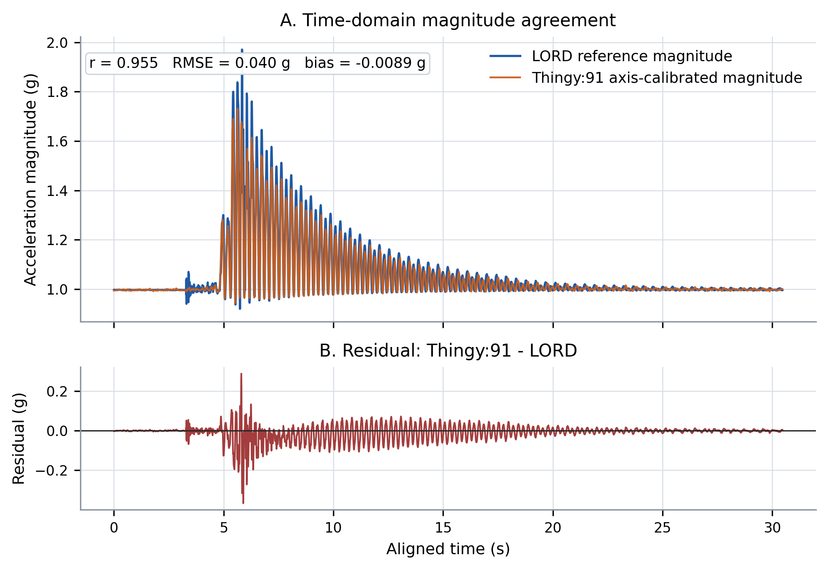
Figure 4.1. Time-domain validation of axis-calibrated magnitude. The upper panel compares LORD reference magnitude with Thingy:91 axis-calibrated magnitude over the aligned validation window; the lower panel shows residual error computed as Thingy:91 minus LORD.

4.3 FFT Viability Test
The FFT viability test used the same aligned and axis-calibrated magnitude signals. Before transformation, each magnitude series was mean-removed and windowed with a Hann window. The comparison was limited to 0-12.5 Hz, which matches the Nyquist limit of the original 25 Hz Thingy:91 acceleration stream.
The frequency-domain result agrees with the time-domain result. FFT amplitude correlation was r = 0.952 with an amplitude RMSE of 0.00258 g over the 0-12.5 Hz band. The dominant mode occurred at approximately 4.50 Hz in the LORD spectrum and 4.46 Hz in the calibrated Thingy spectrum; both spectra also shared the secondary peak near 2.23 Hz. Smaller differences in low-amplitude peaks and the high-frequency floor remain, but the principal vibration content needed for feasibility analysis is retained.
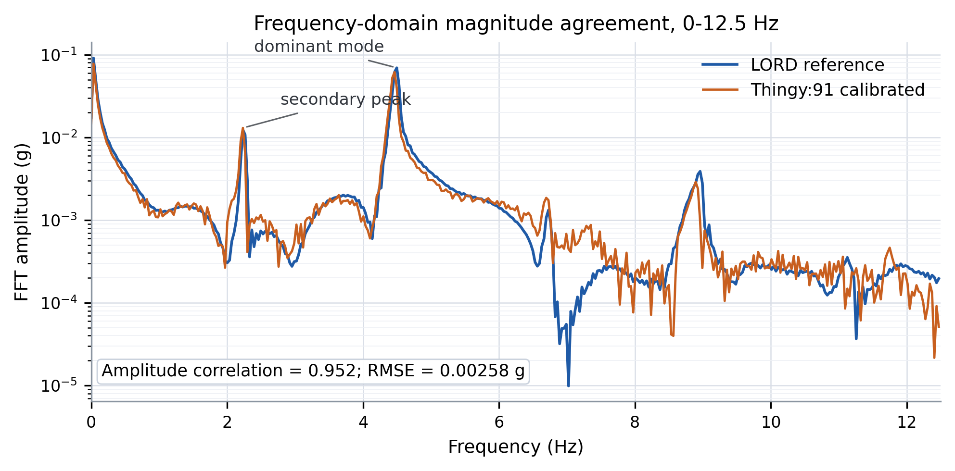
Figure 4.2. Frequency-domain validation of the calibrated magnitude signals. Mean-removed magnitudes were windowed with a Hann window before FFT comparison over 0-12.5 Hz.

4.4 Tilt Extraction Material
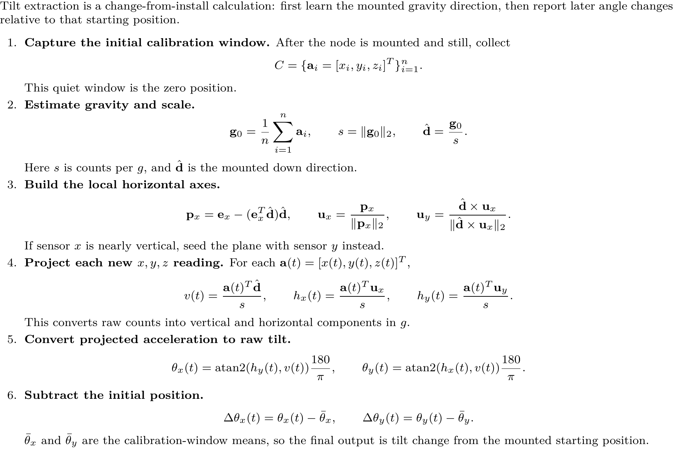

4.5 End-to-End Pipeline Evidence
This section consolidates the evidence that acceleration batches moved from the Thingy:91 X firmware through LTE-M upload, Supabase storage, dashboard visualization, and CSV/XLSX export for validation analysis.
Claim | Success criterion | Evidence to insert | Status
Constant stream power | Prototype must operate unattended long enough to justify tower-site testing; final field design should be duty-cycled and solar-positive. | Three-week outdoor deployment completed; existing power budget separates continuous-post behavior from the duty-cycled solar target; Thingy telemetry confirms internal battery/VBUS domain only. | Partial pass / refine
Accelerometer agreement | Calibrated magnitude agreement should preserve dominant motion and stay within prototype-level error bounds. | 3,900-sample aligned window; calibrated magnitude r = 0.955, RMSE = 0.040 g, bias = -0.0089 g. | Pass for feasibility
Frequency response | FFT comparison should retain the dominant vibration content over the 0-12.5 Hz validation band. | FFT amplitude r = 0.952 over 0-12.5 Hz; dominant peak near 4.5 Hz and secondary peak near 2.23 Hz are retained. | Pass for feasibility
Pipeline | Firmware POSTs should reach Supabase successfully and remain visible for dashboard/export analysis. | Firmware logs show HTTP 201 responses; accel_batches rows feed the dashboard and exported datasets used for report figures. | Pass for prototype

5. Discussion
The results show that the prototype is feasible as a sensor-to-cloud system and ready for controlled PR tower testing, while still short of production deployment. The Thingy:91 X captured triaxial acceleration, posted 100-sample batches over LTE-M, and preserved the main behavior of the LORD reference signal: calibrated magnitude correlation was 0.955, magnitude RMSE was 0.040 g, and FFT correlation was 0.952 over 0-12.5 Hz. The successful three-week outdoor deployment also shows that basic unattended operation outside the laboratory has already been demonstrated. The remaining power work is not another generic outdoor proof, but tower-site confirmation, external-buffer state-of-charge visibility, and firmware duty-cycle optimization.

5.1 Limitations
The reference-sensor validation window was short and controlled, so the agreement should be treated as prototype evidence rather than a final accuracy claim. The completed outdoor deployment reduces risk around basic unattended operation, but it does not replace tower-specific validation. Mount stiffness, axis orientation, and calibration may change in a real tower installation. LTE coverage and solar exposure will also vary by site, and firmware telemetry still describes the Thingy internal battery/PMIC domain instead of the external 10 Ah buffer. These limits do not invalidate the result, but they define the PR tower test conditions.

5.2 Future Work
Future work should keep the tested hardware platform and move from outdoor soak testing to controlled PR tower validation. The sensing node and external power architecture have been assembled, checked, and successfully deployed outdoors for three weeks, so the next field step is installation on Puerto Rico transmission towers. Firmware work should continue in parallel through duty-cycled sampling/upload, watchdog confirmation, and clearer recovery after failed POSTs, while the tower test compares data gaps, battery trend, LTE signal, and vibration spectra under real structural conditions.

6. Conclusion
This project demonstrates that a low-cost Thingy:91 X cellular accelerometer node can support prototype structural health monitoring. The tested hardware platform, LTE-M upload path, cloud pipeline, reference-sensor comparison, and successful three-week outdoor deployment are strong enough to justify moving from bench and outdoor validation to controlled PR tower testing. The system is not yet a production tower-monitoring deployment, but it has cleared the main feasibility question: the platform can collect useful vibration data, transmit it reliably enough for analysis, and operate within a solar-assisted architecture that is ready for tower-site validation.

References
Preliminary source set for final citation formatting: Nordic Semiconductor Thingy:91 X documentation; Analog Devices ADXL367 datasheet; Adafruit BQ24074 charger documentation; Pololu S7V8F5 regulator specifications; Supabase/PostgREST documentation; LORD/SensorConnect reference material; and structural-health-monitoring background literature on vibration-based condition monitoring.

Appendix A. Hardware Specification
Appendix A will summarize the hardware specification and bill of materials, including the Thingy:91 X platform, ADXL367 sensor, solar charger/load-share, S7V8F5 regulator, external 10 Ah buffer, and Phase 1/Phase 2 mounting assumptions. The source documents are HARDWARE_SPEC.md and BOM.md.

Appendix B. Firmware and Cloud Configuration
Appendix B will summarize firmware and cloud configuration: Zephyr/nRF Connect SDK target, direct ADXL367 I2C reads, TLS/HTTPS upload, Supabase schema/views, remote sample-interval configuration, and dashboard query path. The source documents are FIRMWARE.md, ARCHITECTURE.md, and the Supabase SQL files.

Appendix C. Data Processing and Additional Plots
Appendix C will summarize processing details and additional plots, including SensorConnect exports, peak alignment, axis calibration, calibrated magnitude residuals, FFT validation, tilt extraction, and raw/processed datasets in exports/.

