Final Project Assignment Guidelines
  - Report planning document for the PR-SHM sensor node project
Prepared for | Gabe Kafka-Gibbons
Project | Low-cost cellular accelerometer node for structural health monitoring
Core proofs | Battery/solar feasibility; ADXL367 accelerometer accuracy against LORD S-200 reference
Working dates | Draft for review: Monday, May 11, 2026; advisor-facing final target: Wednesday, May 13, 2026; official deadline: Friday, May 15, 2026

Assignment Statement
Write a final project report that documents the design, implementation, and validation of a low-cost wireless accelerometer node for structural health monitoring. The report should read as a feasibility study: it should explain the broader engineering objective, define the project goals, describe the hardware/software devices, and evaluate results against clear success criteria.
Core thesis for the report
The project should be framed around two proofs: first, that the battery and solar power logic can support long-term field deployment when the firmware is duty-cycled; second, that the Thingy:91 X onboard ADXL367 can produce useful vibration measurements when calibrated and compared against the LORD S-200 reference system.

Advisor-Requested Structure
Required item | What the section must answer | Recommended evidence
1. Broader objective | What larger problem does this project address? | Transmission tower structural health monitoring, hurricane-season resilience, and limits of visual-only inspection.
2. Specific goals | What did this project specifically try to prove or build? | Feasibility of sensing, LTE/cloud data flow, power autonomy, calibration against reference data, and future deployment path.
3. Devices | What hardware and software were used? | Use public/diagrams/final-hardware-architecture.svg as the clean hardware figure, plus the voltage table from HARDWARE_SPEC.md. Split into 3.1 Hardware and 3.2 Software exactly as requested. Include block diagram, parts/specs table, telemetry boundary, and verification pointer.
4. Test results and success criteria | Did it work, by what standard, and what still needs revision? | Battery model, observed power limitation, solar balance, LORD comparison metrics, FFT/magnitude correlations, HTTP 201/Supabase pipeline results.

Project Focus
The final report should stay narrow enough to finish well. The most defensible scope is not a complete deployed SHM product; it is a proof-of-concept node and validation package.
- Primary proof 1: battery logic and solar feasibility for long-term deployment.
- Primary proof 2: ADXL367 accelerometer feasibility against the LORD S-200 reference.
- Supporting proof: end-to-end pipeline from sensor readings to Supabase and frontend visualization.
- Important limitation: the current continuous-post firmware is not yet the final low-power field firmware; discuss it candidly as a result that motivates duty cycling.

Section Writing Guide

1. Broader Objective
Open with the engineering need: transmission towers are exposed to wind, hurricanes, corrosion, fatigue, and connection degradation, but post-event assessment is often visual and episodic. A low-cost, solar-assisted, cellular accelerometer node could make vibration-based monitoring more practical for distributed infrastructure.
- Explain structural health monitoring in plain terms: changes in vibration behavior can indicate changes in stiffness, looseness, or damage.
- Connect the objective to Puerto Rico transmission infrastructure and hurricane-season monitoring.
- State why low cost, cellular backhaul, and solar autonomy matter for remote tower sites.

2. Specific Goals
Goal | Report language to use | Evidence to include
Build a working sensing node | Use an integrated development platform rather than a custom PCB to reduce integration risk. | Thingy:91 X hardware, onboard ADXL367, firmware structure.
Validate accelerometer usefulness | Compare prototype acceleration behavior against a known reference sensor. | LORD S-200/SensorConnect data, calibration method, magnitude and FFT correlations.
Prove data pipeline | Transmit raw acceleration and battery telemetry over LTE-M to a cloud database. | HTTPS POST, Supabase table rows, dashboard screenshots.
Analyze power feasibility | Separate current firmware behavior from the intended duty-cycled solar field design. | Power budget, observed field death, battery telemetry, solar surplus calculation.
Define deployment envelope | Identify what is ready now and what must change before a longer outdoor deployment. | Success criteria table, limitations, next steps.

3. Devices

3.1 Hardware
Figure 3.1-A. Solar hardware specification and Thingy:91 X local architecture
Use this figure as the only hardware diagram in Section 3.1. It orients the reader to the external solar power chain, the Thingy:91 X local hardware domains, and the telemetry boundary.
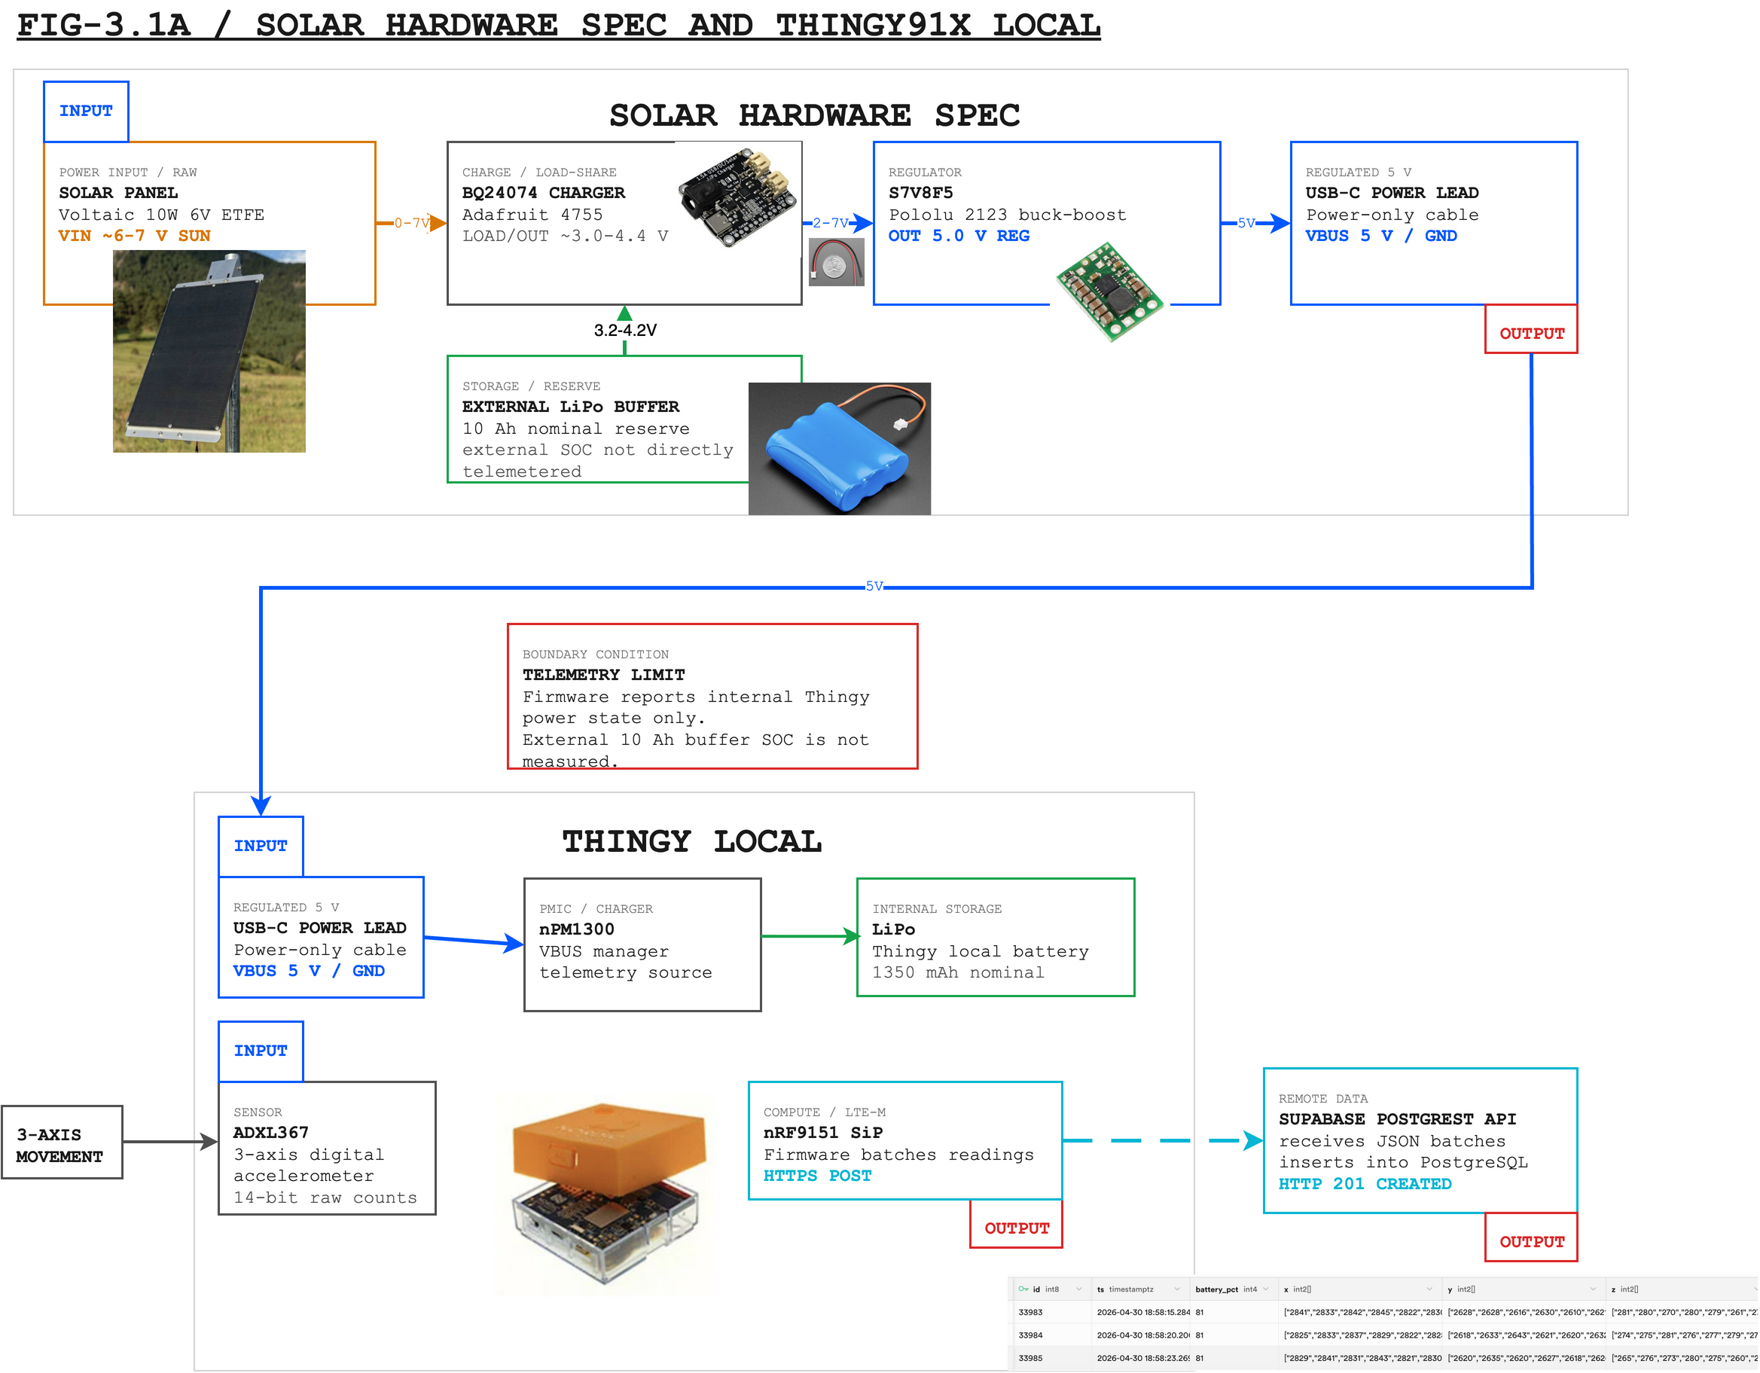
Caption draft: Solar-assisted hardware architecture for the PR-SHM sensor node. The BQ24074 manages solar charging and the external LiPo buffer; the S7V8F5 provides the regulated 5.0 V USB-C input to the Thingy:91 X. Firmware telemetry describes the Thingy internal battery/PMIC domain, not the external 10 Ah buffer state of charge.
Figure source: /Users/gabe/Library/Mobile Documents/com~apple~CloudDocs/Desktop/BIBLE/NYU/puerto-rico/final-report/final-hardware-architecture.png. Editable source: public/diagrams/final-hardware-architecture.drawio. SVG export: public/diagrams/final-hardware-architecture.svg.
Component | Role in system | Report note
Nordic Thingy:91 X | Integrated sensor-node platform | Provides enclosure, USB-C power input, onboard ADXL367, nRF9151 LTE-M, nPM1300 PMIC, antenna, and stock LiPo battery.
ADXL367 accelerometer | Primary vibration sensor | Onboard 3-axis, 14-bit digital accelerometer used for prototype SHM measurements.
nRF9151 SiP | Compute and LTE-M communications | Runs firmware, reads ADXL367 data, and posts batches to Supabase over LTE-M.
nPM1300 PMIC + internal LiPo | Thingy internal power domain | Source of firmware battery voltage/current/VBUS telemetry. This does not measure the external LiPo buffer.
Solar panel | Field energy source | Feeds the BQ24074 charger input; Figure 3.1-A and the final BOM identify the selected panel rating.
BQ24074 solar LiPo charger | Solar charging and load sharing | Charges the external LiPo buffer and provides the LOAD/OUT rail for the 5 V regulator.
External LiPo buffer | Energy storage reserve | Provides overnight and storm reserve for the external power path.
2 A polyfuse | Battery-side short-circuit protection | Inline protection on the external battery positive lead before the charger input path.
Pololu S7V8F5 regulator | Regulated 5 V USB-C supply | Converts the BQ24074 LOAD/OUT rail into the Thingy USB-C 5.0 V input.
Cut USB-A to USB-C power lead | Power connection to Thingy | Carries regulated 5 V and ground only; USB data wires are insulated.
JST pigtails and solder joints | Assembly interconnects | Assembly interconnects documented in HARDWARE_SPEC.md; solder joints require polarity check, insulation, and continuity verification.
Enclosure and mount | Mechanical coupling and weather protection | Stock Thingy shell for Phase 1; IP67 enclosure and rigid bracket remain Phase 2 targets.
LORD S-200 reference system | Validation equipment, not node hardware | Reference acceleration data source for evaluating prototype measurement quality.

3.2 Software
Layer | Implementation | Report emphasis
Firmware | Zephyr/nRF Connect SDK, C, direct I2C reads from ADXL367, LTE-M HTTPS POST, remote sample interval config | Explain why raw 14-bit counts are posted and normalized in analysis.
Power telemetry | Battery voltage/percentage, current sign convention, VBUS presence, charger status | Use this as the bridge between observed battery behavior and power-design revision.
Cloud | Supabase PostgreSQL + PostgREST | Show sensor-to-cloud proof with created rows and timestamps.
Frontend | Vite/React dashboard with live acceleration and battery visualization | Use screenshots as evidence of usability and monitoring workflow.
Analysis | CSV/XLSX exports, calibration scripts/plots, FFT and magnitude comparison | Keep formulas and processing detail in methods or appendix.

4. Test Results and Success Criteria
This is the section that will carry the report. Write it as a results argument, not as a chronological diary. Start with the two core proofs, then cover pipeline and limitations.
Claim to test | Success criterion | Current evidence / status
Battery/solar feasibility | Duty-cycled design supports long-term operation and remains solar-positive. | Duty-cycled model: 1.07 mA average, about 42 days on the internal battery alone and about 249 days on the external 10Ah buffer with conversion margin. Solar model: about 7.7 Wh/day harvest vs about 0.095 Wh/day duty-cycled consumption. Current continuous-post firmware is closer to about 20 mA and still needs duty cycling.
Reference-sensor agreement | Prototype tracks the LORD reference well enough to support feasibility. | 30.46 s aligned test, 3900 samples. Raw magnitude correlation about 0.939. Axis-calibrated magnitude correlation about 0.955, magnitude RMSE about 0.040 g, FFT amplitude correlation about 0.952 from 0 to 12.5 Hz.
Axis-specific behavior | Active-axis response is directionally consistent after calibration. | Active axes showed correlations around 0.698 and 0.697. The LORD up-down channel had low activity (std about 0.067 g), so axis-level conclusions should be qualified.
End-to-end pipeline | Sensor readings reach the cloud and are visible for analysis. | Firmware POSTs to Supabase returned HTTP 201; readings and battery fields appeared in the database/dashboard.
Field readiness | Node survives and transmits without manual intervention. | Observed early battery failure makes this a limitation, not a pass. Use it to justify PSM sleep, reduced transmit duty cycle, and solar/battery verification before deployment.

Suggested Figures and Tables
- System architecture block diagram showing sensor, battery/solar, LTE-M, Supabase, and dashboard.
- Clean hardware architecture figure (public/diagrams/final-hardware-architecture.svg), voltage-node table from HARDWARE_SPEC.md, and hardware table with Thingy:91 X, ADXL367, PMIC/internal LiPo, BQ24074, S7V8F5, external 10Ah buffer, solar panel, reference sensor, and mounting plan.
- Battery/solar table comparing current firmware, duty-cycled target, internal-battery autonomy, external-buffer autonomy, and solar-positive operation.
- LORD vs prototype time-domain overlay after alignment and calibration.
- FFT amplitude comparison over 0 to 12.5 Hz.
- Dashboard screenshot or database evidence showing received samples and battery values.

Recommended Source Files
Use for | Local source
Objective, scope, success criteria | PRD.md, SRS.md
Device details | HARDWARE_SPEC.md, BOM.md, ARCHITECTURE.md, FIRMWARE.md
Power argument | POWER_BUDGET.md, progress.txt
Sensor comparison metrics | exports/sensorconnect_alignment_day2/viability_plotly_axis_calibrated/axis_calibrated_viability_metrics.json
Advisor-ready result summary | exports/advisor_charts/advisor_summary.txt
Candidate report figures | exports/advisor_charts/*.png, exports/sensorconnect_alignment_day2/viability_plotly/*.csv

Full Report Outline
Report part | Purpose | How to write it
Front matter | Title page, abstract, and one-paragraph executive summary. | Write this last. The summary should state the central feasibility claim and the two proof points.
1. Broader Objective | Explain the structural health monitoring problem and why low-cost cellular sensing matters. | Use the PREPA/transmission tower context, hurricane-season motivation, and the gap in visual-only inspection.
2. Specific Goals | Translate the objective into measurable project goals. | Keep this goal-level, not task-level: sensing, power, LTE/cloud pipeline, validation, and deployment envelope.
3. Devices | Document the physical and software system. | Use public/diagrams/final-hardware-architecture.svg as the clean hardware figure, plus the voltage table from HARDWARE_SPEC.md. Split into 3.1 Hardware and 3.2 Software exactly as requested. Include block diagram, parts/specs table, telemetry boundary, and verification pointer.
4. Test Results and Success Criteria | Show whether the system worked and where it still needs revision. | Lead with battery/solar feasibility and LORD comparison. Then cover pipeline, dashboard, limitations, and next steps.
Conclusion | State the feasibility judgment. | Do not overclaim. The report can say the design is feasible with duty cycling and solar, while the current continuous-post firmware exposed the power risk.
Appendices | HARDWARE_SPEC.md, detailed BOM, firmware snippets, SQL schema, raw-data processing notes, and extra charts. | Put the full hardware spec here, or cite the repo file, so the main body stays readable.

Writing Order
Write the draft in the order that reduces risk. Do not start by polishing the introduction; start with the evidence that has to survive advisor review.
- Build the results section first: battery/solar, LORD comparison, pipeline, and limitations.
- Write the methods section next: hardware setup, firmware/data path, reference-sensor alignment, calibration, and power assumptions.
- Draft the broader objective and specific goals after the methods/results are stable.
- Add figures and captions, then write the discussion around what the evidence proves and what it does not prove.
- Write the abstract, conclusion, and appendix list last.

Draft Checklist for Monday, May 11, 2026
- Advisor structure 1-4 is visible in the table of contents or headings.
- The two core proofs appear in the first page of the draft summary.
- Battery section separates modeled dut
- y-cycled feasibility from current continuous-firmware behavior.
- Sensor section includes at least one time-domain comparison and one frequency-domain comparison.
- Limitations are explicit: short validation window, axis-alignment uncertainty, mechanical mounting, current power behavior, and pending outdoor/weather validation.
- Every success criterion has a status: pass, partial, not yet passed, or future work.

One-Paragraph Report Thesis
This project developed and tested a low-cost cellular accelerometer node for structural health monitoring using the Nordic Thingy:91 X platform and its onboard ADXL367 accelerometer. The prototype demonstrated an end-to-end data path from raw acceleration sampling to LTE-M cloud upload and dashboard visualization. Validation against a LORD S-200 reference showed strong agreement in dynamic magnitude and frequency content after alignment and calibration, supporting the feasibility of the onboard accelerometer for prototype SHM measurements. The power analysis shows that a duty-cycled solar-assisted design can support long-term deployment, while observed battery limitations in the current continuous-post firmware define the next engineering step before extended field use.

