Low-Cost Cellular Accelerometer Node for Structural Health Monitoring
Gabe Kafka-Gibbons
NYU Tandon School of Engineering
Advisor: Masoud Ghandehari
Project context: Puerto Rico transmission tower structural health monitoring
Final report due: May 15, 2026
Working thesis
The prototype demonstrates constant-stream sensing, cloud upload, and reference-sensor agreement, with solar/battery support for field operation.

Abstract
Transmission towers in Puerto Rico are exposed to wind, corrosion, fatigue, and notably hurricane loading, but post-event assessment is often limited to visual inspection rather than continuous measurement. This report presents a low-cost cellular accelerometer node for prototype structural health monitoring using the Nordic Thingy:91 X platform, its onboard ADXL367 accelerometer, LTE-M connectivity, and a Supabase/PostgREST cloud data path. The system samples triaxial acceleration as a continuous FIFO stream, packages readings into 100-sample batches, reports battery telemetry, and posts data over HTTPS to a cloud database and dashboard. A solar-assisted power architecture using a 2 W panel, BQ24074 charger/load-share, external 10 Ah LiPo buffer, and S7V8F5 regulated 5.0 V USB-C supply is specified to support unattended operation while keeping the Thingy:91 X hardware unmodified. Sensor viability was evaluated by benchmarking the Thingy accelerometer against a LORD S-200 reference sensor under the same excitation. Magnitude-based comparison reduced sensitivity to axis misalignment, while temporal alignment and calibration improved agreement between the prototype and reference signals. In the current validation dataset, raw magnitude correlation was approximately 0.939, calibrated magnitude correlation was approximately 0.955, magnitude RMSE was approximately 0.040 g, and FFT amplitude correlation was approximately 0.952 over 0 to 12.5 Hz. These results support the feasibility of using the integrated ADXL367 for prototype-level vibration monitoring and demonstrate an end-to-end sensor-to-cloud pipeline. The principal remaining limitations are the short validation window, mounting and axis-alignment uncertainty, external-buffer state-of-charge telemetry, and the need for longer unattended field testing under realistic solar and LTE conditions.

Keywords
structural health monitoring; transmission towers; wireless sensing; cellular IoT; LTE-M; triaxial accelerometer; ADXL367; Nordic Thingy:91 X; solar-assisted power; Supabase; reference-sensor validation; FFT analysis

Table of Contents
Right-click and update field after editing.

1. Broader Objective

1.1 Engineering Context
Electric transmission towers are distributed assets that must remain functional under wind, rain, corrosion, fatigue, and extreme storm loading. In Puerto Rico, this problem is especially important because transmission infrastructure is exposed to hurricane-season hazards, salt-laden coastal air, difficult access conditions, and long recovery timelines after major weather events. Traditional inspection is often periodic or event-driven, so damage that changes the structural behavior of a tower may not be detected until a visual inspection is performed or a service problem appears.
Structural health monitoring addresses this gap by treating changes in measured dynamic response as evidence of possible changes in stiffness, looseness, connection condition, or boundary support. A tower does not need to be fully instrumented to make this useful at the prototype stage: even a small number of reliable vibration measurements can establish baseline behavior, support post-event comparison, and identify whether a site deserves closer inspection. For this reason, the critical engineering question is not only whether an accelerometer can record motion, but whether a low-cost field node can produce repeatable acceleration data, transmit it continuously, and retain enough power autonomy to be useful outside the laboratory.
The engineering constraints shape the system design. A practical node for remote tower monitoring should be low cost, physically simple, cellular rather than Wi-Fi dependent, and capable of operating from a solar-assisted power source. It should also avoid a custom circuit-board design unless the sensing, power, and data-pipeline assumptions are already proven. This project therefore uses the Nordic Thingy:91 X as an integrated sensor-node platform and evaluates whether its onboard ADXL367 accelerometer, LTE-M modem, and external solar/battery front end can support prototype-level structural monitoring with a constant stream of cloud-accessible data.

1.2 Research Objective
[State the broader research objective: prove that a low-cost cellular accelerometer node can collect useful vibration data and maintain a field-capable data path.]

1.3 Scope of This Report
[Clarify that this is a proof-of-concept sensor node and validation study, not a complete deployed SHM network.]

2. Specific Goals

2.1 Goal Summary
[List the measurable goals: sensing node, constant data stream, LTE/cloud pipeline, battery/solar feasibility, reference-sensor validation, and deployment envelope.]

3. Devices
[Introduce the physical and software system. Keep this section descriptive and specific: what was built, what each part does, and what evidence proves it worked.]

3.1 Hardware
[Open with one paragraph that names the hardware domains: solar power front end, Thingy:91 X local hardware, sensing, LTE-M/cloud handoff, and telemetry boundary.]
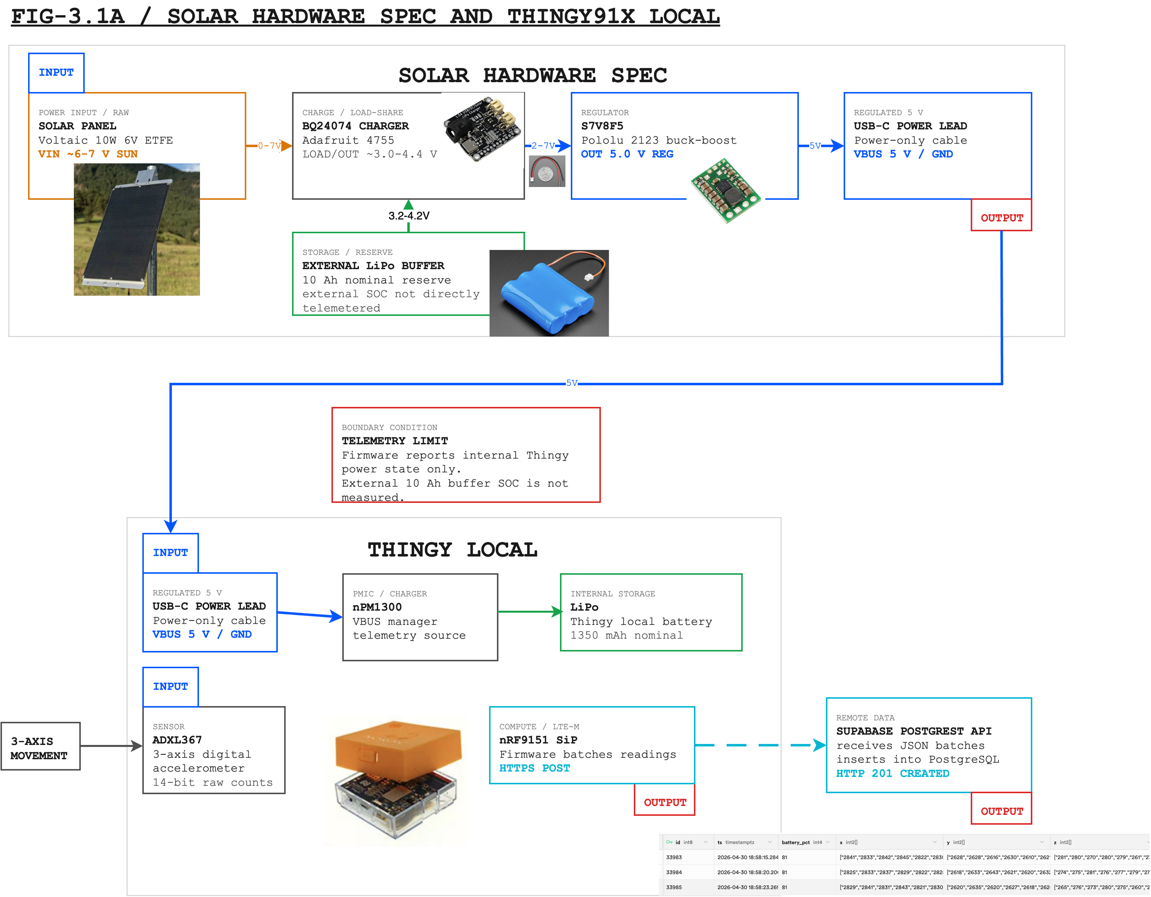
Figure 3.1. Solar-assisted hardware architecture for the PR-SHM sensor node. The BQ24074 manages solar charging and the external LiPo buffer; the S7V8F5 provides the regulated 5.0 V USB-C input to the Thingy:91 X. Firmware telemetry describes the Thingy internal battery/PMIC domain, not the external 10 Ah buffer state of charge.
Editable source: public/diagrams/final-hardware-architecture.drawio. SVG export: public/diagrams/final-hardware-architecture.svg.
[Hardware component write-up placeholder: summarize the Thingy:91 X, ADXL367, nRF9151, nPM1300, solar panel, BQ24074 charger, external LiPo buffer, S7V8F5 regulator, USB-C lead, mount/enclosure plan, and LORD S-200 reference.]

3.2 Firmware and Software
[Describe the current intended field behavior: continuous ADXL367 FIFO sampling, 100-sample batches, battery telemetry, HTTPS POST to Supabase, and LTE reconnect/retry after POST failure. Do not frame duty cycling as required.]

3.3 Cloud Data Pipeline
[Describe Supabase/PostgREST receiving, database rows/batches, dashboard visualization, and how data is exported for analysis.]

4. Test Results and Success Criteria
[Lead with the proof claims, not a chronological build diary. Each subsection should state the test, the metric, the result, and the limitation.]

4.1 Constant-Stream Power and Solar Feasibility
[Use POWER_BUDGET.md. Show daily energy load, external-buffer autonomy, solar harvest margin, and observed battery telemetry. Make the claim that the constant stream is supportable if the budget assumptions hold.]

4.2 Accelerometer Viability Test
[Explain magnitude calculation, unit conversion to g, cross-correlation alignment, linear calibration, RMSE, mean bias, and Pearson correlation against the LORD reference.]

4.3 FFT Viability Test
[Compare frequency-domain amplitude spectra over the range of interest. Report FFT amplitude correlation and matching/different peaks.]

4.4 Tilt Extraction Material
[If retained, explain install-time gravity reference, differential tilt angle, and two-axis decomposition. Keep it as methods or appendix material unless there are results.]

4.5 End-to-End Pipeline Evidence
[Show firmware POST success, Supabase insertion, dashboard visibility, and exported analysis data.]
Claim | Success criterion | Evidence to insert | Status
Constant stream power | [Define pass/fail] | [Power budget + solar margin + telemetry] | [Status]
Accelerometer agreement | [Define pass/fail] | [Time-domain metrics] | [Status]
Frequency response | [Define pass/fail] | [FFT comparison] | [Status]
Pipeline | [Define pass/fail] | [HTTP 201, DB/dashboard evidence] | [Status]

5. Discussion
[Interpret what the results prove and what they do not prove. Separate prototype feasibility from full deployment readiness.]

5.1 Limitations
[Short validation window, mounting uncertainty, LTE/solar variability, external-buffer SOC not directly telemetered, and any sensor-axis caveats.]

5.2 Future Work
[Longer unattended field run, enclosure/mount refinement, outdoor weather validation, and optional watchdog confirmation if enabled.]

6. Conclusion
[One direct feasibility judgment. Do not introduce new evidence here.]

References
[Add datasheets, Nordic Thingy:91 X documentation, ADXL367 datasheet, BQ24074/S7V8F5 docs, LORD/SensorConnect references, and any SHM background citations.]

Appendix A. Hardware Specification
[Paste or cite HARDWARE_SPEC.md and BOM.md.]

Appendix B. Firmware and Cloud Configuration
[Paste or cite FIRMWARE.md, ARCHITECTURE.md, schema, and endpoint notes.]

Appendix C. Data Processing and Additional Plots
[Include SensorConnect exports, calibration scripts, FFT plots, tilt derivation, and raw/processed metrics.]

