**Add your app to Goggle play or AppStore and manage your IAP in store side**

1. [Google play manual](https://docs.unity3d.com/Manual/UnityIAPGoogleConfiguration.html)

2. [Apple AppStore manual](https://docs.unity3d.com/Manual/UnityIAPAppleConfiguration.html)

**Manage your IAP in game side.**

1. Open first scene – Lobby.
2. Select in hierarchy Purchaser.
3. Select Inspector tab.

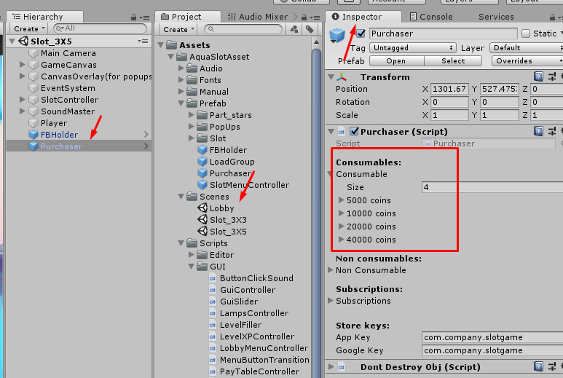

You can see 3 types of goods (Consumables, Non consumables and Subscription).

We use consumable (only for example).

Fold out the item

|  |  |
| --- | --- |
| In green frame – settings for shop window  In red frame – unique ID for store. |  |
|  |  |
| Keys for stores(Apple and Goggle) – your keys |  |

1. Add or remove items

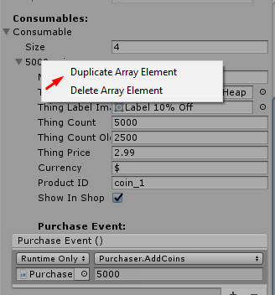

Set up purchase event for each item (what happened after succesfully purchasing)

