Import any sound clips in your app.

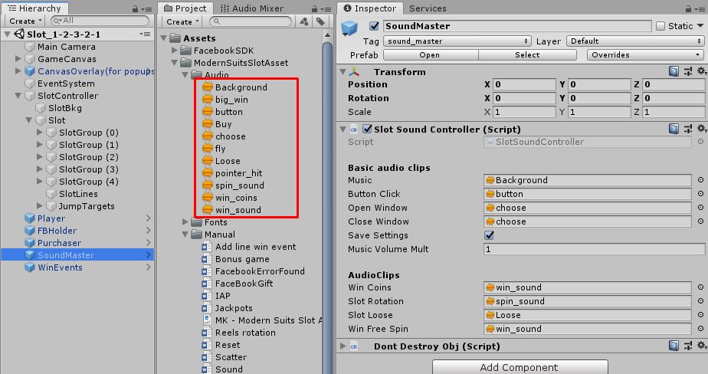

Open Lobby scene.

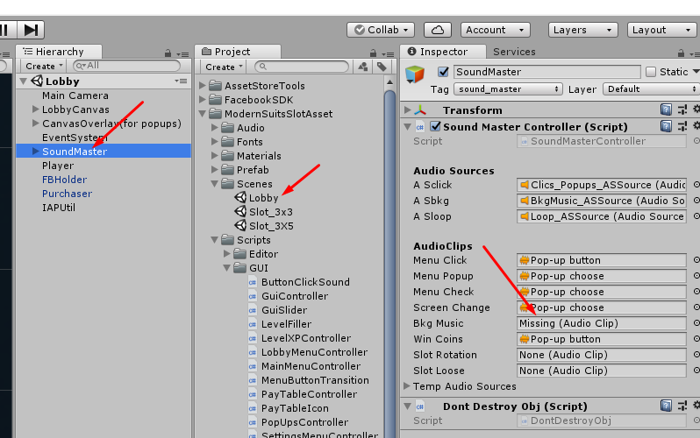

|  |  |
| --- | --- |
| 1.Spin Sound. |  |
| Select SoundMaster  Drag spin clip in to Slot Rotation field |  |
|  |  |
| Click apply. |  |
| Play scene and test.  Don’t forget enable sounds. |  |

|  |  |
| --- | --- |
| Add your clip |  |
| Open SlotSoundController.cs script |  |
| Add field BonusGame for your clip | public AudioClip bonusGame; |
| Add method  SoundPlayBonusGame for your clip | public void SoundPlayBonusGame(float playDelay, Action callBack)  {  PlayClip(playDelay, bonusGame, callBack);  } |
| Drag your clip in to Bonus Game field |  |
| To play your clip from any code place - call | SlotSoundController.Instance.SoundPlayBonusGame(delay time, callBack or null); |