Metacognition in google/gemini-3.1-flash-lite-preview

Research question
Does google/gemini-3.1-flash-lite-preview give calibrated confidence judgments about its own quantitative estimates, and does a brief reflection instruction change those judgments?

Design
The subject model answered 36 self-contained quantitative estimation trials across 18 tasks. Each task appeared once in a direct condition and once in a reflective condition. The reflective condition asked the model to silently consider two ways its estimate could be wrong before reporting the same structured fields.
The task data were synthetic scenario quantities with known answers computed by the experiment script. This avoids scoring against current web facts and reduces the chance that the model is simply recalling a memorized answer.
- Model: google/gemini-3.1-flash-lite-preview
- Temperature: 0.7
- Seed for trial order: 20260502
- Primary metacognitive measures: stated probability of being within 25% of truth, stated probability of being within a factor of 2, and 80% interval coverage.

Results
Overall, the model's median absolute error was 1.01x. It was within 25% on 69.4% of trials while claiming 70.8% average confidence for that event. It was within a factor of 2 on 75.0% of trials while claiming 95.6% average confidence. Its nominal 80% intervals contained the truth on 69.4% of trials.
Condition | N | Median factor error | Within 25% | Mean conf. within 25% | Within 2x | Mean conf. within 2x | 80% interval coverage
direct | 18 | 1.01x | 72.2% | 76.1% | 77.8% | 96.8% | 72.2%
reflective | 18 | 1.01x | 66.7% | 65.6% | 72.2% | 94.4% | 66.7%

The paired reflection effect on 25%-confidence was -10.6 percentage points (reflective minus direct), paired t=-4.13, p=0.001.
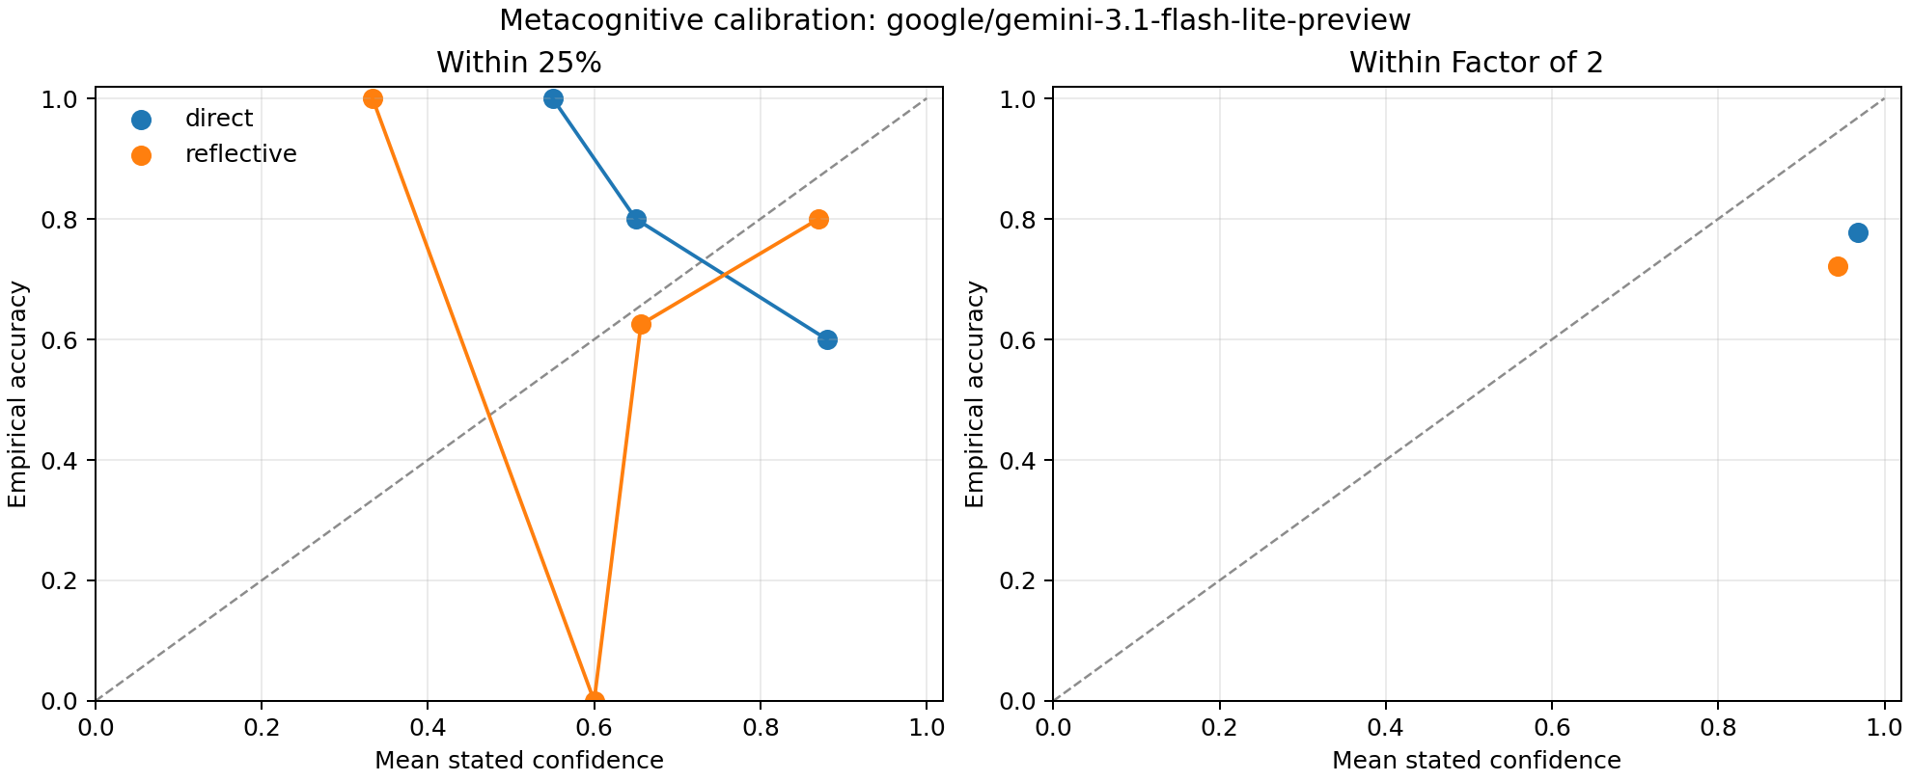
Calibration plot

Largest Errors
Task | Condition | Estimate | Truth | Factor error | Confidence within 25%
grocery_receipts | reflective | 2.18e+04 | 218 | 100.00x | 60%
grocery_receipts | direct | 2.18e+04 | 218 | 100.00x | 85%
coffee_cups | direct | 7.69e+07 | 7.66e+06 | 10.04x | 85%
stadium_trash | reflective | 1.14e+07 | 1.14e+06 | 10.00x | 65%
clinic_gloves | reflective | 3.88e+06 | 3.88e+05 | 10.00x | 85%

Smallest Errors
Task | Condition | Estimate | Truth | Factor error | Confidence within 25%
stadium_trash | direct | 1.14e+06 | 1.14e+06 | 1.00x | 65%
museum_steps | direct | 5.54e+09 | 5.54e+09 | 1.00x | 60%
warehouse_boxes | direct | 1.24e+06 | 1.24e+06 | 1.00x | 90%
warehouse_boxes | reflective | 1.24e+06 | 1.24e+06 | 1.00x | 85%
bus_fuel | direct | 6.1e+05 | 6.1e+05 | 1.00x | 65%

Interpretation
This experiment treats self-reported probabilities as the model's metacognitive judgments. Calibration is imperfect when stated confidence is much higher or lower than empirical hit rates. A model can be numerically accurate while still being metacognitively miscalibrated if its confidence does not track whether its own estimates are likely correct.
Limitations: the tasks are arithmetic-like Fermi scenarios rather than open-world estimates, the sample is small, and confidence reports are prompted text rather than a latent uncertainty measure. The findings should be read as behavior of this model under these prompts, not as a general claim about Gemini models.

