**Slide 14**

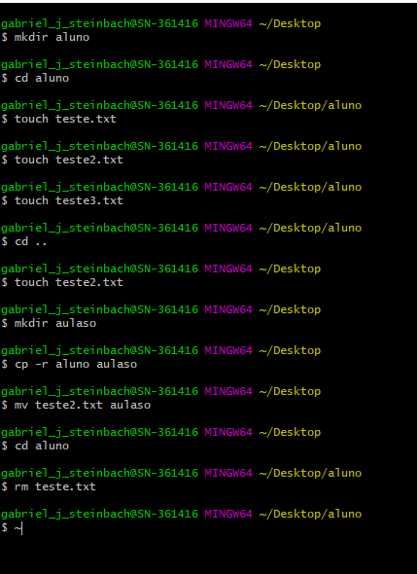

**Slide 15**