**CS 410 Tech Review**

**Investigation of what, why, and how to use TensorFlow**

**Gabe Coelho**

**What is TensorFlow**

Simply put, TensorFlow is an ecosystem for machine learning development, which includes building, training, and deployment of machine learning models. The mathematical background needed to understand TensorFlow includes knowledge about vectors, matrices, and tensors. TensorFlow can run on both CPUs and GPUs and has both “bring your own” as well as pre-trained models. One of the great things about it is that it offers solutions for every machine learning skill level, and it provides ways to prepare data, build and deploy models, and run production-grade models. Be it deep learning or simple

TensorFlow is on the web, server, and mobile platforms, and has a community of experts who provide tech talks as well as courses to help users move ahead on the learning path.

**Why use it**

Some of the strengths of the platform are easy model building, robust ML infrastructure, and a powerful control over research experiments. The APIs available in the built-in libraries save countless hours of writing code, speeding up the process of training models effectively, and reducing errors in programs. The scalability provided by the platform is unbeatable, as there is great flexibility run code on CPUs or GPUs, and even distributed across a large cluster of machines for massive amounts of data. The libraries have integration with programming languages such as C++, Python, and even JavaScript for the web. The amount of control over its numerous features makes TensorFlow a great candidate for ideation, problem-solving, and quick execution.

**How to start**

Before writing any code, the three main topics where a full understanding is needed are listed and explained below.

1. What is a vector?

Vectors are a special type of array/matrix of ordered numbers. They are frequently seen as column matrices since they have one column and a set number of rows. Additionally, vectors include a direction and length.

1. What is a matrix?

A matrix is simply a table of values, which could be numbers, symbols, expressions, organized in rows and columns.

1. What is a tensor?

Tensors are a broad nomenclature for plane vectors, convectors, and linear operators. A tensor is a “mathematical representation of a physical entity that may be characterized by magnitude and *multiple* directions. Tensors are a collection of similar numbers that maintain its meaning under transformations.

The image below illustrates the different mathematical structures leading up to tensors.

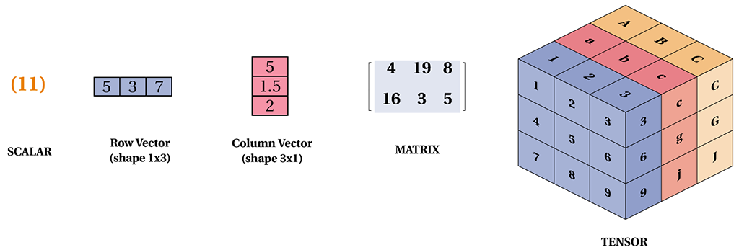

Image from https://tensorflownet.readthedocs.io/en/latest/_static/tensor-naming.png

With those prerequisites in place, one is suited to start following simple tutorials in the TensorFlow.org documentation. In Python, it’s as simple as installing and importing the package like such:

import tensorflow as tf

After that, the possibilities are endless. Following the documentation and some starter guides can help explorer understand a bit more of what can be done with TensorFlow.

**What’s next?**

Now, onto finding a problem to be solved! Be it text-based applications, image recognition, voice search, or a recommendation system, TensorFlow can help. A personal recommendation would be to find an interesting use-case for machine learning in your own life and build something to fix that first. After that, building production ML workflows will be a breeze.

**References**

[1] TensorFlow Tutorial For Beginners, <https://www.datacamp.com/tutorial/tensorflow-tutorial>, Retrieved October 31, 2022

[2] TensorFlow Basics, <https://www.javatpoint.com/tensorflow-basics>, Retrieved October 31, 2022

[3] A primer on the essentials of TensorFlow, <https://medium.com/@Suraj_Yadav/tensorflow-a-beginners-guide-to-the-basics-771cec9b7912>, Retrieved October 31, 2022

[4] TensorFlow Tutorial for Beginners: Your Gateway to Building Machine Learning Models, <https://www.simplilearn.com/tutorials/deep-learning-tutorial/tensorflow>, Retrieved October 31, 2022

[5] TensorFlow, <https://www.tensorflow.org/>, Retrieved October 30, 2022