Data Acquisition Requirements and Approach

1. Introduction
This document is anoverview and description of the data acquisition (DAQ) software developed for the water hammer test stand at Benchmark Space Systems.

The test stand uses two independent DAQ systems operating at different sample rates to simultaneously capture low-frequency static pressure data and high-frequency transient pressure data. The software described manages acquisition from both systems and synchronizes their independent time bases to a common trigger event.

There are three Python scripts:
- daq_labjack.py — LabJack T7 acquisition script
- daq_ni.py — NI cDAQ acquisition script
- merge_sync.py — Post-processing and merge

2. System Architecture

2.1 Hardware Overview

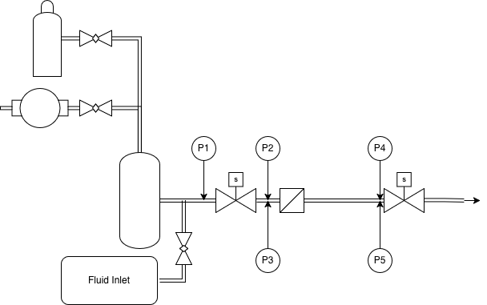
The PCB Piezotronics 113B03 high-frequency pressure transducers (PT-3 and PT-5) require sampling rates on the order of 500 kHz to resolve sub-millisecond pressure transients; this demand is met by the NI cDAQ system. The low-frequency Omega-type transducers (PT-1, PT-2, PT-4) provide steady-state and slowly-varying pressure readings adequate at 1 kHz, handled by the LabJack T7.
ID | Type | Location | DAQ System | Sample Rate
PT-1 | Low-frequency (Omega PX309) | Inlet, 14" from bottle | LabJack T7, AIN0 | 1 kHz
PT-2 | Low-frequency (Omega PX309) | Branch A, upstream | LabJack T7, AIN1 | 1 kHz
PT-3 | PCB Piezotronics 113B03 | Branch A, downstream | NI cDAQ, ai0 | 50 kHz
PT-4 | Low-frequency (Omega PX309) | Branch B, upstream | LabJack T7, AIN2 | 1 kHz
PT-5 | PCB Piezotronics 113B03 | Branch B, downstream | NI cDAQ, ai1 | 50 kHz

Because the two DAQ systems run on independent hardware clocks, a synchronization mechanism is required to align their time bases. The approach used is a shared hardware trigger: the solenoid valve command signal (the electrical pulse sent to SV-2 to initiate valve closure) is routed simultaneously to a digital input on the LabJack T7 (FIO0) and a digital input on the NI cDAQ (port0/line0).

During post-processing, merge_sync.py extracts both t_trigger_epoch values, computes the inter-system clock offset, and re-expresses all data on a common time axis relative to the trigger event (t = 0 s). The LabJack data, sampled at the lower rate, is then added to the NI time base using linear interpolation to produce a single merged dataset containing all five pressure channels at the NI sample rate.

2.3 Data Flow
The end-to-end data flow from test event to analysis-ready dataset is as follows:

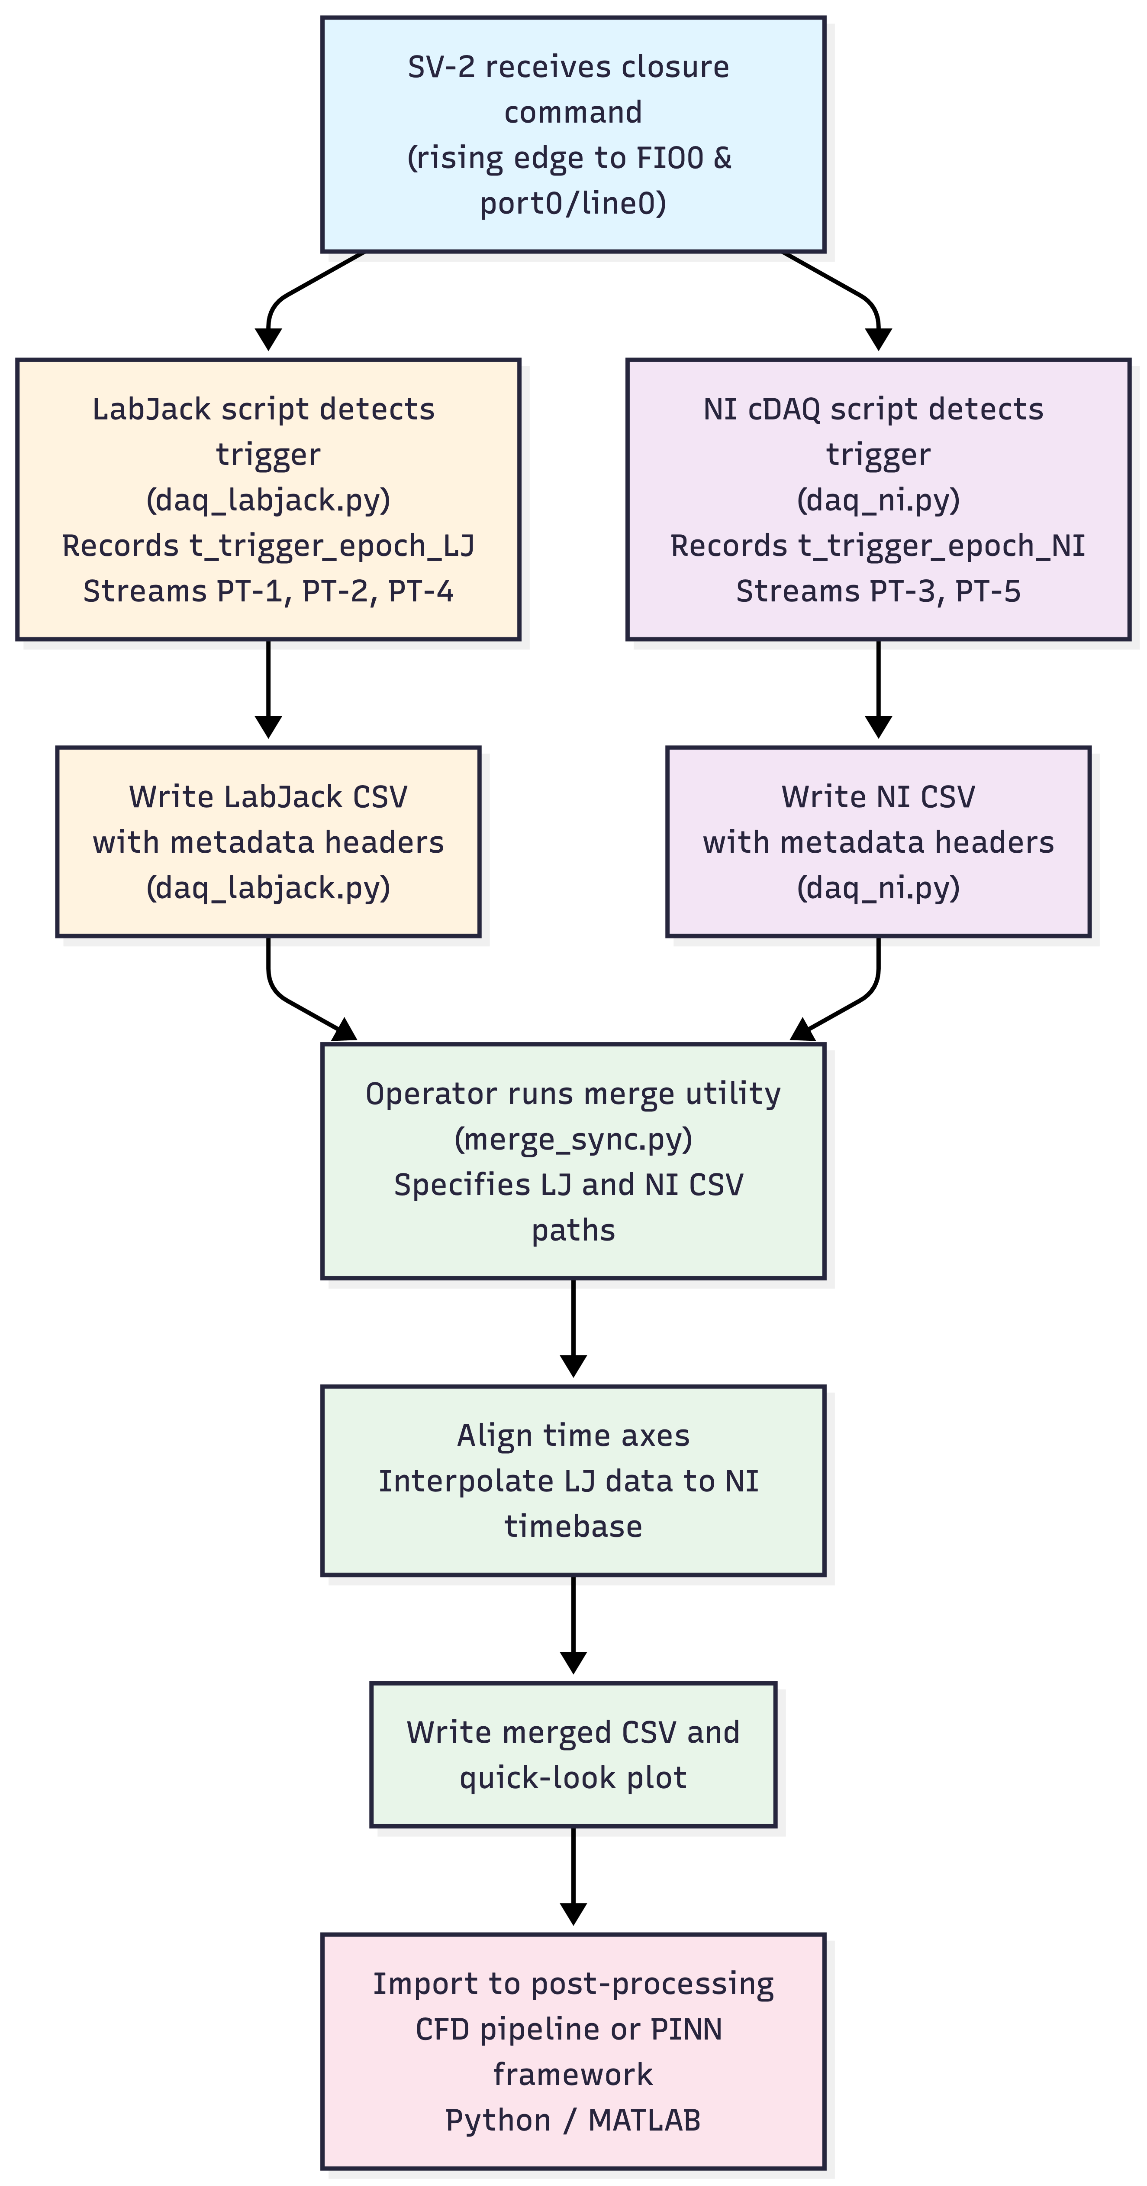

3. Script Descriptions

3.1 daq_labjack.py: LabJack T7
daq_labjack.py manages continuous analog stream acquisition from the LabJack T7 for the three low-frequency pressure transducers. It uses a circular pre-trigger buffer to preserve data recorded prior to the trigger event, detects the solenoid valve trigger edge on a digital input, and writes a timestamped CSV file containing both raw voltage and calibrated pressure values.
Parameter | Default | Description
CHANNELS | AIN0, AIN1, AIN2 | Analog input channels mapped to PT-1, PT-2, PT-4
TRIGGER_DIO | FIO0 | Digital input for valve trigger rising edge
DEFAULT_RATE | 1000 Hz | Scan rate passed to LJM eStreamStart
DEFAULT_DURATION | 5.0 s | Post-trigger data capture window
PRE_TRIGGER_S | 0.5 s | Length of pre-trigger circular buffer
CALIBRATION | Placeholder (100.0 gain) | V → psi linear coefficients; must be updated

The script opens the T7 via the LJM library and configures all AIN channels to ±10 V range with single-ended ground reference. It then starts a hardware-timed stream at the configured scan rate. Data is read from the stream in approximately 100 ms chunks. During the pre-trigger phase, each chunk is written into a circular buffer of length PRE_TRIGGER_S × sample_rate. Concurrently, the script polls FIO0 at 0.5 ms intervals for a rising edge. On trigger detection, the Unix epoch time is recorded and the pre-trigger buffer is flushed to the output array. The script then continues reading post-trigger data for the configured duration before stopping the stream, closing the device, and writing the output CSV.

The output CSV begins with a comment block containing metadata, followed by a column header row and data rows. The comment block includes run_id, UTC timestamp, actual sample rate, trigger status, t_trigger_epoch, and channel identifiers. Data columns are:
t_s | Time in seconds relative to trigger (negative = pre-trigger)
t_epoch | Absolute Unix epoch time for each sample
PT1_inlet_V | PT-1 raw voltage (V)
PT2_branchA_LF_V | PT-2 raw voltage (V)
PT4_branchB_LF_V | PT-4 raw voltage (V)
PT1_inlet_psi | PT-1 calibrated pressure (psi)
PT2_branchA_LF_psi | PT-2 calibrated pressure (psi)
PT4_branchB_LF_psi | PT-4 calibrated pressure (psi)

3.2 daq_ni.py: NI cDAQ Acquisition
daq_ni.py manages the data acquisition from the NI cDAQ chassis for the two PCB pts. It uses the nidaqmx Python library to configure a continuous analog input task, implements a ring buffer for pre-trigger data, and runs a background thread to monitor the digital trigger input without blocking the analog stream.
Parameter | Default | Description
AI_DEVICE | Dev1 | NI device name as shown in NI MAX; update as required
AI_CHANNELS | ai0, ai1 | Analog input channels mapped to PT-3, PT-5
DI_TRIGGER_LINE | Dev1/port0/line0 | Digital input for trigger edge detection
DEFAULT_RATE | 50,000 Hz | Sample rate per channel
DEFAULT_DURATION | 1.0 s | Post-trigger capture window
PRE_TRIGGER_S | 0.1 s | Pre-trigger ring buffer duration
VOLTAGE_MIN/MAX | −5 V / +5 V | Analog input range; must match charge amplifier output range

On execution, the script starts a TriggerWatcher object, which launches a thread polling the configured digital input line at 0.5 ms intervals. An NI analog input task is configured with the specified channel list, input range, and continuous sample clock timing. The task buffer is sized to twice the total expected sample count to prevent overflow. Acquisition proceeds in 10 ms chunks read via AnalogMultiChannelReader. During the pre-trigger phase, chunks populate a NumPy ring buffer. When the TriggerWatcher thread detects a rising edge, it records t_trigger_epoch and sets a flag checked by the main loop. The main loop then transitions to post-trigger capture, reading the configured number of post-trigger samples before stopping the task and proceeding to file output.

Output format mirrors the LabJack CSV structure, with equivalent metadata header and the following data columns:
t_s | Time in seconds relative to trigger (negative = pre-trigger)
t_epoch | Absolute Unix epoch time for each sample
PT3_branchA_HF_V | PT-3 raw voltage (V)
PT5_branchB_HF_V | PT-5 raw voltage (V)
PT3_branchA_HF_psi | PT-3 calibrated pressure (psi)
PT5_branchB_HF_psi | PT-5 calibrated pressure (psi)

The script as written uses add_ai_voltage_chan, which interfaces with the standard NI voltage input module (NI 9205). If the transducers were to be powered directly, the channel configuration call must be replaced with new values.
Example script for running:
python daq_ni.py --run-id 0B_100psi_SV2_run1 --duration 1.0 --sample-rate 50000

3.3 merge_sync.py: Synchronization and Merge
merge_sync.py ingests the independent CSV files produced by daq_labjack.py and daq_ni.py, performs time-base synchronization using the embedded trigger epoch values, interpolates the lower-rate LabJack data onto the higher-rate NI time base, and outputs a single merged CSV alongside a five-panel plot
Time alignment proceeds in four steps. First, t_trigger_epoch is extracted from the comment header of each CSV file. Second, the clock offset is computed. Third, both time axes are re-expressed relative to their respective trigger epochs, producing t = 0 at the moment of valve closure for each system independently. Fourth, the LabJack channels are interpolated onto the NI sample grid using SciPy linear interpolation, with NaN values assigned outside the LabJack data bounds to avoid edge extrapolation artifacts.

The computed clock offset is reported in the merged CSV header and in the quick-look plot footer. A warning is emitted if the offset exceeds 10 ms, as this indicates non-trivial trigger detection jitter that may affect the validity of comparisons between low- and high-frequency channels in the sub-10 ms window immediately following valve closure.

4. Calibration

Channel | Sensor | Calibration Source | Status
PT-1 (AIN0) | Omega PX309 (low-freq.) | Omega calibration certificate | Calibration Needed
PT-2 (AIN1) | Omega PX309 (low-freq.) | Omega calibration certificate | Calibration Needed
PT-4 (AIN2) | Omega PX309 (low-freq.) | Omega calibration certificate | Calibration Needed
PT-3 (ai0) | PCB 113B03 + charge amp | PCB sensitivity + charge amp gain | Calibration Needed
PT-5 (ai1) | PCB 113B03 + charge amp | PCB sensitivity + charge amp gain | Calibration Needed

5. File Naming and Directory Structure
Output files are named automatically. The run ID is provided at the command line:

LJ_[run_id]_[YYYYMMDD_HHMMSS].csv
NI_[run_id]_[YYYYMMDD_HHMMSS].csv
merged_[run_id].csv
merged_[run_id].png

6. Software Dependencies
Package | Version (min.) | Purpose | Install
labjack-ljm | 1.23+ | LabJack T7 hardware interface (LJM library wrapper) | pip install labjack-ljm
nidaqmx | 0.9+ | NI DAQmx Python API for NI cDAQ hardware | pip install nidaqmx
numpy | 1.21+ | Array operations, ring buffers, interpolation grids | pip install numpy
pandas | 1.3+ | CSV I/O and DataFrame manipulation in merge utility | pip install pandas
scipy | 1.7+ | interp1d for LJ-to-NI timebase interpolation | pip install scipy
matplotlib | 3.4+ | Quick-look plot generation | pip install matplotlib

The labjack-ljm Python package requires the LJM C library to be installed separately from LabJack's website. The nidaqmx package requires NI-DAQmx runtime drivers to be installed from National Instruments.

