**ABSTRACT**

The basic function of this system is to available the tender documents online to the customers and download the application forms. Daily many tenders will be released and the new tenders are updated so that customers can view them and if they are interested they can download the tender form. Customers will have to register themselves and will get a permanent user ID and password.  By this ID and password he can download the tender forms in future also.

The tender documents will be supplied to the user. This system can also handle multiple tender documents at one time i.e. the user can access various tenders from the company at onetime and can download the required forms. The user can submit the details along with quotation to the department through online.

Then the department people evaluate all the tenders submitted by users on evaluation date and they allocate that work to the user who is eligible and quoted for less amount.

**EXISTING SYSTEM**

In the current tender handling system all the tenders are processed through documents. It is a manual system. This system is called open document system.In this first of all tender notices are given in news papers with the details about work.Then the contractors read the tender notification and buy the tender schedule by paying the tender fee if they are interested to do that particular work.

In that schedule all the details of the work are available to the contractors.Then the contractors send submission details which includes quotation of the tender  before tender submission closing date through post or by hand.

On evaluation date the department people evaluate all the tender details submitted by the contractors.The department people give that work to the contractor who is eligible and quoted for less amount.

**PROPOSED SYSTEM:**

In this system it will reduce the man power and save the time. This is mainly used for download the tender application form and edit the Document and upload the files as needed. Which is used to view the status of the tender through online.

Reasons To Choose the Online E-Tendering:

🡪SECURITY

🡪Data Protection/Back-up

🡪Mobility

🡪Flexibility

**MODULE DESCRIPTION**

# Number of Modules

After careful analysis the system has been identified to have the following modules:

1. **Admin Module**
2. **Manager Module**
3. **Supplier Module**
4. **Status module**

**1. Admin Module**

Admin will perform all the function that manager and employee can perform and they can view the supplier details and applied tender details, manager details.They can delete and view the supplier tender record Admin will maintain the entire database according to their company rules.

**2.Manager Module**

Managers can view multiple tender request documents at the same time for planning purposes for their respective department. they can approve the tender request based on their request. they can cancel the tender request if it is not suitable to their company rules. Manager can upload new tenders using upload form.

### 3.Supplier Module

Supplier can View the available tenders in company at any time and download the application forms. If the supplier want to apply the tender they are able to send the request to the company manager through online.s Supplier can view response from manager for the requested tender is cancel or approved. One supplier can apply the multiple tenders at the same time.

**4.Status module**

This module is used to display the status as which is the requested tender is going to be approved or cancel by the manager and the result also view by the supplier.

**Software requirements**:

* Operating System : Windows
* Technology : PHP
* Web Technologies : Html, JavaScript, CSS
* IDE : Notepad++
* Web Server : Wamp2.2e
* Database : My SQL

**Hardware requirements**:

* Hardware - Pentium
* Speed - 1.1 GHz
* RAM - 1GB
* Hard Disk - 20 GB
* Key Board - Standard Windows Keyboard
* Mouse - Two or Three Button Mouse
* Monitor - SVGA

**INPUT DESIGN**

The input design is the link between the information system and the user. It comprises the developing specification and procedures for data preparation and those steps are necessary to put transaction data in to a usable form for processing can be achieved by inspecting the computer to read data from a written or printed document or it can occur by having people keying the data directly into the system. The design of input focuses on controlling the amount of input required, controlling the errors, avoiding delay, avoiding extra steps and keeping the process simple. The input is designed in such a way so that it provides security and ease of use with retaining the privacy. Input Design considered the following things:

* What data should be given as input?
* How the data should be arranged or coded?
* The dialog to guide the operating personnel in providing input.
* Methods for preparing input validations and steps to follow when error occur.

**OBJECTIVES**

1.Input Design is the process of converting a user-oriented description of the input into a computer-based system. This design is important to avoid errors in the data input process and show the correct direction to the management for getting correct information from the computerized system.

2. It is achieved by creating user-friendly screens for the data entry to handle large volume of data. The goal of designing input is to make data entry easier and to be free from errors. The data entry screen is designed in such a way that all the data manipulates can be performed. It also provides record viewing facilities.

3.When the data is entered it will check for its validity. Data can be entered with the help of screens. Appropriate messages are provided as when needed so that the user

will not be in maize of instant. Thus the objective of input design is to create an input layout that is easy to follow

**OUTPUT DESIGN**

A quality output is one, which meets the requirements of the end user and presents the information clearly. In any system results of processing are communicated to the users and to other system through outputs. In output design it is determined how the information is to be displaced for immediate need and also the hard copy output. It is the most important and direct source information to the user. Efficient and intelligent output design improves the system’s relationship to help user decision-making.

1. Designing computer output should proceed in an organized, well thought out manner; the right output must be developed while ensuring that each output element is designed so that people will find the system can use easily and effectively. When analysis design computer output, they should Identify the specific output that is needed to meet the requirements.

2.Select methods for presenting information.

3.Create document, report, or other formats that contain information produced by the system.

The output form of an information system should accomplish one or more of the following objectives.

* Convey information about past activities, current status or projections of the
* Future.
* Signal important events, opportunities, problems, or warnings.
* Trigger an action.
* Confirm an action.

**SYSTEM DESIGN**

**Data Flow Diagram / Use Case Diagram / Flow Diagram**

The DFD is also called as bubble chart. It is a simple graphical formalism that can be used to represent a system in terms of the input data to the system, various processing carried out on these data, and the output data is generated by the system.

**Data Flow Diagram**



**Supplier Process:**



**Admin Process:**



**Supplier Login:**



**Manager Login:**





**Usecase Diagram:**

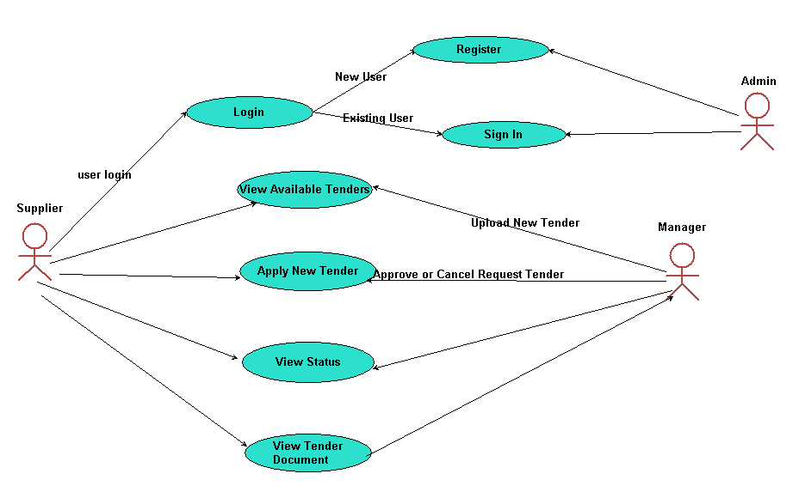

### SYSTEM TESTING

The purpose of testing is to discover errors. Testing is the process of trying to discover every conceivable fault or weakness in a work product. It provides a way to check the functionality of components, sub assemblies, assemblies and/or a finished product It is the process of exercising software with the intent of ensuring that the

Software system meets its requirements and user expectations and does not fail in an unacceptable manner. There are various types of test. Each test type addresses a specific testing requirement.

**TYPES OF TESTS**

**Unit testing**

Unit testing involves the design of test cases that validate that the internal program logic is functioning properly, and that program inputs produce valid outputs. All decision branches and internal code flow should be validated. It is the testing of individual software units of the application .it is done after the completion of an individual unit before integration. This is a structural testing, that relies on knowledge of its construction and is invasive. Unit tests perform basic tests at component level and test a specific business process, application, and/or system configuration. Unit tests ensure that each unique path of a business process performs accurately to the documented specifications and contains clearly defined inputs and expected results.

**Integration testing**

Integration tests are designed to test integrated software components to determine if they actually run as one program. Testing is event driven and is more concerned with the basic outcome of screens or fields. Integration tests demonstrate that although the components were individually satisfaction, as shown by successfully unit testing, the combination of components is correct and consistent. Integration testing is specifically aimed at exposing the problems that arise from the combination of components.

**Functional test**

Functional tests provide systematic demonstrations that functions tested are available as specified by the business and technical requirements, system documentation, and user manuals.

Functional testing is centered on the following items:

Valid Input : identified classes of valid input must be accepted.

Invalid Input : identified classes of invalid input must be rejected.

Functions : identified functions must be exercised.

Output : identified classes of application outputs must be exercised.

Systems/Procedures: interfacing systems or procedures must be invoked.

Organization and preparation of functional tests is focused on requirements, key functions, or special test cases. In addition, systematic coverage pertaining to identify Business process flows; data fields, predefined processes, and successive processes must be considered for testing. Before functional testing is complete, additional tests are identified and the effective value of current tests is determined.

**System Test**

System testing ensures that the entire integrated software system meets requirements. It tests a configuration to ensure known and predictable results. An example of system testing is the configuration oriented system integration test. System testing is based on process descriptions and flows, emphasizing pre-driven process links and integration points.

**White Box Testing**

White Box Testing is a testing in which in which the software tester has knowledge of the inner workings, structure and language of the software, or at least its purpose. It is purpose. It is used to test areas that cannot be reached from a black box level.

**Black Box Testing**

Black Box Testing is testing the software without any knowledge of the inner workings, structure or language of the module being tested. Black box tests, as most other kinds of tests, must be written from a definitive source document, such as specification or requirements document, such as specification or requirements document. It is a testing in which the software under test is treated, as a black box .you cannot “see” into it. The test provides inputs and responds to outputs without considering how the software works.

**Unit Testing:**

Unit testing is usually conducted as part of a combined code and unit test phase of the software lifecycle, although it is not uncommon for coding and unit testing to be conducted as two distinct phases.

**Test strategy and approach**

Field testing will be performed manually and functional tests will be written in detail.

**Test objectives**

* All field entries must work properly.
* Pages must be activated from the identified link.
* The entry screen, messages and responses must not be delayed.

**Features to be tested**

* Verify that the entries are of the correct format
* No duplicate entries should be allowed
* All links should take the user to the correct page.

# Integration Testing

Software integration testing is the incremental integration testing of two or more integrated software components on a single platform to produce failures caused by interface defects.

The task of the integration test is to check that components or software applications, e.g. components in a software system or – one step up – software applications at the company level – interact without error.

**Test Results:** All the test cases mentioned above passed successfully. No defects encountered.

**Acceptance Testing**

User Acceptance Testing is a critical phase of any project and requires significant participation by the end user. It also ensures that the system meets the functional requirements.

**Test Results:** All the test cases mentioned above passed successfully. No defects encountered.

SUPPLIER LOGIN PAGE

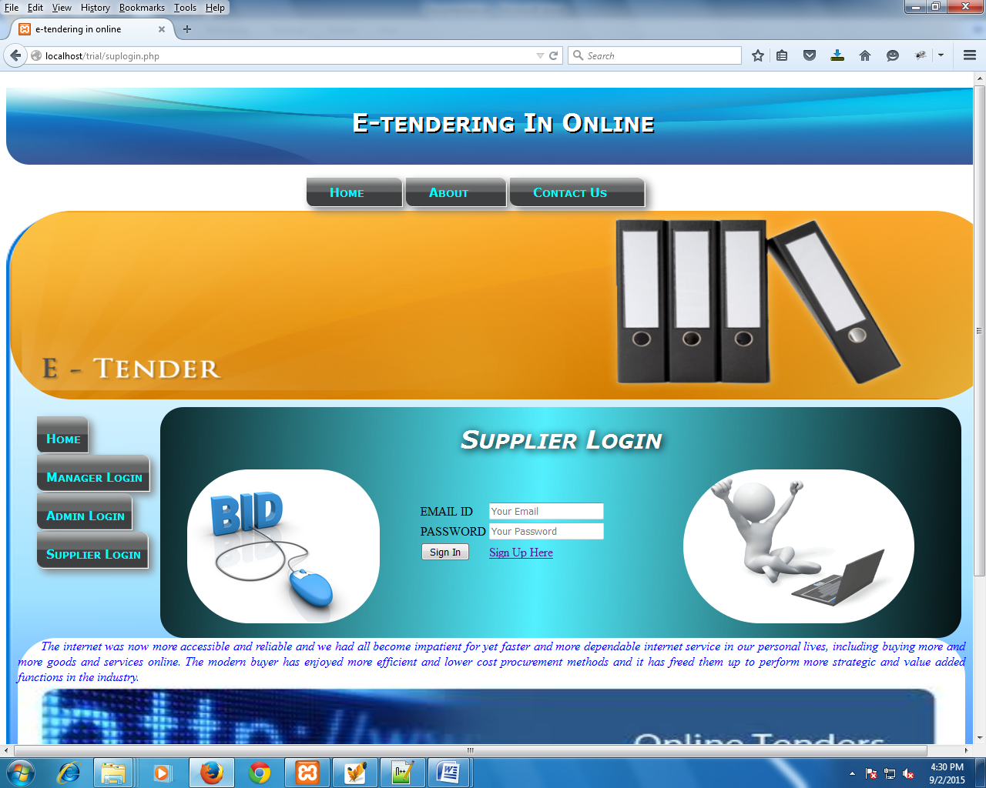

SUPPLIER REGISTRATION

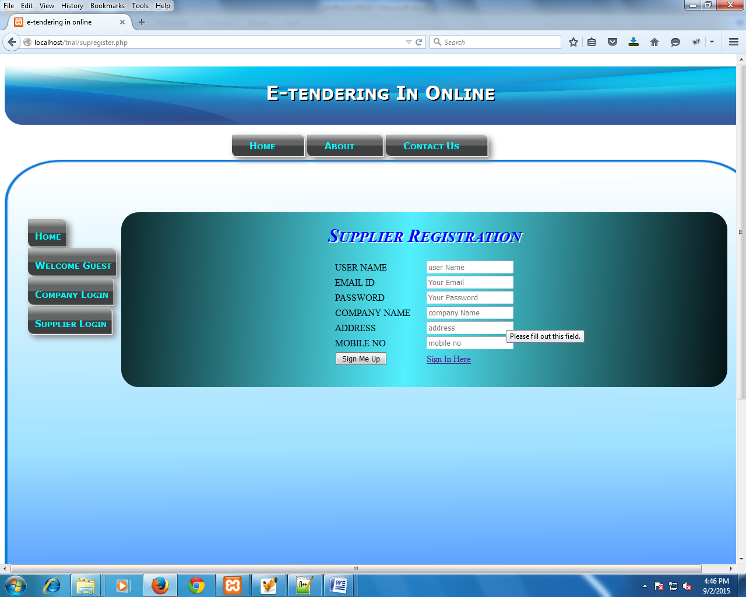

AVAILABLE TENDERS

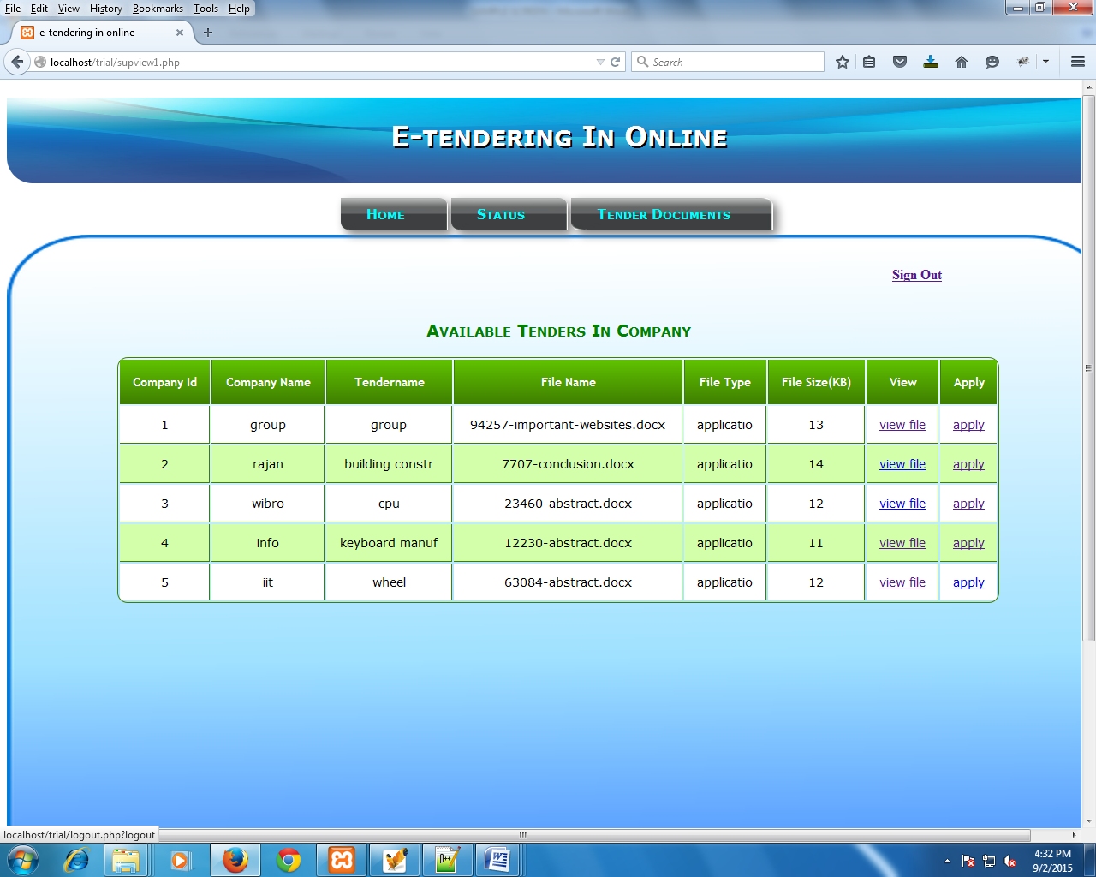

STATUS OF THE SUPPLIER REQUESTED TENDER

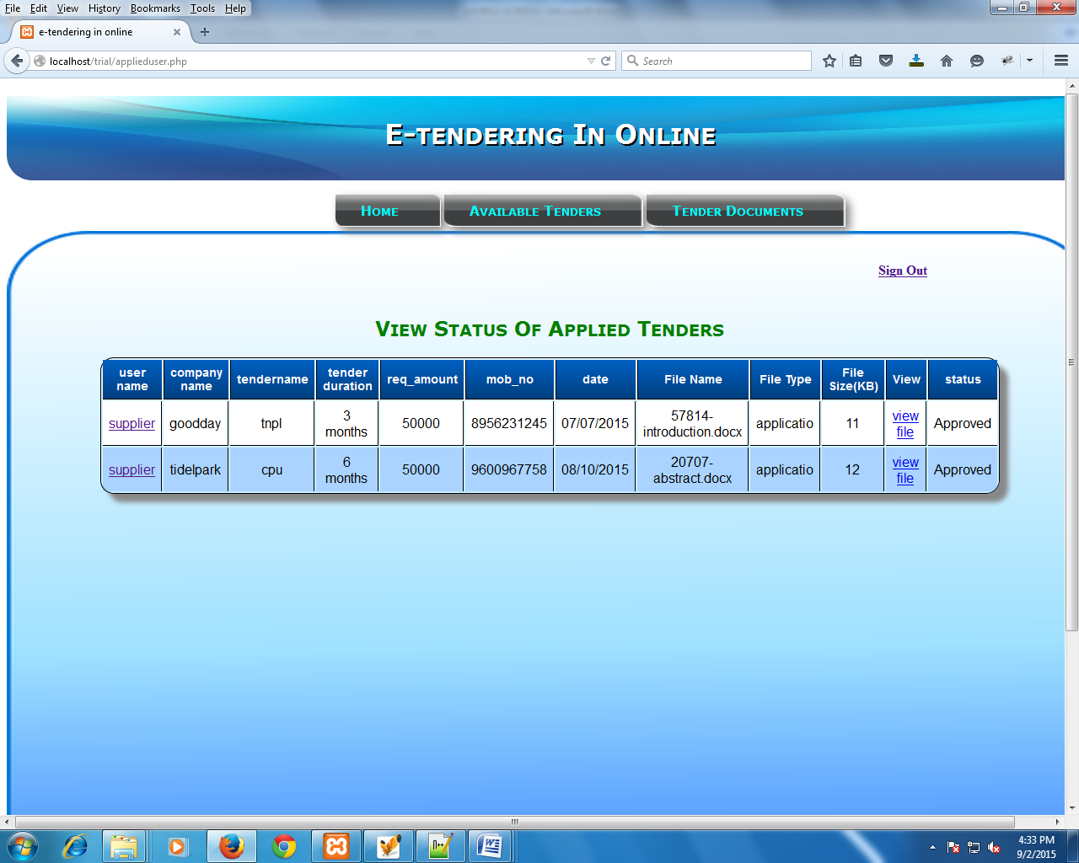

APPLY TENDER:

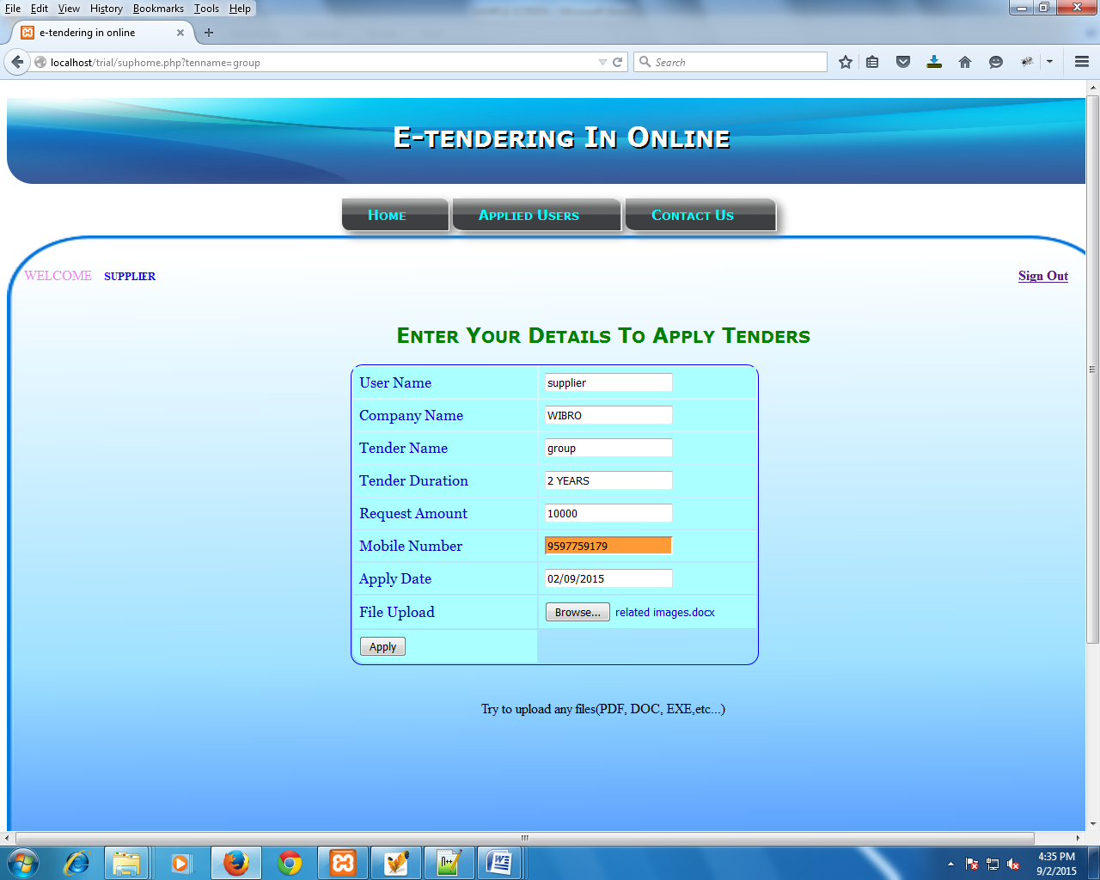

AVILABLE TENDERS

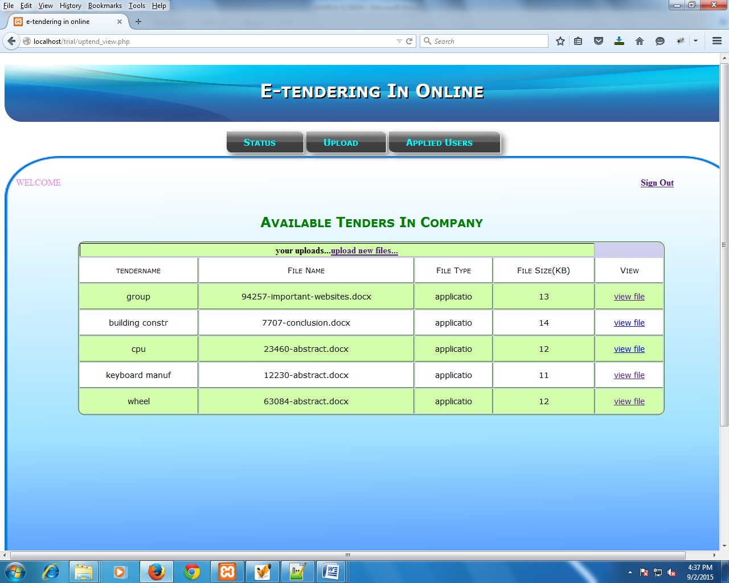

UPLOAD SUPPLIER DETAILS

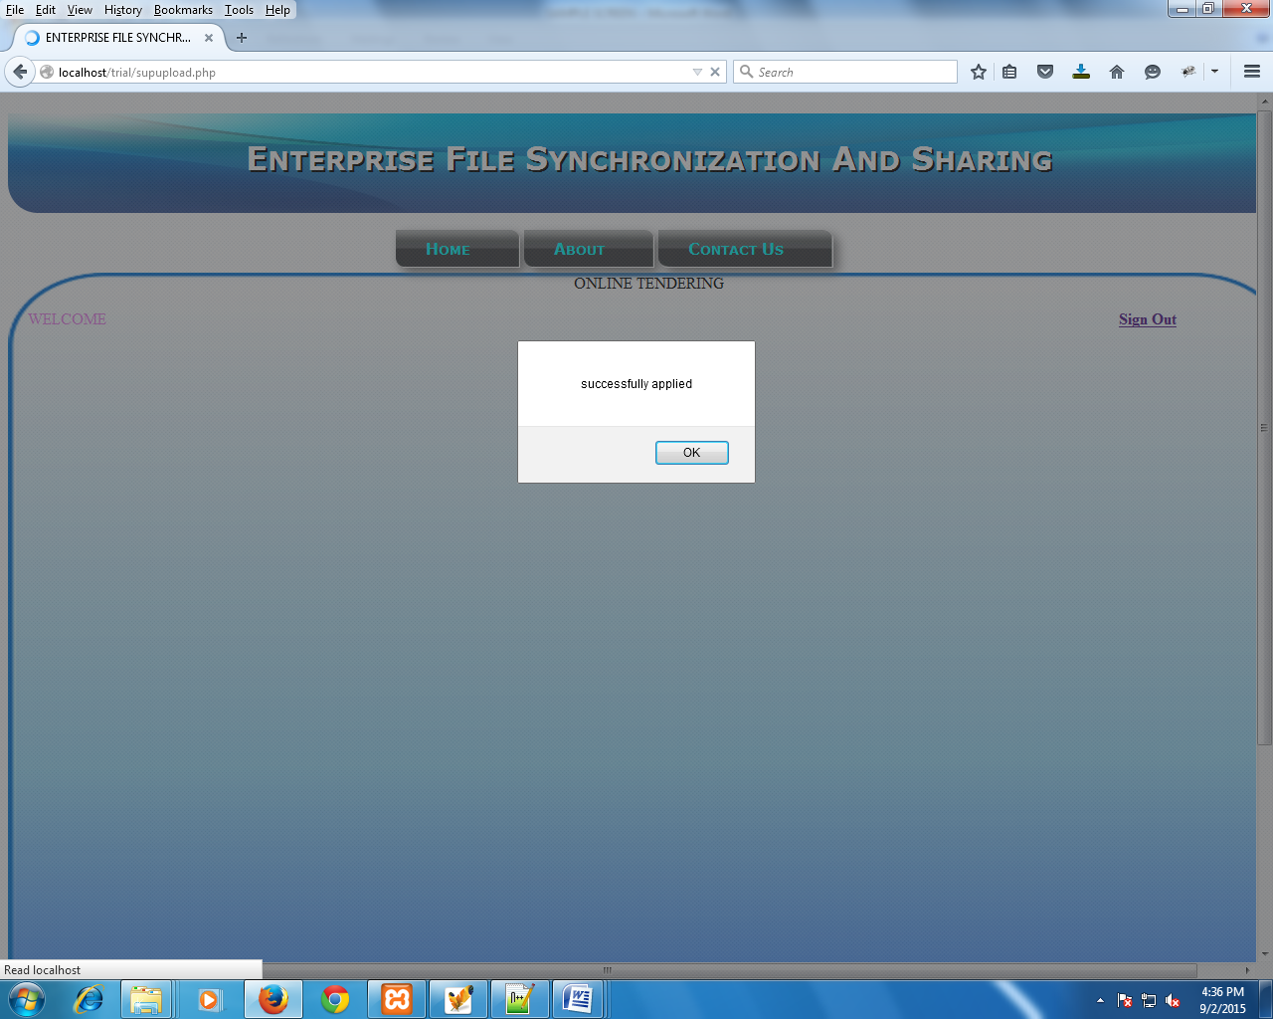

UPLOAD NEW TENDERS

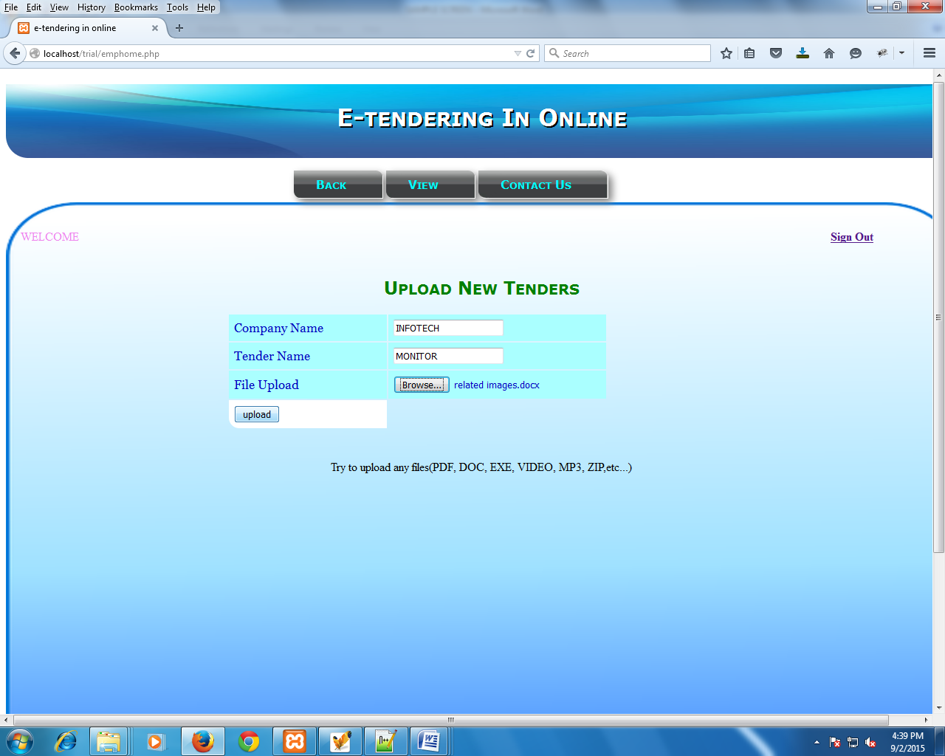

APPROVED OR CANCEL TENDER

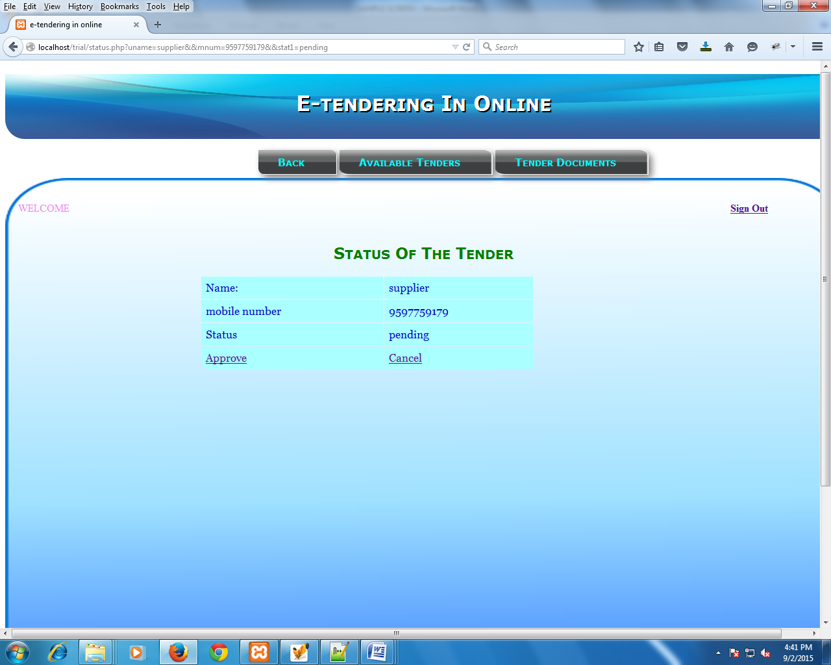

MANAGER REGISTRATION

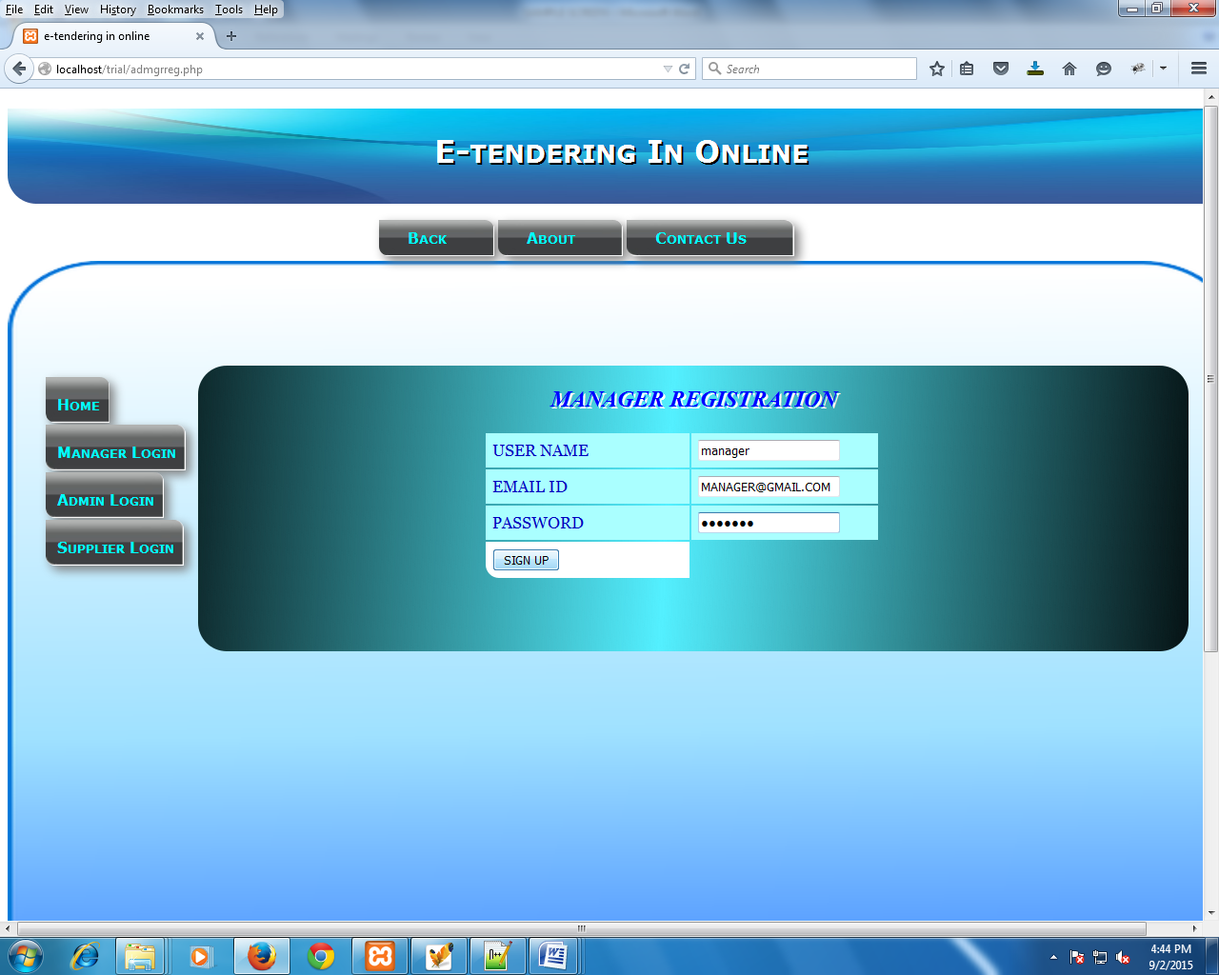

ADMIN OPERATIONS IN COMPANY

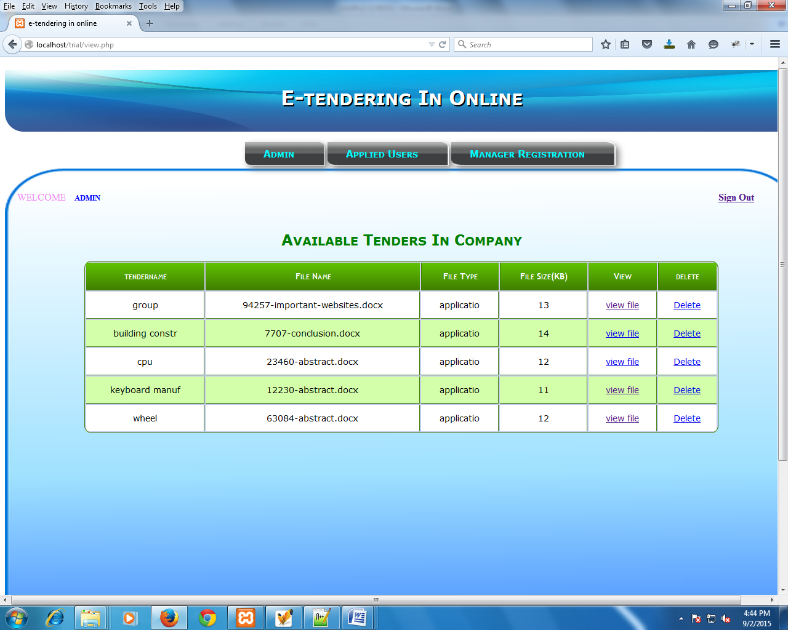

ADMIN OPERATIONS IN SUPPLIER PAGE

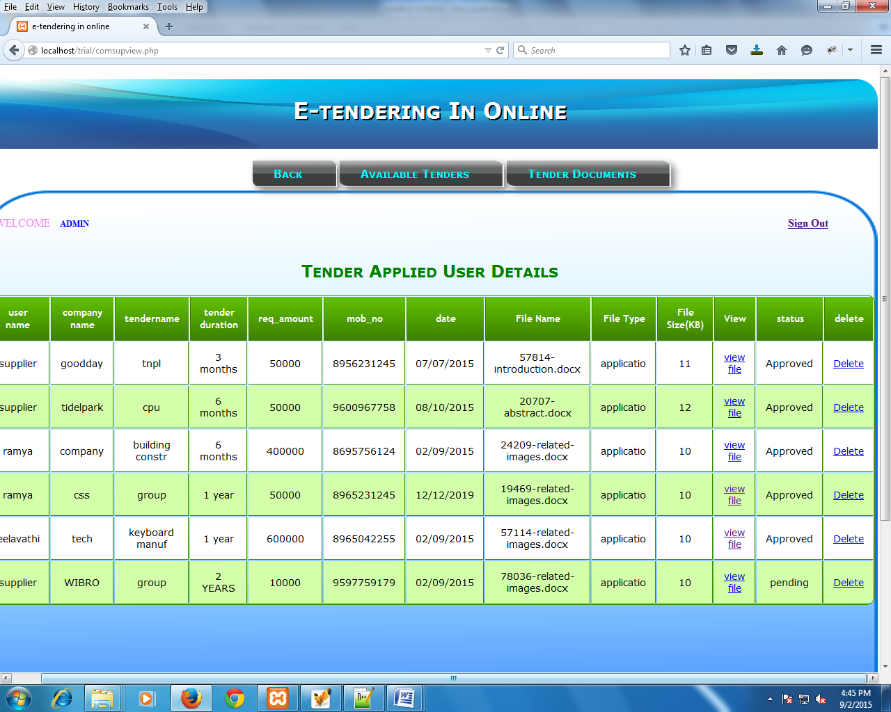

**CONCLUSION**

In this project tender documents will be supplied to the user. This system can also handle multiple tender documents at one time i.e. the user can access various tenders from the company at onetime and can download the required forms. The user can submit the details along with quotation to the department through online. Then the department people evaluate all the tenders submitted by users on evaluation date and they allocate that work to the user who is eligible and quoted for less amount.

It is mainly used to reduce the manpower and the future enhancement of the project is provides high security and create alerts like messages when login manager.

Which is used to share the document between the supplier and manager based on supplier requirement.