**AIRPORT TRAVEL MANAGEMENT SYSTEM**



**MUNYARADZI G CHAMUKORERA**

**[T1852353Z 5118 TTT1 GROUP A&B 2018 TELECOMS]**

**Airport Travel Management System**

By

**MUNYARADZI G CHAMUKORERA**

 Submitted in partial fulfilment of the requirement for the National Diploma in Telecommunication’s

[Submission; July 2021]

Supervisor: [MR SUWALI & MR HWEMA]

**DECLARATIONS**

I hereby declare that I am the sole author of this dissertation. I authorize Trust Academy and the Midlands State University to lend this thesis to other institutions or individuals for the purpose of scholarly research

SUPERVISOR’s name: MR F SUWALI

SUPERVISOR’ signature: ______________________________________

DATE: ________________________________

**ABSTRACT**

Airport Travel Management System is a complete tourist fully integrated travel system .This project is developed to manage the travelers in the Airport Management system, complains, reports and the booking process

**ACKNOWLEDGEMENT**

Firstly, l am grateful for the work made possible due to God’s will. Special thanks to my supervisor MR Suwali, projects coordinator MR Chigwere, my core supervisor Mr Hwema for their guidance and support. Furthermore, this project would not have been successful without support and guidance from all Lecturers at large, in the Electronics Department at the Harare Institute of technology. To me they have been springs of knowledge. I also appreciate the assistance given by our colleagues and school mates in any degree. Without forgetting assistance and moral support from our parents, we are humbled to have such. Thank you all

**DEDICATION**

I dedicate this project to our families, my project supervisor Mr. Suwali and Mr Hwema who made this project a success

**TABLE OF CONTENTS**

**LIST OF APPENDICES**

* Questionnaires
* User Manuals
* Observation Sheet

**1.1 INTRODUCTION**

Travel management system is a computerized software based application designed for Airport Travel. As an innovator l understand current manual system being used to record data and information is not easy, has so many disadvantages and l fully support Airport Travel Company.

**1.2 BACKGROUND INFORMATION**

Airport Travel is a company located in Harare Zimbabwe, it specializes in transporting people in between Zimbabwe cities and across borders. This company consist of mainly hundred placed in various branches of Airport Travel Company across the country.It offers 24/7 of service to customers during normal days. All of the Airport Travel operations and day to day services are recorded manually and are stored in hard files for example ledger, cash book, journals. All the transactions which pertains to monthly income activities are done by a hired professional accountant at the end of each month.

**1.3 PROBLEM DEFINITION**

The Airport Travel Company uses manual system to record its data and information. The hired Accountant at the end of each month manually calculate the financial balance of the Airport Travel this opens a huge room for errors in the business management. It is difficult to manipulate data stored in hard files for example employee records. They is duplication of data since the same data is recorded and stored in different files each day. Management of Airport Travel records by the use of manual system is tedious and opens a huge room to error results. The records occupies a lot of space which might be used for other work which might be beneficial to the company. Delayed processing of query and payments.

**1.4 OBECTIVES**

Easy recovery of data if data loss occurs.

Maintaining data security and integrity by use of validation, verification and passwords.

Minimize data redundancy.

Search and retrieve customer information quickly since disk storage offers a random access to information records

**1.5 FUNCTIONALITY**

Maximizing profit generation.

Expand the market

Manage and monitor Airport Travel operations

**1.6 HYPOTHESIS**

Airport Travel management system will not improve the service time and will encourage the use of electronic payments methods.

**1.7 JUSTIFICATION**

**Advantages**

It offers user creation help by giving steps followed.

The system allows the new user to create account before entering the system only with admin’s permission, username and password.

The system is able to capture errors during data input and also correct the errors, pop a message

**Limitations**

When an error occurs the system is just able to detect that an error has occurred by showing the message on the message box and the system is not able to tell the user on how to correct the error.

**1.8 CONCLUSION**

In conclusion the system is able to analyse Travel Management system by making use of the output reports produced and is specifically for transport movement tolerance and there will be a real time response from Airport Travel team and the government through the use of email notification.

**CHAPTER 2**

**PLANNING PHASE**

**2.0 PLANNING**

The act of formulating of a course of action or drawing of plans relating to Travel Management system. This involves time frame and resources needed during the built of the proposed system .Involves software and hardware part .Software Requirements:

Operating system: Windows {7, 8, 10}, Microsoft packages (Excel, Access)

Visual basic

HARDWARE REQUIREMENTS

|  |  |  |  |
| --- | --- | --- | --- |
| *INPUT* | *Storage* | *Output* | *Processor:* |
| **Scanner** | . {RAM} 2G and above are required. | . Printer | Intel {R} Celeron {R} |
| **Barcode** | . Hard disk capacity: 300G and above are required. | Monitor |  |
| **Printer** |  |  |  |

**2.1 WHY BUILT THE SYSTEM**

Security and integrity to data records will be enhanced. They will be an increase in the profit making of the company. Easy access to system records. Security to records is enhanced. Easy to calculate sales. Reports on the progress of the company’s performance can easily be acquired by looking at the graphs on sales provided by the off the shelf package

**2.2 BUSINESS VALUE**

This is the entire value of the business and encompasses all elements that determine the well-being and healthy of this project which includes brand recognition and trademarks also financial assets and equity of this Travel Management system

**2.3 INFORMATION GATHERING METHODS**

**Observation**

Visual Basic things to be observed by the system analyst

Looking if the current system manually or computer based?

1. Looking if the data in the Airport Travel Company is being securely stored?
2. How is the customer’s request being met?
3. How is data being retrieved and monitored
4. How is the information on quantity of passengers who has booked a seat being stored and obtained?
5. In what order is the current system storing information?

1.

Q

uestionnaire

**Section A**

**Information about the current system**

Name:

Surname:

***Please insert your response in the spaces and boxes provided***

***.***

. How many Departments uses computers in their operation

1

2

. How do you rate?

the performance of the current system?

Low

…..

Average… Maximum……

3

.

What is the type of system currently in use?

Computerized

Manual

4

. Is the current system effective?

Yes…….. N

o………

5

.

Any problems faced using the current system?

Yes…….. No………

6

. How is the bus travelling journeys being monitored?

Manually …………

Electronically……….

7

.

How is the name of supp

Lplier nd customers being r

Encoded

Manually …………

Electronically……….

. What is the method of file access does the Airport Travel company use to access its records?

8

9

. Benefits of the use of the current system

10.

How is the current system being of help to the business?

THANK

(

YOU FOR YOUR CO

-

OPERATION)

*S*

*ignature*

*_______________________*

**TANGABLE BENEFITS**

Easy to calculate sales.

Reports on the progress of the company’s performance can easily be acquired by looking at the graphs on sales provided by the off the shelf package

**INTANGABLE BENEFITS**

Easy access to system records.

Security to records is enhanced

**2.6.1 Technical feasibility:**

Manual system is not technically feasible since books and files are of large volumes they require large stored store rooms, this results in high level of data duplication.

**2.6.2 Economic feasibility:**

Manual system, is not economically feasible since books of records for example ledgers, journals, and cashbook are both expensive to store and buy. The production of computerized system will cutoff these cost thereby increasing profits by minimizing expenses.

**2.6.3 Operational feasibility:**

Manual system is not operational feasible since it has the costs of developing the system and undermining its quality reducing the number of Airport Travel authorities storing data casing data redundancy

**2.6.7 RISKY ANALYSIS:**

It helps us access threats to the company, provided input into how to manage this risks and to enable us to communicate more effectively with the clients about how best to deal with risks

**WORK PLAN**

**GANT CHART**

|  |  |  |
| --- | --- | --- |
| **Planning** | **1 week** |  |
| **Research** | **3 weeks** |  |
| **Design** | **1 week** |  |
| **Implementation** | **3 days** |  |
| **Follow up** | **1 week** |  |

**Conclusion**

In conclusion planning phase made possible due to availability of resources and the ability to take correct procedures

**CHAPTER 3**

**INTRODUCTION**

After analyzing the requirements of the work to be performed, the next step is to consider the problem and understand its content. Studying the existing system is the first step and the other is understanding the requirements and domain of the system

**ANALYSIS OF EXISTING SYSTEM**

The current Airport Travel system is manually based which means almost every work in the company performed on paperwork. Data and records are not safely secured they can be accessed by anyone.

The current manual system is not efficient when we look at the management in movement of busses and their drivers and also their locations.

Computerization is only used for giving bills and receipts for the booked seats.

Absence of any alarm which gives an awareness if the number of seats booked in the bus has been exceeded

It is difficult in retrieving data. So generally the current system does not store data in a systematic way system requires the employees to consistently monitor and count manually the receipts sold

**DATA ANALYSIS, CASE DIAGRAM**

ADMIN IS REGISISTED

ADMIN LOGIN ID & PASSWORD

CHECK LOGIN ID

PASSWORD

INVALID

LOGIN SUCCESSSFUL

SET USER LEVEL PERMISSION

**OVERVIEW OF THE PROPOSED SYSTEM**

It shows the flows between the activity of login, payments, customer information and booking process. The user will be able to search and generate report. It shows the activity flow of editing, adding and updating payments. Features of an Airport Travel management are; travel request, easy travel booking, budget friendly, advanced reporting and approval hierarchies

**Strengths of the current system**:

A trained profession is not required to use the current system.

Passenger’s records are not prone to hacking because they are stored in the form of paperwork.

**Evaluation of Alternatives**:

No security to information pertaining to passengers, Airport Travel daily transactions records because they are no security measures which are undertaken to keep them securely.

A lot of money is consistently required to cover for the expenses in buying books to collect employee’s records, customer records, recording sales and other things required to store the data

The company is incurring expenses in renting a room for the collecting and storing information of the company

The company is hiring a trained accountant to calculate the monthly sales this is an expense to the cafe.

They is no reliable backup of data because hardcopy records can easily be burnt and lost.

The profits are being reduced by some petty expenses

**EVALUATION OF ALTERNATIVES**

* Buying an off the shelve package
* Upgrade the current system **Buying a software package**

**Advantages of buying off the shelve package:**

Easy access to system records.

Security to records is enhanced.

Easy to calculate sales.

Reports on the progress of the company’s performance can easily be acquired by looking at the graphs on sales provided by the off the shelf package

**Disadvantages**:

Off the shelve might not meet the exact requirements of the café.

Off the shelve packages might be expensive

It time consuming to look for software package that might meet the requirements of one’s cafe king at the graphs on sales provided by the off the shelf package.

**Upgrading the current system**

This part allows for the existing system users to look closely on the current system and find those areas which need adjustments to improve the current system performance.

Employ a salesman with a bachelor’s degree in accounting this reduce expenses on the company in hiring an accountant at the end of every month. Going through the transactions at the end of the day to look if they is any errors in the records.

Use of biometric security to restrict the number of system users who have access to the companies’ records.

Use of Microsoft Excel to calculate sales at the end of each day so that they would be a clear pattern on which stock which are being frequently bought.

**Advantages:**

Security and integrity to data records is enhanced.

They will be an increase in the profit making of the company

**Disadvantages:**

Employing an account is expensive.

It time consuming to look record by record of every passenger.

Expenses are incurred when hiring a system analyst when a system is being upgraded use of biometric in security system is expensive than to hire a system analyst and create a new system for the company

**REQUIREMENT ANALYSIS**

It’s an online based application .The main purpose is to provide convenient and easy way for customers to book flights

**S**

UNREGISTERED USER (SIGN UP)

REGISTERED USER (SIGN UP)

SYSTEM USER

STAFF

**CONCLUSION**

It has been a great pleasure for me to work on this challenging project. This method involve introduction of a computerized tailor made system to handle the day to day running of the company records.

**Advantages:**

Tailor made software meets basically all the requirements of the company.

The programmer has the knowledge of the user requirements.

Tailor made software consist of all what the user and programmer insist on the user requirements and they are no unwanted features.

The system interface can be created in such a way that it easy for the users to use (User friendly)

Easy access to system records.

Security and integrity to data records is enhanced by use of passwords and limited access to system records.

Is cheaper than off the shelf packages.

Reduced data loss because records can be easily stored in the hard disk without any losses

The reports on the day to day running of the Airport Travel company can be easily produced and they is easy evaluation on stock which is highly on demand and those which is low on demand.

**Disadvantages:**

It is time consuming because the users of the current system require a lot of adjustment when creating a system.

Computerized are prone to hacking.

They are possibilities in which the organization specifications might be failed to be met.

**CHAPTER 4**

**DESIGN PHASE**

**INTRODUCTION**

This is the phase that bridges the gap between problem domain and the existing system in a manageable way .The complex activity of a system development is divided into several smaller sub activities which coordinate with each other to achieve the main objective o system development.

**SYSTEM DESIGN**

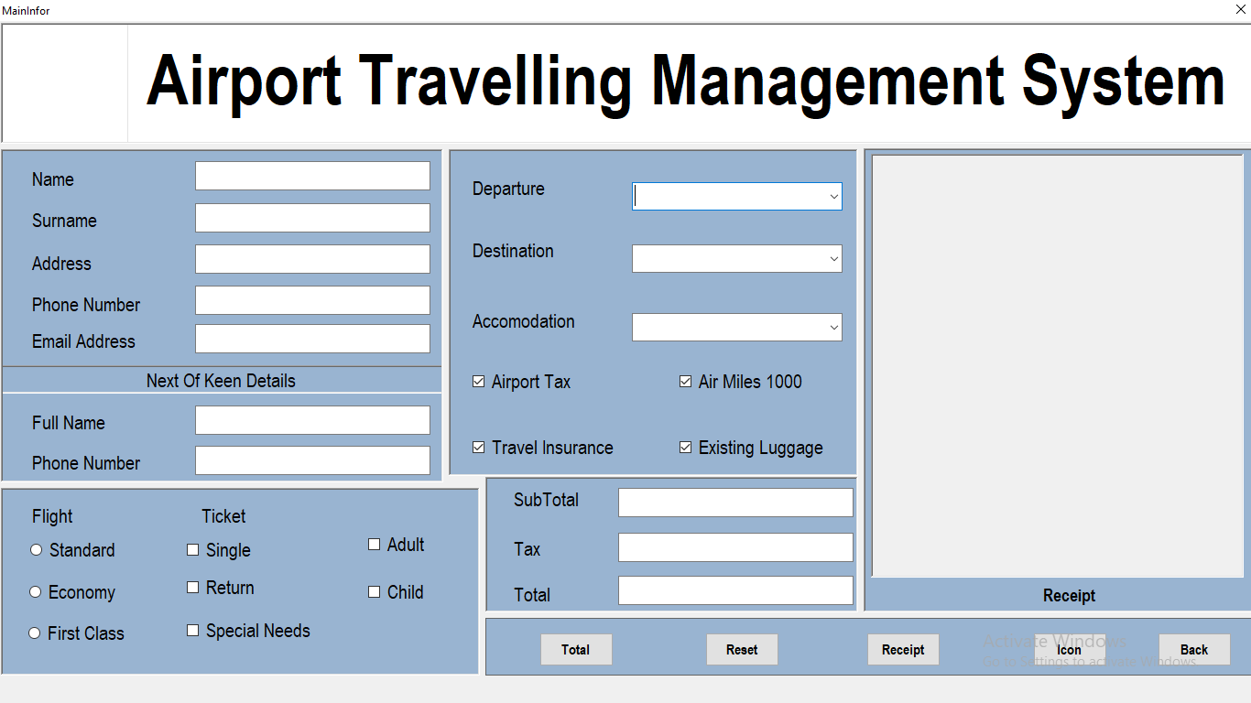

**SYSTEM INPUTS**

Must have features of a travel management system

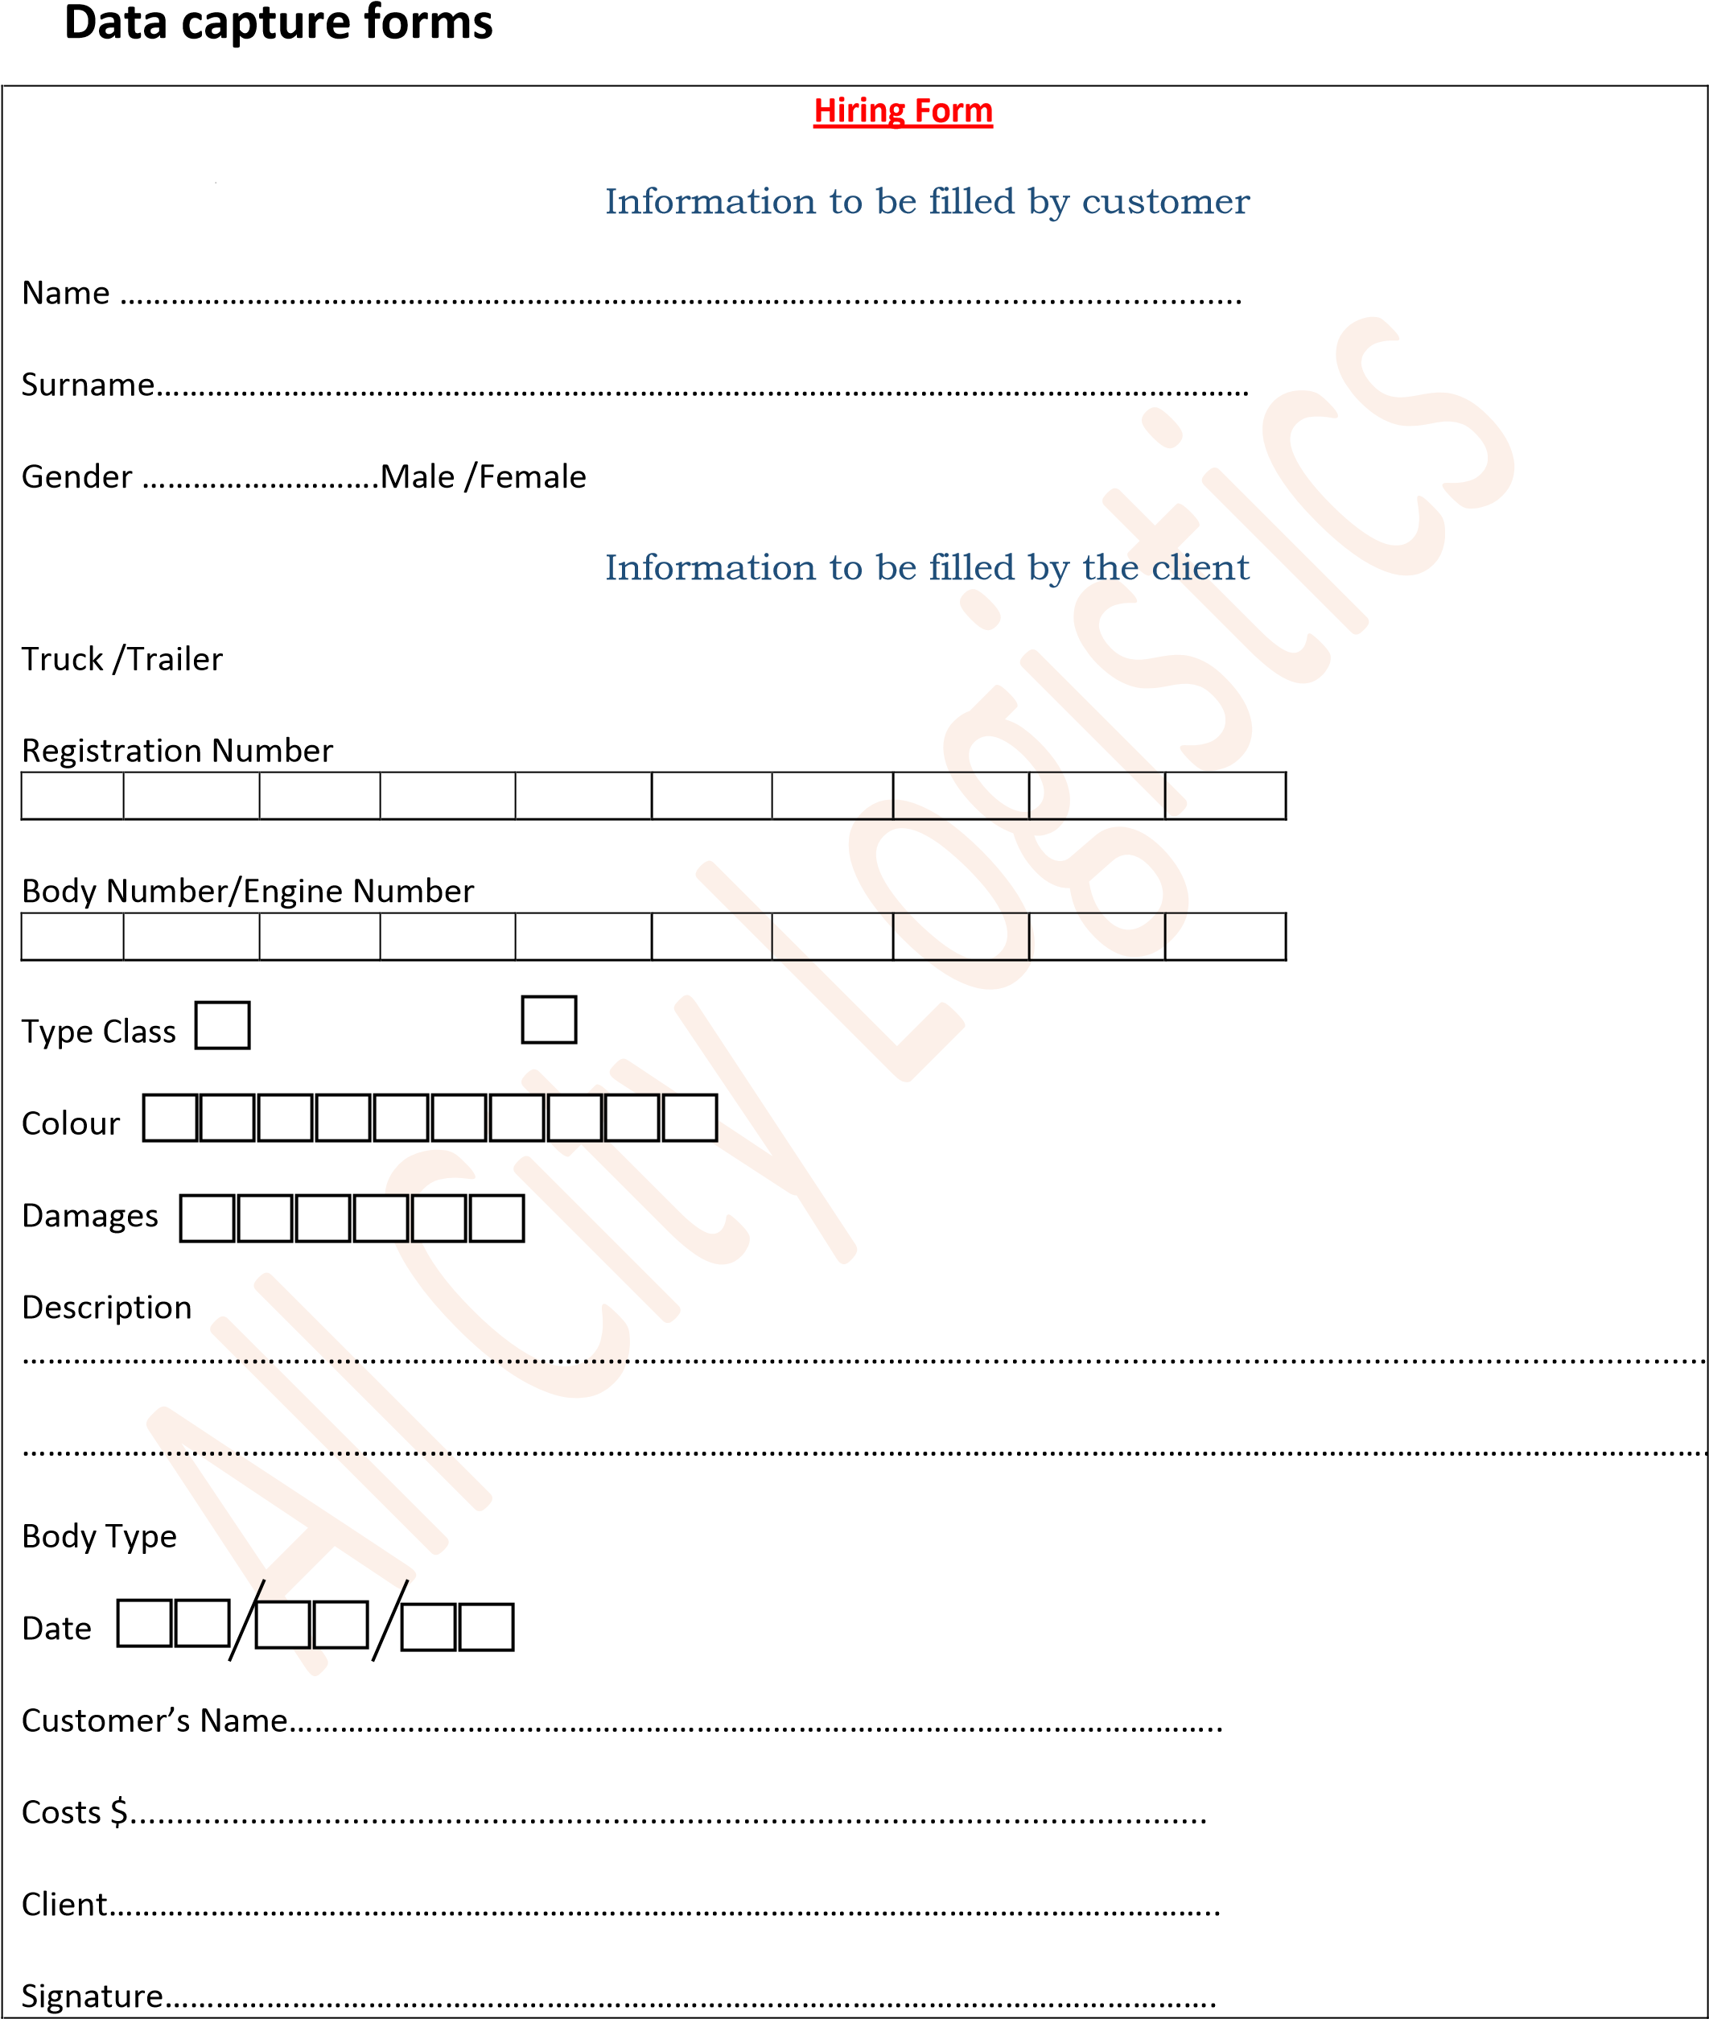

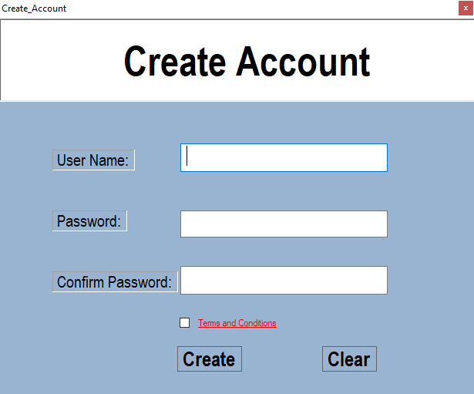

**SYSTEM PROCESSES**



Start



Enter:

Username

:

:

Password



Is

:

:

Username

Password

:

CORRECT



Main Form

NO

YES



Start

Create Account button

**SYSTEM OUTPUT**

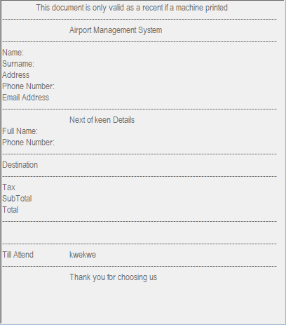

**ARCHITECTURE DESIGN**

WEB SERVER

VISUAL BASIC

FRONTED

What user sees and interact with (VB, HTML)

USER

DATABASE

FILE SYSTEM

(HTML ,CSS)

**PHYSICAL DESIGN**

PACKAGE MANAGEMENT

BOOKING MANAGEMENT

TRANSPORT MANAGEMENT

CUSTOMER MANAGEMENT



Start



Enter:

Username

:

:

Password



Is

:

:

Username

Password

:

CORRECT



Main Form

NO

YES



Start

**INTERFACE DESIGN**

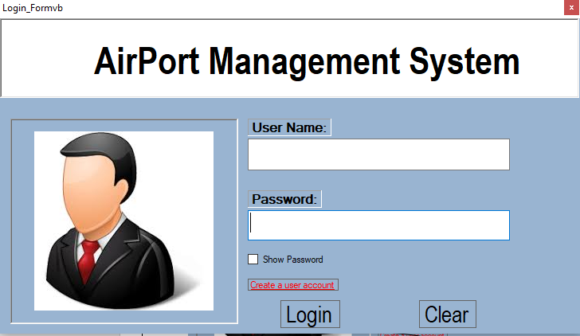



**DATABASE DESIGN**

**Er diagram**

ADMIN

USER

MANAGES

MAP ROUTE

STORESS

SELECTS

BOOKING

DISPLAY

LOCATION

**CLASS DIAGRAM**

ROLE CLASS USER CLASS

+booking_type: string

+booking_description: string

+booking_date: date

+addBooking ()

+user_id: int

+user_name: string

+user_address: string

+role_id: int

+role_tittle: string

+role_description: string

CUSTOMER CLASS BOOKING CLASS

+customer_id: int

+customer_name: string

+customer_mobile: string

+customer_email: string

**CONCLUSION**