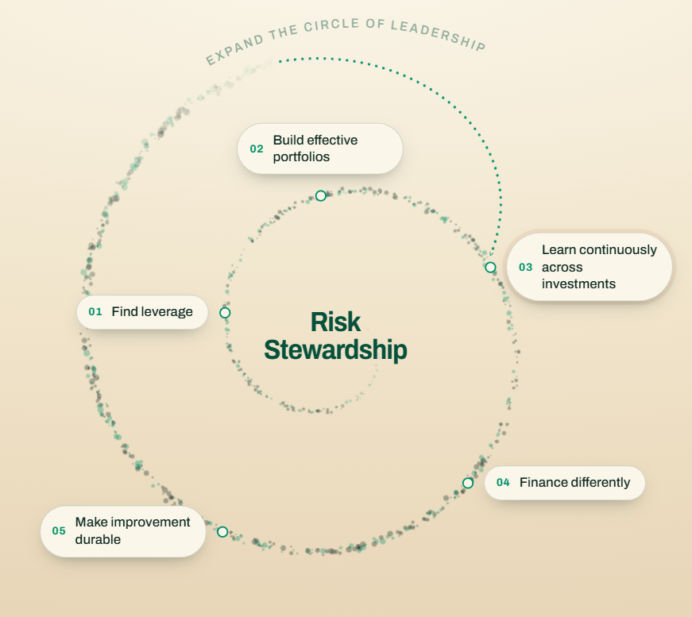
If Expand the Circle of Leadership follows the arch of the outer circle – then I think it will all fit nicely as both a spiral and a circular process. The lettering could be the line for that section of the circle.
I think the ovals might have short lines attaching the oval to the dot it corresponds to… so it is immediately clear that they go together right now they appear to be hovering near, but not directly associated with, the spiral. If we do that, I don’t think we need the numbers.
And the hover-over for expand the circle of leadership should say:
SHCF helps more people turn knowledge into action and share in decisions that affect their communities. It connects community members, practitioners, public leaders, and funders with the evidence, relationships, and resources to improve policy and practice—and sustain what they learn works.

Then, can you add a sentence beneath the image could make the spiral’s meaning explicit:
Each turn of the spiral builds on what is learned, strengthens community capacity, and expands the circle of people able to lead.

