DHCP LAB via Local AD
- Installing the DHCP Server on DC01
Server Manager -> Manage -> Add Roles and Features -> Role-based or feature-based installation -> DC01 highlighted -> Next -> DHCP Server box checked -> Add Features -> Next all the way -> Install
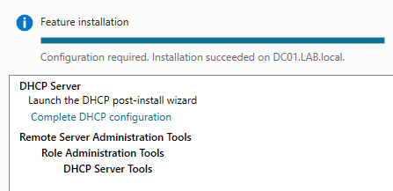
- Authorizing the DHCP Server in AD
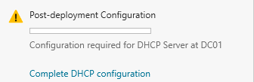
to
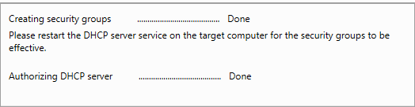
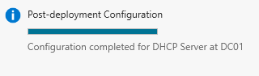
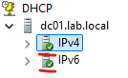
I will now build DHCP scopes. I will create three – Users LAN, Corporate Voice, and Guest Wi-Fi. These will represent three different network segments in a real corporate-like environment.

- Create Scope 1 — Users LAN
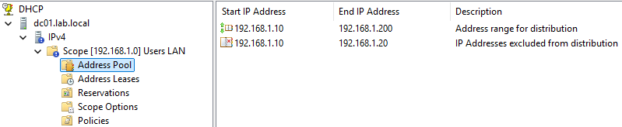
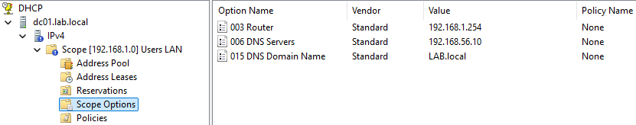
- Create Scope 2 – Corporate Voice
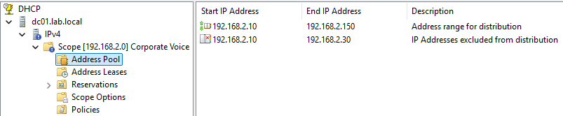
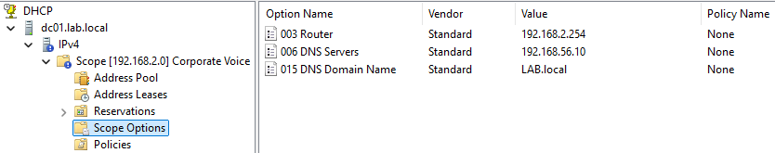
- Create Scope 3 – Guest Wi-Fi
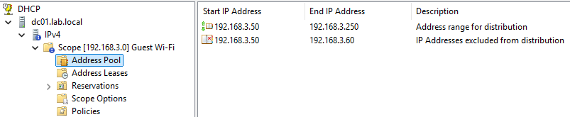
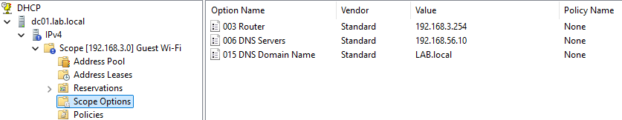
All done:
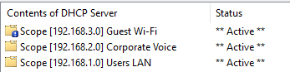
- Adding DNS Domain Name Option to All Three Scopes
All three scopes have them checked under scope -> Scope Options -> Configure Options as so:
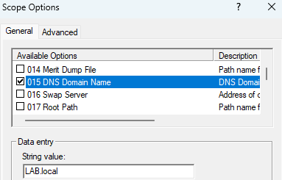

- Creating a DHCP Reservation for the W11 Client (via Users LAN scope)
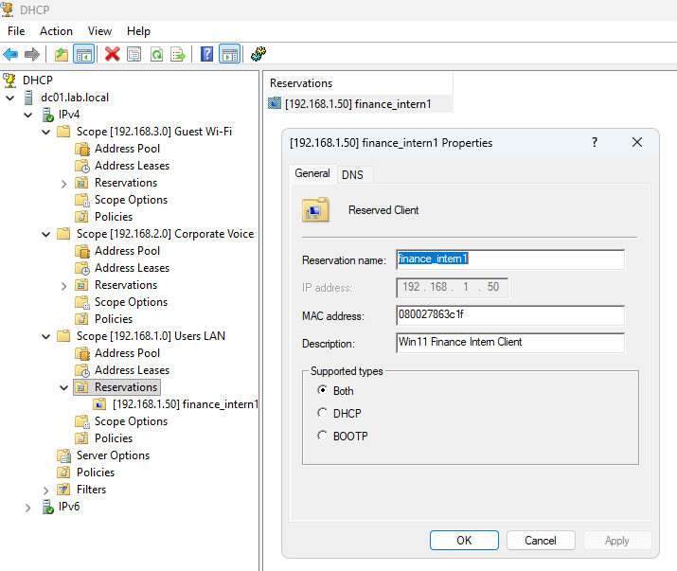
- Live Lease Test – Win11 Client
So, the three scopes created are correctly configured but they represent networks that don’t physically exist in my lab. In a real corporate environment, those scopes would work because there would be a router or Layer 2 switch with a DHCP helper address configured to relay requests from those subnets to the DHCP server. Without the relay, a DHCP server only responds to requests that arrive on a subnet it has a matching scope for. My lab network where the VMs live runs on 192.168.56.x so I need a scope here for real lease testing:
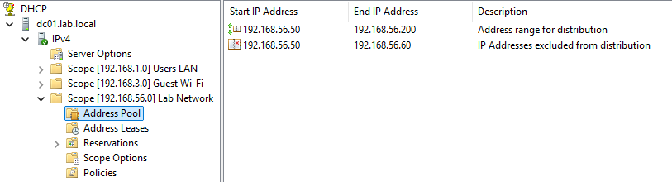
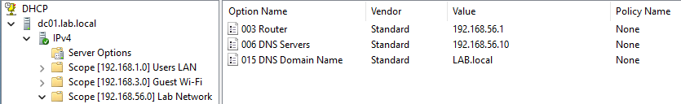

Switching the reservation for “finance_intern1” over to the “Lab Network” scope:
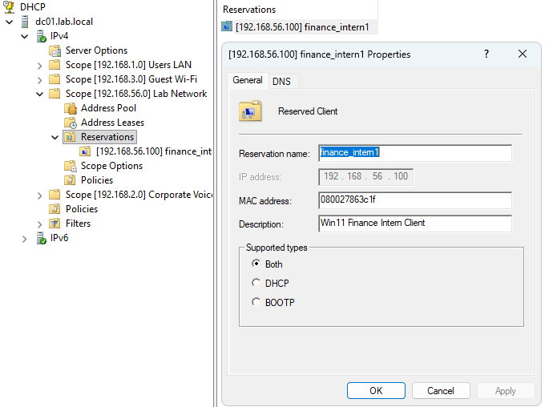
Everything worked properly. All the fields check out:
- IP: 192.168.56.100 — reservation working
- DHCP Server: 192.168.56.10 — DC01 is handing out the lease
- Default Gateway: 192.168.56.1
- DNS Server: 192.168.56.10 — pointing to the domain controller
- DNS Suffix: LAB.local
- Lease duration: 8 hours
- DHCP Enabled: Yes
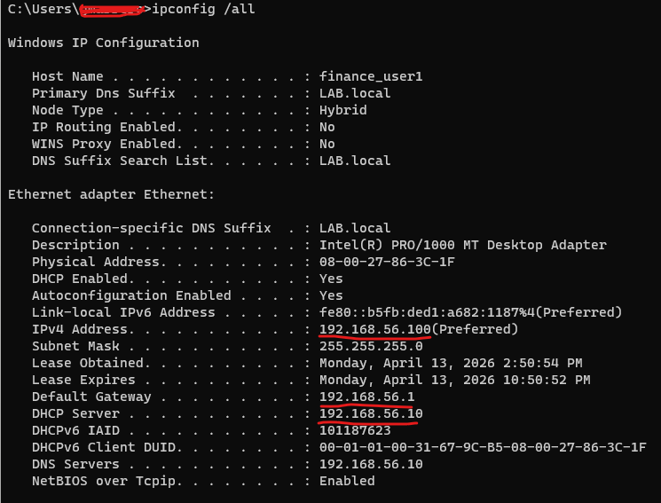

One last verification step:
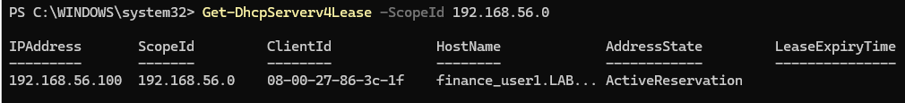
Finance_intern1 has an Active state. All is well.

Conflict detection
This makes the server ping an IP before offering it to make sure nothing is already using it statically.
