Form A.
Test 1.
Look at the first example. At the left, there are four boxes. The last one is empty. Continuing along that row, you see six more boxes, marked a, b, c, d, e, and f. Of those six boxes, one will fit correctly in the empty box.
Here the little tree is bending over more and more in the first three pictures. Choose the correct box from six presented choices on the right to complete the sequence. The correct answer has been given to you in this first example. It’s the tree in the third box, because that’s the one that has tilted over more than the last one in the boxes on the left. Notice that the correct answer, c, has been marked for you in this first example.
Look at the second example. The black part comes down lower and lower each time. So at the next step it would come more than half way down. Choose the answer you think is right and type it in the answer box.

Examples | Answers
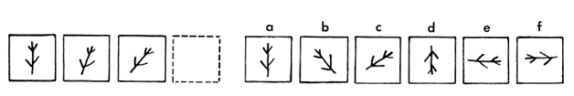 | c
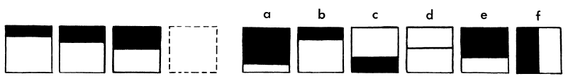

The correct answer for the second example is e.
e

Now take a look at the third example. See, it’s as if something is growing, step by step. In the third box there are three, beginning from the top, so four will go in the empty box. Here, the correct answer is e again. You can see that none of the other choices is quite right.
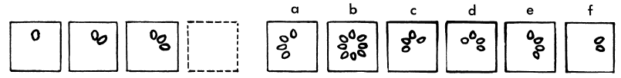 | e

After clicking the “next” button you will be asked to complete the rest yourself.
In each row, choose just one of the boxes on the right which would correctly go in the empty box and type in your answer in the answer box, as you did in the example. You may not have time to finish them all, but work as quickly and carefully as you can. In all the tests you’ll be taking, you may change your answer if you change your mind, but not after the time is over.

Note: Test 1 time limit = 3 minutes

Test 2.
Look at the examples below. Three of the boxes in each example have shapes that are alike in some way, but the other two are different from these three. In each row, you are to find the two boxes that are different from the others. When you have found them, type in your answers in the two boxes that have the same letters under them as the answers you have chosen. In the first example, three figures have three sides and the two different figures are four-sided. They are answers b and d. They are marked for you as the correct answers, because they are different from the other figures in that row.
Look at the second example. Find the two that are different. The filled-in dotted circles are different from the others, and so c and e are the answers to type in.

Examples | Answers
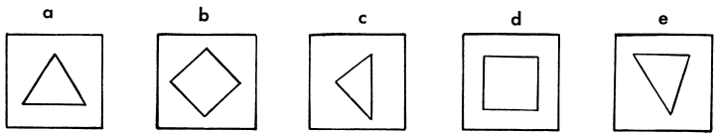 | b  d
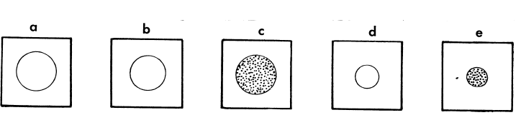 | c  e

You have the idea. Now, click “Next” button to complete the rest yourself. Choose two figures in each row that are different from the others. Then quickly fill in the two boxes with the same letters as the ones you choose. Work carefully and quickly and finish as many as you can on these two pages.
Note: Test 2 time limit = 4 minutes.

Test 3.
Look at the examples. In the large square there are four little boxes. Three of the boxes have drawings in them, but the drawing for the other square is missing. One of the boxes in the row at the right fits correctly in the empty box. You’re to choose the right one and type in the answer of your choice.
In the first example, the second answer, b, has been chosen because it fits best in the empty box.
Now look at the second row. Which is the right answer? Answer e, the little dotted figure facing to the right, fits the empty box best. Type in the correct answer.
In the third example, should we look for one circle or two? We should look for one; and should it be white or dotted? It should be white. So f is the correct answer. Type in the correct answer.
Now, click “Next” button to complete the rest yourself. Find the drawing that would look right in the empty box. Then type in the correct answer in the answer box on your right. See how many you can do.

Examples | Answers
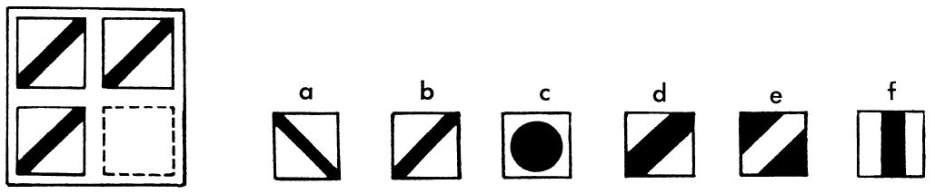 | b
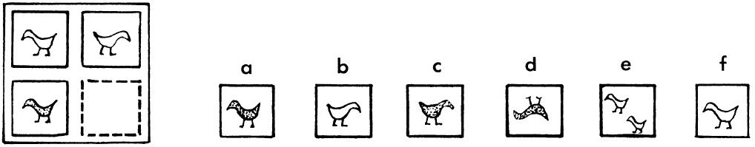
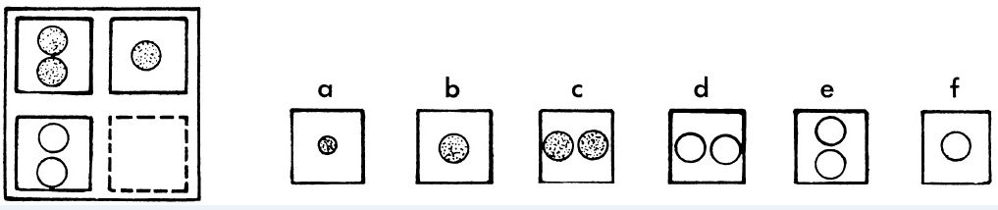
Note: Test 3 time limit = 3 minutes

Test 4.
In the separate box of the first example, there is a dot which is in both the circle and the square. Now look at the row of five possible answers and see if you can find a drawing where you could put in one dot that will be inside both the circle and the square. None of the answers will work except the third one, c. This example shows that the dot can be in both the circle and the square. The c is already marked for you.
Look at the second example. In the separate box, the dot is inside the three-sided figure but outside the four-sided figure. In the row of boxes there is just one figure where you could put a dot in the three-sided figure and not get it in the four-sided figure, too. Look carefully and you will see that the correct answer is d. Type in the correct answer.
In the third example, you notice that the dot is in the three-sided figure and above the curved line. The only figure in the row of choices where we could do the same thing is option b. Type in the correct answer.
Now, click “Next” button to complete the rest yourself. Look carefully where the dot is. Then find a drawing where you could do just the same, and type in your answer.

Examples | Answers
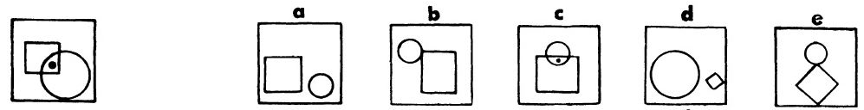 | c
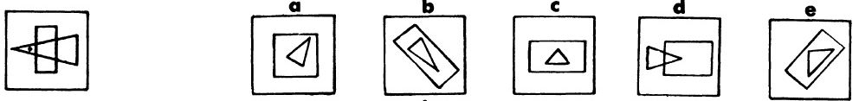
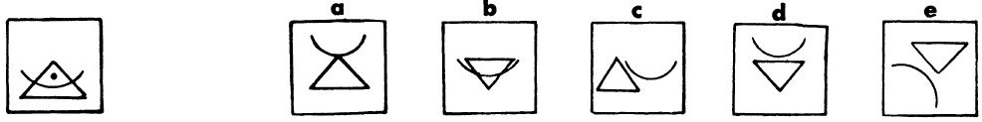

Note: Test 4 time limit = 2.5 minutes

