ASSIGNMENT # 1 (15 POINTS)

1. From the rough estimate of partial self-inductance of 25nH/inch, calculate the partial self-inductance of a surface trace from a capacitor to a via, 50 mils long, and for a via through a board of 64 mils thickness.
2. A. If the effective inductance of one wire bond, when the other current is far away, is 2.5nH and there is 100 mA of current that switches in 1nsec, calculate the ground-bounce voltage generated across the wire bond.
3. When the two wire bonds are routed close together, with a center pitch of 5 mils, and if the total inductance reduced to 1.3nH, calculate the ground bounce voltage of the wire bond.
4. For the decoupling capacitor shown below, connecting the power (Vcc) and ground (Vss) through vias, assume that distance to the plane below is 20mils, and the vias are 10mils in diameter. The original via placement is shown in (a) below. If we want to reduce the total inductance of these vias, guess what should be the spacing between the vias (S2), and the spacing between the power and ground vias (S1).

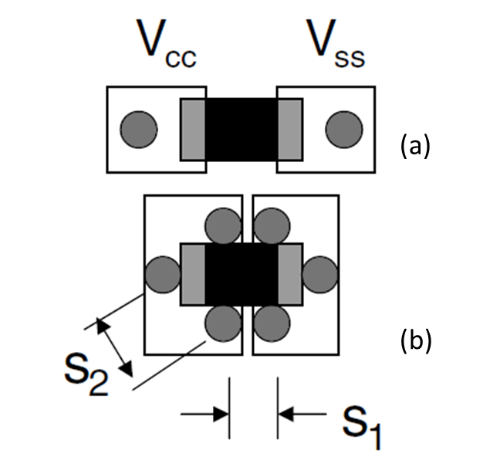

1. What are the ways to reduce loop self-inductance? Describe in your own words.
2. What is the skin depth of the conductor at 10GHz on a ½ oz copper trace? How much is the change in resistance of the copper trace at 10GHz compared to DC resistance?