OS: Windows 10

x64 based processor

7.42 GB usable RAM

g++ version ? – with Cygwin64

Bug report:

1. line 287 – math error, int e=b-3*a+5*c = 36, not 32

Fix: change 5*c to 4*c

1. line 290 – math error, int h=(f/c)/a=2, not 3

Fix: add +1 to line 290

1. line 291 – math error, int m=(d/h)/7=-1, not -2

Fix: change /7 to /6

1. line 293 – math error, int p=(f/e)-h=0, not -1

Fix: add -1 to line 293

1. line 295 – math error, int r=g+m+p+n=-7, not -8

Fix: add -1 to line 295

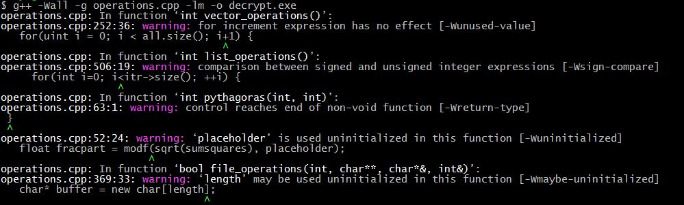

1. line 252, g++ - syntax error, for(uint i=0; i<all.size(); i+1)

Fix: change i+1 to i++

1. line 506, g++ - type comparison, for(int i=0; i<itr->size(); ++i)

Fix: change int to uint

1. line 64, g++ - missing return statement for int Pythagoras(int x, int y)

Fix: add return -1; to end of function on line 62

1. line 369, g++ - variable being used uninitialized

Fix: move char* buffer+new char[length]; below the second infile.seekg(0, infile.beg); below

1. line 296 – lossy conversion, float s=a/f; rounds a/f to an int before converting to float

Fix: change to float s=a/((float)f);

1. line 141 – lossy conversion, float f=((((numerator/d1)/d2)/d3)/d4); rounds to int before converting to float

Fix: cast numerator as a float

1. line 348 – faulty error checking, argc==4

Fix: change to argc!=4

1. line 360 – faulty error checking if(infile)

Fix: change infile to !infile.good()

1. line 377, drmemory – memory leak

Fix: add delete [] buffer; after line 393

1. line 72,74 – out of array bounds

Fix: change (int x=1; x<=size; ++x) to (int x=0; x<size; ++x) on line 72 and the same for y on line 74

1. line 82,83 – incorrect loop bounds

Fix: change (int x=1; x>=size; ++x) to (int x=1; x<=size; ++x) on line 82 and the same for y on line 83

1. line 52, drmemory – uninitialized read, placeholder is never given any memory

Fix: add = new double(); on line 47

1. line 54,60,68 – memory leak, placeholder is never deleted

Fix: for 54 and 60, make an int to hold *placeholder, delete placeholder, return the int. for 68, delete placeholder before the return statement.

1. line 53, 62 – incorrect if statement

Fix: change (fracpart = 0) to (fracpart==0) on both lines

1. line 60 – math error – gdb to examine variables – need absolute value of difference

Fix: put abs() around y*y-x*x

1. line 114 – loop bounds error

Fix: change ++tmp_ptr to ++tmp_ptr2 on line 114

1. line 410 – loop bounds error

Fix: change (uint i=0; i<=inVec.size(); ++i) to (uint i=1; i<inVec.size(); ++i)

1. line 413 – array access error

Fix: change inVec[inVec.size()]; to inVec[inVec.size()-1];

1. line 173 – systemic error – program asks for a vector with values from 1-10 but makes one with values from 0-9

Fix: change i to i+1 on line 174

1. line 409 – systemic error – program wants vector to be modified by vector_sum but doesn’t call by reference

Fix: change std::vector<int> inVec to std::vector<int>& inVec on line 409 and the same on line 29

1. line 201 – uninitialized read

Fix: counter is never initialized, set it to 0 on line 201

1. line 423 – possible array out of bounds

Fix: add if(i==v2.size()) break; before line 423

1. line 423 – systemic error – checks if first value is greater than second value but should check if less than

Fix: change > to < on line 423

1. line 259, 262 – systemic error – using index instead of vector value at that index

Fix: change i to all[i] on lines 259 and 262

1. line 269, 270 – loop bounds error – unsigned int turns into positive below 0 so is always above 0

Fix: change line 269 to for(uint i=couter; i>0; --i) {, and change i on line 270 to i-1

1. line 261 – doesn’t reset counter after previous operations

Fix: put counter=0; on line 256

1. line 523 – uninitialized variable – count is never initialized

Fix: set count=0 on line 523

1. line 456 – systemic error – bad if statement

Fix: change != to == in both cases on line 456

1. line 457 – addressable access, deletes iterator and then tries to use it

Fix: change l500.erase(itr); to itr=l500.erase(itr); on line 457

1. line 526 – skipping a section of the loop

Fix: change break; to continue;