Gabriel Moreira

SedLab

CentOs

1. Sed ‘s/\bJo\b/Josephine/g’ SedLab

In this command i use the first s for it to substitute what i have it search and then the \b makes it so it only changes the word Jo not words like John etc, and then the g at the end makes it do it for every line not just the first it finds

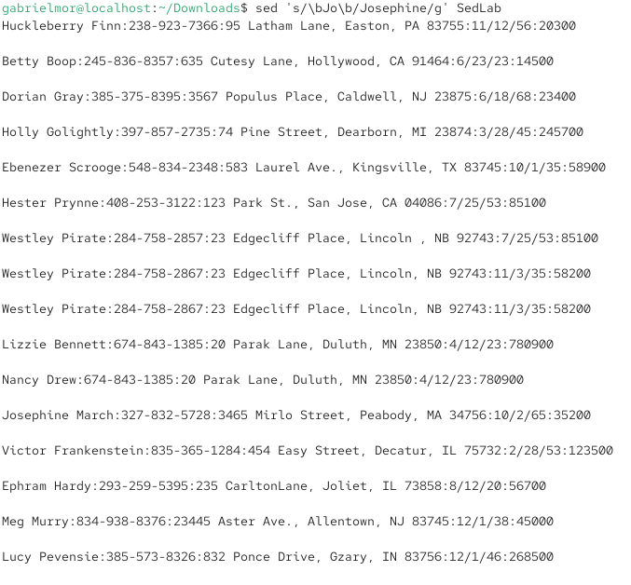

1. Head -n -5 SedLab

Using the Head command I ask it to show the last 5 lines of the file, usually the head command only shows the first part of the file but using -n -5 i specify i only want to see everything but the last 5 lines

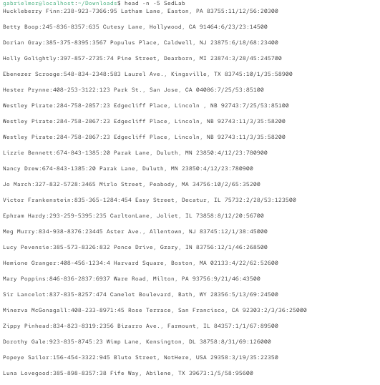

1. Sed -n ‘3-15p’ SedLab

Using the -n command it tells sed not to show anything unless i tell it specifically to show it, and then the 3,15 specifies everything i want shown and the p after the 15 tells it to print

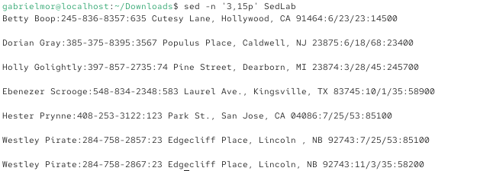

1. Sed ‘/, CA /d’ SedLab

This commands removes any line that contains CA using the / / slashes with , CA inside of it because the address has a comma before the state and then the d after means delete so it wwont show in the output

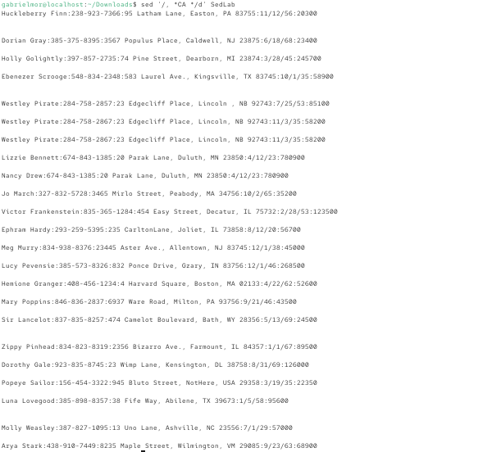

1. sed -n '/:[0-9][0-9]*\/[1-7]\//p' SedLab

The command used -n to make sure sed only prints what the command will be asking for with / _____ \ the input starts with a colon (:) then uses [0-9][0-9] to look for the month and then /_____\ with [1-7] so the next numberit looks for can only be from 1-7 which is the first week and then / to end the search and the p to print

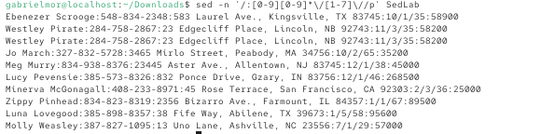

1. sed ‘s/^Sir.*/&***/’ SedLab

For this command i put ^ for it to match ther start of the line and made it target lines that start with Sir and then the * means the rest of the line, and then following that I added & that means the output we found and *** for it to add it on to the end of the line

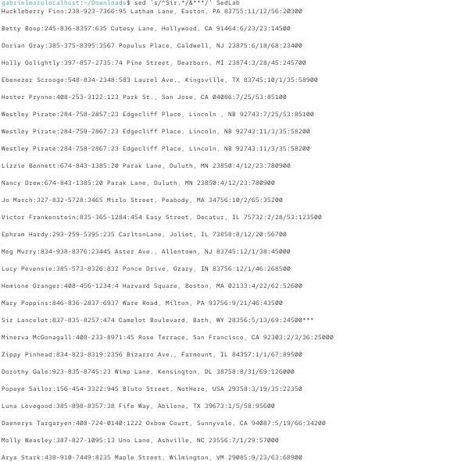

1. Sed ‘/Westley Pirate/c\As you wish’ SedLab

I use the slashes to locate any lines that have Westley Pirate and then use the c\ command to change the whole line to As you wish after the backslash

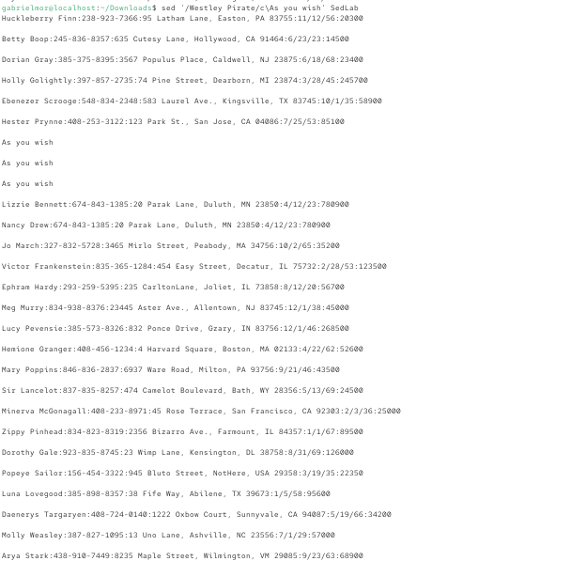

1. sed ‘/Minerva McGonagall/s,[0-9]\+/ [0-9]\+/ [0-9]\+,10/04/1935,’ SedLab

So this command works by putting the name Minerva McGonagall in two brackets for it to serve as a search /Minerva etc/ basically telling sed to look for any line that has this in it and to only make changes on that line if found and then after that the s, is used to tell sed to substitute meaning its going to replace a certain text with another, after that i used [0-9]\+etc for it to be the text it looks for which matches the birthday format and then followed uit with the date that was going to be inserted into the output.

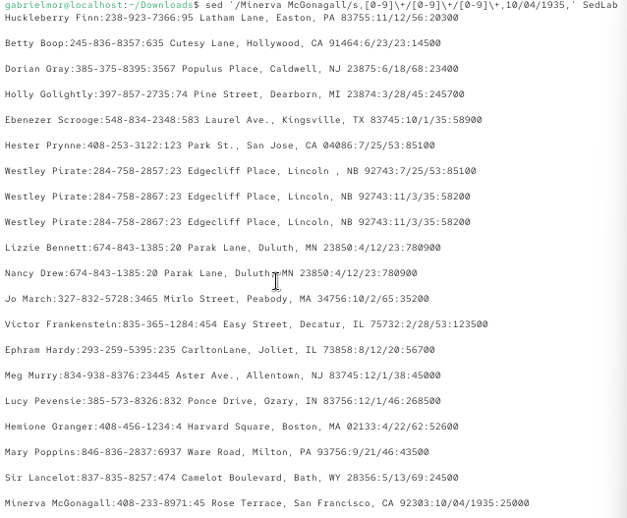

1. Sed ‘/^$/d’

In this command I use ^$ to describe what tyo look for meaning that statement basically is a match to a line that starts and ends with nothing which is the empty lines we are looking for followed by a slash (/) and d which means delete from the output

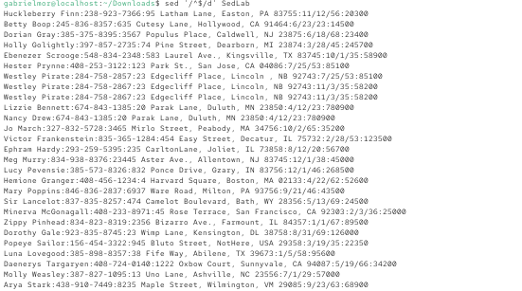

1i\

- Great Literary Characters -

s/\([0-9]\{3\}\)-\([0-9]\{3\}\)-\([0-9]\{4\}\)/1+\1-\2-\3/g

$a\

happily ever after. the end

1i\

- Great Literary Characters - the 1i\ is the command that puts the title at the top of the file, the 1 tells sed to put it before the first line and the i after it tells it to insert it into the output

And then the s/\([0-9]\{3\}\)-\([0-9]\{3\}\)-\([0-9]\{4\}\)/1+\1-\2-\3/g is what i used for sed to look for phone numbers with the format 000-000-0000 using \(_____\) which separates them into groups and then the 1+\1-\2-\3 is what adds the 1+ anhd then finally the g at the ends changes all matches on each line found not just the first line found.

For the Happily Ever After part the $ specifies last line and the a\ tells sed to add the ending text after the last line

