Iron Ore Price Forecasting: Model Results
Generated by iron_ore_forecasting.py from NPSC3001_RawData.xlsx. All headline results are two-year-ahead forecasts on a 62% Fe CFR China basis. Part 1 reproduces the tables in the report; Part 2 contains every supporting diagnostic.

Summary
- Model 1 (P + MC) has the lowest backtest RMSE (US$25.74/t) and MAE (US$18.68/t), but does not pass cointegration testing.
- Model 2 (P + MC + D) is the only specification that passes both unadjusted Johansen tests and has a negative, significant price adjustment. It reduces RMSE by 39% against the Marginal Cost Model. No specification passes after the Reinsel-Ahn correction.
- The Calibrated Marginal Cost Model has the lowest MAPE (14.78%).
- 2026 forecasts: Model 1 US$138.06, Model 2 US$89.11, Calibrated US$123.89, Marginal Cost Model US$90.92/t.
- 2027 forecasts: Model 1 US$214.00, Model 2 US$114.04, Calibrated US$101.82, Marginal Cost Model US$75.33/t.
- Data checks: Yes (raw data file unchanged).

Part 1. Results reported in the paper
Model | RMSE | MAE | MAPE | Mean error
Model 1 | 25.74 | 18.68 | 16.68 | 4.92
Model 2 | 29.49 | 27.11 | 22.92 | 4.54
Calibrated Marginal Cost Model | 29.68 | 20.30 | 14.78 | -15.31
Marginal Cost Model | 48.08 | 42.83 | 33.33 | -42.83
Table 5. Two-year-ahead forecasting accuracy, 2021-2025 (RMSE, MAE, mean error in US$/t; MAPE in %).
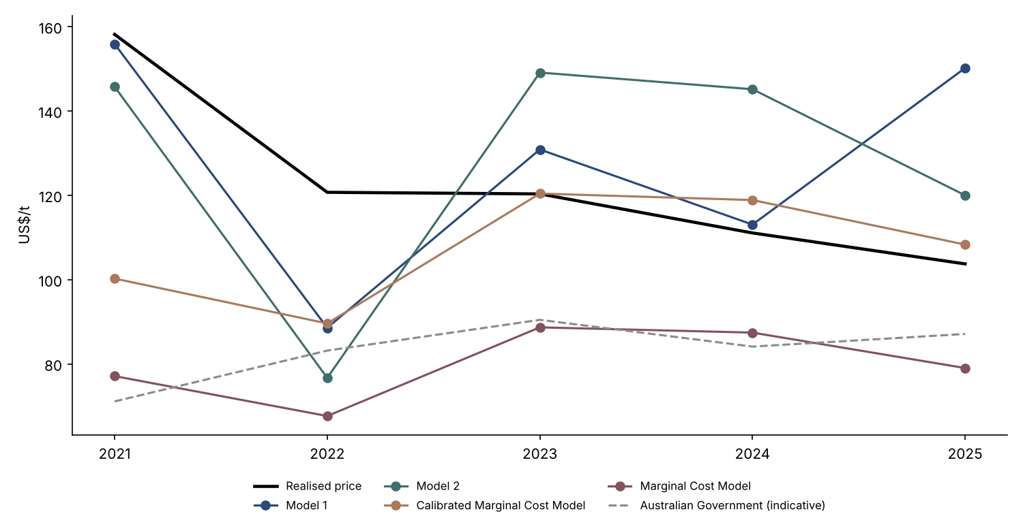
Figure 3. Realised prices and two-year-ahead forecasts, 2021-2025 (US$/t).
Forecasting approach | 2026 | 2027
Model 1 | 138.06 | 214.00
Model 2 | 89.11 | 114.04
Calibrated Marginal Cost Model | 123.89 | 101.82
Marginal Cost Model | 90.92 | 75.33
Table 6. Forecast iron ore prices (US$/t), 2026-2027.
All forecasts are two years ahead: 2026 uses data to 2024 (calibration factor 1.363) and 2027 uses data to 2025 (1.352). 2026 year-to-date (to October) average: US$101.93/t, shown for context only.
Specification | Intercept (long run) | Long-run MC | Long-run MC s.e. | Long-run D | Long-run D s.e. | Alpha P | Alpha P p
Model 1: P + MC | -4.226 | 2.043 | 0.158 | n.a. | n.a. | -1.570 | 0.012
Model 2: P + MC + D | 2.837 | 1.902 | 0.128 | -0.874 | 0.173 | -0.755 | 0.027
Long-run relationships and price adjustment, Models 1 and 2 (ln P = intercept + coefficients x ln variables).

Appendix A. Econometric model selection
Variable | Terms | ADF level p | ADF diff p | KPSS level p | KPSS diff p | Result | Proceeds to cointegration testing
Iron ore price (P) | Constant | 0.476 | 0.020 | 0.100 | 0.100 | I(1) - suggestive (KPSS does not confirm the level is non-stationary) | Yes
Iron ore price (P) | Constant + trend | 0.826 | 0.020 | 0.084 | 0.100 | I(1) - suggestive (KPSS does not confirm the level is non-stationary) | Yes
Marginal cost (MC) | Constant | 0.234 | 0.000 | 0.100 | 0.100 | I(1) - suggestive (KPSS does not confirm the level is non-stationary) | Yes
Marginal cost (MC) | Constant + trend | 0.573 | 0.000 | 0.026 | 0.100 | I(1) - both tests agree | Yes
Seaborne demand (D) | Constant | 0.025 | 0.024 | 0.030 | 0.056 | Conflicting - ADF says stationary, KPSS says non-stationary | Yes
Seaborne demand (D) | Constant + trend | 0.629 | 0.024 | 0.040 | 0.056 | I(1) - both tests agree | Yes
US Dollar Index (DXY) | Constant | 0.643 | 0.000 | 0.031 | 0.100 | I(1) - both tests agree | Yes
US Dollar Index (DXY) | Constant + trend | 0.414 | 0.000 | 0.100 | 0.100 | I(1) - suggestive (KPSS does not confirm the level is non-stationary) | Yes
Baltic Dry Index (BDI) | Constant | 0.066 | 0.000 | 0.100 | 0.100 | I(1) - suggestive (KPSS does not confirm the level is non-stationary) | Yes
Baltic Dry Index (BDI) | Constant + trend | 0.050 | 0.000 | 0.054 | 0.100 | I(1) - suggestive (KPSS does not confirm the level is non-stationary) | Yes
China real GDP (GDP) | Constant | 0.005 | 0.643 | 0.019 | 0.016 | Conflicting - ADF says stationary, KPSS says non-stationary | No
China real GDP (GDP) | Constant + trend | 0.869 | 0.643 | 0.010 | 0.016 | Not I(1) - first difference is not clearly stationary | No
Table A1. ADF and KPSS stationarity tests, 2010-2025 (p-values).
KPSS p-values are interpolated from tables and bounded at 0.01 and 0.10.
Specification | Trace r=0 | Trace CV r=0 | Corrected trace r=0 | Max-eig r=0 | Max-eig CV r=0 | Corrected max-eig r=0 | Result (unadjusted -> corrected)
Model 1: P + MC | 10.72 | 20.26 | 7.65 | 8.78 | 15.89 | 6.27 | 0 -> 0
P + D | 16.20 | 20.26 | 11.57 | 8.60 | 15.89 | 6.14 | 0 -> 0
P + DXY | 10.28 | 20.26 | 7.34 | 6.84 | 15.89 | 4.89 | 0 -> 0
P + BDI | 20.21 | 20.26 | 14.43 | 13.71 | 15.89 | 9.80 | 0 -> 0
Model 2: P + MC + D | 41.06 | 35.19 | 23.46 | 23.58 | 22.30 | 13.48 | 1 -> 0
P + MC + DXY | 39.25 | 35.19 | 22.43 | 27.03 | 22.30 | 15.44 | 1 -> 0
P + MC + BDI | 29.22 | 35.19 | 16.69 | 17.24 | 22.30 | 9.85 | 0 -> 0
P + D + DXY | 41.73 | 35.19 | 23.85 | 17.34 | 22.30 | 9.91 | Mixed -> 0
P + D + BDI | 54.09 | 35.19 | 30.91 | 29.20 | 22.30 | 16.68 | Full -> 0
P + DXY + BDI | 49.89 | 35.19 | 28.51 | 32.45 | 22.30 | 18.55 | 1 -> 0
P + MC + D + DXY | 82.79 | 54.08 | 35.48 | 33.66 | 28.59 | 14.43 | Full -> 0
P + MC + D + BDI | 101.41 | 54.08 | 43.46 | 67.51 | 28.59 | 28.93 | 1 -> Mixed
P + MC + DXY + BDI | 109.45 | 54.08 | 46.91 | 65.86 | 28.59 | 28.23 | 2 -> 0
P + D + DXY + BDI | 86.73 | 54.08 | 37.17 | 41.94 | 28.59 | 17.98 | Mixed -> 0
P + MC + D + DXY + BDI | 837.52 | 76.97 | 239.29 | 386.83 | 34.81 | 110.52 | 4 -> 2
Table A2. Johansen rank-zero tests for all 15 specifications.
Restricted constant, one lagged difference, 14 effective observations. For specifications showing a relationship, the result also reflects the follow-up tests, which are in Part 2 (Table S1).
Specification | Price alpha | Alpha p-value | Alpha assessment
Model 1: P + MC | -1.570 | 0.012 | Negative; significant
P + D | -0.283 | 0.036 | Negative; significant
P + DXY | -0.209 | 0.008 | Negative; significant
P + BDI | -0.521 | 0.035 | Negative; significant
Model 2: P + MC + D | -0.755 | 0.027 | Negative; significant
P + MC + DXY | -0.085 | 0.882 | Not significant
P + MC + BDI | -0.643 | 0.000 | Negative; significant
P + D + DXY | -0.079 | 0.180 | Not significant
P + D + BDI | 0.484 | 0.106 | Not significant
P + DXY + BDI | 0.168 | 0.596 | Not significant
P + MC + D + DXY | -0.127 | 0.684 | Not significant
P + MC + D + BDI | 0.276 | 0.190 | Not significant
P + MC + DXY + BDI | -1.002 | 0.161 | Not significant
P + D + DXY + BDI | 0.656 | 0.004 | Positive; significant
P + MC + D + DXY + BDI | 2.009 | 0.086 | Not significant
Table A3. Price-adjustment coefficients for all 15 VECMs.
Specification | RMSE | MAE | MAPE | Mean error
Model 1: P + MC | 25.74 | 18.68 | 16.68 | 4.92
P + D | 45.94 | 39.22 | 32.37 | 8.54
P + DXY | 188.41 | 158.42 | 133.12 | 139.22
P + BDI | 50.82 | 45.22 | 36.64 | 16.44
Model 2: P + MC + D | 29.49 | 27.11 | 22.92 | 4.54
P + MC + BDI | 39.64 | 35.52 | 29.69 | 11.06
Table A4. Two-year-ahead errors for shortlisted models (negative, significant alpha), 2021-2025.

Appendix B. Seaborne supply-demand balance
Mt wet | 2010 | 2011 | 2012 | 2013 | 2014 | 2015 | 2016 | 2017 | 2018
China seaborne demand | 619 | 686 | 745 | 820 | 933 | 953 | 1,025 | 1,075 | 1,064
Total consumption | 953 | 1,033 | 1,072 | 1,138 | 1,142 | 1,106 | 1,124 | 1,142 | 1,248
Total imports | 622 | 692 | 752 | 828 | 940 | 959 | 1,031 | 1,082 | 1,072
Change in visible inventories | 9 | 18 | -24 | 11 | 14 | -6 | 13 | 30 | -8
Apparent domestic production | 371 | 442 | 420 | 417 | 410 | 375 | 353 | 360 | 335
Statistical / product-mix adjustment | 31 | 83 | 124 | 95 | 194 | 233 | 247 | 270 | 167
Overland imports | 3 | 6 | 8 | 8 | 7 | 6 | 6 | 6 | 7
Other seaborne imports | 431 | 456 | 413 | 463 | 478 | 487 | 489 | 474 | 492
Total seaborne demand | 1,050 | 1,142 | 1,158 | 1,283 | 1,410 | 1,440 | 1,514 | 1,549 | 1,557
Tier-1 supply | 679 | 698 | 763 | 828 | 945 | 1,076 | 1,089 | 1,122 | 1,154
Rio Tinto | 238 | 238 | 253 | 266 | 296 | 328 | 346 | 349 | 353
BHP | 136 | 145 | 170 | 200 | 235 | 268 | 257 | 268 | 275
FMG | 40 | 41 | 58 | 81 | 124 | 165 | 169 | 170 | 170
Vale | 266 | 273 | 282 | 281 | 290 | 314 | 317 | 334 | 355
Simandou | 0 | 0 | 0 | 0 | 0 | 0 | 0 | 0 | 0
Tier-2 supply | 145 | 150 | 153 | 167 | 186 | 191 | 229 | 236 | 243
Tier-3 supply (required) | 225 | 294 | 242 | 288 | 279 | 174 | 195 | 192 | 160
Market balance | n.a. | 87 | -76 | 57 | 5 | -111 | 35 | 26 | -39
Marginal cost (US$/t) | 75 | 110 | 81 | 81 | 77 | 63 | 58 | 63 | 63
62% Fe price, realised (US$/t) | 147 | 168 | 129 | 135 | 97 | 56 | 59 | 71 | 70
Table B. Global seaborne iron ore supply-demand balance, 2010-2018.
Mt wet | 2019 | 2020 | 2021 | 2022 | 2023 | 2024 | 2025 | 2026* | 2027*
China seaborne demand | 1,069 | 1,170 | 1,126 | 1,108 | 1,178 | 1,238 | 1,260 | 1,241 | 1,230
Total consumption | 1,293 | 1,422 | 1,390 | 1,382 | 1,395 | 1,363 | 1,338 | 1,320 | 1,312
Total imports | 1,078 | 1,178 | 1,134 | 1,113 | 1,186 | 1,246 | 1,269 | 1,250 | 1,240
Change in visible inventories | -15 | 3 | 26 | -17 | -14 | 24 | 5 | 0 | 0
Apparent domestic production | 351 | 360 | 394 | 272 | 278 | 293 | 290 | 275 | 260
Statistical / product-mix adjustment | 150 | 112 | 112 | 20 | 83 | 152 | 216 | 205 | 188
Overland imports | 8 | 8 | 8 | 5 | 8 | 8 | 9 | 9 | 10
Other seaborne imports | 465 | 389 | 467 | 408 | 398 | 408 | 410 | 420 | 415
Total seaborne demand | 1,534 | 1,559 | 1,593 | 1,516 | 1,577 | 1,646 | 1,670 | 1,661 | 1,645
Tier-1 supply | 1,068 | 1,090 | 1,089 | 1,088 | 1,114 | 1,128 | 1,145 | 1,178 | 1,232
Rio Tinto | 344 | 348 | 338 | 338 | 348 | 345 | 342 | 346 | 348
BHP | 270 | 285 | 285 | 286 | 290 | 292 | 296 | 298 | 301
FMG | 168 | 178 | 182 | 189 | 192 | 192 | 198 | 203 | 203
Vale | 286 | 279 | 284 | 276 | 284 | 300 | 308 | 314 | 332
Simandou | 0 | 0 | 0 | 0 | 0 | 0 | 1 | 18 | 48
Tier-2 supply | 274 | 284 | 286 | 275 | 288 | 299 | 312 | 322 | 349
Tier-3 supply (required) | 192 | 185 | 218 | 153 | 174 | 219 | 213 | 161 | 65
Market balance | 17 | -4 | 58 | -82 | 7 | 68 | -0 | -52 | -96
Marginal cost (US$/t) | 77 | 68 | 89 | 87 | 79 | 89 | 87 | 91 | 75
62% Fe price, realised (US$/t) | 94 | 108 | 158 | 121 | 120 | 111 | 104 | n.a. | n.a.
Table B. Global seaborne iron ore supply-demand balance, 2019-2027.
Mt wet | 2028* | 2029* | 2030* | 2031* | 2032* | 2033* | 2034* | 2035*
China seaborne demand | 1,220 | 1,210 | 1,195 | 1,175 | 1,155 | 1,135 | 1,110 | 1,085
Total consumption | 1,296 | 1,272 | 1,248 | 1,224 | 1,200 | 1,176 | 1,152 | 1,128
Total imports | 1,230 | 1,220 | 1,205 | 1,185 | 1,165 | 1,145 | 1,120 | 1,095
Change in visible inventories | 0 | 0 | 0 | 0 | 0 | 0 | 0 | 0
Apparent domestic production | 245 | 230 | 215 | 200 | 185 | 170 | 155 | 140
Statistical / product-mix adjustment | 179 | 178 | 172 | 161 | 150 | 139 | 123 | 107
Overland imports | 10 | 10 | 10 | 10 | 10 | 10 | 10 | 10
Other seaborne imports | 410 | 405 | 405 | 405 | 405 | 405 | 410 | 415
Total seaborne demand | 1,630 | 1,615 | 1,600 | 1,580 | 1,560 | 1,540 | 1,520 | 1,500
Tier-1 supply | 1,302 | 1,336 | 1,340 | 1,340 | 1,338 | 1,336 | 1,332 | 1,328
Rio Tinto | 350 | 351 | 351 | 351 | 350 | 349 | 348 | 347
BHP | 306 | 309 | 310 | 311 | 311 | 311 | 310 | 309
FMG | 203 | 204 | 205 | 205 | 204 | 203 | 202 | 201
Vale | 344 | 351 | 353 | 353 | 352 | 352 | 351 | 351
Simandou | 100 | 120 | 120 | 120 | 120 | 120 | 120 | 120
Tier-2 supply | 370 | 375 | 378 | 368 | 366 | 365 | 361 | 358
Tier-3 supply (required) | -42 | -96 | -118 | -129 | -144 | -160 | -172 | -186
Market balance | -107 | -53 | -22 | -11 | -15 | -16 | -12 | -14
Marginal cost (US$/t) | 70 | 66 | 68 | 67 | 65 | 64 | 66 | 67
62% Fe price, realised (US$/t) | n.a. | n.a. | n.a. | n.a. | n.a. | n.a. | n.a. | n.a.
Table B. Global seaborne iron ore supply-demand balance, 2028-2035.
* projection. Market balance = change in Tier-3 required + change in visible inventories. Marginal cost and price rows are in US$/t (shown rounded).

Appendix C. Annual cost curves
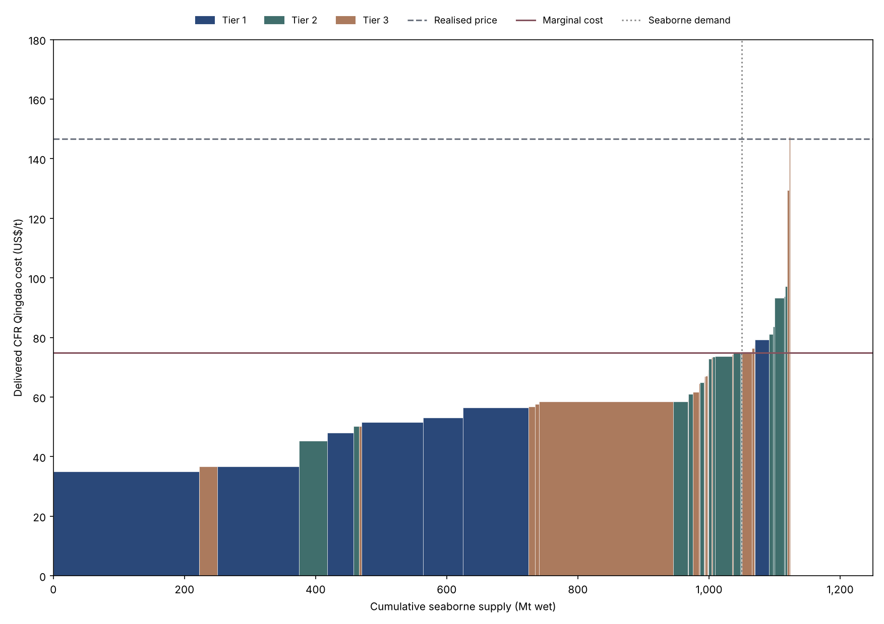
Figure C1. Global seaborne iron ore cost curve (US$/t; Mt wet), 2010. Axis scales vary by year.

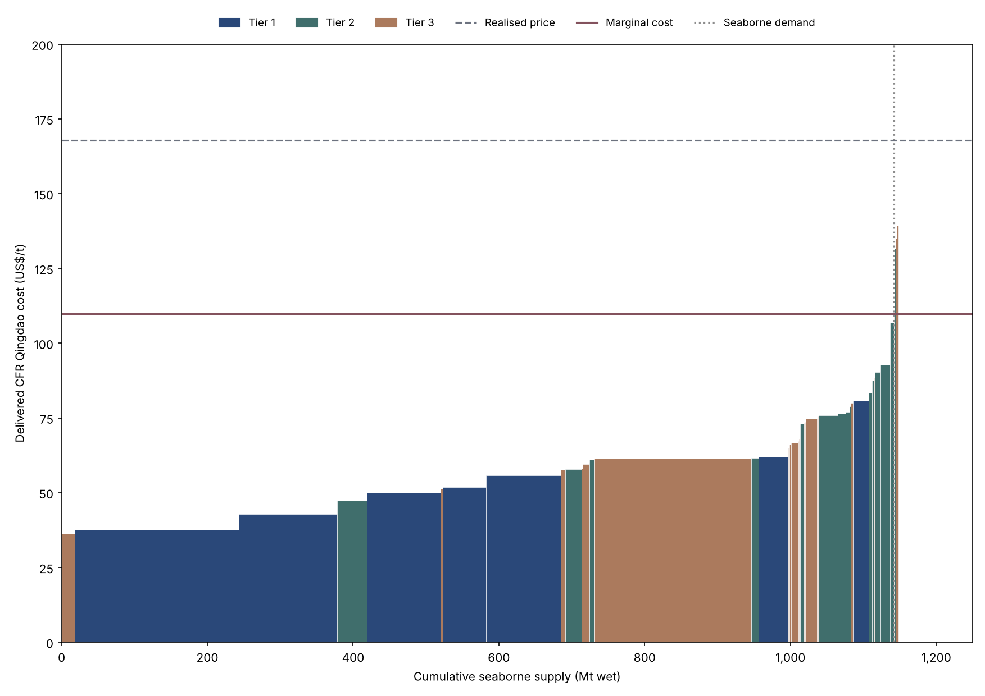
Figure C2. Global seaborne iron ore cost curve (US$/t; Mt wet), 2011. Axis scales vary by year.

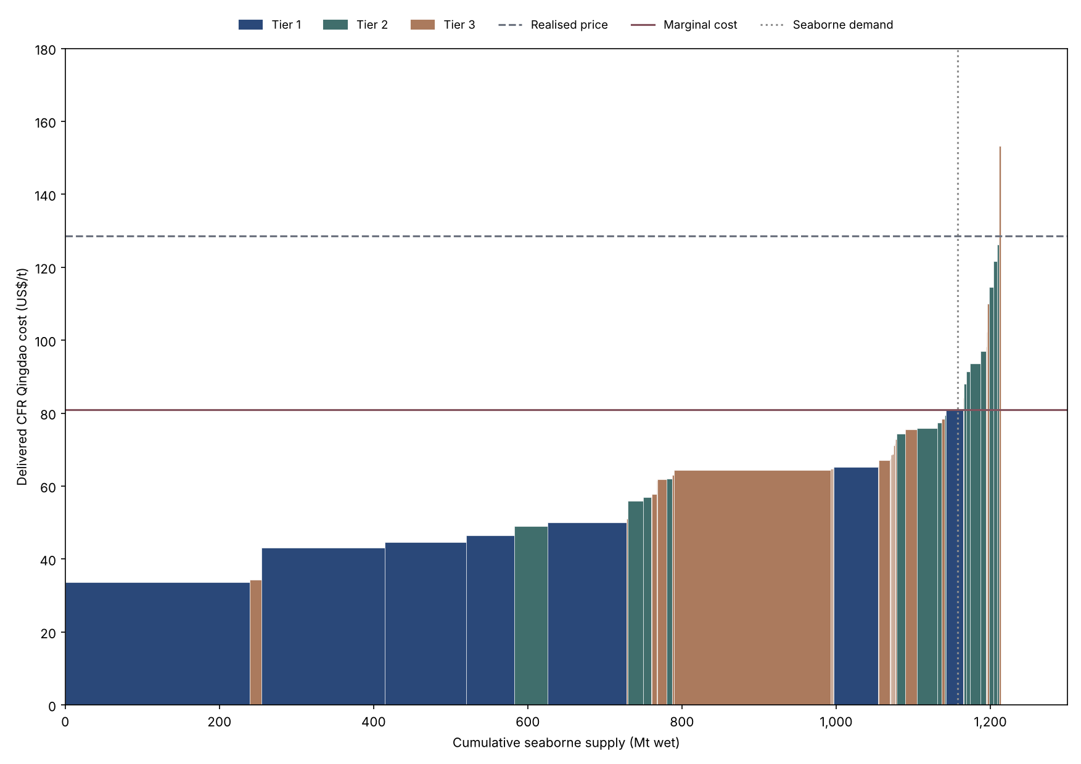
Figure C3. Global seaborne iron ore cost curve (US$/t; Mt wet), 2012. Axis scales vary by year.

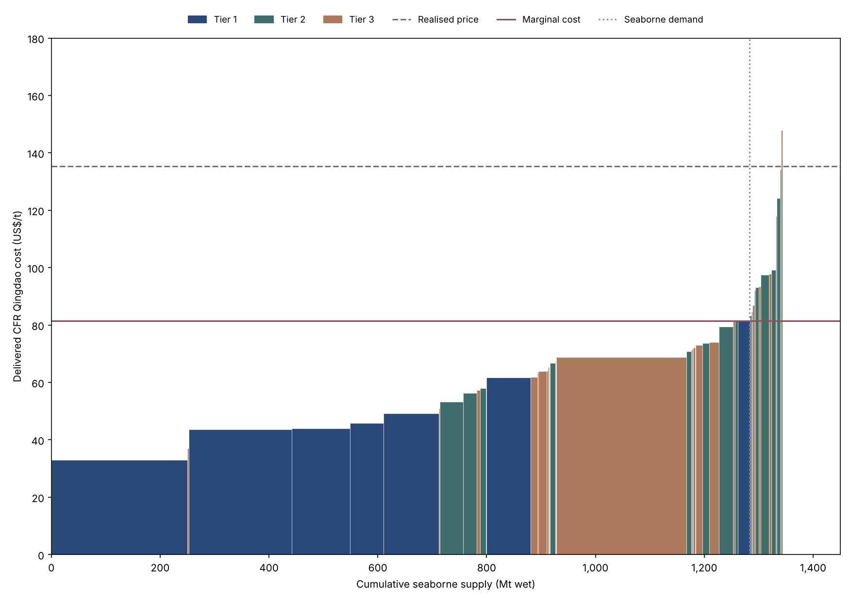
Figure C4. Global seaborne iron ore cost curve (US$/t; Mt wet), 2013. Axis scales vary by year.

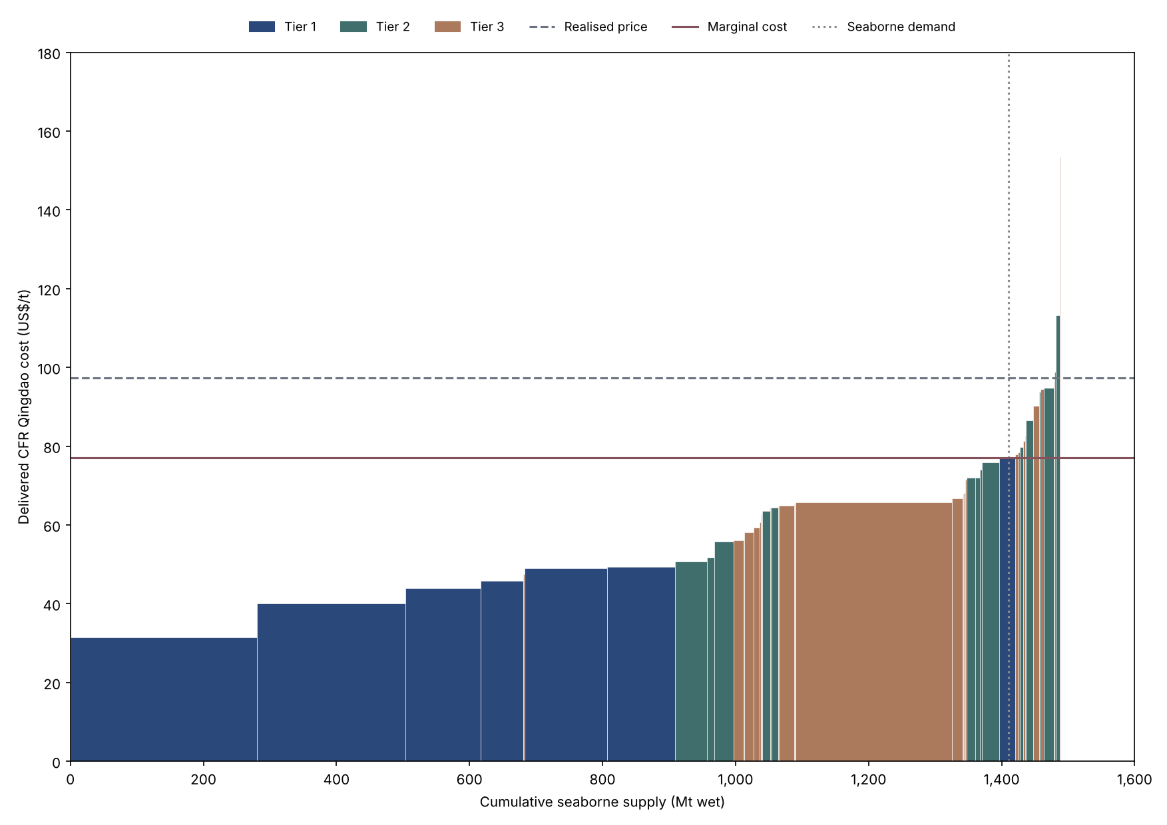
Figure C5. Global seaborne iron ore cost curve (US$/t; Mt wet), 2014. Axis scales vary by year.

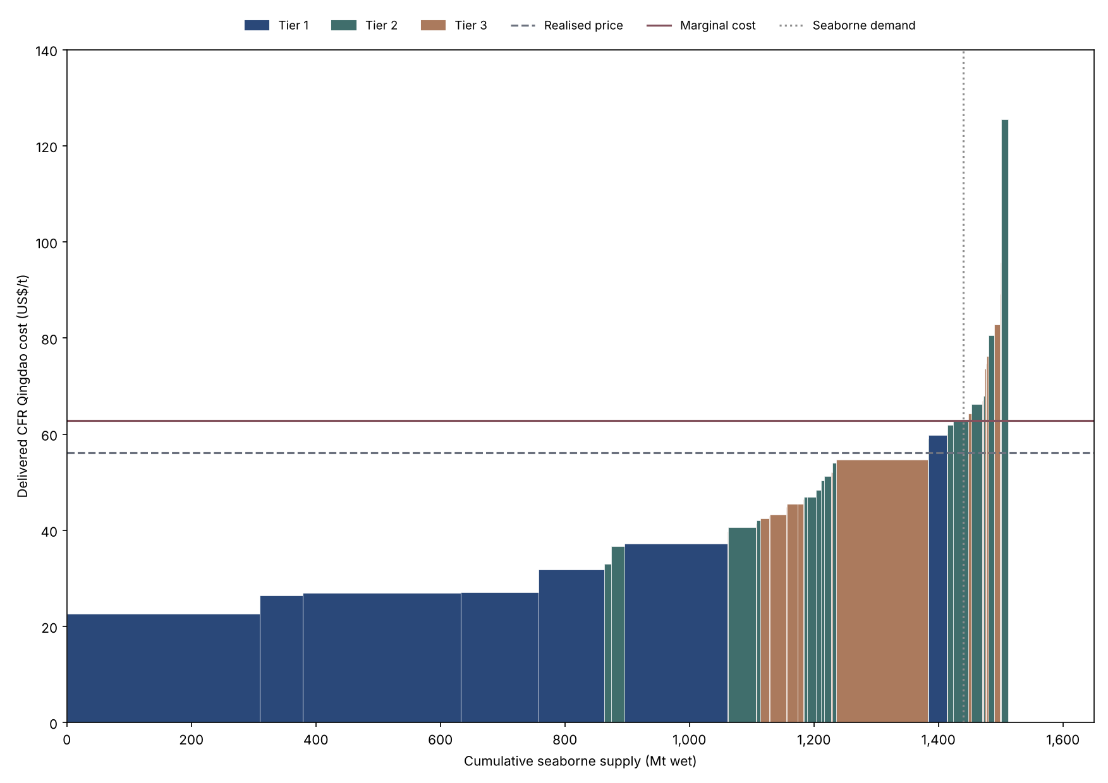
Figure C6. Global seaborne iron ore cost curve (US$/t; Mt wet), 2015. Axis scales vary by year.

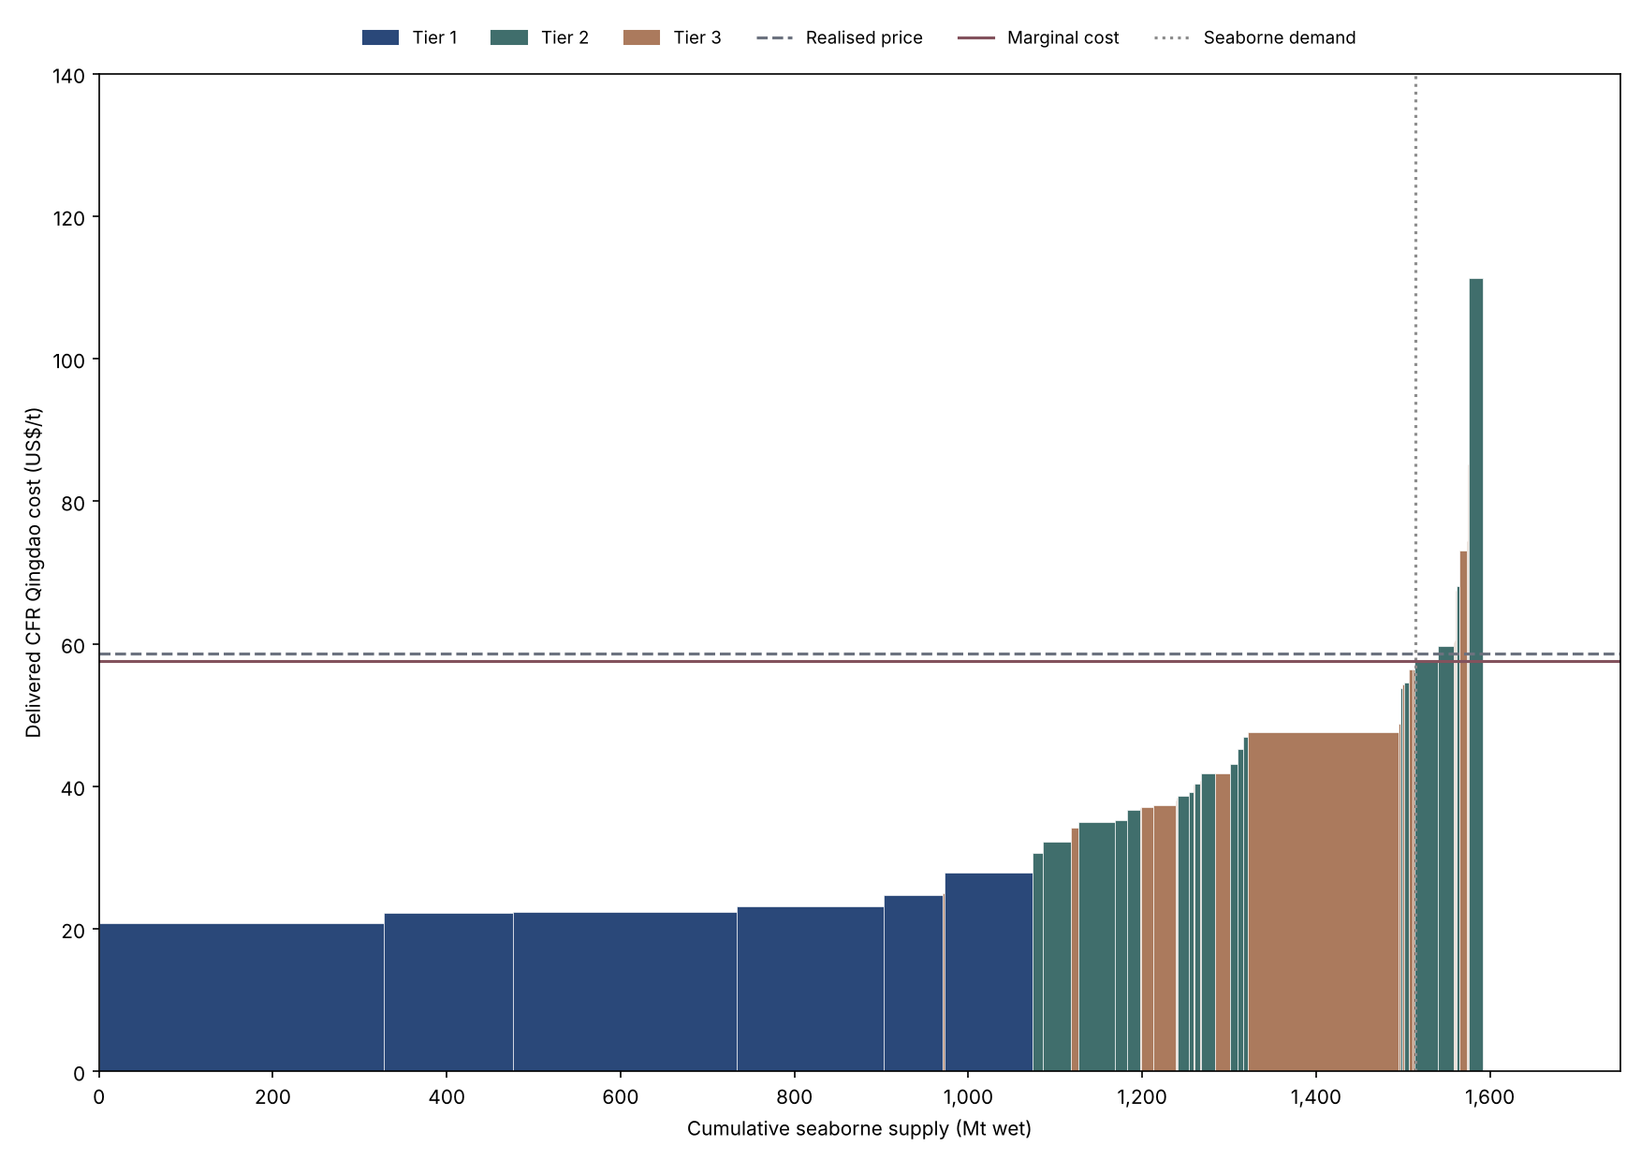
Figure C7. Global seaborne iron ore cost curve (US$/t; Mt wet), 2016. Axis scales vary by year.

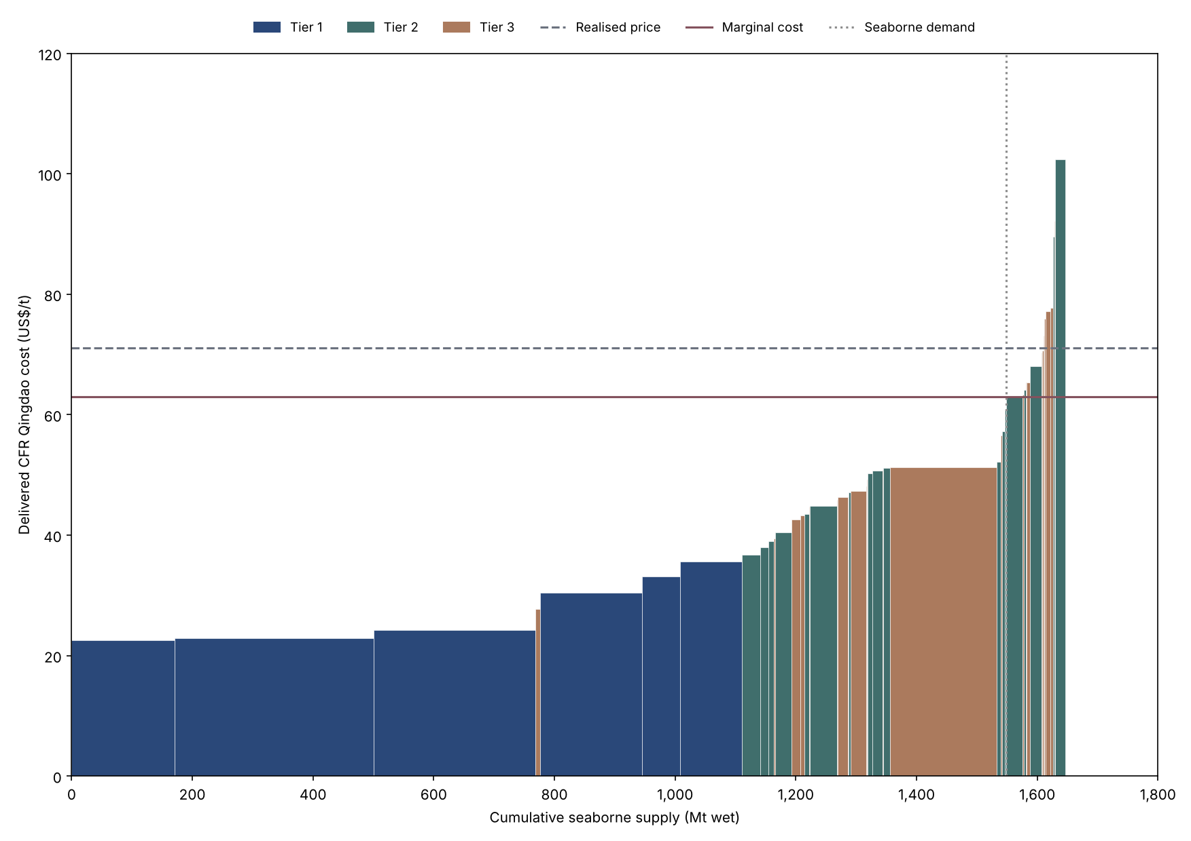
Figure C8. Global seaborne iron ore cost curve (US$/t; Mt wet), 2017. Axis scales vary by year.

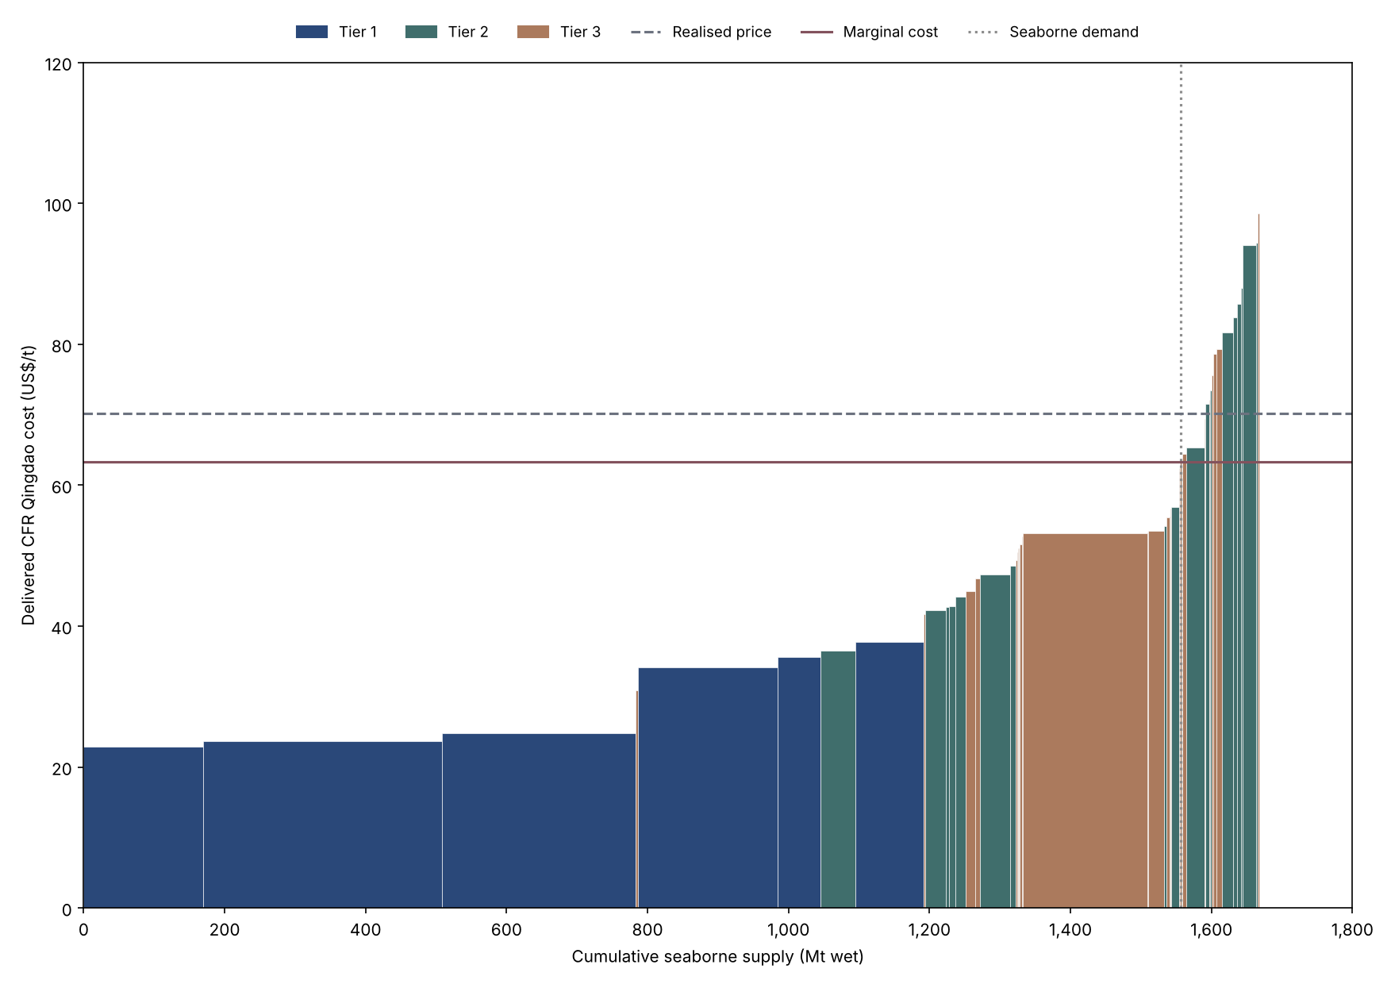
Figure C9. Global seaborne iron ore cost curve (US$/t; Mt wet), 2018. Axis scales vary by year.

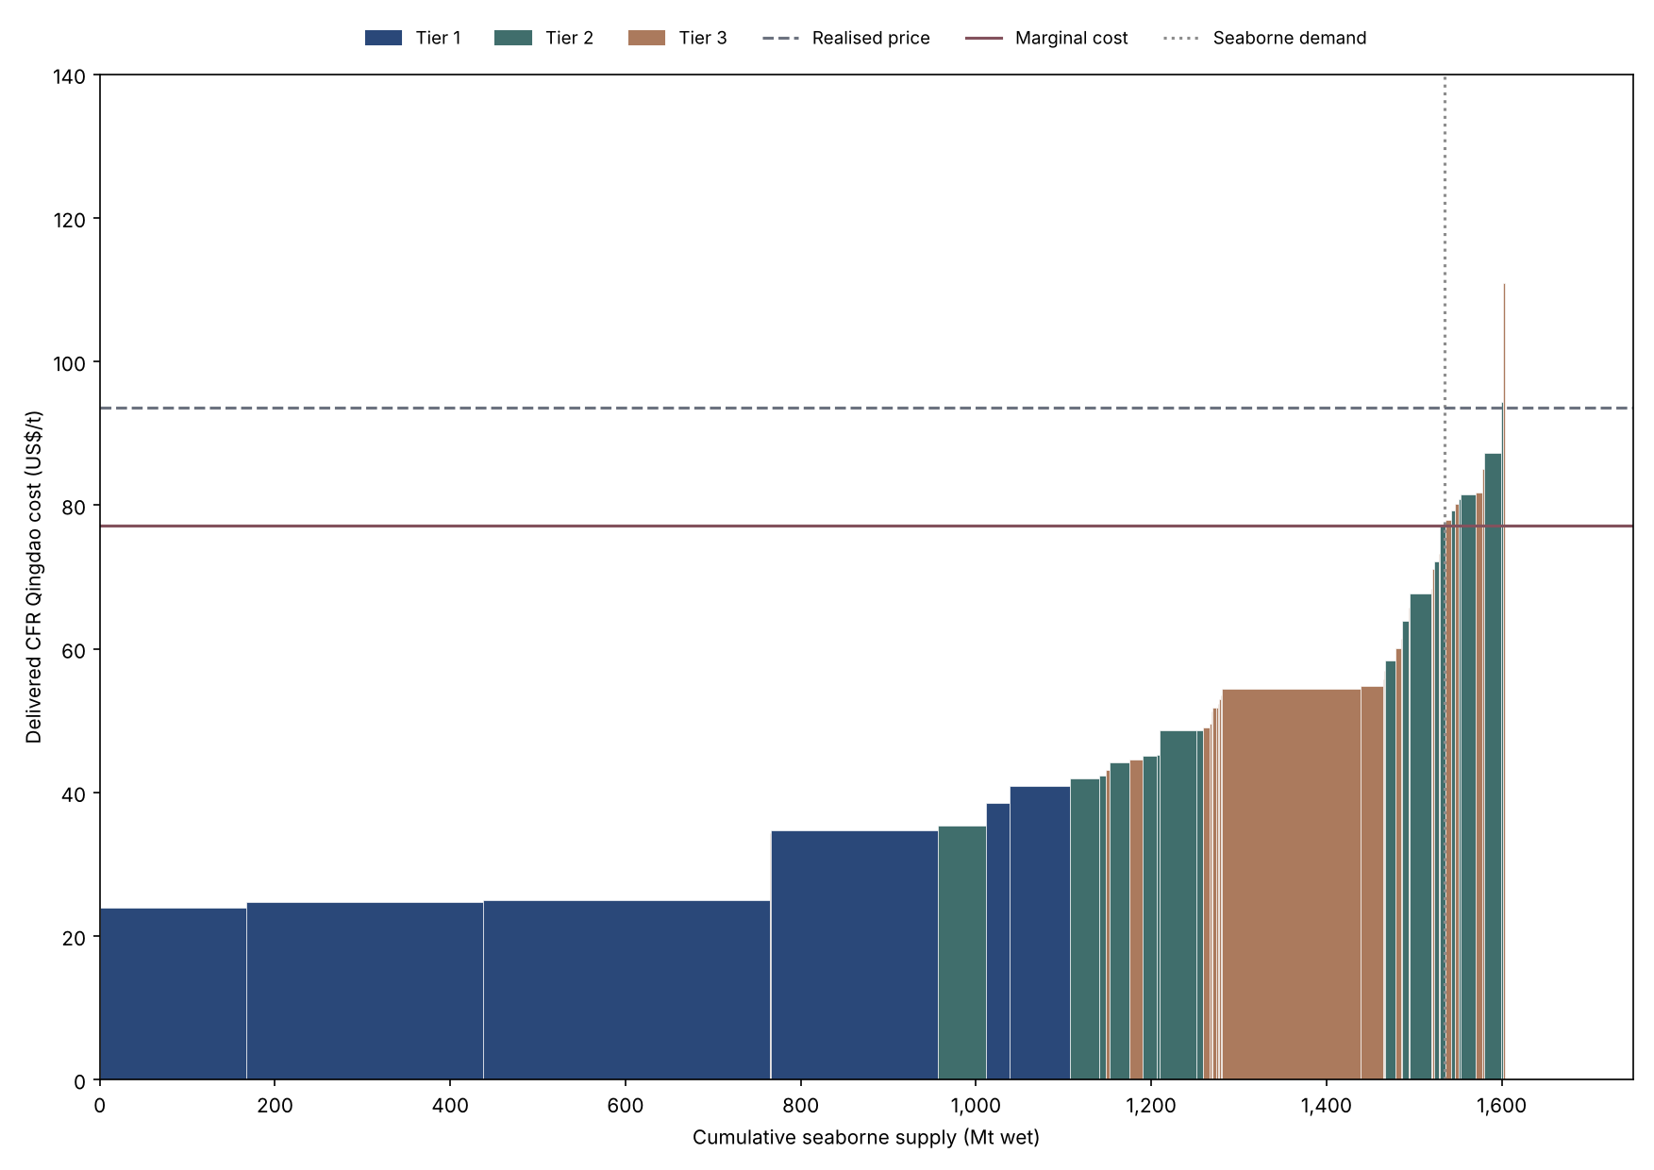
Figure C10. Global seaborne iron ore cost curve (US$/t; Mt wet), 2019. Axis scales vary by year.

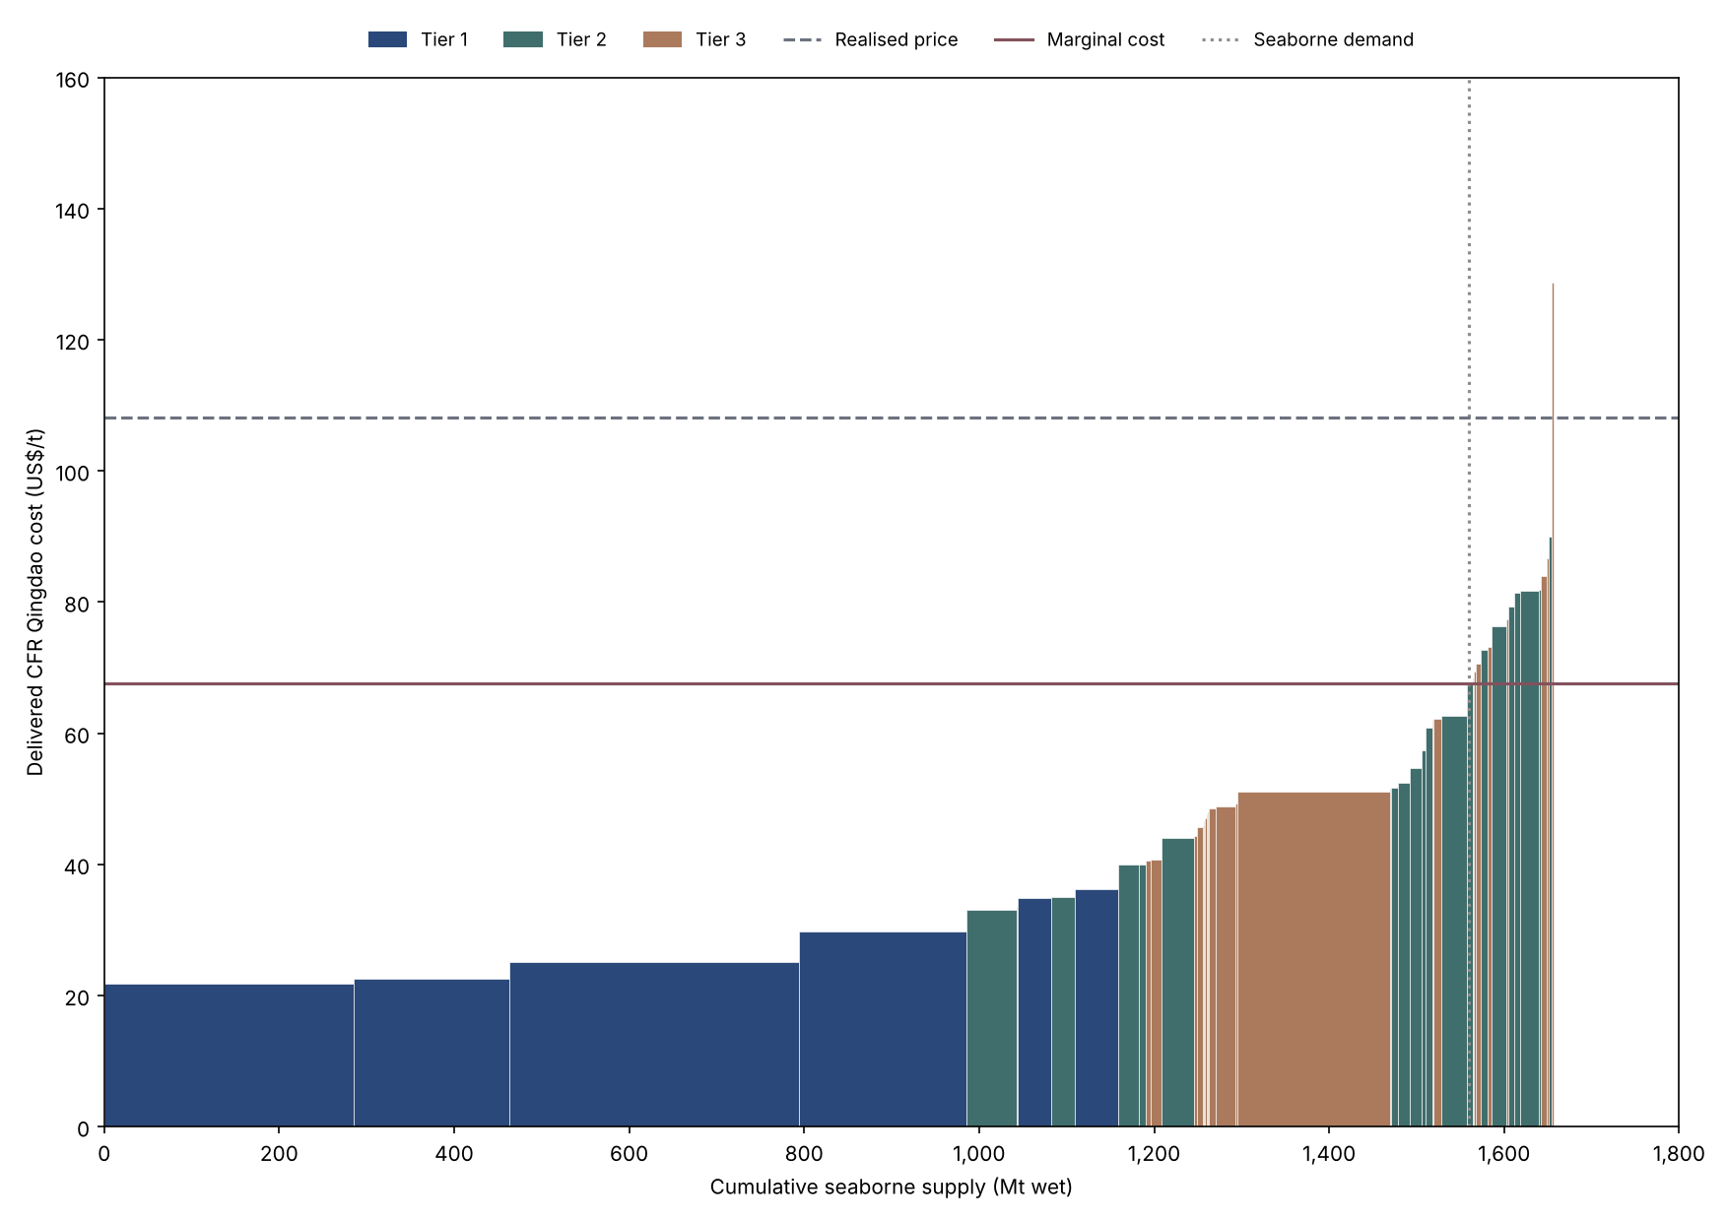
Figure C11. Global seaborne iron ore cost curve (US$/t; Mt wet), 2020. Axis scales vary by year.

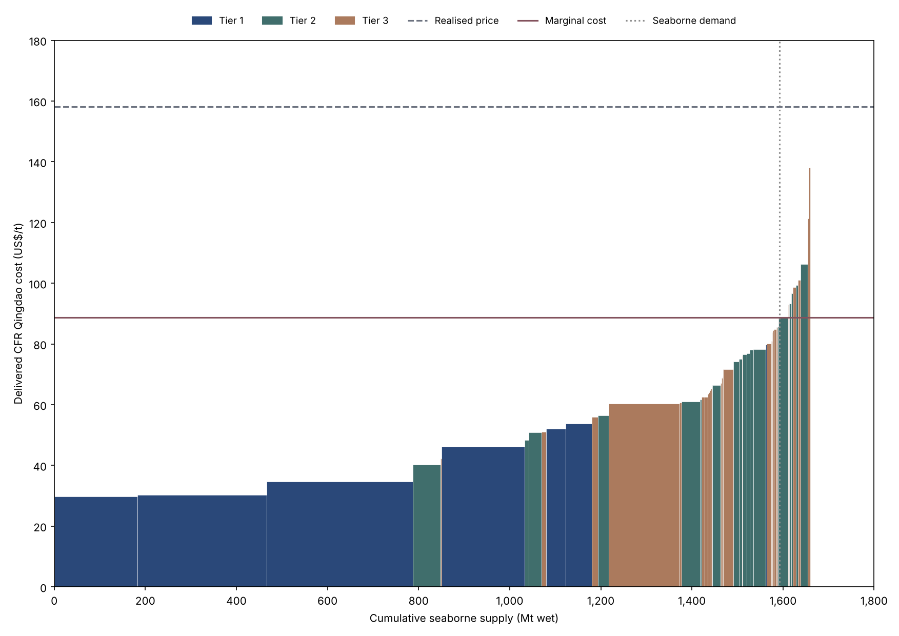
Figure C12. Global seaborne iron ore cost curve (US$/t; Mt wet), 2021. Axis scales vary by year.

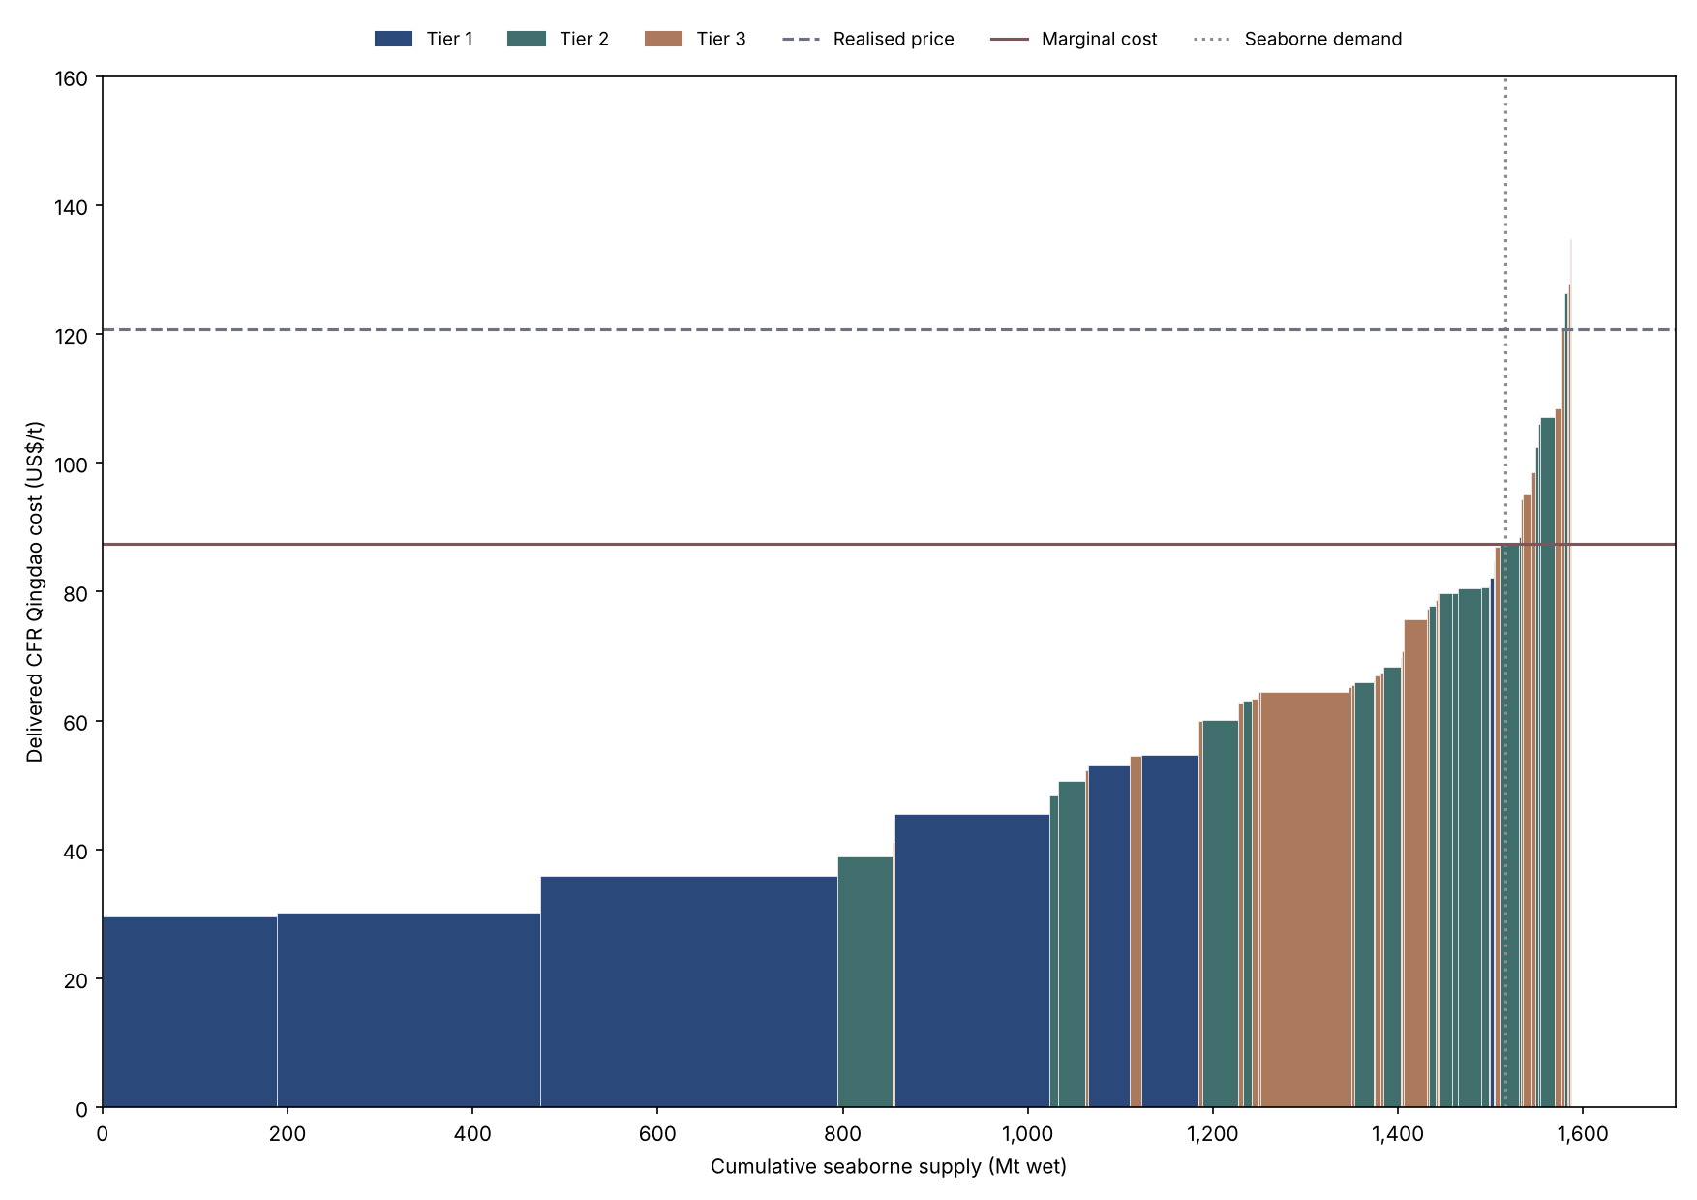
Figure C13. Global seaborne iron ore cost curve (US$/t; Mt wet), 2022. Axis scales vary by year.

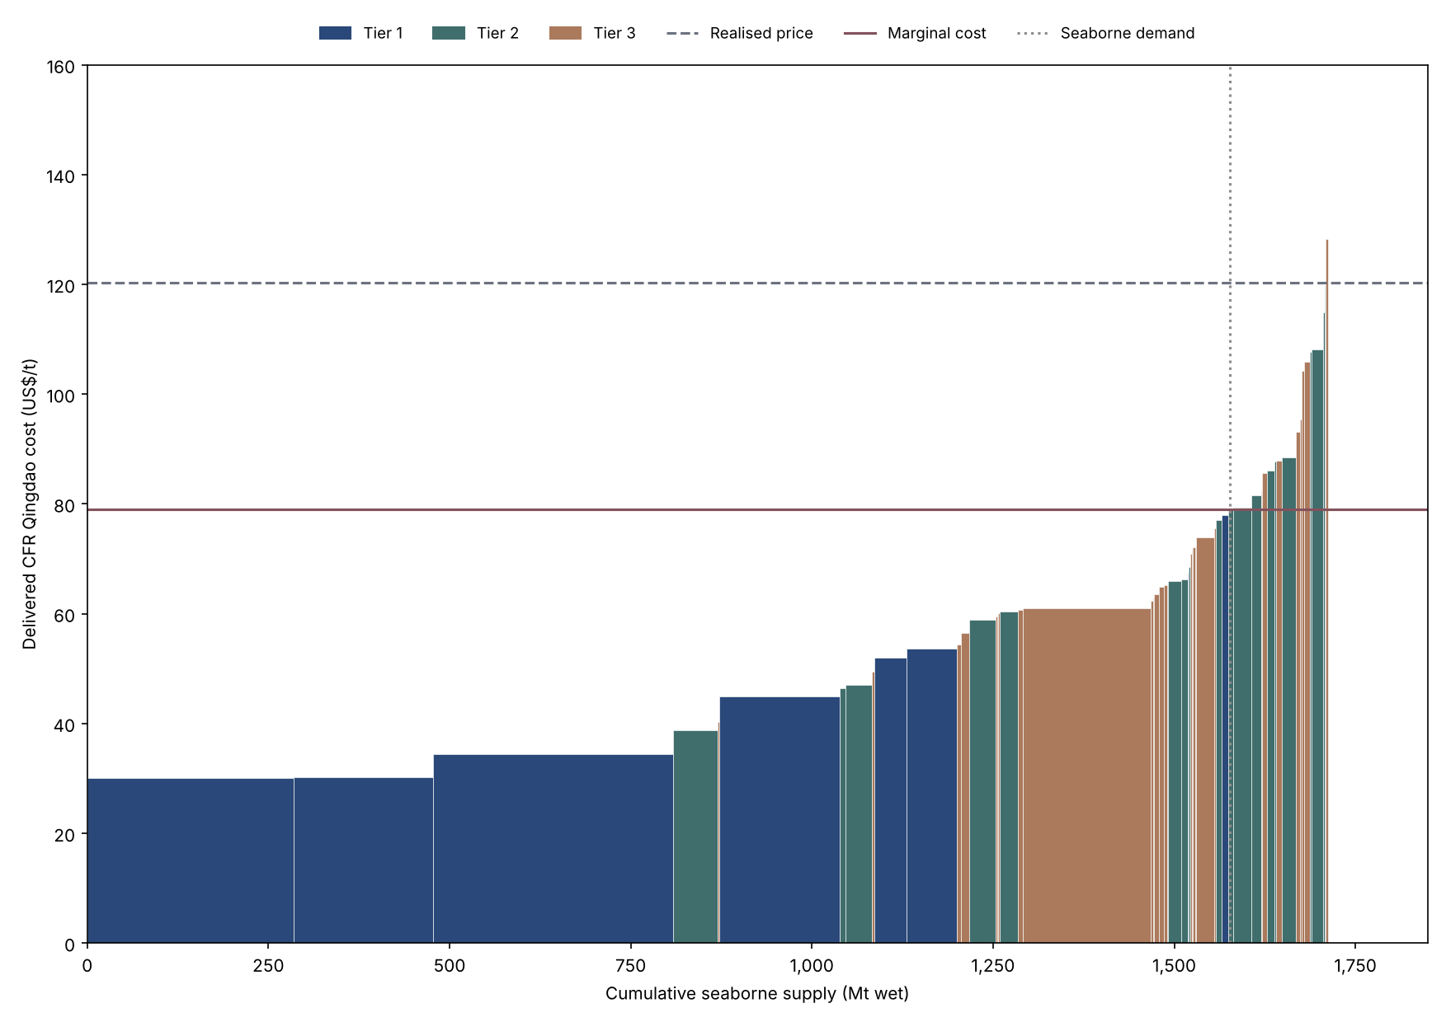
Figure C14. Global seaborne iron ore cost curve (US$/t; Mt wet), 2023. Axis scales vary by year.

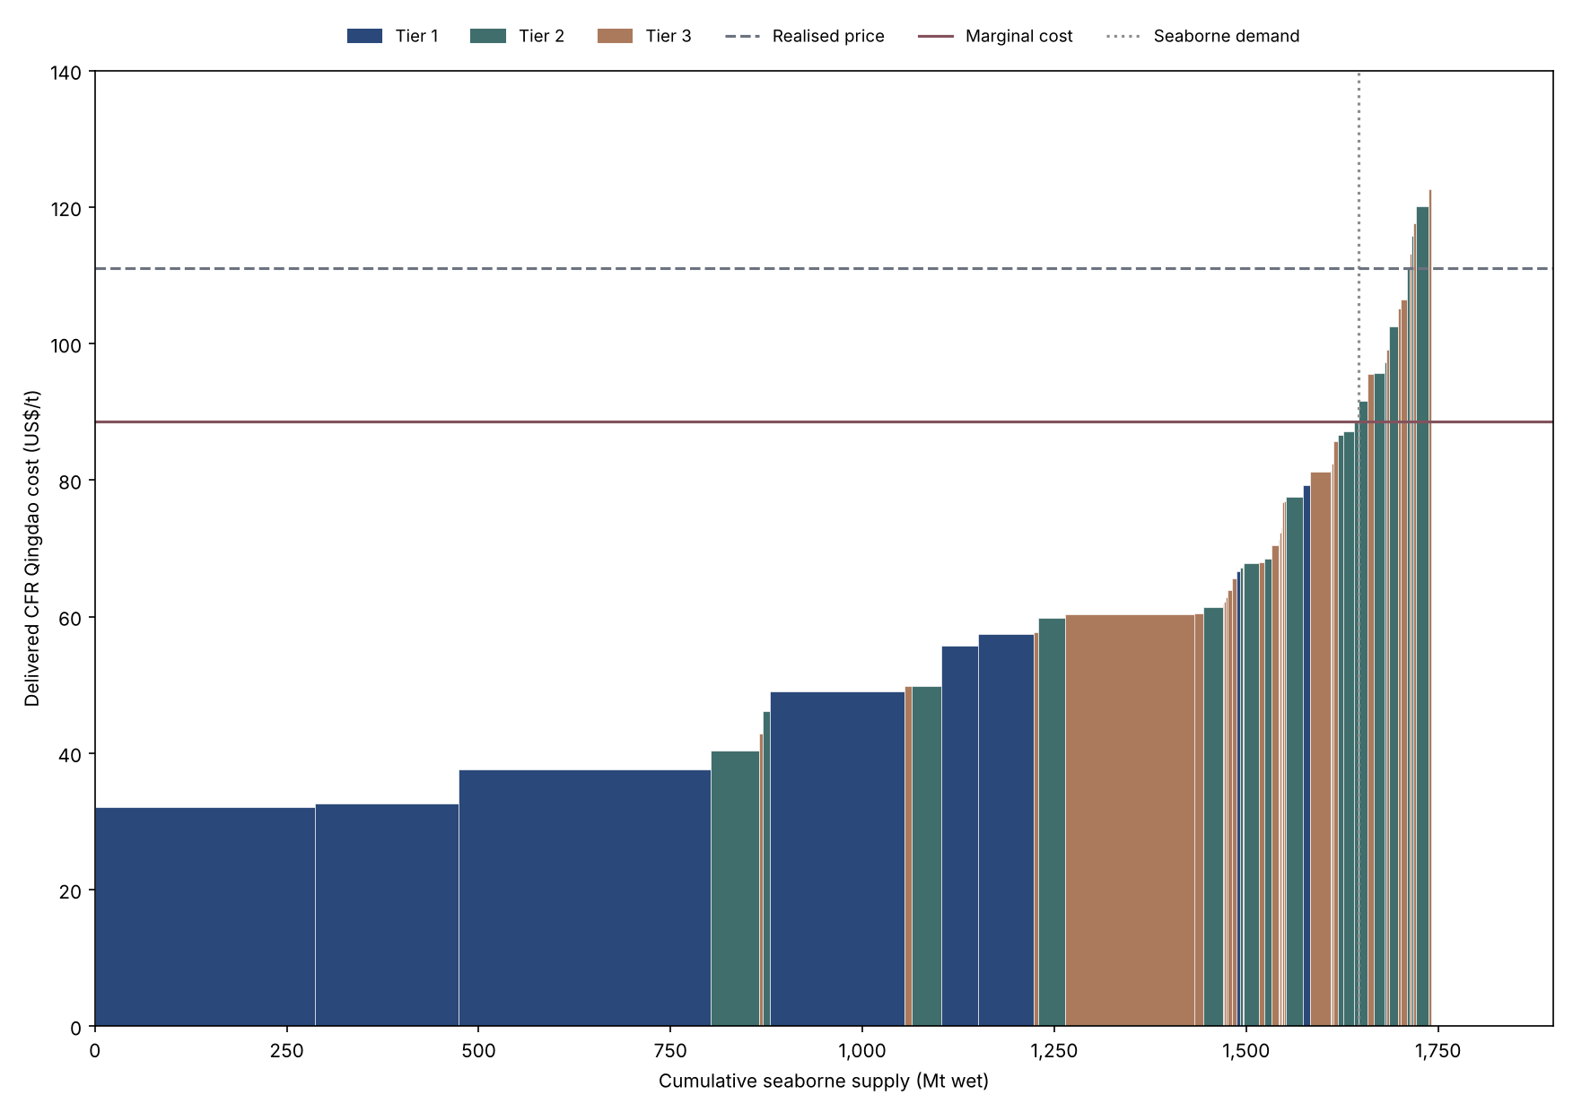
Figure C15. Global seaborne iron ore cost curve (US$/t; Mt wet), 2024. Axis scales vary by year.

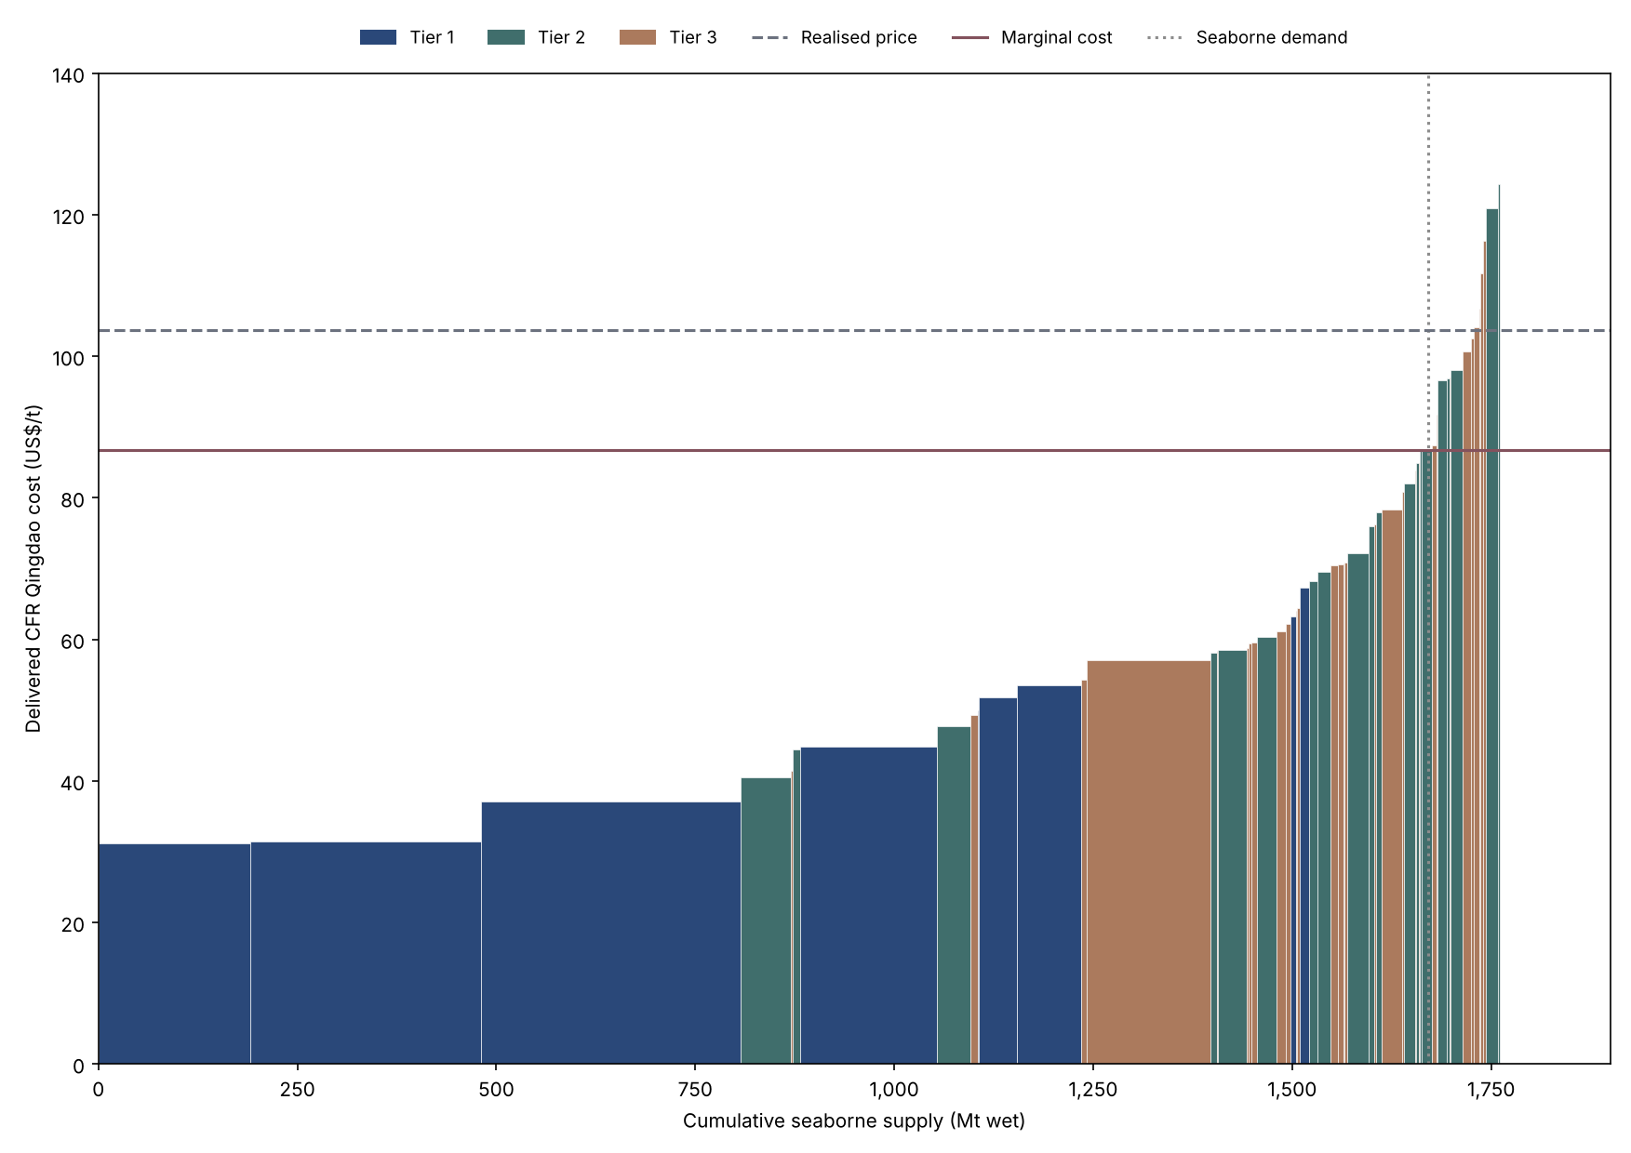
Figure C16. Global seaborne iron ore cost curve (US$/t; Mt wet), 2025. Axis scales vary by year.

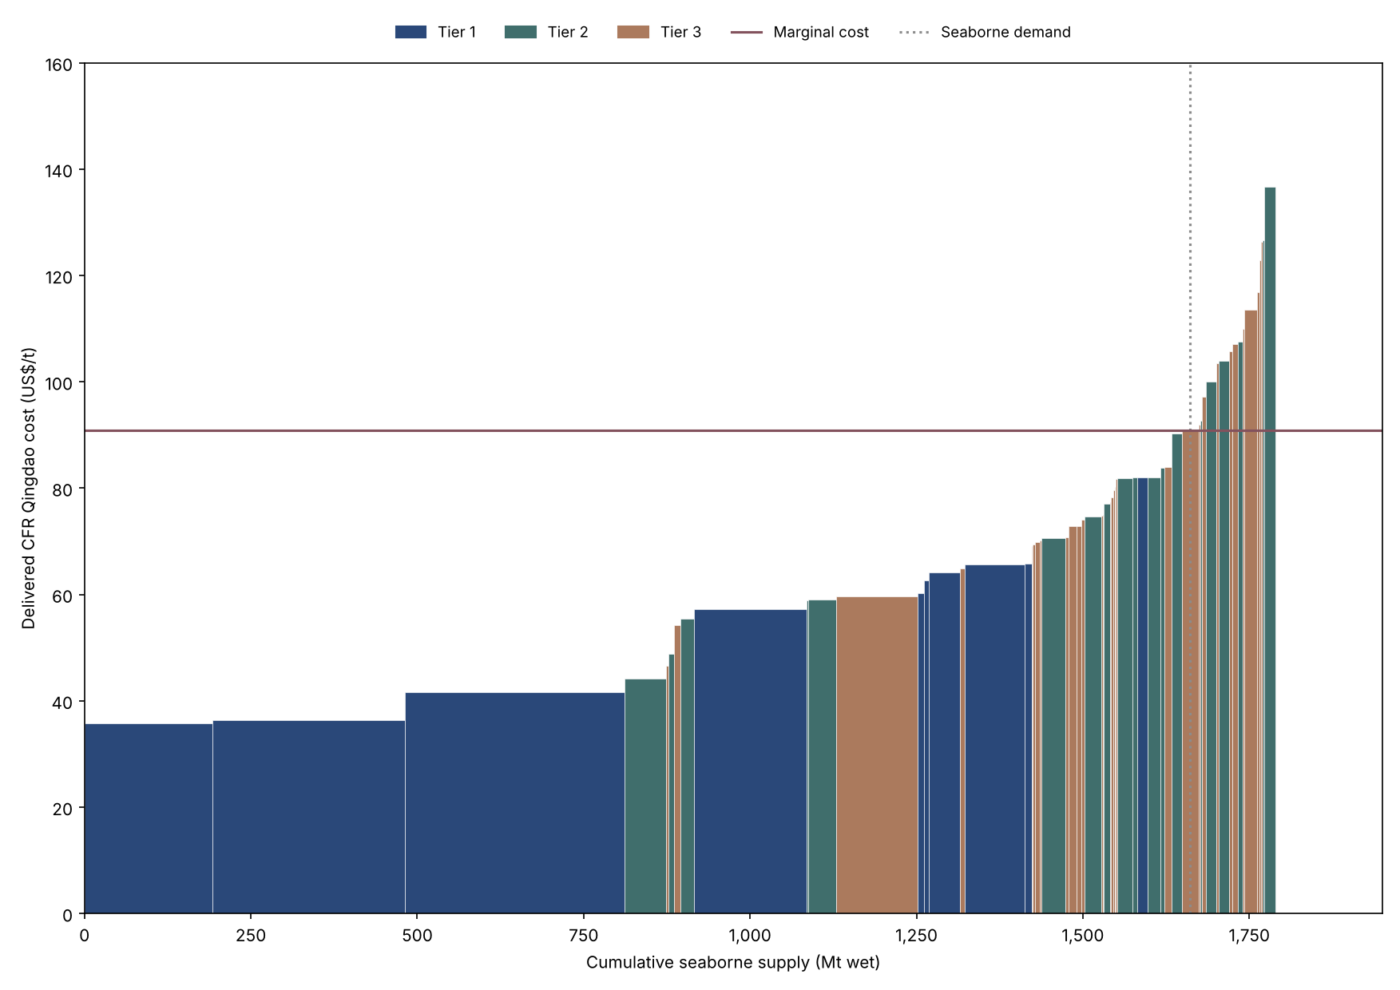
Figure C17. Global seaborne iron ore cost curve (US$/t; Mt wet), 2026 (projection). Axis scales vary by year.

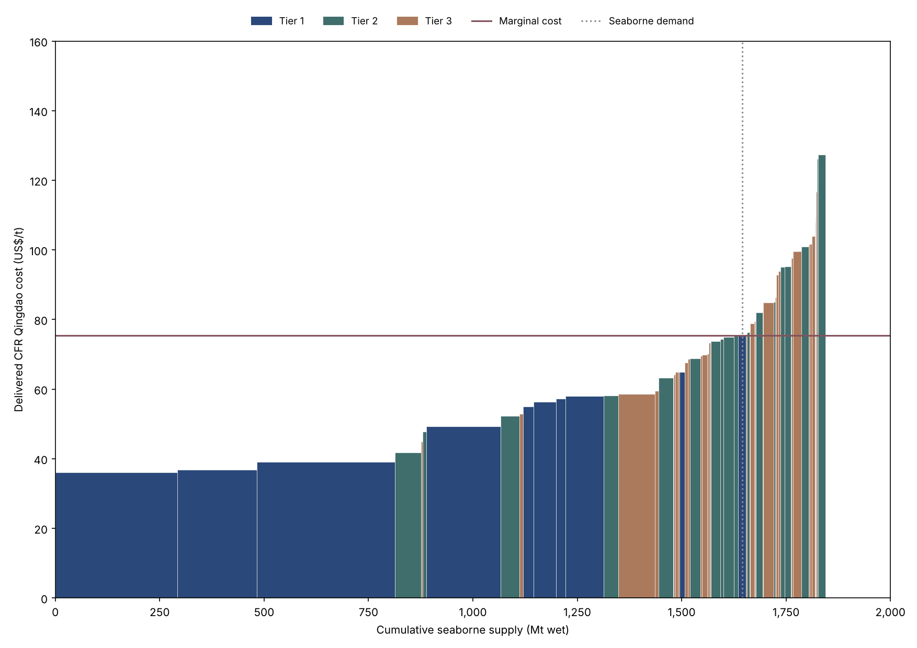
Figure C18. Global seaborne iron ore cost curve (US$/t; Mt wet), 2027 (projection). Axis scales vary by year.

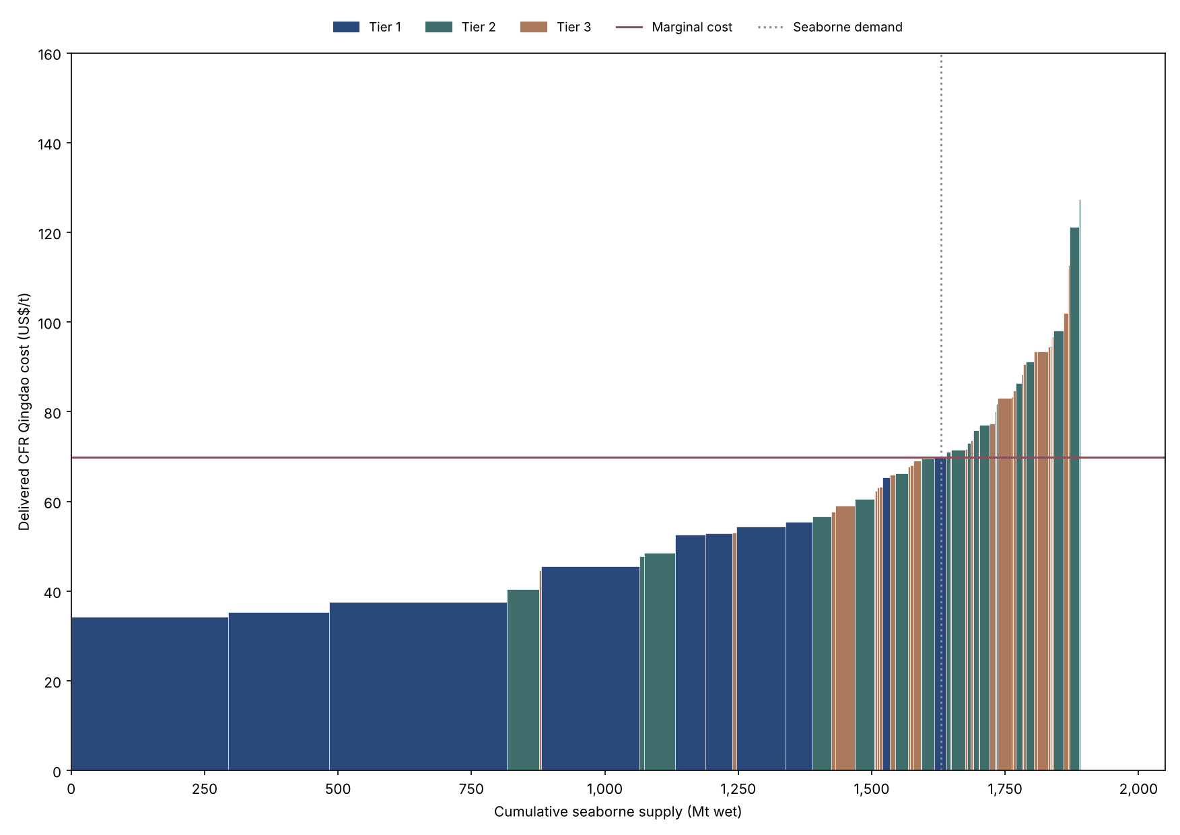
Figure C19. Global seaborne iron ore cost curve (US$/t; Mt wet), 2028 (projection). Axis scales vary by year.

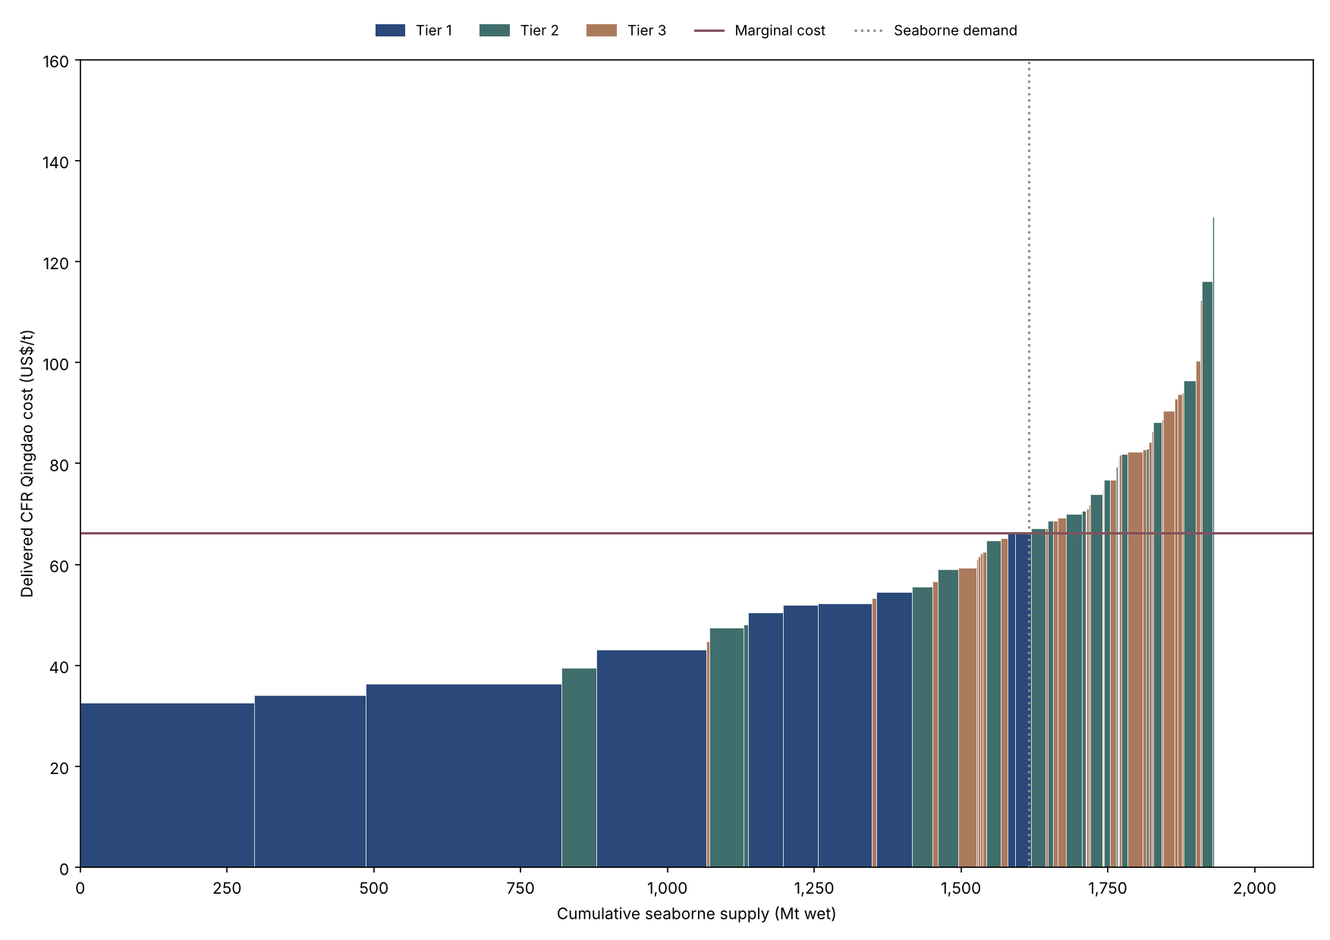
Figure C20. Global seaborne iron ore cost curve (US$/t; Mt wet), 2029 (projection). Axis scales vary by year.

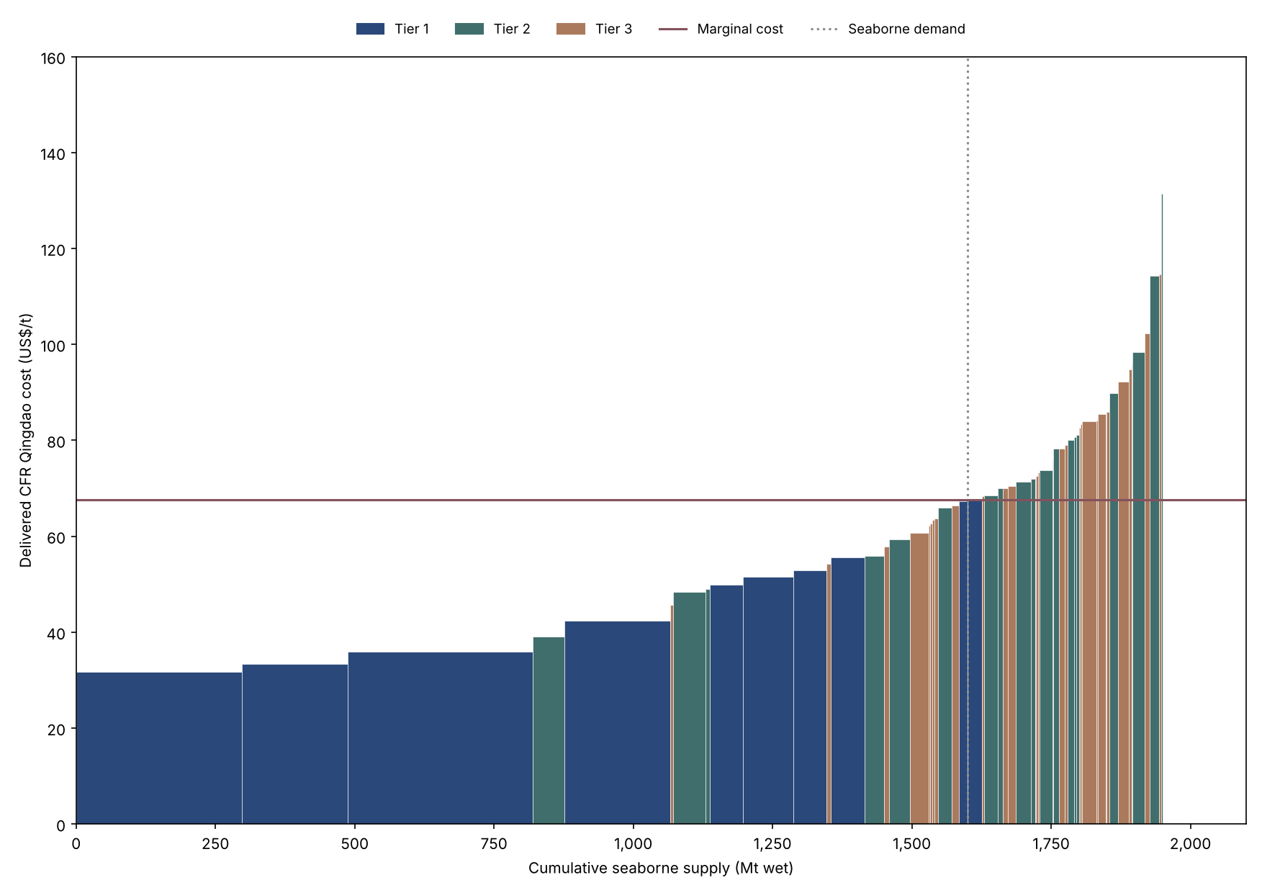
Figure C21. Global seaborne iron ore cost curve (US$/t; Mt wet), 2030 (projection). Axis scales vary by year.

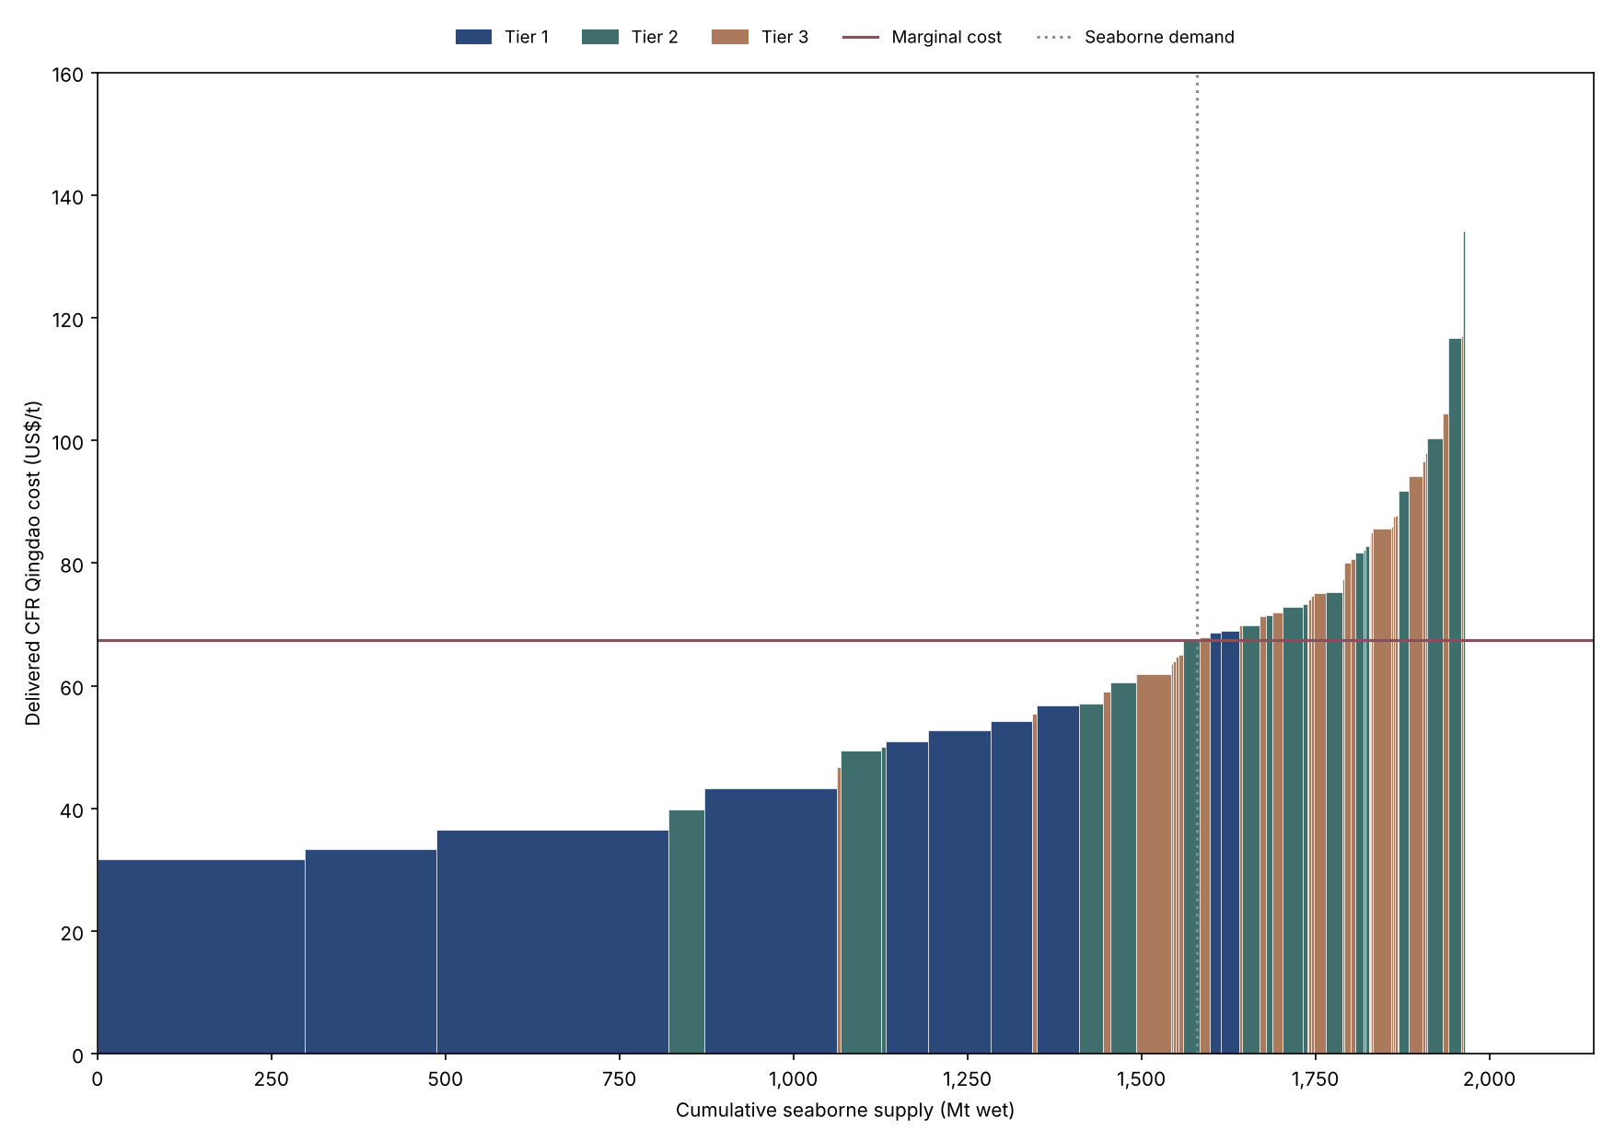
Figure C22. Global seaborne iron ore cost curve (US$/t; Mt wet), 2031 (projection). Axis scales vary by year.

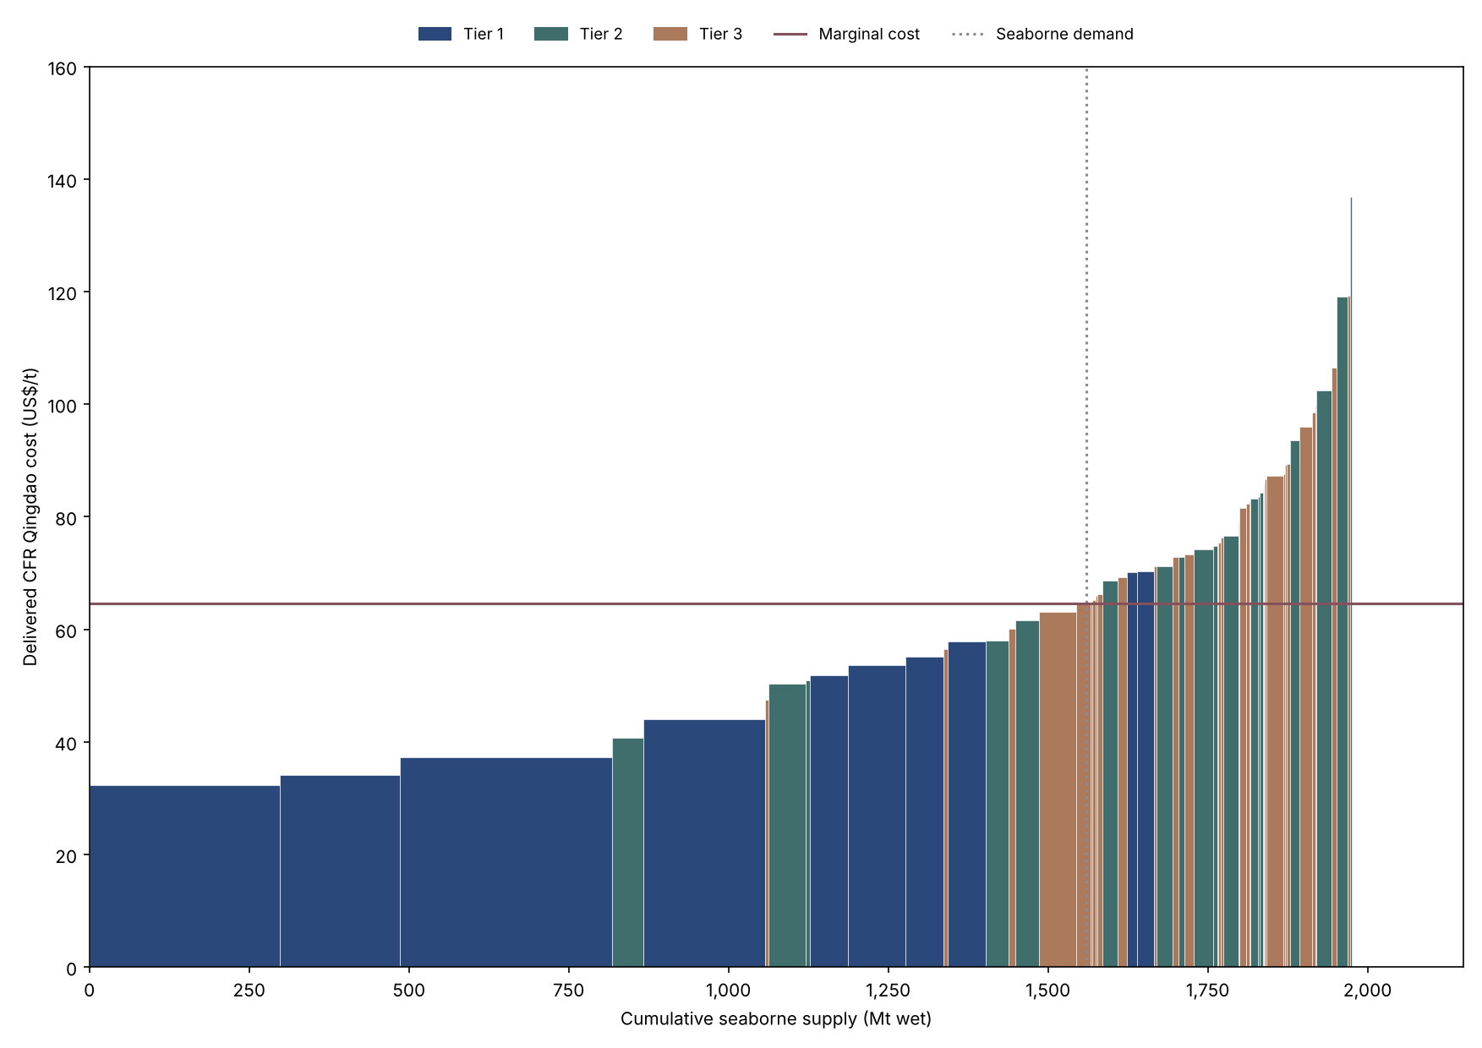
Figure C23. Global seaborne iron ore cost curve (US$/t; Mt wet), 2032 (projection). Axis scales vary by year.

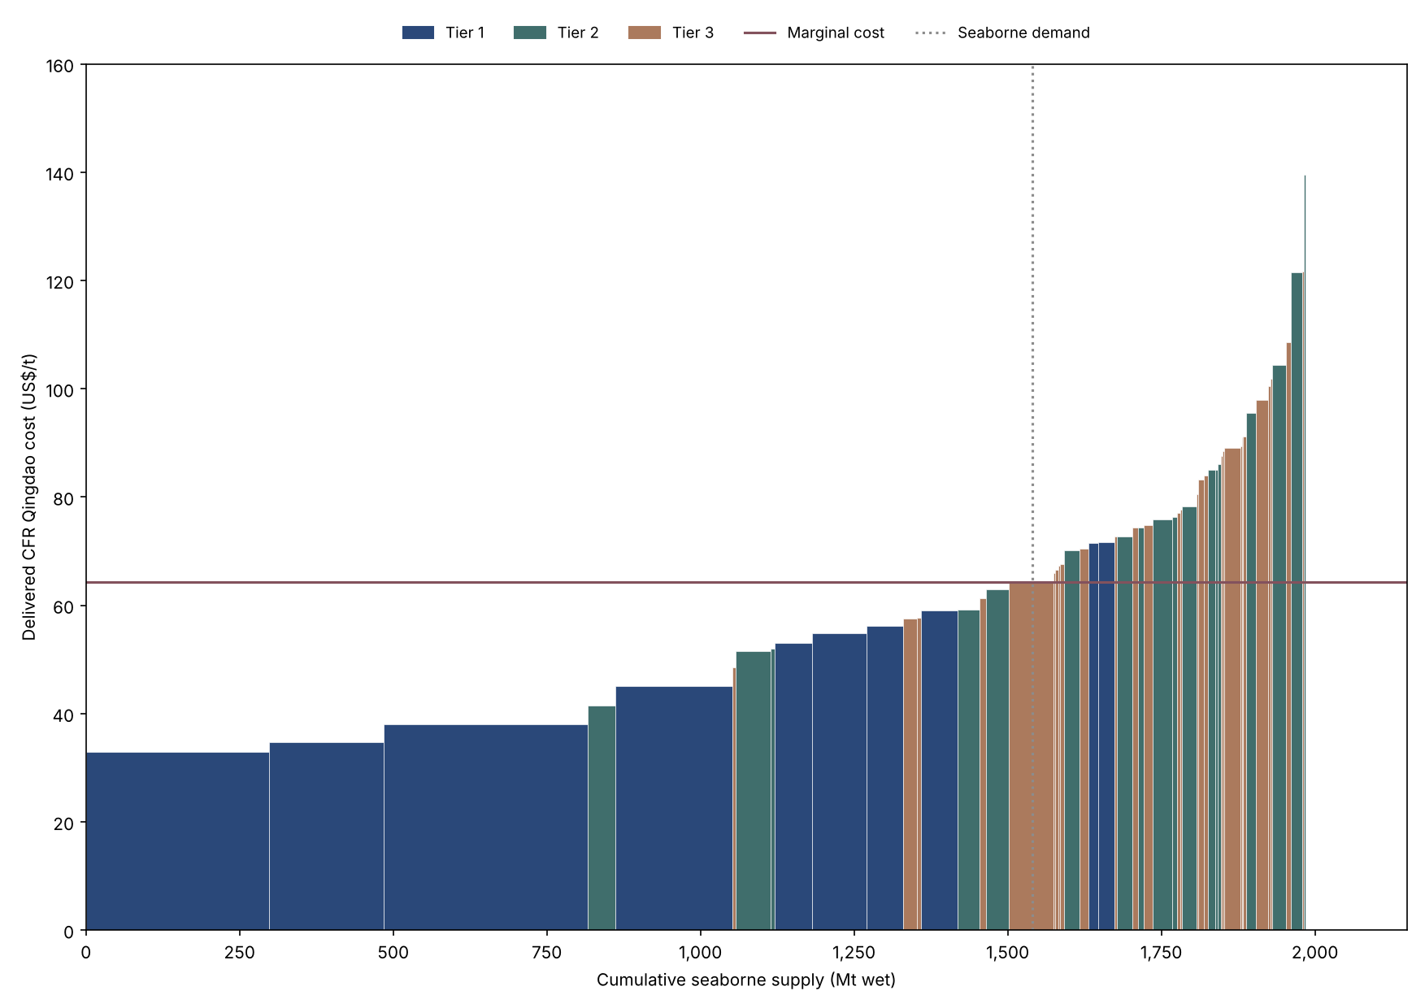
Figure C24. Global seaborne iron ore cost curve (US$/t; Mt wet), 2033 (projection). Axis scales vary by year.

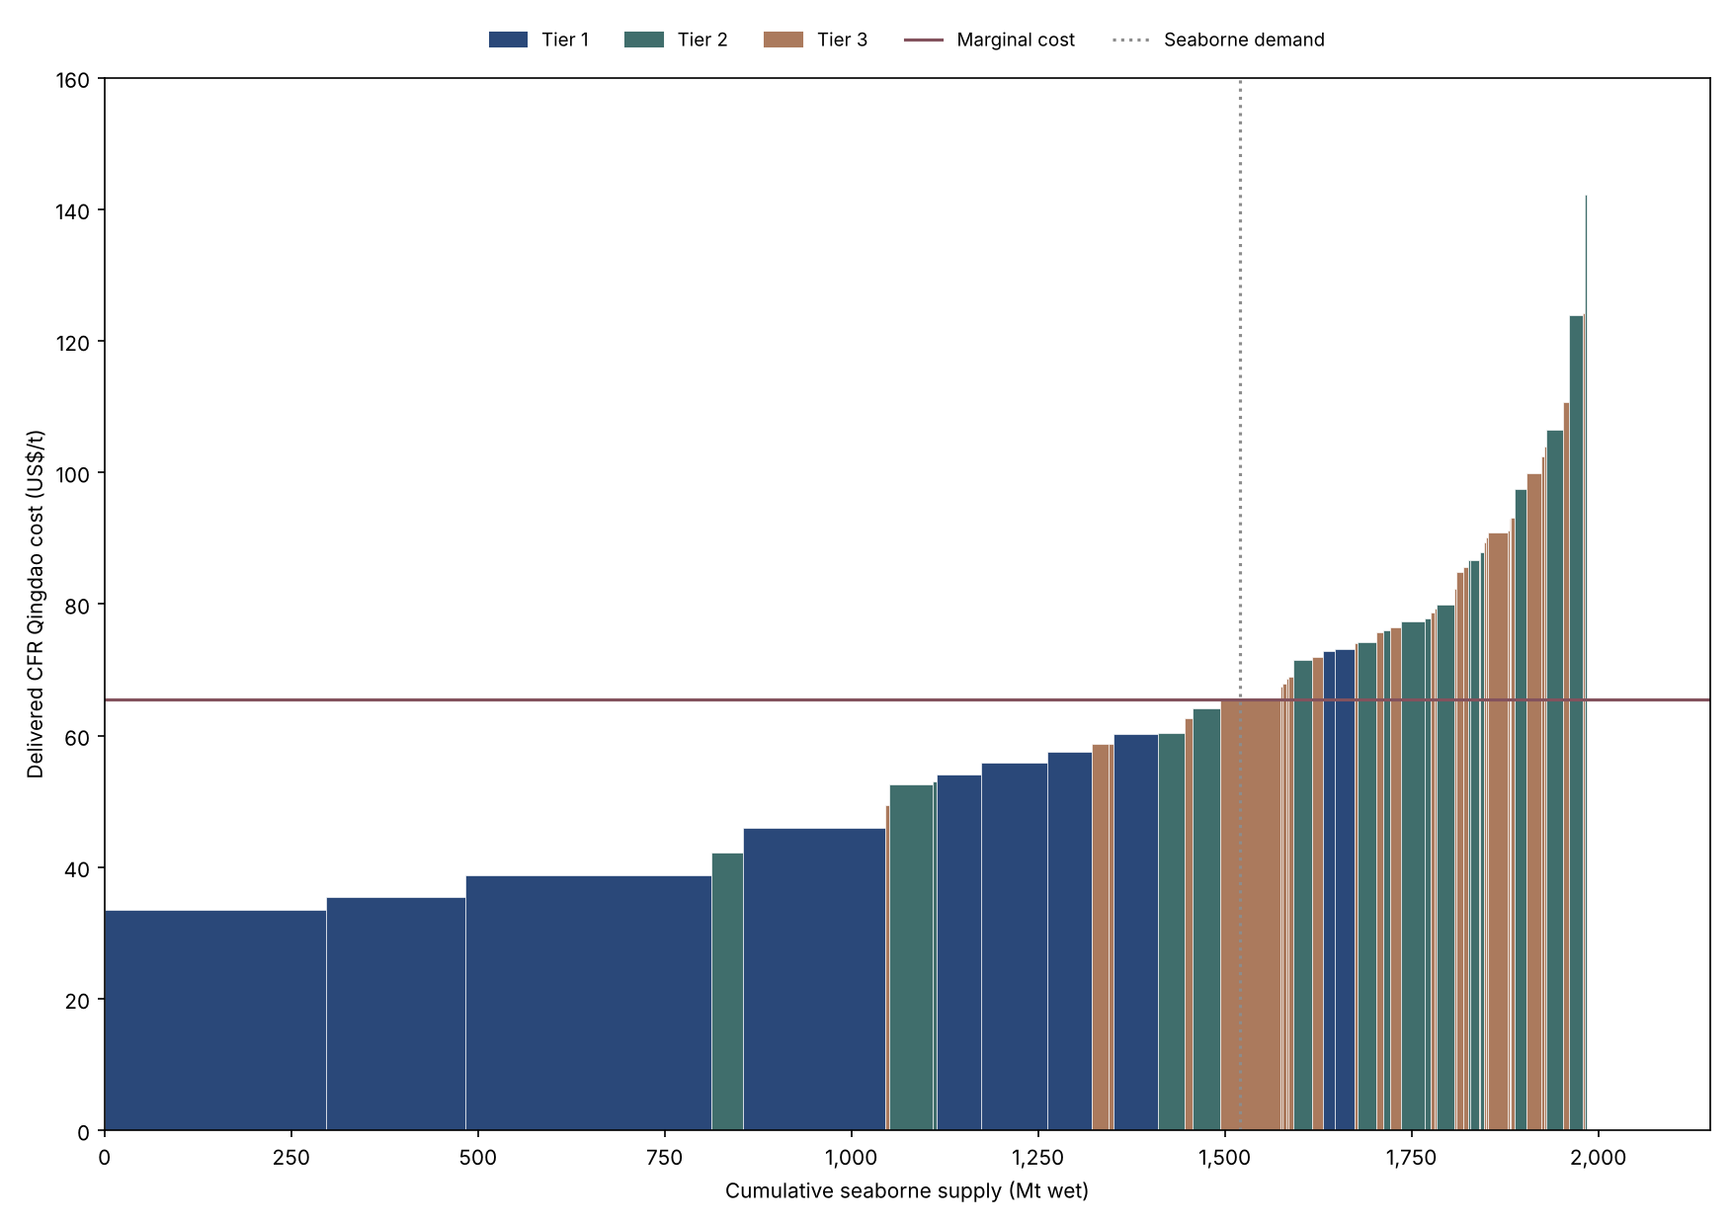
Figure C25. Global seaborne iron ore cost curve (US$/t; Mt wet), 2034 (projection). Axis scales vary by year.

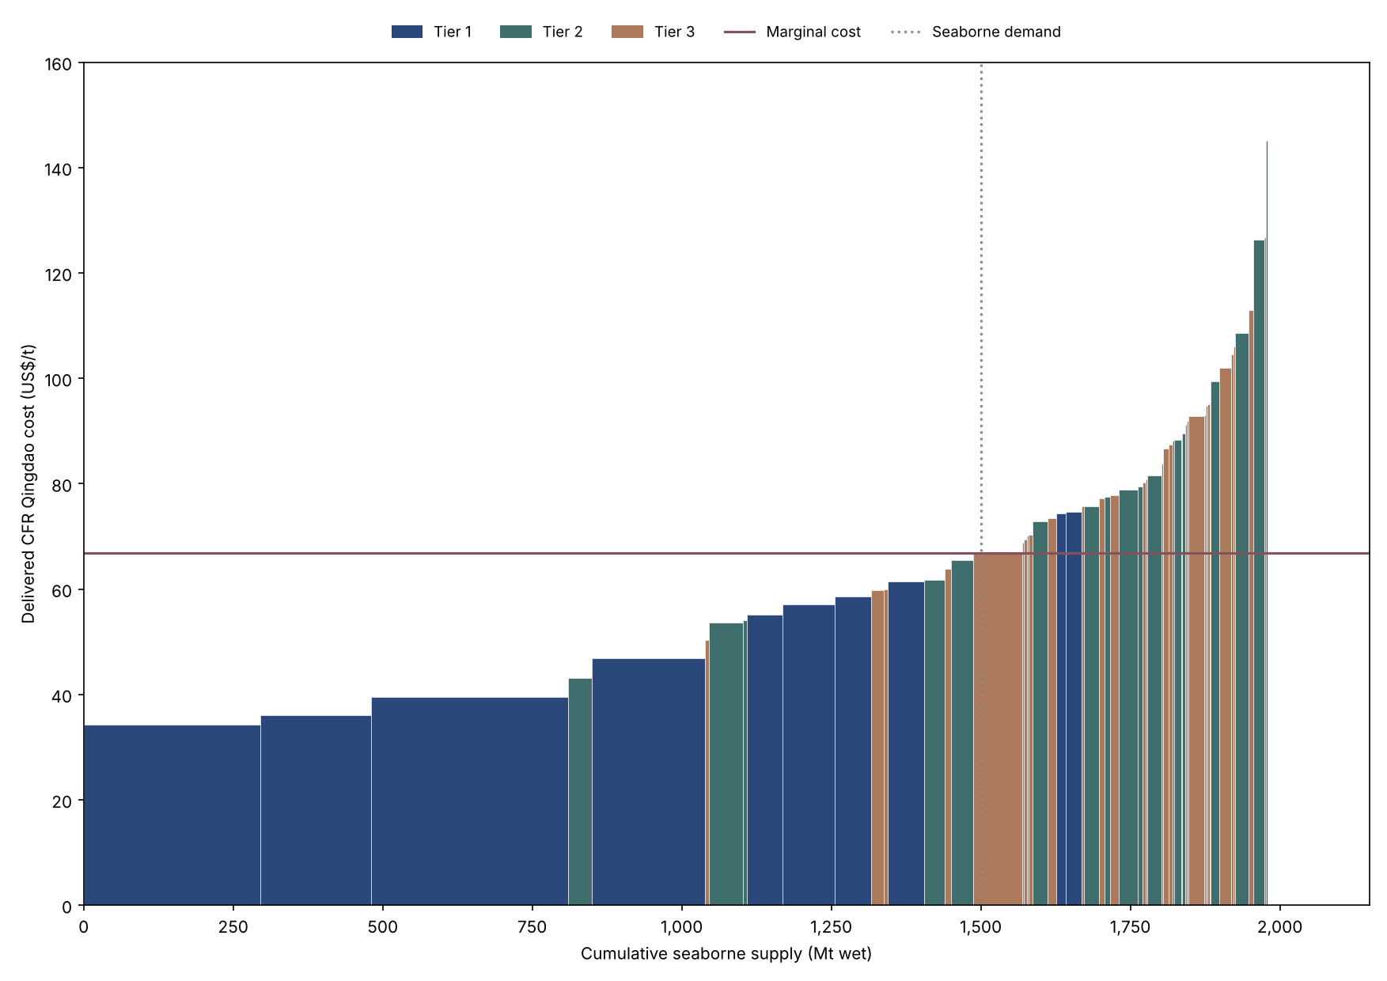
Figure C26. Global seaborne iron ore cost curve (US$/t; Mt wet), 2035 (projection). Axis scales vary by year.

Appendix D. Two-year-ahead backtest forecasts
Forecast year | Estimation period | Actual (US$/t) | Model 1 | Model 1 error | Model 2 | Model 2 error | Calibrated Marginal Cost Model | Calibrated Marginal Cost Model error | Marginal Cost Model | Marginal Cost Model error | Model 2 identification
2,021.00 | 2010-2019 | 158.16 | 155.90 | -2.26 | 145.75 | -12.41 | 100.24 | -57.92 | 77.10 | -81.06 | Not identified
2,022.00 | 2010-2020 | 120.70 | 88.56 | -32.14 | 76.68 | -44.02 | 89.59 | -31.11 | 67.63 | -53.07 | Degenerate (perfect in-sample fit), identified
2,023.00 | 2010-2021 | 120.32 | 130.86 | 10.54 | 149.11 | 28.79 | 120.40 | 0.08 | 88.67 | -31.65 | Identified
2,024.00 | 2010-2022 | 111.06 | 113.04 | 1.98 | 145.15 | 34.09 | 118.86 | 7.80 | 87.42 | -23.64 | Identified
2,025.00 | 2010-2023 | 103.72 | 150.18 | 46.46 | 119.99 | 16.27 | 108.30 | 4.58 | 79.01 | -24.71 | Identified
Table D1. Recursive two-year-ahead forecasts and errors (US$/t), 2021-2025.
Errors are forecast minus actual. Model 2's 2021 forecast uses only eight effective observations and is numerically fragile (statsmodels 0.15.0 gives 145.75).

Appendix E. Demand sensitivity
Year | Demand change (Mt) | Seaborne demand (Mt) | Marginal producer | Marginal Cost Model (US$/t) | Calibrated Marginal Cost Model (US$/t)
2,026.00 | -50 | 1,611 | Shougang Hierro Perú (1 Hub) | 82.04 | 111.79
2,026.00 | -25 | 1,636 | SNIM (3 Hubs) | 90.32 | 123.07
2,026.00 | +0 | 1,661 | ArcelorMittal Mining Canada (1 System) | 90.92 | 123.89
2,026.00 | +25 | 1,686 | Champion Iron Bloom Lake (1 Hub) | 99.97 | 136.22
2,026.00 | +50 | 1,711 | CITIC Sino Iron (1 Hub) | 103.98 | 141.68
2,027.00 | -50 | 1,595 | CMP Los Colorados (1 Hub) | 74.40 | 100.56
2,027.00 | -25 | 1,620 | LKAB (3 Hubs) | 74.99 | 101.36
2,027.00 | +0 | 1,645 | Vale & BHP Germano (1 Hub) | 75.33 | 101.82
2,027.00 | +25 | 1,670 | Tonkolili (1 Hub) | 78.93 | 106.68
2,027.00 | +50 | 1,695 | Goharzamin (1 Hub) | 82.64 | 111.70
Table E1. Sensitivity of Marginal Cost Model and Calibrated Marginal Cost Model prices to seaborne demand, 2026-2027.
Each scenario shifts demand while holding supply and costs constant.

Part 2. Supporting diagnostics (beyond the report)
These tables support the choices made in the report. The dashboard shows the same results interactively.
Check | Result
Raw data file fingerprint (SHA-256) before run | e88309c506d66355be02624e592ac7b520a94635e74e6b6a4bc0021dfb71f7b4
2010: cost curve reaches seaborne demand | Yes
2011: cost curve reaches seaborne demand | Yes
2012: cost curve reaches seaborne demand | Yes
2013: cost curve reaches seaborne demand | Yes
2014: cost curve reaches seaborne demand | Yes
2015: cost curve reaches seaborne demand | Yes
2016: cost curve reaches seaborne demand | Yes
2017: cost curve reaches seaborne demand | Yes
2018: cost curve reaches seaborne demand | Yes
2019: cost curve reaches seaborne demand | Yes
2020: cost curve reaches seaborne demand | Yes
2021: cost curve reaches seaborne demand | Yes
2022: cost curve reaches seaborne demand | Yes
2023: cost curve reaches seaborne demand | Yes
2024: cost curve reaches seaborne demand | Yes
2025: cost curve reaches seaborne demand | Yes
2026: cost curve reaches seaborne demand | Yes
2027: cost curve reaches seaborne demand | Yes
2028: cost curve reaches seaborne demand | Yes
2029: cost curve reaches seaborne demand | Yes
2030: cost curve reaches seaborne demand | Yes
2031: cost curve reaches seaborne demand | Yes
2032: cost curve reaches seaborne demand | Yes
2033: cost curve reaches seaborne demand | Yes
2034: cost curve reaches seaborne demand | Yes
2035: cost curve reaches seaborne demand | Yes
Missing values in 2010-2025 estimation data | None found
Raw data file unchanged after run | Yes
Table S0. Data checks.
Specification | Null hypothesis | Eigenvalue | Trace (restricted constant) | Trace 5% CV | Trace corrected (R-A) | Max-eig (restricted constant) | Max-eig 5% CV | Max-eig corrected (R-A) | Trace (conventional) | Trace CV (conventional) | Max-eig (conventional) | Max-eig CV (conventional)
Model 1: P + MC | r = 0 (trace: r <= 0) | 0.466 | 10.72 | 20.26 | 7.65 | 8.78 | 15.89 | 6.27 | 10.57 | 15.49 | 8.66 | 14.26
Model 1: P + MC | r = 1 (trace: r <= 1) | 0.129 | 1.93 | 9.16 | 1.38 | 1.93 | 9.16 | 1.38 | 1.91 | 3.84 | 1.91 | 3.84
P + D | r = 0 (trace: r <= 0) | 0.459 | 16.20 | 20.26 | 11.57 | 8.60 | 15.89 | 6.14 | 12.10 | 15.49 | 8.60 | 14.26
P + D | r = 1 (trace: r <= 1) | 0.419 | 7.61 | 9.16 | 5.43 | 7.61 | 9.16 | 5.43 | 3.50 | 3.84 | 3.50 | 3.84
P + DXY | r = 0 (trace: r <= 0) | 0.387 | 10.28 | 20.26 | 7.34 | 6.84 | 15.89 | 4.89 | 6.33 | 15.49 | 5.57 | 14.26
P + DXY | r = 1 (trace: r <= 1) | 0.218 | 3.44 | 9.16 | 2.46 | 3.44 | 9.16 | 2.46 | 0.76 | 3.84 | 0.76 | 3.84
P + BDI | r = 0 (trace: r <= 0) | 0.625 | 20.21 | 20.26 | 14.43 | 13.71 | 15.89 | 9.80 | 19.58 | 15.49 | 13.09 | 14.26
P + BDI | r = 1 (trace: r <= 1) | 0.371 | 6.49 | 9.16 | 4.64 | 6.49 | 9.16 | 4.64 | 6.49 | 3.84 | 6.49 | 3.84
Model 2: P + MC + D | r = 0 (trace: r <= 0) | 0.814 | 41.06 | 35.19 | 23.46 | 23.58 | 22.30 | 13.48 | 32.32 | 29.80 | 21.80 | 21.13
Model 2: P + MC + D | r = 1 (trace: r <= 1) | 0.581 | 17.48 | 20.26 | 9.99 | 12.18 | 15.89 | 6.96 | 10.52 | 15.49 | 10.17 | 14.26
Model 2: P + MC + D | r = 2 (trace: r <= 2) | 0.315 | 5.29 | 9.16 | 3.03 | 5.29 | 9.16 | 3.03 | 0.35 | 3.84 | 0.35 | 3.84
P + MC + DXY | r = 0 (trace: r <= 0) | 0.855 | 39.25 | 35.19 | 22.43 | 27.03 | 22.30 | 15.44 | 34.83 | 29.80 | 25.20 | 21.13
P + MC + DXY | r = 1 (trace: r <= 1) | 0.486 | 12.23 | 20.26 | 6.99 | 9.32 | 15.89 | 5.32 | 9.63 | 15.49 | 7.60 | 14.26
P + MC + DXY | r = 2 (trace: r <= 2) | 0.188 | 2.91 | 9.16 | 1.66 | 2.91 | 9.16 | 1.66 | 2.03 | 3.84 | 2.03 | 3.84
P + MC + BDI | r = 0 (trace: r <= 0) | 0.708 | 29.22 | 35.19 | 16.69 | 17.24 | 22.30 | 9.85 | 27.21 | 29.80 | 16.76 | 21.13
P + MC + BDI | r = 1 (trace: r <= 1) | 0.497 | 11.98 | 20.26 | 6.84 | 9.62 | 15.89 | 5.49 | 10.45 | 15.49 | 9.54 | 14.26
P + MC + BDI | r = 2 (trace: r <= 2) | 0.155 | 2.36 | 9.16 | 1.35 | 2.36 | 9.16 | 1.35 | 0.91 | 3.84 | 0.91 | 3.84
P + D + DXY | r = 0 (trace: r <= 0) | 0.710 | 41.73 | 35.19 | 23.85 | 17.34 | 22.30 | 9.91 | 33.48 | 29.80 | 15.97 | 21.13
P + D + DXY | r = 1 (trace: r <= 1) | 0.680 | 24.39 | 20.26 | 13.94 | 15.97 | 15.89 | 9.13 | 17.50 | 15.49 | 12.27 | 14.26
P + D + DXY | r = 2 (trace: r <= 2) | 0.452 | 8.42 | 9.16 | 4.81 | 8.42 | 9.16 | 4.81 | 5.24 | 3.84 | 5.24 | 3.84
P + D + BDI | r = 0 (trace: r <= 0) | 0.876 | 54.09 | 35.19 | 30.91 | 29.20 | 22.30 | 16.68 | 46.01 | 29.80 | 29.12 | 21.13
P + D + BDI | r = 1 (trace: r <= 1) | 0.634 | 24.90 | 20.26 | 14.23 | 14.07 | 15.89 | 8.04 | 16.89 | 15.49 | 11.40 | 14.26
P + D + BDI | r = 2 (trace: r <= 2) | 0.539 | 10.83 | 9.16 | 6.19 | 10.83 | 9.16 | 6.19 | 5.50 | 3.84 | 5.50 | 3.84
P + DXY + BDI | r = 0 (trace: r <= 0) | 0.902 | 49.89 | 35.19 | 28.51 | 32.45 | 22.30 | 18.55 | 42.65 | 29.80 | 32.25 | 21.13
P + DXY + BDI | r = 1 (trace: r <= 1) | 0.592 | 17.44 | 20.26 | 9.97 | 12.56 | 15.89 | 7.18 | 10.40 | 15.49 | 9.56 | 14.26
P + DXY + BDI | r = 2 (trace: r <= 2) | 0.294 | 4.88 | 9.16 | 2.79 | 4.88 | 9.16 | 2.79 | 0.85 | 3.84 | 0.85 | 3.84
P + MC + D + DXY | r = 0 (trace: r <= 0) | 0.910 | 82.79 | 54.08 | 35.48 | 33.66 | 28.59 | 14.43 | 63.98 | 47.85 | 33.57 | 27.59
P + MC + D + DXY | r = 1 (trace: r <= 1) | 0.809 | 49.13 | 35.19 | 21.06 | 23.18 | 22.30 | 9.93 | 30.41 | 29.80 | 16.82 | 21.13
P + MC + D + DXY | r = 2 (trace: r <= 2) | 0.658 | 25.95 | 20.26 | 11.12 | 15.01 | 15.89 | 6.43 | 13.59 | 15.49 | 12.28 | 14.26
P + MC + D + DXY | r = 3 (trace: r <= 3) | 0.542 | 10.94 | 9.16 | 4.69 | 10.94 | 9.16 | 4.69 | 1.30 | 3.84 | 1.30 | 3.84
P + MC + D + BDI | r = 0 (trace: r <= 0) | 0.992 | 101.41 | 54.08 | 43.46 | 67.51 | 28.59 | 28.93 | 91.37 | 47.85 | 67.06 | 27.59
P + MC + D + BDI | r = 1 (trace: r <= 1) | 0.649 | 33.90 | 35.19 | 14.53 | 14.66 | 22.30 | 6.28 | 24.31 | 29.80 | 14.41 | 21.13
P + MC + D + BDI | r = 2 (trace: r <= 2) | 0.620 | 19.24 | 20.26 | 8.25 | 13.56 | 15.89 | 5.81 | 9.90 | 15.49 | 9.43 | 14.26
P + MC + D + BDI | r = 3 (trace: r <= 3) | 0.334 | 5.68 | 9.16 | 2.43 | 5.68 | 9.16 | 2.43 | 0.47 | 3.84 | 0.47 | 3.84
P + MC + DXY + BDI | r = 0 (trace: r <= 0) | 0.991 | 109.45 | 54.08 | 46.91 | 65.86 | 28.59 | 28.23 | 95.00 | 47.85 | 58.57 | 27.59
P + MC + DXY + BDI | r = 1 (trace: r <= 1) | 0.816 | 43.59 | 35.19 | 18.68 | 23.73 | 22.30 | 10.17 | 36.43 | 29.80 | 22.85 | 21.13
P + MC + DXY + BDI | r = 2 (trace: r <= 2) | 0.543 | 19.86 | 20.26 | 8.51 | 10.97 | 15.89 | 4.70 | 13.58 | 15.49 | 8.91 | 14.26
P + MC + DXY + BDI | r = 3 (trace: r <= 3) | 0.470 | 8.89 | 9.16 | 3.81 | 8.89 | 9.16 | 3.81 | 4.67 | 3.84 | 4.67 | 3.84
P + D + DXY + BDI | r = 0 (trace: r <= 0) | 0.950 | 86.73 | 54.08 | 37.17 | 41.94 | 28.59 | 17.98 | 78.00 | 47.85 | 41.55 | 27.59
P + D + DXY + BDI | r = 1 (trace: r <= 1) | 0.773 | 44.79 | 35.19 | 19.20 | 20.74 | 22.30 | 8.89 | 36.45 | 29.80 | 16.77 | 21.13
P + D + DXY + BDI | r = 2 (trace: r <= 2) | 0.691 | 24.05 | 20.26 | 10.31 | 16.42 | 15.89 | 7.04 | 19.68 | 15.49 | 13.12 | 14.26
P + D + DXY + BDI | r = 3 (trace: r <= 3) | 0.420 | 7.63 | 9.16 | 3.27 | 7.63 | 9.16 | 3.27 | 6.56 | 3.84 | 6.56 | 3.84
P + MC + D + DXY + BDI | r = 0 (trace: r <= 0) | 1.000 | 837.52 | 76.97 | 239.29 | 386.83 | 34.81 | 110.52 | 929.03 | 69.82 | 447.53 | 33.88
P + MC + D + DXY + BDI | r = 1 (trace: r <= 1) | 1.000 | 450.68 | 54.08 | 128.77 | 381.34 | 28.59 | 108.95 | 481.50 | 47.85 | 430.43 | 27.59
P + MC + D + DXY + BDI | r = 2 (trace: r <= 2) | 0.954 | 69.34 | 35.19 | 19.81 | 42.97 | 22.30 | 12.28 | 51.07 | 29.80 | 37.37 | 21.13
P + MC + D + DXY + BDI | r = 3 (trace: r <= 3) | 0.734 | 26.38 | 20.26 | 7.54 | 18.54 | 15.89 | 5.30 | 13.69 | 15.49 | 12.23 | 14.26
P + MC + D + DXY + BDI | r = 4 (trace: r <= 4) | 0.428 | 7.83 | 9.16 | 2.24 | 7.83 | 9.16 | 2.24 | 1.46 | 3.84 | 1.46 | 3.84
Table S1. Johansen tests at every rank step: restricted constant (used), Reinsel-Ahn corrected, and conventional unrestricted constant (comparison).
Specification | Alpha P | Alpha P p | Largest non-unit root | Stable system | Ljung-Box (lag 2) p, P eq | Jarque-Bera p, P eq | System normality p | System whiteness (3 lags) p
Model 1: P + MC | -1.570 | 0.012 | 0.673 | Yes | 0.233 | 0.680 | 0.841 | 0.324
P + D | -0.283 | 0.036 | 0.821 | Yes | 0.539 | 0.987 | 0.877 | 0.083
P + DXY | -0.209 | 0.008 | 0.490 | Yes | 0.810 | 0.755 | 0.873 | 0.436
P + BDI | -0.521 | 0.035 | 0.471 | Yes | 0.608 | 0.874 | 0.835 | 0.500
Model 2: P + MC + D | -0.755 | 0.027 | 0.824 | Yes | 0.278 | 0.656 | 0.914 | 0.330
P + MC + DXY | -0.085 | 0.882 | 0.438 | Yes | 0.811 | 0.852 | 0.927 | 0.154
P + MC + BDI | -0.643 | 0.000 | 0.639 | Yes | 0.941 | 0.285 | 0.730 | 0.185
P + D + DXY | -0.079 | 0.180 | 0.892 | Yes | 0.391 | 0.890 | 0.271 | 0.069
P + D + BDI | 0.484 | 0.106 | 0.734 | Yes | 0.448 | 0.526 | 0.750 | 0.228
P + DXY + BDI | 0.168 | 0.596 | 0.853 | Yes | 0.381 | 0.868 | 0.960 | 0.106
P + MC + D + DXY | -0.127 | 0.684 | 0.803 | Yes | 0.851 | 0.653 | 0.965 | 0.081
P + MC + D + BDI | 0.276 | 0.190 | 0.749 | Yes | 0.434 | 0.386 | 0.868 | 0.274
P + MC + DXY + BDI | -1.002 | 0.161 | 0.746 | Yes | 0.321 | 0.744 | 0.842 | 0.267
P + D + DXY + BDI | 0.656 | 0.004 | 0.819 | Yes | 0.565 | 0.559 | 0.918 | 0.132
P + MC + D + DXY + BDI | 2.009 | 0.086 | 0.850 | Yes | 0.916 | 0.052 | n.a. | 1.000
Table S2. VECM diagnostics for all 15 specifications (price equation and system tests).
Stable system = largest non-unit root below 1. Ljung-Box tests for remaining autocorrelation; Jarque-Bera and system normality test whether residuals are normal (p above 0.05 = no problem detected).
Specification | Granger: MC -> P, p | Granger: D -> P, p | Granger: DXY -> P, p | Granger: BDI -> P, p
Model 1: P + MC | 0.018 | n.a. | n.a. | n.a.
P + D | n.a. | 0.003 | n.a. | n.a.
P + DXY | n.a. | n.a. | 0.374 | n.a.
P + BDI | n.a. | n.a. | n.a. | 0.115
Model 2: P + MC + D | 0.003 | 0.028 | n.a. | n.a.
P + MC + DXY | 0.003 | n.a. | 0.157 | n.a.
P + MC + BDI | 0.197 | n.a. | n.a. | 0.068
P + D + DXY | n.a. | 0.004 | 0.658 | n.a.
P + D + BDI | n.a. | 0.010 | n.a. | 0.212
P + DXY + BDI | n.a. | n.a. | 0.435 | 0.588
P + MC + D + DXY | n.a. | n.a. | n.a. | n.a.
P + MC + D + BDI | n.a. | n.a. | n.a. | n.a.
P + MC + DXY + BDI | n.a. | n.a. | n.a. | n.a.
P + D + DXY + BDI | n.a. | n.a. | n.a. | n.a.
P + MC + D + DXY + BDI | n.a. | n.a. | n.a. | n.a.
Table S3. Granger causality within each VECM: does each variable help predict price? (p-values)
Specification | AIC | BIC | HQIC | FPE | Used in report
Model 1: P + MC | 2.00 | 0.00 | 2.00 | 0.00 | 1.00
Model 2: P + MC + D | 2.00 | 2.00 | 2.00 | 2.00 | 1.00
Table S4. Lag selection by information criterion (lagged differences searched 0-2).
A criterion choosing 2 is at the edge of the search range. The report uses 1 for every model.
Sample | Method | Group | n | RMSE | MAE | MAPE | Mean error | Non-identified forecasts | Reliable
All forecasts | Model 1 | Principal | 6 | 27.08 | 24.00 | 19.30 | 3.08 | 0 | Yes
All forecasts | Model 2 | Principal | 6 | 29.17 | 24.47 | 19.46 | -8.55 | 1 | Yes
All forecasts | Calibrated Marginal Cost Model | Principal | 6 | 29.04 | 16.30 | 11.81 | -10.67 | 0 | Yes
All forecasts | Marginal Cost Model | Principal | 6 | 45.68 | 38.94 | 30.55 | -38.94 | 0 | Yes
All forecasts | P + D | Other VECM | 6 | 38.54 | 31.72 | 24.79 | -0.90 | 0 | Yes
All forecasts | P + DXY | Other VECM | 6 | 51.94 | 36.47 | 30.58 | 35.76 | 0 | Yes
All forecasts | P + BDI | Other VECM | 6 | 29.64 | 24.62 | 19.23 | 4.99 | 0 | Yes
All forecasts | P + MC + DXY | Other VECM | 6 | 25.03 | 23.51 | 19.56 | 10.58 | 1 | Yes
All forecasts | P + MC + BDI | Other VECM | 6 | 30.31 | 26.51 | 23.55 | 0.32 | 1 | Yes
All forecasts | P + D + DXY | Other VECM | 6 | 82.30 | 55.97 | 41.56 | 53.95 | 1 | Yes
All forecasts | P + D + BDI | Other VECM | 6 | 24.00 | 18.46 | 14.10 | -4.79 | 1 | Yes
All forecasts | P + DXY + BDI | Other VECM | 6 | 35.79 | 31.57 | 25.86 | 31.36 | 1 | Yes
All forecasts | P + MC + D + DXY | Other VECM | 6 | 31.88 | 26.61 | 22.27 | 13.64 | 4 | No
All forecasts | P + MC + D + BDI | Other VECM | 6 | 2,219.10 | 914.33 | 580.54 | 897.96 | 4 | No
All forecasts | P + MC + DXY + BDI | Other VECM | 6 | 66.40 | 48.35 | 36.78 | -26.81 | 4 | No
All forecasts | P + D + DXY + BDI | Other VECM | 6 | 23,247.78 | 9,513.75 | 6,020.42 | 9,508.25 | 4 | No
All forecasts | P + MC + D + DXY + BDI | Other VECM | 6 | inf | inf | inf | inf | 6 | No
All forecasts | Calibrated (arithmetic markup) | Benchmark | 6 | 28.29 | 15.94 | 11.57 | -7.85 | 0 | Yes
All forecasts | VAR in differences (P + MC) | Benchmark | 6 | 25.02 | 23.31 | 19.40 | -1.76 | 0 | Yes
All forecasts | ARIMA (best AIC) | Benchmark | 6 | 26.65 | 19.83 | 15.30 | -1.68 | 0 | Yes
All forecasts | Random walk (no change) | Benchmark | 6 | 26.65 | 19.83 | 15.30 | -1.68 | 0 | Yes
Identified sample (Models 1-2) | Model 1 | Principal | 5 | 28.64 | 25.34 | 19.96 | 0.24 | 0 | Yes
Identified sample (Models 1-2) | Model 2 | Principal | 5 | 30.70 | 25.41 | 19.69 | -6.31 | 0 | Yes
Identified sample (Models 1-2) | Calibrated Marginal Cost Model | Principal | 5 | 31.62 | 18.00 | 12.72 | -11.23 | 0 | Yes
Identified sample (Models 1-2) | Marginal Cost Model | Principal | 5 | 48.09 | 40.54 | 30.92 | -40.54 | 0 | Yes
Identified sample (Models 1-2) | P + D | Other VECM | 5 | 42.02 | 36.22 | 28.04 | -2.93 | 0 | Yes
Identified sample (Models 1-2) | P + DXY | Other VECM | 5 | 56.05 | 39.40 | 32.65 | 38.55 | 0 | Yes
Identified sample (Models 1-2) | P + BDI | Other VECM | 5 | 32.18 | 27.63 | 21.30 | 7.90 | 0 | Yes
Identified sample (Models 1-2) | P + MC + DXY | Other VECM | 5 | 26.22 | 24.62 | 20.15 | 9.11 | 0 | Yes
Identified sample (Models 1-2) | P + MC + BDI | Other VECM | 5 | 29.23 | 24.77 | 21.75 | 7.42 | 0 | Yes
Identified sample (Models 1-2) | P + D + DXY | Other VECM | 5 | 90.04 | 65.10 | 47.96 | 62.67 | 0 | Yes
Identified sample (Models 1-2) | P + D + BDI | Other VECM | 5 | 26.19 | 21.12 | 15.97 | -4.72 | 0 | Yes
Identified sample (Models 1-2) | P + DXY + BDI | Other VECM | 5 | 37.53 | 32.81 | 26.34 | 32.56 | 0 | Yes
Identified sample (Models 1-2) | P + MC + D + DXY | Other VECM | 5 | 33.49 | 27.50 | 22.62 | 20.80 | 3 | No
Identified sample (Models 1-2) | P + MC + D + BDI | Other VECM | 5 | 2,430.90 | 1,095.31 | 694.90 | 1,079.44 | 3 | No
Identified sample (Models 1-2) | P + MC + DXY + BDI | Other VECM | 5 | 71.23 | 51.45 | 38.05 | -38.75 | 3 | No
Identified sample (Models 1-2) | P + D + DXY + BDI | Other VECM | 5 | 25,466.66 | 11,414.92 | 7,223.03 | 11,411.48 | 3 | No
Identified sample (Models 1-2) | P + MC + D + DXY + BDI | Other VECM | 5 | 73.71 | 49.21 | 35.68 | -26.94 | 5 | No
Identified sample (Models 1-2) | Calibrated (arithmetic markup) | Benchmark | 5 | 30.91 | 18.12 | 12.95 | -8.42 | 0 | Yes
Identified sample (Models 1-2) | VAR in differences (P + MC) | Benchmark | 5 | 26.07 | 24.20 | 19.78 | 1.66 | 0 | Yes
Identified sample (Models 1-2) | ARIMA (best AIC) | Benchmark | 5 | 28.47 | 20.91 | 15.69 | 0.87 | 0 | Yes
Identified sample (Models 1-2) | Random walk (no change) | Benchmark | 5 | 28.47 | 20.91 | 15.69 | 0.87 | 0 | Yes
Table S5.1. 1-year-ahead accuracy for every model and benchmark, all forecasts and the identified sample.
Sample | Method | Group | n | RMSE | MAE | MAPE | Mean error | Non-identified forecasts | Reliable
All forecasts | Model 1 | Principal | 5 | 25.74 | 18.68 | 16.68 | 4.92 | 0 | Yes
All forecasts | Model 2 | Principal | 5 | 29.49 | 27.11 | 22.92 | 4.54 | 1 | Yes
All forecasts | Calibrated Marginal Cost Model | Principal | 5 | 29.68 | 20.30 | 14.78 | -15.31 | 0 | Yes
All forecasts | Marginal Cost Model | Principal | 5 | 48.08 | 42.83 | 33.33 | -42.83 | 0 | Yes
All forecasts | P + D | Other VECM | 5 | 45.94 | 39.22 | 32.37 | 8.54 | 0 | Yes
All forecasts | P + DXY | Other VECM | 5 | 188.41 | 158.42 | 133.12 | 139.22 | 0 | Yes
All forecasts | P + BDI | Other VECM | 5 | 50.82 | 45.22 | 36.64 | 16.44 | 0 | Yes
All forecasts | P + MC + DXY | Other VECM | 5 | 52.71 | 39.96 | 35.82 | 35.05 | 1 | Yes
All forecasts | P + MC + BDI | Other VECM | 5 | 39.64 | 35.52 | 29.69 | 11.06 | 1 | Yes
All forecasts | P + D + DXY | Other VECM | 5 | 459.18 | 257.39 | 214.56 | 239.27 | 1 | Yes
All forecasts | P + D + BDI | Other VECM | 5 | 33.06 | 24.92 | 20.74 | 6.38 | 1 | Yes
All forecasts | P + DXY + BDI | Other VECM | 5 | 63.73 | 55.22 | 44.85 | 31.98 | 1 | Yes
All forecasts | P + MC + D + DXY | Other VECM | 5 | 118.12 | 80.20 | 68.12 | 28.11 | 4 | No
All forecasts | P + MC + D + BDI | Other VECM | 5 | 381,142,861.10 | 170,452,303.11 | 141,219,801.66 | 170,452,261.73 | 4 | No
All forecasts | P + MC + DXY + BDI | Other VECM | 5 | 73.70 | 56.88 | 48.12 | 5.72 | 4 | No
All forecasts | P + D + DXY + BDI | Other VECM | 5 | 297,834.52 | 133,237.92 | 110,387.03 | 133,209.02 | 4 | No
All forecasts | P + MC + D + DXY + BDI | Other VECM | 5 | inf | inf | inf | inf | 5 | No
All forecasts | Calibrated (arithmetic markup) | Benchmark | 5 | 28.44 | 21.05 | 15.63 | -12.48 | 0 | Yes
All forecasts | VAR in differences (P + MC) | Benchmark | 5 | 44.04 | 36.60 | 28.36 | 3.08 | 0 | Yes
All forecasts | ARIMA (best AIC) | Benchmark | 5 | 35.00 | 28.25 | 21.48 | -2.62 | 0 | Yes
All forecasts | Random walk (no change) | Benchmark | 5 | 35.00 | 28.25 | 21.48 | -2.62 | 0 | Yes
Identified sample (Models 1-2) | Model 1 | Principal | 4 | 28.75 | 22.78 | 20.49 | 6.71 | 0 | Yes
Identified sample (Models 1-2) | Model 2 | Principal | 4 | 32.38 | 30.79 | 26.69 | 8.78 | 0 | Yes
Identified sample (Models 1-2) | Calibrated Marginal Cost Model | Principal | 4 | 16.20 | 10.89 | 9.32 | -4.66 | 0 | Yes
Identified sample (Models 1-2) | Marginal Cost Model | Principal | 4 | 35.31 | 33.27 | 28.85 | -33.27 | 0 | Yes
Identified sample (Models 1-2) | P + D | Other VECM | 4 | 49.52 | 42.22 | 36.15 | 17.49 | 0 | Yes
Identified sample (Models 1-2) | P + DXY | Other VECM | 4 | 209.27 | 186.03 | 158.81 | 186.03 | 0 | Yes
Identified sample (Models 1-2) | P + BDI | Other VECM | 4 | 48.67 | 41.86 | 36.53 | 35.21 | 0 | Yes
Identified sample (Models 1-2) | P + MC + DXY | Other VECM | 4 | 58.94 | 49.87 | 44.72 | 43.72 | 0 | Yes
Identified sample (Models 1-2) | P + MC + BDI | Other VECM | 4 | 37.13 | 32.30 | 29.47 | 25.92 | 0 | Yes
Identified sample (Models 1-2) | P + D + DXY | Other VECM | 4 | 512.88 | 310.42 | 261.04 | 310.42 | 0 | Yes
Identified sample (Models 1-2) | P + D + BDI | Other VECM | 4 | 34.61 | 24.66 | 21.83 | 14.46 | 0 | Yes
Identified sample (Models 1-2) | P + DXY + BDI | Other VECM | 4 | 65.06 | 54.50 | 46.88 | 54.50 | 0 | Yes
Identified sample (Models 1-2) | P + MC + D + DXY | Other VECM | 4 | 129.29 | 86.78 | 76.63 | 48.61 | 3 | No
Identified sample (Models 1-2) | P + MC + D + BDI | Other VECM | 4 | 426,130,673.28 | 213,065,357.84 | 176,524,738.76 | 213,065,348.22 | 3 | No
Identified sample (Models 1-2) | P + MC + DXY + BDI | Other VECM | 4 | 81.88 | 66.44 | 57.21 | 2.49 | 3 | No
Identified sample (Models 1-2) | P + D + DXY + BDI | Other VECM | 4 | 332,989.12 | 166,530.17 | 137,972.89 | 166,528.52 | 3 | No
Identified sample (Models 1-2) | P + MC + D + DXY + BDI | Other VECM | 4 | 70.89 | 52.66 | 45.20 | -7.69 | 4 | No
Identified sample (Models 1-2) | Calibrated (arithmetic markup) | Benchmark | 4 | 15.85 | 12.53 | 10.82 | -1.83 | 0 | Yes
Identified sample (Models 1-2) | VAR in differences (P + MC) | Benchmark | 4 | 32.91 | 27.44 | 23.87 | 22.16 | 0 | Yes
Identified sample (Models 1-2) | ARIMA (best AIC) | Benchmark | 4 | 22.14 | 19.18 | 16.65 | 12.86 | 0 | Yes
Identified sample (Models 1-2) | Random walk (no change) | Benchmark | 4 | 22.14 | 19.18 | 16.65 | 12.86 | 0 | Yes
Table S5.2. 2-year-ahead accuracy for every model and benchmark, all forecasts and the identified sample.
Horizon | Year left out | RMSE Model 1 | RMSE Model 2 | RMSE Calibrated Marginal Cost Model | RMSE Marginal Cost Model | Best model
1 | 2020 | 28.64 | 30.70 | 31.62 | 48.09 | Model 1
1 | 2021 | 22.65 | 19.56 | 8.45 | 29.41 | Calibrated Marginal Cost Model
1 | 2022 | 27.72 | 30.00 | 31.81 | 47.95 | Model 1
1 | 2023 | 28.30 | 31.91 | 31.80 | 47.83 | Model 1
1 | 2024 | 24.94 | 30.22 | 31.78 | 47.94 | Model 1
1 | 2025 | 29.60 | 30.78 | 30.90 | 49.58 | Model 1
2 | 2021 | 28.75 | 32.38 | 16.20 | 35.31 | Calibrated Marginal Cost Model
2 | 2022 | 23.87 | 24.54 | 29.31 | 46.75 | Model 1
2 | 2023 | 28.29 | 29.66 | 33.18 | 51.37 | Model 1
2 | 2024 | 28.76 | 28.22 | 32.95 | 52.44 | Model 2
2 | 2025 | 16.98 | 31.95 | 33.10 | 52.31 | Model 1
Table S6. Leave one target year out: RMSE of the principal models, one and two years ahead.
Specification | Data to | Effective obs | Trace r=0 | 5% CV | Trace rank | Max-eig rank | Corrected trace rank | Identification
Model 1: P + MC | 2019 | 8 | 26.25 | 20.26 | 1 | 1 | 0 | Identified
Model 1: P + MC | 2020 | 9 | 32.97 | 20.26 | 1 | 1 | 0 | Identified
Model 1: P + MC | 2021 | 10 | 25.23 | 20.26 | 1 | 1 | 0 | Identified
Model 1: P + MC | 2022 | 11 | 29.68 | 20.26 | 1 | 1 | 0 | Identified
Model 1: P + MC | 2023 | 12 | 30.21 | 20.26 | 1 | 1 | 0 | Identified
Model 1: P + MC | 2024 | 13 | 16.63 | 20.26 | 0 | 0 | 0 | Identified
Model 1: P + MC | 2025 | 14 | 10.72 | 20.26 | 0 | 0 | 0 | Identified
Model 2: P + MC + D | 2019 | 8 | 447.71 | 35.19 | 2 | 2 | 2 | Not identified
Model 2: P + MC + D | 2020 | 9 | 267.88 | 35.19 | 1 | 1 | 1 | Degenerate (perfect in-sample fit), identified
Model 2: P + MC + D | 2021 | 10 | 42.36 | 35.19 | 1 | 1 | 0 | Identified
Model 2: P + MC + D | 2022 | 11 | 43.86 | 35.19 | 1 | 1 | 0 | Identified
Model 2: P + MC + D | 2023 | 12 | 49.46 | 35.19 | 2 | 1 | 0 | Identified
Model 2: P + MC + D | 2024 | 13 | 38.37 | 35.19 | 1 | 0 | 0 | Identified
Model 2: P + MC + D | 2025 | 14 | 41.06 | 35.19 | 1 | 1 | 0 | Identified
Table S7. Johansen evidence at each forecast origin (Models 1 and 2).
Year | Marginal Cost Model | Calibrated Marginal Cost Model | Model 1 (path from 2025) | Model 2 (path from 2025) | Marginal producer
2,026.00 | 90.92 | 123.89 | 145.10 | 110.55 | ArcelorMittal Mining Canada (1 System)
2,027.00 | 75.33 | 101.82 | 214.00 | 114.04 | Vale & BHP Germano (1 Hub)
2,028.00 | 69.84 | 94.40 | 203.83 | 101.03 | Vale & BHP Germano (1 Hub)
2,029.00 | 66.32 | 89.63 | 170.37 | 99.21 | Vale & BHP Germano (1 Hub)
2,030.00 | 67.57 | 91.32 | 160.65 | 100.36 | Vale & BHP Germano (1 Hub)
2,031.00 | 67.40 | 91.09 | 170.20 | 96.26 | Anglo Minas-Rio (1 Hub)
2,032.00 | 64.63 | 87.35 | 179.04 | 94.28 | Baffinland Mary River (1 Hub)
2,033.00 | 64.34 | 86.95 | 178.22 | 94.26 | Opaque Producer Supply
2,034.00 | 65.54 | 88.58 | 173.83 | 92.85 | Opaque Producer Supply
2,035.00 | 66.85 | 90.35 | 172.37 | 91.69 | Opaque Producer Supply
Table S8. Paths to 2035. Only 2026-2027 are two-year-ahead forecasts; later years are structural scenarios (cost curve) and dynamic VECM paths from 2025, not validated forecasts.
Year | Government forecast | Actual | Error | Actual above forecast (%) | Method | n | RMSE | MAE | MAPE | Mean error
2021 | 71.10 | 158.16 | -87.06 | 122.45 | n.a. | n.a. | n.a. | n.a. | n.a. | n.a.
2022 | 83.15 | 120.70 | -37.55 | 45.16 | n.a. | n.a. | n.a. | n.a. | n.a. | n.a.
2023 | 90.45 | 120.32 | -29.87 | 33.02 | n.a. | n.a. | n.a. | n.a. | n.a. | n.a.
2024 | 84.10 | 111.06 | -26.96 | 32.06 | n.a. | n.a. | n.a. | n.a. | n.a. | n.a.
2025 | 87.10 | 103.72 | -16.62 | 19.08 | n.a. | n.a. | n.a. | n.a. | n.a. | n.a.
n.a. | n.a. | n.a. | n.a. | n.a. | Australian Government (indicative, different price basis) | 5 | 46.66 | 39.61 | 30.26 | -39.61
Table S9. Australian Government two-year-ahead forecasts against realised prices (indicative only: different price basis).
Method | Horizon | Origin | Target | Actual | Forecast | Error | Abs % error | Identification
Model 1 | 1 | 2019 | 2020 | 108.07 | 125.36 | 17.29 | 16.00 | Identified
Model 1 | 2 | 2019 | 2021 | 158.16 | 155.90 | -2.26 | 1.43 | Identified
Model 2 | 1 | 2019 | 2020 | 108.07 | 88.31 | -19.76 | 18.29 | Not identified
Model 2 | 2 | 2019 | 2021 | 158.16 | 145.75 | -12.41 | 7.85 | Not identified
Calibrated Marginal Cost Model | 1 | 2019 | 2020 | 108.07 | 100.24 | -7.83 | 7.25 | Identified
Calibrated Marginal Cost Model | 2 | 2019 | 2021 | 158.16 | 100.24 | -57.92 | 36.62 | Identified
Marginal Cost Model | 1 | 2019 | 2020 | 108.07 | 77.10 | -30.97 | 28.65 | Identified
Marginal Cost Model | 2 | 2019 | 2021 | 158.16 | 77.10 | -81.06 | 51.25 | Identified
P + D | 1 | 2019 | 2020 | 108.07 | 117.31 | 9.24 | 8.55 | Identified
P + D | 2 | 2019 | 2021 | 158.16 | 130.91 | -27.25 | 17.23 | Identified
P + DXY | 1 | 2019 | 2020 | 108.07 | 129.89 | 21.82 | 20.19 | Identified
P + DXY | 2 | 2019 | 2021 | 158.16 | 110.15 | -48.01 | 30.35 | Identified
P + BDI | 1 | 2019 | 2020 | 108.07 | 98.49 | -9.58 | 8.87 | Identified
P + BDI | 2 | 2019 | 2021 | 158.16 | 99.51 | -58.65 | 37.08 | Identified
P + MC + DXY | 1 | 2019 | 2020 | 108.07 | 126.00 | 17.93 | 16.59 | Not identified
P + MC + DXY | 2 | 2019 | 2021 | 158.16 | 158.50 | 0.34 | 0.21 | Not identified
P + MC + BDI | 1 | 2019 | 2020 | 108.07 | 72.88 | -35.19 | 32.57 | Not identified
P + MC + BDI | 2 | 2019 | 2021 | 158.16 | 109.78 | -48.38 | 30.59 | Not identified
P + D + DXY | 1 | 2019 | 2020 | 108.07 | 118.40 | 10.33 | 9.56 | Not identified
P + D + DXY | 2 | 2019 | 2021 | 158.16 | 112.87 | -45.29 | 28.64 | Not identified
P + D + BDI | 1 | 2019 | 2020 | 108.07 | 102.93 | -5.14 | 4.76 | Not identified
P + D + BDI | 2 | 2019 | 2021 | 158.16 | 132.21 | -25.95 | 16.41 | Not identified
P + DXY + BDI | 1 | 2019 | 2020 | 108.07 | 133.42 | 25.35 | 23.46 | Not identified
P + DXY + BDI | 2 | 2019 | 2021 | 158.16 | 100.06 | -58.10 | 36.73 | Not identified
P + MC + D + DXY | 1 | 2019 | 2020 | 108.07 | 85.93 | -22.14 | 20.49 | Not identified
P + MC + D + DXY | 2 | 2019 | 2021 | 158.16 | 104.28 | -53.88 | 34.07 | Not identified
P + MC + D + BDI | 1 | 2019 | 2020 | 108.07 | 98.64 | -9.43 | 8.73 | Not identified
P + MC + D + BDI | 2 | 2019 | 2021 | 158.16 | 73.95 | -84.21 | 53.24 | Not identified
P + MC + DXY + BDI | 1 | 2019 | 2020 | 108.07 | 140.96 | 32.89 | 30.43 | Not identified
P + MC + DXY + BDI | 2 | 2019 | 2021 | 158.16 | 176.78 | 18.62 | 11.78 | Not identified
P + D + DXY + BDI | 1 | 2019 | 2020 | 108.07 | 100.14 | -7.93 | 7.34 | Not identified
P + D + DXY + BDI | 2 | 2019 | 2021 | 158.16 | 89.21 | -68.95 | 43.59 | Not identified
P + MC + D + DXY + BDI | 1 | 2019 | 2020 | 108.07 | inf | inf | inf | Not identified
P + MC + D + DXY + BDI | 2 | 2019 | 2021 | 158.16 | inf | inf | inf | Not identified
Calibrated (arithmetic markup) | 1 | 2019 | 2020 | 108.07 | 103.04 | -5.03 | 4.66 | Identified
Calibrated (arithmetic markup) | 2 | 2019 | 2021 | 158.16 | 103.04 | -55.12 | 34.85 | Identified
VAR in differences (P + MC) | 1 | 2019 | 2020 | 108.07 | 89.18 | -18.89 | 17.48 | Identified
VAR in differences (P + MC) | 2 | 2019 | 2021 | 158.16 | 84.93 | -73.23 | 46.30 | Identified
ARIMA (best AIC) | 1 | 2019 | 2020 | 108.07 | 93.62 | -14.45 | 13.37 | Identified
ARIMA (best AIC) | 2 | 2019 | 2021 | 158.16 | 93.62 | -64.54 | 40.81 | Identified
Random walk (no change) | 1 | 2019 | 2020 | 108.07 | 93.62 | -14.45 | 13.37 | Identified
Random walk (no change) | 2 | 2019 | 2021 | 158.16 | 93.62 | -64.54 | 40.81 | Identified
Model 1 | 1 | 2020 | 2021 | 158.16 | 115.32 | -42.84 | 27.08 | Identified
Model 1 | 2 | 2020 | 2022 | 120.70 | 88.56 | -32.14 | 26.63 | Identified
Model 2 | 1 | 2020 | 2021 | 158.16 | 101.67 | -56.49 | 35.72 | Degenerate (perfect in-sample fit), identified
Model 2 | 2 | 2020 | 2022 | 120.70 | 76.68 | -44.02 | 36.47 | Degenerate (perfect in-sample fit), identified
Calibrated Marginal Cost Model | 1 | 2020 | 2021 | 158.16 | 89.59 | -68.57 | 43.35 | Identified
Calibrated Marginal Cost Model | 2 | 2020 | 2022 | 120.70 | 89.59 | -31.11 | 25.77 | Identified
Marginal Cost Model | 1 | 2020 | 2021 | 158.16 | 67.63 | -90.53 | 57.24 | Identified
Marginal Cost Model | 2 | 2020 | 2022 | 120.70 | 67.63 | -53.07 | 43.97 | Identified
P + D | 1 | 2020 | 2021 | 158.16 | 91.82 | -66.34 | 41.94 | Identified
P + D | 2 | 2020 | 2022 | 120.70 | 86.01 | -34.69 | 28.74 | Identified
P + DXY | 1 | 2020 | 2021 | 158.16 | 168.87 | 10.71 | 6.77 | Identified
P + DXY | 2 | 2020 | 2022 | 120.70 | 436.44 | 315.74 | 261.59 | Identified
P + BDI | 1 | 2020 | 2021 | 158.16 | 109.17 | -48.99 | 30.98 | Identified
P + BDI | 2 | 2020 | 2022 | 120.70 | 107.40 | -13.30 | 11.02 | Identified
P + MC + DXY | 1 | 2020 | 2021 | 158.16 | 130.73 | -27.43 | 17.34 | Degenerate (perfect in-sample fit), identified
P + MC + DXY | 2 | 2020 | 2022 | 120.70 | 108.41 | -12.29 | 10.18 | Degenerate (perfect in-sample fit), identified
P + MC + BDI | 1 | 2020 | 2021 | 158.16 | 170.33 | 12.17 | 7.69 | Degenerate (perfect in-sample fit), identified
P + MC + BDI | 2 | 2020 | 2022 | 120.70 | 107.94 | -12.76 | 10.58 | Degenerate (perfect in-sample fit), identified
P + D + DXY | 1 | 2020 | 2021 | 158.16 | 318.58 | 160.42 | 101.43 | Degenerate (perfect in-sample fit), identified
P + D + DXY | 2 | 2020 | 2022 | 120.70 | 1,126.90 | 1,006.20 | 833.64 | Degenerate (perfect in-sample fit), identified
P + D + BDI | 1 | 2020 | 2021 | 158.16 | 107.23 | -50.93 | 32.20 | Degenerate (perfect in-sample fit), identified
P + D + BDI | 2 | 2020 | 2022 | 120.70 | 100.30 | -20.40 | 16.90 | Degenerate (perfect in-sample fit), identified
P + DXY + BDI | 1 | 2020 | 2021 | 158.16 | 196.02 | 37.86 | 23.94 | Degenerate (perfect in-sample fit), identified
P + DXY + BDI | 2 | 2020 | 2022 | 120.70 | 234.78 | 114.08 | 94.51 | Degenerate (perfect in-sample fit), identified
P + MC + D + DXY | 1 | 2020 | 2021 | 158.16 | 179.67 | 21.51 | 13.60 | Not identified
P + MC + D + DXY | 2 | 2020 | 2022 | 120.70 | 44.35 | -76.35 | 63.26 | Not identified
P + MC + D + BDI | 1 | 2020 | 2021 | 158.16 | 5,593.73 | 5,435.57 | 3,436.76 | Not identified
P + MC + D + BDI | 2 | 2020 | 2022 | 120.70 | 852,261,467.26 | 852,261,346.56 | 706,098,878.67 | Not identified
P + MC + DXY + BDI | 1 | 2020 | 2021 | 158.16 | 10.39 | -147.77 | 93.43 | Not identified
P + MC + DXY + BDI | 2 | 2020 | 2022 | 120.70 | 0.00 | -120.70 | 100.00 | Not identified
P + D + DXY + BDI | 1 | 2020 | 2021 | 158.16 | 57,103.29 | 56,945.13 | 36,004.76 | Not identified
P + D + DXY + BDI | 2 | 2020 | 2022 | 120.70 | 666,098.92 | 665,978.22 | 551,763.23 | Not identified
P + MC + D + DXY + BDI | 1 | 2020 | 2021 | 158.16 | 0.00 | -158.16 | 100.00 | Not identified
P + MC + D + DXY + BDI | 2 | 2020 | 2022 | 120.70 | 0.00 | -120.70 | 100.00 | Not identified
Calibrated (arithmetic markup) | 1 | 2020 | 2021 | 158.16 | 91.99 | -66.17 | 41.84 | Identified
Calibrated (arithmetic markup) | 2 | 2020 | 2022 | 120.70 | 91.99 | -28.71 | 23.79 | Identified
VAR in differences (P + MC) | 1 | 2020 | 2021 | 158.16 | 134.91 | -23.25 | 14.70 | Identified
VAR in differences (P + MC) | 2 | 2020 | 2022 | 120.70 | 135.75 | 15.05 | 12.47 | Identified
ARIMA (best AIC) | 1 | 2020 | 2021 | 158.16 | 108.07 | -50.09 | 31.67 | Identified
ARIMA (best AIC) | 2 | 2020 | 2022 | 120.70 | 108.07 | -12.63 | 10.46 | Identified
Random walk (no change) | 1 | 2020 | 2021 | 158.16 | 108.07 | -50.09 | 31.67 | Identified
Random walk (no change) | 2 | 2020 | 2022 | 120.70 | 108.07 | -12.63 | 10.46 | Identified
Model 1 | 1 | 2021 | 2022 | 120.70 | 144.36 | 23.66 | 19.60 | Identified
Model 1 | 2 | 2021 | 2023 | 120.32 | 130.86 | 10.54 | 8.76 | Identified
Model 2 | 1 | 2021 | 2022 | 120.70 | 145.26 | 24.56 | 20.35 | Identified
Model 2 | 2 | 2021 | 2023 | 120.32 | 149.11 | 28.79 | 23.92 | Identified
Calibrated Marginal Cost Model | 1 | 2021 | 2022 | 120.70 | 120.40 | -0.30 | 0.25 | Identified
Calibrated Marginal Cost Model | 2 | 2021 | 2023 | 120.32 | 120.40 | 0.08 | 0.07 | Identified
Marginal Cost Model | 1 | 2021 | 2022 | 120.70 | 88.67 | -32.03 | 26.54 | Identified
Marginal Cost Model | 2 | 2021 | 2023 | 120.32 | 88.67 | -31.65 | 26.31 | Identified
P + D | 1 | 2021 | 2022 | 120.70 | 177.42 | 56.72 | 46.99 | Identified
P + D | 2 | 2021 | 2023 | 120.32 | 205.13 | 84.81 | 70.48 | Identified
P + DXY | 1 | 2021 | 2022 | 120.70 | 234.04 | 113.34 | 93.90 | Identified
P + DXY | 2 | 2021 | 2023 | 120.32 | 348.40 | 228.08 | 189.56 | Identified
P + BDI | 1 | 2021 | 2022 | 120.70 | 159.19 | 38.49 | 31.89 | Identified
P + BDI | 2 | 2021 | 2023 | 120.32 | 195.17 | 74.85 | 62.21 | Identified
P + MC + DXY | 1 | 2021 | 2022 | 120.70 | 152.42 | 31.72 | 26.28 | Identified
P + MC + DXY | 2 | 2021 | 2023 | 120.32 | 161.37 | 41.05 | 34.12 | Identified
P + MC + BDI | 1 | 2021 | 2022 | 120.70 | 141.59 | 20.89 | 17.30 | Identified
P + MC + BDI | 2 | 2021 | 2023 | 120.32 | 140.95 | 20.63 | 17.14 | Identified
P + D + DXY | 1 | 2021 | 2022 | 120.70 | 156.88 | 36.18 | 29.98 | Identified
P + D + DXY | 2 | 2021 | 2023 | 120.32 | 149.92 | 29.60 | 24.60 | Identified
P + D + BDI | 1 | 2021 | 2022 | 120.70 | 140.55 | 19.85 | 16.45 | Identified
P + D + BDI | 2 | 2021 | 2023 | 120.32 | 126.78 | 6.46 | 5.37 | Identified
P + DXY + BDI | 1 | 2021 | 2022 | 120.70 | 175.48 | 54.78 | 45.39 | Identified
P + DXY + BDI | 2 | 2021 | 2023 | 120.32 | 151.30 | 30.98 | 25.75 | Identified
P + MC + D + DXY | 1 | 2021 | 2022 | 120.70 | 141.26 | 20.56 | 17.04 | Not identified
P + MC + D + DXY | 2 | 2021 | 2023 | 120.32 | 136.13 | 15.81 | 13.14 | Not identified
P + MC + D + BDI | 1 | 2021 | 2022 | 120.70 | 108.58 | -12.12 | 10.04 | Not identified
P + MC + D + BDI | 2 | 2021 | 2023 | 120.32 | 137.75 | 17.43 | 14.49 | Not identified
P + MC + DXY + BDI | 1 | 2021 | 2022 | 120.70 | 80.06 | -40.64 | 33.67 | Not identified
P + MC + DXY + BDI | 2 | 2021 | 2023 | 120.32 | 152.58 | 32.26 | 26.81 | Not identified
P + D + DXY + BDI | 1 | 2021 | 2022 | 120.70 | 143.91 | 23.21 | 19.23 | Not identified
P + D + DXY + BDI | 2 | 2021 | 2023 | 120.32 | 117.02 | -3.30 | 2.74 | Not identified
P + MC + D + DXY + BDI | 1 | 2021 | 2022 | 120.70 | 134.85 | 14.15 | 11.72 | Not identified
P + MC + D + DXY + BDI | 2 | 2021 | 2023 | 120.32 | 129.71 | 9.39 | 7.81 | Not identified
Calibrated (arithmetic markup) | 1 | 2021 | 2022 | 120.70 | 123.73 | 3.03 | 2.51 | Identified
Calibrated (arithmetic markup) | 2 | 2021 | 2023 | 120.32 | 123.73 | 3.41 | 2.83 | Identified
VAR in differences (P + MC) | 1 | 2021 | 2022 | 120.70 | 162.19 | 41.49 | 34.37 | Identified
VAR in differences (P + MC) | 2 | 2021 | 2023 | 120.32 | 177.49 | 57.17 | 47.51 | Identified
ARIMA (best AIC) | 1 | 2021 | 2022 | 120.70 | 158.16 | 37.46 | 31.04 | Identified
ARIMA (best AIC) | 2 | 2021 | 2023 | 120.32 | 158.16 | 37.84 | 31.45 | Identified
Random walk (no change) | 1 | 2021 | 2022 | 120.70 | 158.16 | 37.46 | 31.04 | Identified
Random walk (no change) | 2 | 2021 | 2023 | 120.32 | 158.16 | 37.84 | 31.45 | Identified
Model 1 | 1 | 2022 | 2023 | 120.32 | 100.39 | -19.93 | 16.56 | Identified
Model 1 | 2 | 2022 | 2024 | 111.06 | 113.04 | 1.98 | 1.79 | Identified
Model 2 | 1 | 2022 | 2023 | 120.32 | 116.69 | -3.63 | 3.01 | Identified
Model 2 | 2 | 2022 | 2024 | 111.06 | 145.15 | 34.09 | 30.70 | Identified
Calibrated Marginal Cost Model | 1 | 2022 | 2023 | 120.32 | 118.86 | -1.46 | 1.21 | Identified
Calibrated Marginal Cost Model | 2 | 2022 | 2024 | 111.06 | 118.86 | 7.80 | 7.03 | Identified
Marginal Cost Model | 1 | 2022 | 2023 | 120.32 | 87.42 | -32.90 | 27.34 | Identified
Marginal Cost Model | 2 | 2022 | 2024 | 111.06 | 87.42 | -23.64 | 21.29 | Identified
P + D | 1 | 2022 | 2023 | 120.32 | 146.83 | 26.51 | 22.03 | Identified
P + D | 2 | 2022 | 2024 | 111.06 | 145.66 | 34.60 | 31.15 | Identified
P + DXY | 1 | 2022 | 2023 | 120.32 | 166.61 | 46.29 | 38.47 | Identified
P + DXY | 2 | 2022 | 2024 | 111.06 | 252.53 | 141.47 | 127.38 | Identified
P + BDI | 1 | 2022 | 2023 | 120.32 | 149.40 | 29.08 | 24.17 | Identified
P + BDI | 2 | 2022 | 2024 | 111.06 | 167.31 | 56.25 | 50.65 | Identified
P + MC + DXY | 1 | 2022 | 2023 | 120.32 | 137.53 | 17.21 | 14.30 | Identified
P + MC + DXY | 2 | 2022 | 2024 | 111.06 | 210.39 | 99.33 | 89.44 | Identified
P + MC + BDI | 1 | 2022 | 2023 | 120.32 | 114.43 | -5.89 | 4.90 | Identified
P + MC + BDI | 2 | 2022 | 2024 | 111.06 | 146.03 | 34.97 | 31.48 | Identified
P + D + DXY | 1 | 2022 | 2023 | 120.32 | 236.09 | 115.77 | 96.22 | Identified
P + D + DXY | 2 | 2022 | 2024 | 111.06 | 308.00 | 196.94 | 177.33 | Identified
P + D + BDI | 1 | 2022 | 2023 | 120.32 | 134.75 | 14.43 | 11.99 | Identified
P + D + BDI | 2 | 2022 | 2024 | 111.06 | 176.59 | 65.53 | 59.00 | Identified
P + DXY + BDI | 1 | 2022 | 2023 | 120.32 | 148.59 | 28.27 | 23.49 | Identified
P + DXY + BDI | 2 | 2022 | 2024 | 111.06 | 159.69 | 48.63 | 43.79 | Identified
P + MC + D + DXY | 1 | 2022 | 2023 | 120.32 | 185.60 | 65.28 | 54.26 | Not identified
P + MC + D + DXY | 2 | 2022 | 2024 | 111.06 | 357.46 | 246.40 | 221.86 | Not identified
P + MC + D + BDI | 1 | 2022 | 2023 | 120.32 | 120.32 | 0.00 | 0.00 | Not identified
P + MC + D + BDI | 2 | 2022 | 2024 | 111.06 | 159.19 | 48.13 | 43.34 | Not identified
P + MC + DXY + BDI | 1 | 2022 | 2023 | 120.32 | 137.63 | 17.31 | 14.39 | Not identified
P + MC + DXY + BDI | 2 | 2022 | 2024 | 111.06 | 216.67 | 105.61 | 95.09 | Not identified
P + D + DXY + BDI | 1 | 2022 | 2023 | 120.32 | 193.16 | 72.84 | 60.54 | Not identified
P + D + DXY + BDI | 2 | 2022 | 2024 | 111.06 | 245.67 | 134.61 | 121.20 | Not identified
P + MC + D + DXY + BDI | 1 | 2022 | 2023 | 120.32 | 146.15 | 25.83 | 21.47 | Not identified
P + MC + D + DXY + BDI | 2 | 2022 | 2024 | 111.06 | 184.49 | 73.43 | 66.11 | Not identified
Calibrated (arithmetic markup) | 1 | 2022 | 2023 | 120.32 | 121.89 | 1.57 | 1.30 | Identified
Calibrated (arithmetic markup) | 2 | 2022 | 2024 | 111.06 | 121.89 | 10.83 | 9.75 | Identified
VAR in differences (P + MC) | 1 | 2022 | 2023 | 120.32 | 98.57 | -21.75 | 18.08 | Identified
VAR in differences (P + MC) | 2 | 2022 | 2024 | 111.06 | 100.50 | -10.56 | 9.51 | Identified
ARIMA (best AIC) | 1 | 2022 | 2023 | 120.32 | 120.70 | 0.38 | 0.32 | Identified
ARIMA (best AIC) | 2 | 2022 | 2024 | 111.06 | 120.70 | 9.64 | 8.68 | Identified
Random walk (no change) | 1 | 2022 | 2023 | 120.32 | 120.70 | 0.38 | 0.32 | Identified
Random walk (no change) | 2 | 2022 | 2024 | 111.06 | 120.70 | 9.64 | 8.68 | Identified
Model 1 | 1 | 2023 | 2024 | 111.06 | 146.99 | 35.93 | 32.35 | Identified
Model 1 | 2 | 2023 | 2025 | 103.72 | 150.18 | 46.46 | 44.79 | Identified
Model 2 | 1 | 2023 | 2024 | 111.06 | 134.24 | 23.18 | 20.87 | Identified
Model 2 | 2 | 2023 | 2025 | 103.72 | 119.99 | 16.27 | 15.69 | Identified
Calibrated Marginal Cost Model | 1 | 2023 | 2024 | 111.06 | 108.30 | -2.76 | 2.48 | Identified
Calibrated Marginal Cost Model | 2 | 2023 | 2025 | 103.72 | 108.30 | 4.58 | 4.42 | Identified
Marginal Cost Model | 1 | 2023 | 2024 | 111.06 | 79.01 | -32.05 | 28.86 | Identified
Marginal Cost Model | 2 | 2023 | 2025 | 103.72 | 79.01 | -24.71 | 23.82 | Identified
P + D | 1 | 2023 | 2024 | 111.06 | 93.03 | -18.03 | 16.23 | Identified
P + D | 2 | 2023 | 2025 | 103.72 | 88.95 | -14.77 | 14.24 | Identified
P + DXY | 1 | 2023 | 2024 | 111.06 | 135.59 | 24.53 | 22.09 | Identified
P + DXY | 2 | 2023 | 2025 | 103.72 | 162.54 | 58.82 | 56.71 | Identified
P + BDI | 1 | 2023 | 2024 | 111.06 | 132.32 | 21.26 | 19.14 | Identified
P + BDI | 2 | 2023 | 2025 | 103.72 | 126.77 | 23.05 | 22.22 | Identified
P + MC + DXY | 1 | 2023 | 2024 | 111.06 | 146.46 | 35.40 | 31.87 | Identified
P + MC + DXY | 2 | 2023 | 2025 | 103.72 | 150.52 | 46.80 | 45.12 | Identified
P + MC + BDI | 1 | 2023 | 2024 | 111.06 | 158.49 | 47.43 | 42.70 | Identified
P + MC + BDI | 2 | 2023 | 2025 | 103.72 | 164.57 | 60.85 | 58.67 | Identified
P + D + DXY | 1 | 2023 | 2024 | 111.06 | 118.11 | 7.05 | 6.35 | Identified
P + D + DXY | 2 | 2023 | 2025 | 103.72 | 112.65 | 8.93 | 8.61 | Identified
P + D + BDI | 1 | 2023 | 2024 | 111.06 | 117.78 | 6.72 | 6.05 | Identified
P + D + BDI | 2 | 2023 | 2025 | 103.72 | 109.98 | 6.26 | 6.03 | Identified
P + DXY + BDI | 1 | 2023 | 2024 | 111.06 | 153.59 | 42.53 | 38.30 | Identified
P + DXY + BDI | 2 | 2023 | 2025 | 103.72 | 128.04 | 24.32 | 23.45 | Identified
P + MC + D + DXY | 1 | 2023 | 2024 | 111.06 | 124.46 | 13.40 | 12.06 | Degenerate (perfect in-sample fit), identified
P + MC + D + DXY | 2 | 2023 | 2025 | 103.72 | 112.29 | 8.57 | 8.26 | Degenerate (perfect in-sample fit), identified
P + MC + D + BDI | 1 | 2023 | 2024 | 111.06 | 112.35 | 1.29 | 1.16 | Degenerate (perfect in-sample fit), identified
P + MC + D + BDI | 2 | 2023 | 2025 | 103.72 | 84.48 | -19.24 | 18.55 | Degenerate (perfect in-sample fit), identified
P + MC + DXY + BDI | 1 | 2023 | 2024 | 111.06 | 125.49 | 14.43 | 12.99 | Degenerate (perfect in-sample fit), identified
P + MC + DXY + BDI | 2 | 2023 | 2025 | 103.72 | 96.53 | -7.19 | 6.93 | Degenerate (perfect in-sample fit), identified
P + D + DXY + BDI | 1 | 2023 | 2024 | 111.06 | 135.88 | 24.82 | 22.35 | Degenerate (perfect in-sample fit), identified
P + D + DXY + BDI | 2 | 2023 | 2025 | 103.72 | 108.25 | 4.53 | 4.37 | Degenerate (perfect in-sample fit), identified
P + MC + D + DXY + BDI | 1 | 2023 | 2024 | 111.06 | 126.76 | 15.70 | 14.13 | Not identified
P + MC + D + DXY + BDI | 2 | 2023 | 2025 | 103.72 | 110.84 | 7.12 | 6.87 | Not identified
Calibrated (arithmetic markup) | 1 | 2023 | 2024 | 111.06 | 110.89 | -0.17 | 0.15 | Identified
Calibrated (arithmetic markup) | 2 | 2023 | 2025 | 103.72 | 110.89 | 7.17 | 6.91 | Identified
VAR in differences (P + MC) | 1 | 2023 | 2024 | 111.06 | 134.21 | 23.15 | 20.84 | Identified
VAR in differences (P + MC) | 2 | 2023 | 2025 | 103.72 | 130.70 | 26.98 | 26.01 | Identified
ARIMA (best AIC) | 1 | 2023 | 2024 | 111.06 | 120.32 | 9.26 | 8.34 | Identified
ARIMA (best AIC) | 2 | 2023 | 2025 | 103.72 | 120.32 | 16.60 | 16.00 | Identified
Random walk (no change) | 1 | 2023 | 2024 | 111.06 | 120.32 | 9.26 | 8.34 | Identified
Random walk (no change) | 2 | 2023 | 2025 | 103.72 | 120.32 | 16.60 | 16.00 | Identified
Model 1 | 1 | 2024 | 2025 | 103.72 | 108.08 | 4.36 | 4.21 | Identified
Model 2 | 1 | 2024 | 2025 | 103.72 | 84.53 | -19.19 | 18.50 | Identified
Calibrated Marginal Cost Model | 1 | 2024 | 2025 | 103.72 | 120.64 | 16.92 | 16.31 | Identified
Marginal Cost Model | 1 | 2024 | 2025 | 103.72 | 88.53 | -15.19 | 14.64 | Identified
P + D | 1 | 2024 | 2025 | 103.72 | 90.22 | -13.50 | 13.02 | Identified
P + DXY | 1 | 2024 | 2025 | 103.72 | 101.61 | -2.11 | 2.04 | Identified
P + BDI | 1 | 2024 | 2025 | 103.72 | 103.39 | -0.33 | 0.32 | Identified
P + MC + DXY | 1 | 2024 | 2025 | 103.72 | 92.36 | -11.36 | 10.95 | Identified
P + MC + BDI | 1 | 2024 | 2025 | 103.72 | 66.24 | -37.48 | 36.13 | Identified
P + D + DXY | 1 | 2024 | 2025 | 103.72 | 97.65 | -6.07 | 5.85 | Identified
P + D + BDI | 1 | 2024 | 2025 | 103.72 | 90.06 | -13.66 | 13.17 | Identified
P + DXY + BDI | 1 | 2024 | 2025 | 103.72 | 103.09 | -0.63 | 0.61 | Identified
P + MC + D + DXY | 1 | 2024 | 2025 | 103.72 | 86.96 | -16.76 | 16.16 | Identified
P + MC + D + BDI | 1 | 2024 | 2025 | 103.72 | 76.18 | -27.54 | 26.56 | Identified
P + MC + DXY + BDI | 1 | 2024 | 2025 | 103.72 | 66.63 | -37.09 | 35.76 | Identified
P + D + DXY + BDI | 1 | 2024 | 2025 | 103.72 | 95.14 | -8.58 | 8.27 | Identified
P + MC + D + DXY + BDI | 1 | 2024 | 2025 | 103.72 | 71.50 | -32.22 | 31.06 | Not identified
Calibrated (arithmetic markup) | 1 | 2024 | 2025 | 103.72 | 123.37 | 19.65 | 18.95 | Identified
VAR in differences (P + MC) | 1 | 2024 | 2025 | 103.72 | 92.38 | -11.34 | 10.93 | Identified
ARIMA (best AIC) | 1 | 2024 | 2025 | 103.72 | 111.06 | 7.34 | 7.08 | Identified
Random walk (no change) | 1 | 2024 | 2025 | 103.72 | 111.06 | 7.34 | 7.08 | Identified
Table S10. Every backtest forecast, every model, one and two years ahead (US$/t).
Year | Price (US$/t) | Marginal cost (US$/t) | Marginal producer | Seaborne demand (Mt) | Total supply on curve (Mt) | Assets producing | DXY | BDI | China real GDP
2010 | 146.72 | 74.81 | Chadormalu (1 Hub) | 1,050 | 1,124 | 46 | 81.21 | 2,758 | 517,309
2011 | 167.79 | 109.78 | ArcelorMittal Liberia (1 Hub) | 1,142 | 1,148 | 49 | 76.50 | 1,549 | 566,378
2012 | 128.53 | 81.02 | Vale & BHP Germano (1 Hub) | 1,158 | 1,214 | 51 | 80.58 | 920 | 610,824
2013 | 135.36 | 81.49 | Vale & BHP Germano (1 Hub) | 1,283 | 1,344 | 51 | 81.44 | 1,206 | 658,307
2014 | 97.39 | 77.09 | Vale & BHP Germano (1 Hub) | 1,410 | 1,488 | 53 | 82.55 | 1,105 | 707,664
2015 | 56.14 | 62.80 | LKAB (3 Hubs) | 1,440 | 1,512 | 50 | 96.31 | 718 | 757,367
2016 | 58.57 | 57.51 | LKAB (3 Hubs) | 1,514 | 1,592 | 53 | 96.89 | 673 | 808,487
2017 | 71.13 | 63.00 | LKAB (3 Hubs) | 1,549 | 1,646 | 53 | 96.60 | 1,145 | 864,462
2018 | 70.14 | 63.33 | Rana Gruber (1 Hub) | 1,557 | 1,667 | 53 | 93.59 | 1,353 | 922,789
2019 | 93.62 | 77.10 | Ferrexpo (2 Hubs) | 1,534 | 1,604 | 55 | 97.40 | 1,353 | 979,043
2020 | 108.07 | 67.63 | Ferrexpo (2 Hubs) | 1,559 | 1,656 | 52 | 95.82 | 1,066 | 999,107
2021 | 158.16 | 88.67 | CITIC Sino Iron (1 Hub) | 1,593 | 1,659 | 60 | 92.49 | 2,943 | 1,087,584
2022 | 120.70 | 87.42 | CITIC Sino Iron (1 Hub) | 1,516 | 1,587 | 58 | 104.00 | 1,934 | 1,121,647
2023 | 120.32 | 79.01 | CMP Copiapó Valley (1 Hub) | 1,577 | 1,712 | 59 | 103.44 | 1,378 | 1,181,903
2024 | 111.06 | 88.53 | CMP Copiapó Valley (1 Hub) | 1,646 | 1,740 | 60 | 104.20 | 1,755 | 1,240,989
2025 | 103.72 | 86.78 | Champion Iron Bloom Lake (1 Hub) | 1,670 | 1,761 | 65 | 100.80 | 1,681 | 1,302,657
2026 | n.a. | 90.92 | ArcelorMittal Mining Canada (1 System) | 1,661 | 1,789 | 66 | n.a. | n.a. | n.a.
2027 | n.a. | 75.33 | Vale & BHP Germano (1 Hub) | 1,645 | 1,844 | 68 | n.a. | n.a. | n.a.
2028 | n.a. | 69.84 | Vale & BHP Germano (1 Hub) | 1,630 | 1,891 | 67 | n.a. | n.a. | n.a.
2029 | n.a. | 66.32 | Vale & BHP Germano (1 Hub) | 1,615 | 1,931 | 67 | n.a. | n.a. | n.a.
2030 | n.a. | 67.57 | Vale & BHP Germano (1 Hub) | 1,600 | 1,950 | 64 | n.a. | n.a. | n.a.
2031 | n.a. | 67.40 | Anglo Minas-Rio (1 Hub) | 1,580 | 1,965 | 63 | n.a. | n.a. | n.a.
2032 | n.a. | 64.63 | Baffinland Mary River (1 Hub) | 1,560 | 1,975 | 63 | n.a. | n.a. | n.a.
2033 | n.a. | 64.34 | Opaque Producer Supply | 1,540 | 1,985 | 63 | n.a. | n.a. | n.a.
2034 | n.a. | 65.54 | Opaque Producer Supply | 1,520 | 1,985 | 63 | n.a. | n.a. | n.a.
2035 | n.a. | 66.85 | Opaque Producer Supply | 1,500 | 1,980 | 63 | n.a. | n.a. | n.a.
Table S11. Annual series used by the model (2026-2035 are workbook projections).

